Getting Started with AWS Cloud

Copyright

Contents
Introduction 4
Getting Started 5
Create an AWS Account 5
Provide Account Information 5
Add Contact Information 6
Add a Payment Method 7
Confirm Your Identity 7
Choose a Support Plan 9
Access the AWS Management Console 11
Sign In as the Root User 11
Secure Your Account 13
Enable MFA for the Root User 13
Create a Daily Admin User 15
Set Up a Billing Alarm 16

Introduction
Amazon Web Services (AWS) is a cloud platform that provides on-demand access to compute, storage, and databases over the internet on a pay-as-you-go basis.
This guide helps you get started with AWS through the essential steps to:
- Create an AWS account
- Access the AWS Management Console
- Secure your AWS account
- Configure billing alerts
Prerequisites
- A valid email address
- A phone number
- A credit or debit card
- Internet access

Getting Started
This section explains how to create an AWS account and complete the initial setup.
The account creation process involves several steps, including providing account information, adding contact details, setting up payment information, and verifying your identity.

Create an AWS Account
In the AWS cloud, you need an account to access AWS services and resources.
To create an account, perform the following steps:
- Go to the AWS homepage.
- Click Create account.
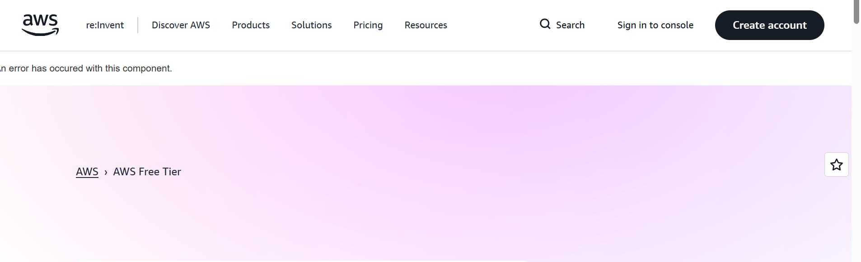
The Sign up page appears.

Provide Account Information
On the Sign up page, provide the following account information:
- In the Root user email address field, enter your email address.
- In the AWS account name field, enter a name for your account.
- Click Verify email address. 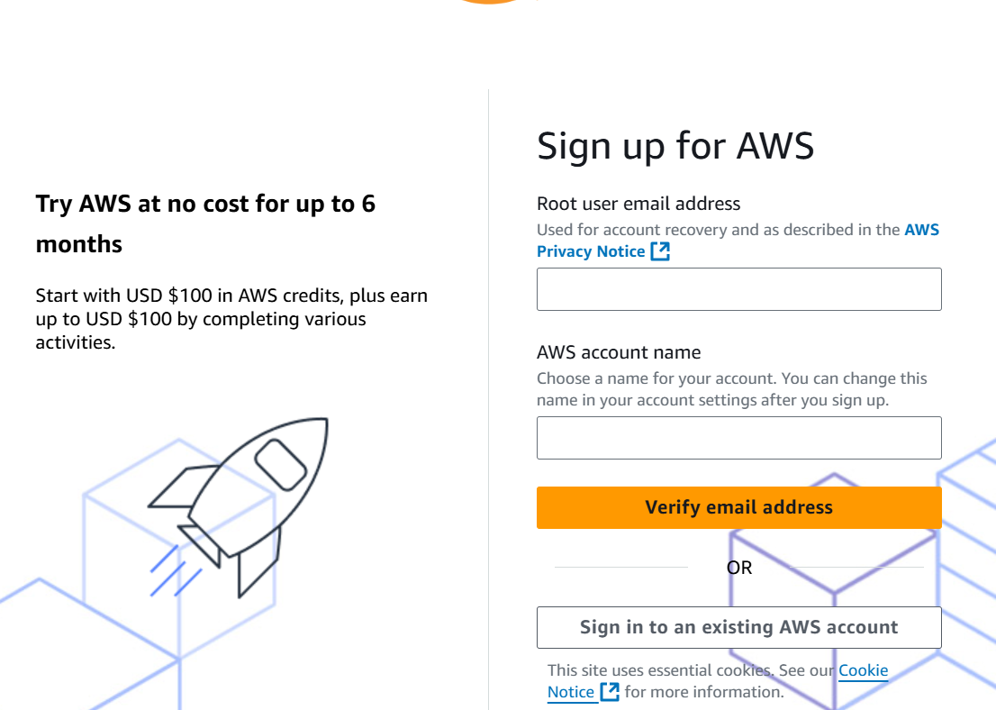
AWS sends a verification code to your email address, and the Verification Code page appears.
- In the Verification Code field, enter the code.
- In the Password field, enter and confirm your password.
- Click Continue (step 1 of 5).
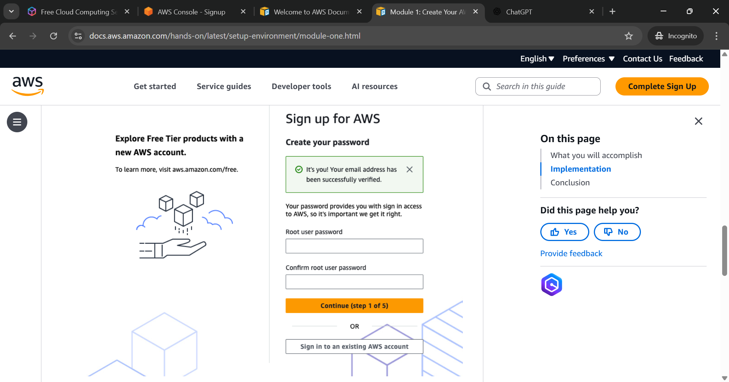
The Contact Information page appears and begins step 2 of the account setup process.

Add Contact Information
On the Contact Information page, perform the following steps:
- Select Personal or Business as the account type.
- In the Full Name field, enter your name.
- In the Country Code list, select your country code.
- In the Phone Number field, enter your phone number.
- In the Country or Region field, select your country or region.
- In the Address field, enter your address.
- In the City field, enter your city.
- In the State, Province, or Region field, enter your state, province, or region.
- In the Postal Code field, enter your postal code.
- In the Customer Agreement section, read and accept the agreement.
- Click Continue (step 2 of 5).
The Billing Information page appears and begins step 3 of the account setup process.

Add a Payment Method
On the Billing Information page, add a payment method.
You can choose either a Credit/Debit card or UPI AutoPay.
For Credit or Debit Card, perform the following steps:
- In the Payment Method section, select Credit or Debit Card.
- In the Expiration Date field, enter the card expiration date.
- In the Security Code field, enter the card security code.
- In the Cardholder’s Name field, enter the cardholder’s name.
- Click Verify and Continue (step 3 of 5).
AWS sends a One-Time Password (OTP) to your registered mobile number.
- In the One-Time Password field, enter the OTP.
- Click Submit.
For UPI AutoPay, perform the following steps:
- In the Payment Method section, select UPI AutoPay.
- In the UPI ID field, enter the UPI ID.
- Click Verify and Add.
- In the Billing Address section, select Use my contact address or Use a new address.
- Click Verify and Continue (step 3 of 5).
The Confirm Your Identity page appears and begins step 4 of the account setup process.

Confirm Your Identity
AWS verifies your identity before activating your account.
On the Confirm Your Identity page, perform the following steps:
- In the Primary Purpose section, select the option that describes your use of AWS.
- In the Ownership Type field, select the ownership type.
- In the Document Type menu, select your document type.
- In the PAN Number field, enter your PAN number.
- Click Continue.
- In the Date of Birth field, enter your date of birth.
- Click Continue (step 4 of 5).
To verify your phone number, perform the following steps:
- Select Text message (SMS) or Voice call.
- In the Country or Region Code list, select your country or region code.
- In the Mobile Phone Number field, enter your mobile number.
- Click Send SMS (step 4 of 5).
A Security Verification dialog box appears.
- In the CAPTCHA field, enter the code.
- Click Submit.
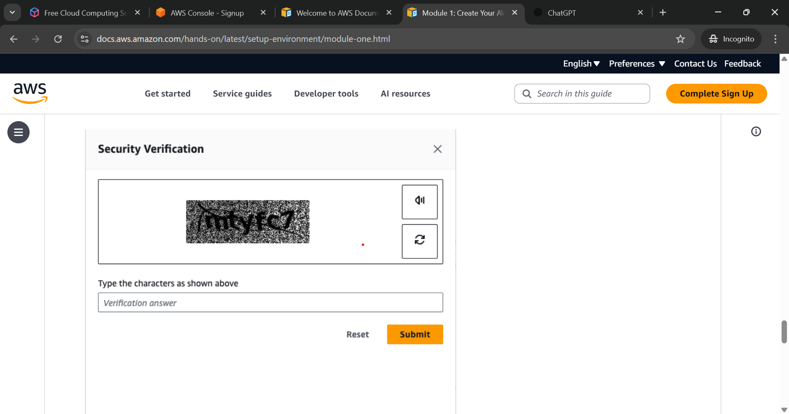
AWS sends a verification code.
- In the Verification Code field, enter the code you receive.
- Click Continue (step 4 of 5).
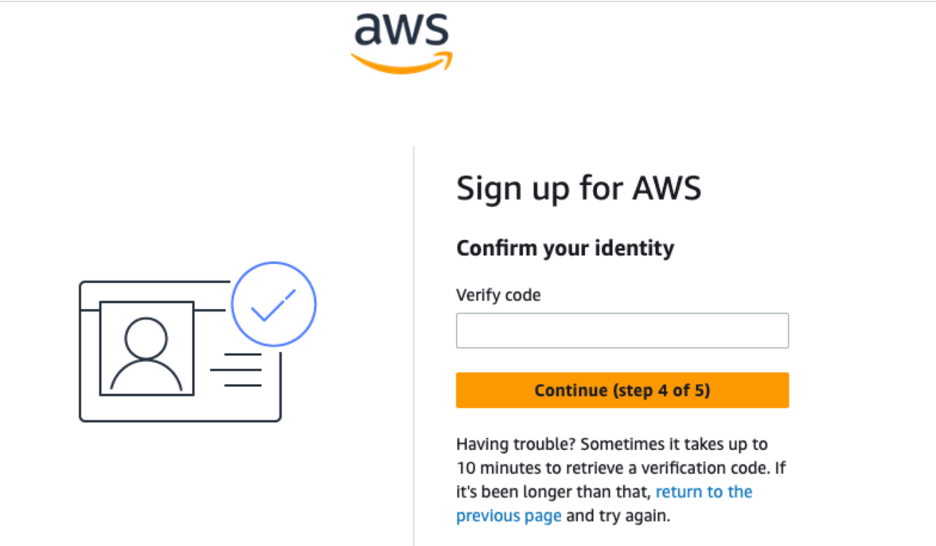
The Support Plan page appears and begins step 5 of the account setup process.

Choose a Support Plan
A support plan provides access to AWS technical support and customer service.
You can choose one of the following plans:
- Basic (Free): Provides 24/7 customer service and access to Free Tier benefits.
- Business/Developer (Paid): Provides quick technical support and additional features.
Beginners can select the Basic (Free) support plan.
On the Support Plan page, perform the following steps:
- Select the support plan you want.
- Click Complete sign up.

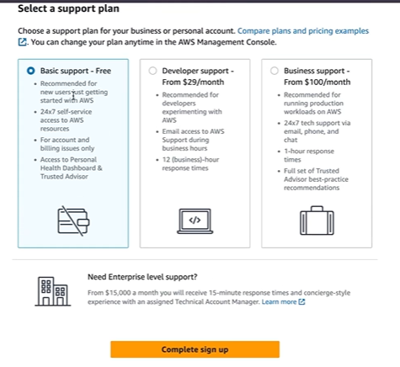
AWS activates your account and sends you a welcome email.
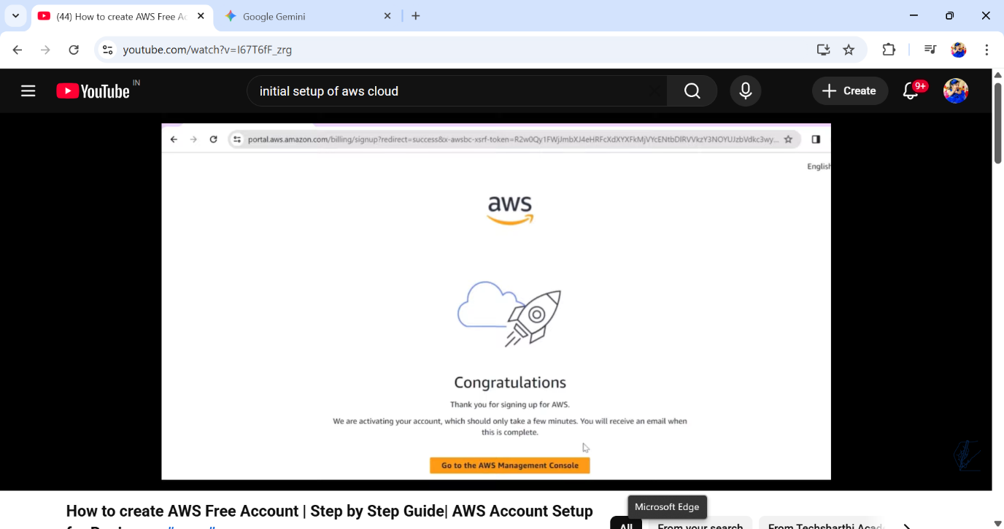

Access the AWS Management Console
The AWS Management Console allows you to manage and monitor AWS services and resources.
To access the AWS Management Console, perform the following steps:
- On the confirmation page, click Go to the AWS Management Console.
- On the console page, click Sign in to the Console.
The Sign in page appears.
Two sign in options are available:
- Root User: The account owner.
- IAM User: A user created by the root user or an administrator.

Sign In as the Root User
To sign in to the AWS Management Console for the first time, perform the following steps:
- On the Sign in page, select Root User.
Note: Use the Root user option for your initial login.
- In the Root User email address field, enter your email address.
- Click Next.

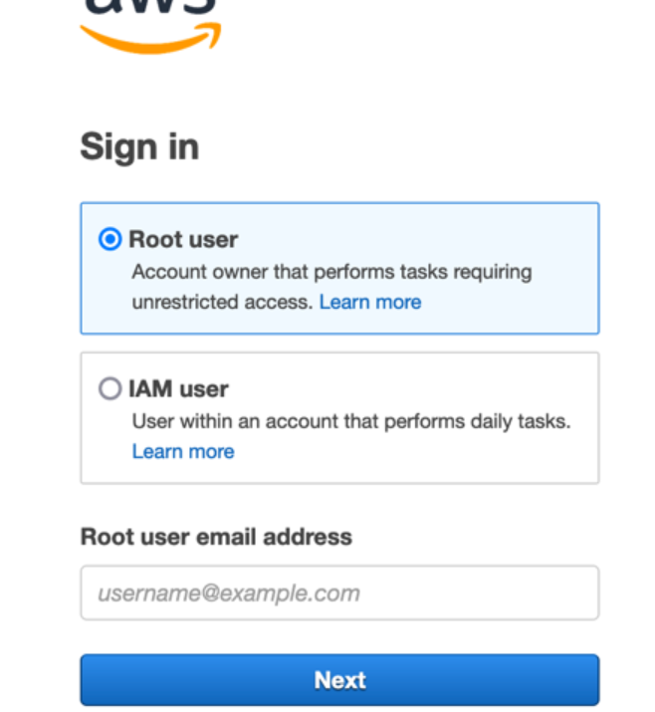
- In the Password field, enter your password.
- Click Sign in.
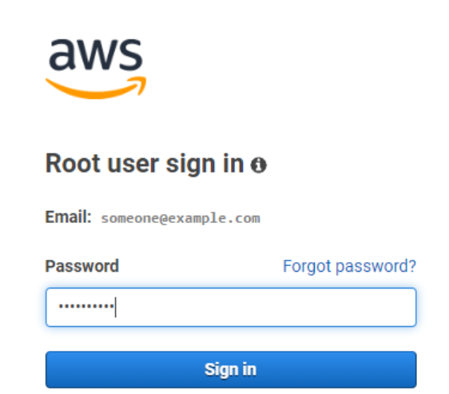
The AWS Console Home page appears.

Secure Your Account
You can secure your AWS account from unauthorized access.
Recommended security practices include:
- Enabling Multi-Factor Authentication (MFA) for the root user
- Creating an IAM administrator user for daily tasks
- Setting up billing alerts

Enable MFA for the Root User
You can secure your root user account with MFA.
To enable MFA, perform the following steps:
- On the Console Home page, click your account name.
- In the dropdown list, select Security credentials.
The Security credentials page appears.
- In the Multi-Factor Authentication (MFA) section, click Assign MFA device.
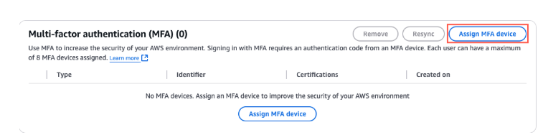
The MFA device page appears.
- In the Device name field, enter a device name.
- In the Device options section, select Authenticator app.
- Click Next.
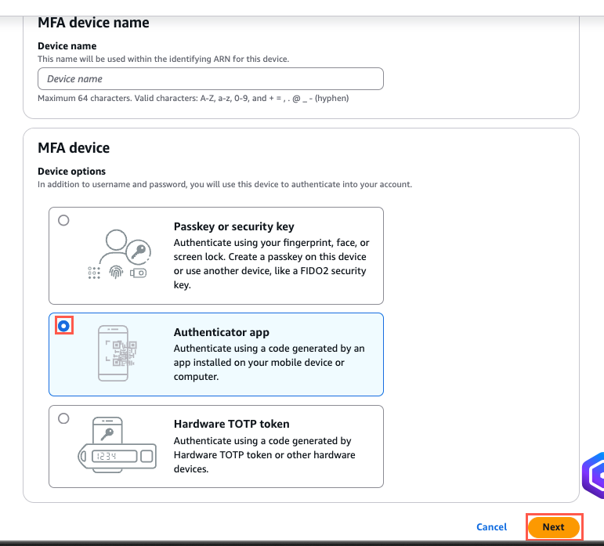
The Set up device page appears.
- On the Set up device page, click Show QR code.
- Scan the QR code using an authenticator app.
- In the code field, enter the two verification codes generated by the app.
- Click Add MFA.
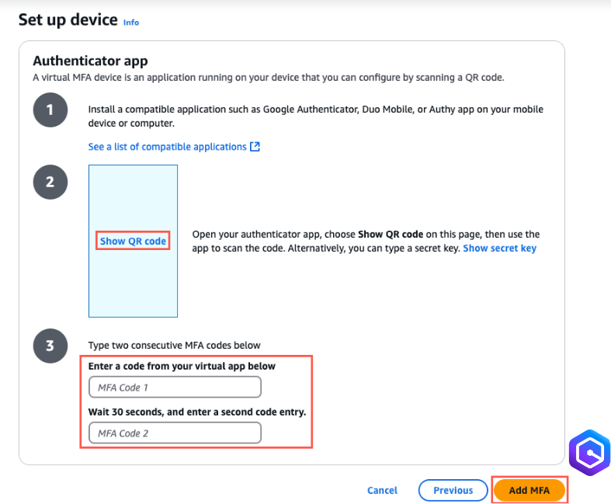
The confirmation message appears.
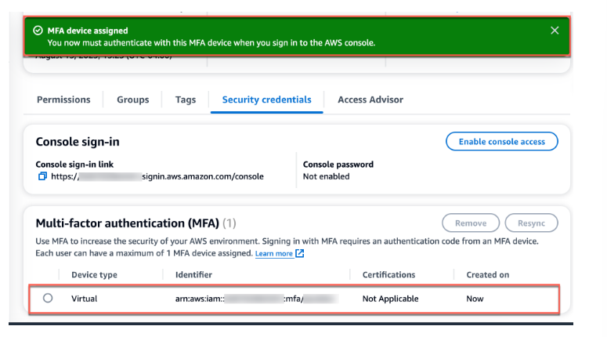
Your root account is now secured.

Create a Daily Admin User
A daily admin user allows you to perform everyday tasks in AWS without using the root account.
To create an IAM admin user, go to the Console Home page and perform the following steps:
- In the console search bar, search for IAM.
- Open the IAM Dashboard.
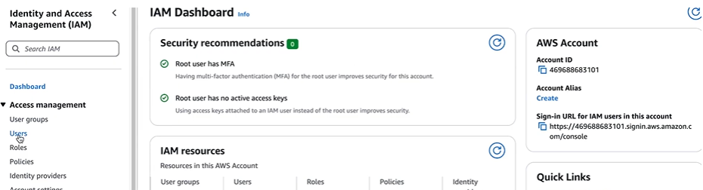
- In the left navigation pane, click Users.
- In the right pane, click Create user.
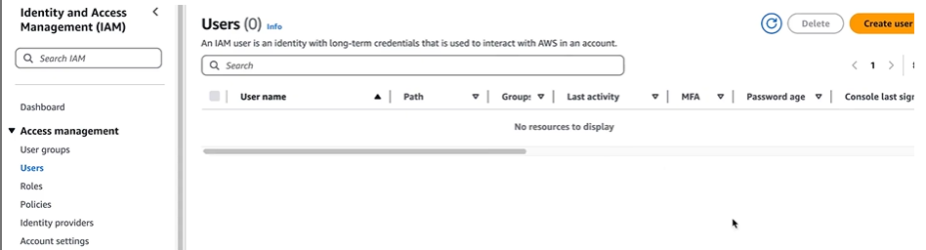
The Specify user details page appears.
- In the User name field, enter a user name.
- Select Provide user access to the AWS Management Console.
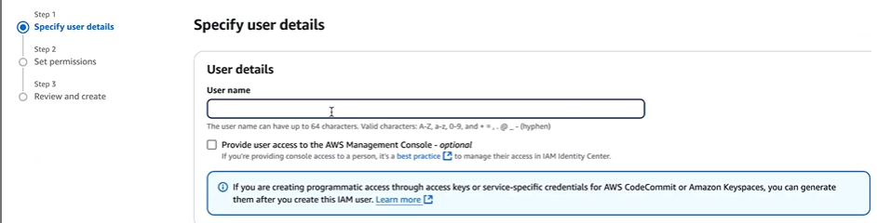
The Providing console access box appears.
- In the providing console access section, select I want to create an IAM user.
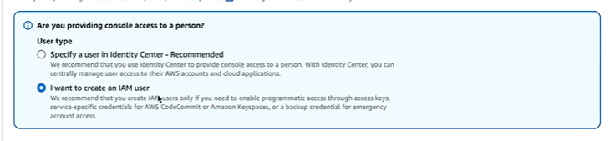
- In the Custom password field, enter a password.
- Click Next.
The Set permissions page appears.
- In Permissions options, select Attach policies directly.
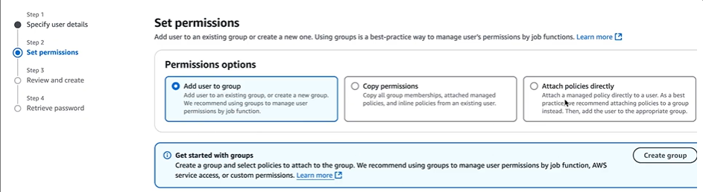
- In the Policy list, select AdministratorAccess.
- Click Next, and then Create user.
The Retrieve password page appears.
- On the Retrieve password page, click Download.csv file.
This file contains your Console sign in URL.
- Click Return to users list.
You can now use the administrator user for daily tasks.

Set Up a Billing Alarm
A billing alarm notifies you when your AWS charges exceed a specified limit.
To set up a billing alarm, go to the Console Home page and perform the following steps:
- In the console search bar, search for Billing and Cost Management.
The Billing and Cost Management home screen appears.
- In the left pane, click Billing Preferences.
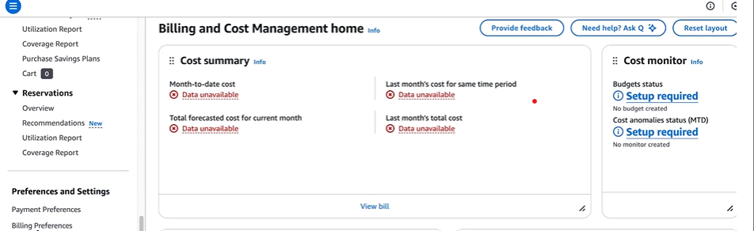
The Billing preferences page appears.
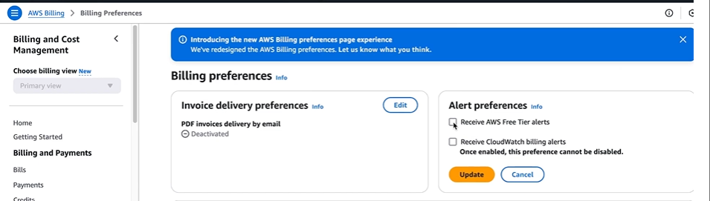
- In the Alert preferences section, enable the following options:
- Receive PDF Invoice by Email.
- Receive Free Tier Usage Alerts.
- Receive Billing Alerts.
- Click Update.
- In the search bar of the same page, enter and select CloudWatch.
The CloudWatch page appears.
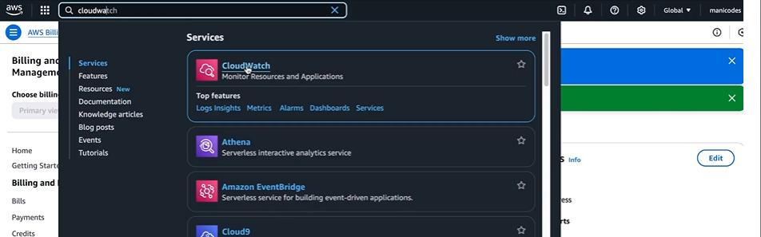
- In the left pane, click Alarms.
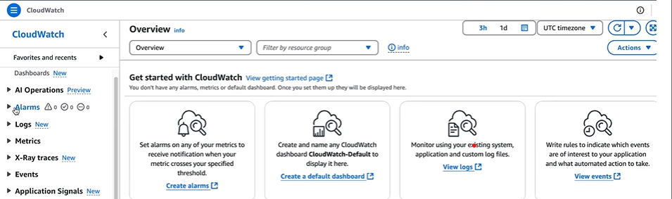
- In the Alarms menu, select Billing.
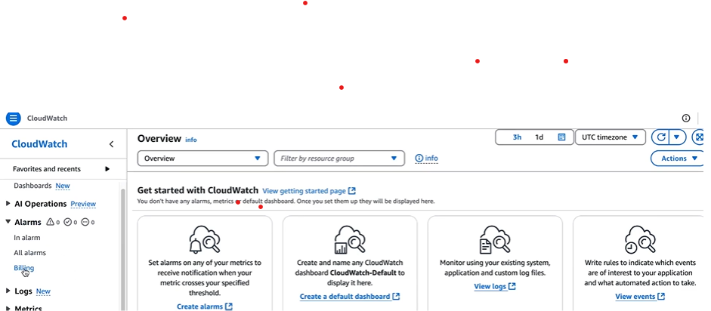
The Billing alarms page appears.
- In the right pane, click Create alarm.
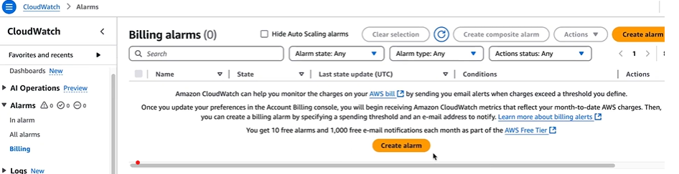
The Specify metric and conditions page appears.
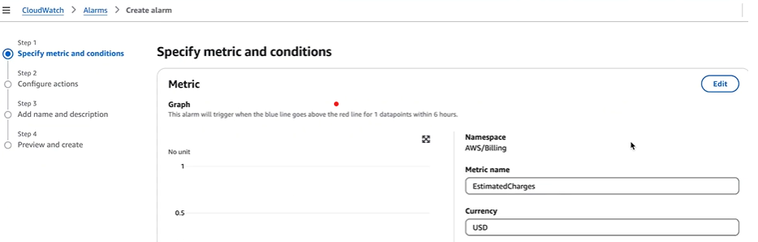
- On the Specify metric and conditions page, perform the following steps:
- In the Metric name field, select EstimatedCharges.
- In the Currency field, enter USD.
- In the Statistics field, select Maximum.
- In the Period field, select the period.
- In the Conditions field, select the following options:
- Static as the threshold type.
- Select the Estimated charges option.
- Set the threshold value.
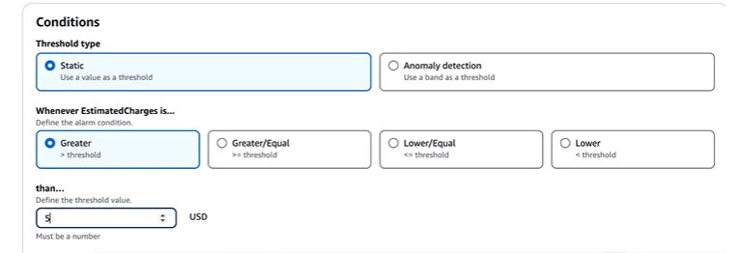
- Click Next.
The Configure actions page appears.
- In the Notification section, select Create topic.
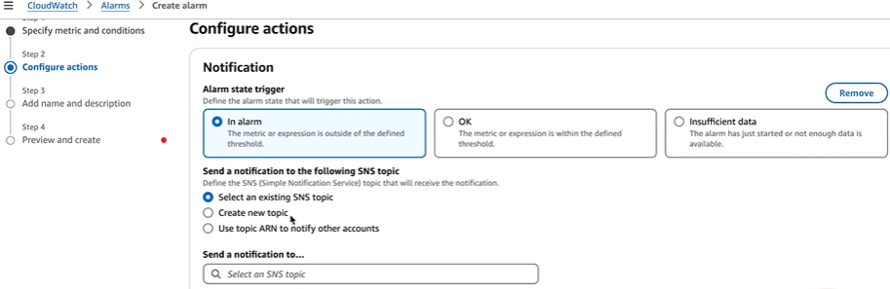
- In the Email field, enter your email address and click Next.
The Add name and description page appears.
- In the Alarm name field, enter the name.
- Click Next.
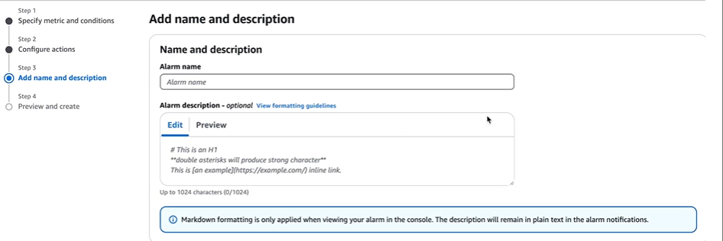
The Preview and create page appears.
- In the right pane, check the preview.
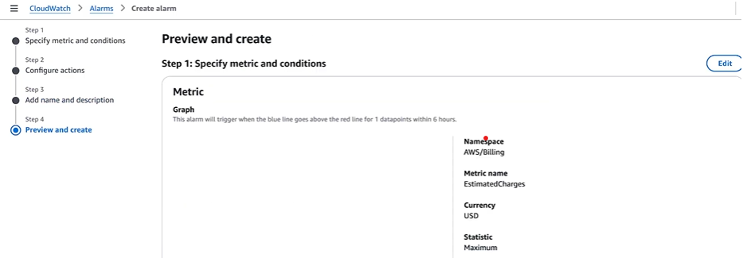
- Click Create alarm.
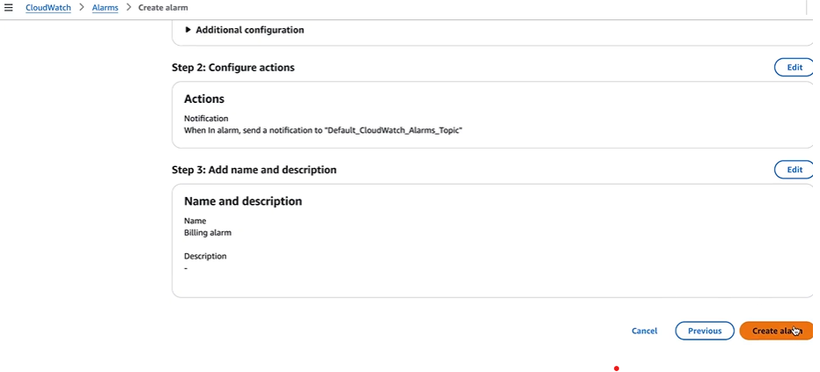
AWS sends a confirmation email. Click the link in the email to activate the notification.
Your billing alarm is now set.
You can now access AWS services.

