1. OSI Layer for Wi-Fi Standard/Protocol
Wi-Fi (IEEE 802.11) operates at Layer 1 (Physical) and Layer 2 (Data Link) of the OSI model.
- Physical Layer (L1): Handles radio frequency transmission, modulation (OFDM, DSSS), signal encoding, and frequency bands (2.4 GHz / 5 GHz / 6 GHz).
- Data Link Layer (L2): The MAC (Medium Access Control) sublayer handles frame formatting, CSMA/CA (collision avoidance), association, authentication, and addressing via MAC addresses.
Wi-Fi does not operate at Layer 3 or above — IP addressing and routing are handled by upper layers.

2. Wi-Fi Devices & Generations
Here's a mapping of common everyday devices to Wi-Fi generations based on typical capabilities:
Device | Standard | Wi-Fi Generation | Bands | Max Speed
Modern Smartphone (2022–24) | 802.11ax | Wi-Fi 6 / 6E | 2.4 / 5 / 6 GHz | ~9.6 Gbps
Laptop (2020–23) | 802.11ax | Wi-Fi 6 | 2.4 / 5 GHz | ~9.6 Gbps
Older Laptop (2017–19) | 802.11ac | Wi-Fi 5 | 2.4 / 5 GHz | ~3.5 Gbps
Smart TV | 802.11ac | Wi-Fi 5 | 2.4 / 5 GHz | ~1.3 Gbps
Budget Android Phone | 802.11n | Wi-Fi 4 | 2.4 GHz | ~300 Mbps
IoT Devices / Smart Bulbs | 802.11n/b/g | Wi-Fi 4 or older | 2.4 GHz | ~54–150 Mbps
To check your own device (Windows): Run netsh wlan show interfaces in Command Prompt — it shows Radio Type, SSID, signal, etc.

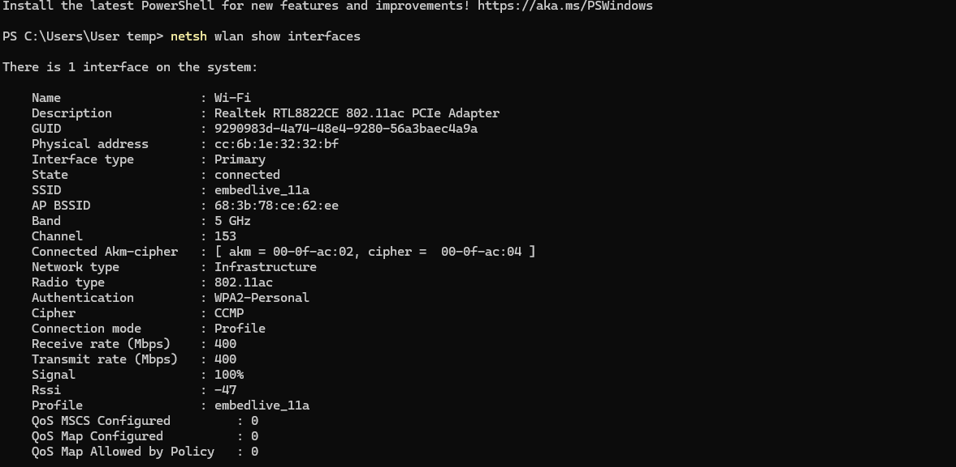

3. What is BSS and ESS?
BSS – Basic Service Set The fundamental building block of a Wi-Fi network. It consists of one Access Point (AP) and all the client devices (stations) associated with it. Every BSS has a unique BSSID (which is the AP's MAC address).
- IBSS (Independent BSS): An ad-hoc network with no AP — devices connect directly to each other.
- Infrastructure BSS: Clients connect through a central AP.
ESS – Extended Service Set A collection of two or more BSSs connected via a Distribution System (DS) (usually a wired backbone like Ethernet). All BSSs in an ESS share the same SSID, enabling seamless roaming. When you walk around a campus and stay connected to "CollegeWiFi" through multiple APs — that's an ESS.
[BSS 1: AP1 + clients] ---DS--- [BSS 2: AP2 + clients]
↑_____________ESS______________↑
Same SSID, different BSSID

4. Basic Functionalities of a Wi-Fi Access Point
Function | Description
Wireless Association | Allows client devices to connect/authenticate
SSID Broadcasting | Advertises the network name via Beacon frames
DHCP Relay/Server | Assigns IP addresses to clients (or relays to a router)
Bridging | Bridges wireless clients to the wired network
Security | Enforces WPA2/WPA3 encryption and authentication
Traffic Forwarding | Routes data between wireless clients and the internet
QoS | Prioritizes traffic (voice, video, data)
Channel Management | Selects and manages radio channels to reduce interference
Roaming Support | Supports handoff between APs in an ESS

5. Bridge Mode vs Repeater Mode
Feature | Bridge Mode | Repeater Mode
Purpose | Connects two separate networks | Extends the range of an existing network
How it works | Links a wired LAN to a wireless network (or two wired networks wirelessly) | Receives Wi-Fi signal and re-broadcasts it
IP Addressing | Devices get IPs from the main router | Devices get IPs from the main router
NAT | Disabled — transparent bridging | Disabled (passes through)
Bandwidth | Full bandwidth on each link | ~50% bandwidth loss (uses same channel to receive and transmit)
Use Case | Connecting a wired-only device/network wirelessly | Eliminating dead zones in large spaces
Example | Connecting a Smart TV's wired port to Wi-Fi | Boosting Wi-Fi to the far end of a house

6. Differences Between 802.11a and 802.11b
Feature | 802.11a | 802.11b
Year | 1999 | 1999
Frequency Band | 5 GHz | 2.4 GHz
Max Data Rate | 54 Mbps | 11 Mbps
Modulation | OFDM | DSSS (Direct Sequence Spread Spectrum)
Range | Shorter (~35m indoors) | Longer (~38–140m indoors)
Interference | Less (5 GHz less crowded) | More (2.4 GHz shared with Bluetooth, microwaves)
Non-overlapping Channels | 23 channels | 3 channels (1, 6, 11)
Compatibility | Not compatible with 802.11b | Not compatible with 802.11a
Cost (at launch) | Higher | Lower
Adoption | Enterprise | Consumer/Home

7. 2.4 GHz vs 5 GHz — Observed Differences
Here's a typical tabulation after connecting the same device to both bands:
Property | 2.4 GHz | 5 GHz
Frequency | 2.4 GHz | 5 GHz
Channel Width | 20/40 MHz | 20/40/80/160 MHz
Typical Speed | 150–300 Mbps | 433 Mbps – 1.3 Gbps
Range | Longer (better wall penetration) | Shorter (attenuates faster)
Interference | Higher (crowded band) | Lower
Latency | Slightly higher | Lower
Connected Devices | More devices tend to crowd here | Fewer devices, less congestion
Signal Strength (same location) | Stronger | Slightly weaker
Ideal Use | IoT, long-range, low-bandwidth | Video streaming, gaming, high-bandwidth
To check on Windows: netsh wlan show interfaces shows Radio Type and signal strength for your current connection.

8. IEEE vs WFA
Aspect | IEEE (Institute of Electrical and Electronics Engineers) | WFA (Wi-Fi Alliance)
Type | International standards body | Industry consortium / trade association
Role | Defines technical standards (the "how it works") | Certifies products for interoperability (the "it works together")
Wi-Fi Output | IEEE 802.11 standards (a/b/g/n/ac/ax) | Wi-Fi 4/5/6/6E/7 branding + certification programs
Membership | Academic, industry, government engineers | Companies: Apple, Intel, Qualcomm, Cisco, etc.
Focus | Technical specification, protocol design | Market adoption, branding, interoperability testing
Example | Defined 802.11ax protocol | Branded it "Wi-Fi 6" and certifies devices as "Wi-Fi 6 Certified"
In short: IEEE creates the spec, WFA makes sure products from different vendors actually work with each other.

9. Wi-Fi Internet Connectivity Backhaul Types
Backhaul = the connection between the Access Point and the internet/core network.
Backhaul Type | Description | Properties
Fiber (FTTH/FTTB) | Fiber optic to home/building | High speed (100 Mbps–10 Gbps), low latency, very reliable
DSL (ADSL/VDSL) | Over copper telephone lines | 1–100 Mbps, higher latency, distance-dependent
Cable (DOCSIS) | Over coaxial cable (TV cable) | 100 Mbps–1 Gbps, shared medium
4G/5G Cellular | Wireless via mobile towers | 50–1000 Mbps, mobile, higher latency than fiber
Leased Line | Dedicated point-to-point line | Symmetrical, SLA-backed, expensive — used in colleges/enterprises
Microwave/Wireless Backhaul | Point-to-point wireless links | Used by ISPs for last-mile in rural/remote areas
Satellite | Geostationary or LEO (e.g., Starlink) | High latency (GEO) or low latency (LEO), used in remote areas
Typical home/college in India: FTTH (JioFiber, ACT, BSNL Fiber) or Leased Line for college — providing 100 Mbps–1 Gbps symmetric with low latency (~5–10 ms).

10. Wi-Fi Topologies and Use Cases
Topology | Description | Use Case
Infrastructure Mode (BSS) | Clients connect to a central AP | Home networks, offices, cafes
Ad-Hoc / IBSS | Peer-to-peer, no AP needed | File sharing between two laptops, temporary setups
ESS (Extended Service Set) | Multiple APs, same SSID, wired backbone | Campuses, airports, malls — seamless roaming
Mesh Network | Multiple nodes relay traffic wirelessly to each other | Large homes, warehouses, smart city coverage
Point-to-Point (PtP) | Two directional antennas linking two locations | Connecting two buildings wirelessly
Point-to-Multipoint (PtMP) | One central AP serves multiple remote nodes | Rural ISP distribution, campus backbone
Wi-Fi Direct | Device-to-device without AP (successor to Ad-Hoc) | Wireless printing, screen mirroring (Miracast), file transfer
Hotspot / Tethering | Device acts as AP sharing cellular data | Mobile internet sharing

