WhatNext Vision Motors: Shaping the Future of Mobility with Innovation and Excellence

Use Case :
WhatsNext Vision Motors, a pioneering force in the automotive industry, is dedicated to transforming the mobility sector with innovative technology and solutions that prioritize customer needs. The company has embarked on an ambitious Salesforce project with the core objective of enhancing the customer experience and streamlining its operational processes.
At the heart of this project is the improvement of the customer ordering process. The system is designed to automatically suggest the nearest dealer location to customers based on their address. This feature is intended to significantly enhance the convenience and efficiency of the ordering experience, making it more customer-friendly and reducing the time and effort required from the customer's end.
The project also addresses a common issue in the automotive industry: stock availability. The system includes a mechanism that prevents customers from placing orders for vehicles that are out of stock. This proactive approach ensures that customers can only create orders for vehicles that are currently available, thus avoiding potential confusion and disappointment that may arise from stock unavailability. This feature not only enhances customer satisfaction but also improves the accuracy of the company's order fulfillment process.
Furthermore, the project incorporates a scheduled process for updating the status of bulk order records. This automated process is designed to update the order status based on stock availability. If a vehicle is out of stock at the time of order placement, the system will update the order status to 'Pending.' On the other hand, if the vehicle is in stock, the system will update the status to 'Confirmed.' This ensures that all orders are accurately reflected in terms of their fulfillment status, providing clear and transparent communication to customers regarding the status of their orders.
The implementation of this Salesforce project at WhatsNext Vision Motors is expected to yield several benefits. It aims to create a more efficient ordering system that reduces the potential for errors and improves the overall service provided to customers. By streamlining the ordering process and ensuring accurate stock availability, the company can enhance customer satisfaction and loyalty.
Moreover, the project is expected to contribute to operational efficiency by reducing the administrative burden on staff. By automating certain processes, employees can focus on more strategic tasks that require human intervention and expertise. This not only improves the overall productivity of the company but also allows for a more agile response to market demands and customer needs.

Requirements :

Salesforce CRM Implementation
- Store and manage vehicle details, stock availability, and dealer information in Salesforce.
- Track customer orders, test drives, and service requests efficiently.
- Automate workflows to assign orders to the nearest dealer based on customer location.
- Process Automation
- Prevent order placement if the vehicle is out of stock.
- Auto-assign orders to the nearest dealer based on the customer’s location.
- Send automated email reminders for scheduled test drives.

3. Apex and Trigger
- Implement Apex triggers to enforce business rules such as stock validation and automatic dealer assignment.
- Use trigger handlers to follow best practices and ensure modularity and maintainability.

4. Batch Jobs
- Develop a batch Apex job to periodically check vehicle stock levels and update availability.
- Send scheduled email notifications for stock replenishment and order processing.
What you'll learn :
- Data Modelling
- Fields and Relationships
- Lightning App Builder
- Record Triggered Flows
- Apex and Apex Triggers
- Batch Apex
- Scheduled Apex

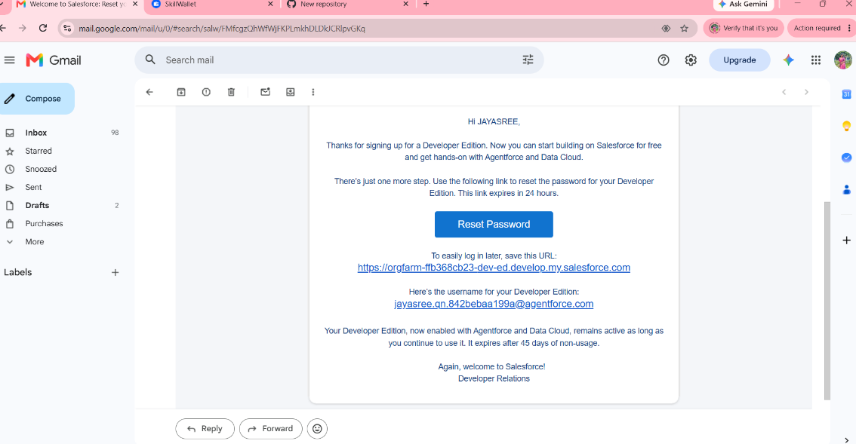
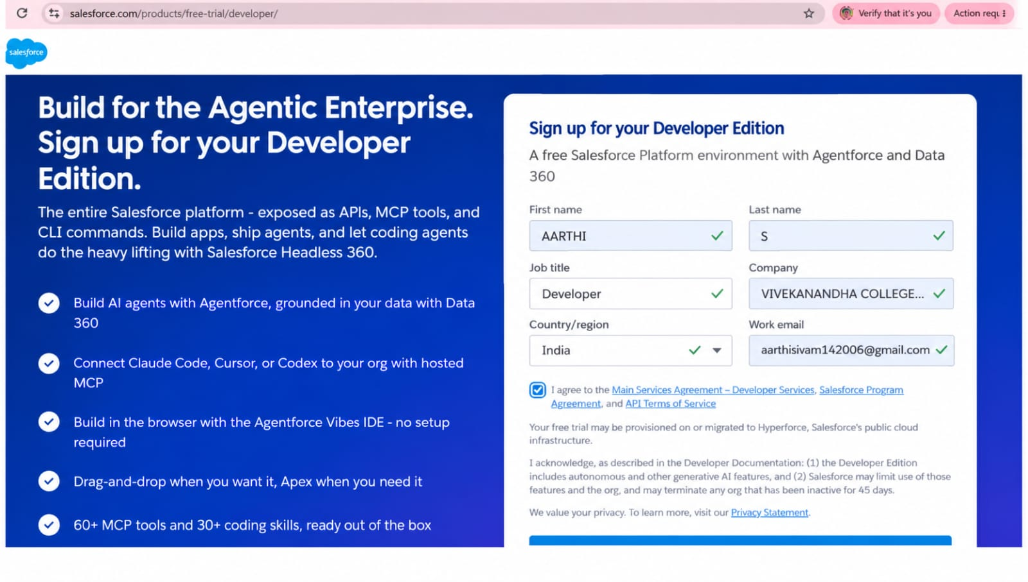

MileStone 2 :

Objects & Relationships

Object Name | Purpose | Relationships
Vehicle__c | Stores vehicle details | Related to Dealer & Orders
Vehicle_Dealer__c | Stores authorized dealer info | Related to Orders
Vehicle_Customer__c | Stores customer details | Related to Orders & Test Drives
Vehicle_Order__c | Tracks vehicle purchases | Related to Customer & Vehicle
Vehicle_Test_Drive__c | Tracks test drive bookings | Related to Customer & Vehicle
Vehicle_Service_Request__c | Tracks vehicle servicing requests | Related to Customer & Vehicle

Activity 1: Create Vehicle Object
I created the Vehicle custom object to store vehicle details. I configured the Vehicle Name as the record name, enabled reporting and searching, and saved the object successfully.

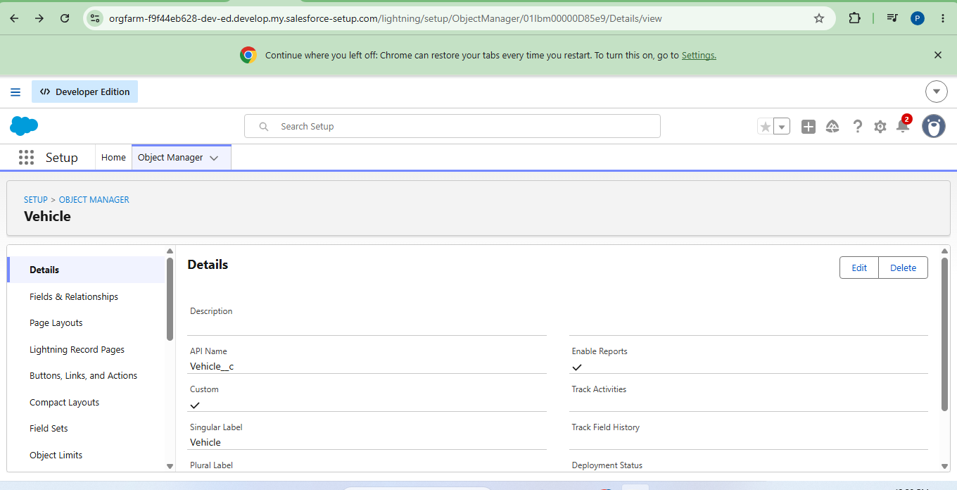

Activity 2: Create Dealer Object
I created the Vehicle Dealer custom object to maintain dealer information. I configured the Dealer Name as the record name, enabled reporting and searching, and saved the object.

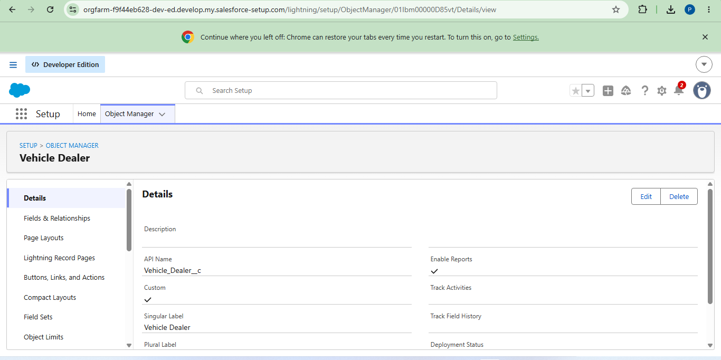

Activity 3: Creating remaining objects

I completed the remaining custom objects required for the project, including Vehicle Customer, Vehicle Order, Vehicle Test Drive, and Vehicle Service Request. These objects are used to manage customer, order, test-drive, and service-related information.

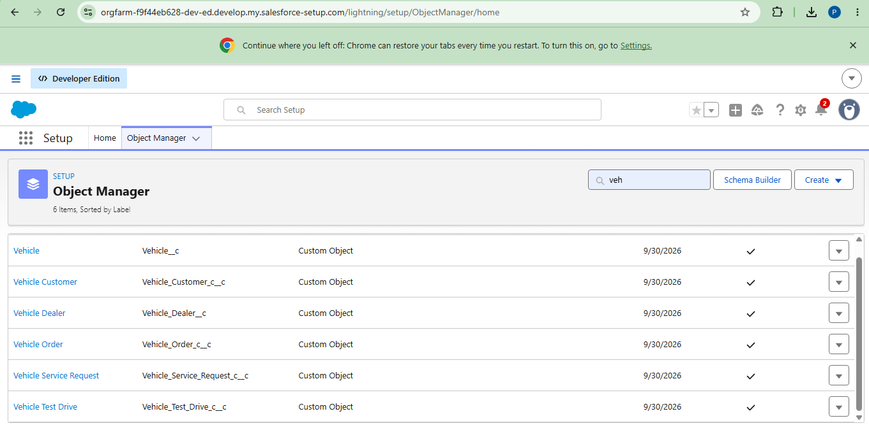

Milestone 3 - Tabs

Activity 1: Creating a Custom Tab(Vehicle)
I created a custom tab for the Vehicle object from the Salesforce Setup page. I selected the Vehicle object, configured the tab style, and saved the tab successfully.

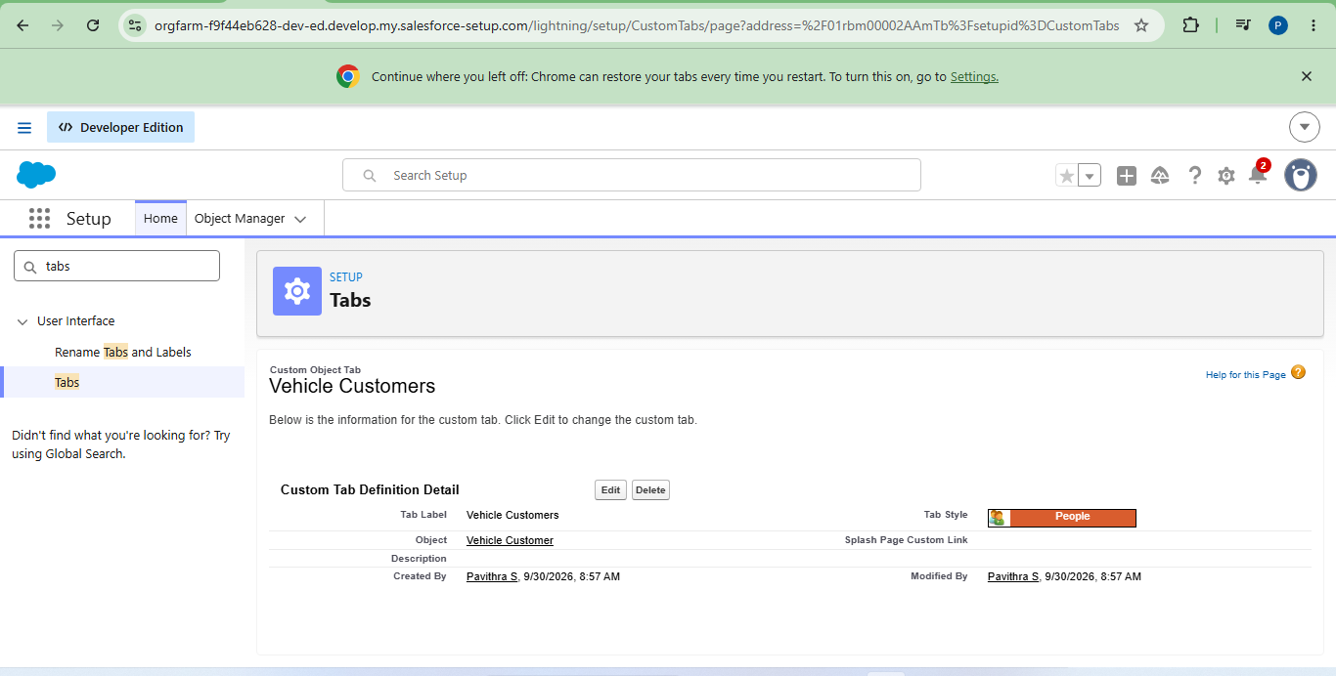

Activity 2:
I created custom tabs for the other objects that were created in the previous milestone. This makes the objects easily accessible from the Salesforce application.

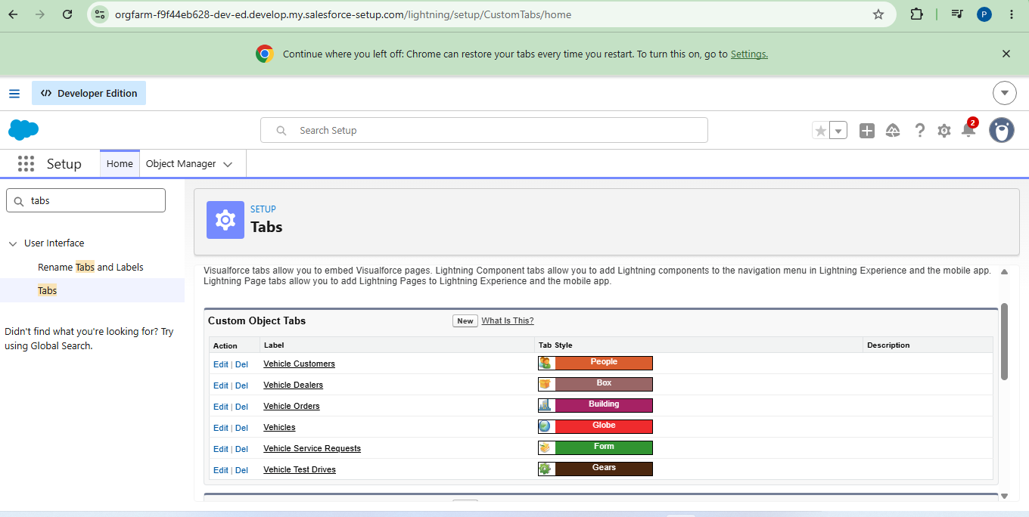

Milestone 4- The Lightning App:

Activity 1: Create a Lightning App
I created the WhatNext Vision Motors Lightning App. I configured the app details and added navigation items such as Vehicle, Dealer, Customer, Order, Test Drive, Service Request, Reports, and Dashboard, and finally added the System Administrator profile.

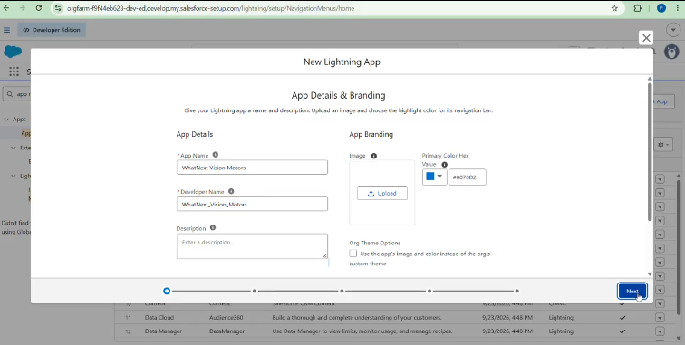

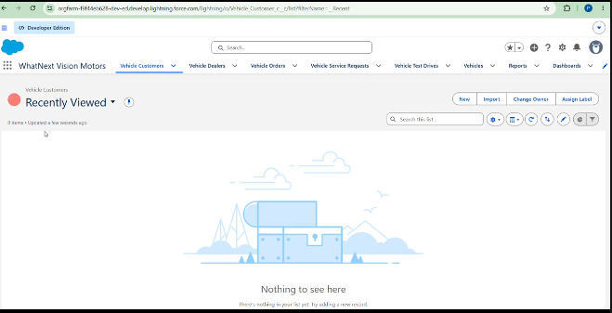

Milestone 5 : Fields & Relationships

Activity 1: Creating a Field in Vehicle Object
I created a Vehicle Model picklist field in the Vehicle object. I added the required picklist values and saved the field successfully.

Activity 2 : Creating Stock Quantity field in vehicle object
I created the Stock Quantity field in the Vehicle object using the Number data type. This field is used to store the available quantity of each vehicle.

Activity 3 : Creating a Lookup RelationShip in Vehicle Object to Dealer Object
I created a Lookup Relationship between the Vehicle and Dealer objects. This relationship connects each vehicle with the corresponding dealer information.

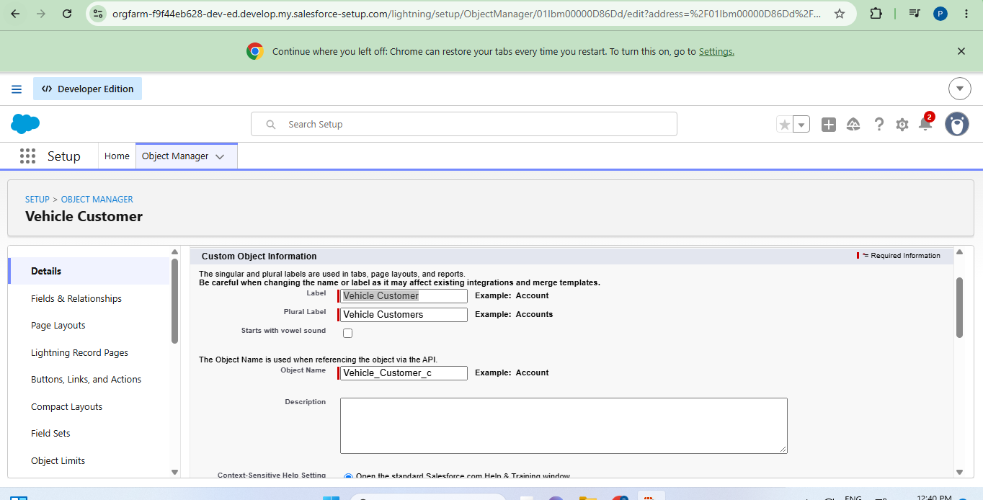

Activity 4 : Creating Remaining Objects and Fields.
I completed the remaining required objects and fields for the project. These fields support vehicle, dealer, customer, order, test-drive, and service-request information.

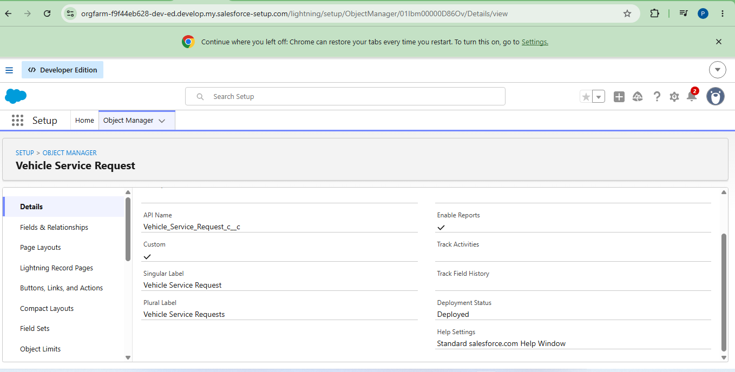

MileStone 6 :

Flow 1 : Creating a record triggered flow to assign nearest dealer to the customer’s location

I created a record-triggered flow for the Vehicle Order object. When an order is created with Pending status, the flow gets the customer information, finds the dealer based on the customer's location, and assigns the dealer to the order.

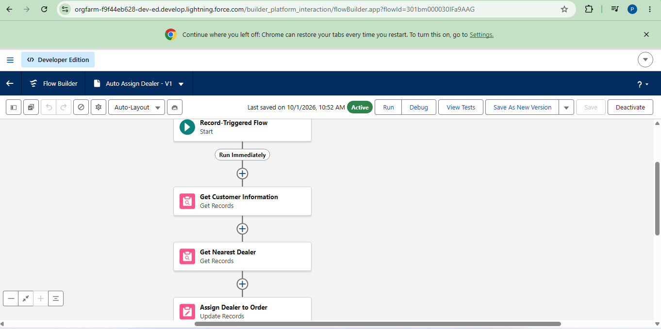

Flow 2 : Creating record triggered flow to send an email to the customer reminding about the test drive.
I created another record-triggered flow for the Vehicle Test Drive object. When a test drive is scheduled, the flow creates a scheduled path and sends an email reminder to the customer one day before the test drive.

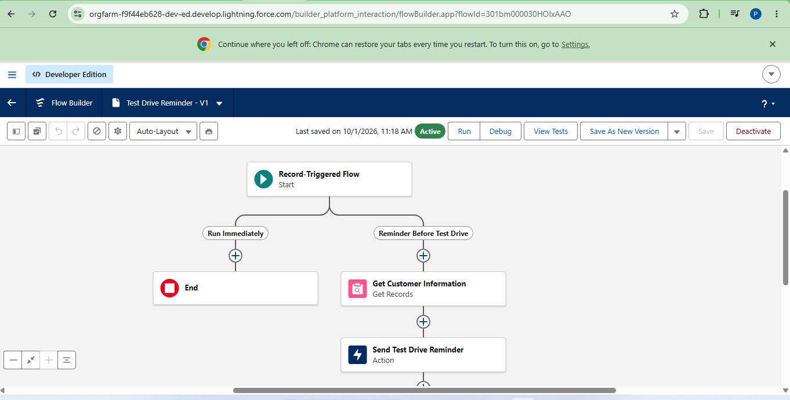

MileStone 7 :

Create Apex and Trigger Batch Jobs :

Activity 1 – Create Apex Class

I created the VehicleOrderTriggerHandler Apex class in the Developer Console. The class contains the business logic for checking vehicle stock and updating stock when an order is confirmed.

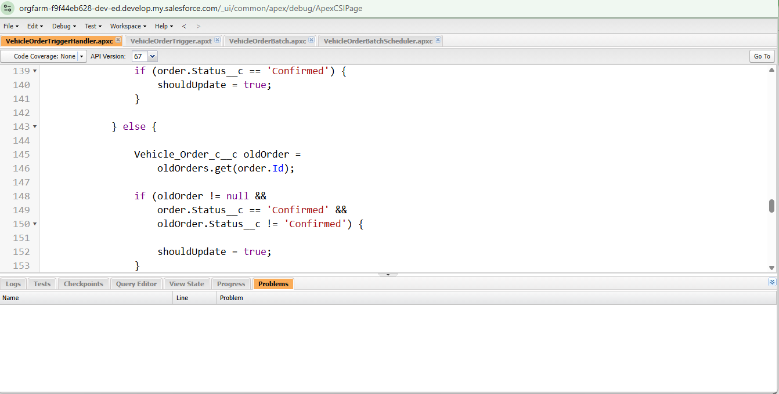
Activity 2 – Prevent Out-of-Stock Orders

I implemented the Apex logic to check the vehicle's stock quantity before placing an order. If the stock quantity is zero or less, the system displays an error and prevents the order from being placed.

Activity 3 – Update Vehicle Stock

is then saved I implemented the logic to automatically reduce the vehicle stock when a confirmed order is placed. The updated stock quantity back to the Vehicle record.

Activity 4 – Create Trigger

I created the Vehicle Order trigger and connected it with the Apex trigger handler class. The trigger calls the required Apex logic during order creation or update.

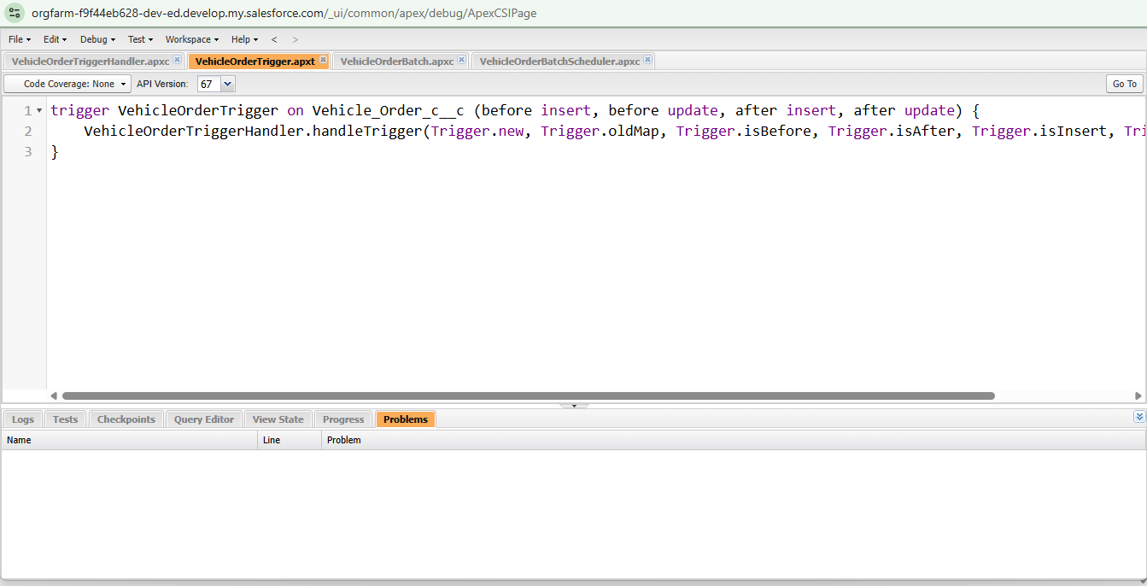

Activity 5 – Create Batch Job

I created the Batch Apex process for vehicle orders. When a vehicle is out of stock, the order remains pending, and after stock is available, the batch process updates the order accordingly.

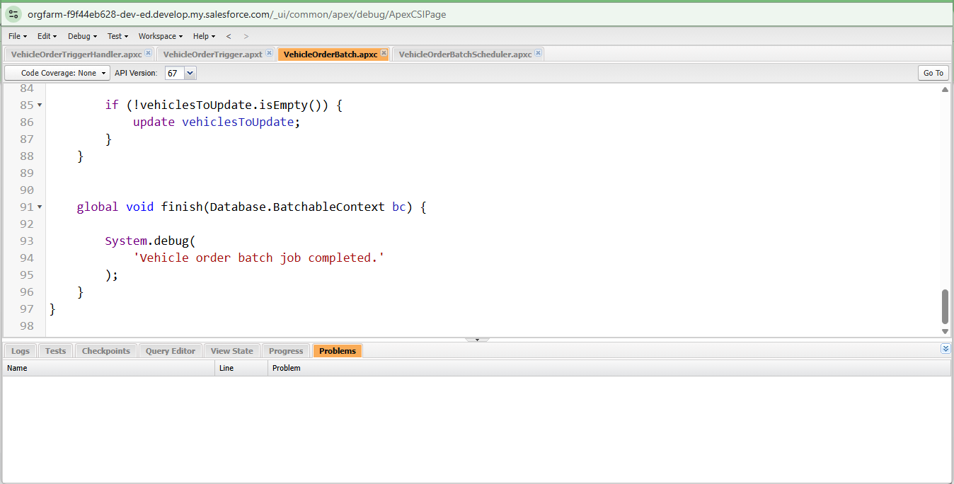

Activity 6 – Create Schedule Class

I created the VehicleOrderBatchScheduler class to execute the batch job automatically. The scheduler calls the Vehicle Order Batch class with a batch size of 50.

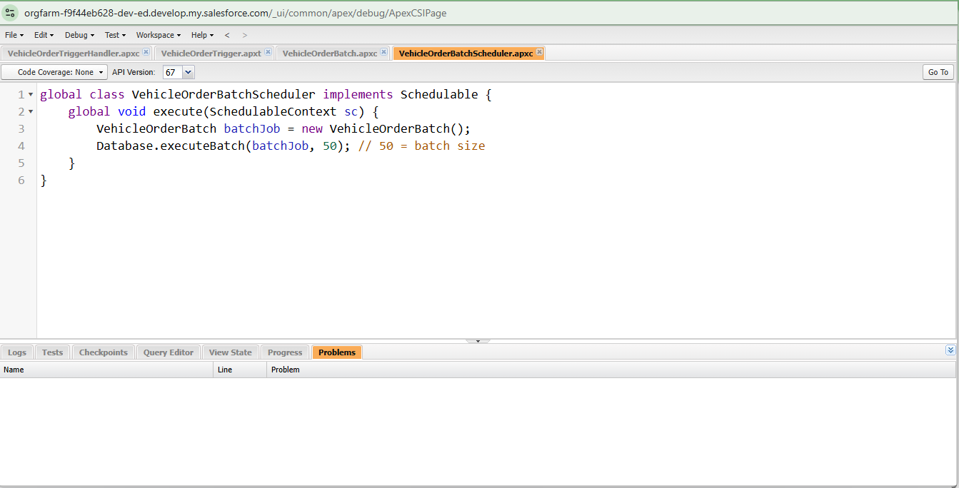

Activity 7 – Schedule the Batch Job

I scheduled the batch job to run automatically using a CRON expression. This allows the Vehicle Order processing to run on a scheduled basis without manual execution.

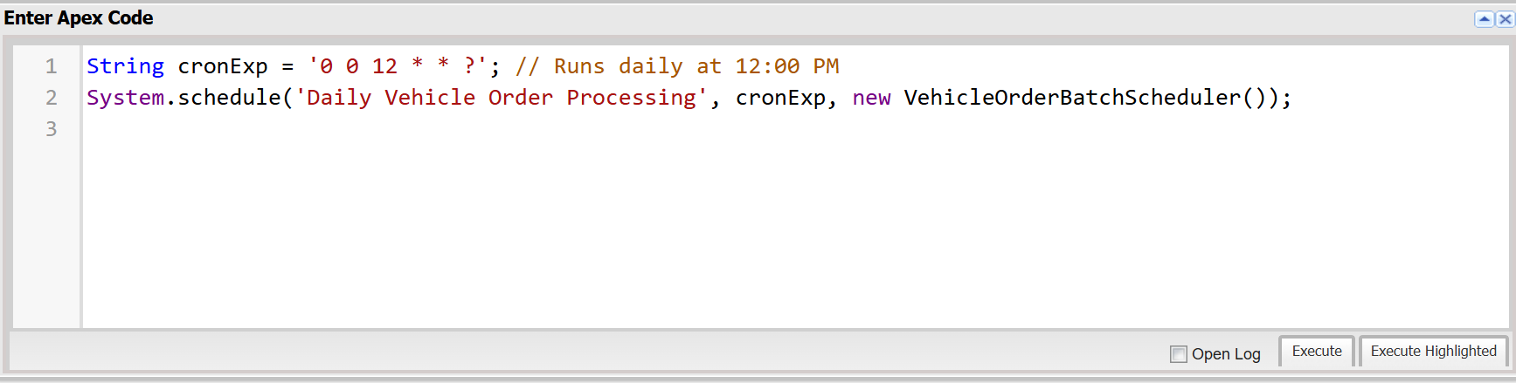

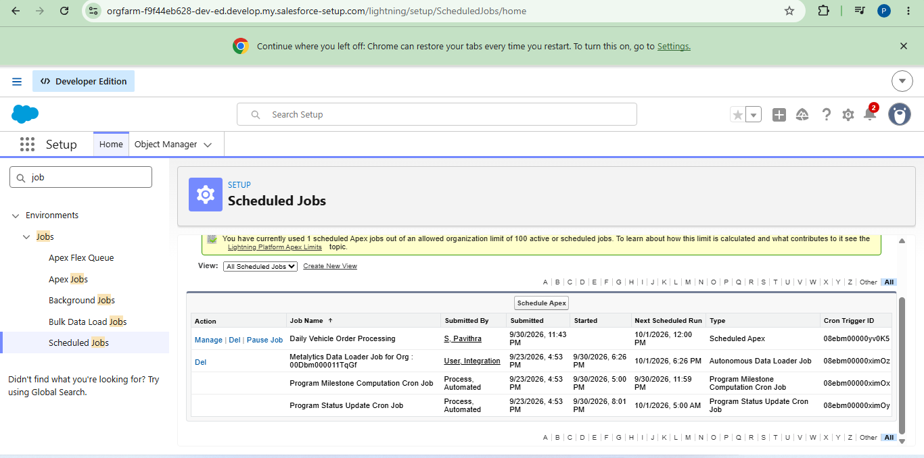

Thank you

