# PRODUCT DEPLOYMENT GUIDE

## Ensure that you have MS Excel or OpenOffice Calc and Salesforce DataLoader installed to your computer.

## First, extract records from following objects, unless separately advised in deployment notes. (order doesn’t matter in extraction phase).

* + Price Book
  + Price Book Entry
  + Product
  + Product Child Item
  + Product Relationship
  + Vlocity Attribute Category
  + Vlocity Attributes
  + Attribute Assignments
  + Vlocity Rule
  + Vlocity Rule Filter
  + Vlocity Rule Action
  + Vlocity Entity Filter
  + Vlocity Entity Filter Condition
  + Product Configuration Procedures
  + Offerings
  + Master Solution Area

## Then filter the extracted records to have only required records to be deployed. Records that are directly related to Product record are Attribute assignments, Product Configuration Procedures, Product Child Items and Product Relationships. The other related records needs to be figured out based on these other relationships (or see what’s listed into the deployment notes)

# DataLoader for Export/extraction

Select “**Export**” to proceed.

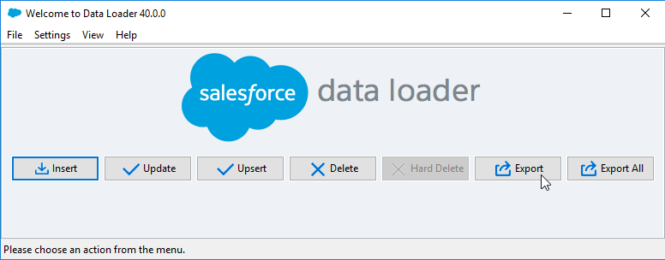

Enter your login details and set the Salesforce login URL accordingly:

(NOTE! For Production Environment, the Security Token is required after your password.)

Sandbox: <https://test.salesforce.com>

Production: <https://login.salesforce.com>

Proceed by selecting “Next”.

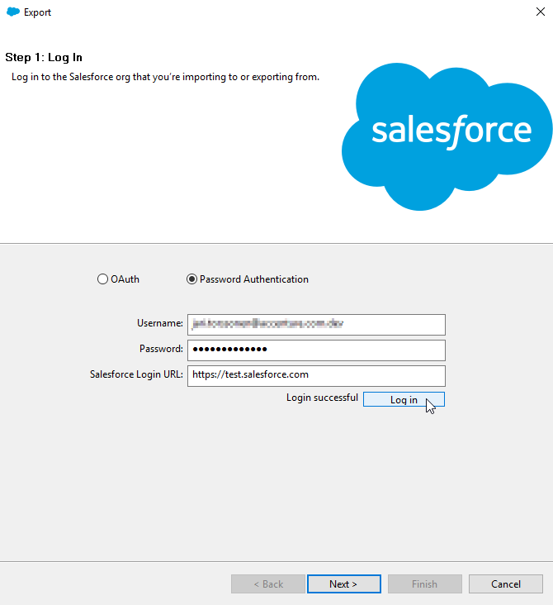

Select the correct object from the list and note, that if you cannot find it you need to select the “Show all salesforce objects”-tickbox.

Also define a target file .csv where you want to store the records.

Proceed by selecting “Next”.

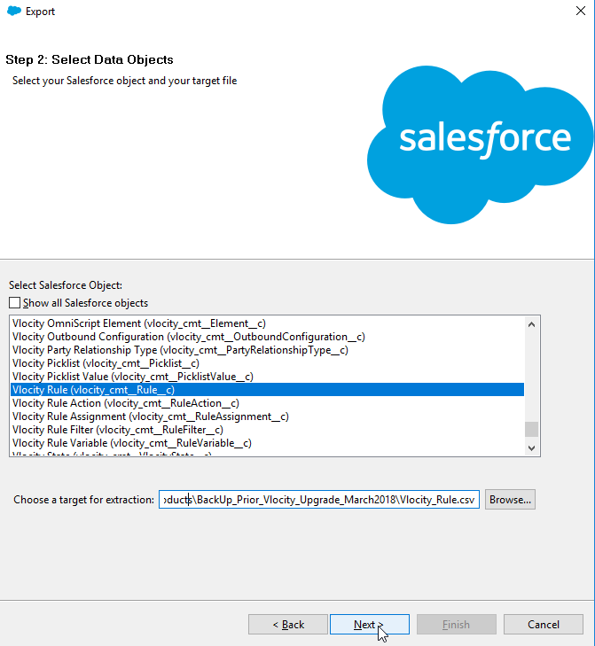

Select All fields to be exported. (In this view you can also add conditions if required.)

Proceed by selecting “Finish”.

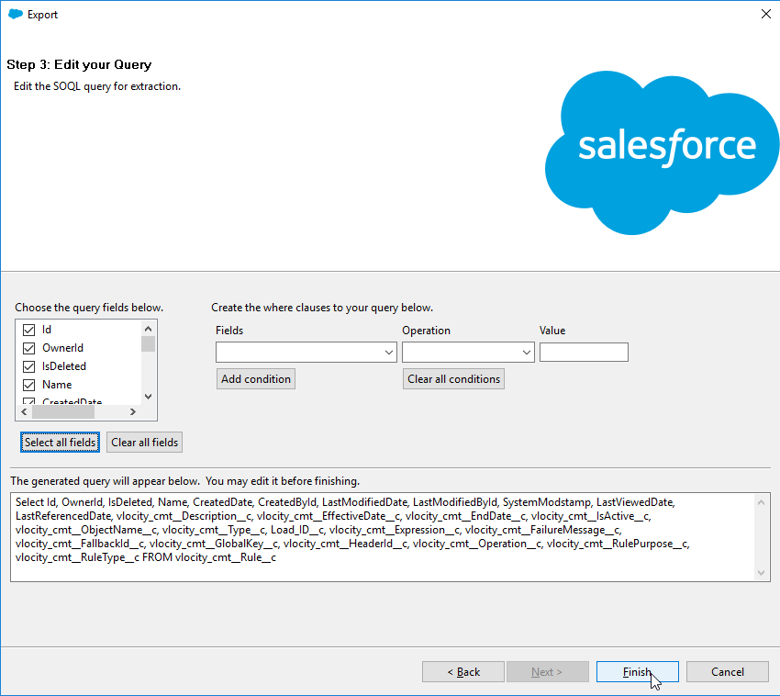

Select “Yes” to launch the export process.

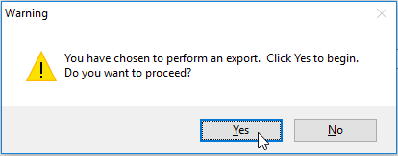

# Extraction from following objects:

* + 1. Export records from object “**Vlocity Rule**” (vlocity_cmt__Rule__c)
       - Include all fields
    2. Export records from object “**Vlocity Entity Filter**” (vlocity_cmt__EntityFilter__c)
       - Include all fields
    3. Export records from object “**Entity Filter Condition**” (vlocity_cmt__EntityFilterCondition__c)
       - Include all fields
    4. Export records from object “**Rule Filter**” (vlocity_cmt__RuleFilter__c)
       - Include all fields
    5. Export records from object “**Rule Action**” (vlocity_cmt__RuleAction__c)
       - Include all fields
    6. Export records from object “**Product Configuration Procedures**” (vlocity_cmt__ProductConfigurationProcedure__c)
       - Include all fields
    7. Export records from object “**Price Book**” (Pricebook2)
* Include all fields
  + 1. Export records from object “**Product**” (Product2)
* Include all fields (Except vlocity_cmt__JSONAttribute__c)
  + 1. Export records from object “**Price Book Entry”** (PricebookEntry)
* Include all fields
  + 1. Export records from object “**Attribute Assignment**” (vlocity_cmt__AttributeAssignment__c)
* Include all fields (Except vlocity_cmt__ObjectLink__c)
  + 1. Export records from object “**Vlocity Attribute Category**” (vlocity_cmt__AttributeCategory__c)
* Include all fields
  + 1. Export records from object “**Vlocity Attribute**” (vlocity_cmt__Attribute__c)
* Include all fields
  + 1. Export records from object “**Product Child Item**” (vlocity_cmt__ProductChildItem__c)
* Include all fields
* Exclude all records where Name is “Root PCI”.
  + 1. Export records from object “**Product Relationship**” (vlocity_cmt__ProductRelationship__c)
* Include all fields
  + 1. Export records from object “**Offerings**” (Offerings__c)
  + Include all fields

NOTE! Validate if export is needed, or if Offerings exists already in target environment. In this case only do mapping against the target environment record IDs.

* + 1. Export records from object “**Master Solution Area**” (telia_Solution_Area__c)
  + Include all fields

NOTE! Validate if export is needed, or if Master Solution Areas exists already in target environment. In this case only do mapping against the target environment record IDs.

## After you have exported all required objects, you can start preparing the data for importing. In Importing phase the order matters, and basically you first need to import the core records, and then the related ones. So please pay a close attention to the order, also pay attention to existing records in target environment if such exists. So that the existing ones will get updated, instead of creating unnecessary duplicates.

## While importing gather your “Success” and “Error”-result log files of the imports, as You will need especially the IDs from the success-files. Those files include the original ID (source environment) as well as the current ID (target environment) of those records. And you will need these IDs for mapping the related records in later stages.

Please check the examples at the end of the document.

# Import following objects:

NOTE! When importing new records, You need to be sure that you DO NOT create duplicate data, so please check the Target environment first to be sure that the records do not exist that you’re about to import. If they do, please ensure if they should be updated, and then use those record IDs while mapping the records.

* + 1. Import previously exported “**Price Book**” records in target environment
       - Exclude ID column if present;
       - Note down ID of created records from result log
    2. Import previously exported “**Offerings**” records in target environment
       - Exclude ID column if present;
       - Note down ID of created records from result log
    3. Import previously exported “**Master Solution Areas**” records in target environment
       - Exclude ID column if present;
       - Note down ID of created records from result log
    4. Import previously exported “**Product**” records in target environment
       - Exclude ID column if present
       - Note down ID of created records from result log
       - Replace values in column “TELIA_SUB_SOLUTION_AREA__C” with respective record IDs of Master Solution Area from target environment.
  + Replace values in column “TELIA_CONTRACT_OFFERING_NAME__C” with respective record IDs of Master Solution Area from target environment.

1. Import previously exported “**Price Book Entry**” records in target environment
   * + - Replace values in column “PRICEBOOK2ID” with respective record ID’s of Price Book from target environment – the one imported in previous step (**a**) or existing one in target environment
       - Replace values in column “PRODUCT2ID” with respective record ID’s of Products from target environment – the ones which were imported in previous step (**d**) or existing one in target environment

**Note:** Each price book has it’s own product entries, thus Price Book Entries must be created/updated for each price book.

1. Import previously exported “**Vlocity Attribute Category**” records in target environment
   * + - Exclude ID column if present
       - Note down ID of created records from result log
2. Import previously exported “**Vlocity Attribute**” records in target environment
   * + - Replace values in column “VLOCITY_CMT__ATTRIBUTECATEGORYID__C” with respective record ID’s of Vlocity Attribute Category from previous step (**f**)
       - Note down ID of created records from result log
3. Import previously exported “**Attribute Assignment**” records in target environment
   * + - Replace values in column “VLOCITY_CMT__OBJECTID__C” with respective record ID’s of Products from step (**d**) or existing one in target environment
       - Replace values in column “VLOCITY_CMT__ATTRIBUTECATEGORYID__C” with respective record ID’s of Vlocity Attribute Category from step (**f**)
       - Replace values in column “VLOCITY_CMT__ATTRIBUTEID__C” with respective record ID’s of Vlocity Attribute from step (**e**)
4. Import previously exported “**Product Child Item**” records in target environment
   * + - Replace values in column “VLOCITY_CMT__PARENTPRODUCTID__C” with respective record ID’s of Products from previous step (**d**) or existing one in target environment
       - Replace values in column “VLOCITY_CMT__CHILDPRODUCTID__C” with respective record ID’s of Products from previous step (**d**) or existing one in target environment
5. Import previously exported “**Product Relationship**” records in target environment
   * + - Replace values in column “VLOCITY_CMT__PRODUCT2ID__C” with respective record ID’s of Products from step (**d**) or existing one in target environment
       - Replace values in column “VLOCITY_CMT__RELATEDPRODUCTID__C” with respective record ID’s of Products from step (**d**) or existing one in target environment
6. Import previously exported “**Vlocity Rule**” records in target environment
   * Note! You need to check whether **Vlocity Rule** with same name exists already in target environment.
7. Import previously exported “**Vlocity Entity Filter**” records in target environment
   * Note! You need to check whether **Vlocity Entity Filter** with same name exists already in target environment.
8. Import previously exported “**Entity Filter Conditions**” records in target environment
   * + - Replace values in column “VLOCITY_CMT__ENTITYFILTERID__C” with respective record ID’s of Vlocity Entity Filters from target environment, step (**l**)
9. Import previously exported “**Rule Filter**” records:
   * + - Replace values in column “VLOCITY_CMT__RULEID__C” with respective record ID’s of Vlocity Rules from target environment, step (**k**)
       - Replace values in column “VLOCITY_CMT__ENTITYFILTERID__C” with respective record ID’s of Vlocity Entity Filters from target environment, step (**l**)
10. Import previously exported “**Rule Action**” records:
    * + - Replace values in column “VLOCITY_CMT__RULEID__C” with respective record ID’s of Vlocity Rules from target environment, step (**l**)
        - Replace values in column “VLOCITY_CMT__CALCULATIONPROCEDUREID__C” with respective record ID’s of Vlocity Calculation Procedure from target environment
11. Import previously exported “**Product Configuration Procedures**” records:
    * + - Replace values in column “VLOCITY_CMT__ENTITYFILTERID__C” with respective record IDS’s of Vlocity Entity Filters from target environment, step (**l**)
        - Replace values in column “VLOCITY_CMT__PRODUCTID__C” with respective record IDs of Vlocity Products from target environment,
12. Export records from object “**Offerings**” (Offerings__c)
    * Include all fields
13. Export records from object “**Master Solution Area**” (telia_Solution_Area__c)
    * Include all fields

## Additional things to pay attention while importing:

### Scandic letters (ä,Ä,ö,Ö,å,Å) might get broken if your encoding is not set properly

* The Export file might get broken if you use Excel and have the JSON syntax in any of the fields

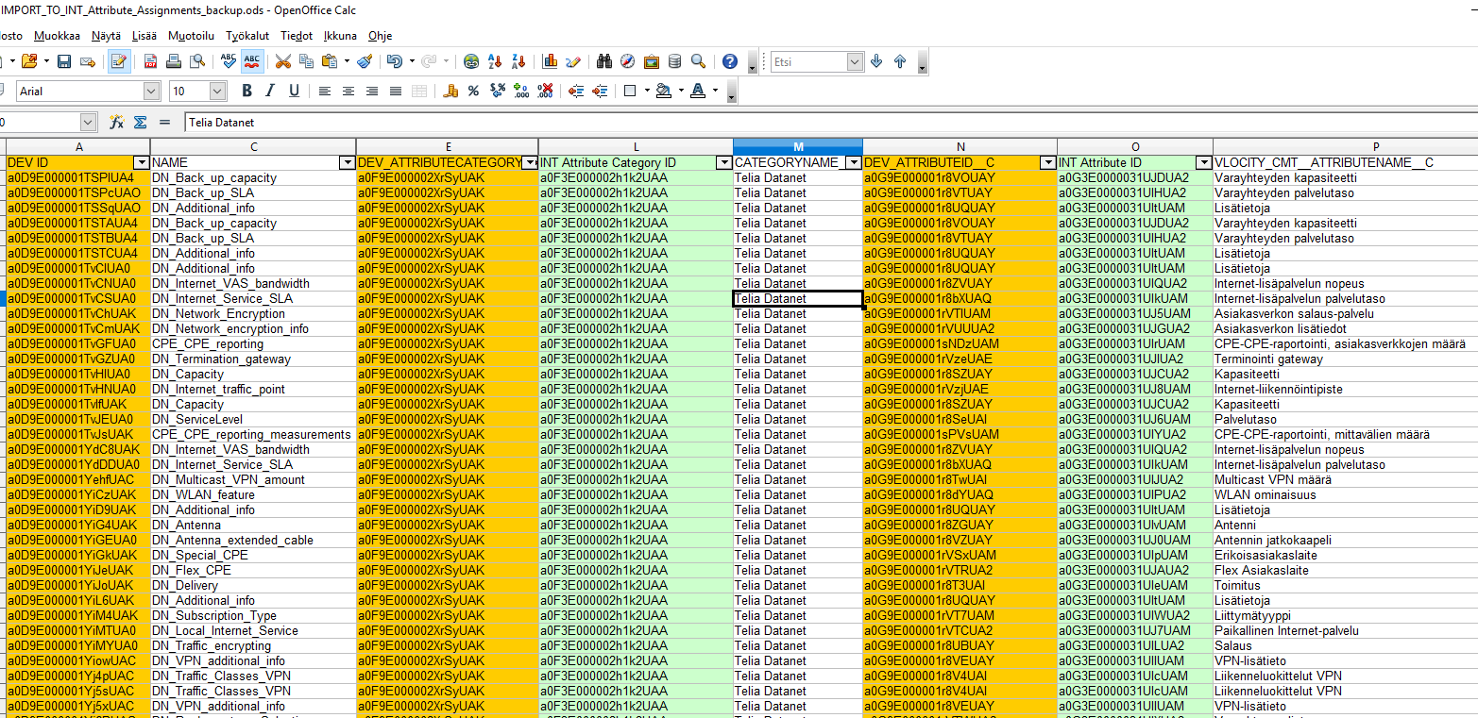Example of the mapping with VLOOKUP-function in excel:

# DataLoader for Import

Select “**Insert**” if you are only importing new records into the target environment.

Select “**Update**” if you are only updating existing records into the target environment.

Select “**Upsert**” if you are importing new and updating existing records into the target environment.

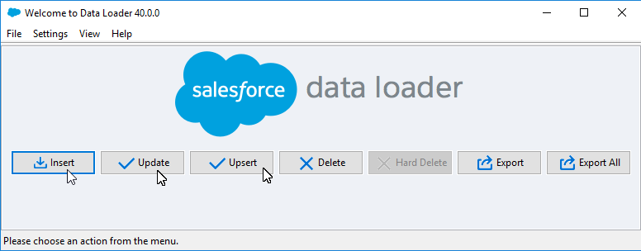

Enter your login details and set the Salesforce login URL accordingly:

(NOTE! For Production Environment, the Security Token is required after your password.)

Sandbox: <https://test.salesforce.com>

Production: <https://login.salesforce.com>

Proceed by selecting “Next”.



Select the correct object from the list and note, that if you cannot find it you need to select the “Show all salesforce objects”-tickbox.

Also define .csv file that you want to import.

Proceed by selecting “Next”.

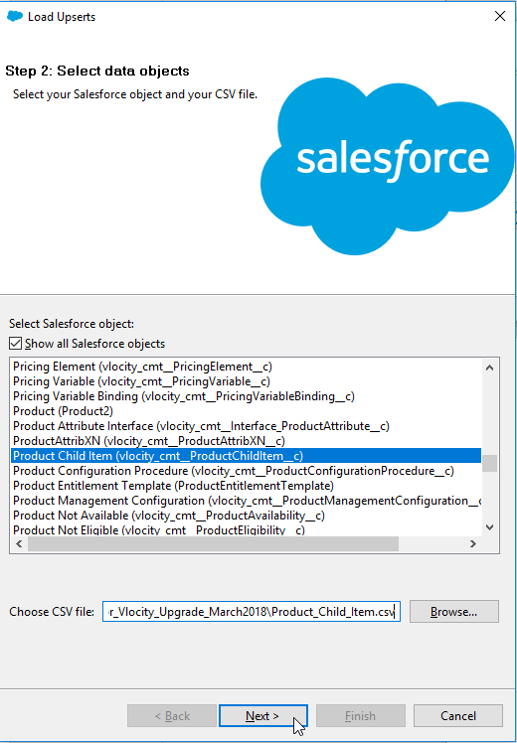

For Some records you need to define the ID field that you want to use for matching the records.

Select “**Id**”.

Click “**Next**” to proceed.

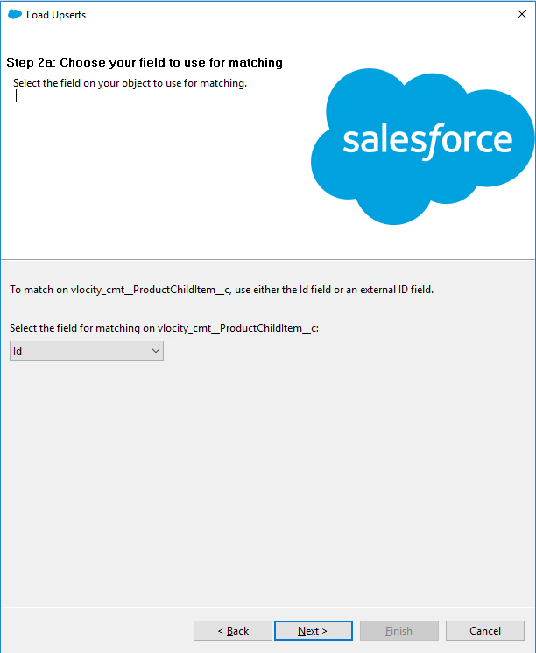

Next is the data mapping between the CSV-file and the target system.

Select “**Create or Edit a Map**”.

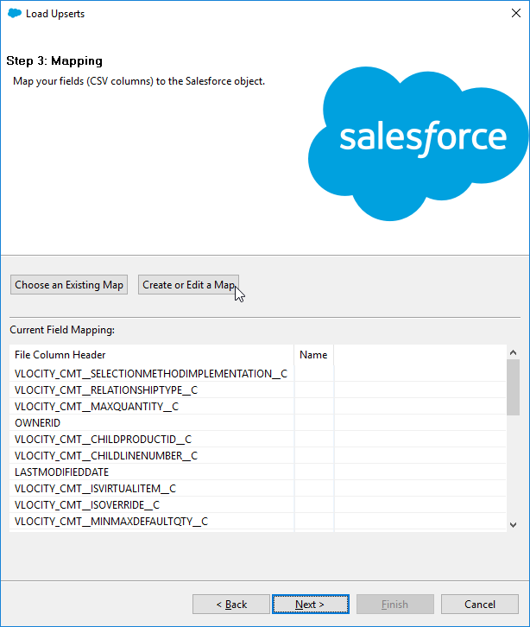

Note that You need to map the relevant IDs to the NEW target environment IDs columns. Like in the example there’s “VLOCITY_CMT_CHILDPRODUCTID_C” Which refers to the actual field, but in the excel that has the source environment Id. And then there are these new Target environment IDs named as: “PRODUCTION Child Product ID”, so that they are easy to find in this mapping table.

Select “**OK**” to proceed.

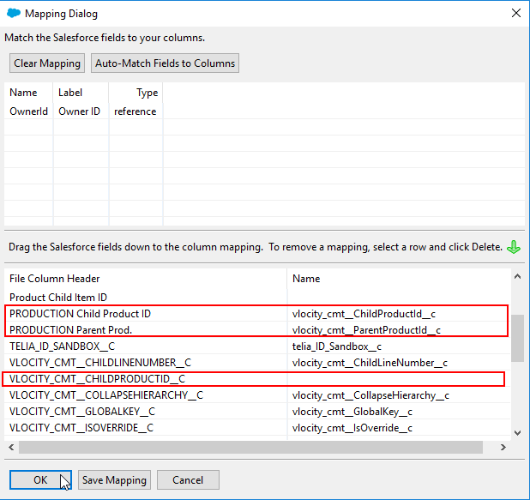

Set a folder where you want to store your **Success** and **Error** result log files.

Please set this, so you can easily find these reports, as mentioned earlier. You will need these for mapping the related data.

Select “**Finish**” to Proceed.

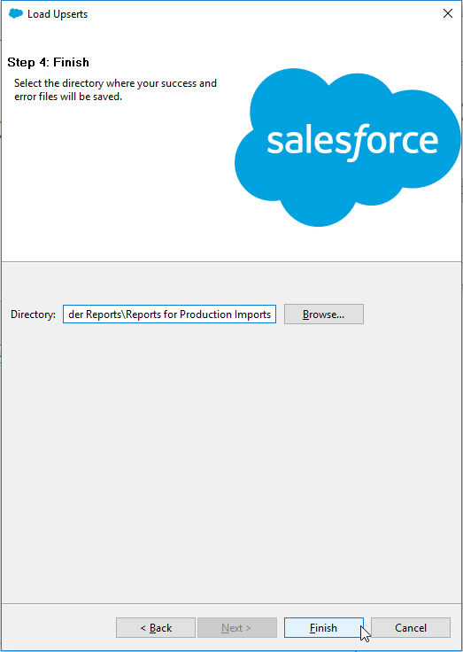a

You will still get additional window, as a reminder that the import cannot be undone.

Select “**Yes**” to proceed.

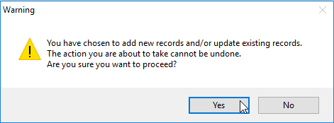

After the import is done, you will get a result window that shows all records that you tried to import, and at the end of each line there’s either “**Item Created**”; “**Item Updated**” or some “**Error: …”** message.

Please check this file through and also check the results in the target environment, that all data was imported as planned.

# After deployment

When the data deployment actions are completed, there are a couple of Vlocity batches that needs to be run from the system. They can be found from Vlocity CMT Administration-tab. From “Maintenance Jobs” – the “Product Hiearchy Maintenance” and from Upgrade Jobs – the “Root Product Child Item upgrade”

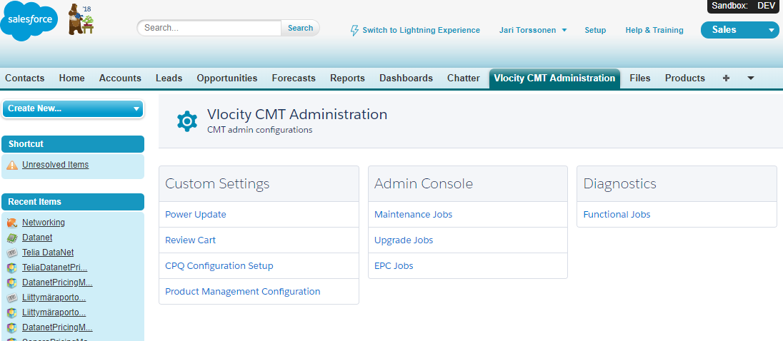

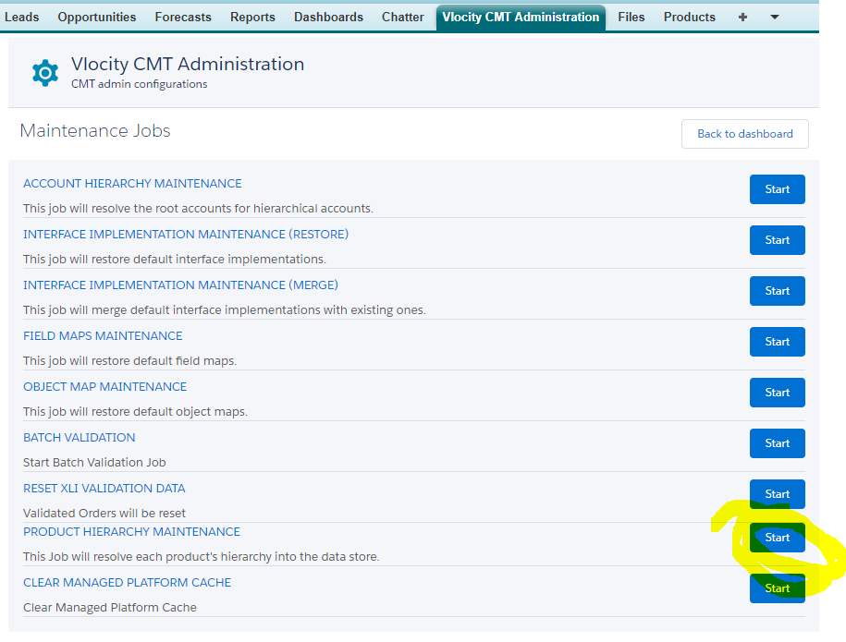

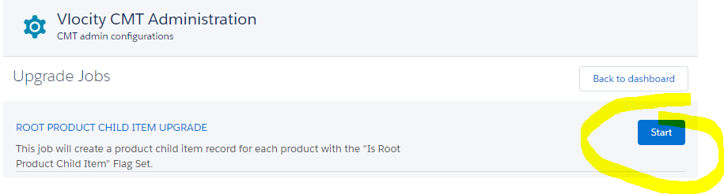

# EXAMPLES of DataLoader Export queries:

*B2O Products:*

*Select Id, Name, ProductCode, Description, QuantityScheduleType, QuantityInstallmentPeriod, NumberOfQuantityInstallments, RevenueScheduleType, RevenueInstallmentPeriod, NumberOfRevenueInstallments, CanUseQuantitySchedule, CanUseRevenueSchedule, IsActive, Family, RecordTypeId, ExternalDataSourceId, ExternalId, DisplayUrl, QuantityUnitOfMeasure, IsDeleted, LastViewedDate, LastReferencedDate, vlocity_cmt__IsLocationDependent__c, vlocity_cmt__IsNotAssetizable__c, vlocity_cmt__Scope__c, vlocity_cmt__TimeToLive__c, telia_Sub_Solution_Area__c, Telia_Contract_Offering_ID__c, Telia_Contract_Offering_Name__c, telia_Case_Mgmt_Product_Name__c, telia_ID_Sandbox__c, telia_Priority__c, telia_Top_Level_Offer__c, telia_device_filter__c, telia_fin_id__c, telia_one_time_estimate__c, telia_profitability__c, telia_recurring_estimate__c, telia_sap_code__c, telia_fi_product_description__c, telia_id_prd_sandbox__c, telia_product_modelled__c, telia_se_product_description__c, Manual_Pricing__c, Product_SF_ID__c, Telia_Matrix_Entity_Filter__c, telia_Don_t_Show_In_Documents__c, telia_Reporting_Product__c, vlocity_cmt__ApprovedBy__c, vlocity_cmt__ApprovedOn__c, vlocity_cmt__CategoryData__c, vlocity_cmt__ChangeDetectorImplementation__c, vlocity_cmt__ClassId__c, vlocity_cmt__EffectiveDate__c, vlocity_cmt__EndDate__c, vlocity_cmt__GlobalKey__c, vlocity_cmt__HeaderData__c, vlocity_cmt__HelpText__c, vlocity_cmt__ImageId__c, vlocity_cmt__IsConfigurable__c, vlocity_cmt__IsOrderable__c, vlocity_cmt__Modification__c, vlocity_cmt__ObjectTypeId__c, vlocity_cmt__ParentClassId__c, vlocity_cmt__ProductSpecId__c, vlocity_cmt__ProductTemplateProductId__c, vlocity_cmt__SpecificationType__c, vlocity_cmt__StandardPremium__c, vlocity_cmt__Status__c, vlocity_cmt__SubType__c, vlocity_cmt__TrackAsAgreement__c, vlocity_cmt__Type__c, vlocity_cmt__VendorAccountId__c, Bookable__c, Shippable__c, Type__c, telia_Code_Type__c, telia_Connection_Purpose__c, telia_Line_Type__c, telia_Profit_Center__c, telia_risk_category__c, Load_ID__c, telia_SAP_profit_center__c, telia_sproject_product_id__c, vlocity_cmt__AttributeDefaultValues__c, vlocity_cmt__AttributeMetadata__c, Product_Hash__c, Commercial_Code__c, Requested_Action_Date__c, Subscription_Product__c FROM Product2 WHERE Type__c = 'B2O'*

*Product Child Item:*

*Select Id, Name, vlocity_cmt__ChildLineNumber__c, vlocity_cmt__ChildProductId__c, vlocity_cmt__CollapseHierarchy__c, vlocity_cmt__IsOverride__c, vlocity_cmt__IsRootProductChildItem__c, vlocity_cmt__IsVirtualItem__c, vlocity_cmt__MaxQuantity__c, vlocity_cmt__MaximumChildItemQuantity__c, vlocity_cmt__MinMaxDefaultQty__c, vlocity_cmt__MinQuantity__c, vlocity_cmt__MinimumChildItemQuantity__c, vlocity_cmt__ParentProductId__c, vlocity_cmt__Quantity__c, vlocity_cmt__RelationshipType__c, vlocity_cmt__SelectionMethodImplementation__c, vlocity_cmt__SeqNumber__c, vlocity_cmt__GlobalKey__c, telia_ID_Sandbox__c, Load_ID__c FROM vlocity_cmt__ProductChildItem__c*

*Product Relationship:*

*Select Id, IsDeleted, Name, vlocity_cmt__ActionParameters__c, vlocity_cmt__AddMode__c, vlocity_cmt__AttributeModificationContext__c, vlocity_cmt__DefaultQuantity__c, vlocity_cmt__Description__c, vlocity_cmt__Family__c, vlocity_cmt__IsConditional__c, vlocity_cmt__MaxQuantity__c, vlocity_cmt__MinQuantity__c, vlocity_cmt__Product2Id__c, vlocity_cmt__RelatedProductFilterId__c, vlocity_cmt__RelatedProductId__c, vlocity_cmt__RelationshipType__c, telia_ID_Sandbox__c, Load_ID__c, vlocity_cmt__Context__c, vlocity_cmt__GlobalKey__c FROM vlocity_cmt__ProductRelationship__c*

*Vlocity Attribute Category:*

*Select Id, IsDeleted, Name, vlocity_cmt__ApplicableSubType__c, vlocity_cmt__ApplicableTypes__c, vlocity_cmt__Code__c, vlocity_cmt__ColorCode__c, vlocity_cmt__Description__c, vlocity_cmt__DisplayFilter__c, vlocity_cmt__DisplaySequence__c, vlocity_cmt__EffectiveFromDate__c, vlocity_cmt__EffectiveUntilDate__c, vlocity_cmt__IndustryVertical__c, vlocity_cmt__IsActive__c, vlocity_cmt__IsPrivate__c, vlocity_cmt__LockedFlg__c, vlocity_cmt__Status__c, vlocity_cmt__UIControlType__c, telia_ID_Sandbox__c, Type__c, Load_ID__c, vlocity_cmt__ApplicableTypesFilter__c, vlocity_cmt__GlobalKey__c, vlocity_cmt__IsUserAttributesCreatedPrivate__c FROM vlocity_cmt__AttributeCategory__c WHERE Type__c = 'B2B'*

*Vlocity Attributes:*

*Select Id, IsDeleted, Name, vlocity_cmt__AttributeCategoryId__c, vlocity_cmt__ActiveFlg__c, vlocity_cmt__ApplicableToAllRecords__c, vlocity_cmt__ApplicableToEntity__c, vlocity_cmt__AttributeCategoryCode__c, vlocity_cmt__AttributeCategoryName__c, vlocity_cmt__AutoCode__c, vlocity_cmt__Code__c, vlocity_cmt__Configurable__c, vlocity_cmt__CopyMode__c, vlocity_cmt__CustomConfigUiTemplate__c, vlocity_cmt__Description__c, vlocity_cmt__DesignTime__c, vlocity_cmt__DisplaySequence__c, vlocity_cmt__EditMode__c, vlocity_cmt__EffectiveFromDate__c, vlocity_cmt__EffectiveUntilDate__c, vlocity_cmt__Filterable__c, vlocity_cmt__HelpText__c, vlocity_cmt__IsCloneable__c, vlocity_cmt__Overridable__c, vlocity_cmt__PicklistId__c, vlocity_cmt__RunTime__c, vlocity_cmt__UniqueNameField__c, vlocity_cmt__ValueType__c, vlocity_cmt__Value__c, telia_ID_Sandbox__c, Telia_Solution_Area__c, Type__c, Load_ID__c, vlocity_cmt__GlobalKey__c, vlocity_cmt__IsPrivate__c, vlocity_cmt__OwnerId__c FROM vlocity_cmt__Attribute__c WHERE Type__c = 'B2B'*

*Attribute Assignments:*

*Select Id, IsDeleted, Name, vlocity_cmt__AddDate__c, vlocity_cmt__AttributeCategoryId__c, vlocity_cmt__AttributeCloneable__c, vlocity_cmt__AttributeConfigurable__c, vlocity_cmt__AttributeDisplayNameOverride__c, vlocity_cmt__AttributeDisplayName__c, vlocity_cmt__AttributeDisplaySequence__c, vlocity_cmt__AttributeFilterable__c, vlocity_cmt__AttributeId__c, vlocity_cmt__AttributeName__c, vlocity_cmt__AttributeUniqueCode__c, vlocity_cmt__CategoryCode__c, vlocity_cmt__CategoryDisplaySequence__c, vlocity_cmt__CategoryName__c, vlocity_cmt__ConfigurationDetail__c, vlocity_cmt__CustomConfigUiTemplate__c, vlocity_cmt__Data__c, vlocity_cmt__DefaultPicklistEntryId__c, vlocity_cmt__DefaultPicklistValueId__c, vlocity_cmt__DisplaySequence__c, vlocity_cmt__EndStory__c, vlocity_cmt__ExcludedPicklistEntryIds__c, vlocity_cmt__ExcludedPicklistValues__c, vlocity_cmt__FormatMask__c, vlocity_cmt__HasRule__c, vlocity_cmt__HelpText__c, vlocity_cmt__IsActiveAssignment__c, vlocity_cmt__IsActive__c, vlocity_cmt__IsConfigurable__c, vlocity_cmt__IsHidden__c, vlocity_cmt__IsOverride__c, vlocity_cmt__IsQueryDriven__c, vlocity_cmt__IsReadOnly__c, vlocity_cmt__IsRequired__c, vlocity_cmt__LookupFilter__c, vlocity_cmt__LookupObjectId__c, vlocity_cmt__LookupObjectTypeId__c, vlocity_cmt__ObjectId__c, vlocity_cmt__ObjectLink__c, vlocity_cmt__ObjectType__c, vlocity_cmt__PicklistId__c, vlocity_cmt__QueryCode__c, vlocity_cmt__QueryLabel__c, vlocity_cmt__RemoveDate__c, vlocity_cmt__RemovedFlag__c, vlocity_cmt__RuleData__c, vlocity_cmt__RuleMessage__c, vlocity_cmt__StartStory__c, vlocity_cmt__StyleClass__c, vlocity_cmt__UIDisplayType__c, vlocity_cmt__ValidValuesData__c, vlocity_cmt__ValueDataType__c, vlocity_cmt__ValueDescription__c, vlocity_cmt__ValueInNumber__c, vlocity_cmt__Value__c, vlocity_cmt__IsDynamic__c, telia_ID_Sandbox__c, Telia_Solution_Sub_Type__c, Load_ID__c, vlocity_cmt__GlobalKey__c FROM vlocity_cmt__AttributeAssignment__c*

*Vlocity Rule:*

*Select Id, IsDeleted, Name, vlocity_cmt__Description__c, vlocity_cmt__EffectiveDate__c, vlocity_cmt__EndDate__c, vlocity_cmt__IsActive__c, vlocity_cmt__ObjectName__c, vlocity_cmt__Type__c, Load_ID__c, vlocity_cmt__Expression__c, vlocity_cmt__FailureMessage__c, vlocity_cmt__FallbackId__c, vlocity_cmt__GlobalKey__c, vlocity_cmt__HeaderId__c, vlocity_cmt__Operation__c, vlocity_cmt__RulePurpose__c, vlocity_cmt__RuleType__c FROM vlocity_cmt__Rule__c*

*Vlocity Rule Filter:*

*Select Id, IsDeleted, Name, vlocity_cmt__RuleId__c, vlocity_cmt__EntityFilterId__c, vlocity_cmt__Index__c, Load_ID__c, vlocity_cmt__ActionTaken__c, vlocity_cmt__ContextActionId__c, vlocity_cmt__Sequence__c FROM vlocity_cmt__RuleFilter__c*

*Vlocity Rule Action:*

*Select Id, IsDeleted, Name, vlocity_cmt__RuleId__c, vlocity_cmt__CalculationProcedureId__c, vlocity_cmt__EntityFilterId__c, vlocity_cmt__Index__c, vlocity_cmt__OfferingProcedureId__c, vlocity_cmt__ProductConfigurationProcedureId__c, vlocity_cmt__ProductRelationshipId__c, Load_ID__c, vlocity_cmt__ProductConfigurationProcedureProductId__c, vlocity_cmt__ProductRelationshipParentId__c FROM vlocity_cmt__RuleAction__c*

*Vlocity Entity Filter:*

*Select Id, IsDeleted, Name, vlocity_cmt__AttributeLookupFieldName__c, vlocity_cmt__Description__c, vlocity_cmt__EvaluationCriteria__c, vlocity_cmt__FilterOnObjectName__c, vlocity_cmt__FormulaForConditions__c, vlocity_cmt__IsActive__c, vlocity_cmt__Type__c, vlocity_cmt__ValidFromDate__c, vlocity_cmt__ValidUntilDate__c, Load_ID__c, vlocity_cmt__Code__c, vlocity_cmt__Expression__c, vlocity_cmt__FailureMessage__c, vlocity_cmt__GlobalKey__c, vlocity_cmt__Operation__c FROM vlocity_cmt__EntityFilter__c*

*Vlocity Entity Filter Condition:*

*Select Id, IsDeleted, Name, vlocity_cmt__EntityFilterId__c, vlocity_cmt__FieldName__c, vlocity_cmt__FieldType__c, vlocity_cmt__Index__c, vlocity_cmt__Operator__c, vlocity_cmt__Type__c, vlocity_cmt__ValueLabel__c, vlocity_cmt__Value__c, Load_ID__c, vlocity_cmt__Code__c, vlocity_cmt__ConditionType__c, vlocity_cmt__FailLevel__c, vlocity_cmt__FailureMessage__c, vlocity_cmt__FunctionJSON__c, vlocity_cmt__IsNot__c, vlocity_cmt__VlocityFunctionId__c FROM vlocity_cmt__EntityFilterCondition__c*

*Product Configuration Procedures:*

*Select Id, IsDeleted, Name, vlocity_cmt__ActionParameters__c, vlocity_cmt__EntityFilterId__c, vlocity_cmt__ProductId__c, vlocity_cmt__GlobalKey__c FROM vlocity_cmt__ProductConfigurationProcedure__c*