PARIVARTANA: Teaching a Model to Read 1960s COBOL and Write Modern Python
Discussion Post — Aarthy Ramachandran

The Project, the Challenges, and the Data
My project, PARIVARTANA (Sanskrit for “transformation”), tackles a problem that is hiding in plain sight: roughly 800 billion lines of COBOL still run the world’s banks, insurers, and government systems, yet the workforce that can maintain that code is retiring faster than it is being replaced. Hand-rewriting COBOL costs an estimated one to five dollars per line, which turns full modernization into a multi-billion-dollar problem. My goal was to build a system that converts legacy COBOL into Python 3 that is not merely runnable, but readable and semantically faithful.
Three challenges defined the work. First, COBOL is fixed-format 1960s code: the meaning of a line depends on which character column it occupies (columns 1–6 are line numbers, column 7 is a marker, columns 8–72 hold the statement), so a naive tokenizer mangles it immediately. Second, the supervised signal barely exists — there is no large parallel COBOL-to-Python corpus, and COBOL makes up less than 0.01% of the data that modern code models were pre-trained on. Third, evaluation is genuinely hard. My gold corpus, the NIST COBOL Test Suite, is dominated by conformance-harness programs that exit non-zero when run standalone, so execution-based scoring only applies to a small self-contained subset. I worked with four datasets after a deliberate scope cut: NIST for evaluation, IBM Open COBOL samples for training, a FEVER-based natural-language-inference set for semantic validation, and a 12,500-entry COBOL identifier dictionary spanning eight business domains.

NLP Architecture and the Role of the Ontology
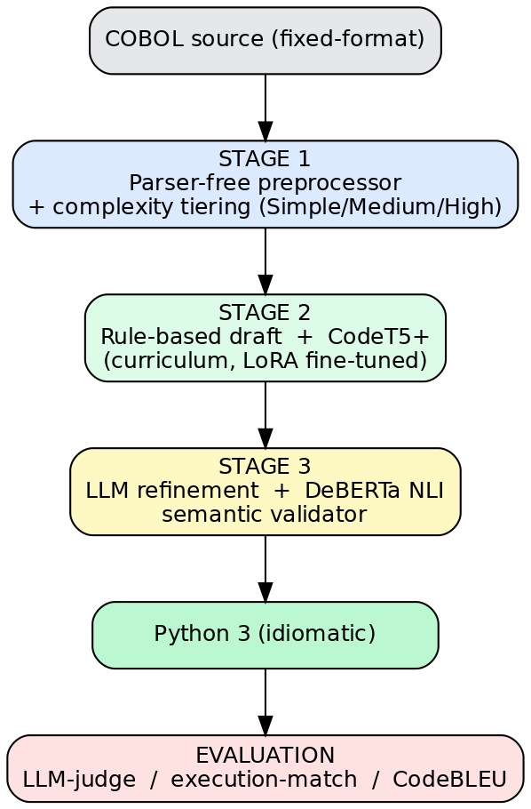
Figure 1. The three-stage PARIVARTANA pipeline, from COBOL source to evaluation.
The architecture is a three-stage pipeline (Figure 1). Stage 1 is a deterministic, parser-free preprocessor that strips column metadata, normalizes encoding, lexes a focused COBOL verb subset, builds a lightweight abstract syntax tree, and scores each program’s complexity. Stage 2 produces the translation in one of two interchangeable modes: a fast rule-based template engine that serves as a deterministic draft, and a curriculum-trained CodeT5+ neural model (a 220-million-parameter encoder-decoder transformer) fine-tuned with Low-Rank Adaptation so it trains on an Apple M3 Pro. Stage 3 sends the draft to a large language model that renames variables, writes docstrings, and rewrites the code idiomatically, with a DeBERTa NLI model checking that the COBOL comment and the Python docstring still mean the same thing.
My ontology did real, decision-making work rather than sitting in a diagram. The AST node-type taxonomy — Program contains Divisions, which contain Paragraphs, which contain statements — is exactly what I linearize into the neural model’s prompt, so the network conditions on program structure instead of raw character columns; that was a feature-engineering decision driven directly by the ontology. A second ontology decomposes each cryptic identifier such as WS-ACCT-BAL-AMT into scope, domain, and type components, which both powers a feature (the dictionary-based renaming) and resolves a classification question (which of eight business domains a name belongs to). Most importantly, the Simple, Medium, and High complexity classes are an ontological taxonomy that became the spine of the training curriculum and the human-review flag in Stage 3. The biggest design challenge was the parser itself. The original plan used a full ANTLR4 COBOL-85 grammar; an ablation across the entire NIST suite showed the thin preprocessor ingested every one of the 500-plus files with zero Stage-1 failures, so I removed the grammar entirely and reinvested that time in the machine learning. Two further challenges were a CodeT5+ tokenizer incompatibility with newer libraries, which I solved with an auto-patching loader, and a silent adapter-loading bug where evaluation used stale weights, which I solved by merging the LoRA adapter into a clean checkpoint.

Results and Interpretation
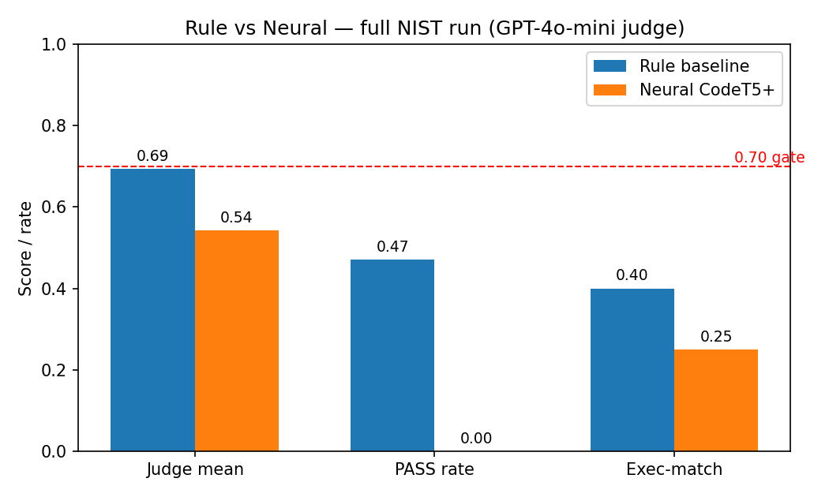
Figure 2. Rule vs. neural on the full NIST run (GPT-4o-mini judge).
I evaluate with an LLM-as-judge weighted correctness score (the only oracle that runs on the full conformance corpus), execution-match on the runnable subset, and CodeBLEU where available. On full NIST under a GPT-4o-mini judge, the rule-based draft reaches 0.69 weighted correctness while the neural model reaches 0.54 (Figure 2); neither clears the 0.70 reporting gate, and the rule engine leads on every metric. A controlled run on the same 50 programs under a local judge preserves the ordering (0.52 versus 0.21). The interpretation is honest and important: the neural model underperforms a hand-tuned rule engine, which is exactly what you would expect from fine-tuning a 220-million-parameter model on roughly 200 examples — only about 16 of them execution-verified — with no warm-start. The value is that the neural deliverable now exists, is trained end-to-end, and is evaluated under the proposal’s own metrics, where previously it was hypothetical. The gap is a data problem, not an architectural dead end.
It is worth naming how large language models fit in, because they play three distinct roles and each carries its own trade-off. As a teacher, an LLM generates the candidate Python that the execution filter then verifies, which is the only practical way to manufacture supervision in a domain with no labels. As a refiner, the Stage-3 model improves naming and readability and writes docstrings. As a judge, an LLM scores correctness where execution cannot run. The benefit is that LLMs supply both the training targets and the evaluation oracle the domain otherwise lacks; the cost is that local models are slow and sometimes emit malformed code, and that judge behavior varies enough to demand discipline in reporting. Recognizing these as three separate roles, rather than one undifferentiated step, was itself a useful clarification.

Breakthrough Moments
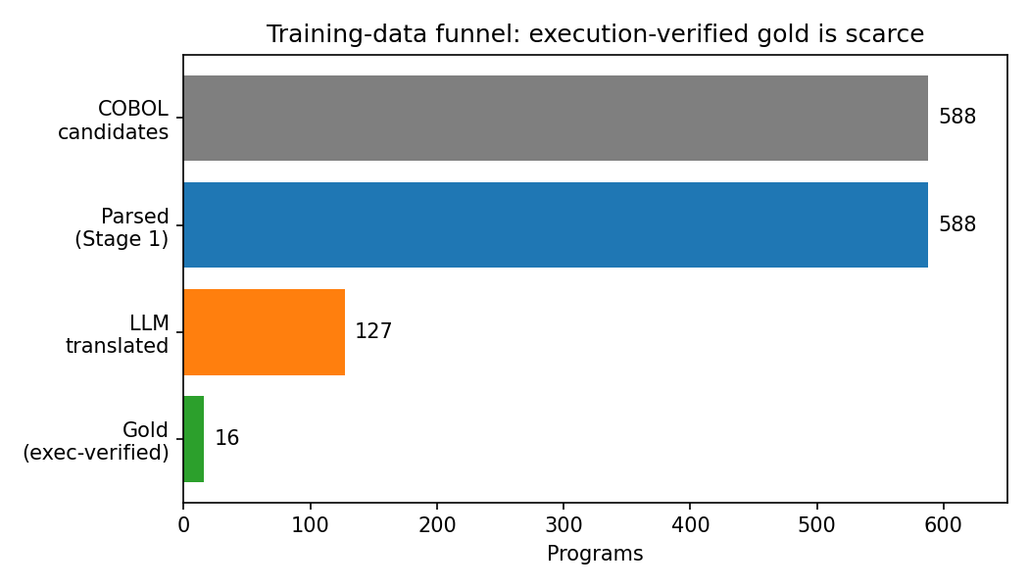
Figure 3. The training-data funnel: execution-verified gold pairs are scarce.
Three insights crystallized this week. The first and largest is that the bottleneck is not the architecture but the data (Figure 3). Of 588 candidate programs, only a few tens are self-contained enough to execution-verify, so I adopted a distillation recipe inspired by MultiPL-T: generate Python targets with a teacher LLM and keep only those whose output matches the COBOL output under the GnuCOBOL compiler. Execution, not surface similarity, is the filter — the same lesson TransCoder taught for unsupervised code translation. The second insight is that “silver” data is quietly lethal: 41 of 221 teacher-generated targets did not even compile as Python, so a one-line compile filter measurably cleans the training signal, and up-weighting the scarce gold examples keeps them from being drowned. The third insight is methodological: judge choice matters more than I assumed. The same systems scored about 0.15 lower under a local 7-billion-parameter judge than under GPT-4o-mini, so absolute scores are only comparable within a fixed judge — a caveat I now state explicitly in every results table. A smaller but practical lesson was that running the data builder and the trainer at the same time starved the GPU and stretched each training step to nearly five minutes; serializing them cut training to about twenty.

What Generalizes
The most transferable part of this project is the recipe, not the COBOL specifics. Any low-resource translation problem where no parallel corpus exists can use the same three moves: represent the input with a structural ontology (an AST) so the model conditions on meaning rather than surface form; manufacture supervision by LLM distillation rather than waiting for labeled data; and — crucially — filter generated targets on execution rather than on textual similarity. That pattern applies directly to other legacy languages such as RPG, PL/I, and Fortran, to schema and configuration migrations, and more broadly to any domain where an output is cheap to verify even when it is expensive to author by hand. The curriculum idea generalizes too: when examples vary widely in difficulty, ordering them easy-to-hard and releasing harder tiers only as validation plateaus is a low-cost way to stabilize training on noisy, scarce data. If you are tracking a problem with an abundant verifier but a scarce labeler, this approach is likely to help you.

