MediBot
AI Medical PDF Study Assistant
A Retrieval-Augmented Generation (RAG) Based Generative AI Application

PROJECT REPORT
Prepared by
Aarti Ashok Dorale

GitHub
aarti-ashok-dorale/MediBot

Live Demo
Streamlit Community Cloud

1. Project Overview
MediBot is a Generative AI medical study assistant that answers questions using a pre-loaded medical reference PDF. It uses Retrieval-Augmented Generation (RAG) so that the LLM receives relevant information retrieved from the project’s own document before generating an answer. The application is built with Python and Streamlit and is deployed on Streamlit Community Cloud.
The user does not upload a PDF at runtime. The medical document is processed beforehand, converted into embeddings, and stored in a FAISS vector database.

2. How MediBot is Useful for Students
MediBot is designed as a study assistant for students who work with large medical reference documents. Instead of manually searching through hundreds of PDF pages, students can directly ask questions and receive relevant answers from the pre-loaded study material.
- Faster Study – Quickly find relevant information without manually searching the entire PDF.
- Easy Question Answering – Ask questions in natural language instead of searching for exact keywords.
- Source-Based Learning – Answers are generated from the provided medical document and include relevant source-page references.
- Saves Time – Reduces the time required to locate definitions, symptoms, causes, characteristics, and other study-related information.
- Better Understanding – The LLM converts retrieved information into a simple, readable answer.
- Focused Learning – Students can concentrate on specific topics instead of going through the complete document repeatedly.
- Document-Grounded Answers – The RAG approach helps reduce unsupported answers by using retrieved content from the reference document.
- Practical AI Learning – The project demonstrates how Generative AI, RAG, embeddings, FAISS, and LLMs can be used to build a real-world application.
Example: A student studying from a large medical encyclopedia can ask “What are the symptoms of X?” and MediBot retrieves relevant content and provides an answer along with the source page.

3. How MediBot is More Useful Than a General Chatbot for This Use Case
MediBot is not intended to replace ChatGPT or other general-purpose AI assistants. Its advantage is that it is designed specifically for document-based medical study. For this particular use case, MediBot provides a more focused workflow around the selected reference document.
- Focused Knowledge Source – MediBot works with a specific pre-loaded medical reference document rather than a broad general-purpose knowledge space.
- Document-Grounded Answers – Relevant content is retrieved from the FAISS vector database before Gemini generates the response.
- Source Page References – Students can see the relevant PDF page numbers and verify the answer in the original study material.
- Less Information Overload – The application focuses on the selected study document instead of providing broad information outside the intended source.
- Study-Oriented Workflow – Students can directly ask questions instead of manually searching through hundreds of PDF pages.
- Irrelevant-Question Handling – When sufficiently relevant information is not retrieved, MediBot is designed to say that the information could not be found in the provided document rather than guessing.
- Custom Knowledge Base – The same architecture can be adapted to other subjects or multiple academic PDFs by changing the indexed documents.
- End-to-End AI Learning – The project demonstrates a complete RAG pipeline including PDF processing, embeddings, FAISS retrieval, LLM generation, UI, and deployment.
In simple words: ChatGPT is a general-purpose AI assistant, while MediBot is a focused study assistant built around a specific medical reference document. Therefore, MediBot's main strength is focused, retrievable, and source-referenced question answering for that document.

4. Problem Statement
Large medical reference PDFs contain useful information across many pages. Manually locating an answer can be time-consuming. A general LLM may also produce information that is not present in the student’s reference material. MediBot is designed to make document-based study easier by retrieving relevant content and generating an answer grounded in that content.

5. Objectives
- Build a practical document-based AI question-answering system.
- Implement an end-to-end RAG pipeline.
- Use semantic embeddings and FAISS for document retrieval.
- Use Google Gemini 2.5 Flash for answer generation.
- Show source page references with answers.
- Handle irrelevant questions without inventing information.
- Build and deploy a simple Streamlit application.
- Gain practical experience with Generative AI, LangChain, vector databases, APIs, Git/GitHub, and deployment.

6. Key Features
- Pre-loaded medical PDF knowledge base
- RAG-based question answering
- all-MiniLM-L6-v2 embeddings
- FAISS similarity search
- Google Gemini 2.5 Flash
- Source page references
- Irrelevant-question handling
- Simple Streamlit UI
- Secure API key through environment variables / Streamlit Secrets
- Streamlit Community Cloud deployment

7. Technology Stack
Technology | Purpose
Python | Application development
Streamlit | Web UI and deployment
LangChain | RAG and LLM integration
Google Gemini 2.5 Flash | Answer generation
Hugging Face | Embedding model integration
all-MiniLM-L6-v2 | Semantic text embeddings
FAISS | Vector storage and similarity search
PyPDFLoader | PDF loading
RecursiveCharacterTextSplitter | Text chunking
Git/GitHub | Version control and repository
Streamlit Community Cloud | Deployment

8. RAG Architecture
Medical PDF
↓
PDF Loading
↓
Text Extraction
↓
Text Chunking
↓
Hugging Face Embeddings
↓
FAISS Vector Database
User Question
↓
Similarity Search
↓
Relevant Chunks
↓
Gemini 2.5 Flash
↓
Answer + Source Pages

9. How the Project Works

Step 1 – PDF Processing
The medical PDF is loaded using PyPDFLoader and DirectoryLoader.

Step 2 – Chunking
The extracted text is divided into smaller overlapping chunks using RecursiveCharacterTextSplitter. The current configuration uses chunk_size=500 and chunk_overlap=50.

Step 3 – Embeddings
Each chunk is converted into a semantic vector using sentence-transformers/all-MiniLM-L6-v2.

Step 4 – FAISS
The vectors are stored in FAISS. The generated local database contains index.faiss and index.pkl.

Step 5 – User Query
The user enters a medical question in the Streamlit interface.

Step 6 – Retrieval
MediBot performs similarity search and retrieves up to eight candidate chunks. A relevance threshold is used to filter weak matches.

Step 7 – LLM Generation
The retrieved context and question are sent to Gemini 2.5 Flash with a strict prompt instructing it to use only the provided context.

Step 8 – Output
The answer is displayed together with the relevant source page numbers.

10. Document and Vector Database
During development, the selected medical PDF contained 759 pages. The indexing script generated 7,080 text chunks and successfully created the FAISS database.
Vector store structure:
vectorstore/
└── db_faiss/
├── index.faiss
└── index.pkl

11. Important RAG Safety / Grounding Logic
MediBot is explicitly instructed not to use outside knowledge, guess, assume, or invent information. If no sufficiently relevant document content is retrieved, the system returns:
“I could not find this information in the provided medical document.”
This makes the application document-grounded rather than a general medical chatbot. The system is for educational purposes and is not a substitute for professional medical advice.

12. Implementation Files
File | Responsibility
app.py | Streamlit UI, question input, answer display, source pages, error handling
create_memory_for_llm.py | PDF loading, chunking, embeddings, FAISS creation
connect_memory_with_llm.py | Retrieval, context creation, Gemini invocation, response cleaning, source pages
requirements.txt | Python dependencies
vectorstore/db_faiss/ | Saved FAISS index files
README.md | Project documentation

13. User Interface
The interface is intentionally simple so that a user can enter a question and receive an answer without configuring the retrieval pipeline manually.
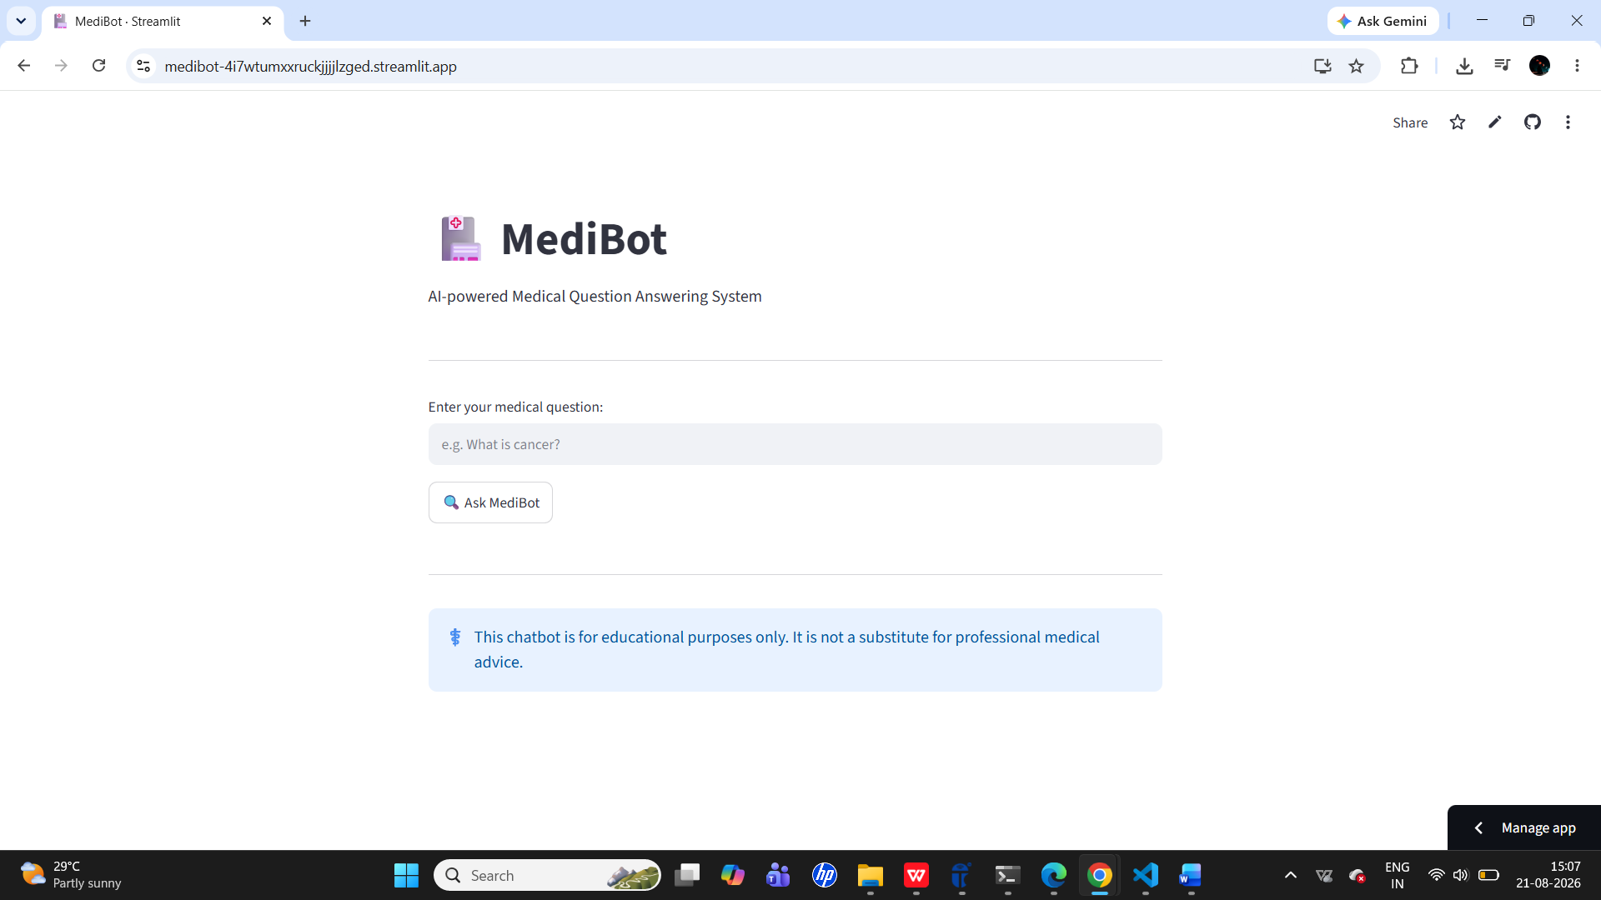
Home / MediBot interface
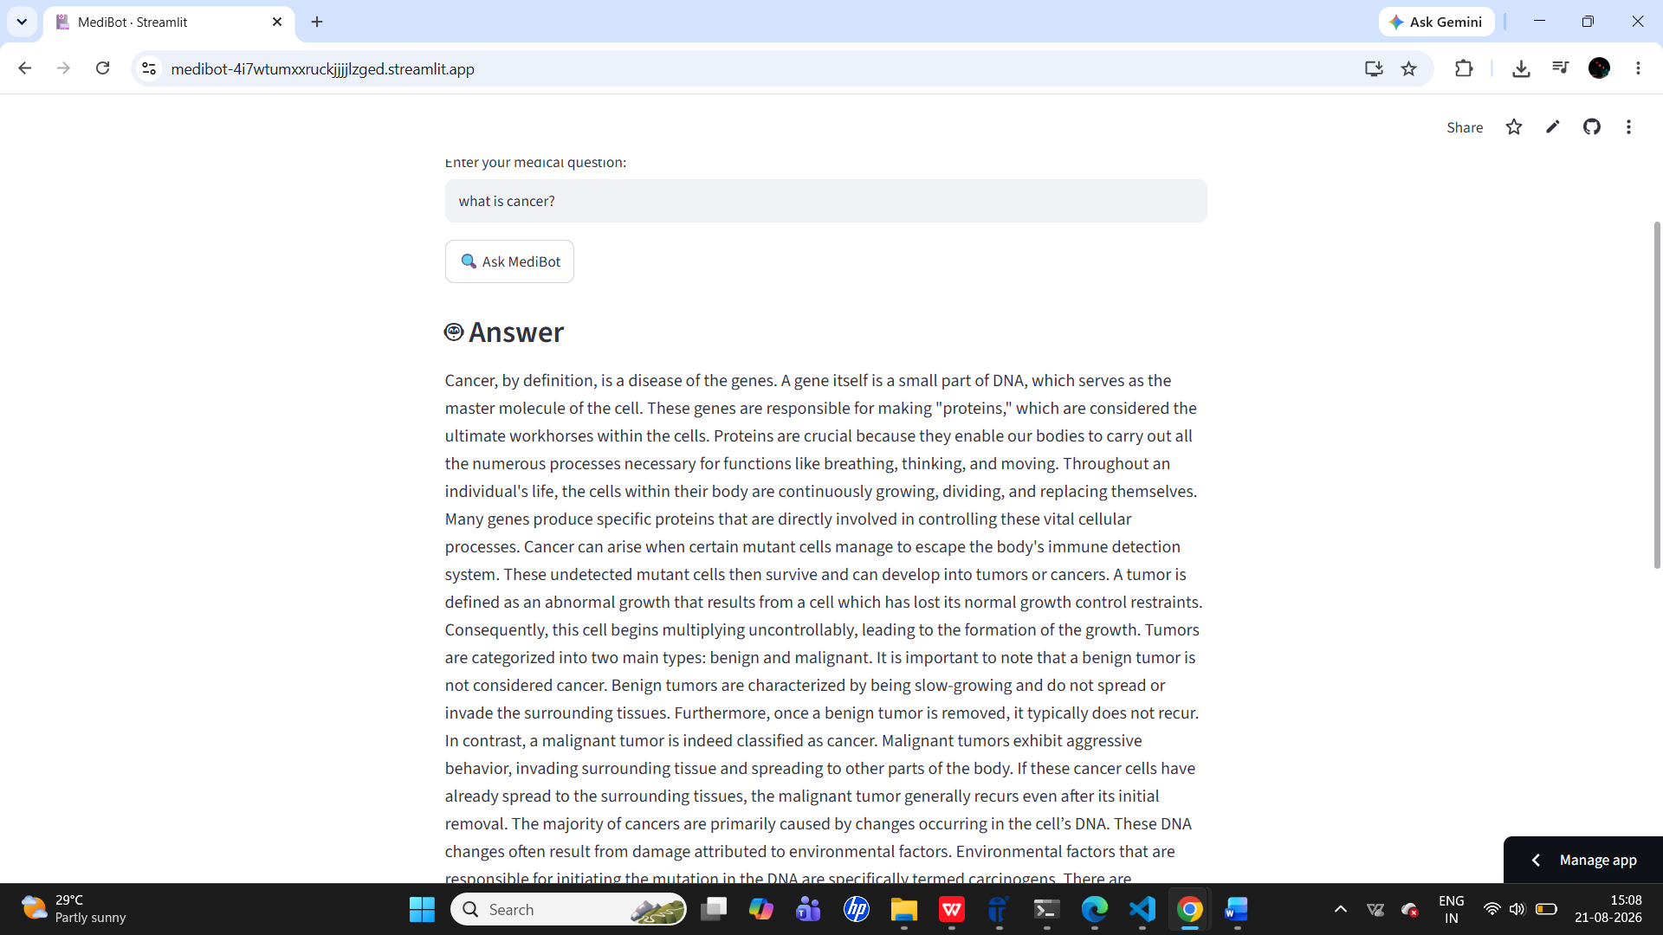
Question and generated answer

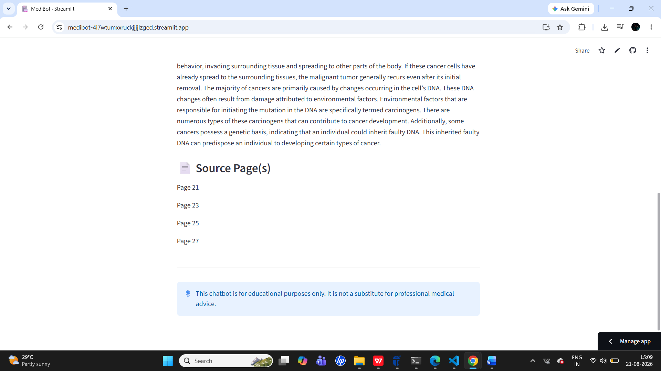
Question and generated answer
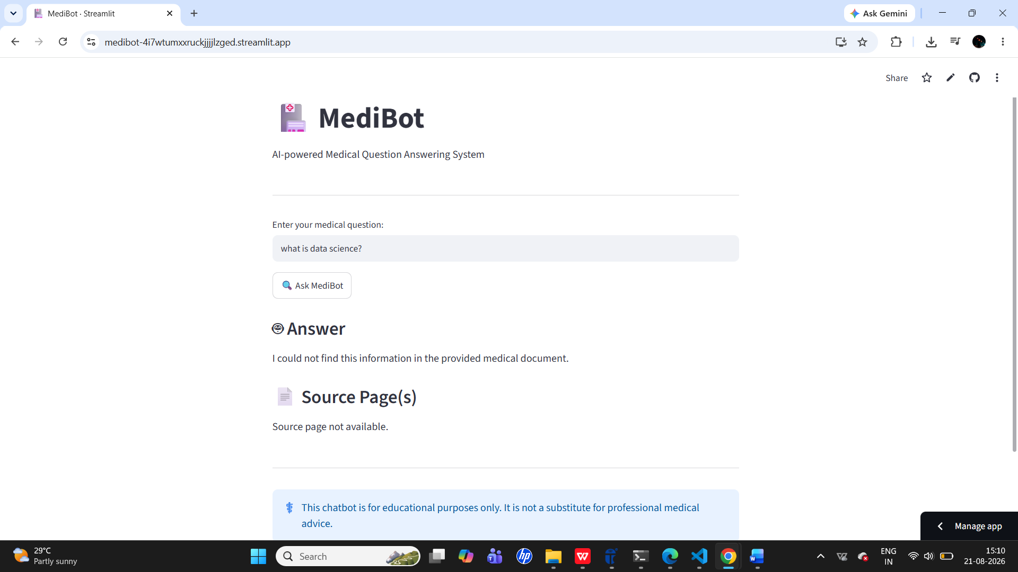
Irrelevant Question Answer

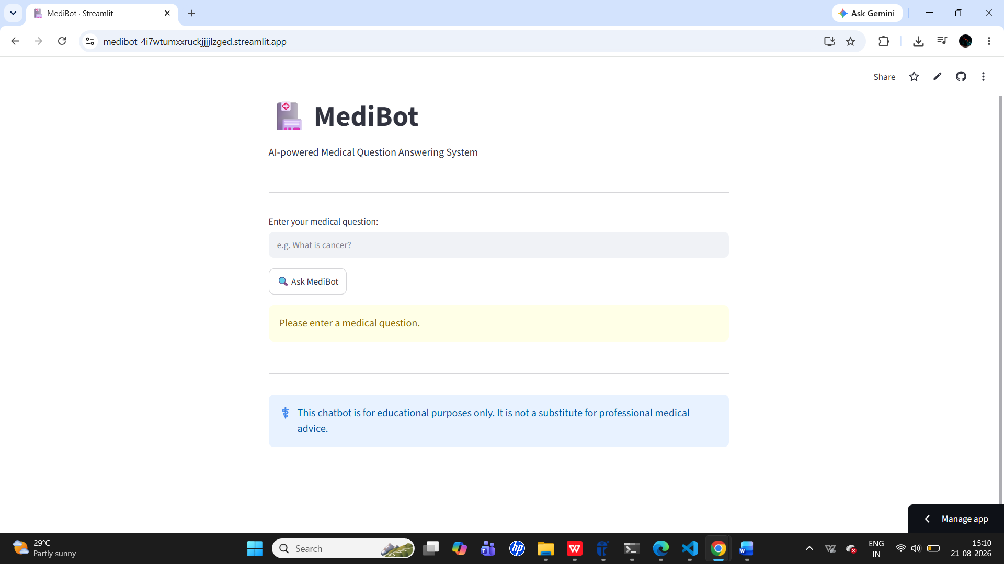
No Input Question

14. Testing and Results
Test Case | Expected Result | Status
Relevant medical question | Grounded answer from retrieved context | Passed
Irrelevant question | Document-not-found response when no relevant context is retrieved | Implemented
Empty input | Validation warning | Passed
Source pages | Relevant page numbers displayed | Implemented
FAISS database | Index loads successfully | Passed
Gemini API | LLM generates answer from retrieved context | Implemented
Streamlit app | Application runs successfully | Passed

15. Deployment
The project is deployed on Streamlit Community Cloud from the GitHub repository. The main file is app.py, the branch is main, and the Google Gemini API key is stored securely using Streamlit Secrets.
Item | Value
Repository | aarti-ashok-dorale/MediBot
Branch | main
Main file | app.py
Platform | Streamlit Community Cloud
LLM | Gemini 2.5 Flash
Secret | GOOGLE_API_KEY
Live Demo: https://medibot-4i7wtumxxruckjjljzged.streamlit.app/

16. Challenges Faced
- Understanding RAG architecture and the role of each component.
- Processing a large PDF into useful chunks.
- Choosing and integrating an embedding model.
- Creating and loading the FAISS vector store.
- Managing Gemini API keys securely.
- Handling Git conflicts during repository synchronization.
- Deploying the application with external model/API dependencies.

17. Key Learnings
- How RAG reduces dependence on an LLM’s general knowledge by retrieving source context.
- How embeddings represent semantic meaning.
- How FAISS performs vector similarity search.
- How LangChain connects loaders, embeddings, vector stores, and LLMs.
- How prompt instructions can improve grounded responses.
- How to build an AI UI using Streamlit.
- How to manage code using Git/GitHub.
- How to deploy a Python AI application and manage secrets.

18. Limitations
- One pre-loaded medical reference document is currently used.
- Users cannot upload their own PDF at runtime.
- Answer quality depends on retrieval quality and document coverage.
- The application depends on Gemini API availability and limits.
- The system must not be used for diagnosis, treatment, or medical decision-making.

19. Future Enhancements
- Multiple medical PDFs and collections
- Conversational chat history
- Controlled PDF upload feature
- Hybrid search and reranking
- Improved source citations
- Voice-based questions
- Improved UI/UX
- Automated RAG evaluation metrics
- Support for additional LLM providers

20. Project Structure
MediBot/
├── app.py
├── connect_memory_with_llm.py
├── create_memory_for_llm.py
├── requirements.txt
├── Dockerfile
├── .dockerignore
├── .gitignore
├── README.md
└── vectorstore/
└── db_faiss/
├── index.faiss
└── index.pkl
- Main learning – Understanding how a real RAG application connects document processing, embeddings, vector search, an LLM, UI, and deployment.

21. Conclusion
MediBot is a practical fresher-level Generative AI project that demonstrates an end-to-end RAG application. It combines document processing, semantic embeddings, FAISS retrieval, Gemini-based generation, source references, Streamlit UI, and cloud deployment. The project is suitable for demonstrating practical understanding of modern AI application development in interviews and classroom presentations.

Project Links
GitHub: https://github.com/aarti-ashok-dorale/MediBot
Live Demo: https://medibot-4i7wtumxxruckjjljzged.streamlit.app/

