 

INSTITUTE FOR ADVANCED

COMPUTING AND

SOFTWARE DEVELOPMENT

AKURDI, PUNE

Documentation On

**“Ecommerce Shopping Application”** PG-DAC SEPT 2021

*Submitted By:*

**Group No: 40**

**Names & roll numbers**

**Aarti Kulkarni -219002**

**Samruddhi Gadadare - 219061**

**Prashant Karhale Mr. Kashinath Patil**

**Centre Coordinator Project Guide**

# Table of Contents

1. **Introduction ..................................................................................................................... 1**

Document Purpose ....................................................................................................... 2

Problem Statement ....................................................................................................... 2

Product Scope .............................................................................................................. 2

Aim & Objectives ........................................................................................................ 2

1. **Overall Description ......................................................................................................... 3**

Benefits of Ecommerce system ..................................................................... 3

User and Characteristics ............................................................................................... 3

Operating Environment ................................................................................................ 3

Design and Implementation Constraints ....................................................................... 3

1. **Requirements Specification ............................................................................................ 4**

External Interface Requirements .................................................................................. 4

3.3 Non-Functional Requirements ................................................................................... 12

1. **System Diagram ............................................................................................................ 11**

Class Diagram ........................................................................................................... 15

Use Case Diagram ..................................................................................................... 16

ER Diagram ............................................................................................................... 16

1. **Table Structure ............................................................................................................. 17**

Table Design …………………………………………………………………………..17

**Conclusion ..................................................................................................................... 19**

Future Scope .............................................................................................................. 19

1. **References ...................................................................................................................... 20**

**E commerce Website**

**Introduction:**

**Purpose:**

This document is meant to delineate the features of online Shopping Portal, so as to serve as a guide to the developers on one hand and software validation document for the prospective client on the other.

It is a system design especially for Customer to buy product and to grow business.

The Online shopping provides complete functionality of listing and placing order raise query if any.

**Documentation Purpose**

In recent times, it has become necessary for any business to have an online presence in order to remain relevant and competitive. As a result of this necessity many businesses, including small enterprises, now operate an e-commerce web store so as to increase sales and attract new customers. Also, business owners do not have to worry about finding a place to erect their stores and customers can have unhindered access to a wide range of products at anytime and anywhere in the world.

Before the advent of e-commerce and the internet, consumers had to visit the traditional brick and mortar stores to purchase goods or services, and the sellers had to find a space where they could sell their products, but due to the arrival of ecommerce and the internet some decades ago shoppers do not have to visit these stores to make a purchase, neither do the sellers have to find a place to locate their stores. In fact, buying and selling without any form of e-commerce is unthinkable, complicated and cumbersome to many these days.

We are developing project to develop an e-commerce Java web application for a small retail store where the store owner sells his/her products online. The application allows the owner to manage products, customers, and orders. Also, with the application customers make orders and pay for the ordered products

**Enhance Business Processes:**

To be able to use internet technology to project to the global world instead of limiting their services to their local domain alone, thus increase their return on investment (ROI).

Door To Door Service –

People don’t have to go to shops to buy their products they can shop from their home.

Secure Payment-

They can check whether what the product is they wish to purchase for then they can pay.

They can pay from remote location also and also by cash as they wish. This builds the relation between user and sellers.

## Problem Statement

Before, consumers had to visit the traditional brick and mortar stores to purchase goods or services, and the sellers had to find a space where they could sell their products, but due to the arrival of ecommerce and the internet some decades ago shoppers do not have to visit these stores to make a purchase, neither do the sellers have to find a place to locate their stores. In fact, buying and selling without any form of e-commerce is unthinkable, complicated and cumbersome to many these days.

E-commerce provides an easy way to sell products to a large customer base. However, there is a lot of competition among multiple e-commerce sites. When users land on an e-commerce site, they expect to find what they are looking for quickly and easily. Also, users are not sure about the brands or the actual products they want to purchase. They have a very broad idea about what they want to buy. Many customers nowadays search for their products on Google rather than visiting specific e-commerce sites. They believe that Google will take them to the e-commerce sites that have their product.

## Product Scope

This project traverses a lot of areas ranging from business concept to computing field, and required to perform several researches to be able to achieve the project objectives. The area covers include:

* commerce industry: This includes study on how the daily Commercial work actually is being done, process involved and opportunity that exist for improvement.
* J2EE Technology used for the development of the application.
* General customers as well as the Application Management Staff will be able to use the system effectively.
* Web-platform means that the system will be available for access 24/7 except when there is a temporary server issue which is expected to be minimal.

## Aims & Objectives

Specific goals are: -

* To produce a web-based system that allow the admin to manage users who work for website like editor shipper salesperson manager and provide functionalities to its role.
* To ease customers to buy products they wish for by providing different categories and products and managing them.
* To ease editor salesperson and shipper to help him in his work to manage orders items and delivery respectively and provide ease to customer so he can always satisfied.

**Overall Description**

**Product Perspective**

**Existing System:**

Before the advent of ecommerce and the internet consumers had to visit the traditional brick and mortar stores to purchase goods and services and the sellers had to find a space where they could sell there product. Customer have to visit these stores to make a purchase and sellers have to find the place to locate their stores. Using online Shopping Store the user can purchase the dairy products such as milk, butter, cheese etc online instead of going out in the shops or malls. The Purpose of the project is to make a full functional online store system that allows its users to search and purchase a product or accessories online based on category.

**Need For New System:**

E-commerce, which is now an integral part of many businesses, is used primarily to boost sales revenue, to attract new customers and to survive in today’s competitive business environment. Also, it has benefitted the customers as they now have easy access to a wide range of goods and services at anytime and anywhere in the world. Well-known examples of e-commerce companies are Amazon, Snapdeal, Flipkart, Myntra, ajio, Meesho eBay, and Zalando.

**Benefits of Ecommerce System-**

1. Faster buying process  
2. Store and product listing creation  
3. Cost reduction  
4. Affordable advertising and marketing  
5. Flexibility for customers  
6. No reach limitations  
7. Product and price comparison  
8. Faster response to buyer/market demands  
9. Several payment mode

**Users and Characteristics:**

Admin-

1. Admin can login using verified username and password.
2. Admin can manage all the details of user, and also manage all the user request.
3. Administrators can control product information such as adding products, editing information, and deleting the products which are not available or expired.

Customer-

If the Users want to purchase, than they can register as a member, the user will become a member after he/she has performed the login process, they can also modify personal information, modify the password.

User can view all the products.

User can Search the product by title.

User can add the product in the cart which user wants to buy, modify quantity of product, can be able to remove the product from the cart.

User can order the product, review the details of existing order and place the order, cancel the order.

After the user places the order, he has to perform the payment.

# MODULE SPECIFICATION

**Non-Functional Requirements**:

Following Non-Functional Requirements will be there in the

insurance to the internet:

(i) Secure access to consumer’s confidential data.

(ii) 24X7 availability.

(iii) Better component design to get better performance at peak

time.

(iv) Flexible service based architecture will be highly desirable for Future extension. Non-Functional Requirements define system

properties and constraints.

Various other Non-Functional Requirements are:

Security

Reliability

Maintainability

Portability

Extensibility

Reusability

Compatibility

Resource Utilization

**HARDWARE REQUIREMENT**

Hardware requirements for insurance on internet

will be same for both parties which are as follows:

|  |  |
| --- | --- |
| **RAM** | 2 GB |
| **Hard disk** | 320 GB |
| **Processor** | Dual Core |

**Software Requirements**

**Client side:**

|  |  |
| --- | --- |
| **Web Browser** | Google Chrome or any  compatible browser |
| **Operating System** | Windows or any equivalent OS |

**Application Interfaces:**

**OS:** Windows 7, Linux

**Web Browser:**

The system is a web-based application; clients need a modern web browser such as Mozilla Firebox, Internet Explorer, Opera, and Chrome. The computer must have an Internet connection in order to be able to access the system.

**Communications Interfaces:**

* + This system uses communication resources which includes but not limited to, HTTP protocol for communication with the web browser and web server and TCP/IP network protocol with HTTP protocol.
  + This application will communicate with the database that holds all the booking information. Users can contact with server side through HTTP protocol by means of a function that is called HTTP Service. This function allows the application to use the data retrieved by server to fulfil the request fired by the user.

**ER Diagram**

The Entity-Relationship (ER) model was originally proposed by Peter in 1976 [Chen76] as a way to unify the network and relational database views. Simply stated the ER model is a conceptual data model that views the real world as entities and relationships. A basic component of the model is the Entity-Relationship diagram which is used to visually represent data objects. Since Chen wrote his paper the model has been extended and today it is commonly used for database design for the database designer, the utility of the ER model is:

* It maps well to the relational model. The constructs used in the ER model can easily be transformed into relational tables.
* It is simple and easy to understand with a minimum of training. Therefore, the model can be used by the database designer to communicate the design to the end user.
* In addition, the model can be used as a design plan by the database developer to implement a data model in specific database management software.

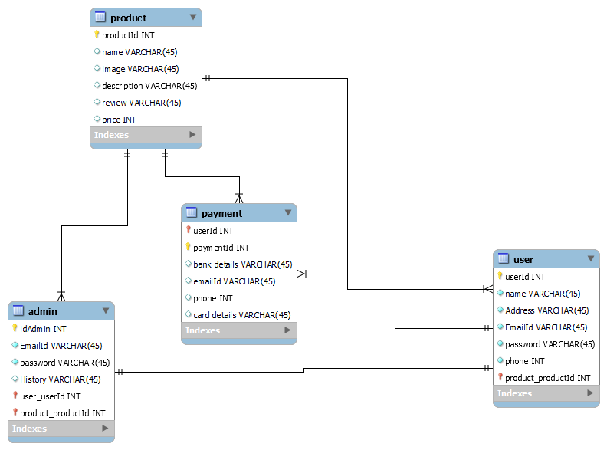

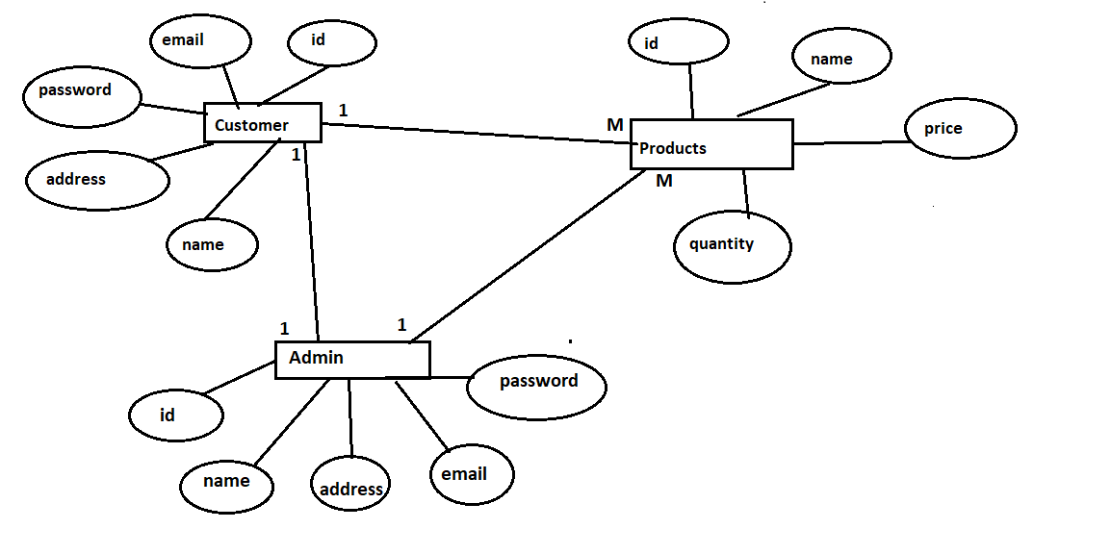

**Tables in DB :**

**Customers-**

|  |  |  |  |  |  |
| --- | --- | --- | --- | --- | --- |
| Field | Type | Null | Key | Default | Extra |
| Id | int | No | Primary | Null | Auto_increment |
| Address | Varchar(100) | No |  | Null |  |
| Email | Varchar(45) | No | Unique | Null |  |
| Name | Varchar(20) | No |  | Null |  |
| password | Varchar(20) | No |  | Null |  |

**Products-**

|  |  |  |  |  |  |
| --- | --- | --- | --- | --- | --- |
| Field | Type | Null | Key | Default | Extra |
| Id | int | No | Primary | Null | Auto_increment |
| Price | double | No |  | Null |  |
| Name | Varchar(20) | No |  | Null |  |
| quantity | int | No |  | Null |  |

**Use Case Diagram-**

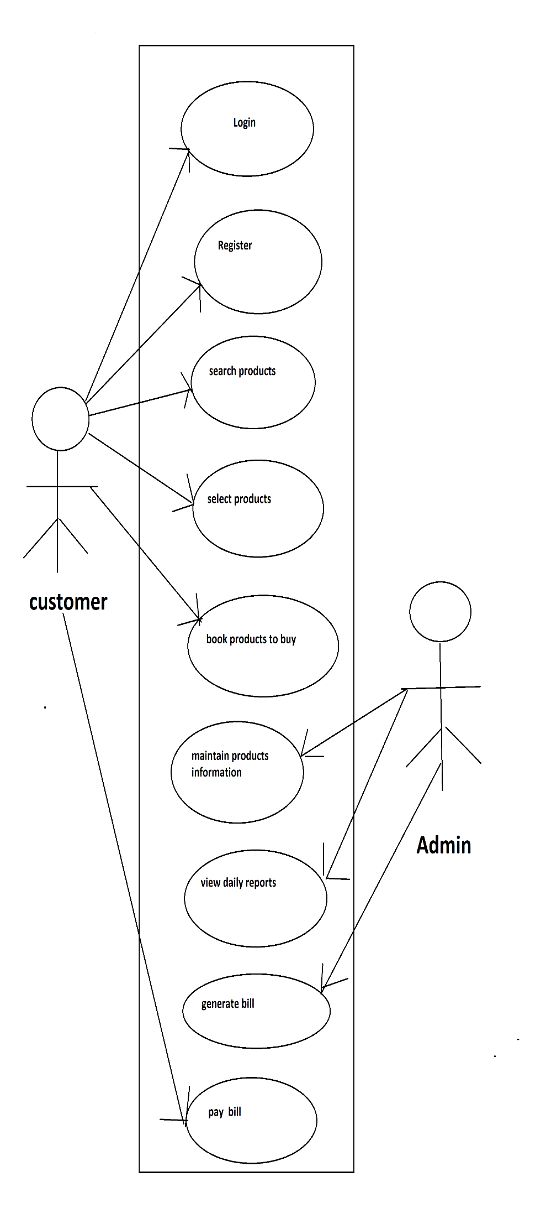

**Activity-**

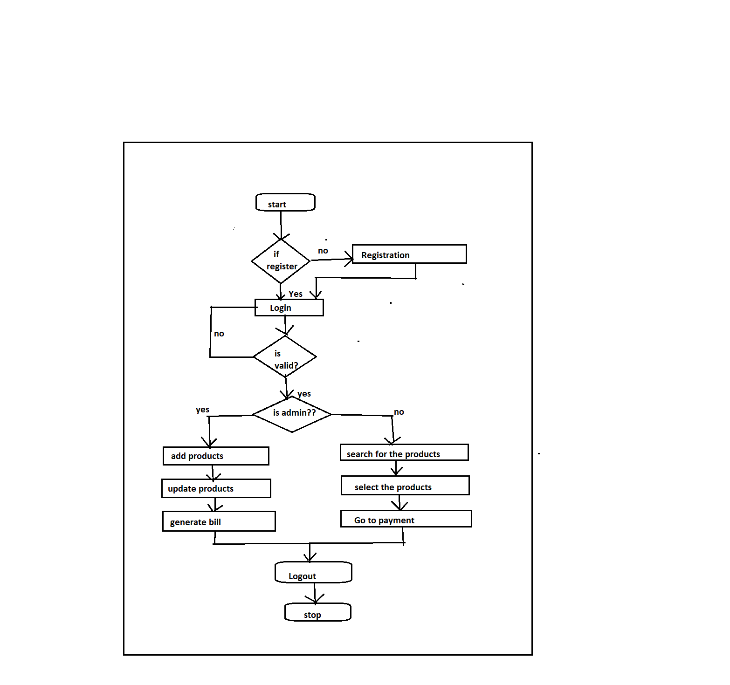

**Conclusion-**

E-Commerce has undeniably become an important part of our society. The successful companies of the future will be those that take E-Commerce seriously, dedicating sufficient resources to its development. E-Commerce is not an IT issue but a whole business undertaking. Companies that use it as a reason for completely re-designing their business processes are likely to reap the greatest benefits. Moreover, E-Commerce is a helpful technology that gives the consumer access to business and companies all over the world.

# Future Scope

This project can be enhanced further by all types of commercial business oriented organisations. The software is flexible enough to be modified and implemented as per future requirements. We have tried our best to present this free and user–friendly website to store or shop owner and their respective staff. Message and Email alerts for various happenings in the product management list can be added to the system so that users do not miss the updates and happenings of their respective shops and stores. The billing can be done further. We can add different options such as cash on delivery, credit card, debit car etc.

**ONLINE REFERENCE**

https://www.studocu.com/in/document/punjabi-university/post-graduation-diploma-in-computer-application/inventory-mgt-sys-srs-for-inventory-management-system/7770491?shared=1&sid=01645188636