Project title: Library management System

**INTRODUCTION:**

* **Objective:** The objective of the **“Library Management Software”** is to handle the entire activity of a library. The software keeps track of all the information about the academic books, magazines, newspapers in the library, their cost, their complete details and total number of books available in the Library. The user will find it easy in this automated system rather than using the manual writing system. The system contains a database where all the information will be stored safely. The system is user-friendly and error free.

**Scope:** Thisproject is helpful to track all the book and library information and to rate the maximum number of books, student information, techer information. The software will be able to handle all the necessary information.

**PROJECT CATEGORY:**

RDMS

**PROJECT DESCRIPTION:**

The software to be produced is on **Library Management System**. Here there are 4 users. They are The one Admin and the 3 receptionist. The first procedure is ther the registration of the borrower i.e either student or teacher. The receptionist has the authority to enter the name of the borrower , name of book, book of code number and contact number of the borrower and issued date of the book. And if the borrower is the student then the name of the student, enrollment number, roll no this information is also added along with it. Their entry and exit time to the library will be noted down. This calculates the total amount of time they spent in library. A library card will also be provided to the customers who visit daily. A person can also borrow the book for particular days. All the information will be entered in the system. If the person doesn’t return the book before the due date, a fine will be added and the information will be sent to that particular person about the fine.

Admin has the authority to add, delete or modify the details of the book available to/from the system. He also has the authority to provide username and password for the receptionist. He can also add the details of the book purchased from shops along with the shop name. Monthly expense report, books purchased report, cash collected for fee can also be viewed.

**Modules of the software:**

* **Books:** Admin has the authority to add, delete or modify the details of the book available to/from the system.
* **Library Registration:** The first procedure is the registration of the people who arrive to the library. The receptionist has the authority to enter the name, address and contact number of the people who visit the library along with the name of the book they want to read.
* **Time spent:** Their entry and exit time to the library will be noted down. This calculates the total amount of time they spent in library.
* **Purchase books:** Admin can also add the details of the book purchased from shops along with the shop name. He also has the authority to delete from or modify it to the database.
* **Borrow books:** A person can also borrow the book for particular days. All the information will be entered in the system. If the person doesn’t return the book before the due date, a fine will be added and the information will be sent to that particular person about the fine.
* **Login registration:** Admin also has the authority to provide username and password for the receptionist.
* **Reports:** Monthly expense report, books purchased report, cash collected for fee can also be viewed.

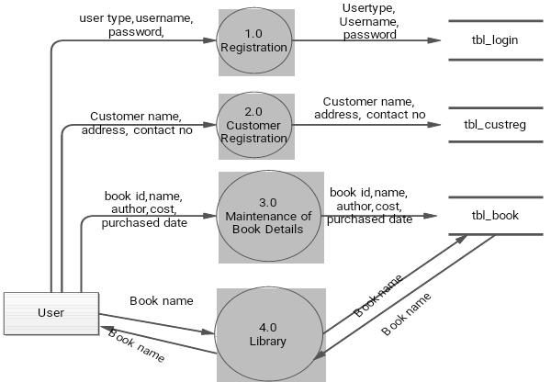

**HARDWARE REQUIREMENTS:**

* **Processor:** Intel dual core or above
* **Processor Speed:**1.0GHZ or above
* **RAM:** 1 GB RAM or above
* **Hard Disk:** 20 GB hard disk or above

**SOFTWARE REQUIREMENTS:**

* **Language:** Java Application
* **Database:** My SQL

**CONCLUSION:**

**Library Management System** allows the user to store the book details and the customer details. This software package allows storing the details of all the data related to library. The system is strong enough to withstand regressive yearly operations under conditions where the database is maintained and cleared over a certain time of span. The implementation of the system in the organization will considerably reduce data entry, time and also provide readily calculated reports.

**BIBILIOGRAPHY:**

**Books**

* “Database Management System”- Elmasri and Navathe

**Websites**

* <http://www.wikipedia.com>
* <http://www.java-basic-tutorials.com>