**A] Nengo-gui for the ACT**

1. Have below files in your local for running the model on nengo-gui:
   1. default.py (can be renamed, I wanted our model to open up in nengo gui by default)
   2. 3 .npy files related to dictionaries

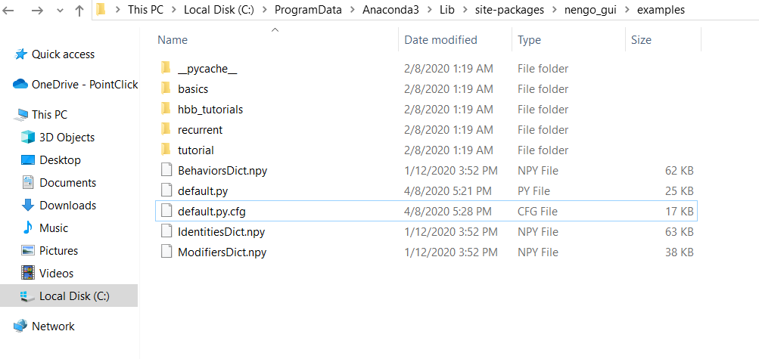

1. Copy the CalcProfileApp jar in any suitable location. Run the jar file from cmd prompt

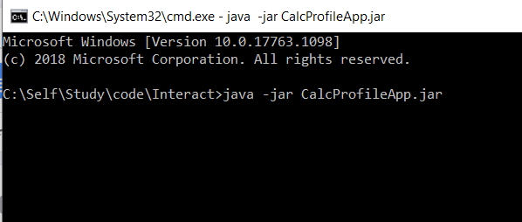

1. Start the nengo and I used ‘C:\\Users\\malhoa\\’ in the code, which can be replaced by dictionary location, and see the model and output

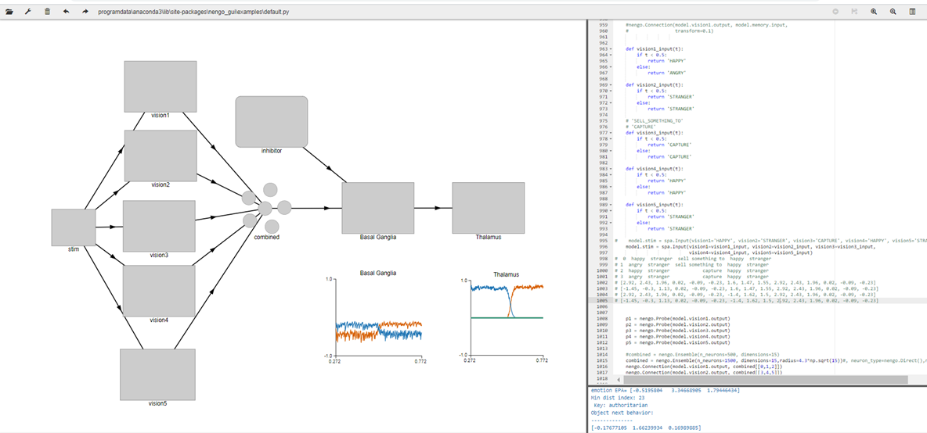

**B] Debugging in local**

1. I had below files in my user directory where anaconda picks it from
   1. Debugging-inhibition_v2.0.ipynb
   2. 3 .npy files related to dictionaries
2. Ensure the jar is running CalcProfileApp.jar (refer to A.2 in previous page)
3. Run the notebook cells (the Vision inputs and eval points should change based on scenario. It is now defaulting to transition ANGRY STRANGER CAPTURE HAPPY STRANGER

