**Lung Cancer Detection using Image Processing and Artificial Neural Network**

Submitted in partial fulfillment of the

requirements of the degree of

Bachelor of Technology

by

|  |  |
| --- | --- |
| **Aarti Barai** | **Iiiiiiiiiii 1iiiiiiii144109** |
| **M. Bikramjit Khumancha** | **144129** |
| **Thotakura Saichand** | **134158** |

Supervisor:

**Dr.C.B.Rama Rao**

Professor



**DEPARTMENT OF ELECTRONICS AND COMMUNICATION ENGINEERING**

**NATIONAL INSTITUTE OF TECHNOLOGY, WARANGAL**

**2017-2018**

**Approval Sheet**

This Project Work entitled “**Lung Cancer Detection Using Image processing and Artificial Neural Network ” Aarti Barai (144109), M.Bikramjit Khumancha (144129)**  and **Saichand Yadav (134158)** is approved for the degree of Bachelor of Technology.

Supervisor:

**Dr.C.B.Rama Rao**

(Professor, Department of Electronics and Communication Engineering)

Chairman:

**Dr. N.Bheema Rao**

(Head, Department of Electronics and Communication Engineering)

Date: 24th April 2018

Place: NIT Warangal

**Declaration**

We declare that this written submission represents our ideas in our own words and where other ideas or words have been included, we have adequately cited and referenced the original sources. We also declare that we have adhered to all principles of academic honesty and integrity and have not misrepresented or fabricated or falsified any idea / data / fact / source in our submission. We understand that any violation of the above will be a cause for disciplinary action by the Institute and can also evoke penal action from the sources which have thus not been properly cited or from whom proper permission has not been taken when needed.

Aarti Barai (144109)

M.Bikramjit Khumancha

(144129)

Date: 24th April 2018

**CERTIFICATE**

This is to certify that the project work entitled “**Lung Cancer Detection using Image processing and Artificial Neural Network**” is a bonafide record of work carried out by **Aarti Barai (144109) and M.Bikramjit Khumancha (144129)** submitted to the faculty of the department of Electronics and Communication Engineering in partial fulfillment of the requirements for the award of the degree of Bachelor of Technology in Electronics and Communication Engineering at the National Institute of Technology, Warangal during the academic year 2017-’18.

**Head of the Department** **Project Supervisor**

**Dr. N. Bheema Rao Dr.C.B.Rama Rao**

Head of the Department, Professor,

Department of Electronics and Department of Electronics and

Communication Engineering, Communication Engineering,

NIT Warangal. NIT Warangal.

**Abstract**

Lung Cancer is the most common cancer among men and women these days. With increasing patients of Lung Cancer every year, it is important to detect Lung Cancer so as to give proper medical treatments. Low dose CT Scan images are used for the detection of Lung Cancer. There are several stages of cancer. If cancer has metastasized then it becomes difficult for a doctor to treat them .This increases the importance of pre-mature lung cancer detection. In this project, lung cancer detection is done with the help of 3D Convolutional Neural Network.

The project objective is achieved by first detecting lung nodules and afterward detecting that lung nodules whether it is malignant or benign.

The ﬁrst step is to detect the pulmonary nodules in Lungs. LUNA16 data has 888 CT scans with annotated nodules in the CT scans. The annotation has coordinates of the lung nodules. A 32×32×32 cube is made around the nodules with nodule as center. A 3D CNN is used to detect nodules using these cubes. Secondly for Lung Cancer detection, Data Science Bowl 2017 kaggle competition data is used. It has 1595 CT scans. Lung nodules are predicted on this data using the nodule detector by running on the CT scans as grids. An ROI mask for lungs is applied on the CT scan using Image Processing. The predicted nodules coordinates are used to make cubes around nodules as the same size as before and a second 3D CNN is used to predict cancer using it.

The architecture of the 3D CNN is being inspired by U-Net and AlexNet CNN. This approach for lung cancer detection is new as compared to different methods in various research paper.

**Content**

Abstract……………………………………………………………………..……………………….4

List of Figures………………………………………………………………………….…………...7

List of Table………………………………………………….......................................................9

Abbreviations Notation and Nomenclature…………………………………………………….10 1.Introduction……………………………………………………………………………………...11 iiiiiiiiiiiii1.1 Overview……………………………………………………………………………….11 iiiiiiiiiiiiiiiiiiiiii1.1.1 Causes of Lung Cancer………………………………………………………13

Iiiiiiiiiiiiiiiiiiiiii1.1.2 Types of Lung Cancer………………………………………………………..15

Iiiiiiiiiiiii1.2 Motivation for work…………………………………………………………………..16

Iiiiiiiiiiiii 1.3 Problem Statement…...…………………………………………………………….17

iiiiiiiiiiiiii1.4 Methodology………...…...…………………………………………………………..18

1.5 Organization………………………………………………………………………….18

2. Review of Literature……………………………………………………………………………19

3.Data………………………………………………………………………………………………21

3.1 Dataset Description………………………………………………………………….21

4.Convolutional Neural Network……………………………………….…….............................24

4.1 Introduction to Neural Network…………………………………………...…………24

Iiiiiiiiiiiiii4.2 Structure of Convolutional Neural Network………………………………………...28

4.3 Overfitting and Underfitting a neural network………………...……………………33

4.4 Steps to train CNN……………………………………………………………………34

Iiiiiiiiiiiiii4.5 Importance of CNN……………………………………………………………………35

Iiiiiiiiiiiiii4.6 Inspiration of the CNN architecture used……………………………………………36

5.Training the 3D CNN for Nodule Detection…………………………………………………….39

iiIiiiiiiiiiiii5.1 Preprocessing………………………………………………………………………….39

iiiiiiiiiiiiiii5.2 Creating Dataset for Nodule Detection……………………………………………...39

iiiiiiiiiiiiiii5.3 Results of Nodule Detector…………………………………………………………...43

iiiiiiiiiiiiiii5.4 Predicting Nodules in Kaggle dataset…………………………………………….....44

6.Training the 3D CNN for Cancer Detection………………………………………………….46

6.1 Morphological Operations………………………………………………………….46

Iiiiiiiiiiiiiii6.2 Segmentation of CT scan…………………………………………………………..48

Iiiiiiiiiiiiiii6.3 Making of Training Dataset for Cancer Detection………………………………..52

Iiiiiiiiiiiiiii6.4 Training for Cancer Detection…………………………………………………….…53

7.Results…………………………………………………………………………………………...55

8. Conclusions and Future Scope……………………………………………………………....57

Iiiiiiiiiiiiiii8.1 Conclusion……………………………………………………………………………57

Iiiiiiiiiiiiiii8.2 Future scope…………………………………………………………………………57

*LITERATURE CITED* ……………………………………………………………………………59

*ACKNOWLEDGEMENT*………………………………………………………………………….60

**List of Figures**

Figure 1.1 Cancer cell division…………………………………….…………..……...11

Figure 1.2 CT Scan containing Cancerous Nodule …………………………….…….....17

Figure 3.1 3D View of lungs……………………………………….…………..……….21

Figure 3.2 Slices of a CT scan…………………………………….………..………..22

Figure 4.1 Neural Network…………………………………………...………………..25

Figure 4.2 Convolution in 2D of two functions………………………...…………….26

Figure 4.3 3D input to Neural Network…………………………………...……….…26

Figure 4.4 Operation of 3D Convolution…………………………………………....…27

Figure 4.5 Convolution in 3D…………………………………………………………..27

Figure 4.6 Activation maps………………………………………...…………………28

Figure 4.7 Pictorial representation of average and max pooling………………………...29

Figure 4.8 ReLu activation function…………………………………………………..30

Figure 4.9 ReLu operation………………………………………………………….…..30

Figure 4.10 Sigmoid Function……..………………………………………………….….31

Figure 4.11 Processing of fully connected layer……………………………………….…31

Figure 4.12 Architecture of Convolutional neural network……………………………....32

Figure 4.13 AlexNet structure………………………………………………….….…...36

Figure 4.14 Architecture of U-net Convolutional Neural network………………….…36

Figure 4.15 A confusion matrix………………………………………………………....37

Figure 5.1 Nodules and non-nodule cube…………………………………………….…40

Figure 5.2 2D slice of CT scan flipped by 180 degrees……...…………………….…41

Figure 5.3 Architecture of the 3D CNN used for nodule detection………………….42

Figure 5.4 Confusion matrix of Nodule detection…………………………………….43

Figure 5.5 Nodules detected by the nodule detector on a 2D slice of CT scan……….44

Figure 6.1 Morphological operations………………………………………………........47

Figure 6.2 Opening and closing results…………………………………………….…47

Figure 6.3 Summary of Segmentation…………………………………………………..48

Figure 6.4 Erosion operation erodes the boundary……………………………………...49

Figure 6.5 Small holes removal by Closure operation………………………………..50

Figure 6.6 Pictorial representation of Segmentation………………………………..…...50

Figure 6.7 Original and its mask…… …………………………………….………….51

Figure 6.8 Application of mask on Lung CT Scan…………………….……………….51

Figure 6.9 Two 64mm × 64mm × 64mm cubes……… …………………………….......52

Figure 6.10 Architecture of the 3D CNN for cancer detection………..……………….....54

Figure 7.1 Confusion matrix for Cancer Detection……………………………………...55

Figure 7.2 Plot of loss function versus epoch for cancer detection………………….56

Figure 7.3 Plot of accuracy versus epoch for cancer detection……………………….56

**List of Tables**

Table 1.1 Lung Cancer Stats…………………………………………………............12

Table 1.2 Chemicals in Cigarettes……………………………………………………...13

Table 1.3 Causes of Cancer…………………………………………….………..…...14

Table 1.4 Different stages of lung cancer…………………………………………….…15

Table 5.1 Number of nodules and non-nodules in dataset……………………………...39

Table 5.2 Nodule Detection Layer…………………………………………………..…43

Table 6.1 Radiodensity of various substances………………………………………......48

Table 6.2 Cancer Detection Layer…………………………………………………........53

**Abbreviations Notation and Nomenclature**

CT Computed Tomography

CNN Convolutional Neural Network

DICOM Digital Imaging and Communications in Medicine

TP True Positive

TN True Negative

FP False Positive

FN False Negative

3D Three Dimensional

GLCM Gray Level Co-occurrence Matrix

AUC Area under the Curve

ROI Region of Interest

HU Hounsfield scale

SGD Stochastic Gradient Descent

MSE Mean Squared Error

**Chapter 1**

**Introduction**

* 1. **Overview**

When a person gets hurt by falling or the person gets cut by some sharp object, the skin peels off. But after some days it gets completely healed because cells grow and divide so as to replace the damaged cells or old cells. This process also happens in order to replace many cells inside human body due to many other reasons. All these processes occur in a controlled manner. These processes are necessary for a person to be healthy. Cancer happen when these natural process of cell division goes in an uncontrolled manner shown in Figure 1.1.

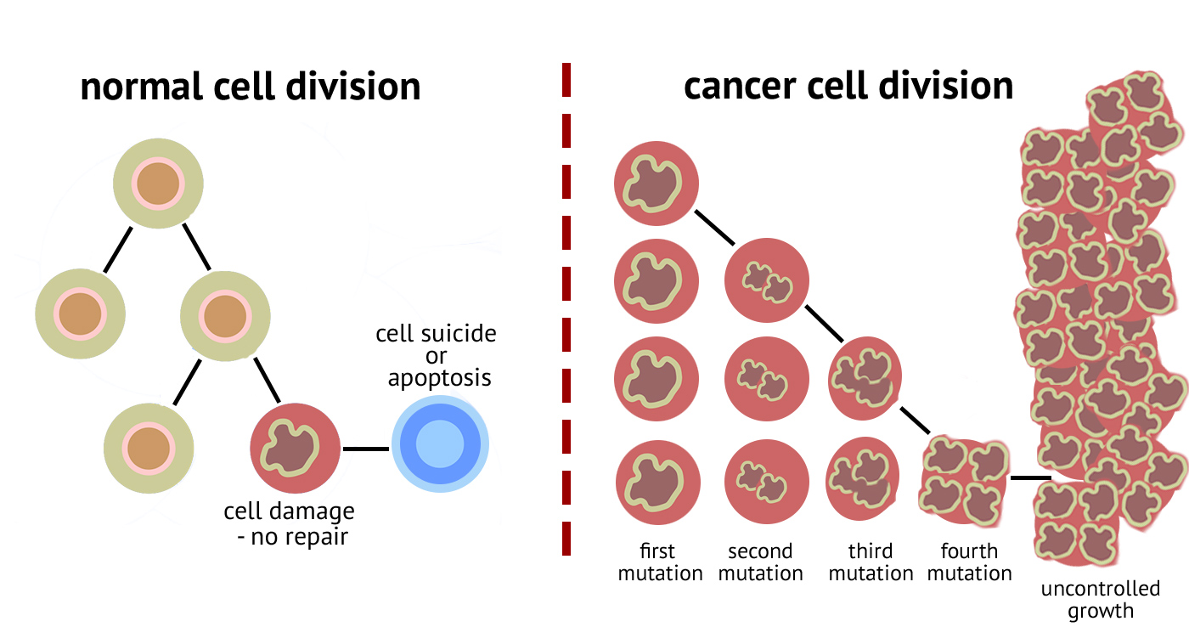

**Figure 1.1**: Cancer cell division

Cancer is not just single diseases, it comprises of more than 100 diseases. When proliferation of cells goes awry it doesn’t work according to the signal given by body to stop, malignant cells multiply to form tumors in organs and tissues. This is a life threatening process because they spread throughout the body. Tumors are of two types- benign and malignant. Benign tumor can be removed from the body and thus preventing them from spreading into the body whereas malignant tumor spread to other sites in the body. Many times it has been found out that lung has been common site of malignant tumor than other parts of the body. Since it spreads throughout the body hence it is difficult to treat a patient suffering from cancer. The cancer statistics is shown in Table 1.1.

|  |  |  |
| --- | --- | --- |
| Cancer | Men | Women |
| Lung and Bronchus | 28% | 26% |
| Prostate | 10% | 14% |
| Colon and Rectum | 9% | 9% |
| Pancreas | 6% | 7% |
| Liver | 5% | 5% |

**Table 1.1**: Cancer Stats[1]

According to the latest study shown in Table 1.1, it has been found out that lung cancer is one of the most common cancer among men and women worldwide. It has been known that smoking is the major cause of lung cancer but many non-smokers also have lung cancer. So it actually indicates that lung cancer is caused by what type of air is inhaled these days as air pollution is increasing day by day so many people are affected by lung cancer. When smoke is inhaled, which consists of cancer causing elements, it causes changes in lung tissues. Normally the lung is able to repair all those damages but because of repeated exposure the process of cell division become abnormal. Thus, it slowly leads to tumors which is cancerous or non-cancerous. The amount of spread of these tumors in the body is called as metastases.

* + 1. **Causes of lung cancer**
* Smoking- Depending upon how many cigarettes a person is taking and how frequently, increases the risk of lung cancer. Cigarette consist of 70 known elements causing lung cancer. Table 1.2 shows the amount of cancer causing chemical per cigarette and Table 1.3 shows the contribution of different causes of cancer.

|  |  |
| --- | --- |
| **Chemical** | **Amount per cigarette** |
| Acrylonitrile | formerly 1 to 2 milligrams. This product was used as a fumigant in tobacco. Its use has since been discontinued. |
| 4-Aminobiphenyl | 0.2 to 23 nanograms |
| Arsenic | Unknown |
| Benzene | 5.9 to 75 micrograms |
| Beryllium | 0.5 nanograms |
| 1,3-Butadiene | 152 to 400 micrograms |
| Cadmium | 1.7 micrograms |
| 1,1-Dimethylhydrazine | Unknown |
| Hydrazine | 32 micrograms |
| Acetaldehyde | 980 micrograms |

**Table 1.2**: Chemicals in Cigarettes[2]

|  |  |
| --- | --- |
| **Causes of Cancer** | **Contribution** |
| Smoking | 83% |
| Asbestos | 6% |
| Second-hand smoke | 3% |
| Radiotherapy | 0.8% |
| Radon | 0.5% |
| Other | 6.7% |

**Table 1.3**: Causes of Cancer[3]

* **Passive Smoking** - When people who do not smoke tend to have inhaled smoke because of other people smoking nearby them. Research has shown that non-smokers who reside with a smoker have a 24% increase in risk for developing lung cancer when compared with other non-smokers. An estimated 7,300 lung cancer deaths occur each year that are attributable to passive smoking.
* **Exposure to Radon gas** - The natural breakdown of uranium in soil and water leads to the generation of radon gas which becomes a part of air that humans inhale. This is the second most factor causing lung cancer. It decays to form products that emit a type of ionizing radiation. Radon gas is a known cause of lung cancer, with an estimated 12% of lung cancer deaths attributable to radon gas, or 15,000 to 22,000 lung cancer-related deaths annually. As with asbestos exposure, concomitant smoking greatly increases the risk of lung cancer with radon exposure. Radon gas can travel up through soil and enter homes through gaps in the foundation, pipes, drains, or other openings.
* **Exposure to Asbestos** - These increases the risk factor of having cancer by more than 30 fold times. Asbestos fibers are silicate fibers that can persist for a lifetime in lung tissue following exposure to asbestos. The workplace is a common source of exposure to asbestos fibers, as asbestos was widely used in the past for both thermal and acoustic insulation materials. Today, asbestos use is limited or banned in many countries. Both lung cancer and mesothelioma (a type of cancer of the pleura or of the lining of the abdominal cavity called the peritoneum) are associated with exposure to asbestos. Cigarette smoking drastically increases the chance of developing an asbestos-related lung cancer in exposed workers. Asbestos workers who do not smoke have a fivefold greater risk of developing lung cancer than non-smokers, and those asbestos workers who smoke have a risk that is 50 to 90 times greater than non-smokers.
* **Air pollution** - The contaminated air consist of various lung cancer causing elements because of increasing environmental changes. Air pollution, from vehicles, industry, and power plants, can raise the likelihood of developing lung cancer. Up to 1% of lung cancer deaths are attributable to breathing polluted air, and experts believe that prolonged exposure to highly polluted air can carry a risk similar to that of passive smoking for the development of lung cancer.
* **Family history** - While the majority of lung cancers are associated with tobacco smoking, the fact that not all smokers eventually develop lung cancer suggests that other factors, such as individual genetic susceptibility, may play a role in the causation of lung cancer. Numerous studies have shown that lung cancer is more likely to occur in both smoking and non-smoking relatives of those who have had lung cancer than in the general population.

**1.1.2** **Types of Cancer**

There are several stages of lung cancer depending upon how far the lung cancer has metastasized. Table 1.4 shows the tumor sizes at different stages of cancer.

|  |  |
| --- | --- |
| Stage | Condition |
| Stage 1 | Tumor less than 3 cm |
| Stage 2 | Tumor less than 6 cm |
| Stage 3 | Tumor more than 6 cm |
| Stage 4 | Tumor spreads to other organs |

**Table 1.4**: Different stages of lung cancer[4]

**Stage I**: The cancer is located only in the lungs and has not spread to any lymph nodes.

**Stage II**: The cancer is in the lung and nearby lymph nodes.

**Stage III**: Cancer is found in the lung and in the lymph nodes in the middle of the chest, also described as locally advanced disease. Stage III has two subtypes:

* If the cancer has spread only to lymph nodes on the same side of the chest where the cancer started, it is called stage IIIA.
* If the cancer has spread to the lymph nodes on the opposite side of the chest, or above the collar bone, it is called stage IIIB.

**Stage IV**: This is the most advanced stage of lung cancer, and is also described as advanced disease. This is when the cancer has spread to both lungs, to fluid in the area around the lungs, or to another part of the body, such as the liver or other organs.

**1.2 Motivation for Work**

As known in 2012 there are 1.8 million of different types of new lung cancer cases and now it is 2018 so one can just imagine how this 1.8 million might have just increased.

Studying all those cases will be difficult for a doctor. Lung cancer should be detected in its earlier stage and thus a person’s life can be saved. The objective is to develop an artificial neural network model to detect lung cancer in its earlier stage so that it will help doctors to improve their medication and thus a trained model will analyse many more new different cases of lung cancer since it trains itself and thus its efficiency will be increased.

The aim is to detect the presence of early or non-early stage cancer in CT scan image of Lungs with the help of Image Processing, Computer Vision and Deep Learning methods, particularly 3D Convolutional Neural Networks. The system will take the 3D CT Scan Image as input and give an output, whether the patient is cancerous or not.

A 3D CNN cannot be directly used on a 3D CT Scan Image as it will be difﬁcult to detect small nodules in such a large area of the image. The solution is to reduce the search area by cutting out small cubes containing nodules from the CT Scan image for training a nodule detector using a 3D CNN. After the detection of nodule, another 3D CNN can be trained for identiﬁcation of cancerous and non-cancerous nodules. Figure 1.2 shows a slice of CT Scan containing a cancerous nodule.

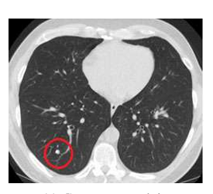

**Figure 1.2:** CT Scan containing Cancerous Nodule

**1.3 Problem Statement**

The drawbacks of the existing methods of Lung Cancer detection is that those models are not able to fully utilise the 3D structure of the lung nodule. As they are predicting using only 2D slices, they miss the features which can be extracted from 3D nodules and which can be an important feature in prediction of cancer. So the aim of this project is to build a neural network model for cancer detection which can take the whole CT Scan as input and give output as probability of cancer for each CT Scan. For this, 3D CNN is to be used on CT scan images of DICOM format.

**1.4 Methodology**

In order to detect lung cancer, 3D convolution network is being used. The nodule can be located in any part of the whole 3D CT Scan. The lung nodule size is very small. So in order to reduce the searching part and thus reducing computation part, only a small chunk of CT scan is considered and then fed to neural network, whose main objective is to detect whether that chunk is a lung nodules or not. If that chunk is a lung nodule then it is fed to another neural network to detect whether it is cancerous or not. So the task is divided into two part:

* Detecting lung nodules
* Detecting whether that lung nodule is malignant or not.

**1.5 Organization**

Chapter 2 Review of Literature

Chapter 3 Data

Chapter 4 Convolutional Neural Network

Chapter 5 Training 3D CNN for nodule detection

Chapter 6 Training 3D CNN for cancer detection

Chapter 7 Result

Chapter 8 Conclusion and Future Scope

**Chapter 2**

**Review of Literature**

There are many different types of method used to detect lung cancer. CT scan is a 2D grayscale image. Image processing techniques are used to segment the lung nodules from the given CT scan after that Features extraction techniques is used to extract features for that segmented part. Feature extraction is mainly used to reduce the redundancy and repetition of pixels and thus reducing the computation power. There were many features such as area, perimeter, eccentricity, height to width ratio, central moment, average distance of black pixels from the central point, histogram etc.[5]. One of the most popular way for feature extraction is Gray Level Co-Occurrence Matrix (GLCM)[6]. It basically extracts the textural features from images. There are total 14 textural feature that can be extracted such as Angular second moment (energy), inertia moment, correlation , entropy , inverse difference moments etc.

After extracting features a model is trained using machine learning[7]. All these features are fed to neural network for the classification of cancerous and non cancerous images.

The model were trained with algorithm like K-Nearest Neighbour, multinomial multivariate Bayesian, Support Vector Machine with back propagation neural network[8].

Some of the other approaches are 2D multiscale filtering is used for the lung nodule detection and then false-positive nodules are reduced by logical AND operator of continuous CT slices. Features in this case is extracted using Curvelet Transform and then fed them to neural network[9].

All the existing methods of cancer detection uses 2D CT Scan images in which one slice of the whole CT scan is taken and features from them is extracted using Image Processing. While this method works but it misses the 3D structure of the nodule which can be very informative in detection of the cancerous nodule. In 2D images it is difficult to distinguish a nodule from blood vessels and air gap. While in 3D images, it is easier to detect.

One of the latest method for cancer detection is the use of 3D Convolutional neural network (CNN)[10]. For this there is very small amount of preprocessing needed[11]. 3D CNN is also known for its space invariant and shift invariant artificial neural network. The approach used currently using CNN if first to segment the lung nodule using U-Net CNN and after finding the location extract features from the image and feed it to some Machine Learning algorithm like XGBoost, SVM, KNN, etc.

**Chapter 3**

**Data**

**3.1 Dataset Description**

The input data is CT Scan images of lungs in DICOM (Digital Imaging and Communications in Medicine) format. Each CT scan consists of 2D slices. The total number of slices in each CT Scan are in the range 70-120. The slices of CT Scan of lungs are stacked together to obtain the 3D image of lungs. Figure 3.1 and 3.2 shows the 3D view of Lungs and the slices of a CT Scan respectively.

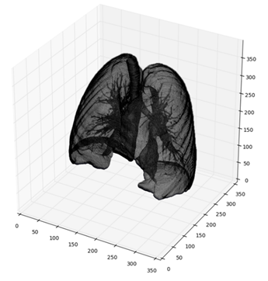

**Figure 3.1**: 3D view of lungs

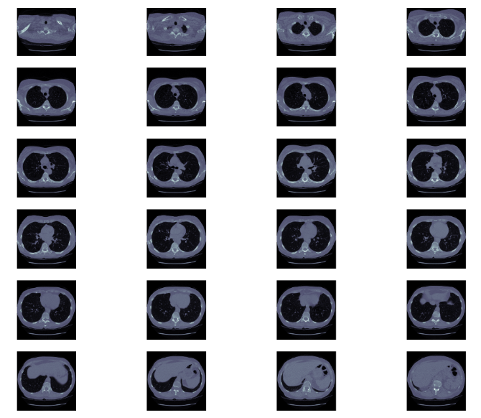

**Figure 3.2**: Slices of CT scan

Lung cancer in stage 4 is easily detectable by CT scan because it clearly shows cancerous portion in a larger size and volume. Whereas to detect premature cancer, is a very difficult task because that tumor might be at any places in lung known as lung nodules.

An average CT scan size is *200mm×200mm×200mm* whereas and average nodule is of 10 mm diameter. Thus, this indicates that the cancer nodule is 36000 times smaller than an average CT scan. So this a problem which requires a lot of data for the algorithm to learn and large computation power.

Lung nodule detection is a major task before detecting whether a candidate is cancerous or not because it is a very small part in a very large volume of lung. For this the data has been collected from Lung Nodule Analysis 2016 data (LUNA16). This dataset has 888 CT scans. It is a subset of the LIDC/IDRI dataset from the Cancer Imaging Archive. The dataset has scans less than or equal to 2.5 mm. The annotations were done by 4 radiologists. All nodules which are greater than 3 mm and accepted by 3 out of 4 radiologists has been included while nodules smaller than that has been excluded. It also has candidates for false positive reduction. The annotation ﬁle is a csv ﬁle with each ﬁnding per line. Each annotation has Series Instance UID of the scan, the x, y and z coordinate of the nodule in world coordinates and the diameter of the nodule in millimeter. The dataset has 408186 annotations.

In order to detect whether that nodule is cancerous or not a different dataset has been used. The data used for Cancer Detection is from the Kaggle competition Data Science Bowl 2017. It has 1595 CT scans with an annotation ﬁle which has the patient ID and a value 1 or 0 according to whether the patient has cancer or not. The images are in DICOM format. The dataset has 1176 non-cancerous and 419 cancerous patients.

**Chapter 4**

**Convolutional Neural Network**

**4.1 Introduction to Neural Network**

‘Neural network’ indicates to us something related to the neurons in brain. Whenever a person does any kind of movement or thinks about something, how this happens and how a person does want he or she wants to do. The answer is, the brain direct this message in the body. For example whenever a person wants to move the hand, this message is now in the brain thus now brain is actually sending this message to hands through the interconnected neurons in the body. Thus, brain does a lot amount of work.

So through vision one can understand how to distinguish or classify certain things in certain category. For example how does a person actually distinguish between apple and orange. The brain understands the fact that apple is red in color and orange is orange in color. Thus, whenever an image of any fruits is shown to a person, the person is able to give a label of either it is apple or orange or any other fruits because the brain has the capacity to recognize pattern, texture and other features which makes a person to know how an apple is an apple and how an orange is an orange. But sometime there are certain cases in which apple resembles a lot like orange thus the brain gets confused. If the computer is developed to have such pattern recognition skill just like human brain, many different objects in day today life can be identified.

So neural network is a network interconnected with several neurons which each connection has certain weights in order to classify images and some pattern into some categories. The network consist of multi layer which many neurons in its which has all possible inputs feed to it and eventually training the neuron connection by having certain numeric weights for classification purpose. Figure 4.1 is an image of a neural network.

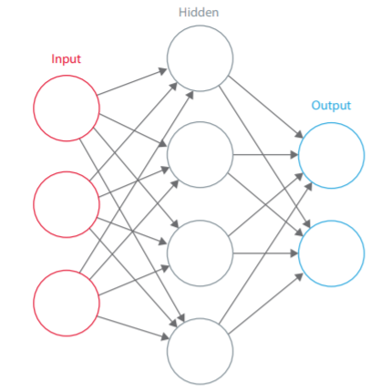

**Figure 4.1:** Neural Network

Convolutional neural network is one of popular category of neural network that has been tested and proved after many years that it is best network for image recognition. Its efficiency is more than all the other types of neural networks for image classification.

In order to perform certain classification certain pattern, shape and many other features have to be searched. For a compute , images is just an array of pixel ranging from value from 0 to 255, which depending on its size and resolution, image will be indicated by an array of 32x32x3 (3 because it represents RGB value). These pixels value has no meaning to us for classification but computer has the input of images in this fashion along with certain probability as why that image comes under some category.

When two functions exist in which the integral of dot product of two function while translating second function over the entire range gives rise to third function which is slightly the modified version of the first function. This mathematical operation is called as convolution. Figure 4.2 shows an example of 2D convolution.

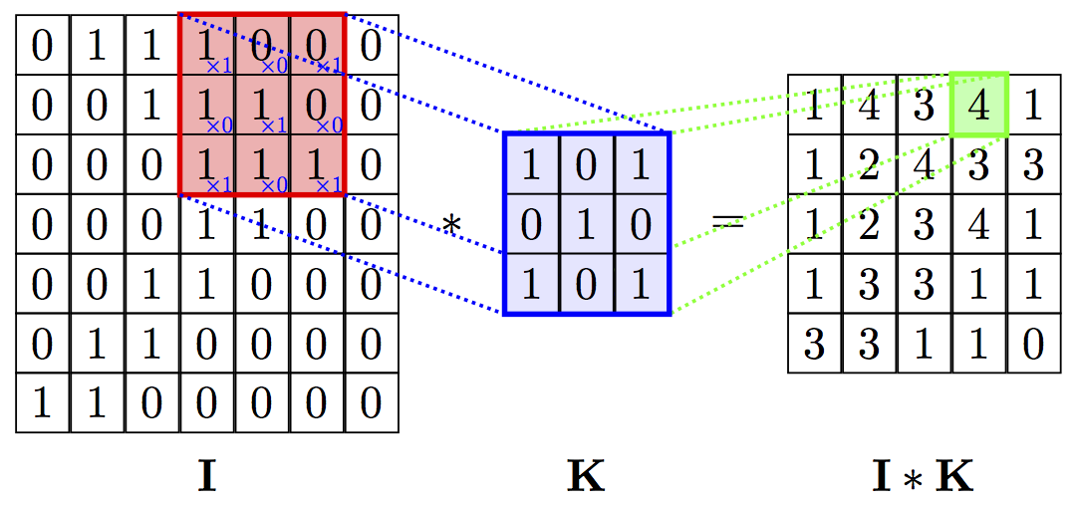

**Figure 4.2:** Convolution in 2D of two functions

For 3D CNN, assume some 3D input as shown in Figure 4.3 of size 32x32x3 to the neural network. Consider some other function of size 5x5x3. The other function is mostly called as filter. The filter is placed over the input and dot product is taken which is a scalar value. Figure 4.4 and 4.5 show a 3D image and 3D convolution applied to a 3D image respectively.

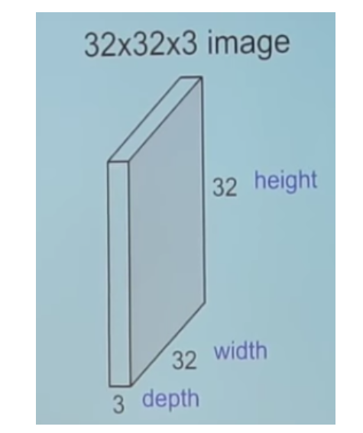

**Figure 4.3 :** 3D input to neural network

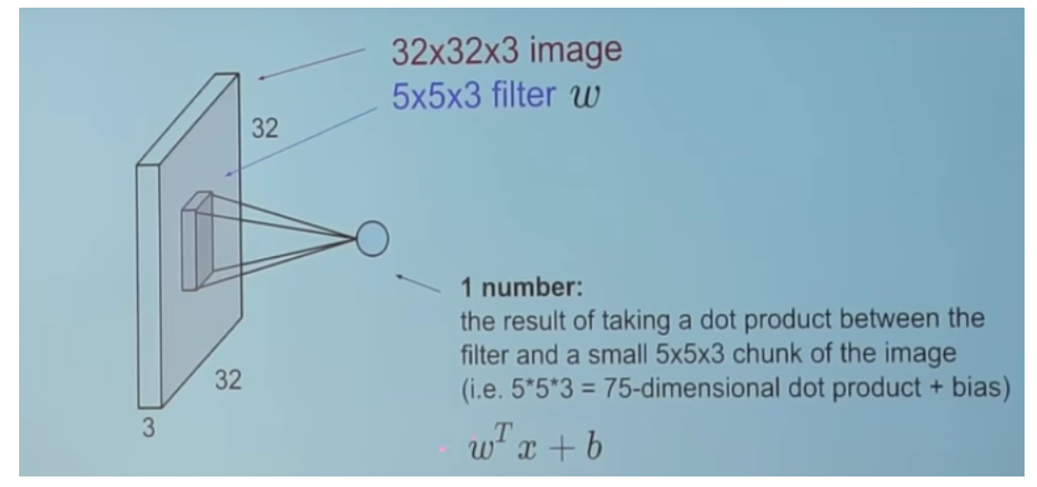

**Figure 4.4:** Operation of 3D convolution

Now this filter is moved over all the region of image and result is obtained. This result is called activation map. Figure 4.5 shows the result obtained after 3D convolution.

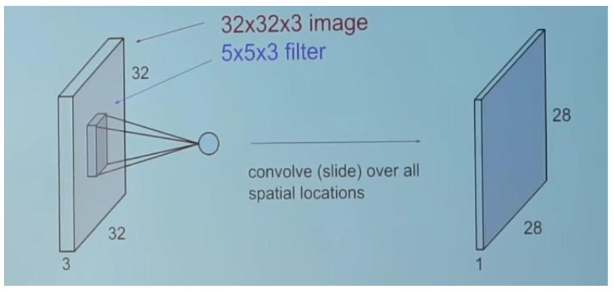

**Figure 4.5 :** Convolution in 3D

So CNN mainly consists of convolutional Layer. These convolutional layer has many feature map which many different activation which help to develop a classifier for image recognition. All these are stack up together. In the Figure 4.6 six activation maps are used.

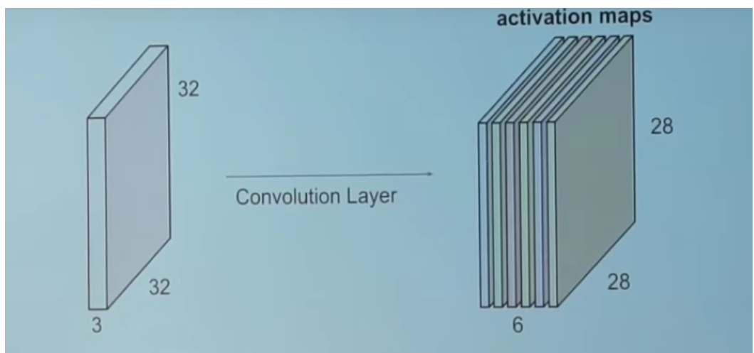

**Figure 4.6:** Activation maps

**4.2 Structure of convolutional neural network**

Many different types of features extracted layers stack up together in order to develop complex architecture for classification. There are total four types of layers which are used in neural network.

* Convolution Layer
* Pooling / subsampling
* Non-linear layers
* Fully connected layers

1. ***Convolution layer:*** The first layer of CNN extracts normal features such as edges, shape, lines, curves and corner. It is an important building block of CNN. Through the translation of filter throughout the input volume, and after performing dot product operation it leads to the generation of activation map of filter. Because of this, networks learns as in when the filter activates and at what kind of specific features. Thus, all these activation map when stacked up together leads to output volume of convolution layer. So this layer try to search certain parameter that matches with that of activation layer.

There are three important parameters for output volume which are:

**a. Depth**: It controls the number of neurons in the convolution layer.

**b. Stride**: In what fashion does the filter is convolved with the input. When stride is two then it indicates the filter jumps by two pixel while its translation.

c. **Padding:** Along the boundary of input some zeroes are padded. This is done to control the output volume spatial size.

1. ***Pooling Layer:***  Pooling is majorly done to do the subsampling operation. This down sampling is done in non-linear fashion. It reduces the resolution of features. It will become more robust to noise and distortion. There are two ways of doing that they are: max pooling and average pooling. Input is divided into non-overlapping small areas. So in max pooling maximum value of those small non-overlapping areas is considered and all other value are*discarded whereas in average pooling average of all the values in that*non-overlapping areas is considered and all other values are discarded. Now those new value of pixels will represent the input and thus down sampling occurs. This layer greatly reduce the spatial size which in turn reduce the parameters*and thus reduce the computation. This layer hence control overfitting. Figure 4.7 shows a pictorial representation of average and max pooling.

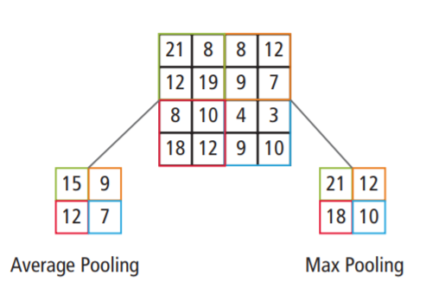

**Figure 4.7:** Pictorial representation of average and max pooling

1. ***Non-linear layer:*** After every convolutional layer, an additional operation such as ReLu is also used. ReLu stands for Rectified Linear Unit. The function is shown in Figure 4.8.

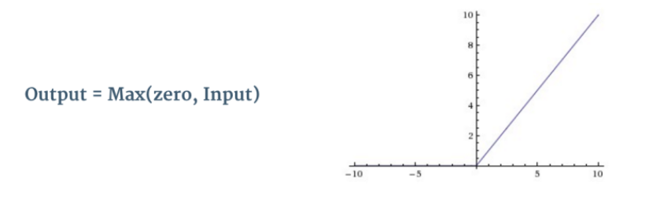

**Figure 4.8:** ReLu activation function

This operation is done in order to include non-linearity factor because in reality there are many non-linear factors that forms an important part of features. It replaces all the negative value in feature map by zero as shown in figure and thus non-linearity is added in Convolutional network. Its operation is shown in Figure 4.9.

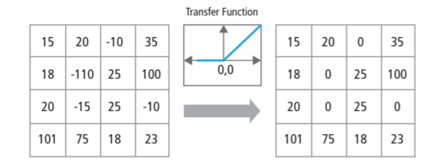

**Figure 4.9:** ReLu operation

There are many other ways to introduced non-linearity such as *sigmoid* and *tanh* function. Sigmoid is mostly used to calculate probability of which it comes under certain category i.e. for binary classification. Sigmoid function is shown in Figure 4.10.

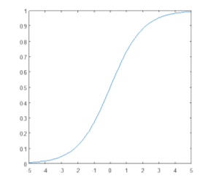

**Figure 4.10 :** Sigmoid function

1. ***Fully connected layer:*** These layers are the final layers and they are used to learn non-linear combinations of the features. Neurons in this layer have connections to all the activations in the previous layers. Figure 4.11 depicts the processing of fully connected layer.

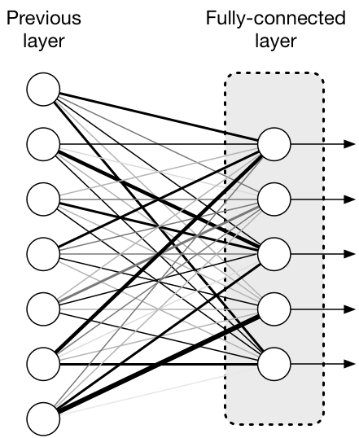

**Figure 4.11:** Processing of fully connected layer

Sometimes fully connected layer leads to over fitting. In order to solve that dropout is used. Thus, Dropout is also important.

There are many other important parameters such as:

* Number of filters being used
* Max pooling size
* Filter shape

Putting all those layers together a convolutional network is being formed and it is shown in Figure 4.12.

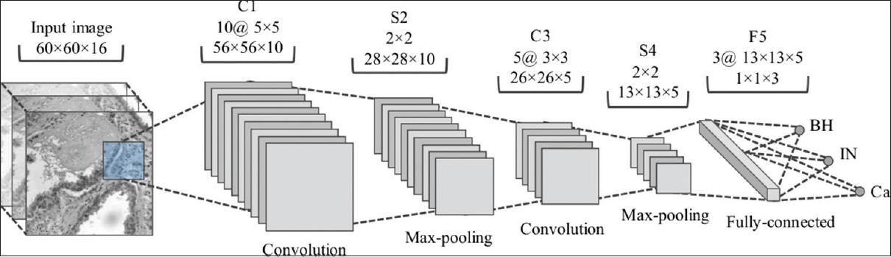

**Figure 4.12 :** Architecture of Convolutional neural network

* Input image is passed to the first convolutional layer. The convoluted output is obtained as an activation map. The filters applied in the convolution layer extract relevant features from the input image to pass further.
* Each filter shall give a different feature to aid the correct class prediction. To retain the size of the image, the same padding (zero padding), otherwise valid padding is used since it helps to reduce the number of features.
* Pooling layers are then added to further reduce the number of parameters
* Several convolution and pooling layers are added before the prediction is made. Convolutional layer help in extracting features. As the network gets deeper, more specific features are extracted as compared to a shallow network where the features extracted are more generic.
* The output layer in a CNN as mentioned previously is a fully connected layer, where the input from the other layers is flattened and sent so as the transform the output into the number of classes as desired by the network.
* The output is then generated through the output layer and is compared to the output layer for error generation. A loss function is defined in the fully connected output layer to compute the mean square loss. The gradient of error is then calculated.
* The error is then backpropagated to update the filter (weights) and bias values.
* One training cycle is completed in a single forward and backward pass.

**4.3 Overfitting and Underfitting a neural network**

* **Overfitting**: Overfitting means doing too well on the training data and badly on the validation data. The model fails to generalize on new data. Overfitting occurs when a model learns the data as well the noise too well so that any small amount of noise can severely affect the output. The network fails to generalize in overfitting. Overfitting can be prevented by using regularization, dropout, reducing the complexity of the model or getting more training data so that the network can generalize better.
* **Underfitting**: Underfitting occurs when a model neither learns from training data nor generalize to new data. The model has a very poor performance on training data. The model fails to learn features from the training data. Underfittng can be prevented by increasing the depth and width of the network, reducing regularization and dropout.

A model needs to be selected which is in the sweet spot between overfitting and underfitting. A sweet spot is a point where the validation loss starts increasing. Before the both training and validation loss must decrease. At this point, the model is in local minima and has a good skill on both training data and unseen data.

**4.4 Steps to train a CNN**

The steps to train a CNN are as follows:

* **Define the architecture of the CNN**: The first step is to select an architecture of CNN. Any CNN can be used for this. Some of the very popular CNNs are ResNet, AlexNet, VCG16, VCG19.
* **Prepare training data**: The next step is to prepare data to feed into the network. The images are reshaped according to the input size of CNN. The data is split randomly into training, validation and test set.
* **Select loss function, optimizer and evaluation metric**: The next step is to select a loss function. The main object of the CNN is to reduce the loss function so that it converges to a local minima. Some of the popular loss functions are binary cross-entropy, MSE, AUC. After that an optimizer such as SGD, Adam is decided for backpropagation. The performance of the model needs to be evaluated. So an evaluation metric needs to be defines. The most popular evaluation metric is accuracy. For biomedical classification, precision and recall are popular.
* **Fix the number of epochs, minibatch size and learning rate**: The next step is to fix the number of epochs or the number of iterations, the batch size and learning rate and start iterating.
* **Tune the hyper parameters to converge the network to a local minima**: On the basis of the first iteration results, the parameters learning rate, number of layers, number of filters, batch size and number of epochs are tuned to avoid both underfitting and overfitting.
* **Iterate and tune repetitively until it converges to a minima**: After each iteration, the parameters are changed according to the results and network is iterated again. This continues until it converges to a local minima.
* **Save the model and evaluation**: The model which has the minimum validation loss is saved and tested on the test data. The final results are examined using some evaluation metric.

**4.5 Importance of CNN**

There are some important factor as in why CNN is used:

* ***Robust to distortions and shifts in an image:***Image will become distorted because of change in camera lens, horizontal and vertical shifts, different lighting condition etc. But CNN is space invariant which leads to the fact that it has same weight across space.
* ***Small amount of memory requirements:*** In case of network containing fully connected layer, there is a requirement of large number of coefficient. Whereas in case of Convolutional neural network, the same coefficients can be used along the space.
* ***Better training:*** In standard neural network, larger number of parameters are used thus leading to more computations and increase in the training time. If training time is exceeded then many noise tend to enter the neural network. In Convolutional neural network, there are very less parameters required as compared to standard one and making the training process better and easier.

Convolutional neural network have layer varying from 5 to 25. In 3D CNN only different is that the input to the network is 3D in shape. Different types of CNNs are defined by different number of filters with different sizes and how much dropout needs to be used in order to decrease computation.

**Dropout to reduce Overfitting**

Dropout is a technique used to reduce overfitting in neural networks. In dropout, some randomly chosen neurons are ignored. At each layer, individual neurons are dropped out of the network with probability *p* and kept with the probability *1-p*. This reduces independent learning amongst the neurons and removes co-dependency which will otherwise lead to overfitting. Dropout enables the network to learn more robust features. Dropout increases the number of iterations taken to converge while each iteration becomes much faster.

**4.6 Inspiration for the CNN architecture used**

The CNN architecture that is used was constructed using two very popular CNN:

* **AlexNet (2012):** This network consist of five convolution layer, max pooling, dropout and three fully connected layers. In this as the network gets deeper, the width and length of the activation map decrease while the number of filters increases. Dropouts are used

to prevent overfitting. As the network gets deeper, dropout is increased. Its architecture is shown in Figure 4.13.

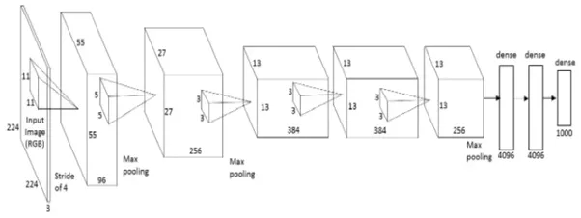

**Figure 4.13:** AlexNet structure

* **U-Net Convolutional network**: This U-net Convolutional network is used for biomedical segmentation. The architecture of U-net is shown in the Figure 4.14

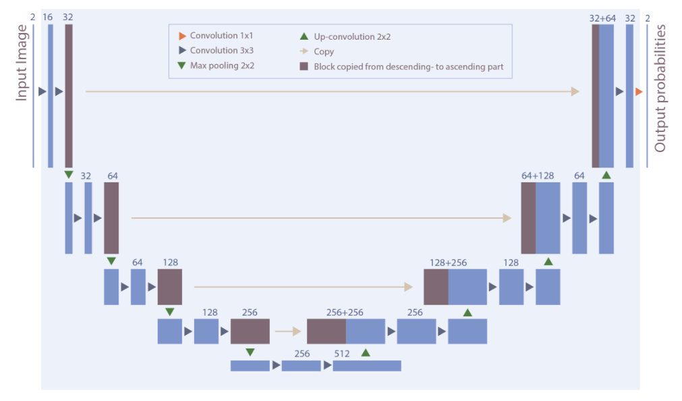

**Figure 4.14:** Architecture of U-net Convolutional Neural network

U-net is called as “U” because of its unique architecture as well the U-shape architecture. U-net is a kind of encoder-decoder type architecture for image segmentation process. In downsampling part, activation or feature maps from convolution part is given as input to the convolution part of up-sampling.

As since from the architecture the number of filters used in first layer is 64 and then for another layer the number of filter just got doubled that is 128 filters and after some other layer it has increased up to 512 filters. During the up convolution part that is right side of U-net the number of filter gradually reduces. The main task of neural network is to reduce the computation as the layers goes on increasing because the final answer that is desired is in terms of probability of belonging to certain category.

Average pooling is also used in U-net in order to have smoothening effect on input image so as to have less noise level. Max pooling and dropout take care of the overfitting and downsample the amount of data.

**Important parameters to evaluate a biomedical classification**

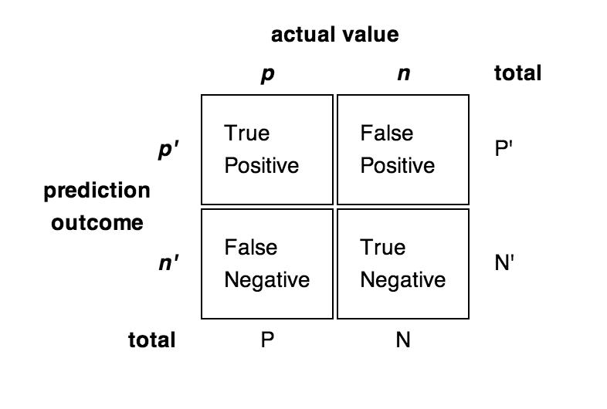

**Figure 4.15**: A confusion matrix

* **Confusion matrix**: it is an array consisting of true positive, true negative, false positive and false negative numbers shown in Figure 4.15.
* **Precision** : The fraction of correct true among predicted true.

Precision=True Positive / (True Positive + False Positive)

* **Recall**: The fraction of predicted correct true among all the correct true.

Recall=True Positive / (True Positive + False Negative)

* **F1 score**: It is the harmonic mean of precision and recall

**Chapter 5**

**Training the 3D CNN for Nodule Detection**

Before using any neural network, minimal preprocessing needs to be done. So the first step is preprocessing.

**5.1 Preprocessing**

The ﬁrst step for preprocessing is to make the CT scans homogenous. Every scan was rescaled so that each voxel represented a volume *1mm×1mm×1mm*. Then the pixel values in each image was converted into Hounsﬁeld units (HU), which is a measurement of radiodensity. Some CT scan scanners have cylindrical scanning bounds, but the output image is a square. Those pixels which fall outside this bound get the ﬁxed value  ***-2000***. This pixel values are made ***1***. This is done to make all the unnecessary pixels black and to get the lung region properly. The next step is to scale all the pixel values between **0** and **1** and then images are made to have same orientations. The last step is to zero-center the data by subtracting the mean of all the images.

**5.2 Creating Dataset for Nodule Detection**

The annotations provided with the LUNA16 dataset contain 408186 candidates. Some candidates were also provided for False Positive reduction. The annotation has the coordinates of the candidate and diameter in mm. The number of annotated nodules in LUNA16 dataset was originally low (1186). So the LIDC/IDRI annotations is used to get more nodules. This increased the number of nodules to 5,000. Table 5.1 depicts the summary of dataset obtained.

|  |  |
| --- | --- |
| **Description** | **Quantity** |
| Nodules candidate  Non-nodules  Candidates for false positive reduction | 5,000  400,000  7,000 |

**Table 5.1:** Number of nodules and non-nodules in dataset

A typical CT scan generally have sizes around *200mm×200mm×200mm* while the nodules in early stages have size less than 10mm. So the amount of signal vs noise is around ***1:1000,000.*** Due to this, a 3D CNN is not be able to learn from whole CT scan image. This problem is solved by cropping small 3D cubes around the candidate coordinates. The size of the cube used is ***32×32×32***. The low amount of candidates is handled by doing data augmentation (two lossless data augmentation used-3D ﬂipping and translation). After performing data augmentation, dataset ﬁnally has 20,000 nodules,4000000 non-nodules and 7,000 candidates for false positive reduction. These are randomly shufﬂed and divided into training set,cross-validation set and test set. The train set, validation set and test set consist of 32,138,04 , 803,452 and 9,744 candidates respectively. The training is done on the raw image cubes of the lung CT scan.

A ***64mm × 64mm × 64mm*** cube is shown in Figure 5.1 . Each slice of the cube along the z-axis are stacked together and represented in a 8×8 grid image. Thickness of each slice is 1 mm. Figure 5.1:a is the image of a nodule. Figure 5.1:b is the image of a non-nodule. Each of these cubes are further cropped to ***32mm×32mm×32mm*** before feeding to CNN.

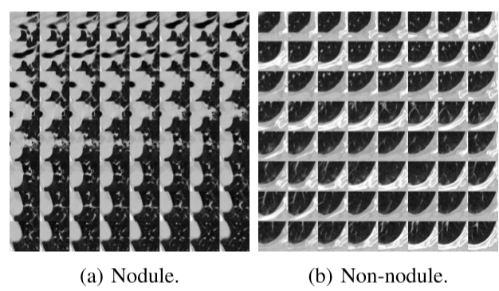

**Figure 5.1:** Nodules and non-nodule cube

A 64mm×64mm×64mm cubes cropped out from the lung region with the candidate as center.The slices along z axis are represented as a grid image. The white portion corresponds to lung walls.

The training set had only 5000 nodules compared to 400,000 non-nodules. For deep learning, huge data set is needed to obtain good result. Image augmentation is used to deal with the low amount of nodule data and to prevent overfitting.

Image augmentation artificially creates training data by changing its orientation. Two processes flipping and translation are used on nodule images to create more nodule data:

* **Flipping**: Flipping produces different set of images from rotation at angle of 90 degrees.
* **Translation**: The nodule can be present at the corner , edges or center of the image. So it can shifted to various locations in the image.

The image of CT scan obtained from flipping is shown in Figure 5.2.

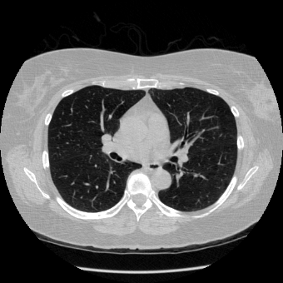 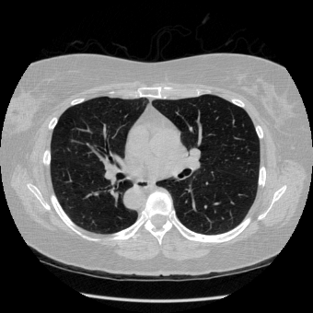

**Figure 5.2**: 2D slice of CT Scan flipped by 180 degrees

A 3D CNN is used for the nodule detection. The CNN has convolutional layers with *RELU* activation function for all except the last one. The last one has a sigmoid activation function which will give the value of whether a candidate is a nodule or not. The optimizer used is SGD (Stochastic Gradient Descent). Dropouts of 0.3,0.4 and 0.4 are used after the second, third and fourth Max Pooling Layer respectively. This helps prevent overfitting. A proper dropout needs to be selected to get to the get to the right point between overfitting and underfitting. Too much dropout would lead to underfitting and network would not be learn anything. It would always predict the value for the more dominant class in the training set. If dropuThe loss function used is Binary Cross entropy and the metrics used in training are Binary Cross entropy and Binary Accuracy. The network is run for 12 epochs. The Learning Rate used is 0.001 which is decreased to 0.0001 after ﬁfth epoch using a learning rate scheduler. A threshold(**0.6**) is used to classify the candidates. The model is trained in Keras with Tensorﬂow backend using Google Colaboratory cloud. A visualisation of the CNN architecture is shown in Figure 5.3 and its detailed description is given in Table 5.2 given below.

iiiiiiiiiiiiiiiiiiiiiiiiiiiiiiiiiiiiiiiiiiii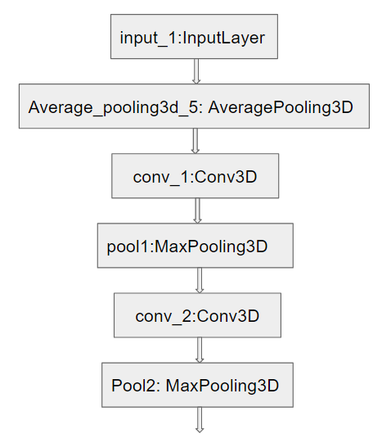

bbiiiiiiiiiiiiiiiiiiiiiiiiiiiiiiiiiiiiiiiiiiiiib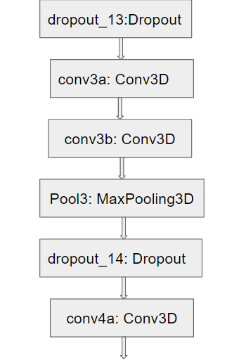

bbiiiiiiiiiiiiiiiiiiiiiiiiiiiiiiiiiiiiiiiiiiibiib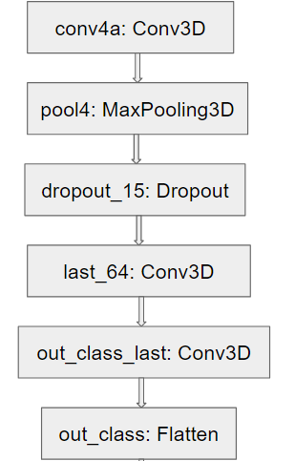

**Figure 5.3:** Architecture of the 3D CNN used for nodule detection.

|  |  |  |  |
| --- | --- | --- | --- |
| **Layer** | **Parameter** | **Activation** | **Output** |
| Input  Average Pool  3D Convolutional  Max Pooling  3D Convolutional  Max Pooling  3D Convolutional  3D Convolutional  Max Pooling  3D Convolutional  3D Convolutional  Max Pooling  3D Convolutional  3D Convolutional | 2x1x1  3x3x3  1x2x2  3x3x3  2x2x2  3x3x3  3x3x3  3x3x3  3x3x3  3x3x3  2x2x2  2x2x2  2x2x2 | relu  relu  relu  relu  relu  relu  relu  sigmoid | 32x32x32 , 1  16x32x32 , 1 filter  16x32x32 , 64 filters  16x16x16 , 64 filters  16x16x16 , 128 filters  8x8x8 , 128 filters  8x8x8 , 256 filters  8x8x8 , 256 filters  4x4x4 , 256 filters  4x4x4 , 512 filters  4x4x4 , 512 filters  2x2x2 , 512 filters  1x1x1 , 64 filters  1x1x1 , 1 |

**Table 5.2:** Nodule Detection 3D CNN Layers

**5.3 Results of Nodule Detector**

The trained model of nodule detector is tasted on 9744 candidates. The results obtained are shown in the confusion matrix shown in Figure 5.4.

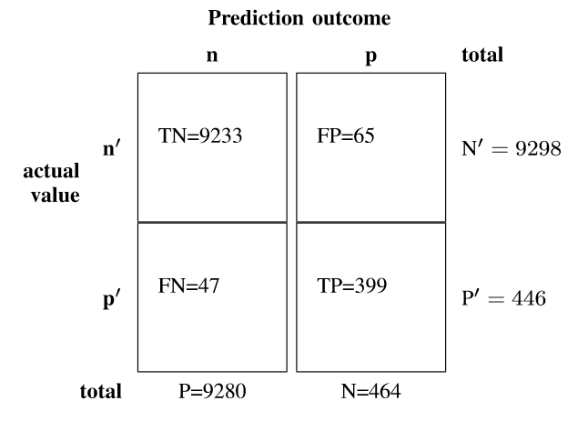

**Figure 5.4:** Confusion matrix of Nodule detection

From the confusion matrix, 9233 non-nodules were correctly predicted to be non-nodule out of 9298 non-nodules. 65 non-nodules were wrongly predicted.

399 nodules were predicted correctly out of the total 446 nodules. 47 nodules were predicted incorrectly.

**The precision and recall obtained is 89.46% and 85.99% respectively**. The trained network on LUNA16 dataset is prone to False Positive prediction.Figure 5.5 depicts small white circle which is lung nodules detected after feeding those CT scan slices to 3D CNN.

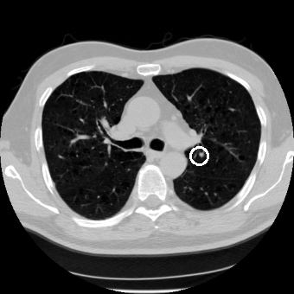 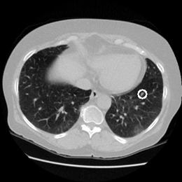

**Figure 5.5:** Nodules detected by the nodule detector on a 2D slice of CT scan. The nodule detected is encircled in a white circle.

**5.4 Predicting Nodules in Kaggle dataset**

The nodule detector CNN model obtained before is now used to detect nodules on the Kaggle dataset and after that the predicted nodules will be used for training a model to predict whether it is cancerous or not. Since the nodule detector predicted nodules in cubes of size ***32mm×32mm×32mm***, the nodule detector is run through the whole 3D CT scan assuming it to be a grid made of cubes with strides of 12mm. The 12mm stride ensures that whole nodule is covered in any one of the cubes that go through the CT scan. If the probability of nodule is greater than a threshold ***(0.6)***, it is classified to be a nodule, otherwise not.

The whole 3D CT scan cube is divided into small cube of 32x32x32 size. Each of these cube is passed through the trained model of Nodule detector neural network. The predicted nodule coordinates (center of the cube in which the nodule is found) is saved for each CT scan. Thus, for each patient, coordinates of the nodules are predicted. This is used to make cancer predictions.

Thus, now all the lung nodules are detected with their x,y and z coordinates . Finally a final 3D convolution neural network is trained for cancer detection. Before actually feeding the small cube containing lung nodules certain image processing needs to be performed in order to reduce noise level. Preprocessing is actually the segmentation of CT scan.

**Chapter 6**

**Training the 3D CNN for Cancer Detection**

Before training CNN, certain pre-processing of data is required to have a clear image of CT scan used for cancer detection. So image processing is being done to create a mask for CT scan which will be free from all types of noise. Morphological concept is used for image processing.

**6.1 Morphological Operations**

Morphological operations are non-linear operations related to shape of features in an image. Pixel ordering changes in these operations. They are applied to grayscale and binary images and absolute values of pixels are of no interest. Some of the common operations are erosion, dilation, opening and closing operation.

***Dilation/Erosion:***

Assume A to be an input image and B is a structuring elements used to process A. Thus, dilation equation can be given by:



Properties of dilation are:

* Dilation increases size of objects by filling holes and connecting broken areas smaller than size of structuring elements.
* In binary images, it adds pixels to the perimeter of each object in the image.

Erosion equation is given by:



On applying the equation A shrinks. Properties of erosion are:

* This is the opposite of dilation. It shrinks the objects in an image and remove anomalies less than the size of structuring element.
* Erosion removes perimeter pixels of each object in the binary image.

Figure 6.1 gives the brief demonstration of erosion and dilation operation.

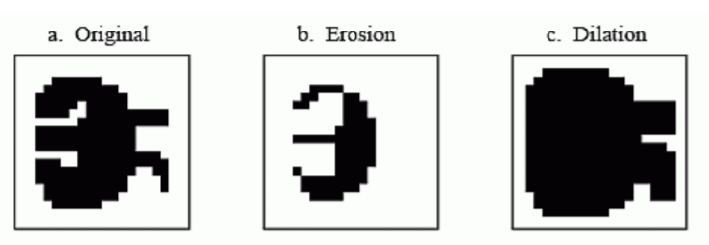

**Figure 6.1:** Morphological operations

**Opening/Closing:**

Opening and closing operations are a combination of erosion and dilation. Opening will smooth the edges and remove small protrusions from a reference image. Closing will smooth edges but as well as join narrow blocks and fill in holes.

Opening:

bbbbbbbbbbb

Closing:

bbbbbbbbbbb

The opening of A is the erosion of A by B and then that image dilated by B. The closing of A is the dilation of A by B and then eroded by B. Opening and closing are dual of each other.

Figure 6.2 depicts opening and closing result in an input image.

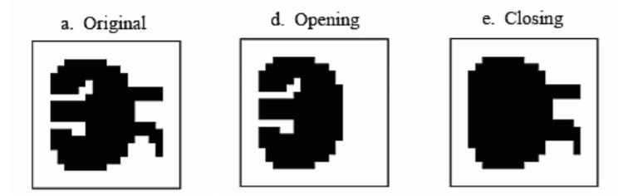

**Figure 6.2:** Opening and closing results

**6.2 Segmentation of CT scan**

Segmentation divides an image into different regions with each region containing pixels of similar attributes. Segmentation makes images more meaningful and easier to analyze. The segmentation of lungs is an important step because the region of interests lies inside the lungs. The main task is to create a mask to separate the lung region from the other areas of the image. The segmentation used has the following steps in figure 6.3:

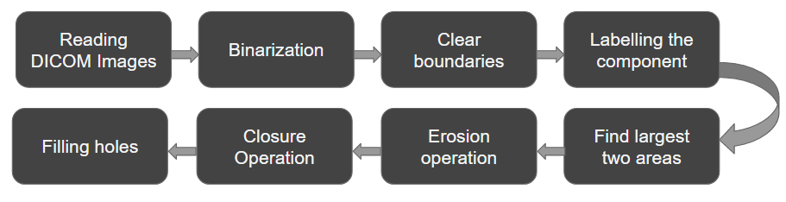

**Figure 6.3:** Summary of Segmentation

1. ***Binarization:*** The ﬁrst step of segmentation is binarization. Binarization is the process of converting an image to a binary image. First the image is converted to grayscale. An important task of this step is to select the threshold for binarization. It is found that Radiodensity(HU) for lung tissue is -500. So, a value of *604(-400 HU)* is used as a threshold to separate lung First item tissue from others. The Radiodensity(HU) of different materials are given in table 6.1.

|  |  |
| --- | --- |
| **Substance** | **Radiodensity (HU)** |
| Air  Lung Tissue  Water and Blood  Bone | -1000  -500  0  700 |

**Table 6.1:** Radiodensity of various substances[10]

1. ***Clear Border:*** The next step is to remove the blobs connected to the boundary of the lungs. This is done using clear border. Clear border removes structures that are lighter than their surroundings and that are connected to the image border.
2. ***Labelling the Image***: The next step is to label the image. A connected component in a binary image is a set of pixels that form a connected group. All the different connected components are assigned different labels. After labelling the labels with the two largest areas are kept.
3. ***Erosion:*** The next step is to perform erosion. Erosion is one of the popular techniques of morphological image processing. It is typically applied on binary images. The basic effect of the operator on a binary image is to erode away the boundaries of regions of foreground pixels (i.e. white pixels, typically). Thus, areas of foreground pixels shrink in size, and holes within those areas become larger. This step is important because it separates the lung nodules from the blood vessels. The structuring used in erosion operation is a disc of radius 2. Mathematical erosion operation is shown in Figure 6.4.

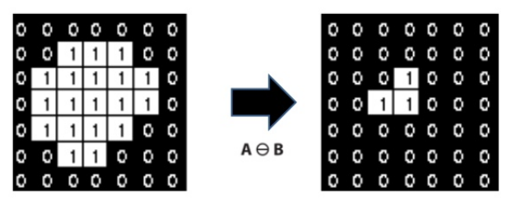

**Figure 6.4:** Erosion operation erodes the boundary

1. ***Closure Operation:*** The next operation is a Closing operation which is a dilation followed by an erosion. The basic effect of dilation on a binary image is to gradually enlarge the boundaries of regions of foreground pixels (i.e. white pixels, typically). Closing ﬁlls holes in the regions while keeping the initial region sizes. This step is done to keep the blobs connected to the walls of the lungs. The structuring elements used in this case is a disk of radius 10. Mathematical closure operation is shown in Figure 6.5.

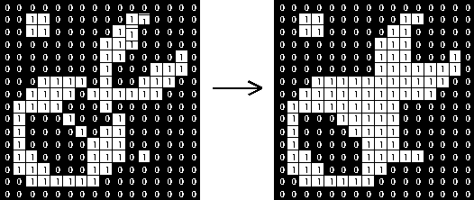

**Figure 6.5:** Small holes removal by Closure operation

1. ***Filling Holes:*** The next step is to ﬁll the holes inside the binary mask of lungs.

Figure 6.6 shows the stepwise demonstration of Segmentation of CT Scan.

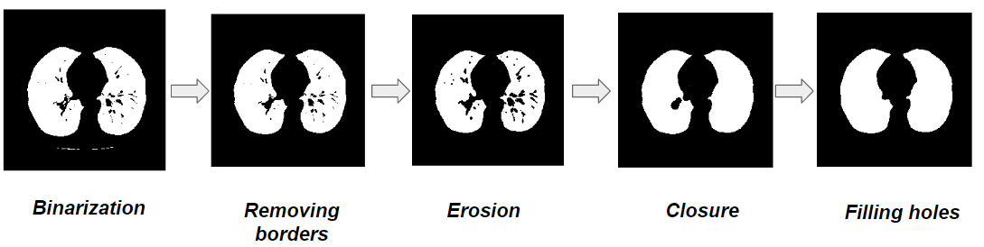

**Figure 6.6:** Pictorial representation of Segmentation

The Figure 6.7 shows original CT scan images and their corresponding masks obtained after segmentation.

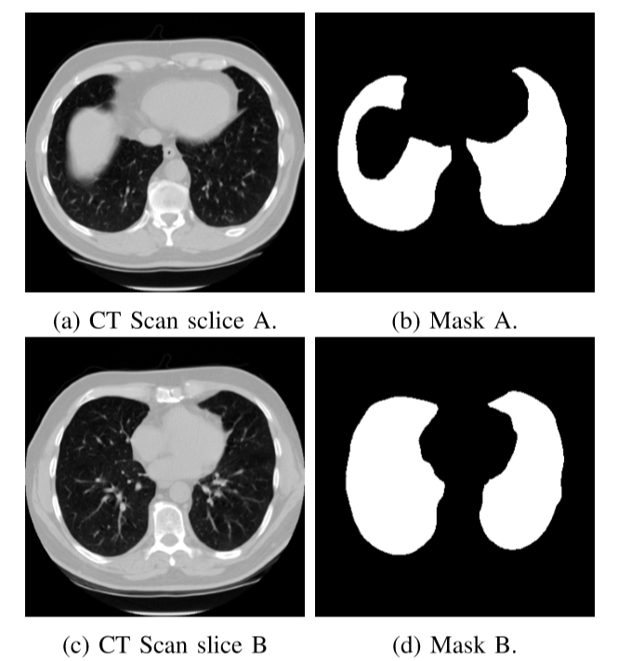

**Figure 6.7:** Original and its mask

The mask obtained in the previous step is multiplied with original CT Image for all the slices of the CT scan. Figure 6.8 shows the original image and image after applying mask on a slice.

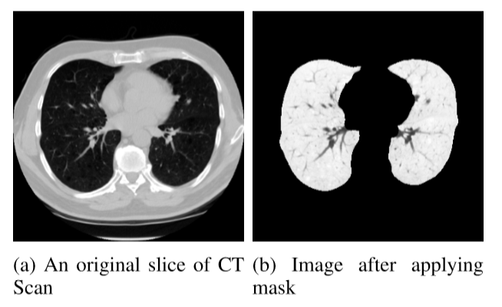

**Figure 6.8:** Application of mask on Lung CT Scan

**6.3 Making of Training Dataset for Cancer Detection**

The coordinates that were saved after nodule detection are taken as center and training cubes of size 32mm×32mm× 32mm are extracted from the images obtained after applying the masks. Figure 6.9 shows two such training cubes of size 64mm×64mm×64mm with slices along z-axis represented on a grid on images.

Since the nodule detector has high probability of False Positive prediction, the predicted nodules for each patient are arranged in descending order according to probability of nodule and take the top four nodules in the dataset. 3,569,608 and 608 nodules are used for training, validation and test respectively.

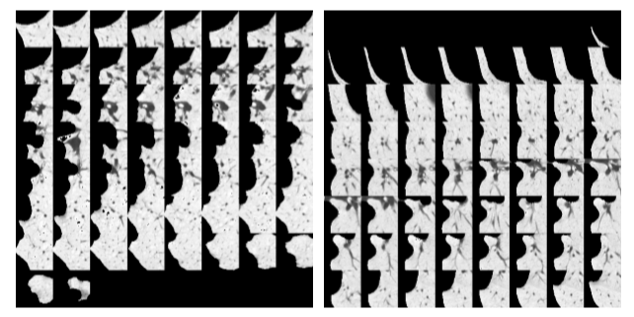

**Figure 6.9:** Two 64mm × 64mm × 64mm cubes cropped out from the segmented image with the predicted coordinate as center. The slices along z axis are represented as a grid image. The white portion corresponds to lung walls.

**6.4 Training for Cancer Detection**

The model for detection of cancer is another 3D CNN. The loss function used is Binary Cross entropy and the metric used for evaluation is Binary Accuracy. The optimizer used is an Adam Optimizer with *Learning Rate* ***0.0001***. The model is trained for ***12 epochs***.The model is smaller in size to prevent overﬁtting as the Kaggle dataset is small in size. The architecture of the model is shown in Figure 6.10 and the detailed description is given in Table 6.2 .

|  |  |  |  |
| --- | --- | --- | --- |
| **Layer** | **Parameter** | **Activation** | **Output** |
| Input  Average Pool  3D Convolutional  Max Pooling  3D Convolutional  Max Pooling  3D Convolutional  Max Pooling  3D Convolutional  3D Convolutional | 2x1x1  3x3x3  1x2x2  3x3x3  2x2x2  3x3x3  2x2x2  3x3x3  3x3x3 | relu  relu  relu  relu  sigmoid | 32x32x32 , 1  16x32x32 , 1 filter  16x32x32 , 32 filters  16x16x16 , 32 filters  16x16x16 , 32 filters  8x8x8 , 32 filters  8x8x8 , 32 filters  4x4x4 , 32 filters  2x2x2 , 32 filters  1x1x1, 1 |

**Table 6.2:** Cancer Detection 3D CNN Layers

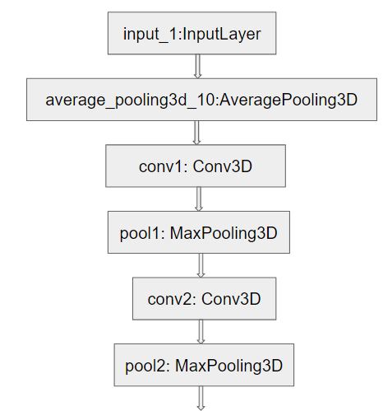

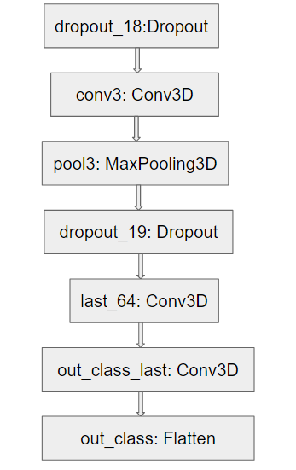

**Figure 6.10:** Architecture of the 3D CNN for cancer detection

**Chapter 7**

**Result**

The model was tested on a test set containing 608 nodules. It is found that the number of observations that are sampled in each iteration, the size of the so-called minibatch, effects the performance of the model. Different mini-batch sizes 8,16,32,64 were tried, out of which minibatch size 16 performed best. Initially training with 30 epochs resulted in validation loss increasing after iterations around 10 indicating overﬁtting. So, after testing with different total number of epochs around 10, it was found that 12 as number of epochs works the best. Different ﬁlter sizes were tried and it was found that a 2 × 2 × 2 for Max Pooling and 3 × 3 × 3 for Convolutional layer works the best. A very low learning rate and low number of ﬁlters for each layer also helped reduce overﬁtting. The results suggest that the architecture of CNN that is used is one of the optimal architecture for this task. The plot of loss function versus epoch and accuracy versus epoch for training and validation set are given in the Figure 7.2 and Figure 7.3 respectively. The confusion matrix is shown in the Figure 7.1. The performance of the system gives satisfactory results and the **precision** and **recall** of the model are **89.24%** and **82.17%** respectively.

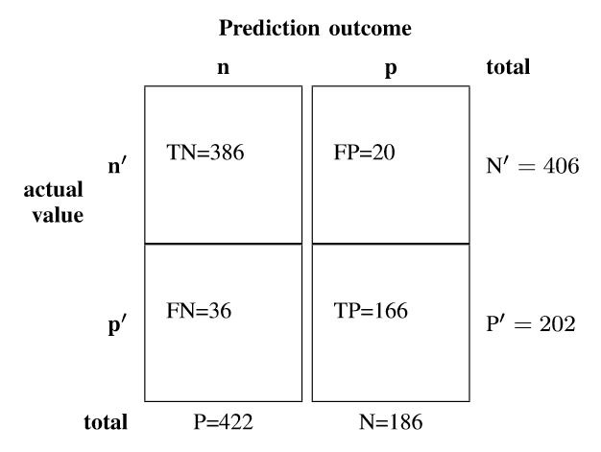

**Figure 7.1:** Confusion matrix for Cancer Detection

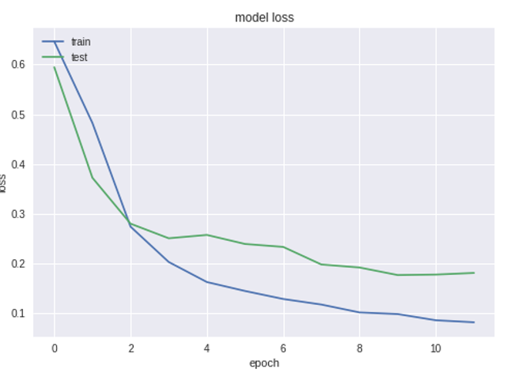

**Figure 7.2:** Plot of loss function versus epoch for cancer detection.

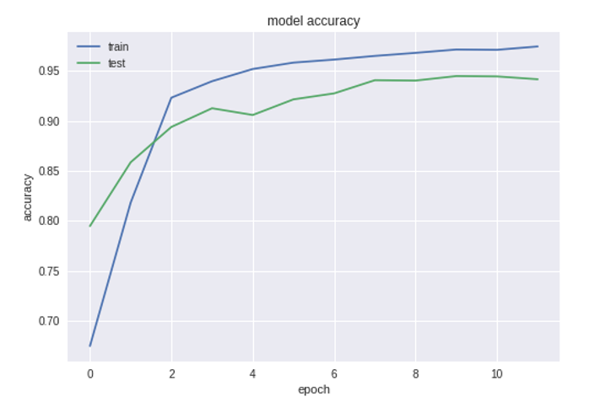

**Figure 7.3:** Plot of accuracy versus epoch for cancer detection.

From the above graph it is noticed that as the neural network learns or in order words when it is trained initially the loss is very high because of no prior knowledge but as the number of epoch increases, the network gradually starts learning and thus loss increases and gain increases.

**Chapter 8**

**Conclusions and Future Scope**

**8.1 Conclusion**

Lung Cancer is very dangerous and just stops a person’s survival. If it is detected at early stage, then it can save someone’s life. The project’s aim is to detect lung cancer and it has been successfully completed with good precision and recall. Two different types of convolutional neural network has been used out of which one is used for nodule detection and other one for cancer detection. The neural network is a combination of U-net and AlexNet Convolutional network. These networks are majorly used for biomedical segmentation. Hence this is a new approach for lung cancer detection. The model is not only able to detect cancer but also to find its location in the lungs. The white marks generally corresponds to lung nodules. Training the neural network takes time around 8 hours with NVIDIA K80 GPU on Keras with Tensorflow backend. The model can be run on any system like computers , mobiles, tablets, etc which can support Tensorflow. To test a new CT scan, nodule detector takes around one minute to run through all the cubes in the lung CT Scan. After that the testing for presence of cancer takes a few seconds. So the model performs well with decent precision and recall. The few drawbacks are the susceptibility to false positive detection in nodule detector and less accurate detection nodules of size less than 3 mm. These can be improved if the network is trained with more of such data.

**8.2 Future Scope**

The cancer detection model is able to detect nodules which are larger than 3mm only. This can be improved if the network is trained using dataset containing nodules less than 3mm diameter. Another one is to use segmentation algorithms to detect nodules in 2D slices and extract features from them which could be then run on some strong and robust algorithms such as XGBoost. The results from this new 2D detection model and the 3D detection model can be ensembled to give better predictions. The model parameters were saved at the best validation binary crossentropy. More models can be trained on other metrics such as AUC and the results can be ensembled. The trained weights of the model can also be extended to other cancer detection problems such as Brain cancer, Liver cancer using Transfer Learning. Other popular neural network architectures such as ResNet, VCG16, VCG19, etc. can also be used . The already available weights of these networks might be useful for doing transfer learning if out computation power is low.

**Literature Cited**

[1] Lung cancer stats, https://www.medicinenet.com/lung_cancer/article.htm# how_common_is_lung_cancer

[2] Chemicals in Cigarette, [https://en.wikipedia.org/wiki/List_of_cigarette_ smoke _ carcinogens](https://en.wikipedia.org/wiki/List_of_cigarette_%20smoke%20_%20carcinogens)

[3] Causes of lung cancer, [http://blogs.nature.com/ ofschemesandmemes /2014/09/11/the-big-issues-affecting-lung-cancer-worldwide](http://blogs.nature.com/%20ofschemesandmemes%20/2014/09/11/the-big-issues-affecting-lung-cancer-worldwide)

[4]Stages of Lung Cancer, <http://www.beaconhospital.com.my/lung-cancer/>

[5] [Md. B. A. Miah](http://ieeexplore.ieee.org/search/searchresult.jsp?searchWithin=%22Authors%22:.QT.Md.%20Badrul%20Alam%20Miah.QT.&newsearch=true), “Detection of lung cancer from CT image using image processing and neural network”, *Electrical Engineering and Information Communication Technology (ICEEICT),* 2015

[6] Ada, “Early Detection and Prediction of Lung Cancer Survival using Neural Network Classifier”, *International Journal of Application or Innovation in Engineering and Management (IJAIEM)*, 2013

[7] S. A. Diwedi, “Lung Cancer Detection and Classification by using Machine Learning and Multinomial Bayesian”, *IOSR Journal of Electronics and Communication Engineering* in the, 2014

[8] B. Gupta, “Lung Cancer Detection using Curvelet Transform and Neural Network”, *International Journal of Computer Applications*, 2014

[9] F. Taher, “Lung cancer detection by using artificial neural network and fuzzy clustering methods”, *GCC Conference and Exhibition*, 2011

[10] A. Chon, “Deep Convolutional Neural Network for Cancer Detection”, *Stanford University*

[11] Sasidhar B, “[Automated Segmentation of Lung Regions using Morphological Operators in CT scan”,](https://www.ijser.org/onlineResearchPaperViewer.aspx?Automated-Segmentation-of-Lung-Regions-using-Morphological-Operators-in-CT-scan.pdf) *[International Journal Of Scientific and Engineering Research , (IJSER)](https://www.ijser.org/onlineResearchPaperViewer.aspx?Automated-Segmentation-of-Lung-Regions-using-Morphological-Operators-in-CT-scan.pdf)* [, 2013](https://www.ijser.org/onlineResearchPaperViewer.aspx?Automated-Segmentation-of-Lung-Regions-using-Morphological-Operators-in-CT-scan.pdf)

**Acknowledgement**

We consider it as a great privilege to express our deep gratitude to many respected personalities who guided, inspired and helped us in the successful completion of our project.

We would like to express my deepest gratitude to our guide **Prof. Dr.C.B.Rama Rao,** Professor, Department of Electronics and Communication Engineering, National Institute of Technology, Warangal, for his constant supervision, guidance, suggestions and invaluable encouragement during this project. We also express sincere thanks to **Dr.N.Bheema Rao,** Head of the Department for all cooperation in carrying out the work at the Institute.

We are grateful to the **Sri.K.V.Sridhar** for his constant guidance throughout the project.

We are very thankful to **Project Evaluation Committee** for their strenuous efforts to evaluate the projects.

We wish to thank all the staff members in the department for their kind cooperation and support given throughout the project work. We are also thankful to all of my friends who have given valuable suggestions and help in all stages of the development of the project.

Aarti Barai-144109

M.Bikramjit Khumancha-144129

Thotakura Saichand-134158

