**System Design:**

**Design for Welcome Page:**

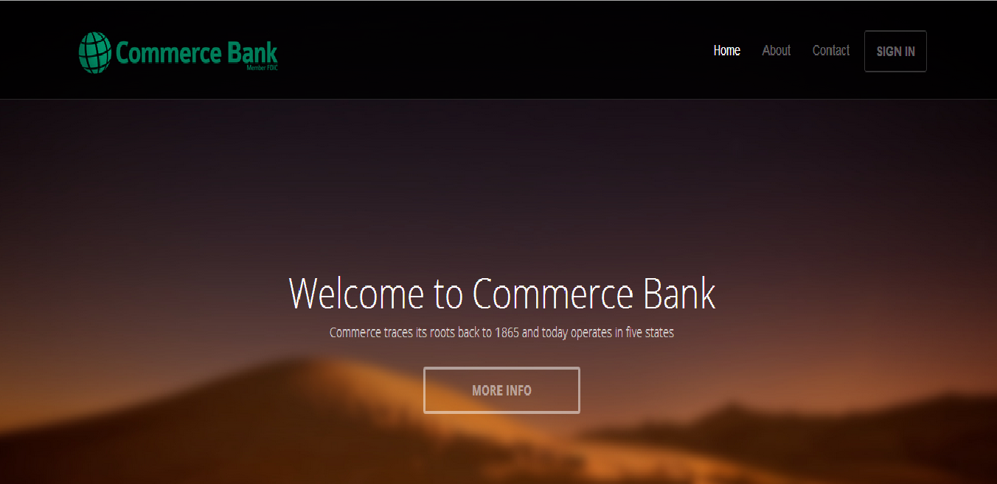

This is the welcome home page and is seen as soon as the application begins. This page contains all the basic features, like About - to know more about the bank, Contact - to contact the bank, Sign in - for signing in and carry out various operations.

**Design for Sign in:**

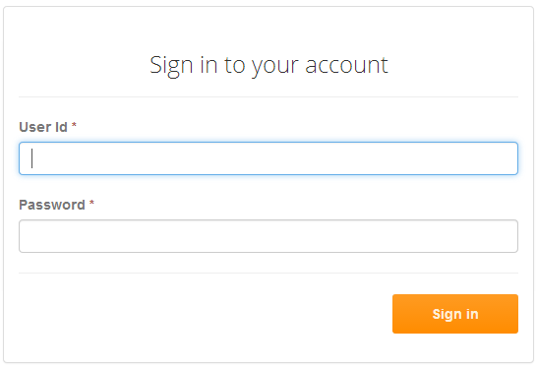

As soon as the user clicks on the Sign in, this page comes up and the user would have to enter the User_Id and the Password. There are two types of users we would be dealing with: Admin and Customers. Depending on the access permissions, the user would be directed to the appropriate page - the Admin to the Admin Page that would have all the operations that would be carried out by the Admin and the Customer to the Customer Page having all operations for the Customers.

Fields:

1. User Id: User_Id of the user.

2. Password: Password of the user.

**Design for Admin module:**

1. **Admin Welcome Page:**

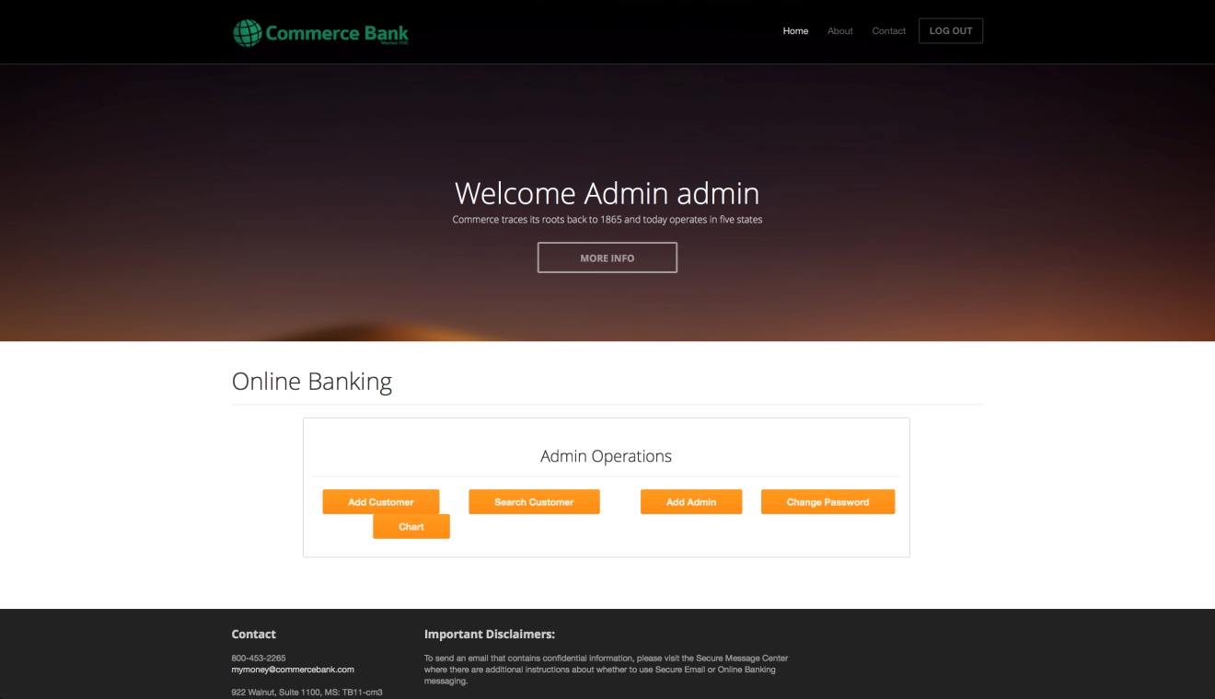

This page is displayed as soon as admin logs in using his user id and password. This page contains all the operations that are supported for admin. It includes following operations:

1. Add customer.

2. Search customer.

a. Search by name.

b. Search by SSN.

c. Search by phone number.

d. Search by customer id.

3. View transaction chart.

4. Add admin.

5. Change password.

1. **Add Customer:**

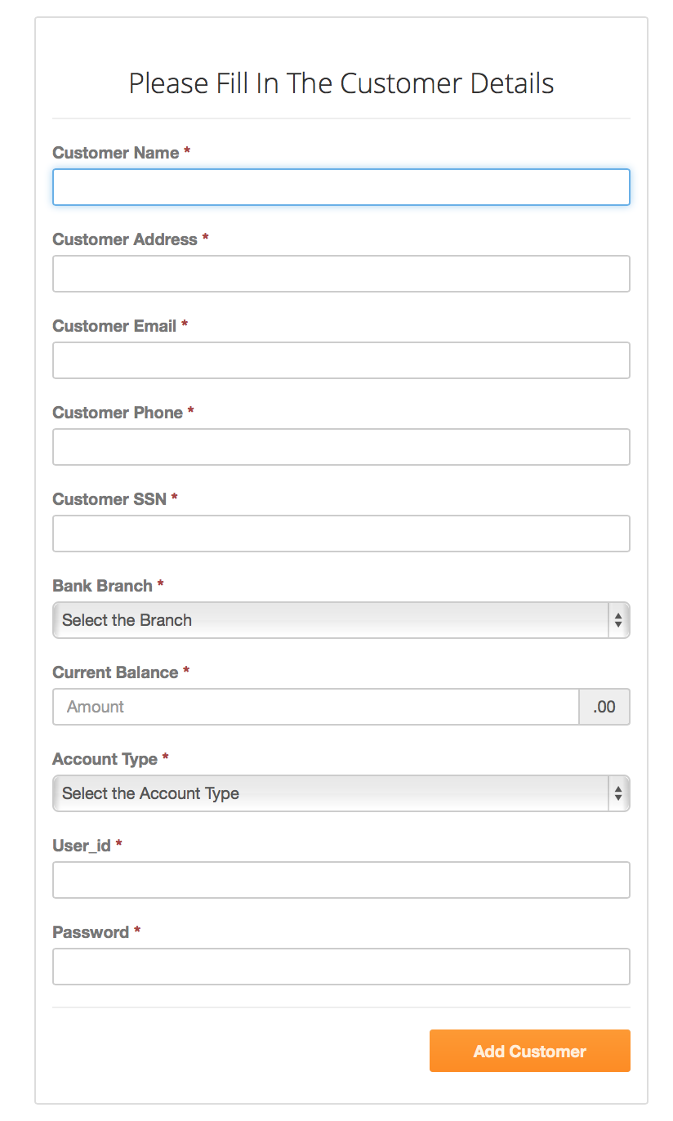

As soon as admin click on add customer this form is displayed. When admin fills all the fields in this form and click on add customer then the customer is added into the system.

Fields:

1. Customer Name: Name of the customer.
2. Customer Address: Address of the customer.
3. Customer Email: Email address of the customer.
4. Customer Phone: Phone number of the customer.
5. Customer SSN: SSN of the customer.
6. Bank Branch: Branch in which customer is to be added.
7. Current Balance: Opening balance for this customer.
8. Account Type: Account type for customer (checkings/savings).
9. User_ID: User_id that the customer will use to log in to the system.
10. Password: Password that customer will use to log in to the system.
11. **Search Customer:**

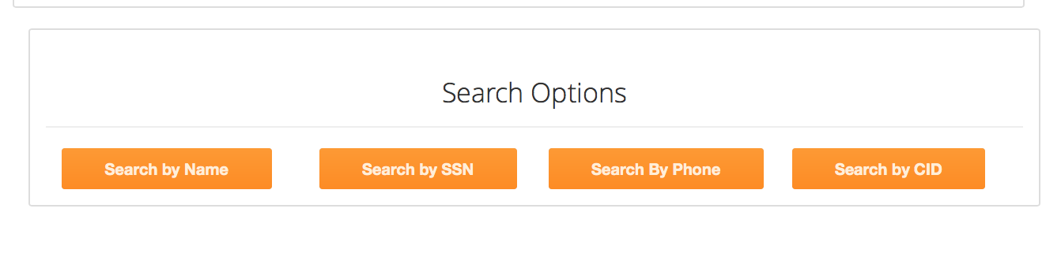

When admin clicks on search customer this page will be displayed. This page in turn has four options for searching a customer.

1. **Search by Name**

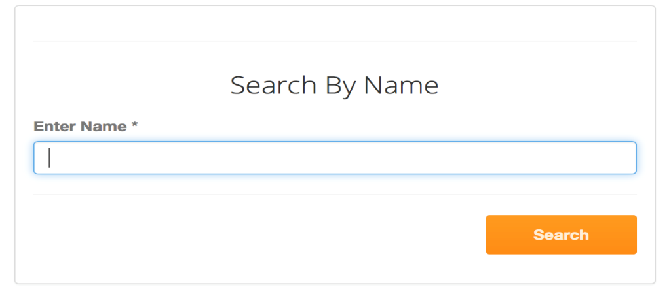

As soon as the admin clicks on search by name this form is displayed. Here admin can enter the name and click on search. System will then look for customers with matching names and then will display the results in tabular format.

1. **Search by SSN**

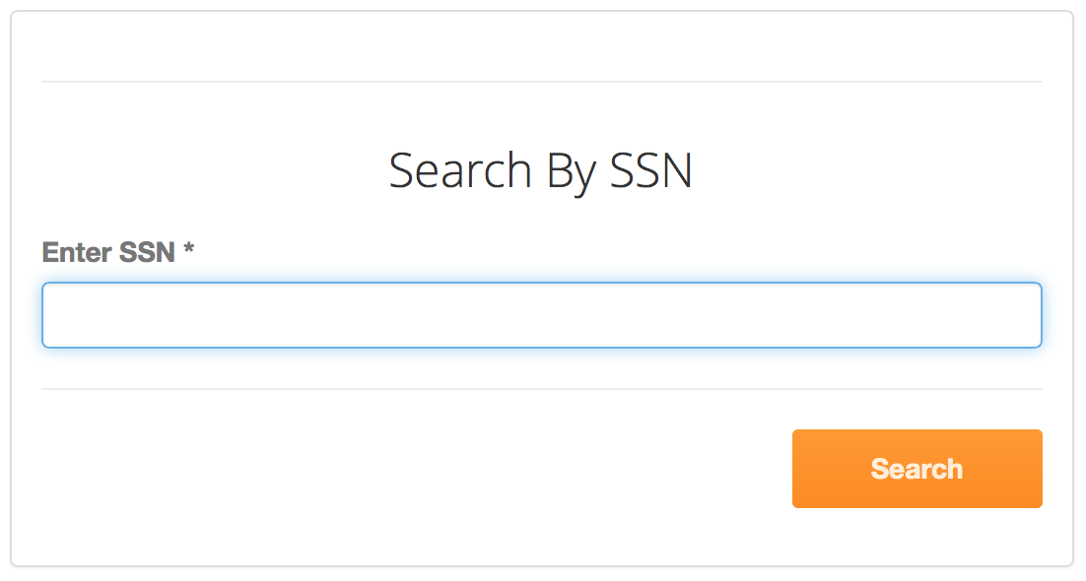

As soon as the admin clicks on search by SSN this form is displayed. Here admin can enter the SSN and click on search. System will then look for customers with matching SSN and then will display the results in tabular format.

1. **Search by Phone**

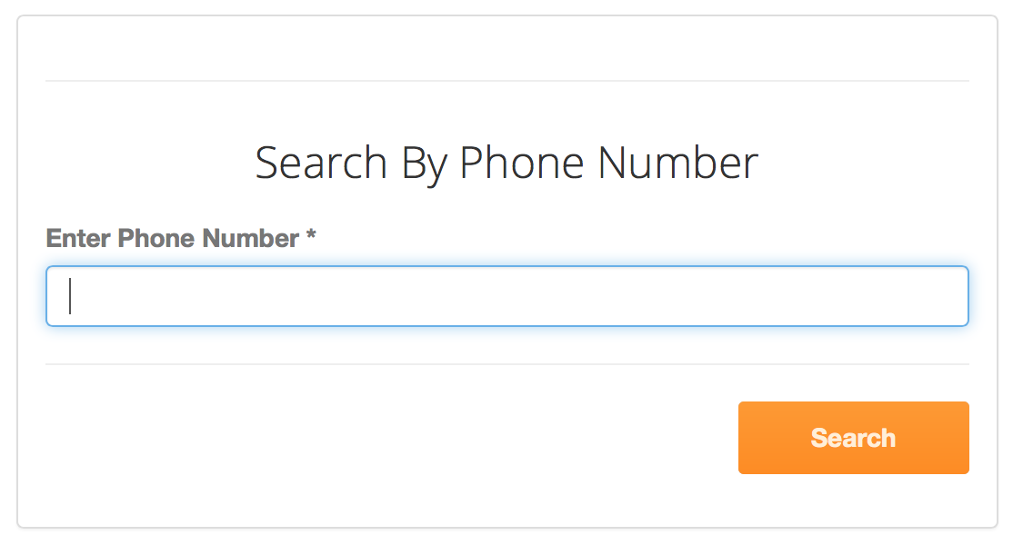

As soon as the admin clicks on search by phone this form is displayed. Here admin can enter the phone number and click on search. System will then look for customers with matching phone number and then will display the results in tabular format.

1. **Search by Customer Id**

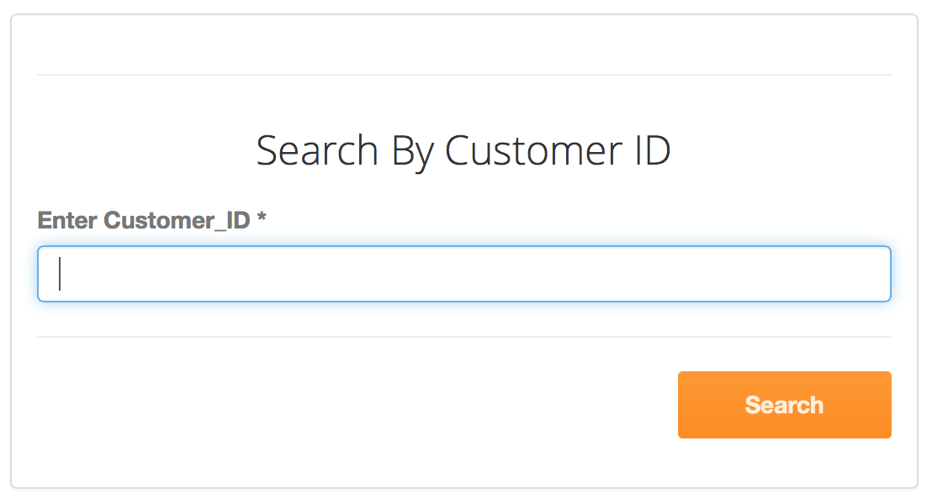

As soon as the admin clicks on search by customer id this form is displayed. Here admin can enter the customer id and click on search. System will then look for customers with matching customer id and then will display the results in tabular format.

The output of all the above search techniques will be displayed as the following form.

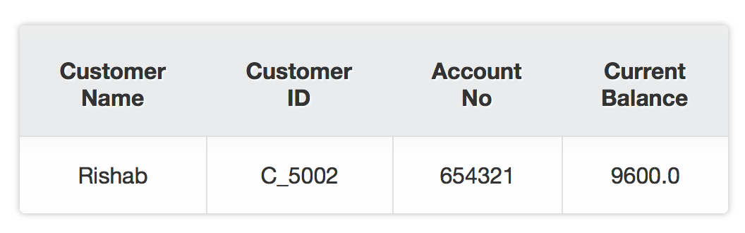

1. **View Transaction Chart:**

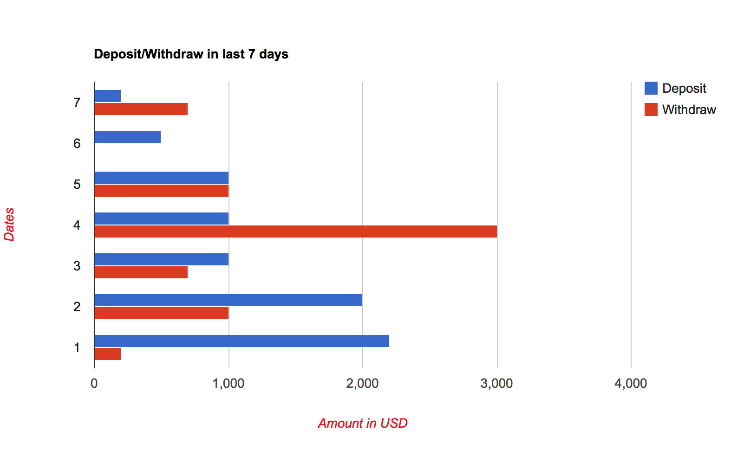

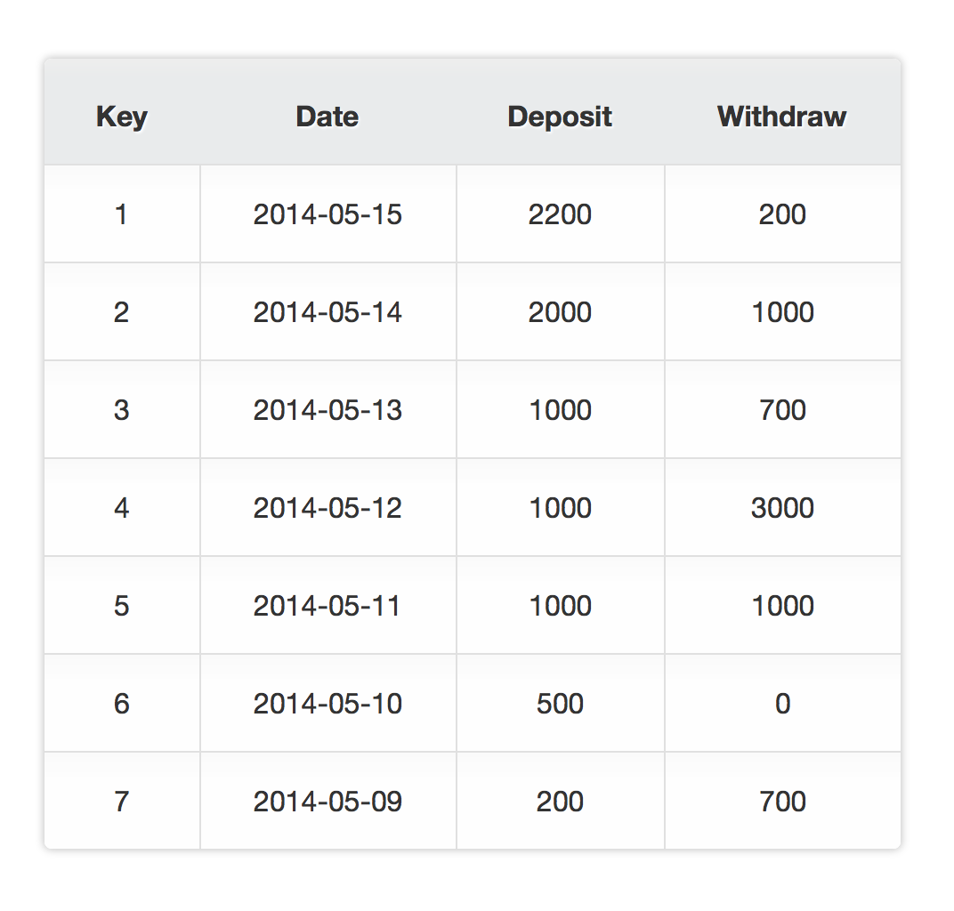

As soon as the admin clicks on view transaction chart this form is displayed. This form contains a bar chart that shows the amount corresponding to deposit and withdrawal in the last 7 days. This form also consists of a table that contains information about the dates and the amount corresponding to deposit and withdrawal on that date.

1. **Add Admin:**

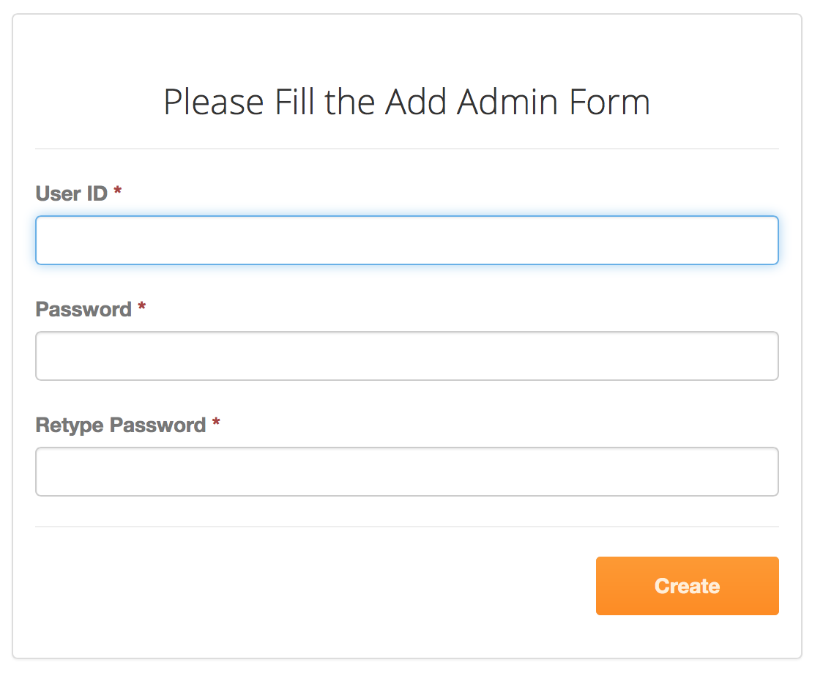

As soon as admin click on add admin this form is displayed. When admin fills all the fields in this form and click on create then the admin is added into the system.

Fields:

1. User_Id: User_Id for new admin.
2. Password: Password for new admin.
3. Retype Password: Retype password just for security.
4. **Change Password:**

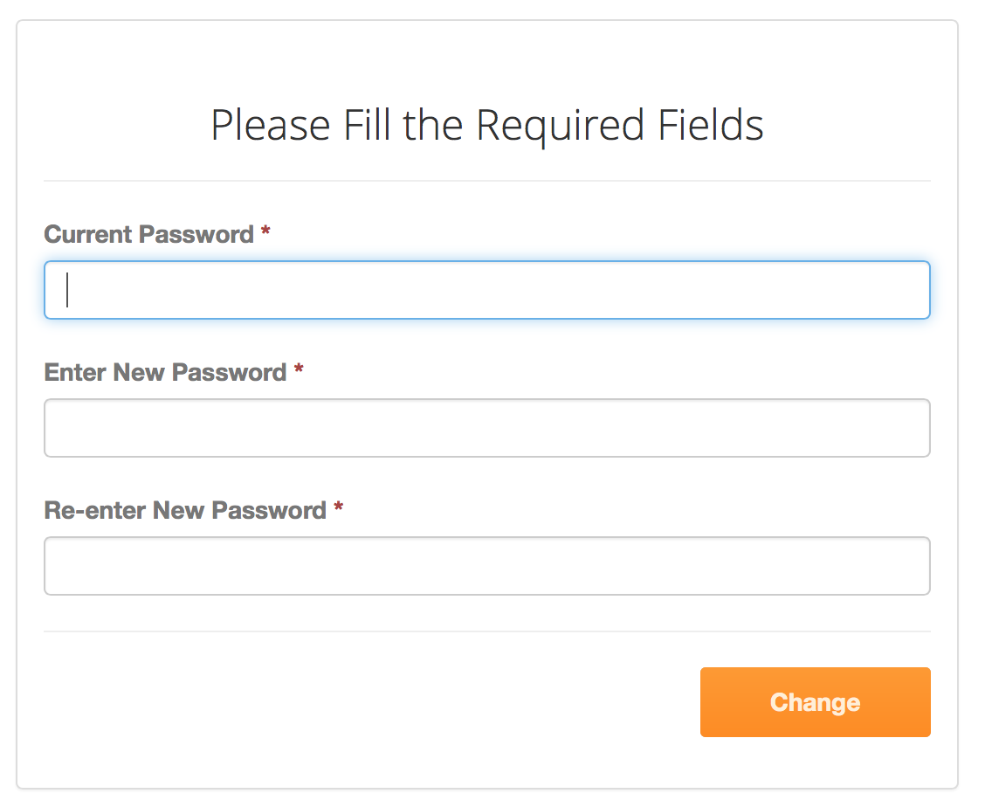

As soon as admin clicks on change password this form is displayed. When admin enters the required fields and click on change then the password for that admin is changed.

Fields:

1. Current Password: Current password for admin.
2. New Password: New password for admin.
3. Retype New Password: Retype new password just for security.

**Design for Customer Module:**

1. **Customer Welcome Page:**

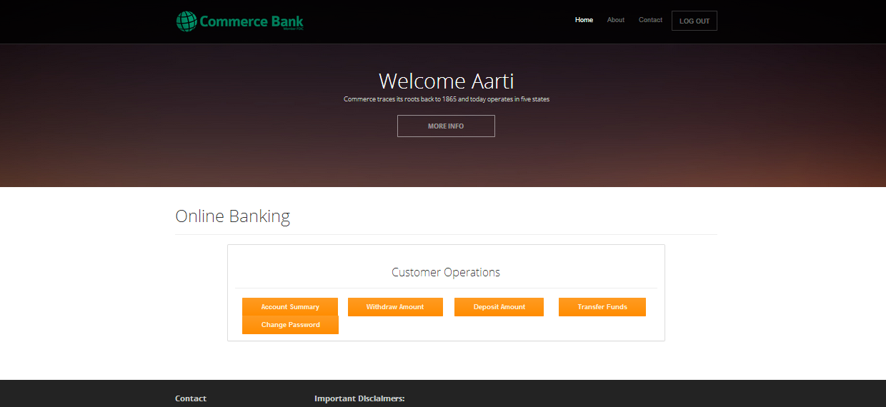

This page is displayed as soon as the Customer signs in using his user_id and password. This page contains all the operations that are supported for customers. It includes the following operations:

1. Account Summary

2. Withdraw Amount

3. Deposit Amount

4. Transfer Funds

5. Change Password

6. View Statement

1. **Account Summary:**

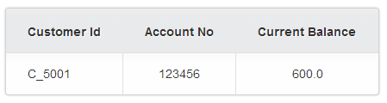

As soon as the customer selects the Account Summary, the details about his account - Customer id, Account number and the Current Balance would be displayed.

1. **Withdraw Amount:**

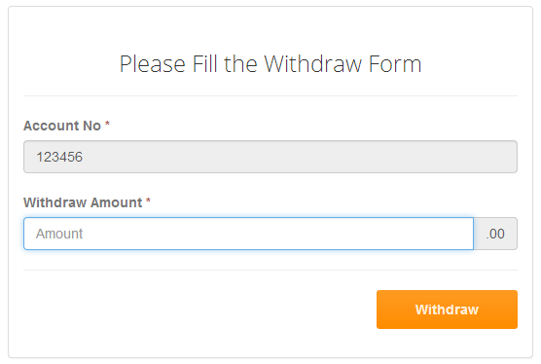

As soon as the customer clicks on the Withdraw Amount, the above form is displayed. The Account number is set to be read-only, so the customer would just have to enter the amount to be withdrawn. If the withdrawal transaction is successful, the following page would appear.

Fields:

1. Withdraw Amount: The amount to be withdrawn
2. Account No: The account number of the customer (read-only)

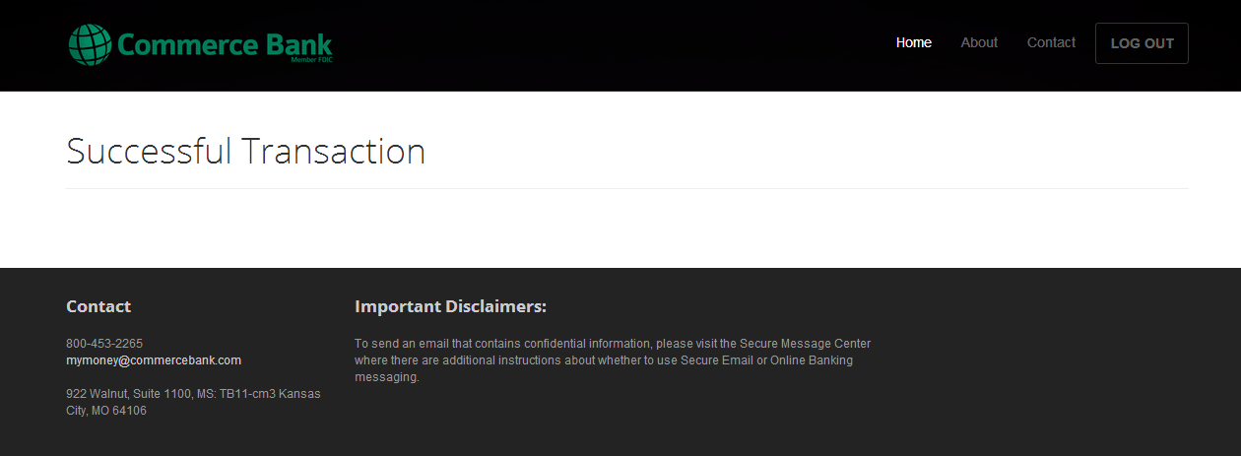

If the customer's account doesn’t have sufficient funds, that is, if the withdrawal amount exceeds the limit (current balance), then the transaction would fail and the customer would get the following page.

1. **Deposit Amount:**

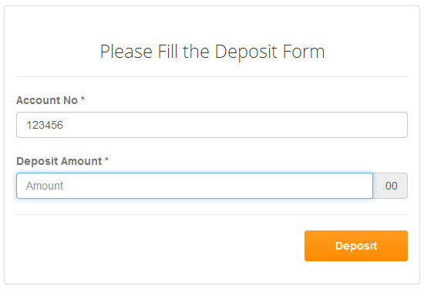

As soon as the customer clicks on the Deposit Amount, the above form is displayed. The Account number is set to be read-only, so the customer would just have to enter the amount to be deposited. If the deposit transaction is successful, they would be directed to the success page.

Fields:

1. Deposit Amount: The amount to be deposited
2. Account No: The account number of the customer (read-only)
3. **Transfer Funds:**

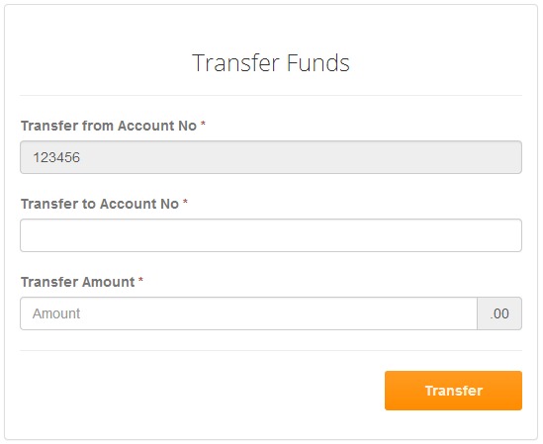

As soon as the customer clicks on the Transfer Funds, the above form is displayed. The Transfer from Account number is set to be read-only, so the customer would have to enter the account number to which he wants to transfer, Transfer to Account number, and the amount that has to be transferred. If the transfer transaction is successful, the customer would be directed to the success page. Otherwise, the following page would appear.

Fields:

1. Transfer from Account No: The account number from which the money is being transferred (read-only)
2. Transfer to Account No: The account number to which the money is being transferred to
3. Withdraw Amount: The amount to be withdrawn
4. **View Statement:**

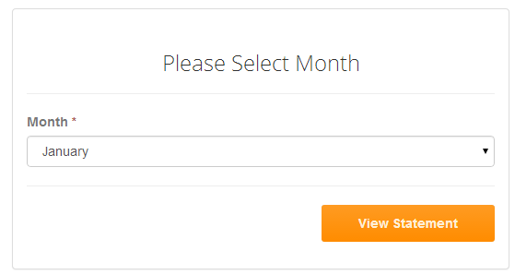

As soon as the customer clicks on view statement, the above form is displayed. The customer would just have to select the required month for which he wants to view the statement.

Fields:

1. Month: The month for which the statement has to be generated.

