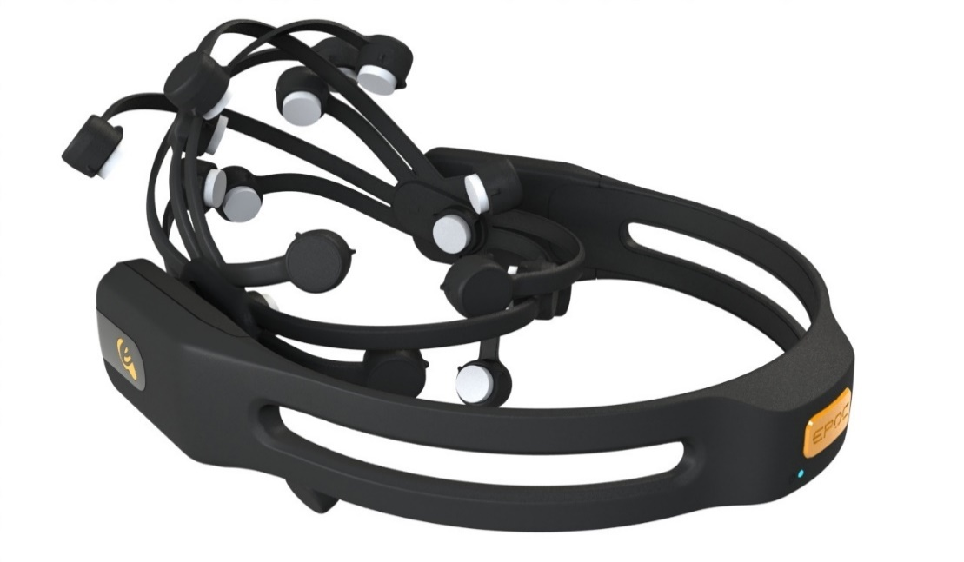**BRAIN CONTROL**

**Mentored By: Team Members:**

Mr. Shatrughan Modi Ansh Arora (101503039)

(Computer Science Department) Akhil Gupta (101553002)

Arshjot Kaur (101503046) Aarti Sharma (101683032)



**Table of Contents**

|  |  |  |
| --- | --- | --- |
| Serial Number | Particulars | Page No. |
| 1 | Mentor Consent Form | 3 |
| 2 | Project Overview | 4 |
| 3 | Need Analysis | 5 |
| 4 | Literature Survey | 6 |
| 5 | Objectives | 12 |
| 6 | Project Execution Plan | 13 |
| 7 | Work Plan | 15 |
| 8 | Project Outcomes | 16 |
| 9 | Individual Roles | 17 |
| 11 | Course Subjects | 18 |
| 12 | References | 19 |

1. **Mentor Consent Form**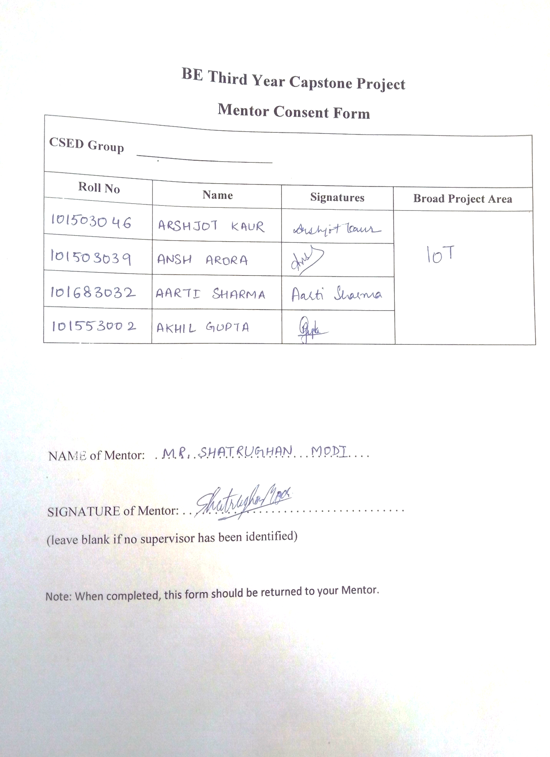
2. **Project Overview**

Today the world has become easier than our ancestors could ever think of. We’ve remote controls for televisions, air conditioners or for that matter, pretty much any electronic device. We have the concept of self-driving cars rising up with several companies already at the brink of launching their first models. Our homes have become smarter, for instance, the room’s light can be controlled by an app or even better, it could automatically switch on detecting your presence.

Moving forward with the same idea, we introduce to you, Superhuman. Fundamentally, you can visualize it as a new technique for controlling things. Till date, you had to move your muscles to do anything whether it be switching on the TV, changing AC temperatures, driving cars or as simple as switching on the lights. With this, you need not move your fingers. Just think and ZAP the work’s done.

Going a bit deeper, we’ll make use of the fact that every thought in our mind is accompanied by racing neurons across the head’s surface. These neurons lead to different points of our scalp being at slightly different potentials and hence potential differences are born. With an EEG (electroencephalography) device we measure this difference. We amplify the signals, cut out the uncalled-for noise and rule out the discrepancies.

Electroencephalography (EEG) is an electrophysiological monitoring method to record electrical activity of the brain. It is typically noninvasive, with the electrodes placed along the scalp.

EEG measures voltage fluctuations resulting from ionic current within the neurons of the brain. In clinical contexts, EEG refers to the recording of the brain's spontaneous electrical activity over a period of time, as recorded from multiple electrodes placed on the scalp.

After getting our data, we train our model on the gathered data to perform a variety of tasks which is only bounded by one’s creativity.

1. **Need Analysis**
2. The world is running faster than ever imagined. People are in a constant haste. Time is becoming as crucial an entity as money. From top businesses to a common man, everyone wants to save time. And our project aims to do exactly what they want by replacing the need to move, for things like controlling lights or fans.
3. Secondly, since, things would be controlled by brain, it would reduce the dependence of *day to day chores* on limbs. So, people with physical disabilities will no longer be dependent on others for fulfilling basic requirements. So, for example, a man with no hands can switch on or off lights of his/her room without calling out for help. A person with problems in walking, would no longer need to rely on someone else for steering his wheelchair.
4. Yet another case where it can be used is in vehicles. The device can detect when the driver is about to doze off and can warn him/her by sounding alarms or flashing lights thus preventing about 1/5th of all road accidents.
5. Apart from improving lifestyles, this can also be used for leisure activities like gaming. An EEG system could prompt a video game character to move forward on a screen if electrodes pick up brain wave patterns associated with smiling. The character could then stop moving if a pattern for frown is detected.
6. **LITERATURE SURVEY**

*Introduction*

Brain–computer interface (BCI) is a state-of-the-art technology that translates brain signals into predefined commands that can be used to communicate with other people or control external devices**.**

In the last few decades, a great number of BCI systems have been developed to provide an alternative communication tool for those with severe neuromuscular disorders, such as amyotrophic lateral sclerosis, spinal cord injury, and brainstem stroke.

EEG has been most widely used due to its noninvasiveness, high temporal resolution, portability, and reasonable cost**.** However, no one has recently investigated general trends in a variety of characteristics of EEG-based BCI research.

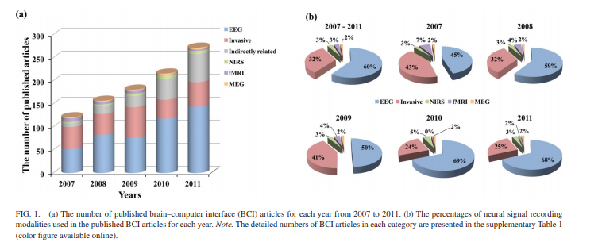

Figure 1(a) shows the numbers of BCI research articles that address the examined topics published from 2007-2011. BCI articles have rapidly increased in number each year, as shown in Figure (a).

Figure 1(b) provides pie charts showing the percentages of the various neural signal recording modalities used in these BCI articles.

*Paradigm Used to Implement the BCI Systems*

A variety of paradigms have been used to realize EEGbased BCI systems. We classified the EEG-based BCI articles into seven categories according to the experimental paradigm employed to elicit different kinds of brain activities: motor imagery, visual P300, steady-state visual evoked potential (SSVEP), nonmotor mental imagery, auditory, hybrid, and other paradigms.

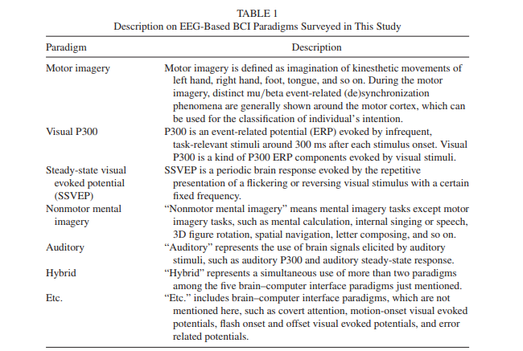

Feature Types

Various feature types have been used in BCI research to accurately discriminate user intentions. We surveyed feature types used in the published EEG-based BCI articles and classified them into five groups: power spectral density (PSD), event-related potential (ERP), use of more than two feature types, phase information, and others. Figure 2 shows the proportions of each kind of features used in the EEG-based BCI articles published from 2007 to 2011. Traditionally, PSD has been used most often, because the PSD values of specific frequency bands can be modulated by specific mental tasks**.**

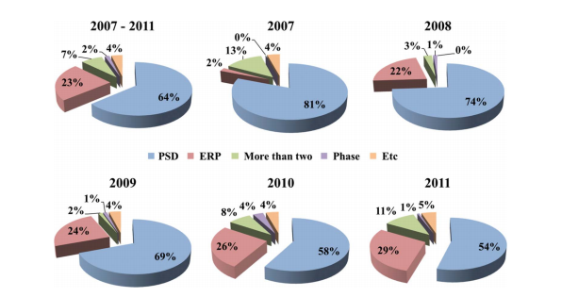

**Figure 2**

Classification Algorithms

Along with feature extraction methods, the classification algorithm is an important component for the successful implementation of a reliable BCI system. Numerous classification algorithms have been introduced in the published EEG-based BCI articles. We classified the classification algorithms into nine groups: linear discriminant analysis (LDA), support vector machine (SVM), use of more than two classifiers, Bayesian classifier, linear regression (LR), finding maximum value, thresholding, neural network (NN), and others. Figure 3 depicts the percentages of the classification methods by year. LDA and SVM have been the most widely used classification methods, used in more than half of the EEG-based BCI articles.

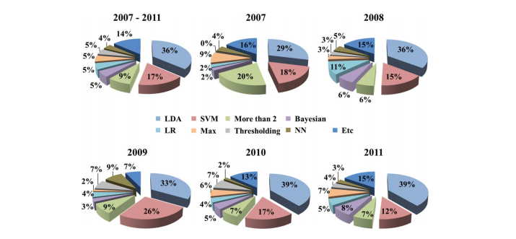

**Figure 3**

Some BCI articles used more than two classiﬁcation algorithms to ﬁnd the best-suited classiﬁer for a speciﬁc feature set. BCI researchers have steadily used Bayesian classiﬁers and NN. In general, LR has been adopted as a classiﬁer for continuous control of BCI applications.

Other classiﬁcation algorithms included k-nearest neighbor (Bashashati, Mason, Borisoff, Ward, & Birch, 2007; Bashashati, Nouredin, Ward, Lawrence, & Birch, 2007; Boye, Kristiansen, Billinger, do Nascimento, & Farina, 2008; Odeh, Hodali, Sleibi, & Salsa, 2009;H.X.Wang&Xu,2011;Weng&Shen,2008), ,Euclidean distance (Galan, Oliva, & Guardia, 2007; Hwang, Kwon, & Im, 2009; Kim et al., 2011; H. W. Wang, 2011).

Conclusion

In study, we found that in Particular, the proportions of EEG-based BCI articles have increased the most among various neural signal recording modalities. Although motor-imagery-based BCI paradigms are still being most widely studied, the use of SSVEP and visual P300 paradigms has been steadily increased as these two paradigms require little user training and show high performance.

1. **Objectives**

* To study research papers and other literature related to Brain Computer Interface.
* To gather data and preprocess it to remove ambiguities.
* To develop Machine Learning algorithms for classification the data into various actions.
* To develop a system for controlling devices based on what one thinks.
* Test and validate the final system in various conditions.

1. **Project Execution Plan**
   1. **Data Acquisition**

The goal is to collect EEG signal data of some subjects. The subject after wearing the emotiv headset, will be asked to perform an action (blinking or hand movements) at specific time intervals. Each EEG session will be recorded in the Emotiv’s Testbench program as an EDF file. Thus, the final data would be five distinguished brain states of all subjects collected in .csv format.

* 1. **Data Preprocessing**

The data collected from each subject will be processed in order to remove noise. Average of similar EEG recordings corresponding to each subject will be calculated.

* 1. **Classification using Deep Learning**

Main objective of this step is to train a classification model for classify of the thoughts of the Emotiv users based on the EEG signals received into five discrete brain states. Aim is to achieve a high accuracy by adjusting and tuning of various parameters.

* 1. **Application Interface Construction**

Construction of an API will be useful for mapping of the actions or thoughts of the users obtained from their EEG signals to the physical actions we want as an output. In our case, we will be mapping the[ user’s five discrete brain states to the five different kinds of motor movements (forward, backward, left, right and stop) in the wheel chair.

* 1. **Hardware Assembly**

This is the last phase of our project and includes the ensembling of Arduino microcontroller (along with ZigBee) or Raspberry Pi microcontroller to operate the modules (forward, backward, left, right, stop) and transmit the instructions though a wireless medium to the wheelchair and make it move or stop.

1. **Work Plan**

The estimated work plan for the capstone project is as follows:

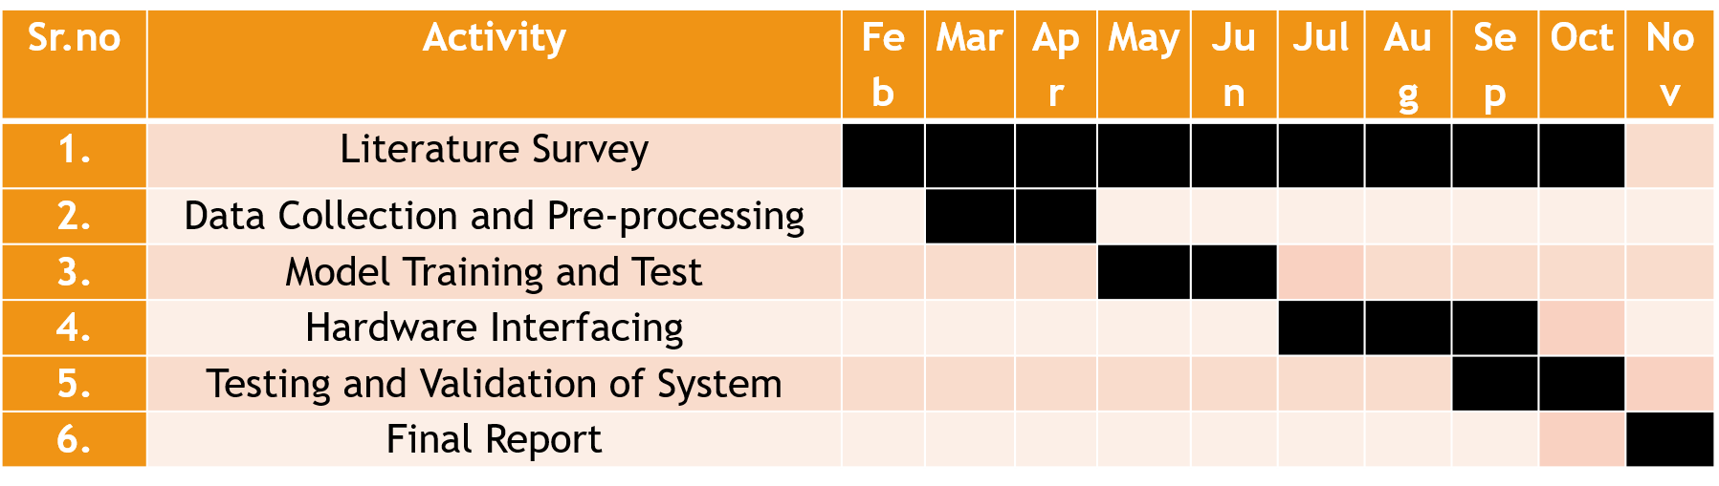

1. **Project Outcomes**

* Patients with disabilities will find a new way to move themselves or the things around.
* There will be a machine learning model ready to tell which action was just performed.
* Electrical component including motors, wheels and other circuit would function according to brain signals.
* Bringing in specific thoughts in the mind and forbidding others, would in general help increase focus.

1. **INDIVIDUAL ROLES**

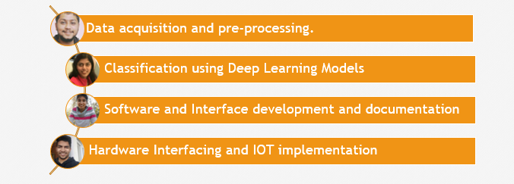

**10. Course Subjects**

A thorough knowledge of the following subjects and tools is required for proper understanding of the concept and its implementation:

1. **Machine Learning:** Deep learning will be used to train the model which would act on the dataset.
2. **Data Analytics:** Before giving the data as input, because it is highly noisy, it has to be preprocessed using various preprocessing techniques.
3. **Basic Electrical Engineering**: To study the signals and potential difference values provided by the EEG device.
4. **C++/ Python/ Matlab:** For coding the model and performing operations on dataset.
5. **EEG Control Panel:** For visualizing the data and training the subjects.
6. **OpenVibe:** For extracting the data from the device.

**11. References**

[1] Abdel Ilah N. Alshbatat, Peter J. Vial, Prashan Premaratne, Le C. Tran (2014) EEG-based Brain-computer Interface for Automating Home Appliances, Journal of computers , Vol. 9, No. 9, September 2014.

[2] Erik Andreas Larsen (2011) Classification of EEG Signals in a Brain-Computer Interface System.  Master's thesis. Trondheim, June 2011.

[3] Felzer, T., & Freisleben, B. (2003, December). Analyzing EEG signals using the probability estimating guarded neural classifier. IEEE transactions on neural systems and rehabilitation engineering : a publication of the IEEE Engineering in Medicine and Biology Society, 11(4), 361–71.

[4] G. Pfurtscheller, C. Neuper, D. Flotzinger, and M. Pregenzer (1997) ‘EEG-based Discrimination between Imagination of Right and Left Hand Movement’, Electroencephalography and Clinical Neurophysiology, vol. 103, pp. 642-651.

[5] Han-Jeong Hwang , Soyoun Kim , Soobeom Choi & Chang-Hwan Im (2013) EEG-Based Brain-Computer Interfaces: A Thorough Literature Survey, International Journal of Human-Computer Interaction, 29:12, 814-826, DOI: 10.1080/10447318.2013.780869

[6] Lotte, F., Congedo, M., L´ecuyer, a., Lamarche, F., & Arnaldi, B. (2007, June), A review of classification algorithms for EEG-based brain-computer interfaces. *Journal of neural engineering*, *4*(2), R1–R13.

[7] Taha Beyrouthy, Samer K Al Kork, Joe Akl Korbane, Alhamza Abdulmonem (2016) EEG Mind Controlled Smart Prosthetic Arm, 2016 IEEE International Conference on Emerging Technologies and Innovative Business Practices for the Transformation of Societies (EmergiTech).

[8] K. R. Müller and B. Blankertz (2006), “Toward non-invasive brain-computer interfaces,” IEEE Signal Processing Magazine, vol. 128, no. 1, pp. 125-128.