Step1.I created a simple Java program/process(Deadlock.java)just for practice, so I can learn how to take a Java thread dump.

public class Deadlock {
static final Object lock1 = new Object();
static final Object lock2 = new Object();

public static void main(String[] args) {

new Thread(() -> {
synchronized(lock1) {
try {
Thread.sleep(100);
} catch(Exception e) {}

synchronized(lock2) {}
}
}).start();

new Thread(() -> {
synchronized(lock2) {
synchronized(lock1) {}
}
}).start();
}
}

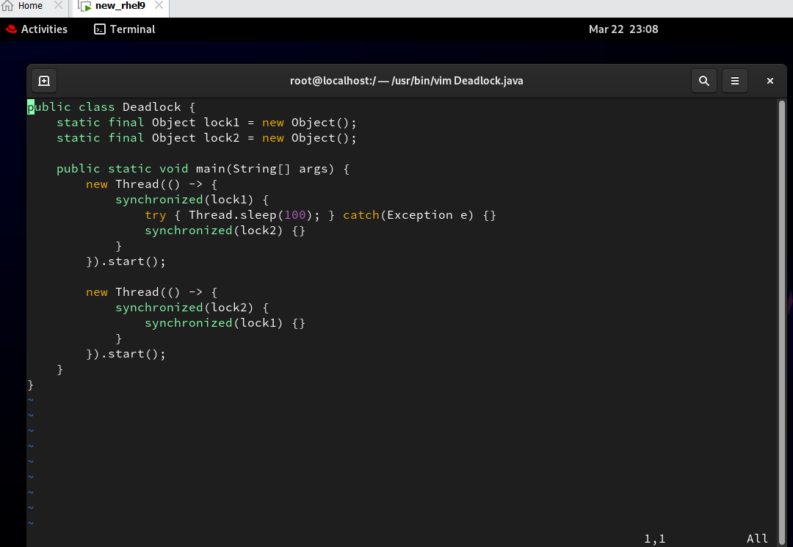

step2. First, I verified that the Java file (Deadlock.java) is created in the system.

step3. To run a Java program, Java (JDK) must be installed on the server.So, I installed Java using the package manager
(yum install java-17-openjdk-devel). now u can run comand like javac,jstack,java,jps.
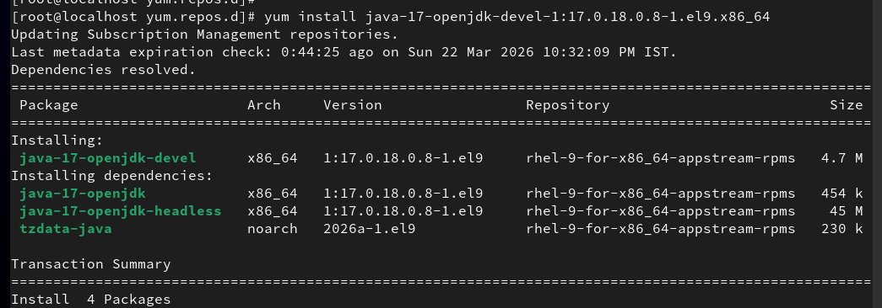
Step4. After installing Java, I compiled the program using: javac Deadlock.java this command creates a bytecode file (Deadlock.class).
Then, I ran the program using: java Deadlock This starts the Java application.

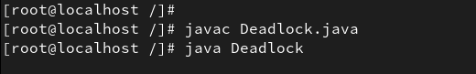

Step5.Verify Application is Running and Find PID
After running the Java program, I verified whether the application is running.First, I used the top command to check running processes and confirmed that the java Deadlock process is active.

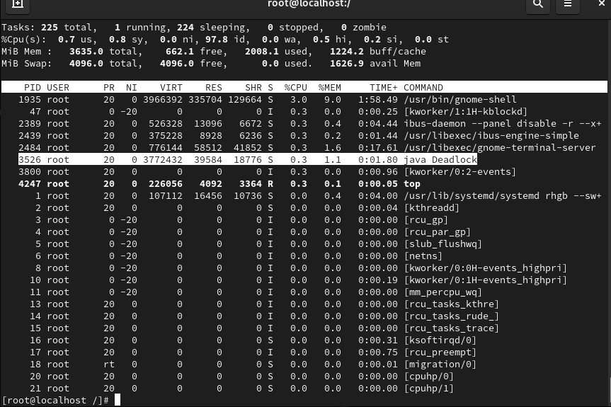

Step 6. Then, I used the jps -l command to list Java processes, where I could see the Deadlock program along with its PID. I also used the ps -ef | grep Deadlock command to find the process manually.Additionally, I verified using ps -ef | grep java to check all Java-related processes.

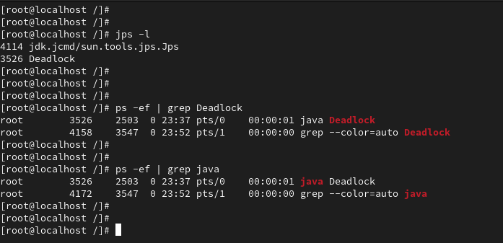

Step7. The Java program is running, but after some time it gets stuck and stops working.Even though the process is active, it is not performing any operation.This indicates there may be an issue,
So I decided to take a thread dump to analyze the problem.



step8.Before taking the thread dump, I checked the TIDs (Thread IDs) of the Java process using its PID by running the command top -H -p <PID>
I observed that none of the threads were consuming high CPU or memory.Even though resource usage was normal, the application was still stuck.This indicates that the issue is not related to CPU or memory, but possibly due to a deadlock or thread waiting condition.

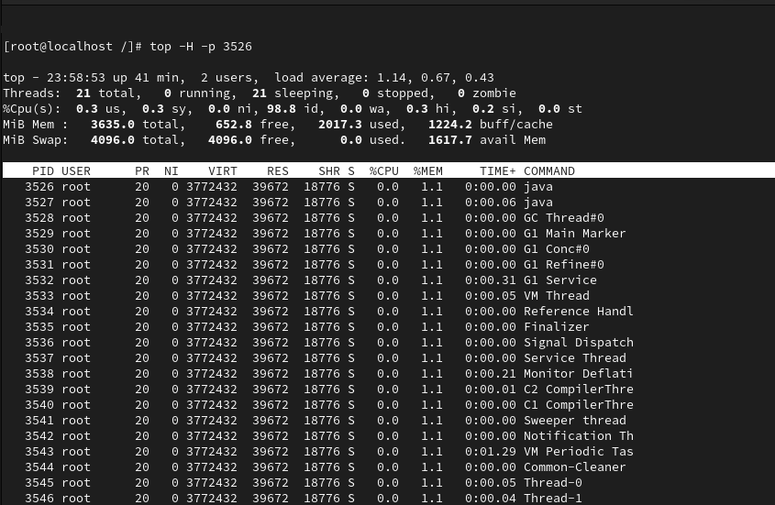

step9. so, I took the thread dump using the jstack command with the PID of the Java process.After running the command, I verified that the thread dump file was successfully created.
👉 This dump file will be used to analyze the issue in the Java application.
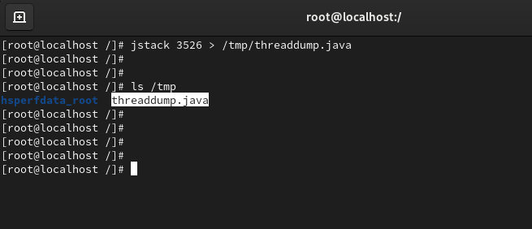

step10.Analyze Thread Dump
After taking the thread dump, I opened the dump file to analyze it.The thread dump shows the state of all threads in the Java application.
In the dump file, I can see that some threads are in a waiting/blocked state.It clearly shows that one thread is waiting to acquire a lock held by another thread, and the second thread is waiting for the first thread.
The dump also explicitly mentions "Found one Java-level deadlock", which confirms the issue.It provides details of both threads, including which locks they are holding and which locks they are waiting for.
👉 From this thread dump, I confirmed that the application is stuck due to a deadlock.
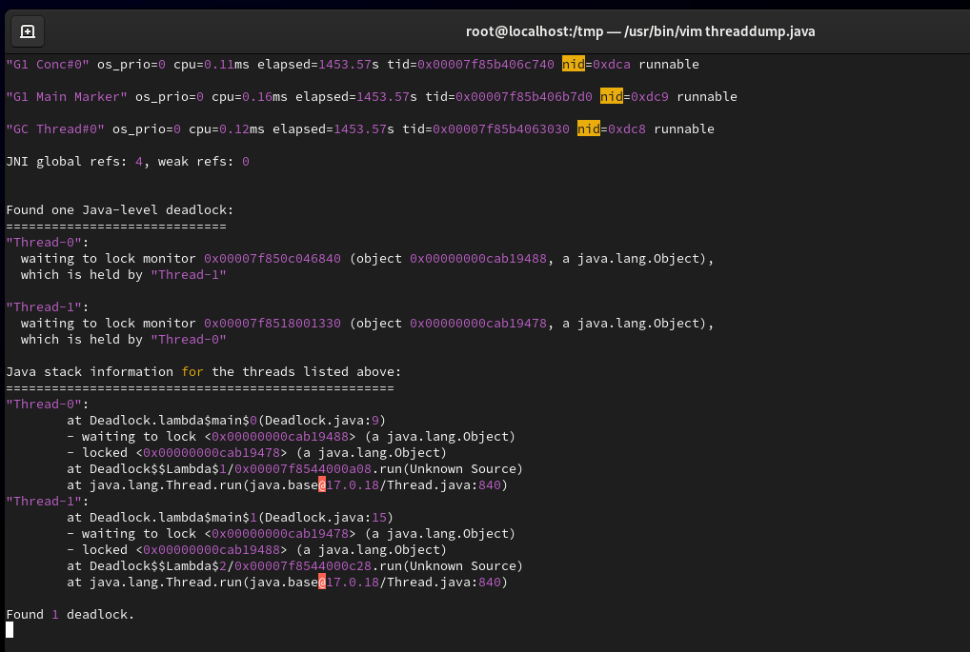

step11 . After analyzing the thread dump file, I identified the problematic threads using their nid (native thread ID).The thread dump shows nid in hexadecimal format (e.g., 0xdd9, 0xdda).
To match these with system-level thread IDs (TIDs), I converted the nid values from hexadecimal to decimal using the printf command.

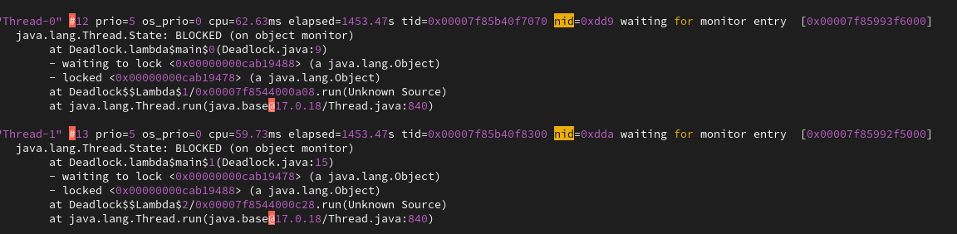

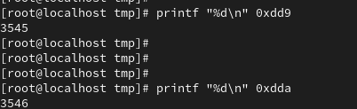

step12 .After converting the nid values to TIDs, I matched them with the threads using the top -H -p 3526 command.I identified the problematic threads in the system.Both threads were in a waiting state and not consuming CPU.From the analysis, it is clear that both threads are waiting for each other’s resources.

