Pesticide Labels Now Report

Draft

2022-04-06

Table of Contents

# How do user characteristics inform or explain their interaction with the ‘[Pesticides Labels Now!](https://deohs.washington.edu/pnash/LabelsNow)’ application?

## Authors: Aarti Tandon, Eddie Kasner, Kit Galvin, Pablo Palmández

# Introduction



alt text

Hi! My name is Aarti Tandon and I am currently working as an Undergraduate Research Assistant here at the University of Washington. Through the [SURE-EH program](https://deohs.washington.edu/apply-sure-eh), I work with the [Pacific Northwest Agricultural Safety and Health Center](https://deohs.washington.edu/pnash/) under the mentorship of Dr. Eddie Kasner and Kit Galvin. This is my markdown file that I have been working on this past year where I have analyzed data from the ‘Bilingual Health and Safety Messaging’ application. My research is focused on reducing the gaps in fair and equal access for marginalized peoples by understanding our user audience and their preferences for app utility. While working on the app, I have been able to stand at the crossroads of technology and human health. Using the tools of statistics and data visualization, I have contributed to research translation and the improvement of human health, environmental resilience, and social and economic equity.

# Executive Summary

The ‘[Pesticides Labels Now!](https://deohs.washington.edu/pnash/LabelsNow)’ mobile application strives to minimize agricultural worker and community exposure and illness from agricultural pesticides through improving access to pesticide labels and safety information in Spanish and English. Pesticide handlers, managers, and supervisors are able to gain access to this information, change behaviors accordingly, and transfer the safety information to others. We hypothesized that user characteristics such as language choice, mobile device type, and location would determine frequency of interactions with the application. This study investigates the application’s user audience and their preferences for app utility. Statistical analysis and graphing was conducted with R Studio (Version 2021.09.1) for users accessing the application over one year starting in August 2020. The raw data set consisted primarily of users from the State of Washington, containing 67,754 interactions and a total of 503 unique users. The results showed that user utilization is predominantly concentrated in central Washington, which is part of the Columbia Basin, and has very productive agricultural land. The overall frequency of each language accessed on the application was relatively comparable - with 59% in English and 41% in Spanish. The analysis further indicated the majority of users utilize the application through an iOS system. An estimated 74% of interactions were accessed through an iPhone device and 26% were accessed through an Android device. By understanding the effect of user characteristics in their interaction with the application, necessary adjustments can be made to the application to create a more user-friendly experience and contribute to improving access to pesticide labels and their safety information.

# Objective

## To understand the ‘[Pesticide Labels Now](https://deohs.washington.edu/pnash/LabelsNow)’ mobile application user audience and their preferences for app utility.

# Features to Help Understand User Characteristics

* Location
* Device
* Language

# Data Subsets

A data dictionary and descriptive statistics were prepared based on the Pesticide Labels Now (PLN) [analysis plan](https://docs.google.com/document/d/1mUHPYdpWljCWroODGenUjYlyae2ZWwqN4MScBLXlr2U/edit). For a better representation of users, we ignored a list of random identifiers (‘aid’ in *ignores.csv*) associated with the project team members and generated descriptive statistics for three subsets:

* evDownload.01
* evStart
* evViewPage.01

# Descriptive Statistics

## evDownload.01

## evStart

## evViewPage.01

# App Use By Location

## Plot for US Sessions

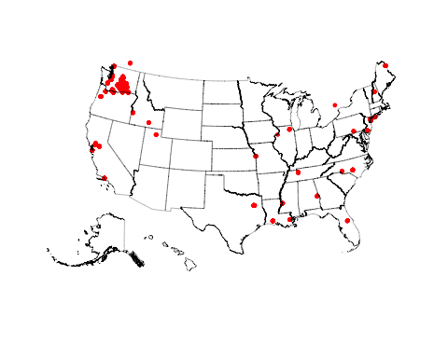

## | | | 0% | |= | 1% | |= | 2% | |== | 2% | |== | 3% | |=== | 4% | |=== | 5% | |==== | 5% | |==== | 6% | |===== | 7% | |===== | 8% | |====== | 8% | |====== | 9% | |======= | 10% | |======= | 11% | |======== | 11% | |======== | 12% | |========= | 13% | |========== | 14% | |========== | 15% | |=========== | 15% | |=========== | 16% | |============ | 16% | |============ | 17% | |============ | 18% | |============= | 18% | |============= | 19% | |============== | 19% | |============== | 20% | |============== | 21% | |=============== | 21% | |=============== | 22% | |================ | 22% | |================ | 23% | |================ | 24% | |================= | 24% | |================= | 25% | |================== | 25% | |================== | 26% | |=================== | 27% | |==================== | 28% | |==================== | 29% | |===================== | 29% | |===================== | 30% | |====================== | 31% | |====================== | 32% | |======================= | 32% | |======================= | 33% | |======================== | 34% | |======================== | 35% | |========================= | 35% | |========================= | 36% | |========================== | 37% | |========================== | 38% | |=========================== | 38% | |=========================== | 39% | |============================ | 39% | |============================ | 40% | |============================= | 41% | |============================= | 42% | |============================== | 43% | |=============================== | 44% | |=============================== | 45% | |================================ | 45% | |================================ | 46% | |================================= | 47% | |================================= | 48% | |================================== | 48% | |================================== | 49% | |=================================== | 49% | |=================================== | 50% | |=================================== | 51% | |==================================== | 51% | |==================================== | 52% | |===================================== | 52% | |===================================== | 53% | |====================================== | 54% | |====================================== | 55% | |======================================= | 55% | |======================================= | 56% | |======================================== | 57% | |======================================== | 58% | |========================================= | 58% | |========================================= | 59% | |========================================== | 60% | |=========================================== | 61% | |=========================================== | 62% | |============================================ | 62% | |============================================ | 63% | |============================================= | 64% | |============================================= | 65% | |============================================== | 65% | |============================================== | 66% | |=============================================== | 66% | |=============================================== | 67% | |=============================================== | 68% | |================================================ | 68% | |================================================ | 69% | |================================================= | 69% | |================================================= | 70% | |================================================= | 71% | |================================================== | 71% | |================================================== | 72% | |=================================================== | 72% | |=================================================== | 73% | |==================================================== | 74% | |==================================================== | 75% | |===================================================== | 75% | |===================================================== | 76% | |====================================================== | 77% | |======================================================= | 78% | |======================================================= | 79% | |======================================================== | 79% | |======================================================== | 80% | |======================================================== | 81% | |========================================================= | 81% | |========================================================= | 82% | |========================================================== | 82% | |========================================================== | 83% | |=========================================================== | 84% | |=========================================================== | 85% | |============================================================ | 85% | |============================================================ | 86% | |============================================================= | 87% | |============================================================= | 88% | |============================================================== | 88% | |============================================================== | 89% | |=============================================================== | 90% | |================================================================ | 91% | |================================================================ | 92% | |================================================================= | 92% | |================================================================= | 93% | |================================================================= | 94% | |================================================================== | 94% | |================================================================== | 95% | |=================================================================== | 95% | |=================================================================== | 96% | |==================================================================== | 97% | |==================================================================== | 98% | |===================================================================== | 98% | |===================================================================== | 99% | |======================================================================| 99% | |======================================================================| 100%

## | | | 0% | | | 1% | |= | 1% | |= | 2% | |== | 2% | |== | 3% | |=== | 4% | |=== | 5% | |==== | 5% | |==== | 6% | |===== | 7% | |===== | 8% | |====== | 8% | |====== | 9% | |======= | 9% | |======= | 10% | |======= | 11% | |======== | 11% | |======== | 12% | |========= | 12% | |========= | 13% | |========= | 14% | |========== | 14% | |========== | 15% | |=========== | 15% | |=========== | 16% | |============ | 16% | |============ | 17% | |============ | 18% | |============= | 18% | |============= | 19% | |============== | 19% | |============== | 20% | |============== | 21% | |=============== | 21% | |=============== | 22% | |================ | 22% | |================ | 23% | |================= | 24% | |================= | 25% | |================== | 25% | |================== | 26% | |=================== | 27% | |=================== | 28% | |==================== | 28% | |==================== | 29% | |===================== | 29% | |===================== | 30% | |===================== | 31% | |====================== | 31% | |====================== | 32% | |======================= | 32% | |======================= | 33% | |======================= | 34% | |======================== | 34% | |======================== | 35% | |========================= | 35% | |========================= | 36% | |========================== | 36% | |========================== | 37% | |========================== | 38% | |=========================== | 38% | |=========================== | 39% | |============================ | 39% | |============================ | 40% | |============================ | 41% | |============================= | 41% | |============================= | 42% | |============================== | 42% | |============================== | 43% | |=============================== | 44% | |=============================== | 45% | |================================ | 45% | |================================ | 46% | |================================= | 46% | |================================= | 47% | |================================= | 48% | |================================== | 48% | |================================== | 49% | |=================================== | 49% | |=================================== | 50% | |=================================== | 51% | |==================================== | 51% | |==================================== | 52% | |===================================== | 52% | |===================================== | 53% | |===================================== | 54% | |====================================== | 54% | |====================================== | 55% | |======================================= | 55% | |======================================= | 56% | |======================================== | 57% | |======================================== | 58% | |========================================= | 58% | |========================================= | 59% | |========================================== | 59% | |========================================== | 60% | |========================================== | 61% | |=========================================== | 61% | |=========================================== | 62% | |============================================ | 62% | |============================================ | 63% | |============================================= | 64% | |============================================= | 65% | |============================================== | 65% | |============================================== | 66% | |=============================================== | 67% | |=============================================== | 68% | |================================================ | 68% | |================================================ | 69% | |================================================= | 69% | |================================================= | 70% | |================================================= | 71% | |================================================== | 71% | |================================================== | 72% | |=================================================== | 72% | |=================================================== | 73% | |=================================================== | 74% | |==================================================== | 74% | |==================================================== | 75% | |===================================================== | 75% | |===================================================== | 76% | |====================================================== | 76% | |====================================================== | 77% | |====================================================== | 78% | |======================================================= | 78% | |======================================================= | 79% | |======================================================== | 79% | |======================================================== | 80% | |======================================================== | 81% | |========================================================= | 81% | |========================================================= | 82% | |========================================================== | 82% | |========================================================== | 83% | |========================================================== | 84% | |=========================================================== | 84% | |=========================================================== | 85% | |============================================================ | 85% | |============================================================ | 86% | |============================================================= | 86% | |============================================================= | 87% | |============================================================= | 88% | |============================================================== | 88% | |============================================================== | 89% | |=============================================================== | 89% | |=============================================================== | 90% | |=============================================================== | 91% | |================================================================ | 91% | |================================================================ | 92% | |================================================================= | 92% | |================================================================= | 93% | |================================================================== | 94% | |================================================================== | 95% | |=================================================================== | 95% | |=================================================================== | 96% | |==================================================================== | 97% | |==================================================================== | 98% | |===================================================================== | 98% | |===================================================================== | 99% | |======================================================================| 99% | |======================================================================| 100%

## Plot for WA sessions with County Names

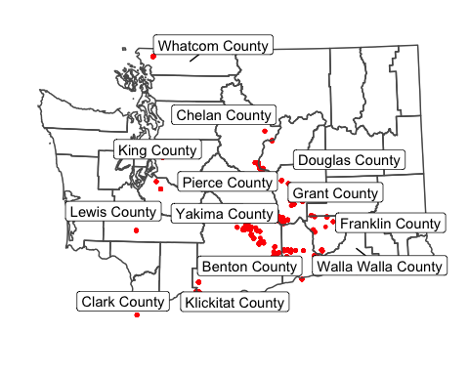

User utilization is predominantly concentrated in central Washington, which is part of the Columbia Basin, and has very productive agricultural land.

# App Use by Device

## Devices Utilized to Access the Application

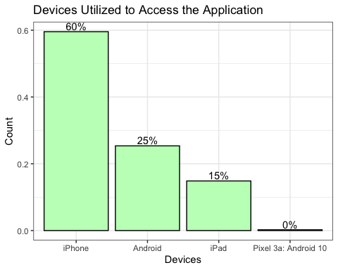

The three devices utilized to access the application were an iPhone, Android, or iPad. Almost 75% of users were accessing the app through an iOS system (e.g. iPhone, iPad) and 25% of users were accessing the app through an Android system.

# App Use by Language

## Frequency of Each Language Accessed on the Application

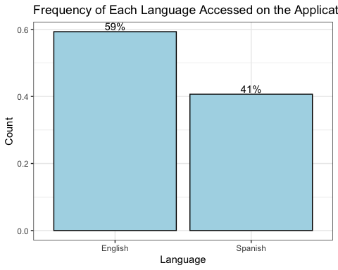

Figure X displays 18% more activity in English than Spanish. Since the ’Pesticides Labels Now! application initially asks the user which language they wish to proceed in, there is no “default” language and the results can be concluded as reliable and robust.

## Frequency of Different Languages by Operating System

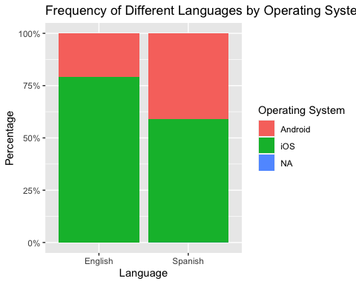

iOS users are more likely to access the information in English than Spanish. Android users are more likely to access the information in Spanish than English. This raises the question why Spanish-speaking users are more likely to have an Android device.

# App Use By Time

## Comparing User Sessions by ‘Day of the Month’, ‘Month’, and ‘Activity of the User’

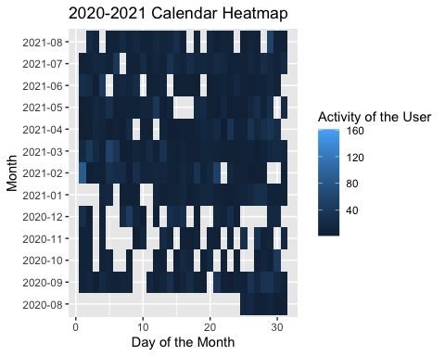 Figure X displays a Time-Series Calendar HeatMap analyzing each session’s duration in comparison to the day of the month, month, and activity of the user. Growing season starts around mid-March till the end of November. Figure X depicts the increase in session duration mid-year. The rise in activity at this time conveys the success of the application targeting this specific population of farmworkers.

## Comparing User Sessions by ‘Hour of the Day’, ‘Day of the Month’, and ‘Activity of the User’

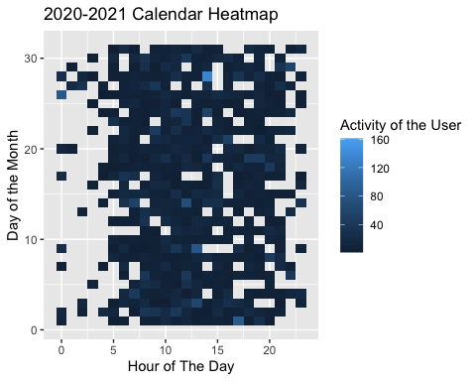

## Comparing User Sessions by ‘Month’, ‘Day of the Month’, and ‘Session Time (in minutes)’

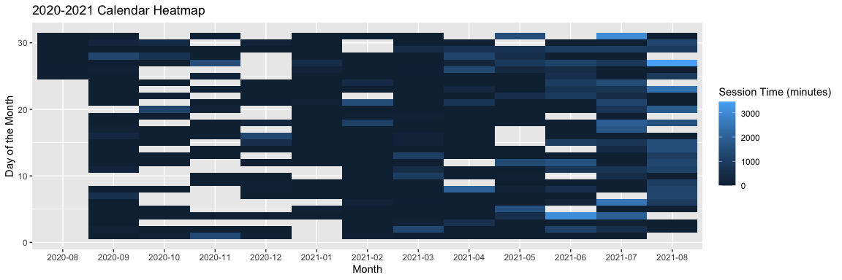 After making changes… it makes sense that from april-august, the app is more utilized

## Comparing User Sessions by ‘Hour of the Month’, ‘Day of the Month’, ‘Month’, and ‘Year’

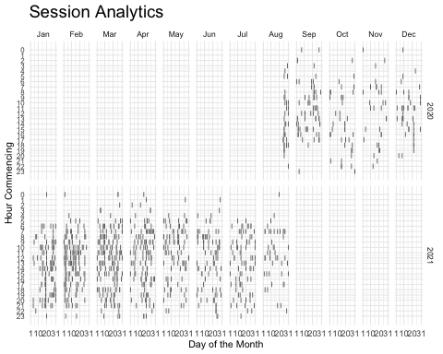

# App Use By Activity

## Frequency of Each Source Page Accessed on the Application

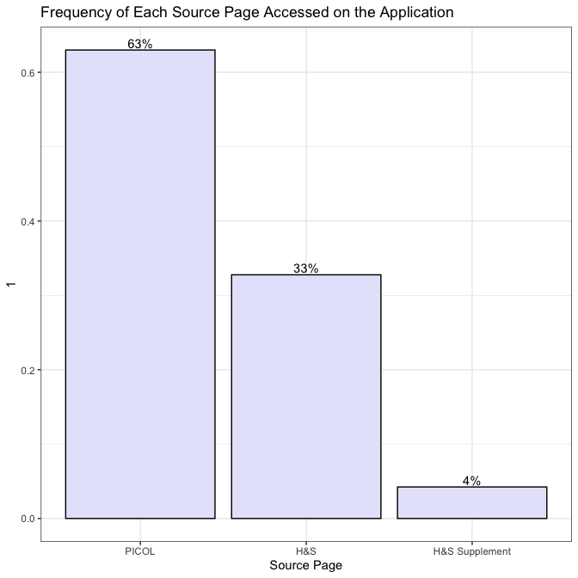 ‘PICOL’ can be notably distinguished as the most popular source page accessed by users.

## Activity in Each Label Section

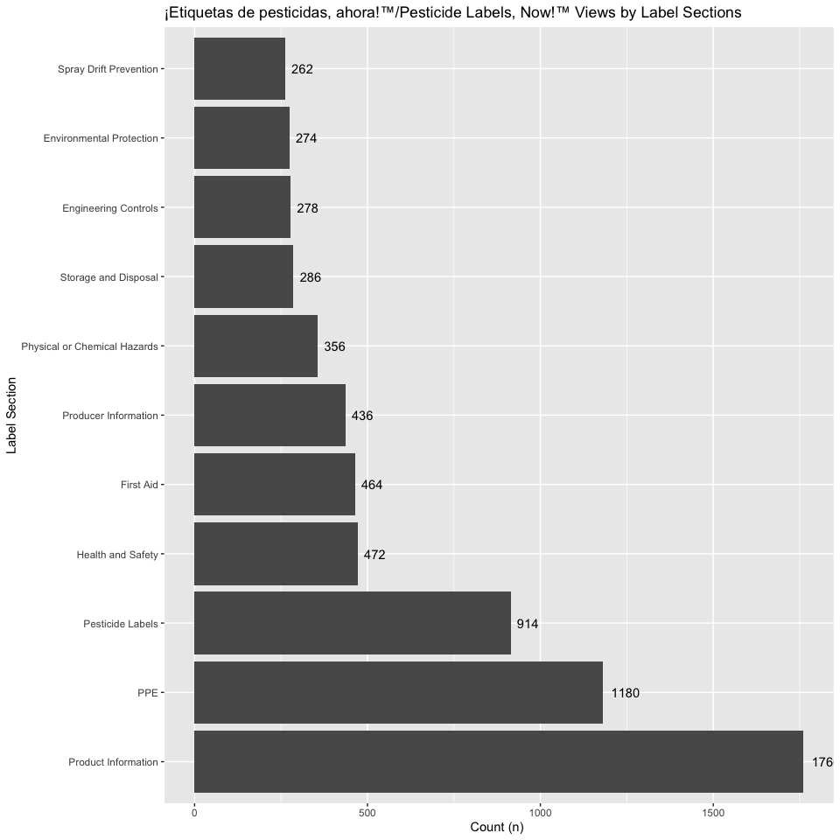 The frequency of each ‘Label Section’ item accessed on the ‘Pesticides Labels Now’ application was analyzed. ‘Product Information’, ‘Personal Protective Equipment’ and ‘Pesticide Labels’ are the most popularly accessed sections by users.

## Frequency of Links Utilized

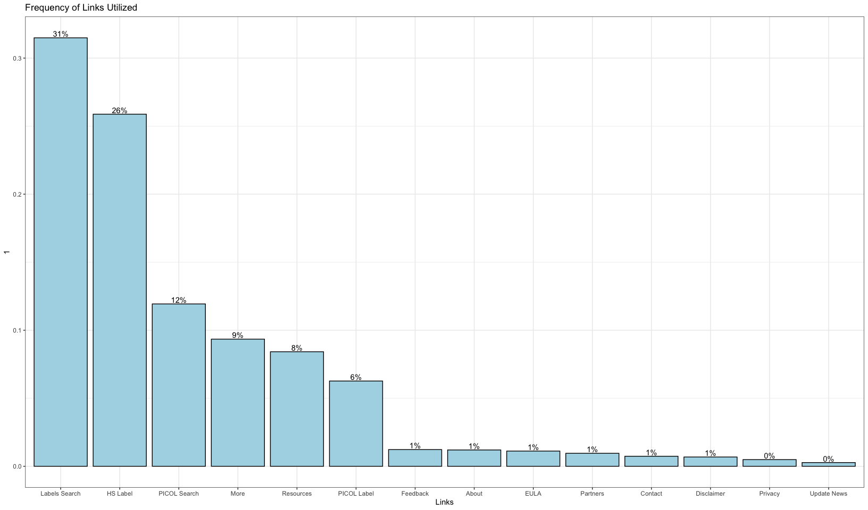 The frequency of each ‘Link’ accessed on the ‘Pesticides Labels Now’ application was analyzed. ‘Labels Search’ was the most popularly viewed section by all users.

## Frequency of Different Links by Language

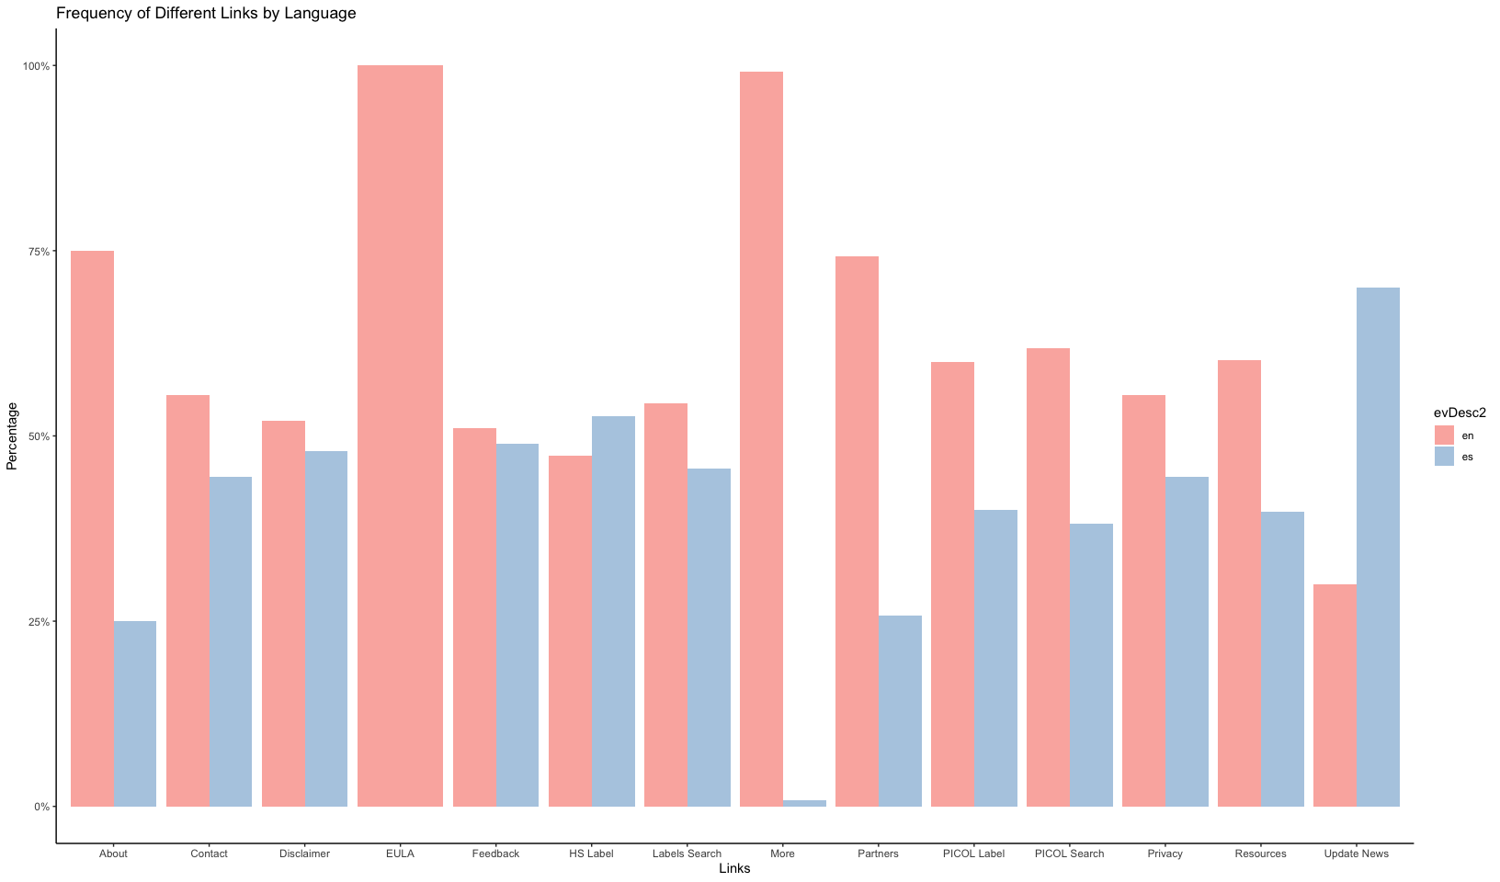 The frequency of each Link accessed on the ‘Pesticides Labels Now’ application was compared to the user’s accessed language. ‘EULA’ was most popularly accessed by English readers and ‘Update News’ was most popularly accessed by Spanish readers.

## Table of Top Ten Searched Pesticides

Var1

Freq

Lorsban® Advanced

23

PARAQUAT 43.2% SL

18

2,4-D AMINE 4 HERBICIDE

16

2,4-D /AMINE 4 HERBICIDE

14

Lorsban®-4E Insecticide

12

440 SUPERIOR SPRAY OIL

11

Delegate® WG

11

Carbaryl 4L

10

ABBA ULTRA MITICIDE/INSECTICIDE

9

440 Superior Spray Oil

8

Amongst 129 total pesticides in the application, Table 1 displays the top ten searched pesticides. ‘Lorsban® Advanced’ was the most popularly looked at pesticide among users from August 2020-2021.

# Average Session Duration

## 90.11 minutes

# [Appendix](https://github.com/aartitandon/SURE-EH-Research-Project/blob/main/Appendix.md)