**LIBRARY MANAGEMENT SYSTEM**

**OOAD – LAB PROJECT**

**B.E – COMPUTER SCIENCE AND ENGINEERING**

**FROM**

**GOVERNMENT COLLEGE OF ENGINEERING,**

**DHARMAPURI – 636704.**

****­­­

**SUBMITTED BY: -**

**DHINESHKUMAR D (613520104008)**

**SIVASAKTHI V (613520104036)**

**Exp No :**

**Date :**

**Aim :**

To Develop a Project Library Management System using ArgoUML software and to implement the software in HTML, CSS, JS, FLUTTER and MongoDB.

**PROBLEM STATEMENT**

A college library management is a project that manages and stores books information electronically according to student’s needs. The system helps both students and library manager to keep a constant track of all the books available in the library. It allows both the admin and the student to search for the desired book. It becomes necessary for colleges to keep a continuous check on the books issued and returned and even calculate fine. This task if carried out manually will be tedious and includes chances of mistakes. These errors are avoided by allowing the system to keep track of information such as issue date, last date to return the book and even fine information and thus there is no need to keep manual track of this information which thereby avoids chances of mistakes.

**SOFTWARE REQUIREMENT SPECIFICATIONS**

**Purpose**

The purpose of this project is to develop an application that will automate the whole procedure of a library. The software that would be developed should have facilities like Add / Delete Members, Add / Delete Books, Issue & Return. The application should be secured, as well as with limited access. The main requirement of the project will be the ease of use, besides being the most efficient and effective tool for the purpose. The application should be user friendly.

* To provide services to all the employees for issue, return & search etc. at one place.
* To improve co-ordination in staff.
* To reduce paper filling work.
* To reduce risk of fraud.
* To reduce chances of information leaking.

**Scope**

For Members: -

* Facility for search of Books based on Author Name or ISBN No.

For Librarian: -

* Simple and intuitive GUI for performing all functions.
* Security features like access control using passwords and username.
* Facility to ADD / DELETE Members, Library Staff & Books and Maintain an easy record of all these.

**PROJECT DESCRIPTION**

**Product Perspective**

The manual library management system includes following drawbacks:

* The existing system involves a lot of paper work and manual calculation. This has led to inconsistency and inaccuracy in the maintenance of data.
* The data, which is stored on the paper only, may be lost, stolen or destroyed due to natural calamity like fire and water.
* The existing system is sluggish and time-consuming causing inconvenience to library staff.
* Since there are many books related to different scopes thus it would be very difficult to find a specific book, or edit the data of some book.

Hence the library management system is proposed with the following Product perspective:

* The computerization of the library system will reduce a lot of paperwork and hence the load on the library staff.
* It would be easy to search a specific book.

**User characteristics**

User1:

**Librarian**- Librarian will add, delete or update book records within the system. He/she will issue the books as per requested by the member. Staff needs to have complete understanding of functionalities and internal processing of the system.

User2:

**Member**- Member will request for book issue and then will return the book. They can search for a specific book. The user does not need to have complete understanding of complex functionalities and internal processing of the system.

**General Constraints**

Any update regarding the book from the library is to be recorded to have update and correct values and any fine on a member should be notified as soon as possible and should be calculated correctly.

**SPECIFIC REQUIREMENTS**

**External Interfaces**

**User Interface**

Various GUI elements like forms, images and standard buttons will be included in the User Interface.

**Performance requirements**

There are no particular extra performance requirements at this point of time.

**Functional Requirements**

* **Login:**

Description: Librarian will login to the system. The user must be registered in the system before login.

Input: Enter the username and password.

Output: Librarian will be able to use the features of software.

Processing: Username and password will be checked by the system. If they are incorrect a message will be displayed.

* **Search:**

Description: The users can search a book by entering book details such as author’s name, ISBN No etc.

Input: Enter the details you know about the book.

Output: The list of available books is displayed.

Processing: A message is displayed if the book related to the entered details is not available.

* **Issues book:**

Description: The Librarian checks the availability of book which the member want to get issued.

Input: Enter Register No of the Member.

Output: Confirmation for book issue or apology for failure in issue.

Processing: If selected book is available then the book will be issued and the record is updated else error will be displayed.

* **Return book:**

Description: The member wants to return the book.

Input: return the book to the library.

Output: The record will be updated.

Processing: If book is not returned.

**Logical Database Requirements**

Proposed database is intended to store, retrieve, update and manipulate information related to college which include:

* Books availability
* Member details

**DATA DICTIONARY**

Legal_character = [a-z|A-Z]

Legal digit = [0-9]

Special_character = [@|$|#]

Book_Details = isbnno + book_name +author_name +publishedyear+ publisher + edition + copies

ISBN No = (legal digit) *

Book_name = (legal character) *

Author_name = (legal character) *

Publisher = (legal character) *

Published Year = (Year Format)

Edition = (legal character) *

Copies = (legal digit) *

Student_details = name+member_id+gender+dob+email+department+aadharno+

username+password

Name=first_name + last name

first_name = (legal character) *

member_id= (legal digits) *

Staff_details = name+member_id+gender+dob+email+department+aadharno+

username+password

staff_id = (legal digit) *

login=username +password

username = (legal character + legal digit) *

password = (legal character + legal digit) *

**SCREENS:**

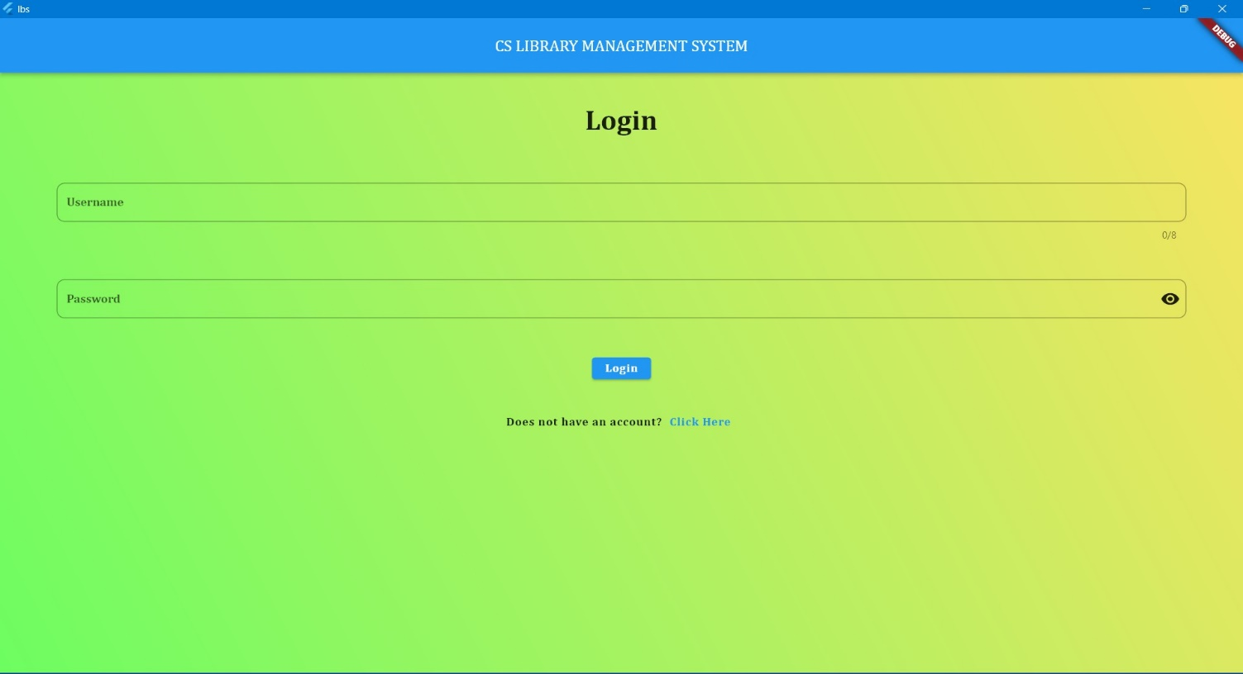

Figure 6.1 Librarian Login Page

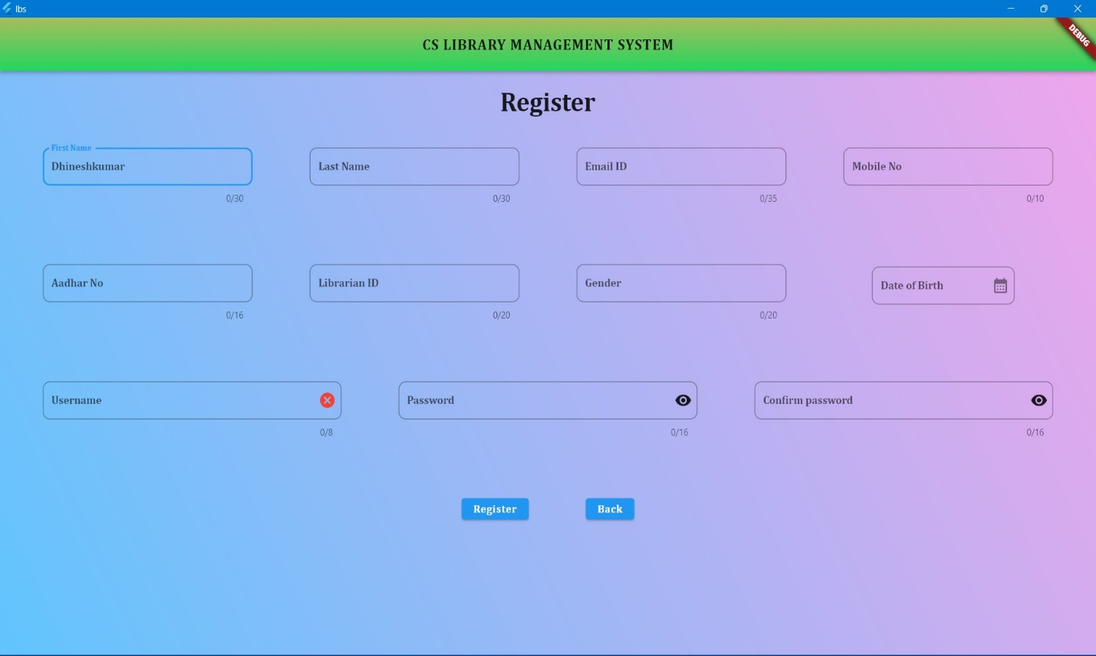

Figure 6.2 Register Librarian Page

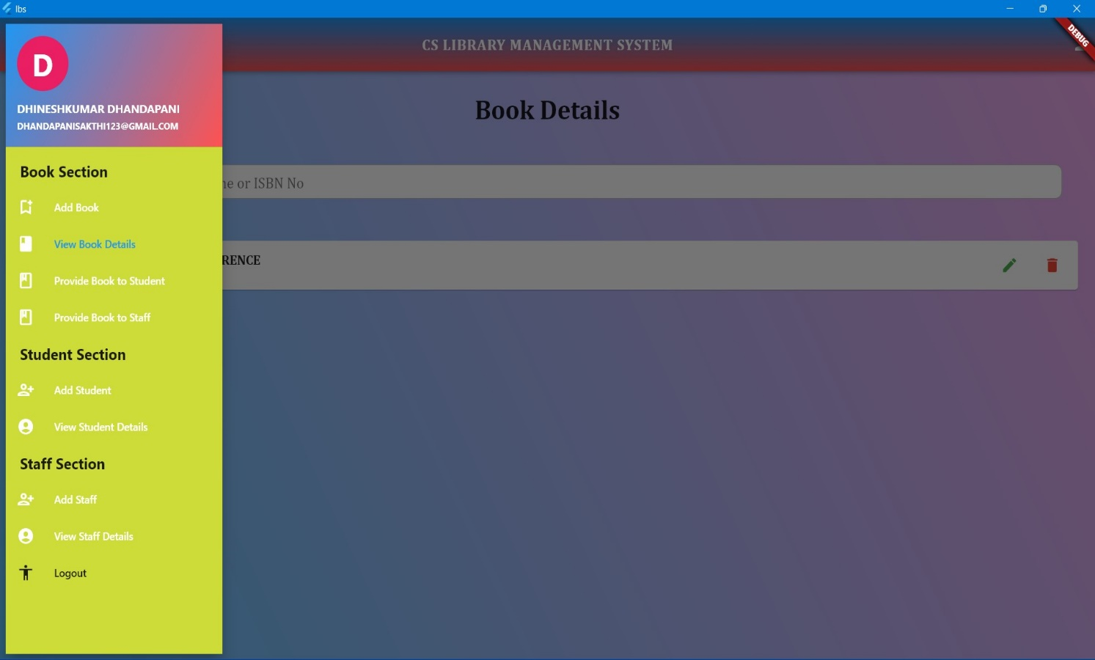

Figure 6.3 Home Page

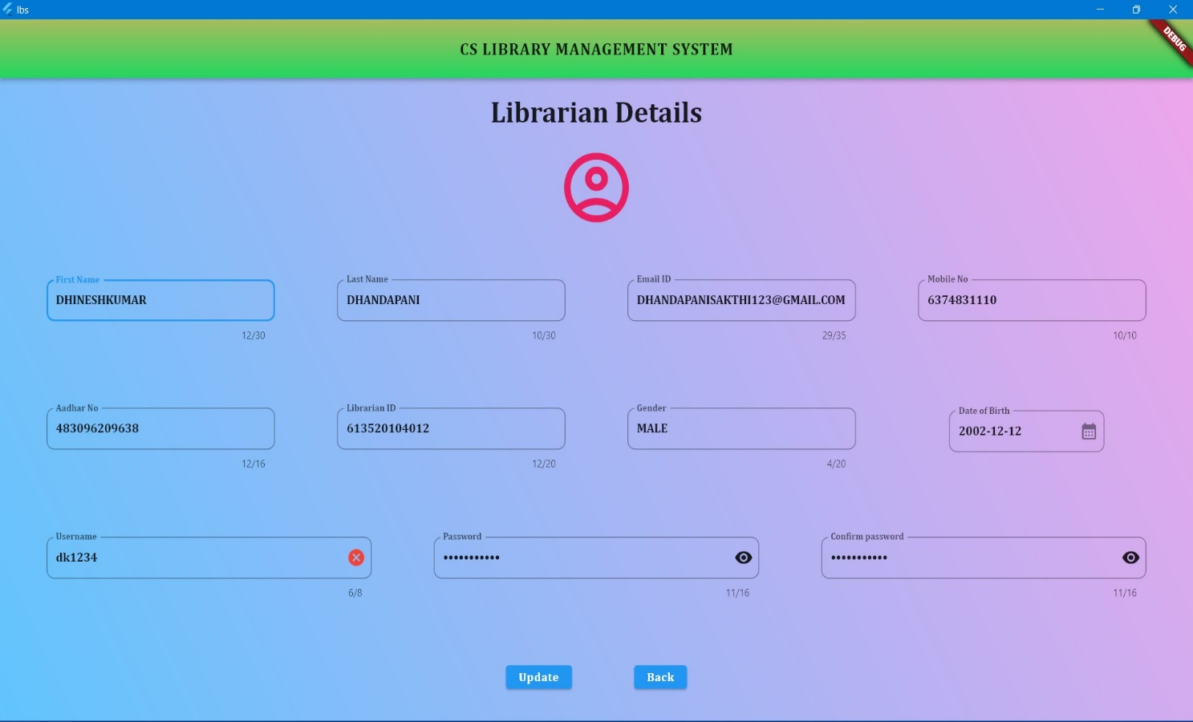

Figure 6.4 Update and View Librarian Details

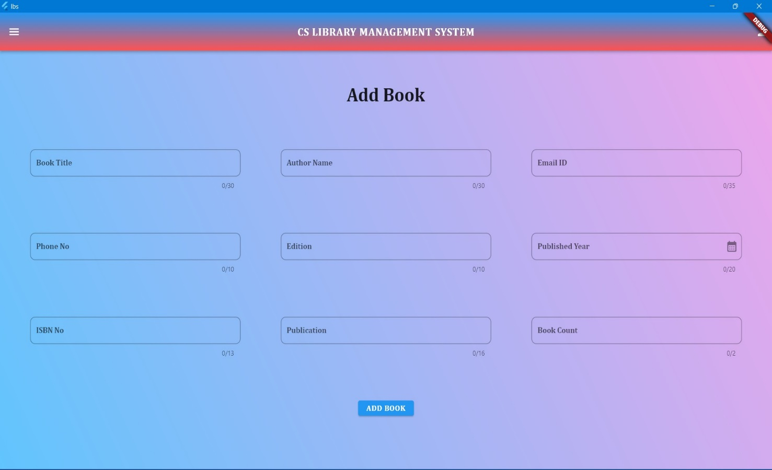

Figure 6.5 Add Book Details

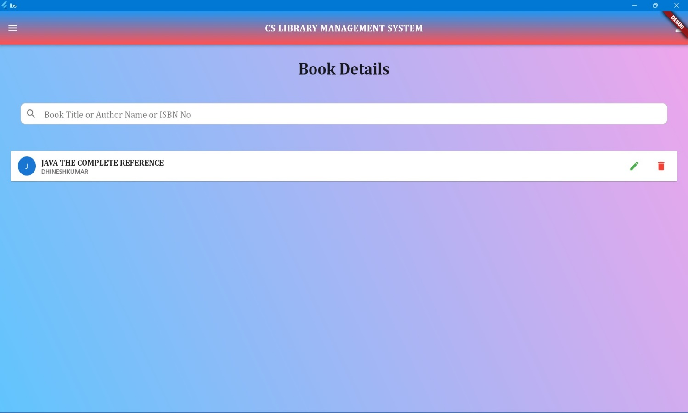

Figure 6.6 View Book Details

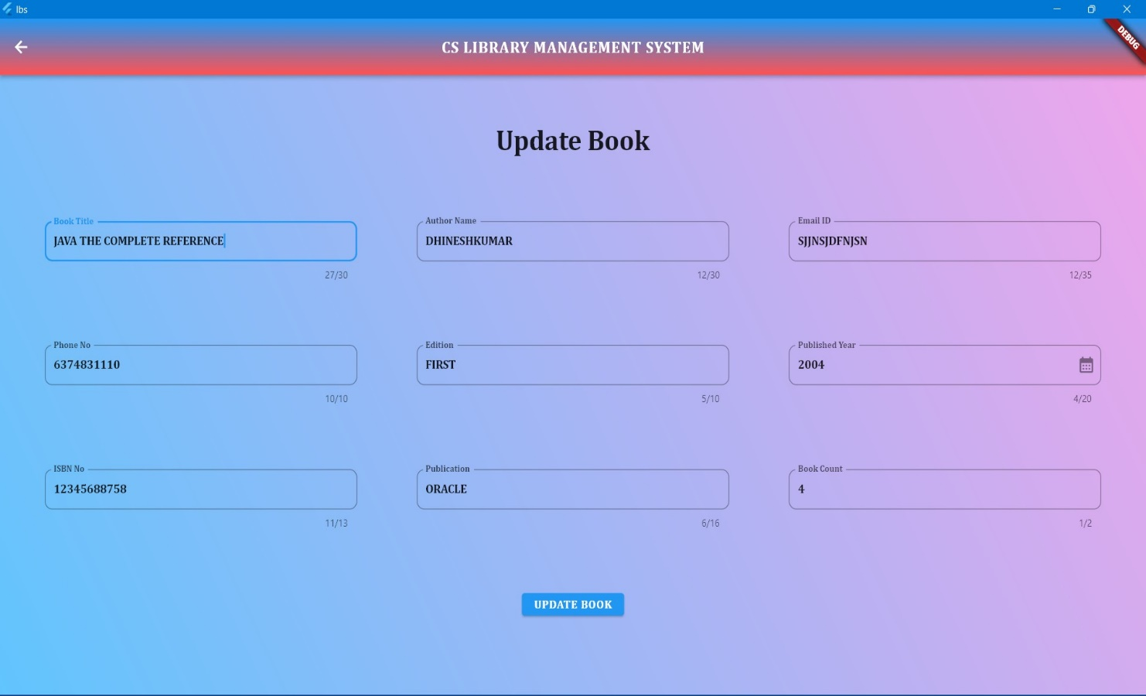

Figure 6.7 Update Book Details

**NOTE :**

* RENEW and RETURN BOOKS Facilities are available in the view students and staff Section.

**USE CASE DIAGRAM**

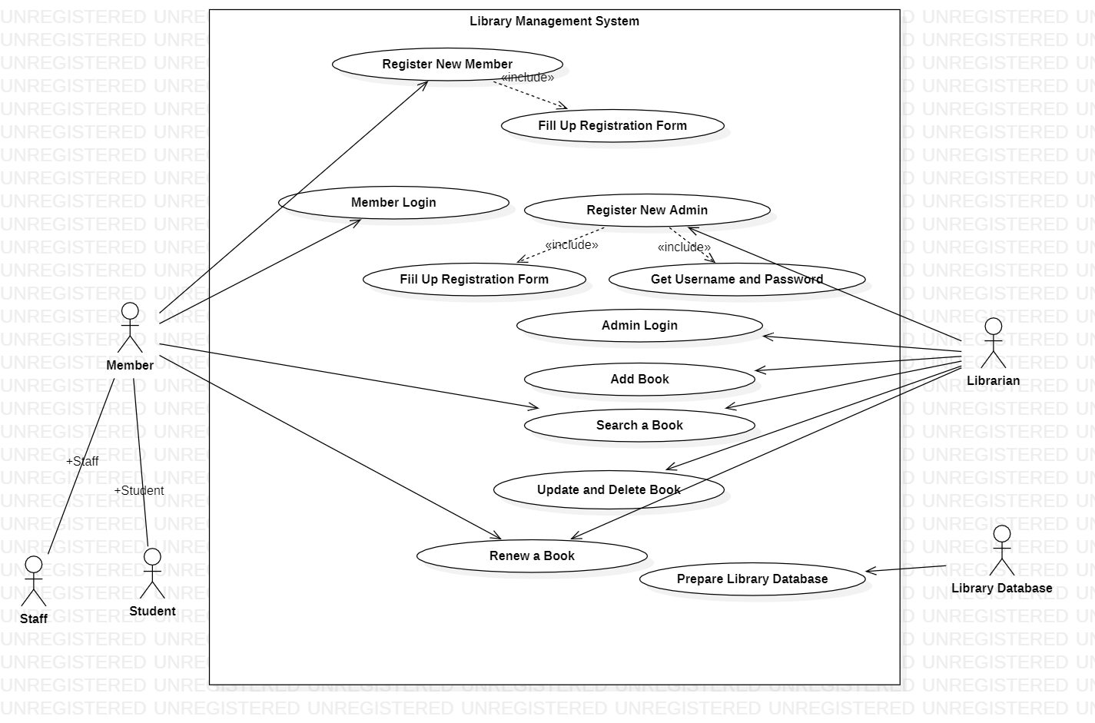

**CLASS DIAGRAM**

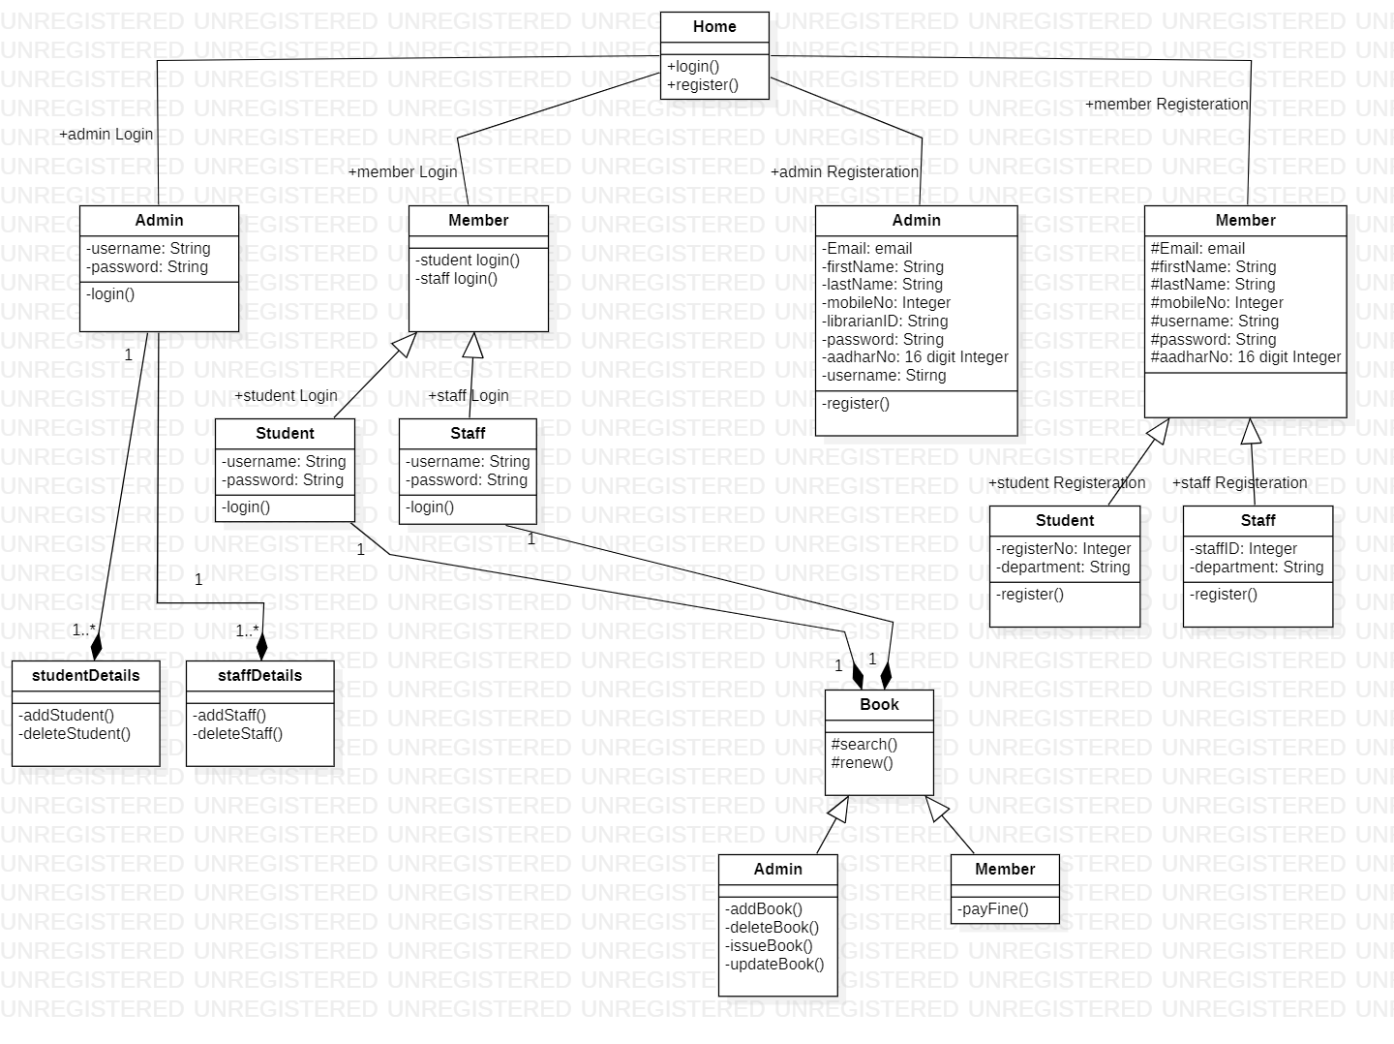

**DFD DIAGRAM**

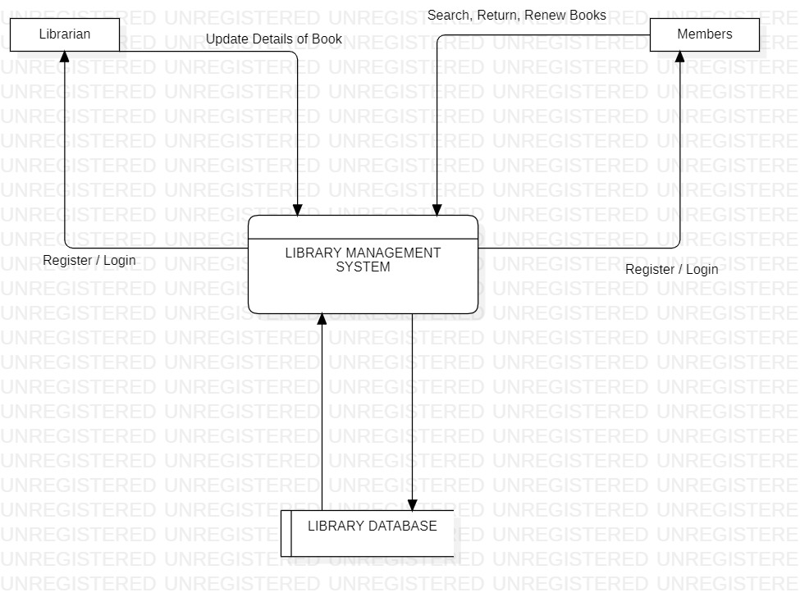

**SEQUENCE DIAGRAM**

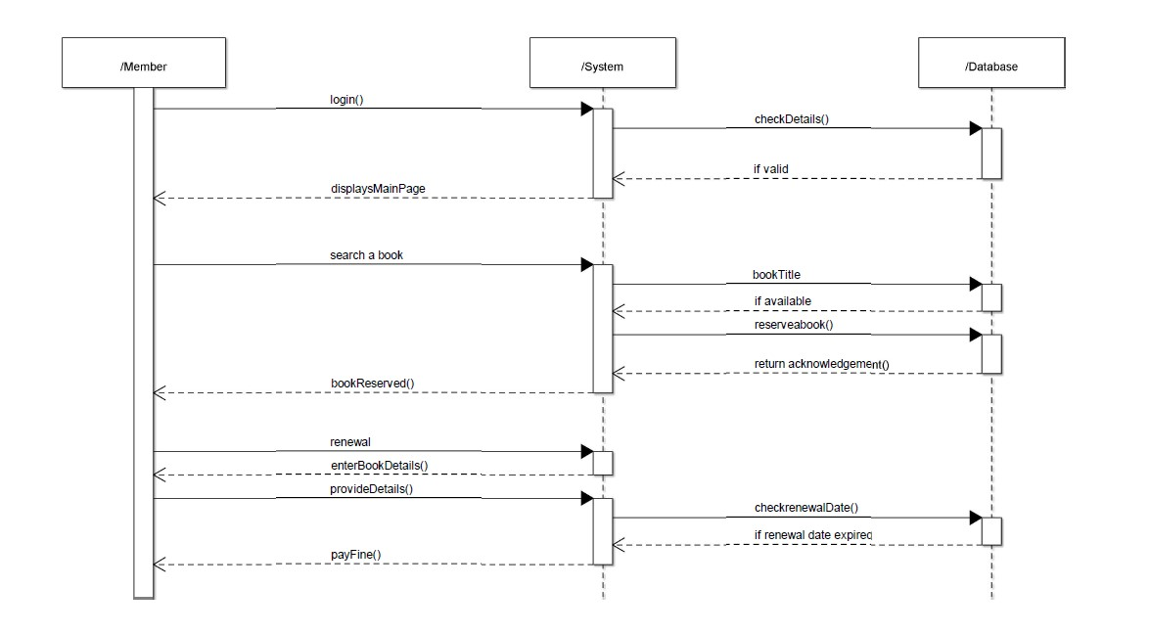

**DATA DESIGN**

**STUDENTS:**

|  |  |  |  |  |
| --- | --- | --- | --- | --- |
| **S.No** | **Data Item** | **Type** | **Length** | **Description** |
| 1 | STUDENTS | | INTEGER | STRING |
| 1.1 | First Name | String | 45 | First Name of the Student |
| 1.2 | Last Name | String | 45 | Last Name of the Student |
| 1.3 | Email | String | 45 | Email of the Student |
| 1.4 | Mobile No | String | 10 | Mobile No of the Student |
| 1.5 | Aadhar No | String | 16 | Aadhar No of the Student |
| 1.6 | Register No | String | 20 | Register No of the Student |
| 1.7 | Gender | String | 10 | Gender of the Student |
| 1.8 | Department | String | 10 | Department of the Student |
| 1.9 | Year | String | 10 | Year of the Student |
| 1.10 | DOB | Date | 10 | Date of the Birth of the Student |
| 1.11 | Username | String | 8 | Username of the Student |
| 1.12 | Password | String | 16 | Password of the Student |
| 1.13 | Count | INT | 10 | Limit of the Borrow the Book |

**STAFFS:**

|  |  |  |  |  |
| --- | --- | --- | --- | --- |
| **S.No** | **Data Item** | **Type** | **Length** | **Description** |
| 1 | STAFFS | | INTEGER | STRING |
| 1.1 | First Name | String | 45 | First Name of the Staff |
| 1.2 | Last Name | String | 45 | Last Name of the Staff |
| 1.3 | Email | String | 45 | Email of the Staff |
| 1.4 | Mobile No | String | 10 | Mobile No of the Staff |
| 1.5 | Aadhar No | String | 16 | Aadhar No of the Staff |
| 1.6 | Register No | String | 20 | Register No of the Staff |
| 1.7 | Gender | String | 10 | Gender of the Staff |
| 1.8 | Department | String | 10 | Department of the Staff |
| 1.9 | DOB | Date | 10 | Date of the Birth of the Staff |
| 1.10 | Username | String | 8 | Username of the Staff |
| 1.11 | Password | String | 16 | Password of the Staff |
| 1.12 | Count | INT | 10 | Limit of the Borrow the Book |

**LIBRARIAN:**

|  |  |  |  |  |
| --- | --- | --- | --- | --- |
| **S.No** | **Data Item** | **Type** | **Length** | **Description** |
| 1 | LIBRARIAN | | INTEGER | STRING |
| 1.1 | First Name | String | 45 | First Name of the Librarian |
| 1.2 | Last Name | String | 45 | Last Name of the Librarian |
| 1.3 | Email | String | 45 | Email of the Librarian |
| 1.4 | Mobile No | String | 10 | Mobile No of the Librarian |
| 1.5 | Aadhar No | String | 16 | Aadhar No of the Librarian |
| 1.6 | Librarian ID | String | 20 | Librarian ID of the Librarian |
| 1.7 | Gender | String | 10 | Gender of the Librarian |
| 1.8 | DOB | Date | 10 | Date of the Birth of the Librarian |
| 1.9 | Username | String | 8 | Username of the Librarian |
| 1.10 | Password | String | 16 | Password of the Librarian |

**BOOKS:**

|  |  |  |  |  |
| --- | --- | --- | --- | --- |
| **S.No** | **Data Item** | **Type** | **Length** | **Description** |
| 1 | BOOKS | | INTEGER | STRING |
| 1.1 | Book Name | String | 45 | Name of the Book |
| 1.2 | Author Name | String | 45 | Author Name of the Book |
| 1.3 | Email | String | 45 | Email of the Book |
| 1.4 | Mobile No | String | 10 | Mobile No of the Book |
| 1.5 | ISBN No | String | 16 | ISBN No of the Book |
| 1.6 | Published Year | String | 20 | Published Year of the Book |
| 1.7 | Publication | String | 10 | Publication of the Book |
| 1.8 | Edition | String | 10 | Edition of the Book |
| 1.9 | Count | INT | 10 | Count of the Book |

**Result :**

Thus, the project to develop Library Management System using ArgoUML diagram to implement it HTML, CSS, JS, FLUTTER and MongoDB is done Successfully.