**Experiment No:3**

Date: 23/08/2020

**Objective:**

To perform Shell scripting in Cygwin.

**Commands:**

* **vi filename-**

It creates a new file otherwise it opens an existing file.

**Note:** For inserting any text you should press **i**

* **bash filename-**

It can run and execute commands from a file.

1. **Write a shell program to write hello world.**

>Create helloWorld.sh file.

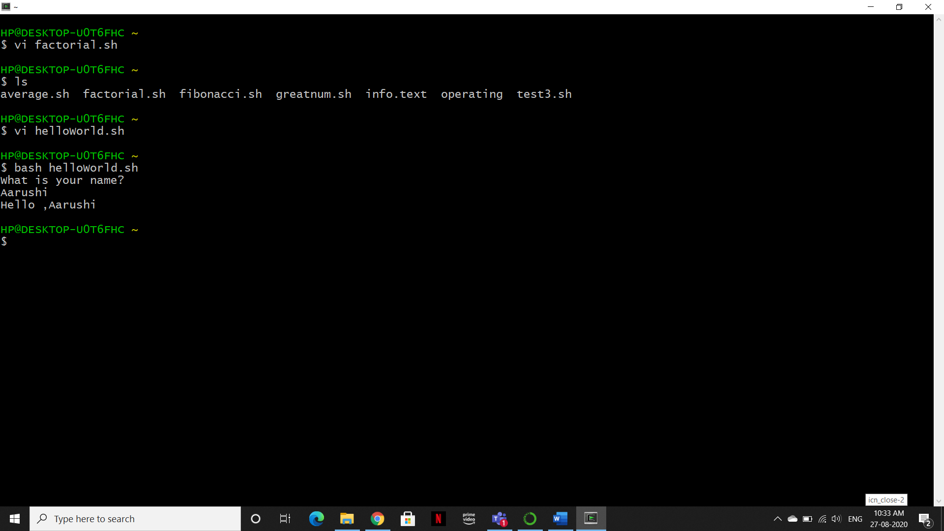

**>** Enter the following code and after completing the code press-“esc : wq” to end the script

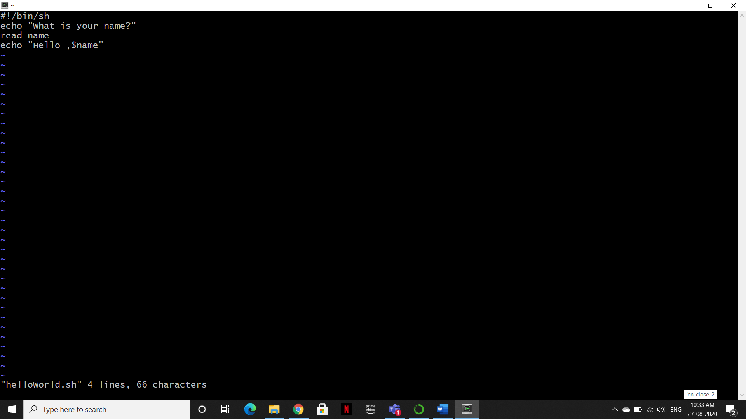

>Run the helloWorld.sh file



1. **Write a shell program to find Factorial of a number.**

>Create a factorial.sh file

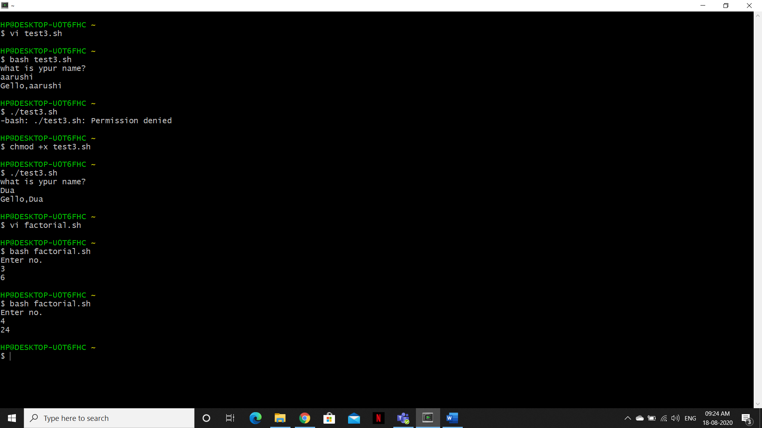

>Enter the following code and after completing the code press-“esc : wq” to end the script

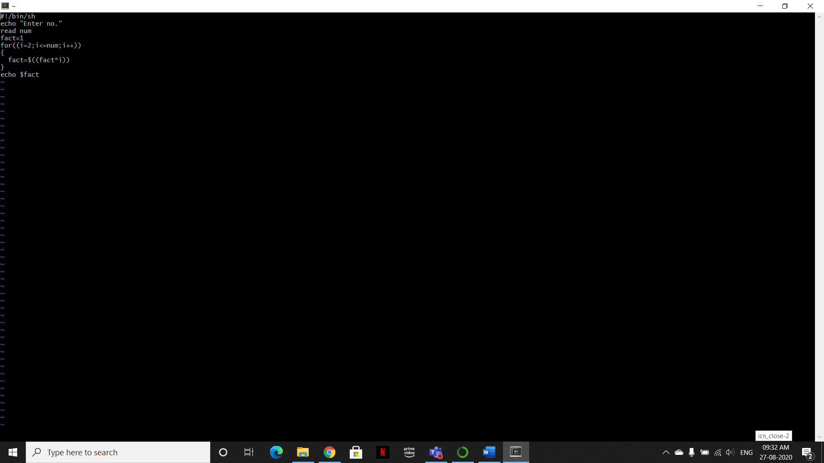

>Run the factorial.sh file 

1. **Write a shell program to find Fibonacci series.**

>Create a Fibonacci.sh file

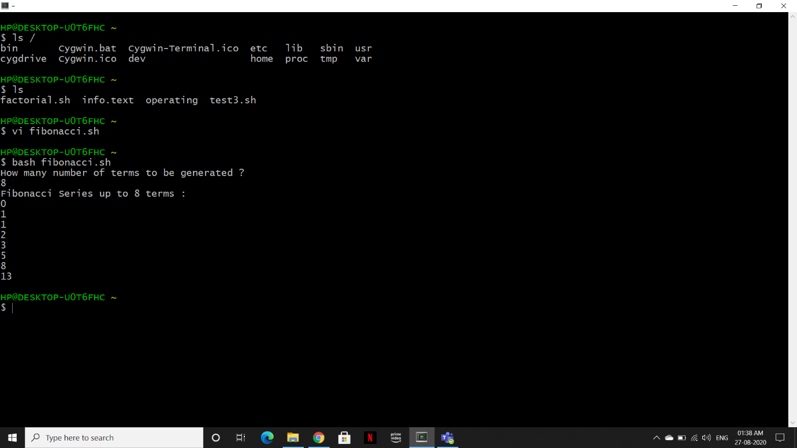

> Enter the following code and after completing the code press-“esc : wq” to end the script.

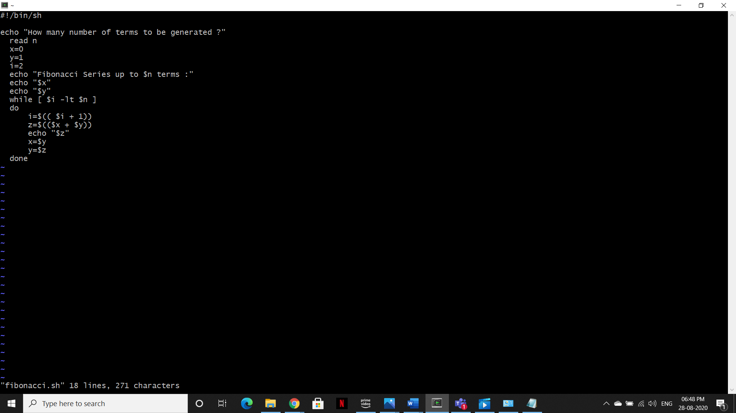

>Run the Fibonacci.sh file



1. **Write a shell program to find largest of three numbers.**

>Create a greatnum.sh file.

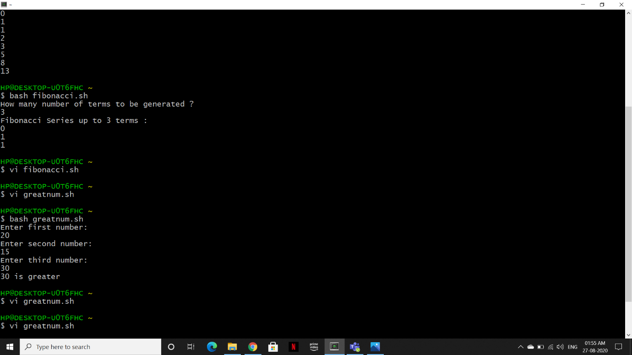

> Enter the following code and after completing the code press-“esc : wq” to end the script.

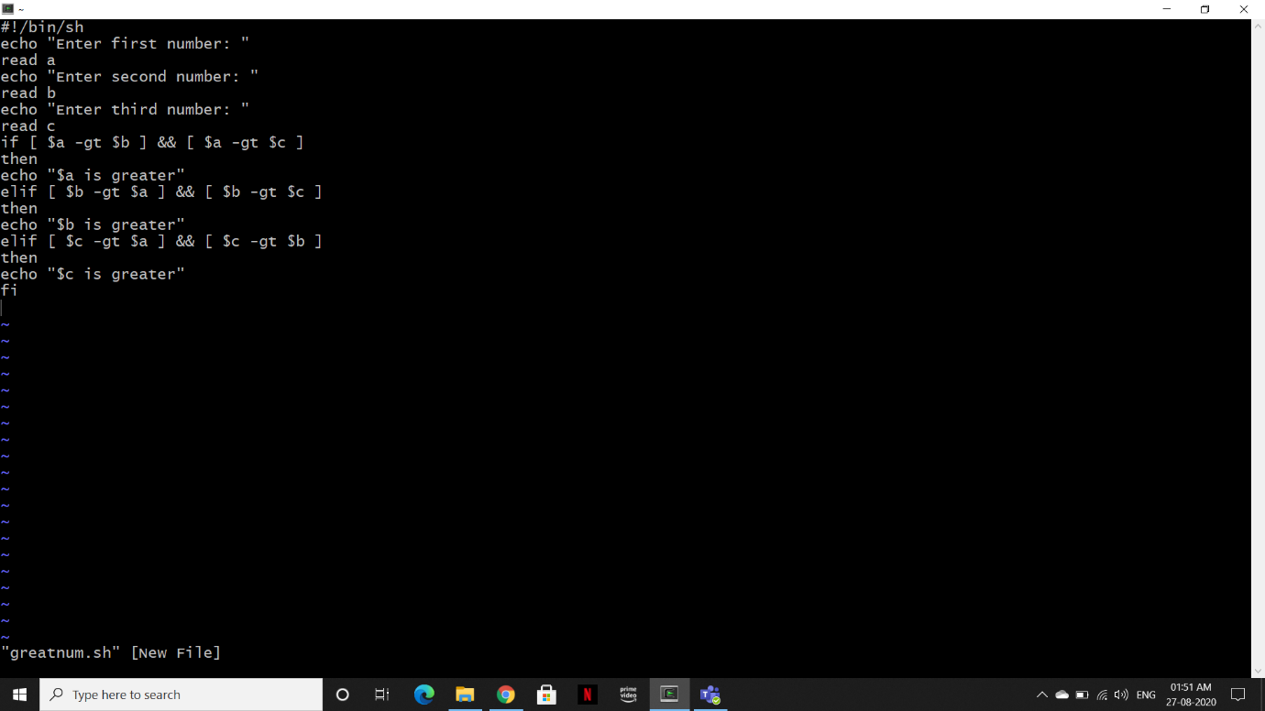

>Run the greatnum.sh file



1. **Write a shell program to find average of N numbers**

>Create a average_num.sh file.

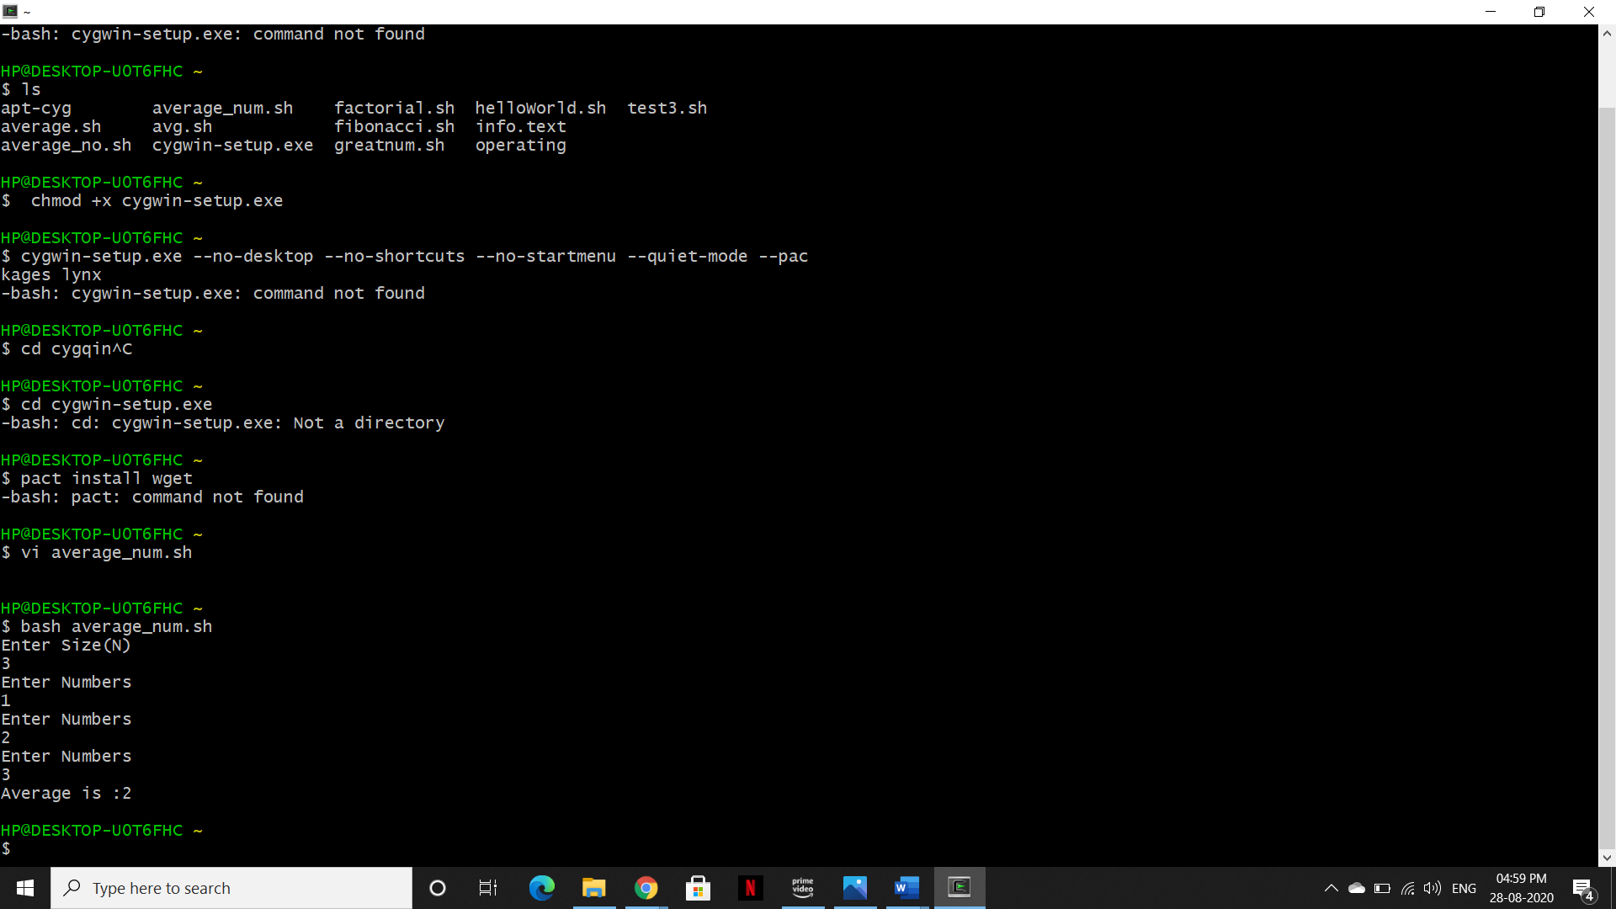

> Enter the following code and after completing the code press-“esc : wq” to end the file.

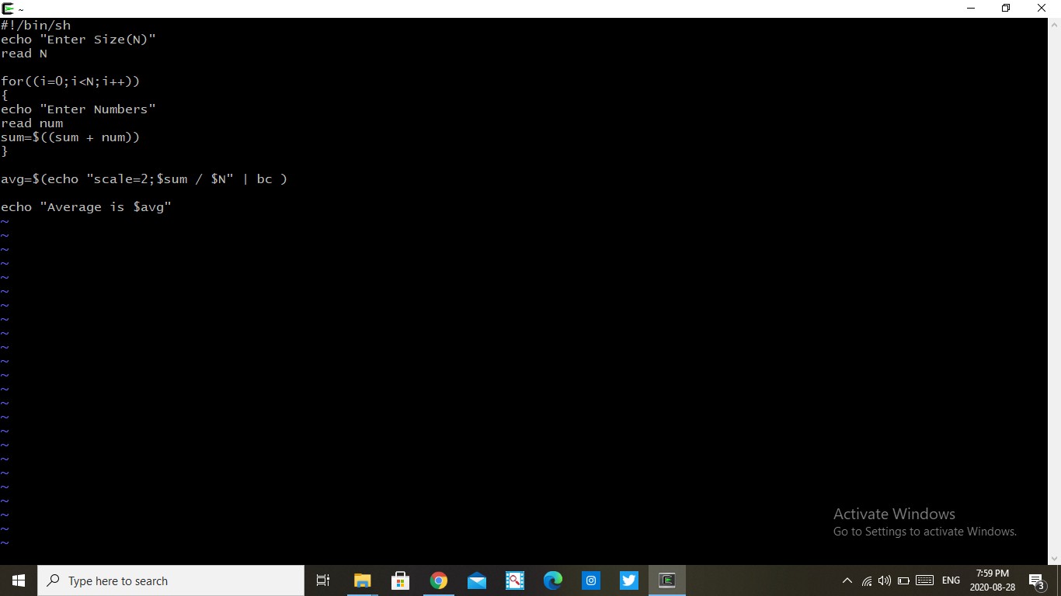

>Run the average_num.sh file

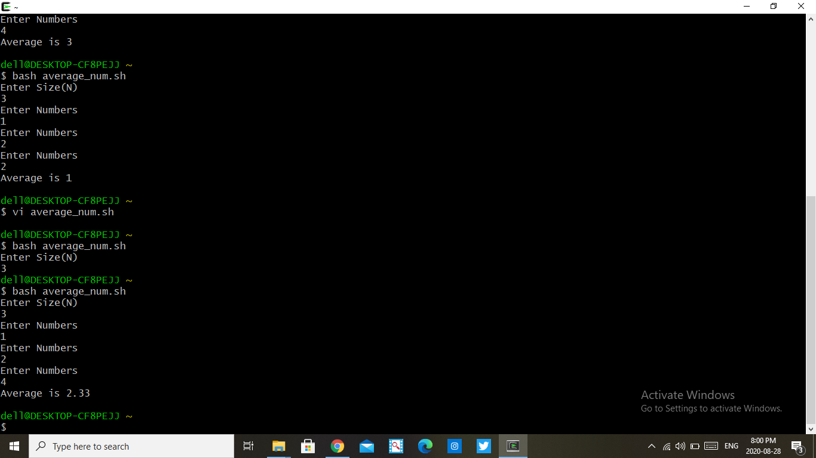

1. **Write a shell program to find gross salary of an employee.**

>Create a gross_salary.sh file

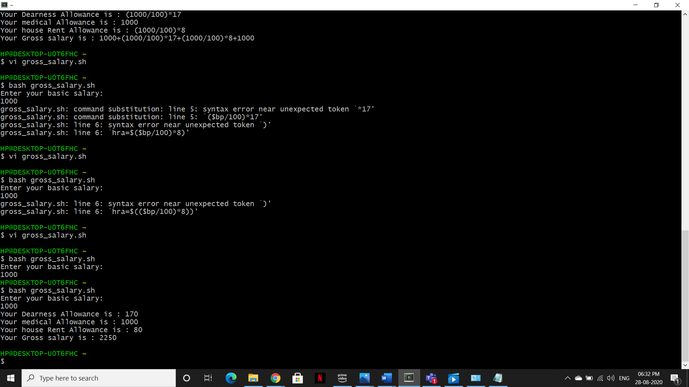

> Enter the following code and after completing the code press-“esc : wq” to end the file.

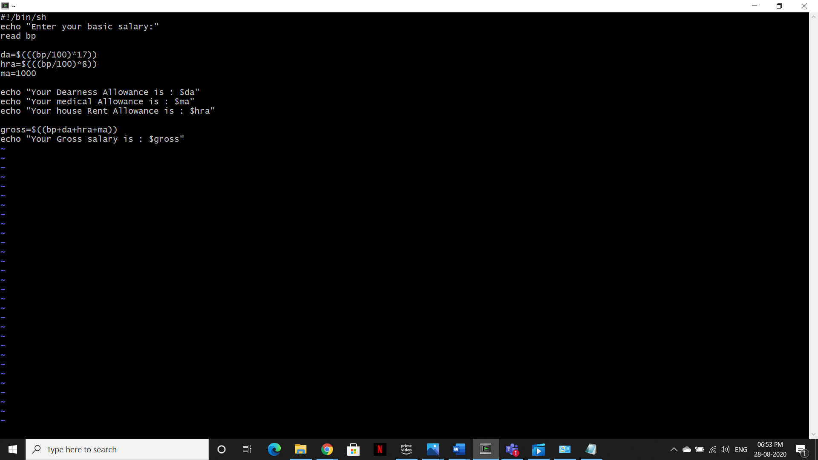

>Run the gross_salary.sh file

