AARUHYA KUMAR N
Full Stack Developer • AI Enthusiast • Tech Leader

Passionate Computer Science student with hands-on experience in full-stack development, AI technologies, and team leadership. Proven ability to build impactful tech solutions and lead teams, with a track record of competing at national-level hackathons and holding multiple leadership roles. Seeking to contribute to innovative, real-world tech challenges.

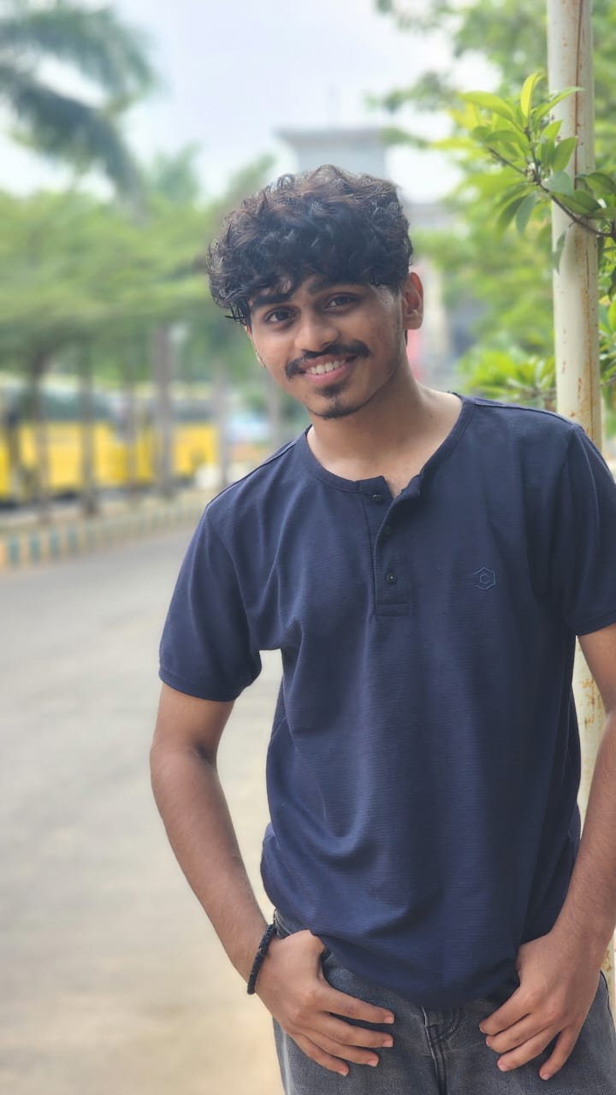  Contact  Phone: 9344531196  Email: nidigantiak@gmail.com  LinkedIn: linkedin.com/in/aaruhya-kumar  GitHub: github.com/aaruhya06  Technical Skills  • Python  • C Programming  • MySQL  • HTML & CSS  • Flutter  • Java (Basics)  Soft Skills  • Leadership & Team Management  • Critical Thinking & Problem Solving  • Adaptability  • Event Coordination  Currently Learning  • Full Stack Development  • UI/UX Design  • Web & App Development  • Freelancing  Hobbies  • Dancing  • Listening to Music  • Reading Novels  • Badminton | Education  Agni College of Technology  BE – Computer Science & Engineering | Expected 2028  RMK Residential School  HSC (Class XII) | 2023–2024 | 78.8%  AM Jain School  SSLC (Class X) | 2021–2022 | 80.00%  Projects  Gramify – Rural E-Commerce Platform  Flutter | Social Impact | UI/UX Design | Team of 4  • Built a prototype promoting local products under the "One Village One Product" initiative  • Focused on inclusive access, emotional design, and rural entrepreneurship  • Demonstrated to 20+ stakeholders; collaborated in a team of 4  PDF to Video Lecture Generator  Python | EdTech | Text-to-Speech | Team of 4  • Transforms static PDFs into dynamic video lectures using text-to-speech and visual rendering  • Designed to enhance accessibility and engagement for learners  Hospital Management System  Python | MySQL | Backend Logic | Team of 4  • Console-based system to manage patient records, appointments, and billing  • Emphasized modular structure and clean database integration  Hackathons & Competitions  Alliance One Hackathon – Top 7 of 40 Teams (National Level)  Feb 19–21, 2026 | Team of 4  • Competed against 40 teams from across India and ranked in the top 7  Stackathon Coding Challenge – 3rd Place  • Secured 3rd place in a competitive coding challenge  Leadership & Experience  Secretary – Rotaract Club | Agni College of Technology | 2024–Present  • Leading club as Secretary; organizing community service and social impact initiatives  • Coordinating members, planning activities, and maintaining club records  Tech Volunteer – College Events | Agni College of Technology | 2024–Present  • Supported setup and logistics for tech fests and workshops  • Managed registration portals, live updates, and cross-team coordination  Sports Secretary (Class XII) | RMK Residential School | 2023–2024  • Organized inter-school sports events and managed student athletics programs  Assistant School Pupil Leader (Class XI) | RMK Residential School | 2022–2023  • Supported school administration and represented student body in key decisions  Honors & Awards  • State-Level Badminton Player – Multiple medals  • Recognized as Creative Mind – School Award  • Academic & Extracurricular Excellence – Multiple prizes  Certifications  • AI with ML – Wipro  • Full Stack Development – Aprotech  • Generative AI – Online Platforms  • AI with Deep Learning – Online Platforms

