**CUDA PROGRAMMING – PARALLEL AND DISTRIBUTED COMPUTING**

**(PCS – 106)**



**SUBMITTED TO: SUBMITTED BY:**

**Ms RUHI SAXENA ARUN KUSHWAHA**

**CSE Deptt. 801732005**

**ME(CS1)**

**INDEX**

|  |  |  |  |
| --- | --- | --- | --- |
| **SNO** | **EXERCISES** | **PAGE NO.** | **REMARKS** |
| 1 | CUDA Program to print “Hello World”. | 1 |  |
| 2 | CUDA Program for matrix addition. | 2 |  |
| 3 | CUDA Program for matrix multiplication. | 5 |  |
| 5 | . CUDA Program for even-odd sorting | 8 |  |
| 4 | . CUDA Program for vector addition | 11 |  |
| 6 | CUDA Program to calculate execution time by increasing  blocks. | 13 |  |
| 7 | CUDA Program to calculate execution time by increasing threads. | 16 |  |
| 8 | CUDA Program for swapping two numbers. | 19 |  |
| 9 | CUDA Program for Bitonic Sorting. | 21 |  |
| 10 | CUDA Program for vector addition through sine function. | 25 |  |
| 11 | CUDA Program for vector addition through cosine  function. | 27 |  |
| 12 | CUDA Program for matrix addition through random  function. | 29 |  |

# PROGRAM 1

**Write a simple program in cuda programming**

#include<stdio.h>

__global__ void Kernel(void)

{

}

int main(void)

{

Kernel<<<1,1>>>();

printf("Hello World/\n");

return 0;

}

**Output**



**PROGRAM 2**

**Write a program of matrix addition in cuda programming**

#include<stdio.h>

#include<stdlib.h>

#include<cuda.h>

#include<math.h>

__global__ void addMat(int a[],int b[],int c[],int m,int n)

{

int index=blockDim.x*blockIdx.x+threadIdx.x;

if(blockIdx.x<m && threadIdx.x<n) {

c[index]=a[index]+b[index];

}}

void readMat(int a[],int r,int c)

{

for(int i=0;i<r;i++)

{

for(int j=0;j<c;j++)

{

scanf("%d",&a[i*c+j]);

}}}

void printMat(int a[],int r,int c)

{

for(int i=0;i<r;i++)

{

for(int j=0;j<c;j++)

{

printf("%d ",a[i*c+j]);

}}}

int main()

{

int r=3,c=3;

int *ha,*hb,*hc,*da,*db,*dc;

size_t size;

size=r*c*sizeof(int);

ha=(int*) malloc(size);

hb=(int*) malloc(size);

hc=(int*) malloc(size);

printf("Matrix A (3*3): ");

readMat(ha,r,c);

printf("Matrix B (3*3): ");

readMat(hb,r,c);

cudaMalloc(&da,size);

cudaMalloc(&db,size);

cudaMalloc(&dc,size);

cudaMemcpy(da,ha,size,cudaMemcpyHostToDevice);

cudaMemcpy(db,hb,size,cudaMemcpyHostToDevice);

addMat<<<r,c>>>(da,db,dc,r,c);

cudaMemcpy(hc,dc,size,cudaMemcpyDeviceToHost);

printf("Matrix after addition Matrix C: ");

printMat(hc,r,c);

cudaFree(da);

cudaFree(db);

cudaFree(dc);

free(ha);

free(hb);

free(hc);

return 0;

}

**Output**

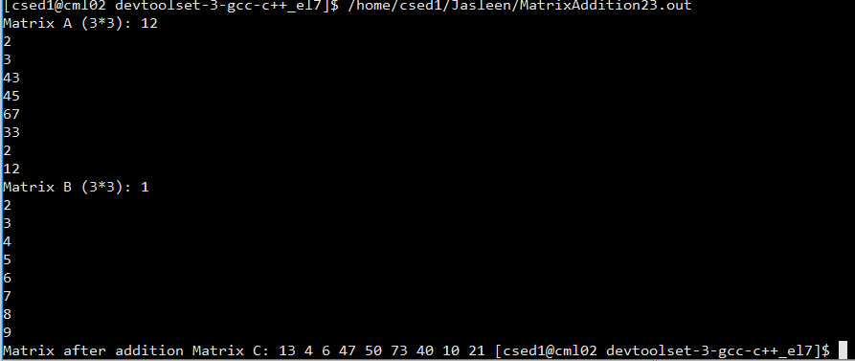

**PROGRAM 3**

**Write a program of matrix multiplication in cuda programming**

#include<cuda.h>

#include<stdio.h>

__global__ void MatrixMulKernel(int *Md, int *Nd, int *Pd, int Width) {

int tId = threadIdx.x;

int bId = blockIdx.x;

int Pvalue = 0;

for(int k = 0; k < Width ; ++k) {

int Mdelement = Md[bId*Width + k];

int Ndelement = Nd[k*Width + tId];

Pvalue += (Mdelement*Ndelement);

}

Pd[bId*Width + tId] = Pvalue;

}

void readMat(int a[], int Width)

{

for(int i=0;i<Width;i++)

{

for( int j=0;j<Width;j++)

{

scanf("%d", &a[i*Width+j]);

}}}

void printMat(int a[], int Width)

{

for(int i=0;i<Width;i++)

{

for(int j=0;j<Width;j++)

{

printf("%d ", a[i*Width+j]);

}}}

int main() {

void MatrixMultiplication(int *, int *, int *, int);

const int Width = 3;

int M[Width*Width], N[Width*Width], P[Width*Width];

printf("\n Enter a 3*3 Matrix M \n");

readMat(M, Width);

printf("\n Enter a 3*3 Matrix N \n");

readMat(N, Width);

MatrixMultiplication(M, N, P, Width);

printf("\n Matrix M ");

printMat(M,Width);

printf("\n Matrix N ");

printMat(N,Width);

printf("\n Matrix P ");

printMat(P,Width);

return 0;

}

void MatrixMultiplication(int *M, int *N, int *P, int Width) {

int size = Width*Width*sizeof(int);

int *Md, *Nd, *Pd;

cudaMalloc((void**)&Md, size);

cudaMemcpy(Md,M,size,cudaMemcpyHostToDevice);

cudaMalloc((void**)&Nd, size);

cudaMemcpy(Nd,N,size,cudaMemcpyHostToDevice);

cudaMalloc((void**)&Pd,size);

MatrixMulKernel<<<Width,Width>>>(Md,Nd,Pd,Width);

cudaMemcpy(P,Pd,size,cudaMemcpyDeviceToHost);

cudaFree(Md);

cudaFree(Nd);

cudaFree(Pd);

}

**Output**

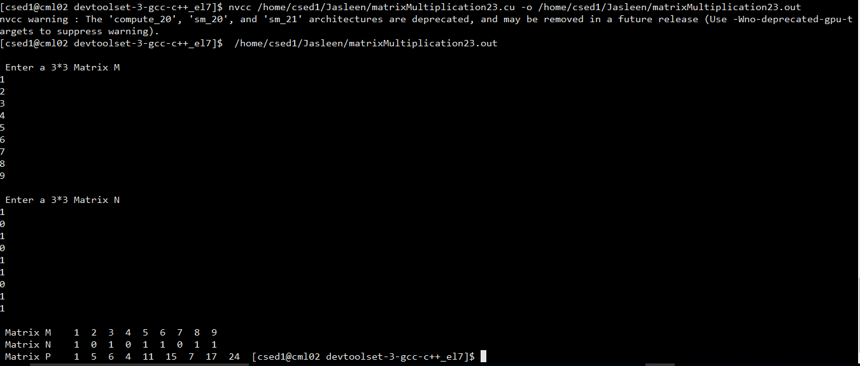

# Program 4

**Write a program of odd even sorting using cuda programming**

#include<stdio.h>

#include<cuda.h>

__global__ void even(int *darr, int n )

{

int k=threadIdx.x;

int t;

k=k*2;

if(k<=n-2)

{

if(darr[k]> darr[k+1])

{

t=darr[k];

darr[k]=darr[k+1];

darr[k+1]=t;

}

}

}

__global__ void odd(int *darr, int n )

{

int k = threadIdx.x;

int t;

k=k*2+1;

if(k<=n-2)

{

if(darr[k]> darr[k+1])

{

t=darr[k];

darr[k]=darr[k+1];

darr[k+1]=t;

}

}

}

int main()

{

int *arr, *darr;

int n,i;

printf("how many numbers to enter:");

scanf("%d", &n);

arr=(int*)malloc(n*sizeof(int));

printf("Enter the nos");

for(i=0;i<n;i++)

{

scanf("%d", &arr[i]);

}

cudaMalloc(&darr, n*sizeof(int));

cudaMemcpy(darr, arr, n*sizeof(int), cudaMemcpyHostToDevice);

for(i=0;i<=n/2;i++)

{

even <<<1,n>>> (darr,n);

odd <<<1,n>>> (darr,n);

}

cudaMemcpy( arr, darr, n*sizeof(int), cudaMemcpyDeviceToHost);

printf("Sorted Array");

for(i=0;i<n;i++)

{

printf("%d\t", arr[i]);

}

return 0;

}

**Output:**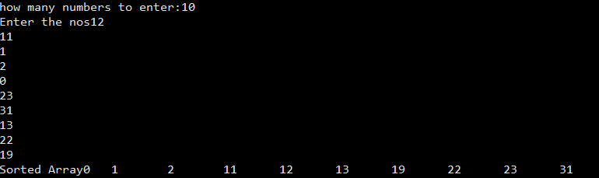

# Program 5

**Write a program of vector addition in cuda**

#include<stdio.h>

#include<stdlib.h>

#include<cuda.h>

#include<cuda_runtime.h>

#define N 10

__global__ void add(int *a,int *b,int *c)

{

int bid=blockIdx.x;

if(bid<N)

c[bid]=a[bid]+b[bid];

}

int main(void)

{

int i,a[N],b[N],c[N];

int *dev_a,*dev_b,*dev_c;

cudaMalloc((void**)&dev_a,N*sizeof(int));

cudaMalloc((void**)&dev_b,N*sizeof(int));

cudaMalloc((void**)&dev_c,N*sizeof(int));

for(i=0;i<N;i++)

{

a[i]=-(i*i);

b[i]=(i*i*i);

}

cudaMemcpy(dev_a,a,N*sizeof(int),cudaMemcpyHostToDevice);

cudaMemcpy(dev_b,b,N*sizeof(int),cudaMemcpyHostToDevice);

add<<<N,1>>>(dev_a,dev_b,dev_c);

cudaMemcpy(c,dev_c,N*sizeof(int),cudaMemcpyDeviceToHost);

printf("\n a+b=c \n");

for(i=0;i<N;i++)

{

printf("%d+%d=%d\n",a[i],b[i],c[i]);

}

cudaFree(dev_a);

cudaFree(dev_b);

cudaFree(dev_c);

}

**Output:**

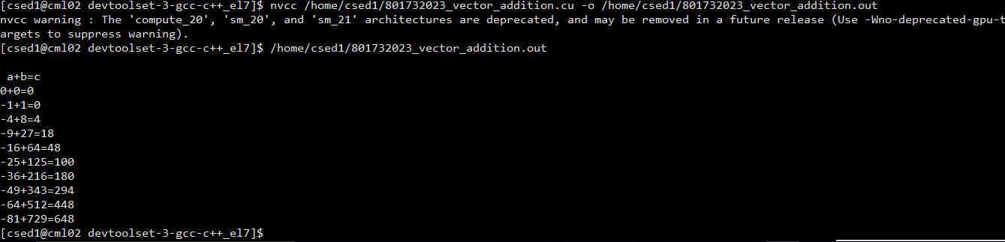

**Program 6**

**WAP to calculate execution time by increasing blocks**

#include<stdio.h>

#include<stdlib.h>

#include<cuda.h>

#include<math.h>

#include <time.h>

__global__ void addMat(int a[],int b[],int c[],int m,int n)

{

int index=blockDim.x*blockIdx.x+threadIdx.x;

if(blockIdx.x<m && threadIdx.x<n) {

c[index]=a[index]+b[index];

}

}

void readMat(int a[],int r,int c)

{

for(int i=0;i<r;i++)

{

for(int j=0;j<c;j++)

{

scanf("%d",&a[i*c+j]);

}

}

}

void printMat(int a[],int r,int c)

{

for(int i=0;i<r;i++)

{

for(int j=0;j<c;j++)

{

printf("%d ",a[i*c+j]);

}

}

printf("\n");

}

int main()

{

int r=3,c=3;

int *ha,*hb,*hc,*da,*db,*dc;

size_t size;

size=r*c*sizeof(int);

ha=(int*) malloc(size);

hb=(int*) malloc(size);

hc=(int*) malloc(size);

printf("Matrix A: ");

readMat(ha,r,c);

printf("Matrix B: ");

readMat(hb,r,c);

cudaMalloc(&da,size);

cudaMalloc(&db,size);

cudaMalloc(&dc,size);

cudaMemcpy(da,ha,size,cudaMemcpyHostToDevice);

cudaMemcpy(db,hb,size,cudaMemcpyHostToDevice);

clock_t tic = clock();

addMat<<<9,1>>>(da,db,dc,r,c);

clock_t toc = clock();

cudaMemcpy(hc,dc,size,cudaMemcpyDeviceToHost);

printf("Matrix after addition Matrix C: ");

printMat(hc,r,c);

cudaFree(da);

cudaFree(db);

cudaFree(dc);

printf("Elapsed: %f seconds\n", (double)(toc - tic) / CLOCKS_PER_SEC);

free(ha);

free(hb);

free(hc);

return 0;

}

**Output:**

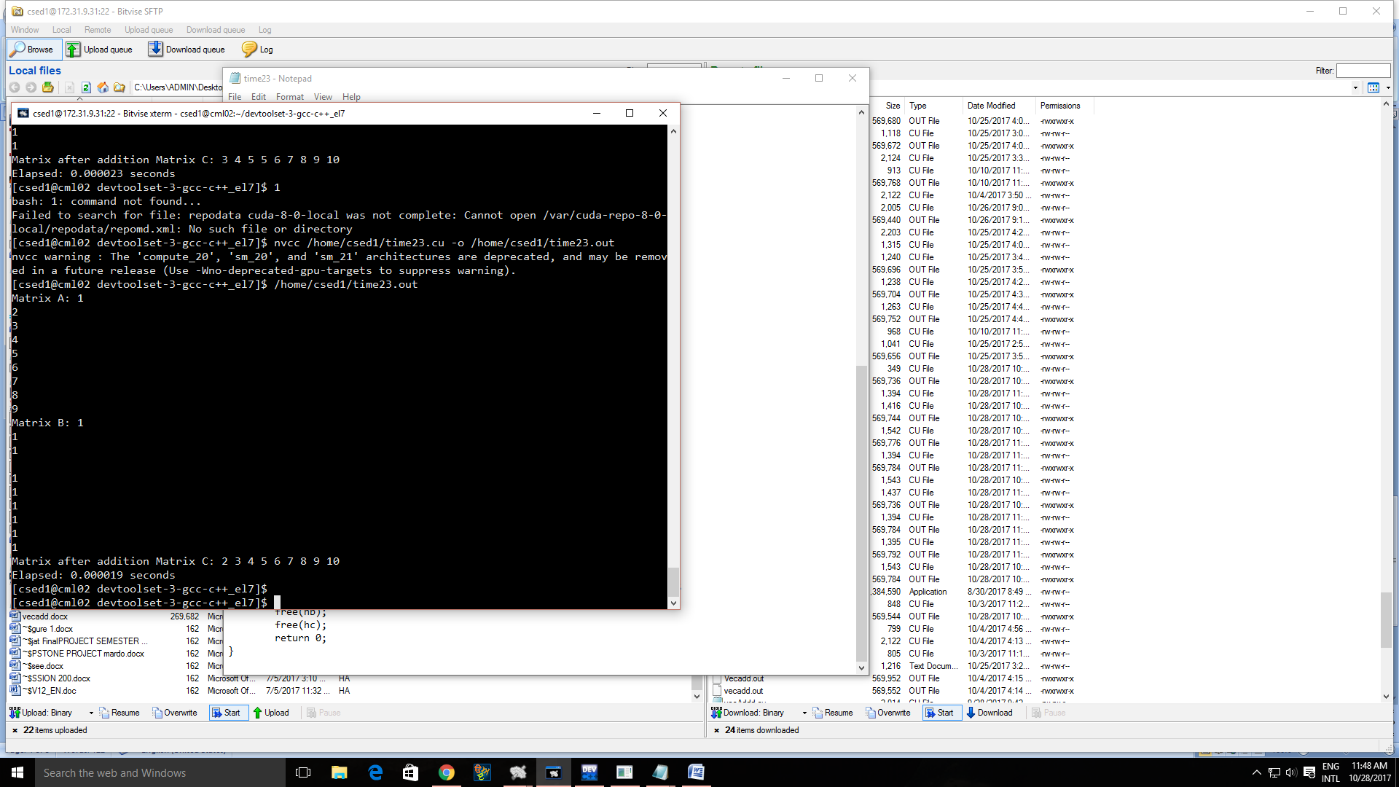

# Program 7

**WAP to calculate CPU execution time by increasing threads**

#include<stdio.h>

#include<stdlib.h>

#include<cuda.h>

#include<math.h>

#include <time.h>

__global__ void addMat(int a[],int b[],int c[],int m,int n)

{

int index=blockDim.x*blockIdx.x+threadIdx.x;

if(blockIdx.x<m && threadIdx.x<n) {

c[index]=a[index]+b[index];

}

}

void readMat(int a[],int r,int c)

{

for(int i=0;i<r;i++)

{

for(int j=0;j<c;j++)

{

scanf("%d",&a[i*c+j]);

}

}

}

void printMat(int a[],int r,int c)

{

for(int i=0;i<r;i++)

{

for(int j=0;j<c;j++)

{

printf("%d ",a[i*c+j]);

}

}

printf("\n");

}

int main()

{

int r=3,c=3;

int *ha,*hb,*hc,*da,*db,*dc;

size_t size;

size=r*c*sizeof(int);

ha=(int*) malloc(size);

hb=(int*) malloc(size);

hc=(int*) malloc(size);

printf("Matrix A: ");

readMat(ha,r,c);

printf("Matrix B: ");

readMat(hb,r,c);

cudaMalloc(&da,size);

cudaMalloc(&db,size);

cudaMalloc(&dc,size);

cudaMemcpy(da,ha,size,cudaMemcpyHostToDevice);

cudaMemcpy(db,hb,size,cudaMemcpyHostToDevice);

clock_t tic = clock();

addMat<<<1,9>>>(da,db,dc,r,c);

clock_t toc = clock();

cudaMemcpy(hc,dc,size,cudaMemcpyDeviceToHost);

printf("Matrix after addition Matrix C: ");

printMat(hc,r,c);

cudaFree(da);

cudaFree(db);

cudaFree(dc);

printf("Elapsed: %f seconds\n", (double)(toc - tic) / CLOCKS_PER_SEC);

free(ha);

free(hb);

free(hc);

return 0;

}

**Output:**

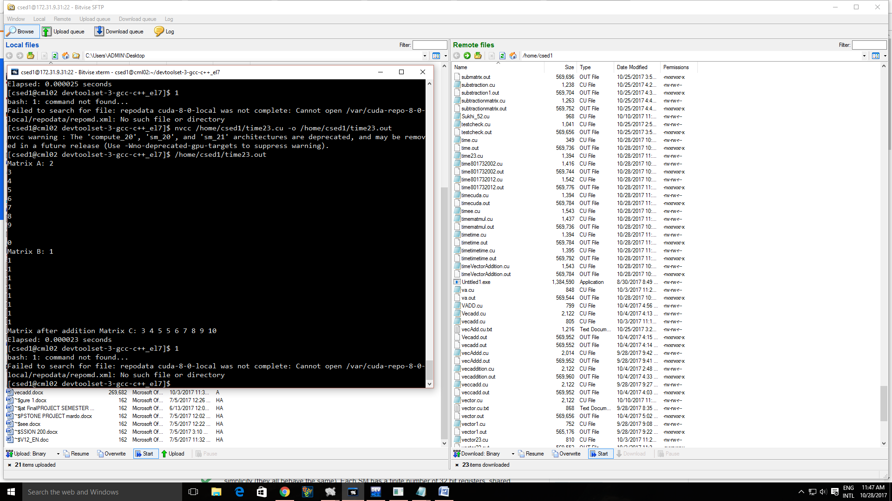

# Program 8

**WAP to swap two numbers using cuda**

#include<stdio.h>

#include<stdlib.h>

__global__ void swap(int *a,int *b,int* c)

{

*c=*a;

*a=*b;

*b=*c;

}

int main(void)

{

int a,b,c;

int * dev_a,*dev_b,*dev_c;

int size=sizeof(int);

cudaMalloc((void **)&dev_a,size);

cudaMalloc((void **)&dev_b,size);

cudaMalloc((void **)&dev_c,size);

a=2;

b=7;

printf("Values before Swaping\n");

printf("%d is the value of a\n",a);

printf("%d is the value of b\n",b);

cudaMemcpy(dev_a,&a,size,cudaMemcpyHostToDevice);

cudaMemcpy(dev_b,&b,size,cudaMemcpyHostToDevice);

swap<<<1,1>>>(dev_a,dev_b,dev_c);

cudaMemcpy(&a,dev_a,size,cudaMemcpyDeviceToHost);

cudaMemcpy(&b,dev_b,size,cudaMemcpyDeviceToHost);

cudaMemcpy(&c,dev_c,size,cudaMemcpyDeviceToHost);

cudaFree(dev_a);

cudaFree(dev_b);

cudaFree(dev_c);

printf("Values after Swaping\n");

printf("%d is the value of a\n",a);

printf("%d is the value of b\n",b);

return 0;

}

**Output:**

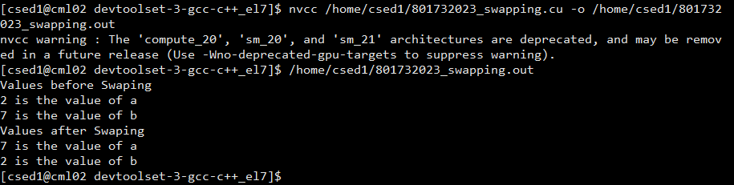

**Program 9**

**WAP to implement bitonic sort in cuda programming**

#include <stdlib.h>

#include <stdio.h>

#include <time.h>

/* Every thread gets exactly one value in the unsorted array. */

#define THREADS 2

#define BLOCKS 4

#define NUM_VALS THREADS*BLOCKS

void print_elapsed(clock_t start, clock_t stop)

{

double elapsed = ((double) (stop - start)) / CLOCKS_PER_SEC;

printf("Elapsed time: %.3fs\n", elapsed);

}

float random_float()

{

return (float)rand()/(float)RAND_MAX;

}

void array_print(float *arr, int length)

{

int i;

for (i = 0; i < length; ++i) {

printf("%1.3f ", arr[i]);

}

printf("\n");

}

void array_fill(float *arr, int length)

{

srand(time(NULL));

int i;

for (i = 0; i < length; ++i) {

arr[i] = random_float();

}

}

__global__ void bitonic_sort_step(float *dev_values, int j, int k)

{

unsigned int i, ixj; /* Sorting partners: i and ixj */

i = threadIdx.x + blockDim.x * blockIdx.x;

ixj = i^j;

/* The threads with the lowest ids sort the array. */

if ((ixj)>i) {

if ((i&k)==0) {

/* Sort ascending */

if (dev_values[i]>dev_values[ixj]) {

/* exchange(i,ixj); */

float temp = dev_values[i];

dev_values[i] = dev_values[ixj];

dev_values[ixj] = temp;

}

}

if ((i&k)!=0) {

/* Sort descending */

if (dev_values[i]<dev_values[ixj]) {

/* exchange(i,ixj); */

float temp = dev_values[i];

dev_values[i] = dev_values[ixj];

dev_values[ixj] = temp;

}

}

}

}

/**

* Inplace bitonic sort using CUDA.

*/

void bitonic_sort(float *values)

{

float *dev_values;

size_t size = NUM_VALS * sizeof(float);

cudaMalloc((void**) &dev_values, size);

cudaMemcpy(dev_values, values, size, cudaMemcpyHostToDevice);

dim3 blocks(BLOCKS,1); /* Number of blocks */

dim3 threads(THREADS,1); /* Number of threads */

int j, k;

/* Major step */

for (k = 2; k <= NUM_VALS; k <<= 1) {

/* Minor step */

for (j=k>>1; j>0; j=j>>1) {

bitonic_sort_step<<<blocks, threads>>>(dev_values, j, k);

}

}

cudaMemcpy(values, dev_values, size, cudaMemcpyDeviceToHost);

cudaFree(dev_values);

}

int main(void)

{

clock_t start, stop;

float *values = (float*) malloc( NUM_VALS * sizeof(float));

array_fill(values, NUM_VALS);

printf(" Array with random numbers ");

array_print(values, NUM_VALS) ;

start = clock();

bitonic_sort(values); /* Inplace */

stop = clock();

printf(" Array After Sorting ");

array_print(values, NUM_VALS) ;

print_elapsed(start, stop);

}

**Output:**

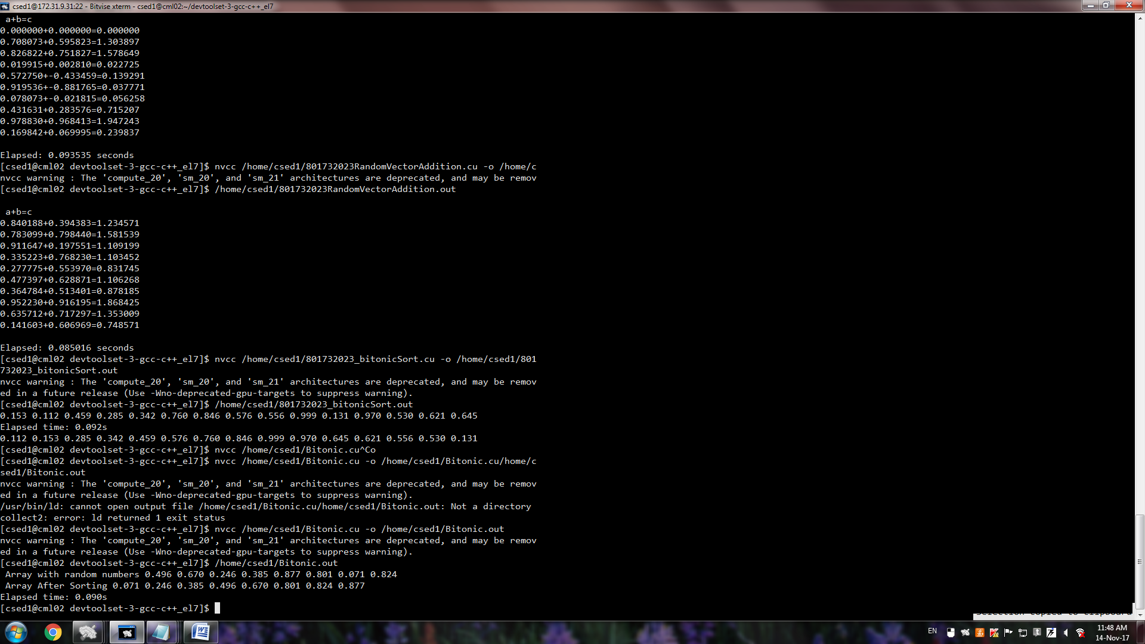

**Program 10**

**WAP to implement vector addition using sine function in cuda programming**

#include<stdio.h>

#include<stdlib.h>

#include<cuda.h>

#include<cuda_runtime.h>

#define N 10

__global__ void add(float *a,float *b,float *c)

{

int bid=blockIdx.x;

if(bid<N)

c[bid]=a[bid]+b[bid];

}

int main(void)

{

int i;

float a[N],b[N],c[N];

float *dev_a,*dev_b,*dev_c;

clock_t tic = clock();

cudaMalloc((void**)&dev_a,N*sizeof(float));

cudaMalloc((void**)&dev_b,N*sizeof(float));

cudaMalloc((void**)&dev_c,N*sizeof(float));

for(i=0;i<N;i++)

{

a[i]=-sin(i)*sin(i);

b[i]=sin(i)*sin(i)*sin(i);

}

cudaMemcpy(dev_a,a,N*sizeof(float),cudaMemcpyHostToDevice);

cudaMemcpy(dev_b,b,N*sizeof(float),cudaMemcpyHostToDevice);

add<<<N,1>>>(dev_a,dev_b,dev_c);

cudaMemcpy(c,dev_c,N*sizeof(float),cudaMemcpyDeviceToHost);

printf("\n a+b=c \n");

for(i=0;i<N;i++)

{

printf("%f+%f=%f\n",a[i],b[i],c[i]);

}

clock_t toc = clock();

cudaFree(dev_a);

cudaFree(dev_b);

cudaFree(dev_c);

printf("\nElapsed: %f seconds\n", (double)(toc - tic) / CLOCKS_PER_SEC);

}

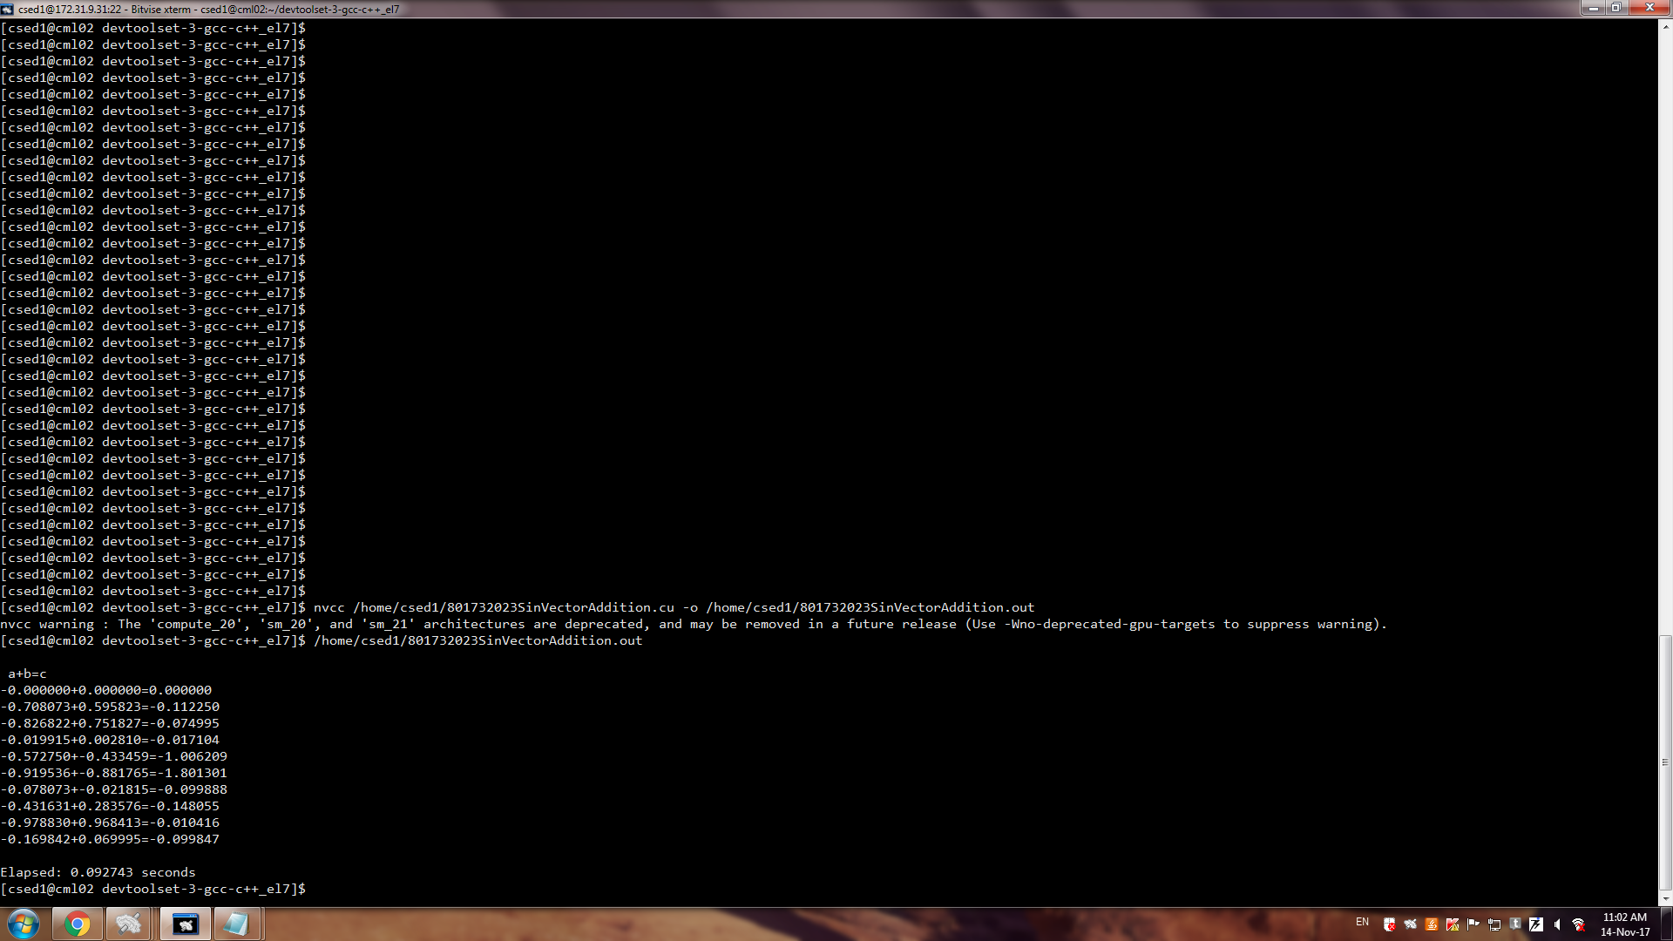

**Program 11**

**WAP to implement vector addition using cosine function**

#include<stdio.h>

#include<stdlib.h>

#include<cuda.h>

#include<cuda_runtime.h>

#define N 10

__global__ void add(float *a,float *b,float *c)

{

int bid=blockIdx.x;

if(bid<N)

c[bid]=a[bid]+b[bid];

}

int main(void)

{

int i;

float a[N],b[N],c[N];

float *dev_a,*dev_b,*dev_c;

clock_t tic = clock();

cudaMalloc((void**)&dev_a,N*sizeof(float));

cudaMalloc((void**)&dev_b,N*sizeof(float));

cudaMalloc((void**)&dev_c,N*sizeof(float));

for(i=0;i<N;i++)

{

a[i]=-cos(i)*cos(i);

b[i]=cos(i)*cos(i)*cos(i);

}

cudaMemcpy(dev_a,a,N*sizeof(float),cudaMemcpyHostToDevice);

cudaMemcpy(dev_b,b,N*sizeof(float),cudaMemcpyHostToDevice);

add<<<N,1>>>(dev_a,dev_b,dev_c);

cudaMemcpy(c,dev_c,N*sizeof(float),cudaMemcpyDeviceToHost);

printf("\n a+b=c \n");

for(i=0;i<N;i++)

{

printf("%f+%f=%f\n",a[i],b[i],c[i]);

}

clock_t toc = clock();

cudaFree(dev_a);

cudaFree(dev_b);

cudaFree(dev_c);

printf("\nElapsed: %f seconds\n", (double)(toc - tic) / CLOCKS_PER_SEC);

}

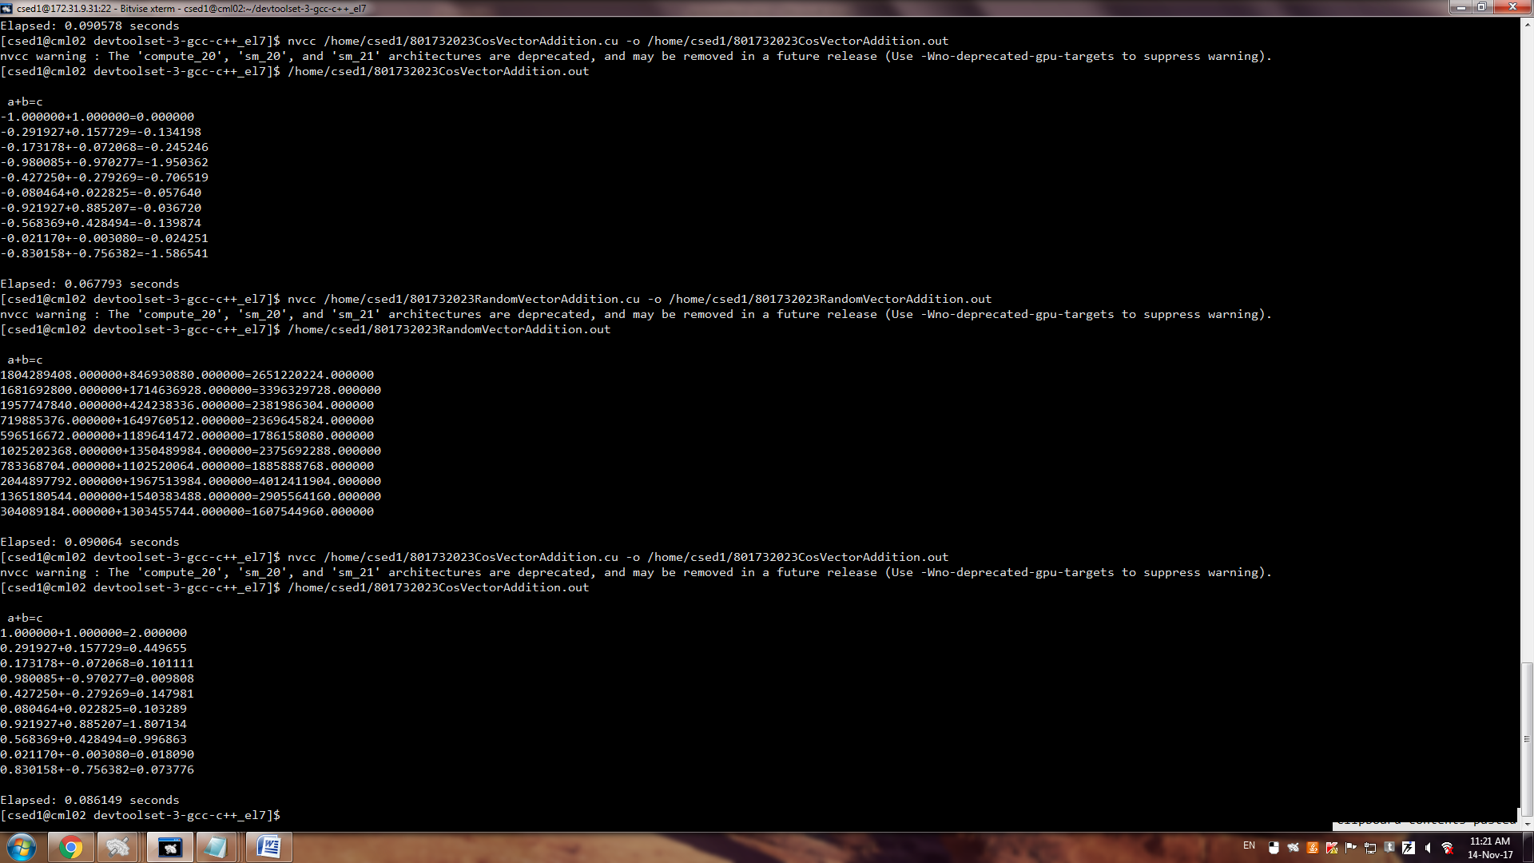

**Program 12**

**WAP to implement vector addition using random function**

#include<stdio.h>

#include<stdlib.h>

#include<cuda.h>

#include<cuda_runtime.h>

#define N 10

__global__ void add(float *a,float *b,float *c)

{

int bid=blockIdx.x;

if(bid<N)

c[bid]=a[bid]+b[bid];

}

int main(void)

{

int i;

float a[N],b[N],c[N];

float *dev_a,*dev_b,*dev_c;

clock_t tic = clock();

cudaMalloc((void**)&dev_a,N*sizeof(float));

cudaMalloc((void**)&dev_b,N*sizeof(float));

cudaMalloc((void**)&dev_c,N*sizeof(float));

for(i=0;i<N;i++)

{

a[i]=rand();

b[i]=rand();

}

cudaMemcpy(dev_a,a,N*sizeof(float),cudaMemcpyHostToDevice);

cudaMemcpy(dev_b,b,N*sizeof(float),cudaMemcpyHostToDevice);

add<<<N,1>>>(dev_a,dev_b,dev_c);

cudaMemcpy(c,dev_c,N*sizeof(float),cudaMemcpyDeviceToHost);

printf("\n a+b=c \n");

for(i=0;i<N;i++)

{

printf("%f+%f=%f\n",a[i],b[i],c[i]);

}

clock_t toc = clock();

cudaFree(dev_a);

cudaFree(dev_b);

cudaFree(dev_c);

printf("\nElapsed: %f seconds\n", (double)(toc - tic) / CLOCKS_PER_SEC);

}

