1: Analyze the relationship between the size of houses (measured in square footage) and their selling prices in a particular neighborhood. You have collected data on various houses in that neighborhood.Create a scatter plot using the below data and share your conclusion/analysis.

Input:

square_footage = np.array([1200, 1400, 1600, 1800, 2000, 2200, 2400, 2600, 2800, 3000])

selling_prices = np.array([250, 290, 315, 380, 410, 450, 500, 525, 570, 610])

Code:

import numpy as np

import matplotlib.pyplot as plt

# Data

square_footage = np.array([1200, 1400, 1600, 1800, 2000, 2200, 2400, 2600, 2800, 3000])

selling_prices = np.array([250, 290, 315, 380, 410, 450, 500, 525, 570, 610])

# Create scatter plot

plt.scatter(square_footage, selling_prices)

plt.title('House Size vs Selling Price')

plt.xlabel('Square Footage')

plt.ylabel('Selling Price ($k)')

plt.grid(True)

plt.show()

Output:

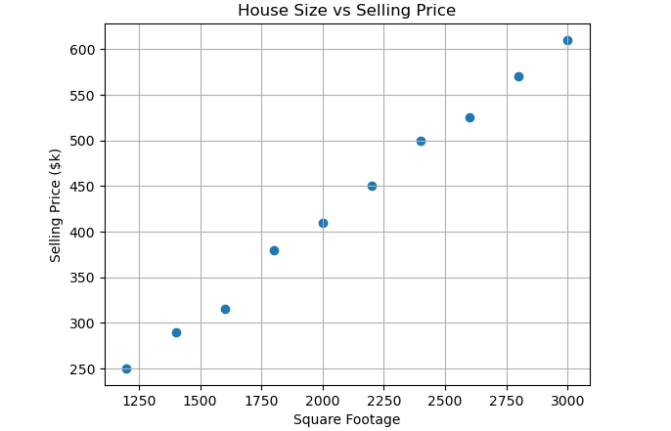

2: Create a pie chart to visualize the distribution of your monthly income by source. You have collected data on the various sources of your income, such as salary, freelance work, investments, and rental income. Share your conclusion/analysis.

Input:

income_sources = ['Salary', 'Freelance', 'Investments', 'Rental', 'Other']

monthly_income = [5000, 1500, 1000, 600, 400]

Code:

import matplotlib.pyplot as plt

# Data

income_sources = ['Salary', 'Freelance', 'Investments', 'Rental', 'Other']

monthly_income = [5000, 1500, 1000, 600, 400]

# Create a pie chart

plt.figure(figsize=(8, 8))

plt.pie(monthly_income, labels=income_sources, autopct='%1.1f%%', startangle=140, colors=['lightblue', 'lightgreen', 'lightcoral', 'lightskyblue', 'lightpink'])

# Adding a title to the chart

plt.title('Monthly Income Distribution by Source')

# Display the chart

plt.show()

Output:

