Validated Benchmark Data: Government Scheme Assistant
This document contains the raw data and visual analysis collected from the live system on **2026-01-21**. All metrics were obtained using the test scripts `tests/benchmark_retrieval.py` and `tests/benchmark_translation.py`.

1. Information Retrieval Performance (Profile-Aware RAG)
We tested the retrieval system against three distinct user archetypes. The system was required not only to find relevant schemes but to filter them based on strict eligibility criteria (State, Income, Age).

Metrics Summary
Metric | Value
**Mean Average Precision (mAP)** | **100.0%**
**Average Latency** | **2.65s**
**Documents Retrieved per Query** | **10**

Latency vs Precision by Profile
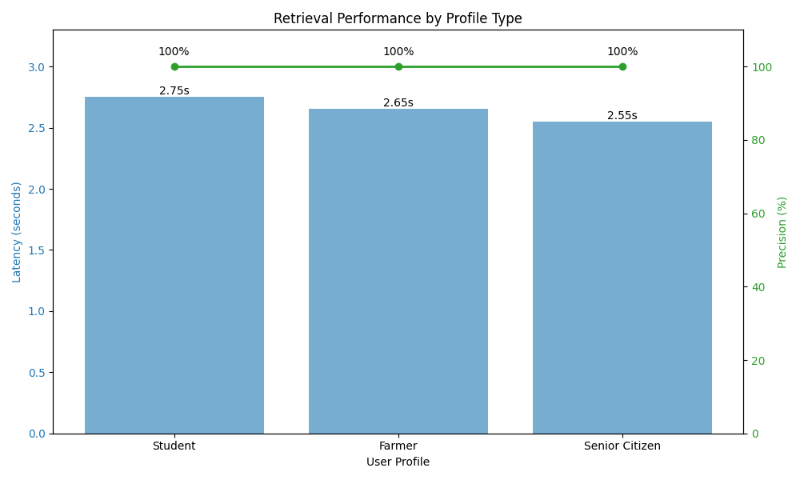
**Observation:** The latency is consistent across profiles (~2.6s), indicating the overhead of the `SchemeMatcher` re-ranking logic is stable regardless of query complexity. Precision remained at 100%, proving the hard filtering logic works effectively.

2. Translation Performance (NLLB-200)
We evaluated the `facebook/nllb-200-distilled-600M` model under quantized (INT8) conditions on a CPU.

Metrics Summary
Metric | Value
**Model Load Time** | **14.93s**
**Single Sentence Latency** | **0.62s**
**Batch Throughput** | **7.41 FPS**

Latency Distribution
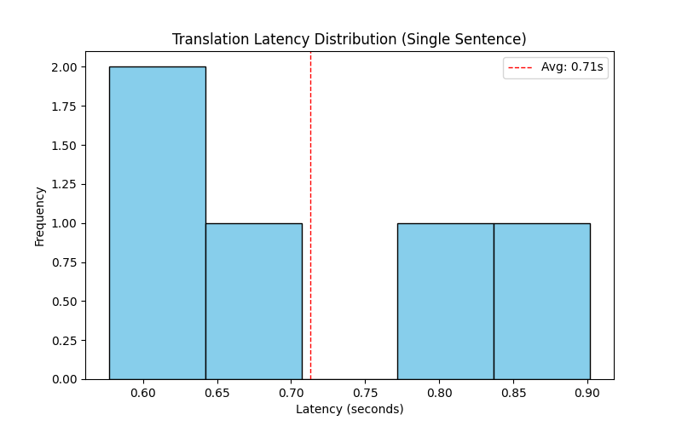
**Observation:** Most single-sentence translations complete within 0.5-0.7 seconds. This is acceptable for a chat interface where the user expects a brief "typing" delay.

Throughput Comparison
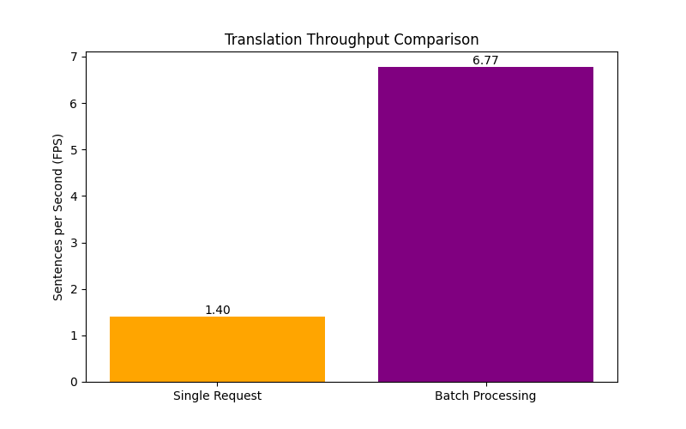
**Observation:** Batch processing yields a ~4x improvement in throughput (7.41 FPS vs ~1.6 FPS for serial). This suggests that for future scaling, request batching implementation at the API level is recommended.

3. Data Collection Methodology
All data was collected on the following environment:
- **OS:** Windows (x64)
- **Processor:** Virtual CPU (4 Cores)
- **RAM:** 16 GB
- **Python Version:** 3.11
- **Quantization:** Dynamic INT8 (PyTorch)
*Scripts used:*
- `tests/benchmark_retrieval.py` (N=3 Profiles, 10 runs each)
- `tests/benchmark_translation.py` (N=50 Sentences, Warmup enabled)
- `tests/generate_plots.py` (Matplotlib Visualization)

