FE Enterprise Python debugging guide

shell india

functional excellence team

|  |  |
| --- | --- |
| **Version Number:** | 1.0 |
| **Draft/Final as of:** | 7/1/2022 |
| **Printed on:** | 4/1/2022 |
| **Author:** | Kallappa Kannamuchanal |
| **Reviewer:** | Sakthivel |

## **Adding the Configuration Details:**

## Step 1: In PyCharm IDE go to Run Menu 🡪 Select “Edit Configurations…” OR click on “ Add Configuration…” option on tool bar.

## 

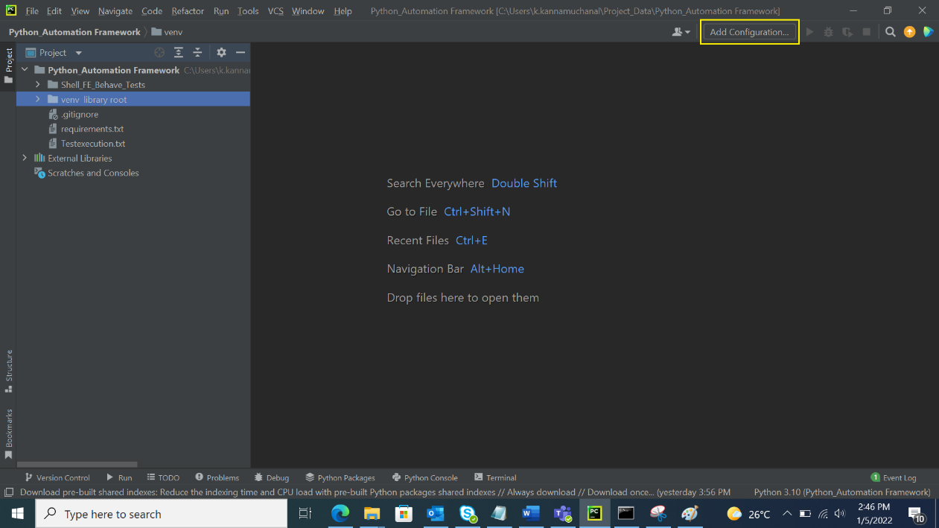

## Step 2: Click “+“ icon or “ Add New…” to insert new configuration on Run/Debug configuration window.

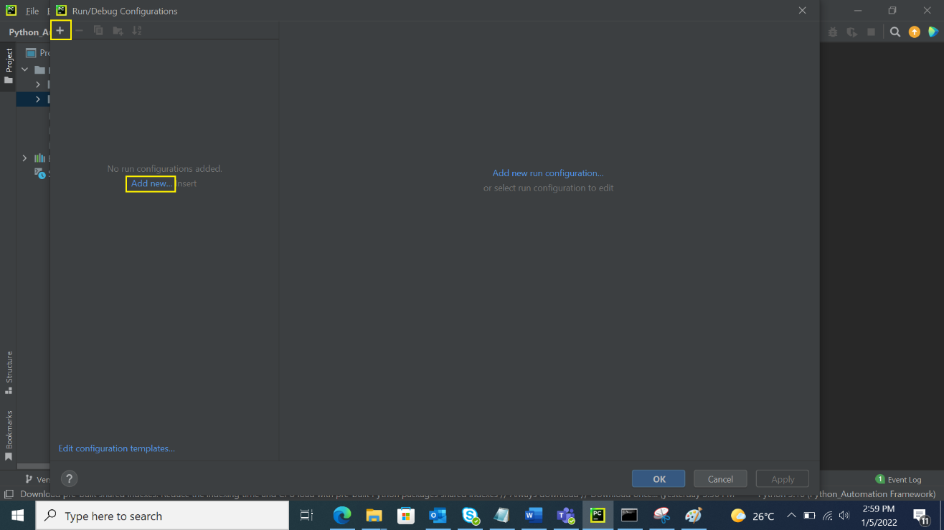

## Step 3: Select & click Python option from Add New Configuration.

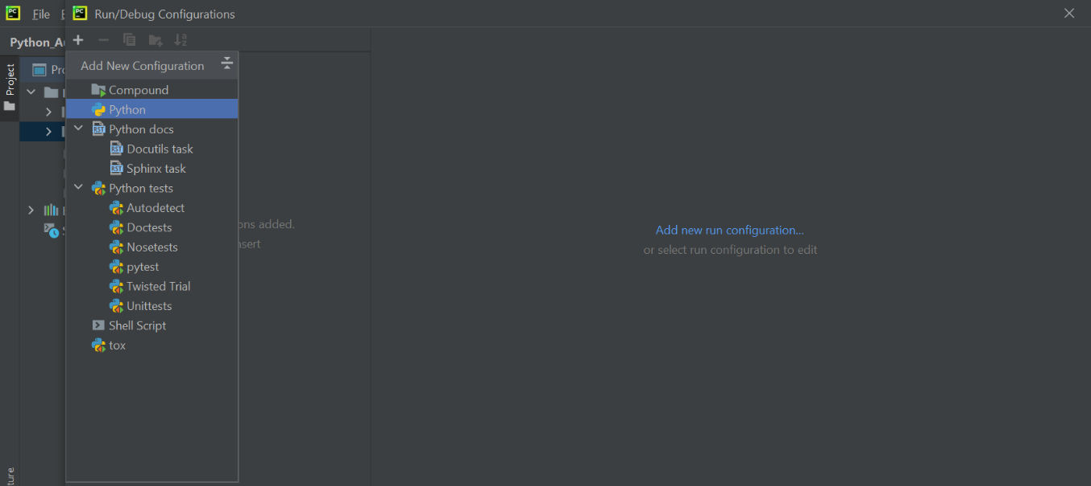

## Step 4: Add the following Configurations and click Apply and OK button.

1. Name: Behave
2. Script Path: Provide the Behave package __main__.py file path

### How to get the __main__.py file path:

Go to project directory 🡪 venv library root 🡪 Lib 🡪 site-packages 🡪 behave 🡪 Select __main__.py 🡪 Right click and select Copy Path/Reference 🡪Click on Absolute path

Paste the copied path to Script path

1. Environment Variable: APP_NAME=behave;PYTHONUNBUFFERED=1
2. Select proper Python interpreter
3. Add working directory

Ex: from root directory to Python_Automation Framework\Shell_FE_Behave_Tests

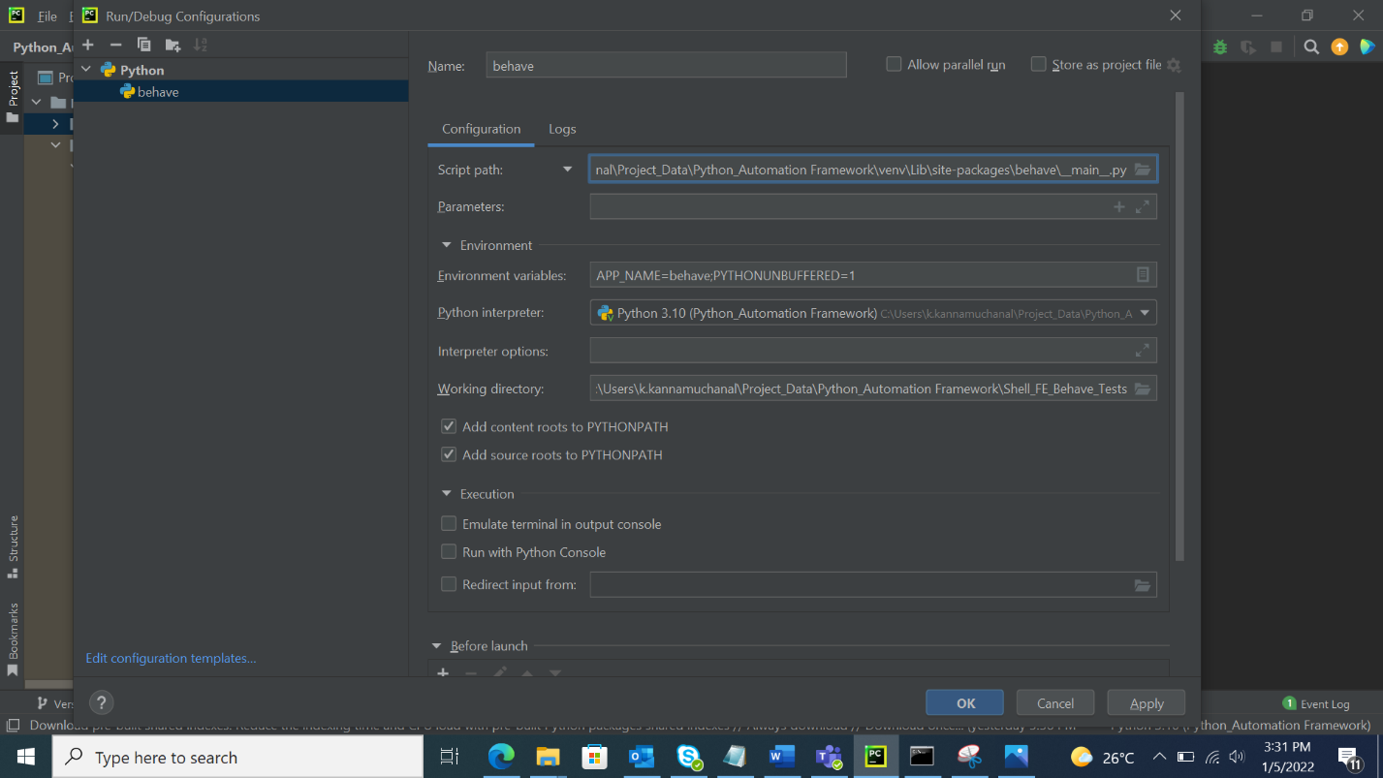

## **How to debug the code:**

## Step 1: Add the break point from where the debug must start

Debug option

## Step 2: Click debug option from tool bar.

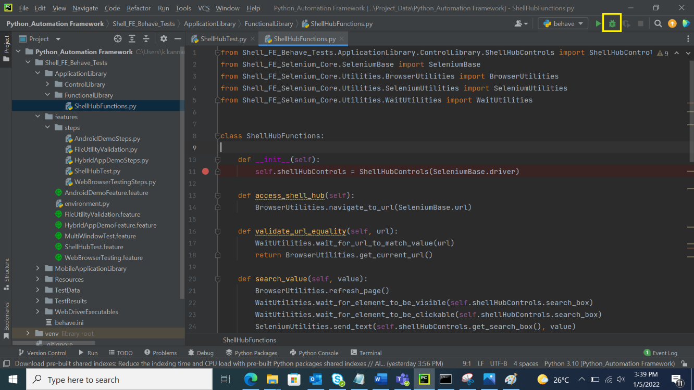

## Step 2: Once the execution reaches the breakpoint the following debug screen will be display, we can use the control present on debug window to debug the execution flow.

## .Ex: Step Over, Step Into, Step into My code, Step out etc.

