K.R. MANGALAM UNIVERSITY
ASSESSMENT-2 · FORMATIVE ASSIGNMENT
AI-Based Visual Branding, Digital Presence & Engagement Analytics
Building Your Personal Digital Brand with AI Tools · VAC-II
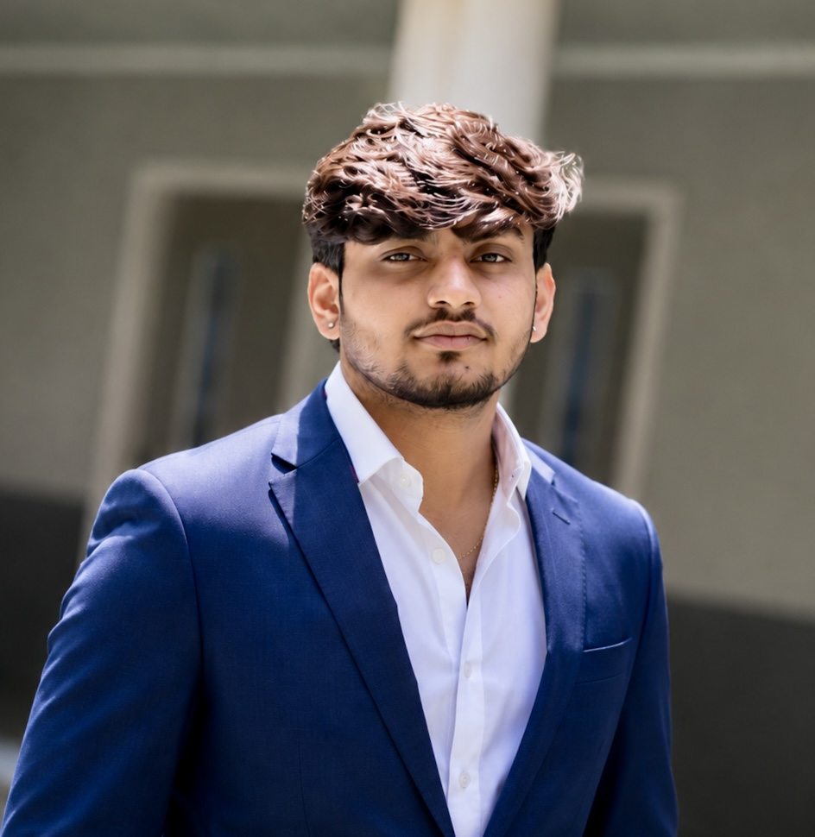

SUBMITTED BY
Aarush Tyagi
Roll No.: 2501201019
BCA (Artificial Intelligence & Data Science), Section A
K.R. Mangalam University, Gurugram, Haryana
Semester III · November 2026
Submitted to: Dr. Aarti

SUBMISSION OVERVIEW

Declaration & Assignment Map
One report, nine tasks. Each task is mapped to the tool used and the section that answers it.
Declaration. I, Aarush Tyagi, declare that this report is my individual submission for Assessment-2 of VAC-II. The branding, copy and plans are based on my own profile, internships and projects. The report text, draft logo, introduction video and portfolio page were produced with the AI assistant Claude (Anthropic) from my own profile details, and I reviewed and edited the outputs. The LinkedIn banner and CREOPM branding are my own. The tasks given to the AI are recorded in Appendix A.
Q | Task | Tool(s) | Section
1 | Personal logo and brand banner | Claude (draft logo); own banner design | Q1
2 | Visual identity: logo, palette, typography | Claude | Q2
3 | 60-second AI-generated introduction video | Claude (script), video rendered with ffmpeg | Q3
4 | Portfolio website | Claude, HTML/CSS on GitHub Pages | Q4
5 | LinkedIn profile optimisation | LinkedIn, Claude | Q5
6 | Five-day AI-assisted content calendar | Claude | Q6
7 | Four analytics metrics and their significance | LinkedIn Analytics / GA4 | Q7
8 | Three strategies to improve engagement | LinkedIn Analytics, GA4 | Q8
9 | Personal branding campaign and evaluation | Claude, LinkedIn Analytics | Q9

FOUNDATION

Brand Foundation
A personal brand works when the visuals, the words and the proof all say the same thing. Before designing any asset I defined who the brand is for, what it stands for and what evidence supports it. Only facts from my own LinkedIn profile and work are used as proof.
Element | Definition
Brand name | Aarush Tyagi
Positioning | A BCA (AI & Data Science) student and co-founder who turns raw data and ideas into practical digital products.
Target audience | Recruiters and internship mentors; data and AI communities; creators and small businesses who could work with CREOPM Technologies.
Brand pillars | 1. Data & analytics (Python, SQL, internships). 2. Applied AI (AI Resume Analyzer). 3. Entrepreneurship (CREOPM Technologies). 4. Learning in public.
Proof points | Internships at Trank Technologies, Oasis Infobyte, Auspify Technologies, SaiKet Systems and Zidio Development; Co-Founder of CREOPM Technologies; 2,318 LinkedIn followers; 500+ connections.
Voice | Clear, curious and practical. Explains what was built, what broke and what was learned.
Visual tone | Modern and clean: deep navy, blue accent, white space and one data-line motif.

Why this tone? Navy and blue read as calm, analytical and trustworthy, which suits a brand built on data. The data-line motif links the visuals back to analytics, and the restrained palette keeps the identity consistent on a LinkedIn banner, a one-page site and a printed report.

QUESTION 01

Personal Logo & Brand Banner
ASSIGNMENT QUESTION Design a personal logo and brand banner using Canva AI, Looka, or Fotor AI.

The logo is a hexagon monogram: the letters AT inside a navy hexagon with a fine inner line and a small rising data line beneath the letters. A hexagon suggests a network node and a data point, which fits a data-science student, and the monogram stays readable at LinkedIn avatar size. Three versions cover light backgrounds, dark backgrounds and monochrome print.

Figure 1a. Primary logo (light backgrounds).

Figure 1b. Reversed logo (dark backgrounds).

Figure 1c. Monochrome logo (print and stamps).

Brand banner
The banner is my own LinkedIn design (1600 × 600 px). The profile photo sits on the left with the tagline "Dream Big. Build Better. Innovate Always."; the name carries a single blue accent on "Tyagi"; a role line (Entrepreneur | Developer | Innovator) and the promise "Turning Ideas into Impact with Technology" sit beside it, and a row of tool icons (Python, HTML, CSS, JavaScript, Node.js) with the CREOPM mark shows what I build with. All key text sits in the middle band, so it survives LinkedIn's wide crop.
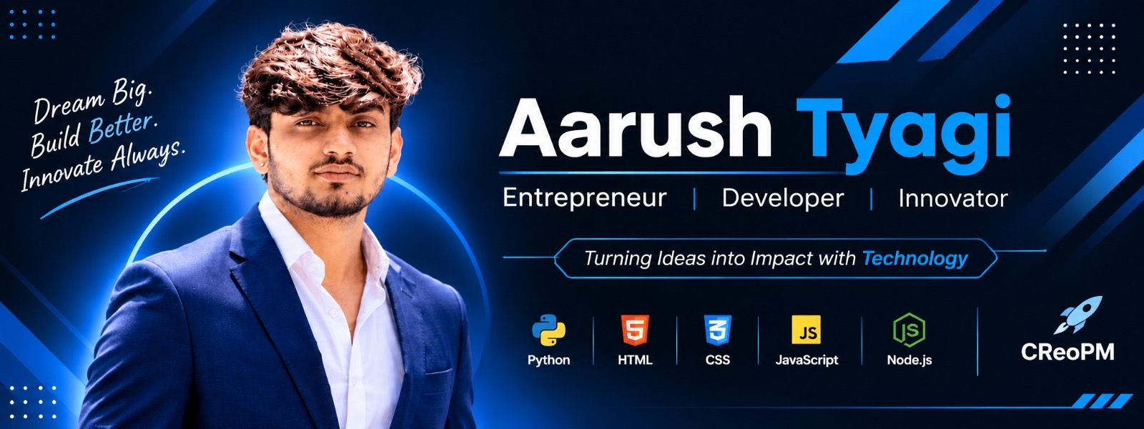
Figure 2. LinkedIn banner (final design).
Choice | Reason
Hexagon + monogram | Memorable shape; works as an avatar, favicon and watermark.
Serif name, sans-serif details | Serif adds credibility; sans-serif keeps small technical text readable.
Blue as the only accent | Keeps the look refined; dark blue is used for text on light backgrounds so contrast passes (see Q2).
Photo + tool icons | A real photo builds trust; the icons show the stack at a glance.

AI TOOL USAGE
The AI assistant Claude generated the monogram logo set from a written brief (Appendix A), and I reviewed the direction and colours against my brand. The banner is my own design made for my LinkedIn profile.

EVIDENCE · LOGO AND BANNER FILES
Figures 1a to 1c (logo) and Figure 2 (banner) above are the final files. They are stored in the project repository: https://github.com/aarush2557/VAC-II

QUESTION 02

Visual Identity System
ASSIGNMENT QUESTION Develop a visual identity consisting of logo, colour palette, and typography.

Logo
The AT hexagon monogram (Q1) is the primary mark, used with the wordmark "AARUSH TYAGI" and a one-line descriptor. Keep clear space equal to the height of the letter "A" on every side.

Colour palette
Ink Navy  #0F1B2D | Deep Blue  #0B5FC4 | Bright Blue  #1A8CFF | Mint  #BEDCFF | Cloud  #F6F8FA | Slate  #5B6676
Text, headlines, dark panels | Accent text and rules on light | Accent on dark backgrounds | Tints and highlights | Page and card backgrounds | Captions, secondary text

Pairing | Contrast | WCAG AA (4.5:1) | Permitted use
Ink Navy on Cloud | 16.2 : 1 | Pass | Body text, headlines
Cloud on Ink Navy | 16.2 : 1 | Pass | Reversed text on dark panels
Bright Blue on Ink Navy | 5.1 : 1 | Pass | Accent text on dark backgrounds
Bright Blue on White | 3.4 : 1 | Fail for text | Lines, icons and shapes only
Deep Blue on White | 6.1 : 1 | Pass | Accent text on light backgrounds
Slate on White | 5.8 : 1 | Pass | Captions and secondary text
Table 1. Contrast ratios calculated with the WCAG relative-luminance formula. Bright blue fails on white, so Deep Blue is used for text on light backgrounds.

Typography
Two free Google Fonts form the pairing: Merriweather for headlines (a sturdy, readable serif) and Inter for interface text, labels and body copy (a clean sans-serif that stays clear at small sizes).
Role | Typeface | Size | Use
Display / name | Merriweather Bold | 32–40 pt | Name on banner, portfolio hero
Headline | Merriweather Bold | 20–26 pt | Section headings, post titles
Label / UI | Inter SemiBold | 8–10 pt caps | DATA SCIENCE · AI · CO-FOUNDER
Body | Inter Regular | 10–12 pt | Paragraphs, captions, tables

Do | Avoid
Use the same name, headline and banner on LinkedIn, the portfolio and the video. | Introducing new colours or fonts on each platform.
Use one blue accent per layout (a rule, a number or a highlight). | Bright blue body text on white backgrounds.
Keep clear space around the logo. | Stretching, rotating or recolouring the hexagon.

QUESTION 03

60-Second Introduction Video
ASSIGNMENT QUESTION Create a 60-second AI-generated personal introduction video.

The script is drafted with Claude using only facts from my profile, then checked by me. It runs about 60 seconds at a calm speaking pace. The video is built from five captioned scenes in the brand colours and rendered to MP4 (1920 × 1080, 60 seconds); a voice-over can be recorded over it using the same script.
Time | Visual | Voice-over | On-screen text
0–8 s | Name card on navy; blue line draws in. | Hi, I'm Aarush Tyagi, a BCA student in AI and Data Science at K.R. Mangalam University in Gurugram. | AARUSH TYAGI
8–20 s | Brand motif; CREOPM logo or name card. | I'm also a co-founder of CREOPM Technologies, where we help creators turn ideas into digital products. | Co-Founder · CREOPM Technologies
20–40 s | Internship names appear one by one; resume analyzer screen. | I've done data science and analytics internships with Trank Technologies, Oasis Infobyte, Auspify, SaiKet Systems and Zidio, cleaning and preprocessing datasets. I work in Python and SQL, and I'm building an AI Resume Analyzer that scores resumes and suggests improvements. | Python · SQL · AI Resume Analyzer
40–52 s | Simple data-line animation. | I enjoy turning messy data into clear insight, and I'm learning in public. | Data → Insight
52–60 s | Logo, banner colours, LinkedIn handle. | Follow along on LinkedIn, and let's connect. | Connect on LinkedIn
Table 2. Storyboard. Voice-over length: 94 words (about 1.6 words per second).
Production workflow: (1) Claude drafts the script from my verified profile facts and I edit it; (2) five scenes are designed in the brand colours with the script as captions; (3) scenes are joined with fades and exported as MP4; (4) the file is uploaded to GitHub and can be posted on LinkedIn (Day 1 of the calendar).
EVIDENCE · VIDEO LINK
Video file: Aarush_Tyagi_Introduction.mp4 (60 s), also playable on my portfolio page. Repository: https://github.com/aarush2557/VAC-II

QUESTION 04

Portfolio Website
ASSIGNMENT QUESTION Build a simple portfolio website using Carrd or Notion.

Platform choice: a one-page HTML/CSS site hosted on GitHub Pages (the brief allows Carrd or Notion; I built the page by hand so it matches the brand exactly and sits next to my code on GitHub). A one-page site loads fast and puts the projects one scroll from the introduction. Notion remains a good option for longer case studies linked from each project card.
# | Section | Content
1 | Navigation | Name and anchor links: About, Projects, Experience, Contact.
2 | Hero | Headline "Turning data into insight and ideas into products", short positioning line, "View projects" button, logo and photo.
3 | About | Three sentences: student, data and AI builder, co-founder.
4 | Projects | AI Resume Analyzer; CREOPM Technologies; internship data work. Each card has a one-line purpose, tech and a link.
5 | Experience | Data science and analytics internships (Trank Technologies, Oasis Infobyte, Auspify Technologies, SaiKet Systems, Zidio Development).
6 | Contact | LinkedIn (linkedin.com/in/aarush-tyagi-4a44913a5) and GitHub (github.com/Aarush2557) with one clear call to action.

Project cards
Project | One-line description | Stack / key points
AI Resume Analyzer | Web app that analyses a resume and helps improve it. | React frontend, Express backend that calls the Claude API; PDF upload, ATS scoring, skill extraction, improvement suggestions, job-description matching, interview question generation.
CREOPM Technologies | Co-founded startup that helps creators turn ideas into digital products. | Co-Founder since Oct 2026. Helps creators go from audience insight to product concept and MVP roadmap.
Internship data work | Data cleaning and analysis on real datasets. | Collected, cleaned and preprocessed structured and unstructured datasets; Python and SQL; worked with mentors on real-world data science problems.

EVIDENCE · LIVE SITE
Live site (GitHub Pages): https://aarush2557.github.io/VAC-II/ | Source: https://github.com/aarush2557/VAC-II (files: index.html, photo.jpg, Aarush_Tyagi_Introduction.mp4)

QUESTION 05

LinkedIn Profile Optimisation
ASSIGNMENT QUESTION Optimize your LinkedIn profile by improving the headline, About section, and featured skills.

Headline
Before: "Founder at CREOPM Technologies". It gives no role keywords for recruiters. After (91 of 220 characters):
NEW HEADLINE
Data Science & AI Student | Co-Founder, CREOPM Technologies | Python · SQL · Data Analytics

About section
The current About text is long and repeats the same sentences. The rewrite leads with a clear one-line promise, shows proof, and ends with an invitation to connect.
I turn data into decisions and ideas into digital products.
I'm a BCA (AI & Data Science) student at K.R. Mangalam University and co-founder of CREOPM Technologies, where we help creators turn ideas into digital products.
What I do
• Data science and analytics: collecting, cleaning and preprocessing structured and unstructured datasets with Python and SQL, through internships at Trank Technologies, Oasis Infobyte, Auspify Technologies, SaiKet Systems and Zidio Development.
• AI product building: an AI Resume Analyzer with PDF upload, ATS scoring, skill extraction, job-description matching and interview question generation (React + Express, using the Claude API).
I'm learning in public: sharing what works, what breaks and what I learn. If you're working on data, AI or creator tools, I'd love to connect.
Skills: Python | SQL | Data Analytics | Data Visualization | Artificial Intelligence
Portfolio: https://aarush2557.github.io/VAC-II/ | GitHub: github.com/Aarush2557
Draft length: about 898 characters of the 2,600 allowed. LinkedIn shows only the opening lines before "see more", so the first two lines carry the key message.

Skills, Featured and other sections
Element | Optimisation applied | Why it matters
Top 3 pinned skills | Python, SQL, Data Analytics | Pinned skills show first and match recruiter searches.
Other skills | Data Visualization, Data Science, Data Structures, Artificial Intelligence, React, Node.js | Truthful coverage of what my work actually used.
Featured section | Introduction video, portfolio, AI Resume Analyzer write-up, CREOPM announcement post | Turns the profile into a proof wall instead of a list.
Title consistency | Use one title for CREOPM (Founder or Co-Founder) in the headline, About and Experience entry | Mismatched titles look careless to recruiters. Confirm which title is correct.
Custom URL | linkedin.com/in/aarush-tyagi-4a44913a5 (shared on the portfolio and video) | Easy to share and consistent across platforms.
Banner + photo | Banner from Q1; clear, well-lit professional headshot | Consistent first impression across platforms.
Consistency check | Same name, headline wording, colours and links on LinkedIn, portfolio and video | Repeated signals build recognition and trust.

EVIDENCE · LINKEDIN PROFILE (CURRENT)
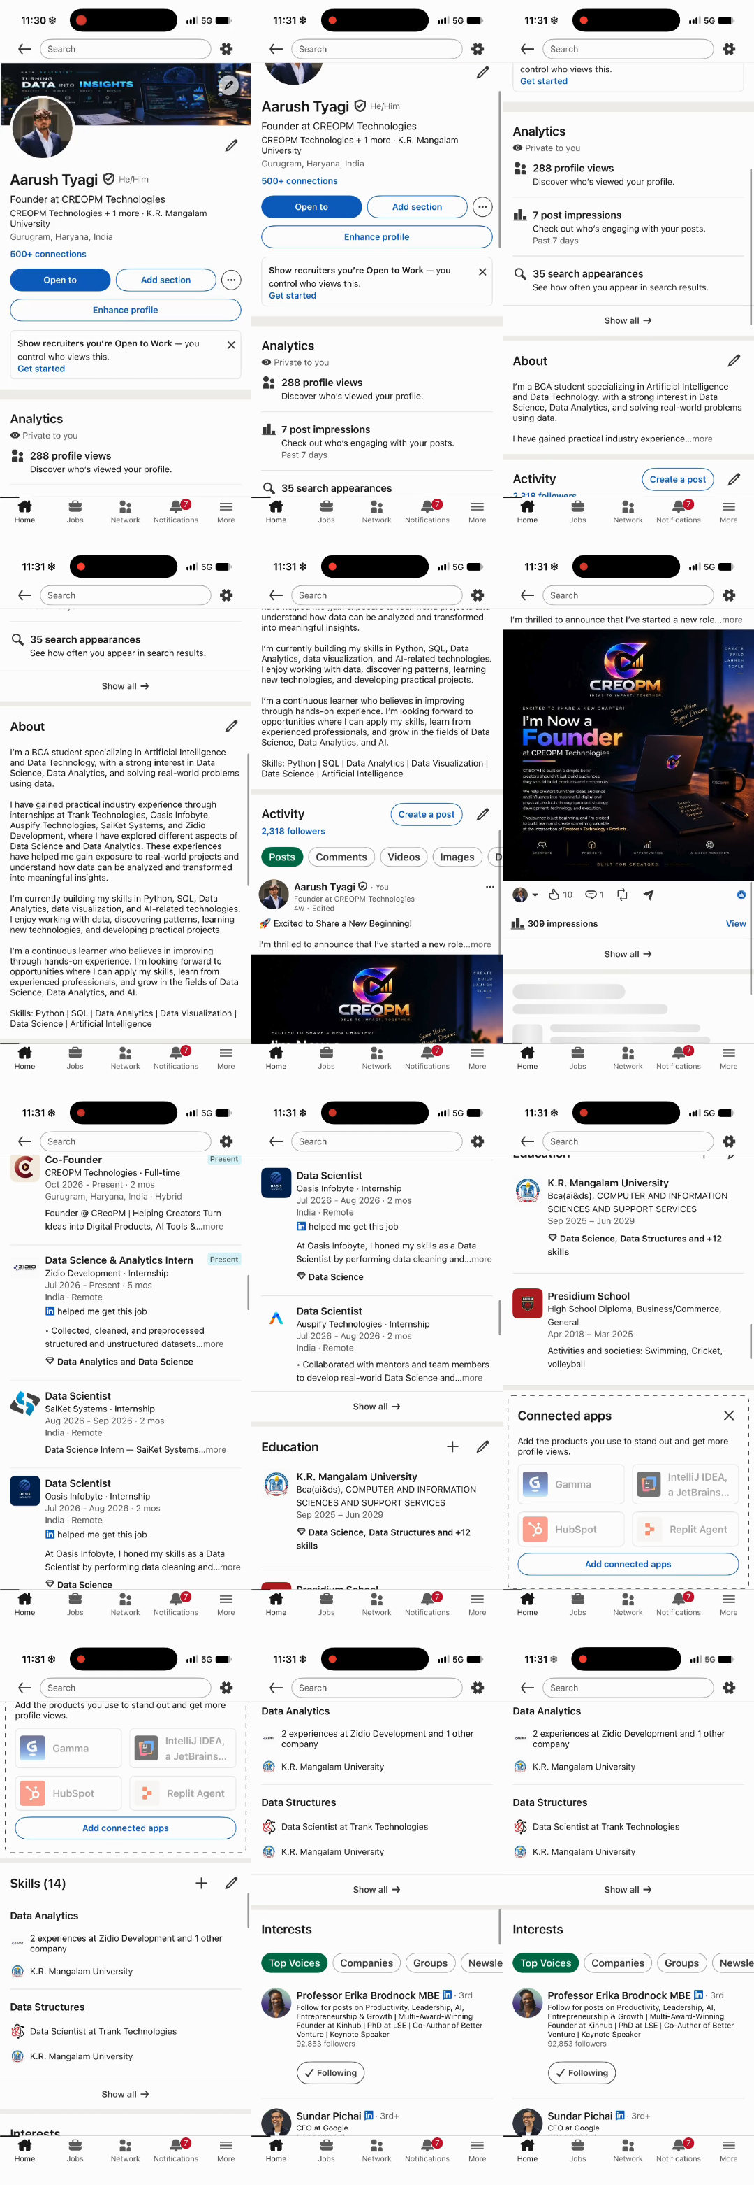
Figure 3. Current LinkedIn profile before optimisation.
ACCURACY
Every statement above comes from my own profile and projects. Nothing is exaggerated or invented, because recruiters check claims and the viva may ask about them.

QUESTION 06

Five-Day LinkedIn Content Calendar
ASSIGNMENT QUESTION Prepare a five-day AI-assisted content calendar for LinkedIn.

The calendar tells one story across five days: who I am, then what I build (AI), how I work with data, what I am building as a founder, and a reflection with a poll. AI supports drafting and design; I choose the topic, check every statement and write the final text in my own voice.
Day | Theme & format | Post draft (hook and gist) | AI assist | CTA
Mon | Introduction: native video + short caption | Hi LinkedIn, I'm Aarush, a BCA (AI & Data Science) student and co-founder of CREOPM. For five days I'm building in public. Day 1 is who I am (60 seconds). | ChatGPT: hook options. Pictory: video (Q3). | What would you like to see in the next four days?
Tue | Project spotlight: AI Resume Analyzer, carousel | What does an ATS actually look at in a resume? I'm building a tool that reads a resume PDF, scores it, pulls out skills and matches it to a job description. | Canva AI: slide layout. ChatGPT: simplify the explanation. | What would you add to a resume checker?
Wed | Data lesson: text + chart image | Most of a data project is cleaning, not modelling. Here is one thing I learned while cleaning and preprocessing real datasets during my internships. | ChatGPT: tighten copy. Canva AI: simple chart. | What is the messiest dataset you have worked with?
Thu | Founder story: CREOPM, text + image | Why we started CREOPM Technologies: helping creators turn ideas into digital products. | ChatGPT: plain-language rewrite. Canva AI: graphic. | What do creators struggle with most?
Fri | Reflection + poll | Day 5 of building in public: what resonated, what did not and what I will change (numbers in the comments). | ChatGPT: reflection outline. LinkedIn poll tool. | Poll: which topic should get a full write-up next?
Table 3. Content calendar. Publish at one consistent time slot for all five days, then adjust the slot using the analytics in Q7 and Q8. Hashtags: #BuildInPublic #DataScience #AI #Analytics.
EVIDENCE · CALENDAR
Table 3 is the working calendar; it can be copied into Notion or any planner.

QUESTION 07

Four Key Analytics Metrics
ASSIGNMENT QUESTION List four key metrics available in LinkedIn Analytics or Google Analytics and explain their significance.

For a personal brand, LinkedIn Analytics is the main source. My dashboard currently shows 288 profile views, 7 post impressions in the past 7 days and 35 search appearances, and my latest announcement post reached 309 impressions with 10 reactions and 1 comment. These numbers become my baseline. Four metrics together tell the whole story: how often content was shown, to how many people, how well it resonated, and whether it led anyone to my profile.
Metric | What it measures | How to read it | Significance for my brand
1. Impressions | Total times a post was shown in feeds; repeat views count again. | Compare posts over the same period. Baseline: 7 in the past 7 days; 309 on my best recent post. | Shows distribution. High impressions with weak engagement points to a hook problem.
2. Members reached | Distinct members who saw a post. | Compare with impressions and with my follower count (2,318). | The real audience size. Growth beyond my connections shows the brand reaches new people.
3. Engagement rate | Interactions (reactions, comments, reposts) as a share of impressions. | (Interactions ÷ impressions) × 100. Baseline: (10 + 1) ÷ 309 ≈ 3.6%. | Normalises for size, so small and large posts can be compared. The clearest quality signal.
4. Profile views | How many members viewed my profile. | Track daily during the campaign against the previous 7 days. Current dashboard: 288. | Measures conversion from interest in a post to interest in me, which matters for internships.
Table 4. Four LinkedIn metrics with my current baseline. Labels and availability depend on account type; verify them in your own dashboard.

Equivalent metrics for the portfolio website (Google Analytics 4)
LinkedIn metric | GA4 equivalent | Why it helps
Impressions / reach | Users and Sessions (traffic acquisition by source/medium) | Shows how many visitors arrive from LinkedIn.
Engagement rate | Engagement rate and average engagement time | Shows whether visitors explore the projects.
Profile views | Key events, such as a click on Contact or a project link | Shows visitors who took the next step.

READING THE METRICS TOGETHER
Impressions alone can hide low interest, and engagement rate alone can hide tiny reach. Reading all four together separates visibility, audience quality, content quality and conversion.

QUESTION 08

Three Strategies to Improve Engagement
ASSIGNMENT QUESTION Suggest three strategies to improve online engagement based on analytics data.

Each strategy follows the same logic: a pattern in the data, one change, and a way to check the change worked. My baseline already shows a pattern: 288 profile views against only 7 post impressions in the past 7 days means people find my profile through search and my network more than through my posts. Thresholds below are decision rules to apply to my numbers after the Day 1 to Day 5 posts; no campaign results are assumed.

Strategy 1: Post consistently so the algorithm and my audience have data
Part | Detail
Signal | Only 7 post impressions in the past 7 days, while my announcement post earned 309 when I did post.
Action | Publish on a fixed schedule (the five-day campaign, then 2–3 posts a week) at one consistent time slot.
Measure | Impressions per week and average engagement rate before and after the schedule starts.

Strategy 2: Rewrite the hook when reach is fine but interaction is low
Part | Detail
Signal | Members reached is at or above my baseline, but engagement rate falls below my 3.6% baseline.
Action | Make the first two lines specific (a problem, a number from my project, a question), shorten paragraphs and end with one clear question.
Measure | Compare two versions of the same topic posted on different days; track comments and engagement rate.

Strategy 3: Convert visibility into action with a tracked path to the portfolio
Part | Detail
Signal | Profile views rise, but visits to the portfolio and new connection requests do not.
Action | Pin the portfolio and project write-ups in Featured; use one link per post with UTM tags (utm_source=linkedin, utm_campaign=build-in-public); add one call to action.
Measure | GA4 sessions from LinkedIn, clicks on Contact and new relevant connection requests.

QUESTION 09

Personal Branding Campaign
ASSIGNMENT QUESTION Design a brief personal branding campaign (e.g., "Build in Public" or "5-Day Visibility Challenge") and explain how you would evaluate its success.

Campaign: Build in Public, 5-Day Visibility Challenge
Element | Plan
Objective | Within five days, make my brand visible to relevant recruiters, data and AI learners, and creators, and move them from reading a post to viewing my profile and portfolio.
Audience | Internship recruiters and mentors; student developers and data learners; creators who could use CREOPM Technologies.
Core message | A student and co-founder who builds with data and AI and shares the process honestly.
Channels | LinkedIn (main), portfolio site (destination), the 60-second video (Q3).
Content | The five posts from Q6, one per day, with the same banner, headline and colours (Q1, Q2, Q5).
Engagement routine | Reply to every comment within the day; leave thoughtful comments on five relevant posts daily; no engagement pods or purchased reach.
Phases | Baseline (record 7-day analytics) → Mon–Tue (intro, AI Resume Analyzer) → Wed–Thu (data lesson, CREOPM) → Fri (reflection and poll) → Follow-up (re-check metrics 7 days later).

How success will be evaluated
Success is judged against my own baseline (Q7), because a first campaign has no reliable external benchmark. The four KPIs map to the four metrics in Q7. Targets are illustrative and will be recalibrated once the 7-day baseline is recorded.
KPI | Metric | Target (vs. my baseline) | Weight
Visibility | Members reached / impressions per post | Each post above the 7 impressions per week baseline; at least one post above 100 | 25%
Content quality | Engagement rate | At or above my 3.6% baseline | 25%
Conversion | Profile views and portfolio sessions (GA4, UTM) | At least 20% above the previous 7 days | 30%
Audience growth | New relevant followers and connections | Higher than the previous 7 days | 20%

Decision rule: the campaign is a success if at least three of four KPIs meet target (and conversion is one of them); partial if two meet target; otherwise not yet successful. Either way, the weakest KPI becomes the focus of the next campaign using the strategies from Q8.

Risks and ethics
Risk | Response
Small sample: five posts can fluctuate by chance. | Compare trends rather than single posts; repeat for a second week.
AI-written text sounds generic. | Edit every draft with real details from my work; remove claims I cannot back up.
Overstating achievements. | Use only verified results and keep screenshots or certificates ready for the viva.

CLOSING

Conclusion, Limitations & Future Scope

Conclusion
This assignment treated a personal brand as a small product. The identity (Q1 to Q3) gives it a recognisable look, the portfolio and LinkedIn profile (Q4, Q5) give it a home, and the calendar, analytics and campaign (Q6 to Q9) give it a feedback loop. The common thread is evidence: every claim comes from my real profile and projects, and every strategy can be checked against a metric.

Limitations
- The campaign has not been run for this report, so no campaign results are presented. Targets are baselines to calibrate, not outcomes.
- AI tools speed up drafting and design, but their output needs human review for accuracy, originality and tone.
- Platform metric labels and availability change over time and differ by account type.
- The AI Resume Analyzer is still in development, so it is described by its planned features.

Future scope
- Run the five-day campaign, record the results in a data capture sheet, and repeat with changes from Strategies 1 to 3.
- Add GA4 and UTM tracking to the portfolio to measure the LinkedIn-to-site journey.
- Publish one long-form case study per project (starting with the AI Resume Analyzer) as a Notion page linked from Featured.

References
- LinkedIn Help Center. Post and profile analytics. https://www.linkedin.com/help/linkedin
- Google. Google Analytics Help Center (GA4: Traffic acquisition, Engagement, Key events). https://support.google.com/analytics
- W3C. Web Content Accessibility Guidelines (WCAG) 2.1, Success Criterion 1.4.3 Contrast (Minimum). https://www.w3.org/TR/WCAG21/#contrast-minimum
- Tool documentation: Canva, Looka, Fotor, Pictory, Lumen5, Animoto, Carrd, Notion.
- Course brief: K.R. Mangalam University, VAC-II Assessment-2.

APPENDIX A

AI Prompt Record
Required by the brief: the prompts used for content generation and visual design. All tasks were given to the AI assistant Claude, together with my own materials (LinkedIn profile screenshots, photo, banner, company video and GitHub details). The outputs were reviewed and edited by me.
Q | Tool | Task given to the AI | My review
All | Claude | Here is the assignment and a sample report structure. Here are my details (name, roll number, LinkedIn screenshots, photo). Update the file with my details, using only facts from my own profile. | Checked every fact against my LinkedIn profile; removed anything not mine.
1 | Claude | Design a minimalist personal logo for "Aarush Tyagi", a data science and AI student and co-founder: hexagon monogram "AT", navy and blue, serif lettering, versions for light, dark and monochrome use. | Chose the direction and colours; banner is my own design.
2 | Claude | Create a colour palette with hex codes, a free Google Fonts serif and sans-serif pairing, and WCAG contrast ratios, matching my blue LinkedIn banner. | Recoloured to match my real banner.
3 | Claude | Write a 60-second first-person introduction script using only my profile facts, and build it into a 60-second captioned video. | Approved the script wording.
4 | Claude | Build a one-page portfolio website (hero, about, projects, experience, video, contact) with commented HTML and CSS that I can host on GitHub Pages. | Checked all facts and links.
5 | Claude | Rewrite my LinkedIn headline (max 220 characters) and About section using only my profile facts; suggest pinned skills and Featured items. | Checked titles and wording.
6 | Claude | Create a 5-day LinkedIn content calendar: introduction, AI Resume Analyzer, data cleaning lesson, CREOPM, reflection. | Edited hooks to my own voice.
7 | Claude | Explain impressions, members reached, engagement rate and profile views in LinkedIn Analytics, using my real dashboard numbers as the baseline. | Verified numbers against my dashboard.
8 | Claude | Suggest three analytics-driven strategies to improve my LinkedIn engagement, each with the data signal, action and how to measure it. | Kept strategies I can apply.
9 | Claude | Design a 5-day "Build in Public" campaign with objective, audience, KPIs and a before/after evaluation method. | Set targets against my own baseline.

