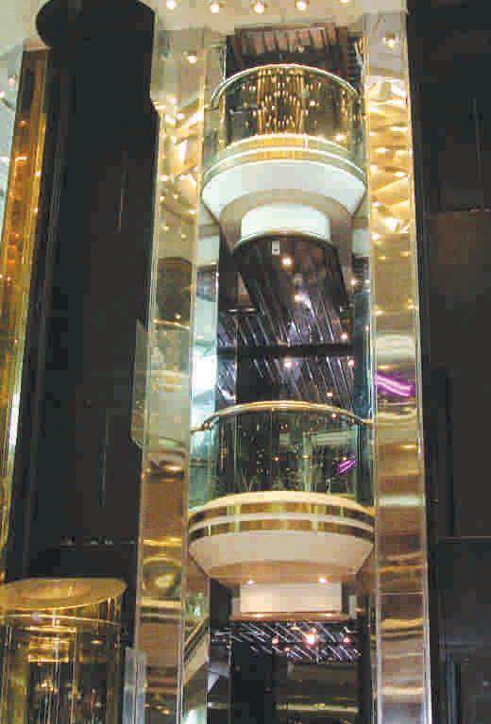
 Passenger Elevator

 Panaromic Elevator

 Hydraulic Elevator

 Hospital Elevator

 Freight Elevator

 Home Elevator

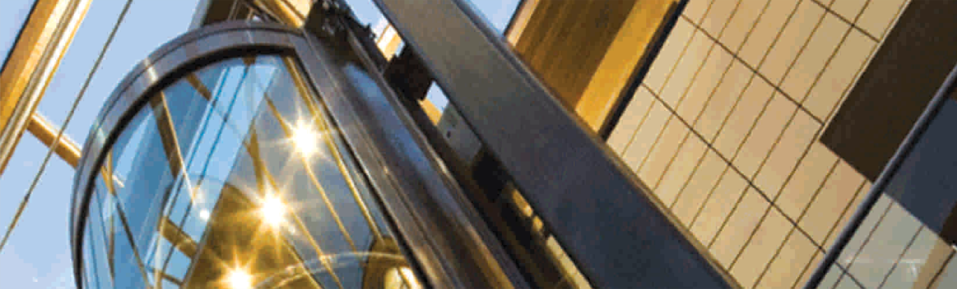
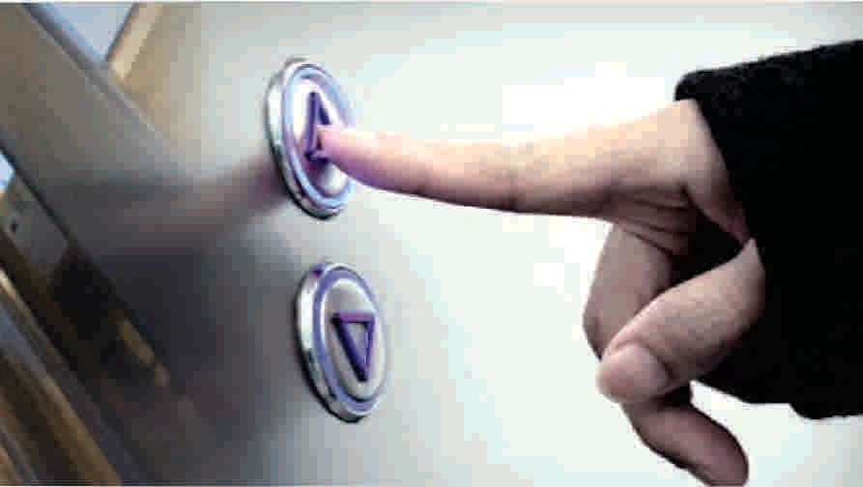
 Machine Roomless Elevator



FUZI Classic Elevators Pvt. Ltd.

PASSENGER ELEVATOR
Note : This is Our Standard Data, If other Special Requirement Please Contact us.
B
D

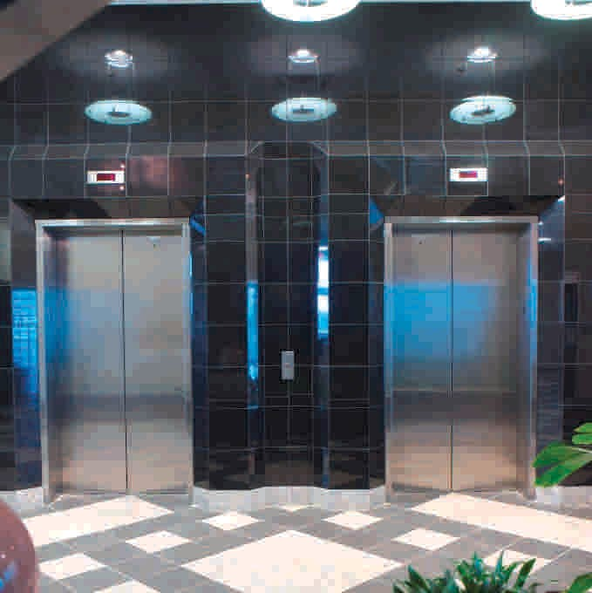
AUTO DOOR
A
E
C
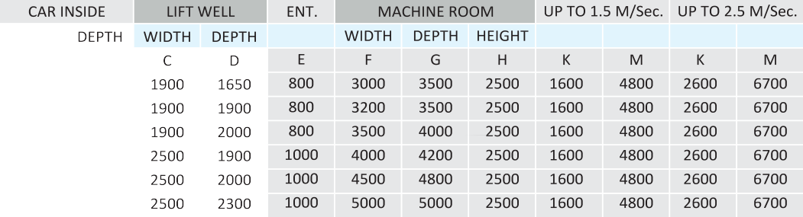

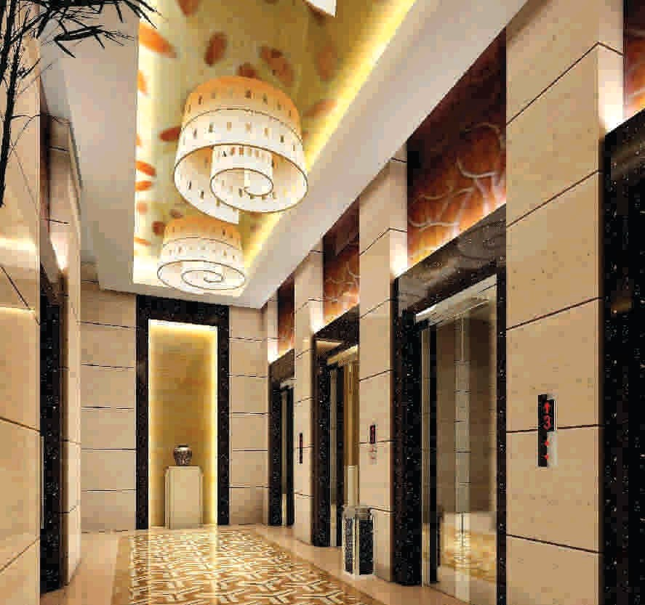
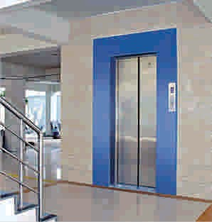
AUTO DOOR AUTO DOOR

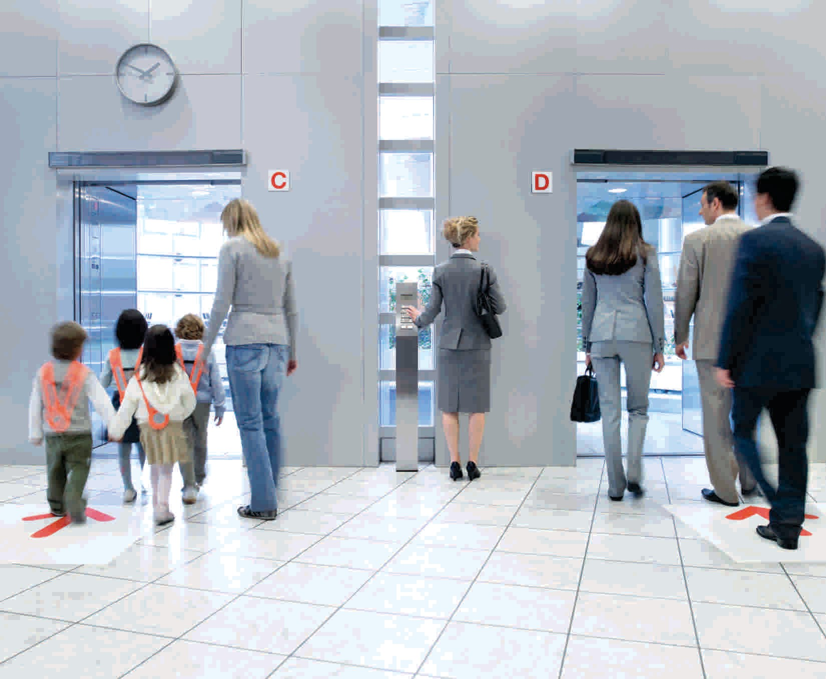
Passenger Elevator  Panaromic Elevator  Hydraulic Elevator
Hospital Elevator
Freight Elevator Home Elevator 
Machine Roomless Elevator 

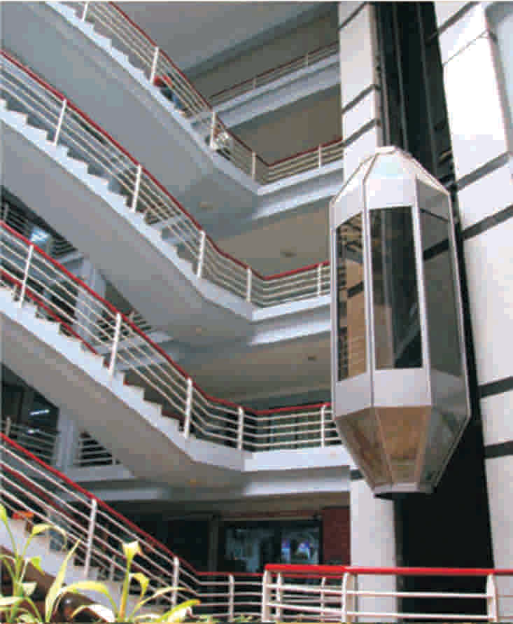

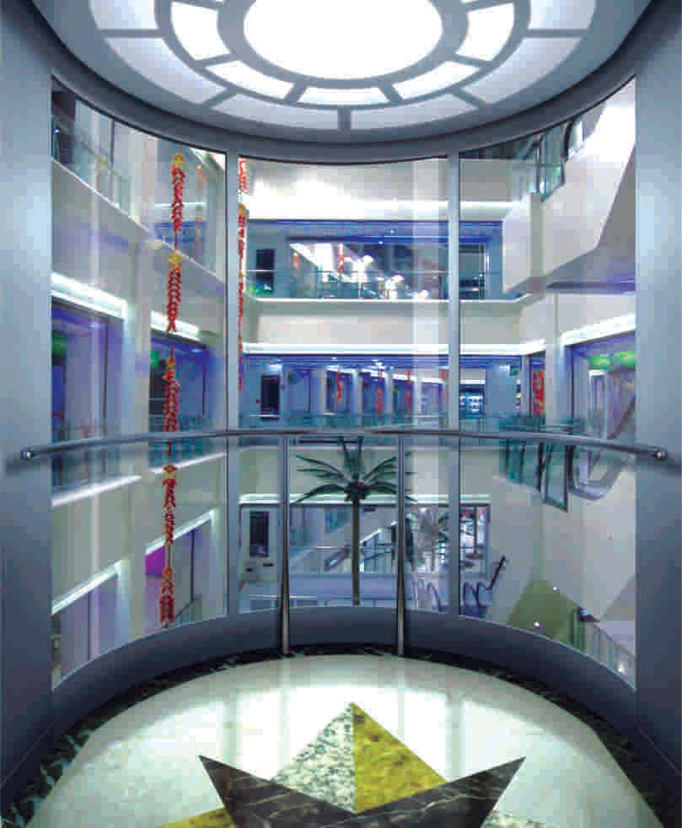
CAPSULE LIFT
CAPSULE LIFT
C1
GLASS FACADE
A
E
C

Note : This is Our Standard Data, If other Special Requirement Please Contact us.
CAPSULE LIFT

CAPACITY
6 TO 20
PASSENGER
We provide all type of capsule lifts having ultra modern design to provide a cosmic zone experience to the passenger. The design provides extemely silent operation. It is also reliable and economical with minimum maintenance. The VVVF close loop microprocessor controller incorporated with the system makes the whole operation very sophisticated.
B
D1
D

Hoist Way Machine Room Size
LOAD
CAR INSIDE
CAPSULE LIFT WITH AUTO DOORS
LIFT WELL
MACHINE ROOM
UP TO 1.5 M/Sec.
ENT.

Per | WEIGHT | WIDTH | DEPTH WIDTH DEPTH |  |  |  |  |  | WIDTH | DEPTH | HEIGHT
 | IN KG. | A | B | C | C1 | D | D1 | E | F | G | H | K | M
6 | 408 | 1000 | 1225 | 1900 | 1340 | 1870 | 1400 | 800 | 3000 | 3500 | 2500 | 2100 | 4800
8 | 544 | 1200 | 1360 | 2150 | 1590 | 2120 | 1600 | 800 | 3200 | 3500 | 2500 | 2100 | 4800
10 | 680 | 1400 | 1460 | 2250 | 1790 | 2220 | 1600 | 800 | 3500 | 4000 | 2500 | 2100 | 4800
15 | 1020 | 1400 | 1850 | 2250 | 1790 | 2610 | 1600 | 900 | 3500 | 4000 | 2500 | 2100 | 4800

HYDRAULIC ELEVATOR
HOISTWAY ELEVATION & PLANS

B D

A

C
Hoist Way Machine Room Size
Persons | Capacity Kg | Car-w (A) | Car-d (B) | Shaft-w (C) | Shaft-d (D)
3 | 225 | 800 | 900 | 1300 | 1300
4 | 300 | 850 | 1050 | 1350 | 1450
5 | 375 | 1000 | 1100 | 1500 | 1500
6 | 450 | 1100 | 1150 | 1600 | 1550
8 | 600 | 1100 | 1400 | 1600 | 1800
10 | 750 | 1200 | 1550 | 1700 | 1950
12 | 900 | 1300 | 1650 | 1800 | 2050
15 | 1125 | 1300 | 2000 | 1800 | 2400
20 | 1600 | 1400 | 2400 | 1900 | 2800

HOSPITAL ELEVATOR
HYDRAULIC ELEVATOR


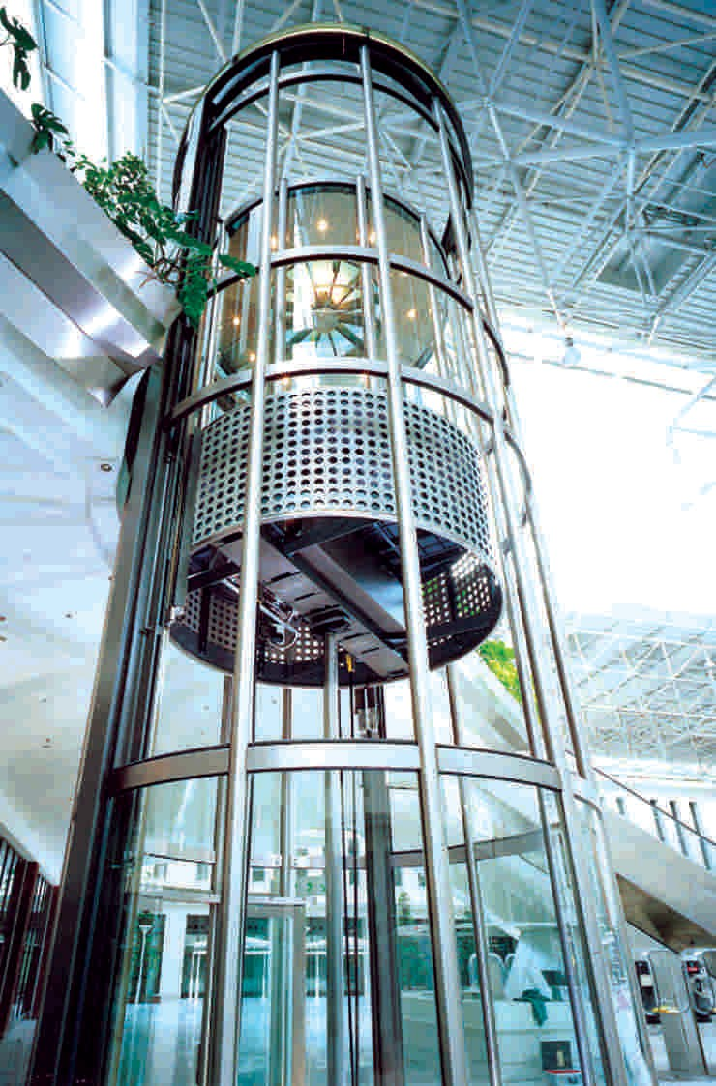

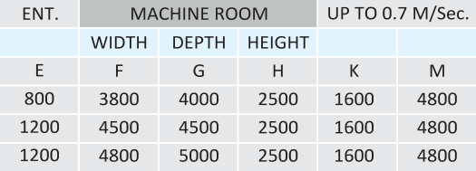
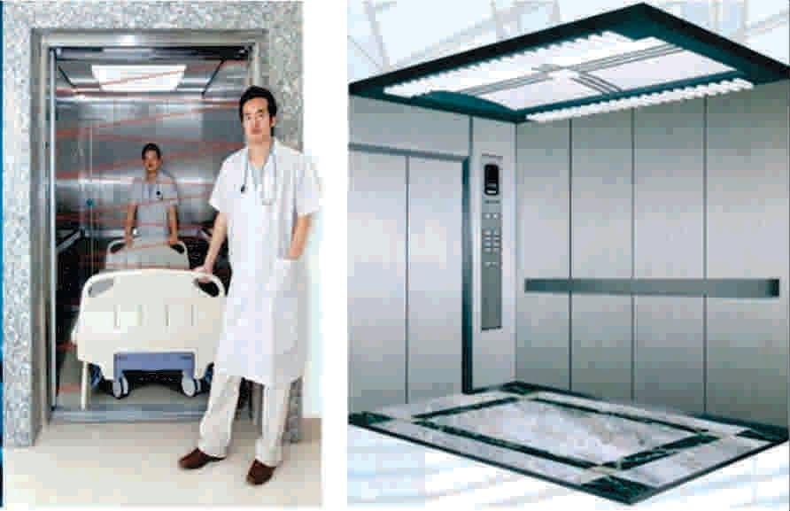
HOISTWAY ELEVATION & PLANS

A
B
D

E
C

HOSPITAL ELEVATOR HOSPITAL ELEVATOR

Note : This is Our Standard Data, If other Special Requirement Please Contact us.

FREIGHT ELEVATOR

CAPACITY
500 to 5000
L D B

E A C
K

TRAP DOOR

HOME ELEVATOR
FREIGHT ELEVATOR

HOISTWAY ELEVATION PLAN



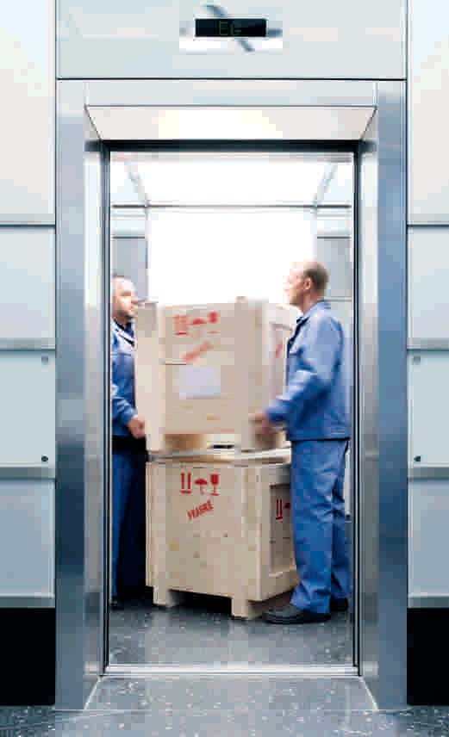

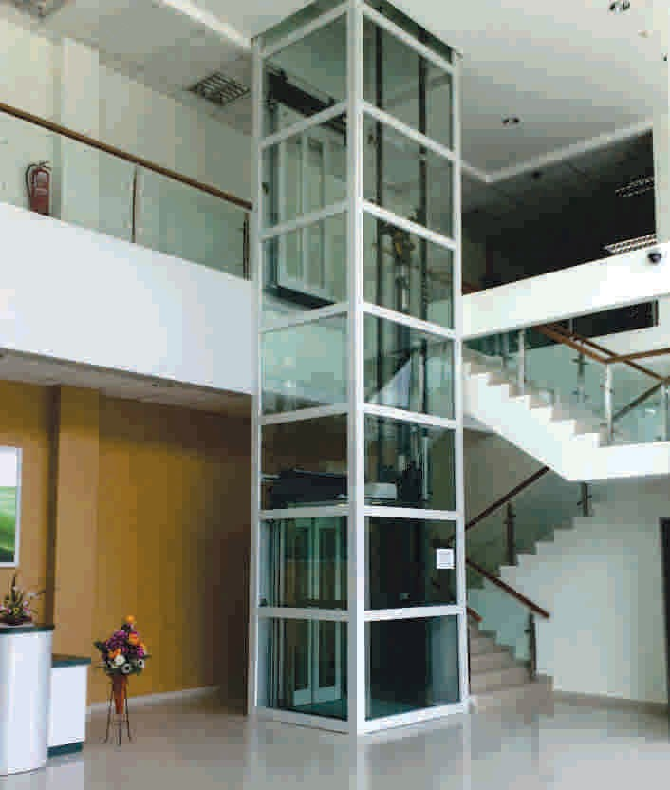

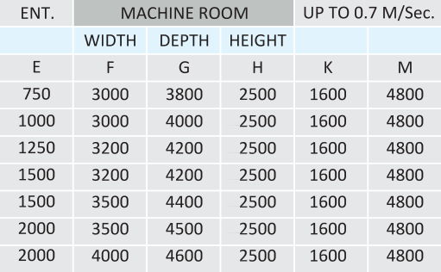

MACHINE

B D
OVER HEAD 3100

TOP FLOOR
ENT. 2000mm
E A C

HOME ELEVATOR
RISE

DIMENSIONS TABLE
CWT WEIGHT
DOOR  OPERATION | LOAD |  | LIFT WELL |  | CAR INSIDE |  | ENTRANCE | SPEED | PIT 550  550 | OVER
 | PERSONS | KGS | C | D | A | B | E | (MPS) |  | HEAD
MANUAL DOOR  MANUAL DOOR | 3  4 | 204  272 | 1100  1300 | 1200  1400 | 810  800 | 700  1200 | 700  700 | 0.3  0.3 |  | 3100  3100
AUTO DOOR | 3 | 204 | 1250 | 1250 | 810 | 700 | 700 | 0.3 | 550 | 3100
AUTO DOOR | 4 | 272 | 1300 | 1600 | 850 | 1150 | 700 | 0.3 | 550 | 3100

BOTTOM FLOOR
PIT 550

Note : This is Our Standard Data, If other Special Requirement Please Contact us.



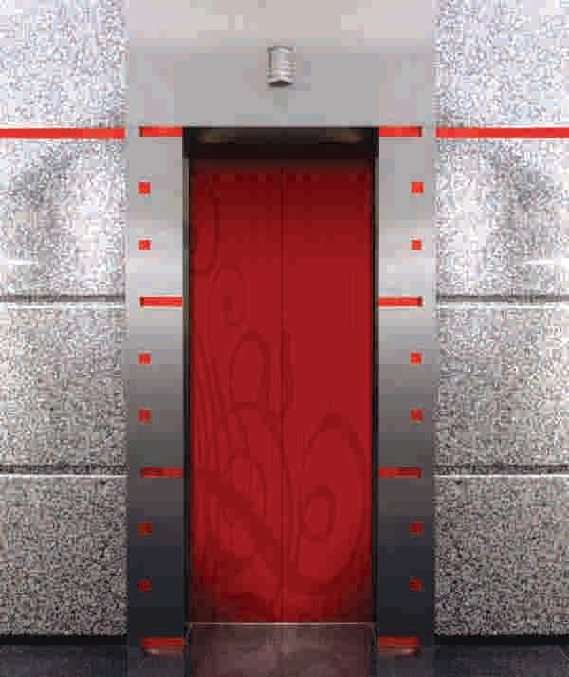
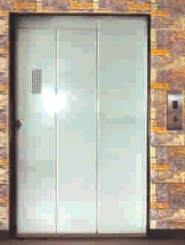
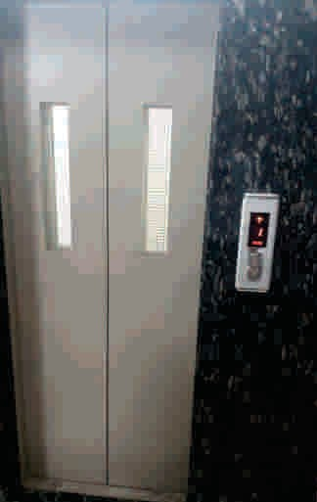
ACCESSORIES

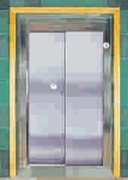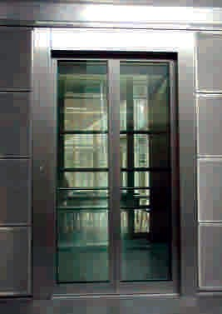

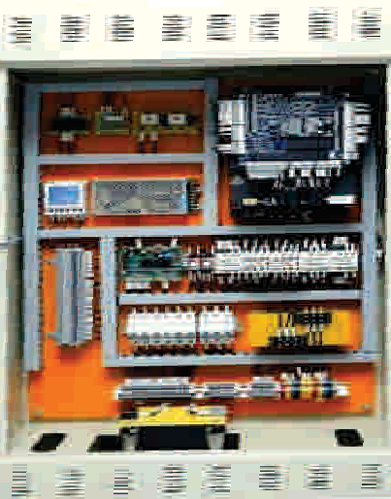
S. S. Auto Telescopic Door S.S. Auto Glass Door
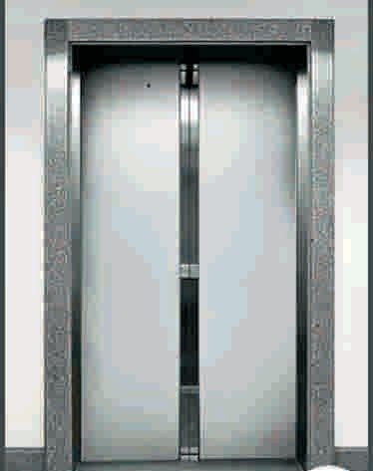
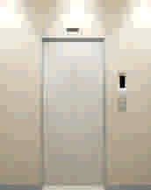
S. S. Auto Door M.S. Auto Door
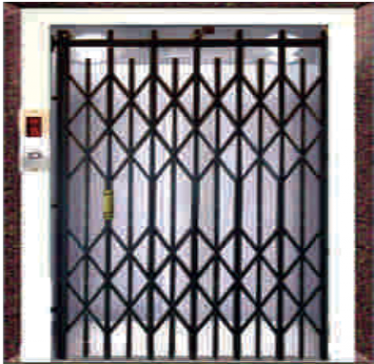
Collapsible Door Control Panel
Range of Door

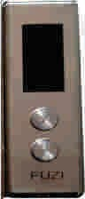
M.S. Swing Door M. S. Manual Telescopic Door



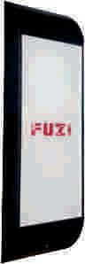

COP LOP

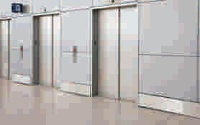
PERFECTION AT ITS FINEST

Passenger Elevator

OUR BRANCHES

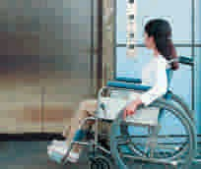
JODHPUR

Hospital Elevator

BIKANER 

NEEMUCH

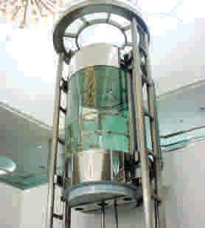
KOTA

Hydraulic Elevator

INDORE

SIKAR

AJMER

BHILWARA

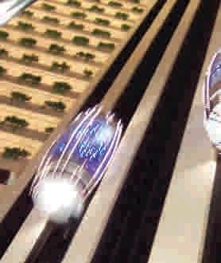
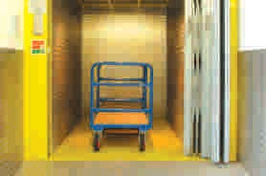
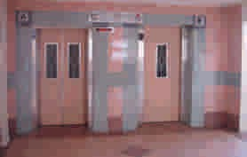

Panaromic Elevator

Freight Elevator

Home Elevator

FUZI Classic Elevators P r i v a t e L i m i t e d
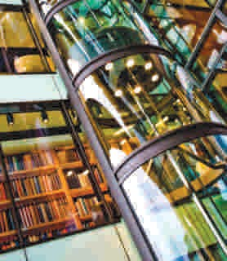
An ISO 9001 & ISO 14000 Certified Company

Machine Roomless Elevator

360, Guru Nanak Pura, Raja Park Jaipur - 302 004, Rajasthan (INDIA)
Tel. No. 0141-2620168, Mob : 9928019671
E-mail : atulsinghal@fuzielevators.com Website : www.fuzielevators.com Toll Free : 1800 102 8421

