WORKFLOW

**DATABASE**

**DASHBOARD**

**RPI 2**

**RPI 1**

sending

retrieving

**TANGLE**

**MAM**

retrieving

retrieving

*the ones in yellow boxes are to be followed. Rest are fully functional.

RASPBERRY PI 1

1. We are sending sensor data at a frequency of 1 minute from Raspberry Pi 1 to the IOTA Tangle.
2. After every minute we increment the index to generate a new address for our given seed (Seed 1 belong to RPI 1). This maintains the security of our messages in the tangle.

RASPBERRY PI 2

1. We retrieve data from the tangle every minute.
2. Here I am retrieving the messages(in trytes) only if the current and previous addresses are different . That is , I am only capturing messages if addresses are different.

DASHBOARD

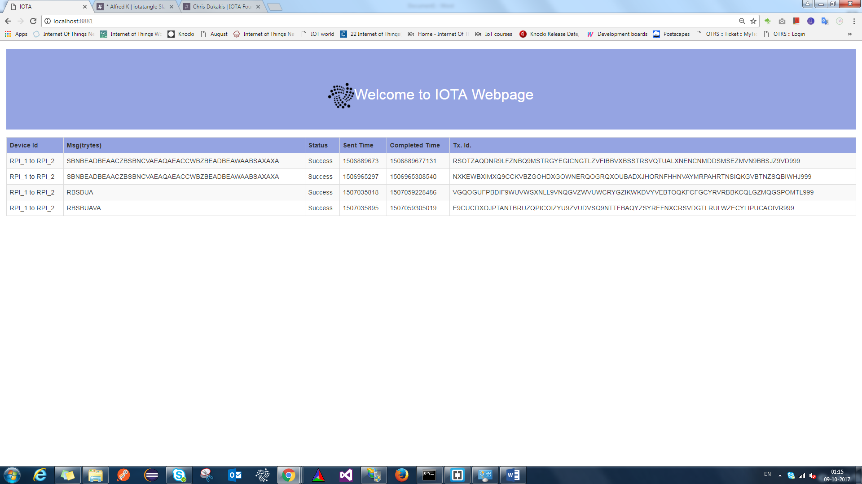

1. We retrieve data from the tangle every minute.
2. Here I am retrieving data only if the current and previous addresses are different . That is, I am only capturing messages if addresses are different.
3. I am retrieving the following :
   1. Device id , i.e., “RPI 1 to RPI 2”
   2. Message in trytes (retrieved from Tangle)
   3. Status of our transaction: “success” or “failure” . It’s a success if a tx. Hash is present in the transfer that is being retrieved
   4. Timestamp at which the bundle was sent to the tangle
   5. Timestamp at which the bundle was attached to the tangle
   6. Tx hash/ Tx. Id