RISC V PROJECT BY AARUSHI KISHORE

The single cycle SimpleRISC successfully run. It was further converted into a 5 layered pipeline, and hazards were taken care of.

`timescale 1ns / 1ps

module riscv(clk,reset);
input clk, reset;
wire [31:0] source1_top,result2_top,result1_top,branchtarget1_top,instruction1_top,addrout5_top,pcplus45_top,addrout1_top,addrout2_top,addrout3_top,source_top,memdataout_top,write_data_top,read_address_top,result_top,addrin_top,B_top,pcplus4_top,addrout_top,branchaddr_top,instruction_top,immx_top,branchtarget_top,writedata_top,op1_top,op2_top;
wire isWb3_top,isCall3_top,isLd3_top,isWb2_top,isSt2_top,isCall2_top,isLd2_top,isRet1_top,isWb1_top,isSt1_top,isBeq1_top,isBgt1_top,isUBranch1_top,isCall1_top,isLd1_top,isImmediate1_top,MemWrite_top,MemRead_top,isRet_top,E_top,sign_top,GT_top,overflow_top,E_in_top,sign_in_top,GT_in_top,overflow_in_top,isBranchTaken_top,isImmediate_top,isWb_top,isSt_top,isBeq_top,isBgt_top,isUBranch_top,isCall_top,isLd_top;
wire [3:0] op22_top,op11_top,B1_top,op21_top,rd4_top,ra4_top,rd3_top,ra3_top,rd2_top,ra2_top,rd1_top,rs21_top,ra1_top,rs11_top,rd_top,rs2_top,rs1_top,ra_top,mux1_top,mux2_top,mux3_top;
wire [4:0] opcode_top,opcode1_top,opcode2_top;
//PC
pc PC(.clk(clk),.reset(reset),.addrin(addrin_top),.pcplus4(pcplus4_top),.addrout(addrout_top));
//PCMUX
addrmux PCMUX(.i0(pcplus4_top),.i1(branchaddr_top),.s0(isBranchTaken_top),.o(addrin_top));
//INSTRUCTIONMEMORY
instructionmemory INSTRUCTIONMEMORY(.clk(clk),.reset(reset),.addrout(addrout_top),.instruction(instruction_top));
//INSTRUCTIONFETCH
instructionfetch INSTRUCTIONFETCH(.clk(clk),.reset(reset),.isImmediate(isImmediate_top),.instruction(instruction_top),.rd(rd_top),.rs2(rs2_top),.ra(ra_top),.rs1(rs1_top),.opcode(opcode_top));
//CONTROLUNIT
controlunit CONTROLUNIT(.clk(clk),.reset(reset),.opcode(opcode1_top),.isRet(isRet_top),.isWb(isWb_top),.isSt(isSt_top),.isBeq(isBeq_top),.isBgt(isBgt_top),.isUBranch(isUBranch_top),.isCall(isCall_top),.isLd(isLd_top));
//MUX1
regmux MUX1(.i0(rs21_top),.i1(rd1_top),.s0(isSt_top),.o(mux1_top));
//MUX2
regmux MUX2(.i0(rs11_top),.i1(ra1_top),.s0(isRet_top),.o(mux2_top));
//MUX3
regmux MUX3(.i0(rd_top),.i1(ra_top),.s0(isCall_top),.o(mux3_top));
//BRMUX
addrmux BRMUX(.i0(branchtarget1_top),.i1(op11_top),.s0(isRet1_top),.o(branchaddr_top));
//IMMUX
addrmux IMMUX(.i0(op2_top),.i1(immx_top),.s0(isImmediate1_top),.o(B_top));
//REGISTERFILE
registerfile REGISTERFILE(.clk(clk),.reset(reset),.isWb(isWb3_top),.mux2(mux2_top),.mux1(mux1_top),.mux3(mux3_top),.writedata(writedata_top),.op1(op1_top),.op2(op2_top));
//IMMEDIATEBRANCH
immediatebranch IMMEDIATEBRANCH(.instruction(instruction1_top),.addrout(addrout1_top),.immx(immx_top),.branchtarget(branchtarget_top));
//MUX4TO1
mux4to1 MUX4TO1(.s0(isCall3_top),.s1(isLd3_top),.i0(result2_top),.i1(source1_top),.i2(pcplus45_top),.o(writedata_top));
//BRANCHUNIT
branchunit BRANCHUNIT(.clk(clk),.reset(reset),.isBeq(isBeq1_top),.isBgt(isBgt1_top),.isUBranch(isUBranch1_top),.isBranchTaken(isBranchTaken_top),.E(E_top),.GT(GT_top));
//ALU
alu ALU(.A(op11_top),.B(B1_top),.aluSignals(opcode2_top),.result(result_top),.E(E_in_top),.sign(sign_in_top),.GT(GT_in_top),.overflow(overflow_in_top));
//FLAGREGISTER
flagregister FLAGREGISTER(.clk(clk),.reset(reset),.E_in(E_in_top),.sign_in(sign_in_top),.GT_in(GT_in_top),.overflow_in(overflow_in_top),.E(E_top),.sign(sign_top),.GT(GT_top),.overflow(overflow_top));
//DATAMEMORY
datamemory DATAMEMORY(.clk(clk),.reset(reset),.MemWrite(MemWrite_top),.MemRead(MemRead_top),.read_address(read_address_top),.Write_data(write_data_top),.MemData_out(memdataout_top));
//MEMORYUNIT
memoryunit MEMORYUNIT(.clk(clk),.reset(reset),.isLd(isLd2_top),.isSt(isSt2_top),.result(result1_top),.op2(op22_top),.memData(memdataout_top),.mar(mar_top),.mdr(mdr_top),.MemRead(MemRead_top),.MemWrite(MemWrite_top),.address(read_address_top),.writeData(write_data_top),.ldResult(source_top));
//IFOF_REGI
IFOF_regi IFOF_REGI(.clk(clk),.reset(reset),.IFrd(rd_top),.IFrs2(rs2_top),.IFra(ra_top),.IFrs1(rs1_top),.OFrd(rd1_top),.OFrs2(rs21_top),.OFra(ra1_top),.OFrs1(rs11_top),.IFaddrout(addrout_top),.IFinstruction(instruction_top),.IFopcode(opcode_top),.IFisImmediate(isImmediate_top),.OFisImmediate(isImmediate1_top),.OFopcode(opcode1_top),.OFaddrout(addrout1_top),.OFinstruction(instruction1_top));
//OPEX_REGI
OFEX_regi OFEX_REGI(.clk(clk),.reset(reset),.EXrd(rd2_top),.EXra(ra2_top),.OFrd(rd1_top),.OFra(ra1_top),.OFaddrout(addrout1_top),.OFbranchtarget(branchtarget_top),.OFA(op1_top),.OFB(B_top),.OFop2(op2_top),.OFisRet(isRet_top),.OFisWb(isWb_top),.OFisSt(isSt_top),.OFisBeq(isBeq_top),.OFisBgt(isBgt_top),.OFisUBranch(isUBranch_top),.OFisCall(isCall_top),.OFisLd(isLd_top),
.OFopcode(opcode1_top),.EXopcode(opcode2_top),.EXaddrout(addrout2_top),.EXbranchtarget(branchtarget1_top),.EXA(op11_top),.EXB(B1_top),.EXop2(op21_top),.EXisRet(isRet1_top),.EXisWb(isWb1_top),.EXisSt(isSt1_top),.EXisBeq(isBeq1_top),.EXisBgt(isBgt1_top),.EXisUBranch(isUBranch1_top),.EXisCall(isCall1_top),.EXisLd(isLd1_top));
//EXMA_REGI
EXMA_regi EXMA_REGI(.clk(clk),.reset(reset),.EXrd(rd2_top),.EXra(ra2_top),.MArd(rd3_top),.MAra(ra3_top),
.MAaddrout(addrout3_top),
.MAop2(op22_top),
.MAisWb(isWb2_top),
.MAisSt(isSt2_top),
.MAisCall(isCall2_top),
.MAisLd(isLd2_top),
.MAresult(result1_top),
.EXresult(result_top),
.EXaddrout(addrout2_top),
.EXop2(op21_top),
.EXisWb(isWb1_top),
.EXisSt(isSt1_top),
.EXisCall(isCall1_top),
.EXisLd(isLd_top));
//MARW_REGI
MARW_regi MARW_REGI(.clk(clk),.reset(reset),.RWrd(rd4_top),.RWra(rd4_top),.MArd(rd3_top),.MAra(rd3_top),
.MAaddrout(addrout3_top),
.MAldResult(source_top),
.MAisWb(isWb2_top),
.MAisCall(isCall2_top),
.MAresult(result1_top),
.RWresult(result2_top),
.RWaddrout(addrout4_top),
.RWldResult(source1_top),
.RWisWb(isWb3_top),
.RWisCall(isCall3_top),
.RWisLd(isLd3_top),
.MAisLd(isLd2_top));
//PC5
pc PC5(.clk(clk),.reset(reset),.addrin(addrout4_top),.pcplus4(pcplus45_top),.addrout(addrout5_top));
//HAZARDUNIT
hazardunit HAZARDUNIT(.reset(reset),.RegWriteM(),.RegWriteW(),.RD_M(),.RD_W(),.Rs1_E(),.Rs2_E(),.ForwardAE(),.ForwardBE());
endmodule

module IFOF_regi(clk,reset,IFrd,IFrs2,IFra,IFrs1,IFaddrout,IFopcode,IFisImmediate,OFrd,OFrs2,OFra,OFrs1,OFisImmediate,OFopcode,IFinstruction,OFaddrout,OFinstruction);
input clk,reset,IFisImmediate;
input [31:0] IFaddrout,IFinstruction;
input [4:0] IFopcode;
input [3:0] IFrd,IFrs2,IFra,IFrs1;
output reg [31:0] OFaddrout,OFinstruction;
output reg OFisImmediate;
output reg [4:0] OFopcode;
output reg [3:0] OFrd,OFrs2,OFra,OFrs1;
always @(posedge clk or posedge reset)
begin
if(reset)
begin
OFaddrout<=32'b00;
OFinstruction<=32'b00;
OFopcode<=5'b00;
OFisImmediate<=1'b0;
OFrd <=4'b00;
OFrs2 <=4'b00;
OFra <=4'b00;
OFrs1 <=4'b00;
end
else
begin
OFaddrout<=IFaddrout;
OFinstruction<=IFinstruction;
OFopcode<=IFopcode;
OFisImmediate<=IFisImmediate;
OFrd <=IFrd ;
OFrs2 <=IFrs2;
OFra <=IFra ;
OFrs1 <=IFrs1;
end
end
endmodule

module OFEX_regi(clk,reset,OFra,OFrd,EXra,EXrd,OFaddrout,OFbranchtarget,OFopcode,EXopcode,OFA,OFB,OFop2,OFisRet,OFisWb,OFisSt,OFisBeq,OFisBgt,OFisUBranch,OFisCall,OFisLd,EXaddrout,EXbranchtarget,EXA,EXB,EXop2,EXisRet,EXisWb,EXisSt,EXisBeq,EXisBgt,EXisUBranch,EXisCall,EXisLd);
input clk,reset;
input [31:0] OFaddrout,OFbranchtarget,OFA,OFB,OFop2;
input OFisRet,OFisWb,OFisSt,OFisBeq,OFisBgt,OFisUBranch,OFisCall,OFisLd;
input [4:0] OFopcode;
input [3:0] OFra,OFrd;
output reg [31:0] EXaddrout,EXbranchtarget,EXA,EXB,EXop2;
output reg EXisRet,EXisWb,EXisSt,EXisBeq,EXisBgt,EXisUBranch,EXisCall,EXisLd;
output reg [4:0] EXopcode;
output reg [3:0] EXra,EXrd;
always @(posedge clk or posedge reset)
begin
if(reset)
begin
EXaddrout <=32'b00;
EXbranchtarget <=32'b00;
EXA <=32'b00;
EXB <=32'b00;
EXop2 <=32'b00;
EXisRet <=1'b0;
EXisWb <=1'b0;
EXisSt <=1'b0;
EXisBeq <=1'b0;
EXisBgt <=1'b0;
EXisUBranch <=1'b0;
EXisCall <=1'b0;
EXisLd <=1'b0;
EXopcode<=5'b00;
EXra<=4'b00;
EXrd<=4'b00;
end
else
begin
EXaddrout <=OFaddrout;
EXbranchtarget <=OFbranchtarget;
EXA <=OFA;
EXB <=OFB;
EXop2 <=OFop2;
EXisRet <=OFisRet;
EXisWb <=OFisWb;
EXisSt <=OFisSt;
EXisBeq <=OFisBeq;
EXisBgt <=OFisBgt;
EXisUBranch <=OFisUBranch;
EXisCall <=OFisCall;
EXisLd <=OFisLd;
EXopcode<=OFopcode;
EXra<=OFra;
EXrd<=OFrd;
end
end
endmodule

module EXMA_regi(clk,reset,
MAaddrout,
MAresult,
MAop2,
MAisWb,
MAisSt,
MAisCall,
MAisLd,MAra,MArd,EXra,EXrd,
EXaddrout,
EXresult,
EXop2,
EXisWb,
EXisSt,
EXisCall,
EXisLd);
input clk,reset;
input [31:0]
EXaddrout,
EXresult,
EXop2;
input
EXisWb,
EXisSt,
EXisCall,
EXisLd;
input [3:0] EXra,EXrd;
output reg [3:0] MAra,MArd;
output reg [31:0]
MAaddrout,
MAresult,
MAop2;
output reg
MAisWb,
MAisSt,
MAisCall,
MAisLd;
always @(posedge clk or posedge reset)
begin
if(reset)
begin
MAaddrout <=32'b00;
MAresult <=32'b00;
MAop2 <=32'b00;
MAisWb <=1'b0;
MAisSt <=1'b0;
MAisCall <=1'b0;
MAisLd <=1'b0;
MAra<=4'b00;
MArd<=4'b00;
end
else
begin
MAaddrout <=EXaddrout;
MAresult <=EXresult;
MAop2 <=EXop2;
MAisWb <=EXisWb;
MAisSt <=EXisSt;
MAisCall <=EXisCall;
MAisLd <=EXisLd;
MAra<=EXra;
MArd<=EXrd;
end
end
endmodule
module MARW_regi(clk,reset,
MAaddrout,
MAldResult,
MAresult,
MAinstruction,MAra,MArd,RWra,RWrd,
MAisWb,
MAisCall,
MAisLd,
RWaddrout,
RWldResult,
RWresult,
RWinstruction,
RWisWb,
RWisCall,
RWisLd);
input clk,reset;
input [3:0] MAra,MArd;
output reg [3:0] RWra,RWrd;
input [31:0]
MAaddrout,
MAresult,
MAinstruction,
MAldResult;
input
MAisWb,
MAisCall,
MAisLd;
output reg [31:0]
RWaddrout,
RWresult,
RWinstruction,
RWldResult;
output reg RWisWb,
RWisCall,
RWisLd;
always @(posedge clk or posedge reset)
begin
if(reset)
begin
RWaddrout <=32'b00;
RWresult <=32'b00;
RWinstruction <=32'b00;
RWldResult <=32'b00;
RWisWb <=1'b0;
RWisCall <=1'b0;
RWisLd <=1'b0;
RWra<=4'b00;
RWrd<=4'b00;
end
else
begin
RWaddrout <=MAaddrout;
RWresult <=MAresult;
RWinstruction <=MAinstruction;
RWldResult <=MAldResult;
RWisWb <=MAisWb;
RWisCall <=MAisCall;
RWisLd <=MAisLd;
RWra<=MAra;
RWrd<=MArd;
end
end
endmodule

module controlunit(clk,reset,opcode,isRet,isWb,isSt,isBeq,isBgt,isUBranch,isCall,isLd);
input clk,reset;
input [4:0] opcode;
output isRet,isSt,isBeq,isBgt,isCall,isLd,isUBranch,isWb;
assign isRet=(opcode==5'b10100);
assign isSt=(opcode==5'b01111);
assign isBeq=(opcode==5'b10000);
assign isBgt=(opcode==5'b10001);
assign isUBranch=(opcode==5'b10010);
assign isCall=(opcode==5'b10011);
assign isLd=(opcode==5'b01110);
assign isWb=(opcode<5'b01110)?1:0;
endmodule

module immediatebranch(instruction,addrout,immx,branchtarget);
input [31:0] instruction,addrout;
output reg [31:0] immx,branchtarget;
always @(*)
begin
immx<={{14{instruction[17]}},instruction[17:0]};
branchtarget<=({{5{instruction[26]}},instruction[26:0]})*4+addrout;
end
endmodule

module alu(A,B,aluSignals,result,E,sign,GT,overflow);
input [31:0] A,B;
input [4:0] aluSignals;
output reg [31:0] result;
output reg E,sign,GT,overflow;
reg [32:0] temp;
always @(*)
begin
GT=1'b0;
overflow=1'b0;
E=1'b1;
sign=1'b0;
result=32'b00;
case(aluSignals)
5'b00000,5'b01110,5'b01111:
begin
temp=A+B;
result=temp[31:0];
GT=temp[32];
if((A[31]==B[31])&&(result[31]!=A[31]))
overflow=1;
end
5'b00001:
begin
temp=A-B;
result = temp[31:0];
GT= temp[32];
if((A[31]!=B[31])&&(result[31]!=A[31]))
overflow=1;
end
5'b00010:
result=A*B;
5'b00011:
if(B!=0)
result=A/B;
else
result=32'b0;
5'b00100:
if(B!=0)
result=A%B;
else
result=32'b0;
5'b00101:
begin
temp={1'b0,A}-{1'b0,B};
result=temp[31:0];
GT=~temp[32];
overflow=(A[31]^B[31])&(A[31]^result[31]);
end
5'b00110:
result=A&B;
5'b00111:
result=A|B;
5'b01000:
result=~A;
5'b01001:
result=B;
5'b01010:
result=A<<B[4:0];
5'b01011:
result=A>>B[4:0];
5'b1000:
result=$signed(A)>>>B[4:0];
default:
result=32'b0;
endcase
E=(result==32'b0);
sign=result[31];
end
endmodule

module instructionfetch(clk,reset,isImmediate,instruction,rd,rs2,ra,rs1,opcode);
input clk,reset;
output isImmediate;
input [31:0] instruction;
output reg [3:0] rd,rs2,ra,rs1;
output reg [4:0] opcode;
assign isImmediate=instruction[26];
always @(posedge clk or posedge reset)
if (reset)
begin
opcode<=5'b0;
rd<=4'b0;
rs1<=4'b0;
rs2<=4'b0;
ra<=4'b1111;
end
else
begin
opcode<=instruction[31:27];
rd<=instruction[25:22];
rs2<=instruction[17:14];
ra<=4'b1111;
rs1<=instruction[21:18];
end
endmodule

module registerfile(clk,reset,isWb,mux2,mux1,mux3,writedata,op1,op2);
input clk,reset,isWb;
input [3:0] mux2,mux1,mux3;
input [31:0] writedata;
output [31:0] op1,op2;
integer k=0;
reg [31:0] registers[31:0];
always @(posedge clk or posedge reset)
begin
if(reset)
begin
for(k=0;k<32;k=k+1)
begin
registers[k]<=32'b00;
end
end
else if(isWb)
begin
registers[mux3]<=writedata;
end
end
assign op1=registers[mux2];
assign op2=registers[mux1];
endmodule

module hazardunit(reset,RegWriteM,RegWriteW,RD_M,RD_W,Rs1_E,Rs2_E,ForwardAE,ForwardBE);
input reset, RegWriteM, RegWriteW;
input [4:0] RD_M, RD_W, Rs1_E, Rs2_E;
output [1:0] ForwardAE, ForwardBE;
assign ForwardAE = (reset == 1'b0) ? 2'b00 :
((RegWriteM == 1'b1) & (RD_M != 5'h00) & (RD_M == Rs1_E)) ? 2'b10 :
((RegWriteW == 1'b1) & (RD_W != 5'h00) & (RD_W == Rs1_E)) ? 2'b01 :
2'b00;
assign ForwardBE = (reset == 1'b0) ? 2'b00 :
((RegWriteM == 1'b1) & (RD_M != 5'h00) & (RD_M == Rs2_E)) ? 2'b10 :
((RegWriteW == 1'b1) & (RD_W != 5'h00) & (RD_W == Rs2_E)) ? 2'b01 :
2'b00;
endmodule

module datamemory(clk,reset,MemWrite,MemRead,read_address,Write_data,MemData_out);
input clk,reset,MemWrite,MemRead;
input [31:0] read_address,Write_data;
output [31:0] MemData_out;
integer k=0;
reg [31:0] D_Memory[63:0];
always @(posedge clk or posedge reset)
begin
if(reset) begin
for(k=0;k<64;k=k+1) begin
D_Memory[k]<=32'b00;
end
end
else if(MemWrite) begin
D_Memory[read_address]<=Write_data;
end
end
assign MemData_out=(MemRead)?D_Memory[read_address]:32'b00;
endmodule

module memoryunit(clk,reset,isLd,isSt,result,op2,memData,mar,mdr,MemRead,MemWrite,address,writeData,ldResult);
input clk,reset,isLd,isSt;
input [31:0] result,op2,memData;
output reg [31:0] mar,mdr,address,writeData,ldResult;
output reg MemRead,MemWrite;
always @(posedge clk or posedge reset)
begin
if(reset)
begin
mar <= 32'b0;
mdr <= 32'b0;
end
else
begin
if(isLd)
begin
mar <= result;
mdr <= memData;
end
else if(isSt)
begin
mar <= result;
mdr <= op2;
end
end
end
always @(*)
begin
MemRead = 0;
MemWrite = 0;
address = mar;
writeData = mdr;
ldResult = mdr;
if(isLd)
MemRead = 1;
if(isSt)
MemWrite = 1;
end
endmodule

module pc(clk,reset,addrin,pcplus4,addrout);
input clk,reset;
input [31:0] addrin;
output reg [31:0] addrout;
output [31:0] pcplus4;
always @(posedge clk or posedge reset)
begin
if(reset)
addrout<=32'b00;
else
addrout<=addrin;
end
assign pcplus4=addrout+4;
endmodule

module addrmux(i0,i1,s0,o);
input [31:0] i0,i1;
input s0;
output [31:0] o;
assign o=(s0==1'b0)?i0:i1;
endmodule

module regmux(i0,i1,s0,o);
input [3:0] i0,i1;
input s0;
output [3:0] o;
assign o=(s0==1'b0)?i0:i1;
endmodule

module instructionmemory(clk,reset,addrout,instruction);
input clk,reset;
input [31:0] addrout;
output reg [31:0] instruction;
integer k=0;
reg [31:0] I_Mem[63:0];
always @(posedge clk or posedge reset)
begin
if(reset)
begin
for(k=0;k<64;k=k+1)
begin
I_Mem[k]<=32'b00;
end
instruction<=32'b00;
end
else
instruction<=I_Mem[addrout/4];
end
endmodule

module mux4to1(s0,s1,i0,i1,i2,o);
input [31:0] i0,i1,i2;
input s0,s1;
output reg [31:0] o;
always @(*)
begin
if(s0==1'b0&&s1==1'b0)
o<=i0;
else if(s0==1'b0&&s1==1'b1)
o<=i1;
else if(s0==1'b1&&s1==1'b0)
o<=i2;
end
endmodule

module branchunit(clk,reset,isBeq,isBgt,isUBranch,isBranchTaken,E,GT);
input clk,reset,isBeq,isBgt,isUBranch,E,GT;
output reg isBranchTaken;
always @(posedge clk or posedge reset)
begin
if(reset)
isBranchTaken=1'b0;
else
isBranchTaken=(isBeq&E)|isUBranch|(isBgt&GT);
end
endmodule

module flagregister(clk,reset,E_in,sign_in,GT_in,overflow_in,E,sign,GT,overflow);
input clk,reset,E_in,sign_in,GT_in,overflow_in;
output reg E,sign,GT,overflow;
always @(posedge clk or posedge reset)
begin
if(reset)
begin
E<=1'b1;
sign<=1'b0;
GT<=1'b0;
overflow<=1'b0;
end
else
begin
E<=E_in;
sign<=sign_in;
GT<=GT_in;
overflow<=overflow_in;
end
end
endmodule

The testbench ran successfully, and custom assembly programs ran too.

module singlecycle_tb;
reg clk,reset;
riscv uut(.clk(clk),.reset(reset));
initial
begin
clk=0;
reset=1;
#5;
reset=0;
#400;
end
always
begin
#5 clk=~clk;

Single cycle elaborated design:
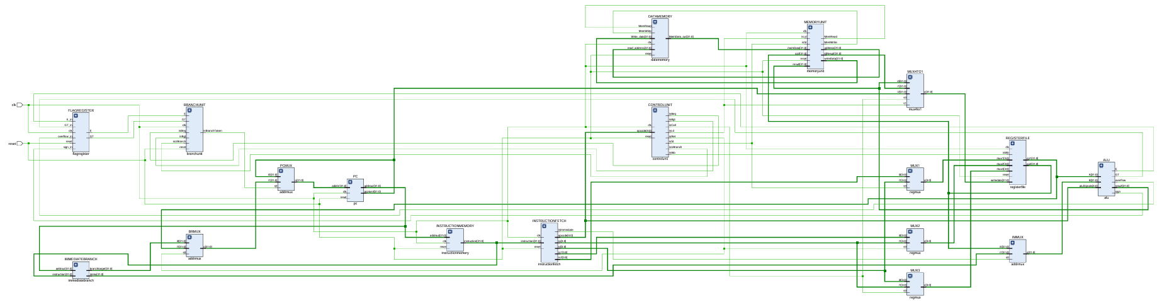
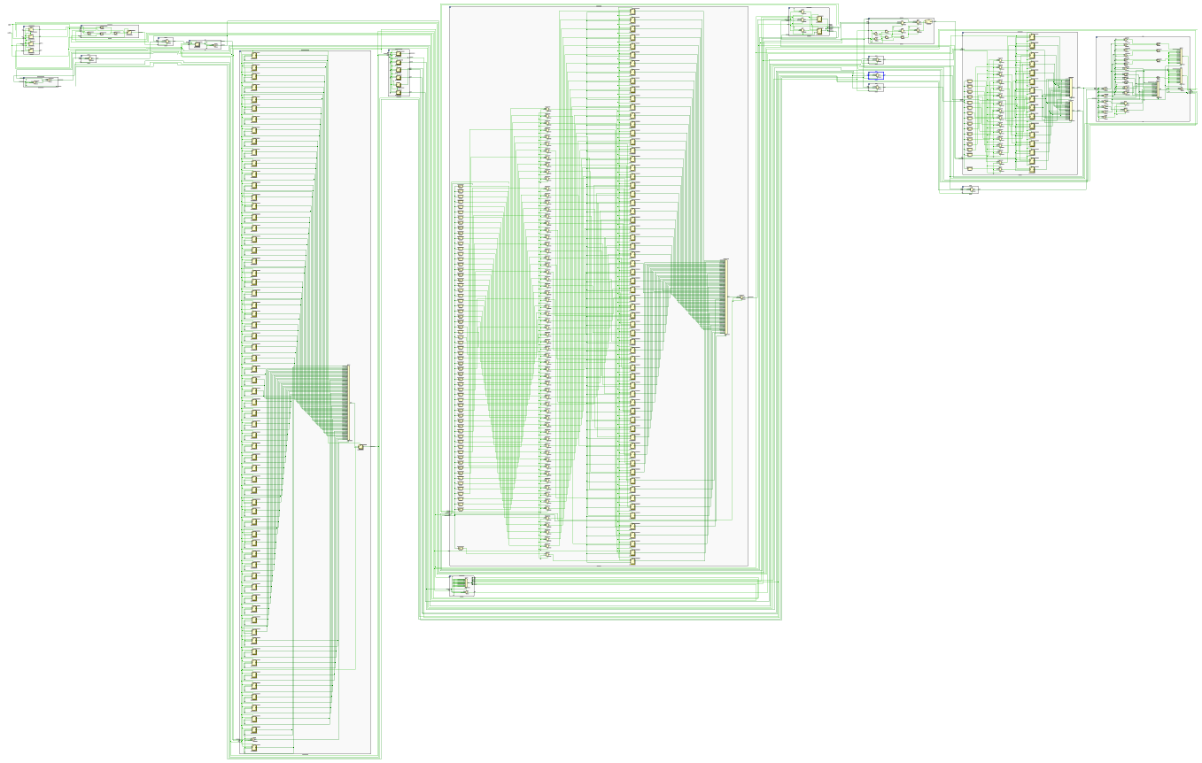

Pipelined elaborated design:
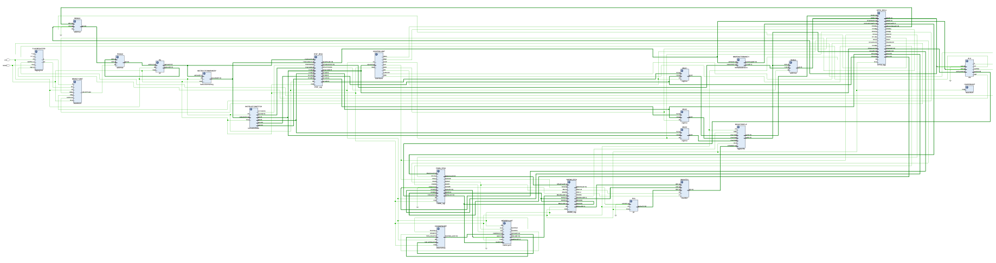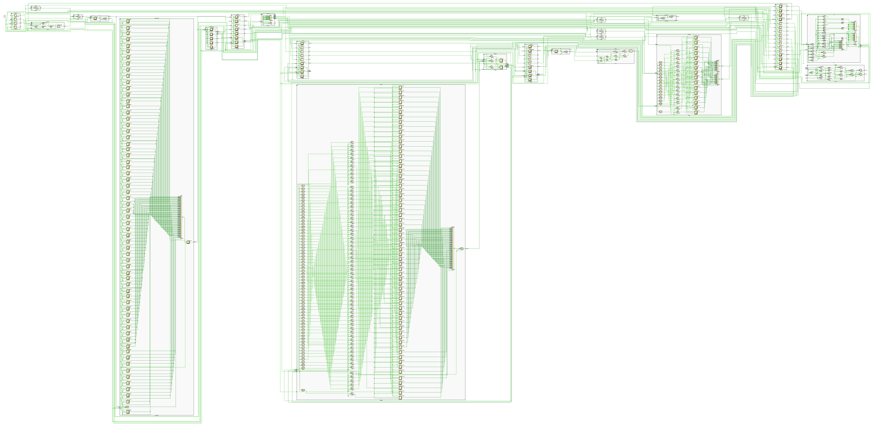

Simulation:
