INFLUENCELIFT AI

LinkedIn Marketing Kit
  - Launch copy, carousel narrative, profile updates, outreach messages, comment strategy, and a 30-day promotion plan for InfluenceLift AI.
Launch and Promotion Edition
Primary author | Mohit Bhatnagar
Collaboration credit | Aarushi Rai - marketing analytics framing and portfolio positioning
Live application | https://influencelift-ai.streamlit.app
Source repository | https://github.com/mohit231007/influencelift-ai
Purpose: help the project owner explain, defend, extend, and market the system in technical and business interviews.

How to use this guide
Use the primary post for Mohit’s profile. The business/marketing variant can be adapted for Aarushi’s profile with role attribution preserved.
This is a practical interview and portfolio manual. Each numbered module is intentionally self-contained so you can revise one topic, rehearse a two-minute answer, and then practise a deeper follow-up.
Module | Topic
01 | Positioning and audience
02 | Primary launch post
03 | Technical launch post
04 | Business/marketing launch post
05 | Short launch version
06 | Carousel: slides 1-5
07 | Carousel: slides 6-10
08 | LinkedIn Project section
09 | Featured section and headline
10 | First-comment and reply bank
11 | Hashtag and tagging strategy
12 | Recruiter direct message
13 | Hiring-manager email/DM
14 | Seven-day launch schedule
15 | Thirty-day content plan
16 | Measurement and iteration

01. Positioning and audience

Core promise
InfluenceLift AI predicts influencer campaign sales before budget is spent and shows how messy data was repaired.

Primary audience
Data-science recruiters, ML engineers, analytics leaders, marketing analytics teams, and hiring managers.

Proof points
Live Streamlit app, public repository, cross-validated Ridge result, FastAPI, Docker, tests, CI, uncertainty, and data-quality audit.

Ownership wording
Mohit Bhatnagar: data science, ML engineering, testing, API, deployment, and open-source packaging. Aarushi Rai: marketing-use-case framing and portfolio positioning.
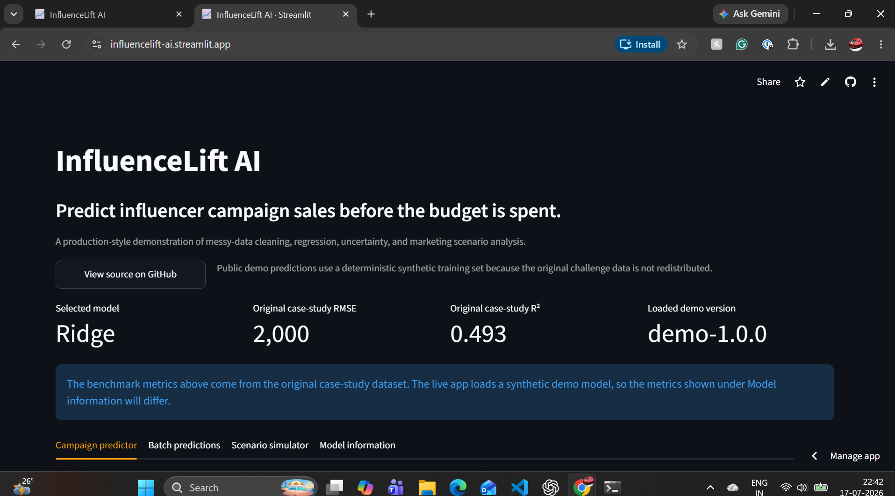

02. Primary launch post
Most machine-learning portfolios stop at a notebook. I wanted to build something a marketing team could actually use.
I have launched InfluenceLift AI - an end-to-end marketing analytics product that predicts influencer campaign sales before budget is spent.
The hard part was not only training a regression model. The source campaign data was deliberately messy: currency symbols, percentage strings, K/M follower units, missing values, negative spend, and unrealistic scales. So I built an auditable cleaning layer that records every repair before the model makes a prediction.
What the project includes:
• Cross-validated model comparison, with Ridge selected over a more complex challenger
• Original case-study result: RMSE 2,000 units and R² 0.493
• Single-campaign forecasting with empirical prediction intervals
• Batch CSV upload, quality audit, prediction, and download
• Baseline-versus-proposed campaign simulator
• FastAPI prediction service with OpenAPI documentation
• Docker, automated tests, GitHub Actions, deployment smoke tests, and a model card
• A public Streamlit application using deterministic synthetic data so the original challenge data is not redistributed
The biggest lesson: the best model is not always the most complex model. Ridge gave the strongest combination of validation performance, stability, explainability, and operational simplicity.
Live demo: https://influencelift-ai.streamlit.app
Source code: https://github.com/mohit231007/influencelift-ai
I would value feedback from data scientists, ML engineers, and marketing analytics professionals: what would you add next - per-prediction explanations, model monitoring, or constrained campaign-budget optimisation?
Use: Publish with one product screenshot or a 20-30 second screen recording.

03. Technical launch post
I just open-sourced InfluenceLift AI, a production-style regression system for messy influencer campaign data.
Engineering highlights:
- custom scikit-learn transformer for parsing and auditable repair
- one pipeline for training and inference to prevent skew
- five-fold out-of-fold evaluation and empirical residual bands
- model bundle with metrics, training ranges, and version metadata
- FastAPI single and batch endpoints
- Streamlit decision simulator
- Python 3.10-3.12 CI, runtime smoke tests, Docker, and Windows QA automation
The selected Ridge model slightly outperformed tuned XGBoost on the original case study. Simplicity won because it earned the best validation and operating profile.
Demo: https://influencelift-ai.streamlit.app
Code: https://github.com/mohit231007/influencelift-ai
Use: Use when your network is primarily engineering and data-science focused.

04. Business and marketing launch post
How much will an influencer campaign sell - before the budget is committed?
InfluenceLift AI is a live marketing analytics case study that turns inconsistent campaign records into an auditable forecast. A user can enter reach, engagement, spend, and content quality; compare two campaign scenarios; or upload a full CSV and download predicted sales with uncertainty ranges.
The project was designed around real marketing problems: incomplete data, inconsistent formats, uncertainty, budget trade-offs, and the need to explain a recommendation to non-technical stakeholders.
Live product: https://influencelift-ai.streamlit.app
Open-source implementation: https://github.com/mohit231007/influencelift-ai
Collaboration: marketing-use-case framing and portfolio positioning by Aarushi Rai; data science, ML engineering, API, testing, and deployment by Mohit Bhatnagar.
Use: Use for Aarushi’s marketing network or as a collaboration repost.

05. Short launch version
Launched: InfluenceLift AI 📈
A live ML product that cleans messy influencer campaign data, forecasts product sales, communicates prediction uncertainty, and compares campaign scenarios before budget is spent.
✅ Ridge selected through cross-validation
✅ Streamlit + FastAPI
✅ Batch CSV workflow
✅ Docker + tests + CI
✅ Public synthetic demo
Live: https://influencelift-ai.streamlit.app
Code: https://github.com/mohit231007/influencelift-ai
Use: Use as a repost, community post, or second-week reminder.

06. Carousel narrative - slides 1 to 5
Slide 1 - Predict influencer campaign sales before the budget is spent.
Slide 2 - The real problem: campaign data arrives with £ symbols, percentages, K/M units, missing values, negative spend, and extreme scales.
Slide 3 - The solution: an auditable data-quality engine that records every correction.
Slide 4 - The modelling approach: leakage-safe preprocessing, five-fold validation, and comparison of linear and nonlinear regressors.
Slide 5 - The result: Ridge selected at RMSE 2,000 units and R² 0.493 on the original case-study data.
Use: Use a clean dark background, large numeric proof points, and no more than 25-35 words per slide.

07. Carousel narrative - slides 6 to 10
Slide 6 - The product: single prediction, batch upload/download, and campaign scenario simulation.
Slide 7 - Trust features: prediction intervals, extrapolation warnings, model version, and a model card.
Slide 8 - Engineering: FastAPI, Streamlit, Docker, pytest, Ruff, and GitHub Actions.
Slide 9 - Responsible demo: the hosted app uses deterministic synthetic data; the original challenge files are not redistributed.
Slide 10 - Try it: live demo and source code, followed by a question asking which feature should be built next.
Use: End with both links and a specific question to invite comments.

08. LinkedIn Project section
InfluenceLift AI | End-to-End Marketing Analytics and ML Platform
Built and deployed a production-style machine-learning product that repairs inconsistent influencer campaign data, predicts attributed product sales, communicates uncertainty, and supports campaign scenario analysis. Compared regularised linear and nonlinear models through five-fold cross-validation and selected Ridge for the best balance of accuracy, stability, explainability, and operational simplicity. Implemented single and batch inference with Streamlit and FastAPI, automated tests, Docker, CI/CD, a model card, extrapolation warnings, and a public synthetic-data demo.
Skills: Python, pandas, NumPy, scikit-learn, regression, cross-validation, feature engineering, FastAPI, Streamlit, Docker, pytest, GitHub Actions, MLOps, marketing analytics, model governance.
Use: Add both live demo and GitHub URL. Use the live URL as the primary media link.

09. Featured section and profile wording
Featured item title: InfluenceLift AI - Live Campaign Sales Forecasting Demo
Description: A production-style ML platform for cleaning messy influencer campaign data, forecasting product sales, communicating uncertainty, and comparing campaign scenarios.
Headline option: Data Scientist | Building Reliable ML Products | Python, PySpark, SQL, MLOps | Marketing and Retail Analytics
About-section sentence: I build end-to-end analytics and ML products that move from unreliable raw data to tested, explainable, and deployable business decisions.
Use: Place the live app first and GitHub repository second in Featured.

10. First comment and reply bank
First comment:
Technical architecture and model-card details are available in the repository. The hosted app intentionally uses synthetic data so the original challenge files are not redistributed.
Reply to “Why Ridge?”:
I compared it with linear and nonlinear alternatives under the same cross-validation setup. Ridge slightly outperformed the tuned XGBoost challenger and had lower operational and explanation cost.
Reply to “Is this causal?”:
No. The model estimates predictive associations from observational campaign data. The UI and model card state that scenario changes are decision support, not causal guarantees.
Reply to “What next?”:
My preferred v1.1 is per-prediction contribution explanations plus a persisted monitoring view for outcomes and interval coverage.
Use: Post the first comment immediately after publishing to add technical depth without overloading the main post.

11. Hashtag, tagging, and accessibility strategy
Primary set (use 5-8):
#DataScience #MachineLearning #MarketingAnalytics #MLOps #Python #Streamlit #FastAPI #OpenSource
Alternative business set:
#InfluencerMarketing #SalesForecasting #MarketingTechnology #Analytics #DecisionScience
Tagging guidance:
Tag collaborators only when they have agreed to the wording. Do not tag unrelated companies or individuals for reach. Mention tools in text only when they are materially used.
Accessibility:
Add concise alt text to screenshots: “InfluenceLift AI dark-mode dashboard showing Ridge model, original case-study metrics, and campaign prediction tabs.”
Use: Rotate hashtag sets; do not use every tag in every post.

12. Recruiter direct message
Hi [Name] - I recently launched InfluenceLift AI, an end-to-end ML portfolio project focused on a realistic marketing analytics problem: forecasting influencer campaign sales from messy operational data. It includes a tested cleaning pipeline, cross-validated model selection, Streamlit and FastAPI interfaces, Docker, CI, and a public demo.
Live demo: https://influencelift-ai.streamlit.app
Code: https://github.com/mohit231007/influencelift-ai
I am exploring data-science and ML roles where reliable data products and business communication matter. I would be glad to hear whether this aligns with work on your team.
Use: Personalise the opening sentence and reference a relevant role or team.

13. Hiring-manager email or DM
Subject: Applied ML portfolio - live campaign forecasting product
Hello [Name],
I am sharing a recent end-to-end project that reflects how I approach applied data science: start with the business decision, make messy inputs auditable, validate simple and complex models fairly, and deploy a product that non-technical users can test. InfluenceLift AI forecasts campaign-attributed sales and includes batch inference, scenario analysis, uncertainty, API access, tests, Docker, and CI.
Live demo: https://influencelift-ai.streamlit.app
Repository: https://github.com/mohit231007/influencelift-ai
The original case study achieved five-fold RMSE of approximately 2,000 units with Ridge selected over tuned XGBoost. I would value any feedback on how this compares with the modelling and product standards used by your team.
Regards,
Mohit Bhatnagar
Use: Use only for relevant roles and add one sentence connecting the project to the job description.

14. Seven-day launch schedule
Day 0: Publish primary launch post with screenshot or short demo video.
Day 0: Add technical first comment and reply to early comments.
Day 1: Add project to Featured and Experience/Projects.
Day 2: Publish a short architecture carousel.
Day 4: Share one lesson: why the simpler model won.
Day 7: Share a short batch-data-quality demo.
Day 10: Publish a system-design diagram.
Day 14: Share a coding lesson from the parser or pipeline.
Day 21: Publish a recruiter-oriented “what I would build next” post.
Day 30: Summarise feedback, usage, and v1.1 roadmap.
Use: Respond thoughtfully; do not optimise only for impressions.

15. Thirty-day content plan
Week 1 - Product proof: launch, demo clip, architecture.
Week 2 - Technical depth: data cleaning, cross-validation, uncertainty.
Week 3 - Business depth: scenario planning, limitations, responsible use.
Week 4 - Career positioning: system-design defense, lessons learned, roadmap.
Reusable content atoms:
- before/after messy values
- Ridge versus XGBoost decision
- one API request and response
- one CI/deployment lesson
- one system-design diagram
- one limitation and responsible-use statement
- one future optimisation concept
Use: Reuse the same proof assets with different narratives instead of creating unrelated posts.

16. Measurement and iteration
Track:
- profile views and relevant connection requests
- live-demo clicks
- GitHub views, clones, stars, and issues
- comments from practitioners versus generic reactions
- recruiter conversations and interview references
- which explanation causes confusion
Iteration rule:
Do not change the project because a post receives low reach. Improve the hook, visual, audience targeting, or call to action first. Change the product when user feedback identifies a real usability, trust, or decision gap.
Use: Review results after 7 and 30 days; keep a small promotion log.

