INFLUENCELIFT AI

System Design Diagram Pack
  - Twenty whiteboard-ready diagrams plus defense notes for architecture, data, ML, deployment, security, scale, and operations.
Portfolio Edition 1.0
Primary author | Mohit Bhatnagar
Collaboration credit | Aarushi Rai - marketing analytics framing and portfolio positioning
Live application | https://influencelift-ai.streamlit.app
Source repository | https://github.com/mohit231007/influencelift-ai
Purpose: help the project owner explain, defend, extend, and market the system in technical and business interviews.

Diagram legend and interview method
Each diagram is followed by a one-page defense sheet. In an interview, draw only the minimum boxes required, label trust and data boundaries, and narrate one request end to end. Use arrows for data or control flow and state which components are current versus future.
- Blue boxes: system components, actors, or data assets.
- Arrows: request, data, deployment, or lifecycle direction.
- Current v1 components should be drawn with solid confidence; future components must be labelled as evolution, not existing production infrastructure.
- Always close with scale, security, monitoring, and one trade-off.
Diagram | Primary interview use
01. System Context | Explain boundary, flow, failure, and next-scale change.
02. Container Architecture | Explain boundary, flow, failure, and next-scale change.
03. Single Prediction Flow | Explain boundary, flow, failure, and next-scale change.
04. Batch Prediction Flow | Explain boundary, flow, failure, and next-scale change.
05. Data Quality Pipeline | Explain boundary, flow, failure, and next-scale change.
06. Training Pipeline | Explain boundary, flow, failure, and next-scale change.
07. Model Selection Loop | Explain boundary, flow, failure, and next-scale change.
08. Prediction Uncertainty | Explain boundary, flow, failure, and next-scale change.
09. API Request Sequence | Explain boundary, flow, failure, and next-scale change.
10. Scenario Simulation | Explain boundary, flow, failure, and next-scale change.
11. Deployment Topology | Explain boundary, flow, failure, and next-scale change.
12. CI/CD Pipeline | Explain boundary, flow, failure, and next-scale change.
13. Observability Model | Explain boundary, flow, failure, and next-scale change.
14. Security Boundaries | Explain boundary, flow, failure, and next-scale change.
15. Threat Model | Explain boundary, flow, failure, and next-scale change.
16. Scale-out Architecture | Explain boundary, flow, failure, and next-scale change.
17. Model Lifecycle | Explain boundary, flow, failure, and next-scale change.
18. Failure Handling | Explain boundary, flow, failure, and next-scale change.
19. Data Storage Future | Explain boundary, flow, failure, and next-scale change.
20. Roadmap Evolution | Explain boundary, flow, failure, and next-scale change.

01. System Context
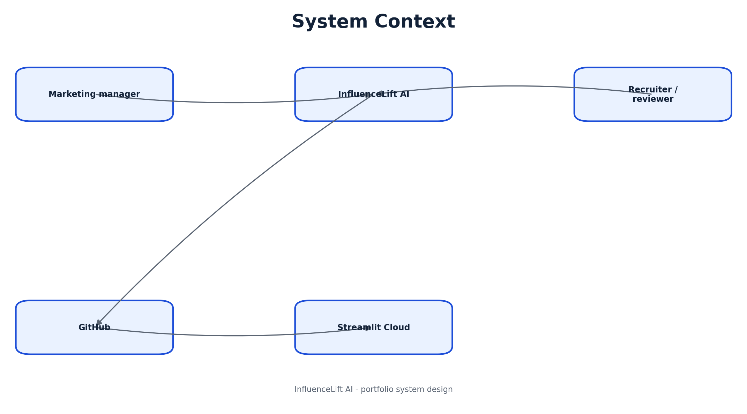
Figure 1: System Context
Whiteboard opening: “I will use this system context view to show the system boundary and the main flow before diving into implementation.”

01A. System Context - defense notes

Narration sequence
- 1. Explain the responsibility of **Marketing manager** and the data or decision it owns.
- 2. Explain the responsibility of **InfluenceLift AI** and the data or decision it owns.
- 3. Explain the responsibility of **Recruiter / reviewer** and the data or decision it owns.
- 4. Explain the responsibility of **GitHub** and the data or decision it owns.
- 5. Explain the responsibility of **Streamlit Cloud** and the data or decision it owns.

Key trade-offs
- Keep current v1 architecture visually distinct from future enterprise additions.
- State the reliability or security risk at the most important boundary.
- Name the metric or test that proves the flow works.
- Describe the first change required at 100x scale.
Defense close: “This system context design is intentionally simple for the current workload, and the next evolution is driven by measured scale, governance, or ownership needs.”

02. Container Architecture
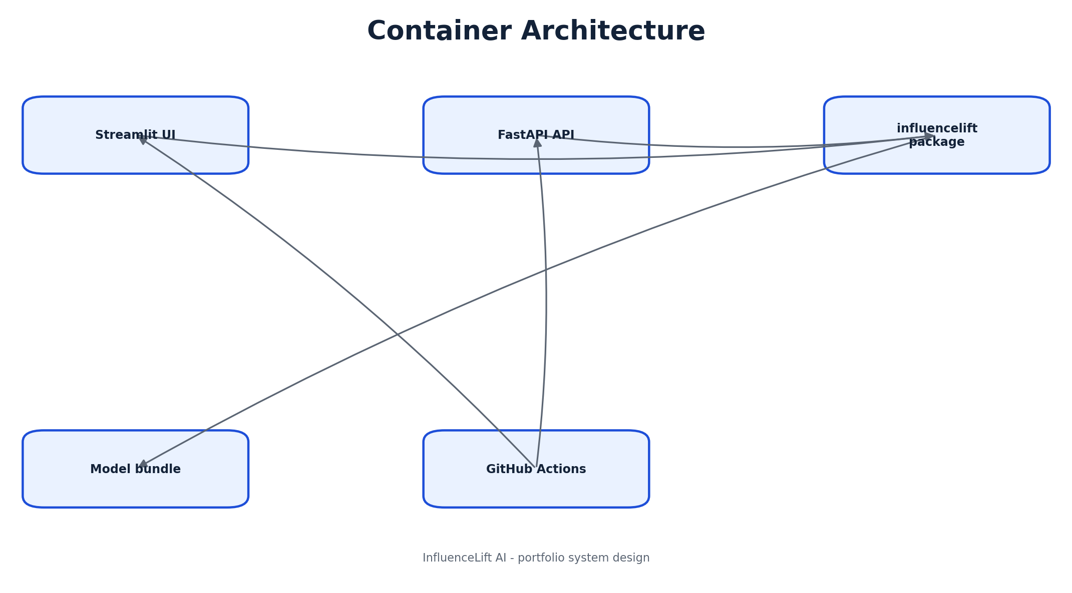
Figure 2: Container Architecture
Whiteboard opening: “I will use this container architecture view to show the system boundary and the main flow before diving into implementation.”

02A. Container Architecture - defense notes

Narration sequence
- 1. Explain the responsibility of **Streamlit UI** and the data or decision it owns.
- 2. Explain the responsibility of **FastAPI API** and the data or decision it owns.
- 3. Explain the responsibility of **influencelift package** and the data or decision it owns.
- 4. Explain the responsibility of **Model bundle** and the data or decision it owns.
- 5. Explain the responsibility of **GitHub Actions** and the data or decision it owns.

Key trade-offs
- Keep current v1 architecture visually distinct from future enterprise additions.
- State the reliability or security risk at the most important boundary.
- Name the metric or test that proves the flow works.
- Describe the first change required at 100x scale.
Defense close: “This container architecture design is intentionally simple for the current workload, and the next evolution is driven by measured scale, governance, or ownership needs.”

03. Single Prediction Flow
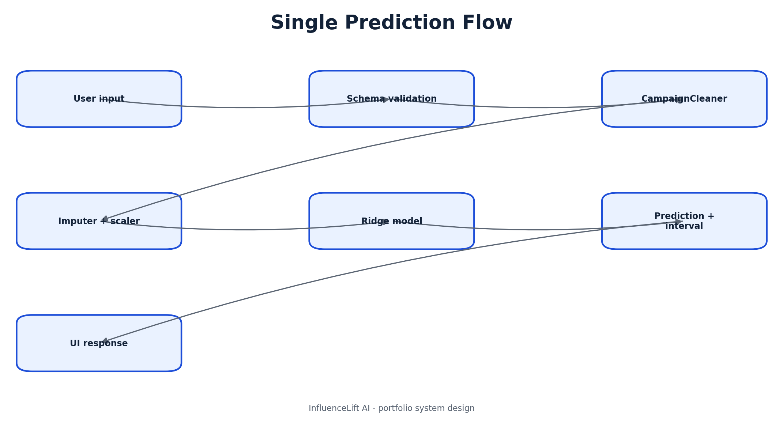
Figure 3: Single Prediction Flow
Whiteboard opening: “I will use this single prediction flow view to show the system boundary and the main flow before diving into implementation.”

03A. Single Prediction Flow - defense notes

Narration sequence
- 1. Explain the responsibility of **User input** and the data or decision it owns.
- 2. Explain the responsibility of **Schema validation** and the data or decision it owns.
- 3. Explain the responsibility of **CampaignCleaner** and the data or decision it owns.
- 4. Explain the responsibility of **Imputer + scaler** and the data or decision it owns.
- 5. Explain the responsibility of **Ridge model** and the data or decision it owns.
- 6. Explain the responsibility of **Prediction + interval** and the data or decision it owns.
- 7. Explain the responsibility of **UI response** and the data or decision it owns.

Key trade-offs
- Keep current v1 architecture visually distinct from future enterprise additions.
- State the reliability or security risk at the most important boundary.
- Name the metric or test that proves the flow works.
- Describe the first change required at 100x scale.
Defense close: “This single prediction flow design is intentionally simple for the current workload, and the next evolution is driven by measured scale, governance, or ownership needs.”

04. Batch Prediction Flow
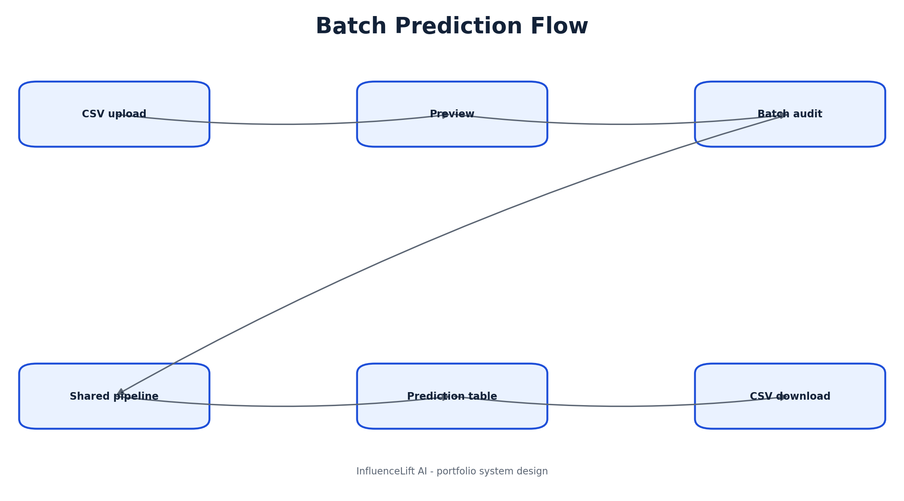
Figure 4: Batch Prediction Flow
Whiteboard opening: “I will use this batch prediction flow view to show the system boundary and the main flow before diving into implementation.”

04A. Batch Prediction Flow - defense notes

Narration sequence
- 1. Explain the responsibility of **CSV upload** and the data or decision it owns.
- 2. Explain the responsibility of **Preview** and the data or decision it owns.
- 3. Explain the responsibility of **Batch audit** and the data or decision it owns.
- 4. Explain the responsibility of **Shared pipeline** and the data or decision it owns.
- 5. Explain the responsibility of **Prediction table** and the data or decision it owns.
- 6. Explain the responsibility of **CSV download** and the data or decision it owns.

Key trade-offs
- Keep current v1 architecture visually distinct from future enterprise additions.
- State the reliability or security risk at the most important boundary.
- Name the metric or test that proves the flow works.
- Describe the first change required at 100x scale.
Defense close: “This batch prediction flow design is intentionally simple for the current workload, and the next evolution is driven by measured scale, governance, or ownership needs.”

05. Data Quality Pipeline
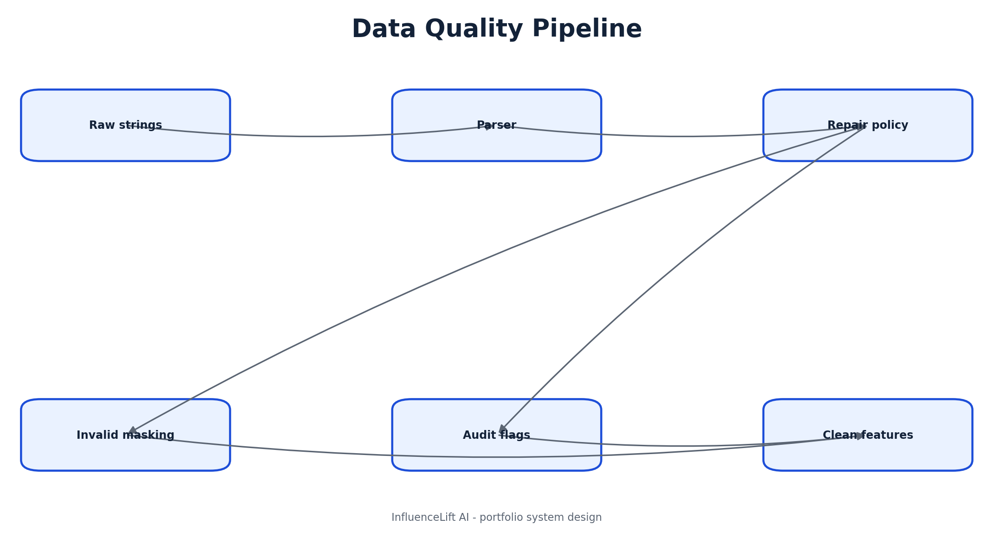
Figure 5: Data Quality Pipeline
Whiteboard opening: “I will use this data quality pipeline view to show the system boundary and the main flow before diving into implementation.”

05A. Data Quality Pipeline - defense notes

Narration sequence
- 1. Explain the responsibility of **Raw strings** and the data or decision it owns.
- 2. Explain the responsibility of **Parser** and the data or decision it owns.
- 3. Explain the responsibility of **Repair policy** and the data or decision it owns.
- 4. Explain the responsibility of **Invalid masking** and the data or decision it owns.
- 5. Explain the responsibility of **Audit flags** and the data or decision it owns.
- 6. Explain the responsibility of **Clean features** and the data or decision it owns.

Key trade-offs
- Keep current v1 architecture visually distinct from future enterprise additions.
- State the reliability or security risk at the most important boundary.
- Name the metric or test that proves the flow works.
- Describe the first change required at 100x scale.
Defense close: “This data quality pipeline design is intentionally simple for the current workload, and the next evolution is driven by measured scale, governance, or ownership needs.”

06. Training Pipeline
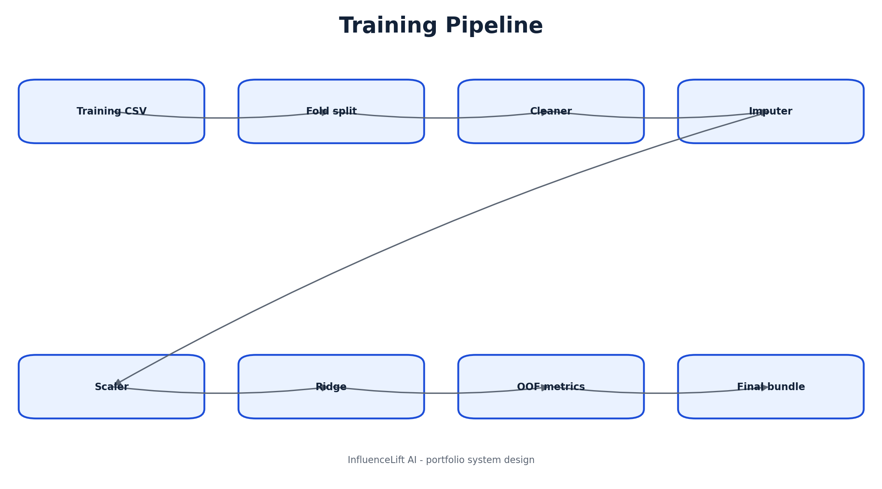
Figure 6: Training Pipeline
Whiteboard opening: “I will use this training pipeline view to show the system boundary and the main flow before diving into implementation.”

06A. Training Pipeline - defense notes

Narration sequence
- 1. Explain the responsibility of **Training CSV** and the data or decision it owns.
- 2. Explain the responsibility of **Fold split** and the data or decision it owns.
- 3. Explain the responsibility of **Cleaner** and the data or decision it owns.
- 4. Explain the responsibility of **Imputer** and the data or decision it owns.
- 5. Explain the responsibility of **Scaler** and the data or decision it owns.
- 6. Explain the responsibility of **Ridge** and the data or decision it owns.
- 7. Explain the responsibility of **OOF metrics** and the data or decision it owns.
- 8. Explain the responsibility of **Final bundle** and the data or decision it owns.

Key trade-offs
- Keep current v1 architecture visually distinct from future enterprise additions.
- State the reliability or security risk at the most important boundary.
- Name the metric or test that proves the flow works.
- Describe the first change required at 100x scale.
Defense close: “This training pipeline design is intentionally simple for the current workload, and the next evolution is driven by measured scale, governance, or ownership needs.”

07. Model Selection Loop
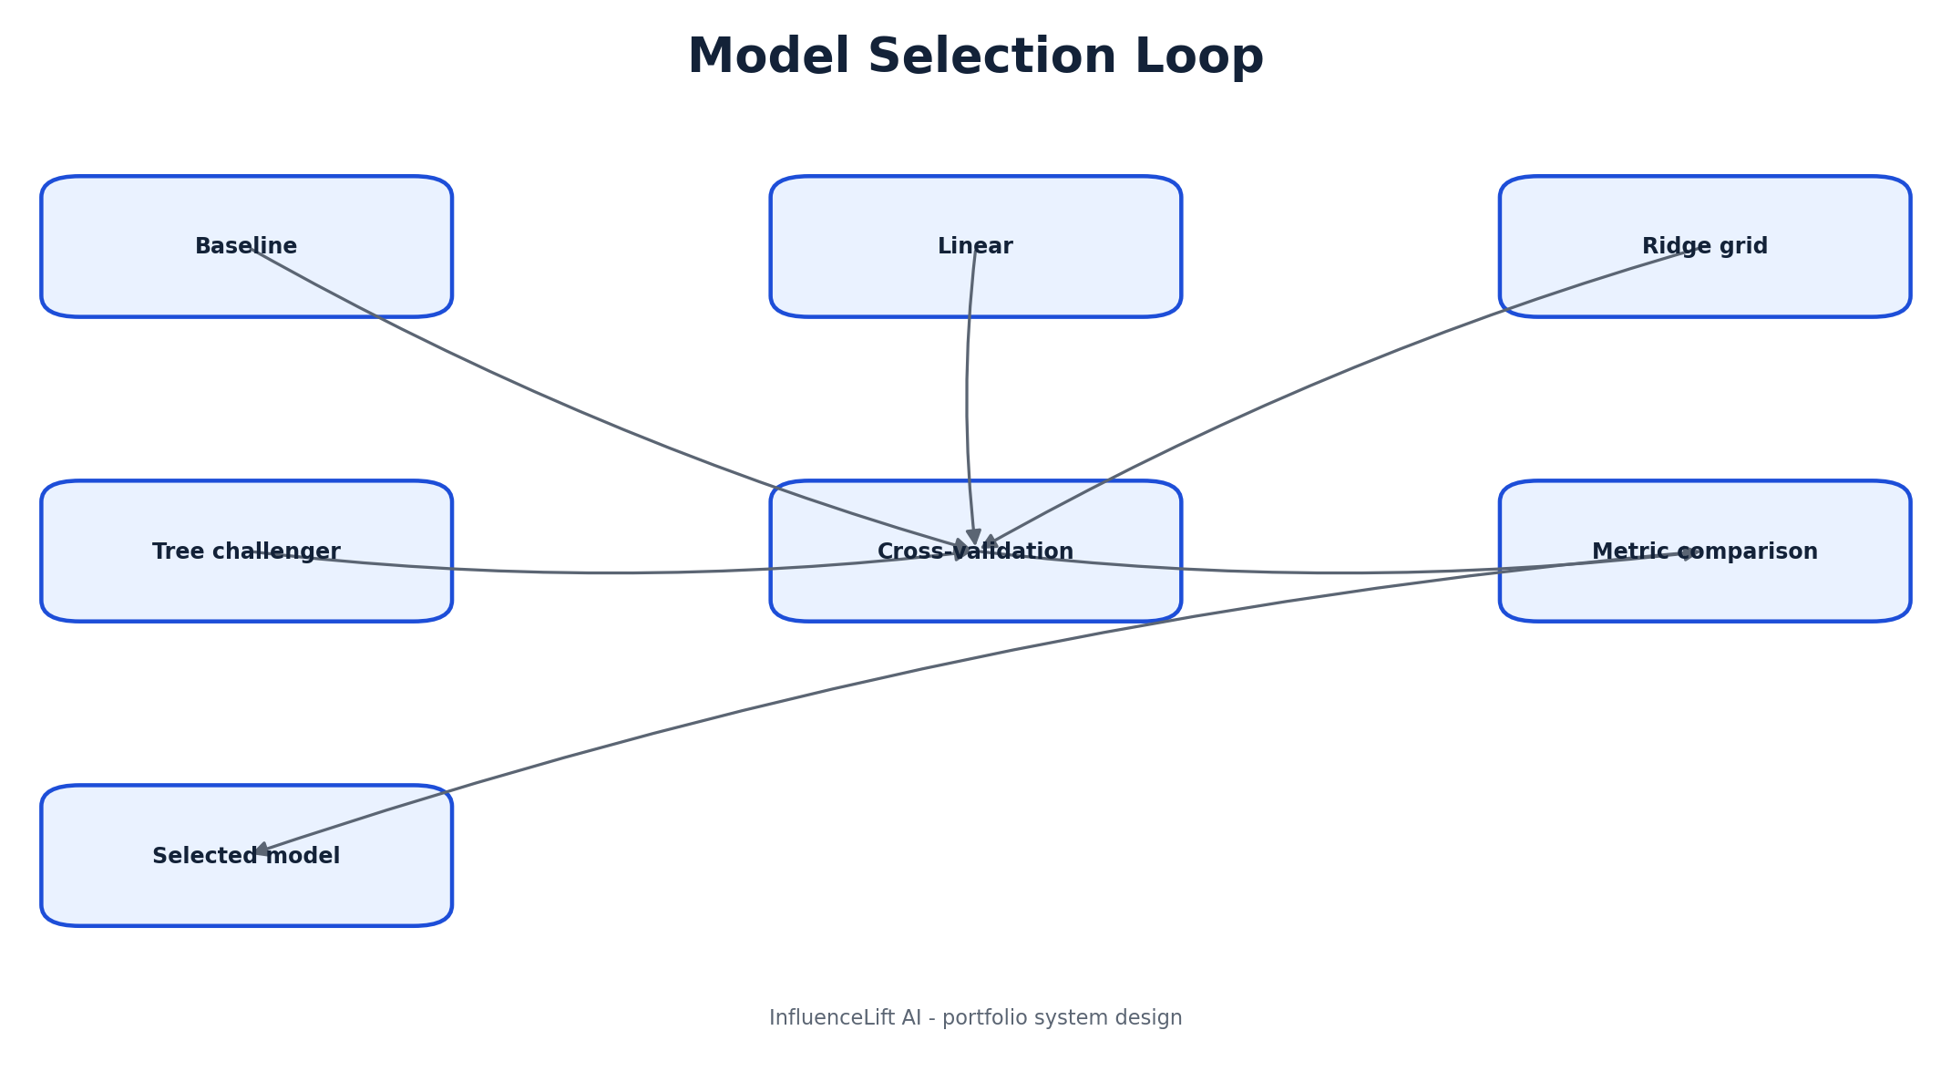
Figure 7: Model Selection Loop
Whiteboard opening: “I will use this model selection loop view to show the system boundary and the main flow before diving into implementation.”

07A. Model Selection Loop - defense notes

Narration sequence
- 1. Explain the responsibility of **Baseline** and the data or decision it owns.
- 2. Explain the responsibility of **Linear** and the data or decision it owns.
- 3. Explain the responsibility of **Ridge grid** and the data or decision it owns.
- 4. Explain the responsibility of **Tree challenger** and the data or decision it owns.
- 5. Explain the responsibility of **Cross-validation** and the data or decision it owns.
- 6. Explain the responsibility of **Metric comparison** and the data or decision it owns.
- 7. Explain the responsibility of **Selected model** and the data or decision it owns.

Key trade-offs
- Keep current v1 architecture visually distinct from future enterprise additions.
- State the reliability or security risk at the most important boundary.
- Name the metric or test that proves the flow works.
- Describe the first change required at 100x scale.
Defense close: “This model selection loop design is intentionally simple for the current workload, and the next evolution is driven by measured scale, governance, or ownership needs.”

08. Prediction Uncertainty
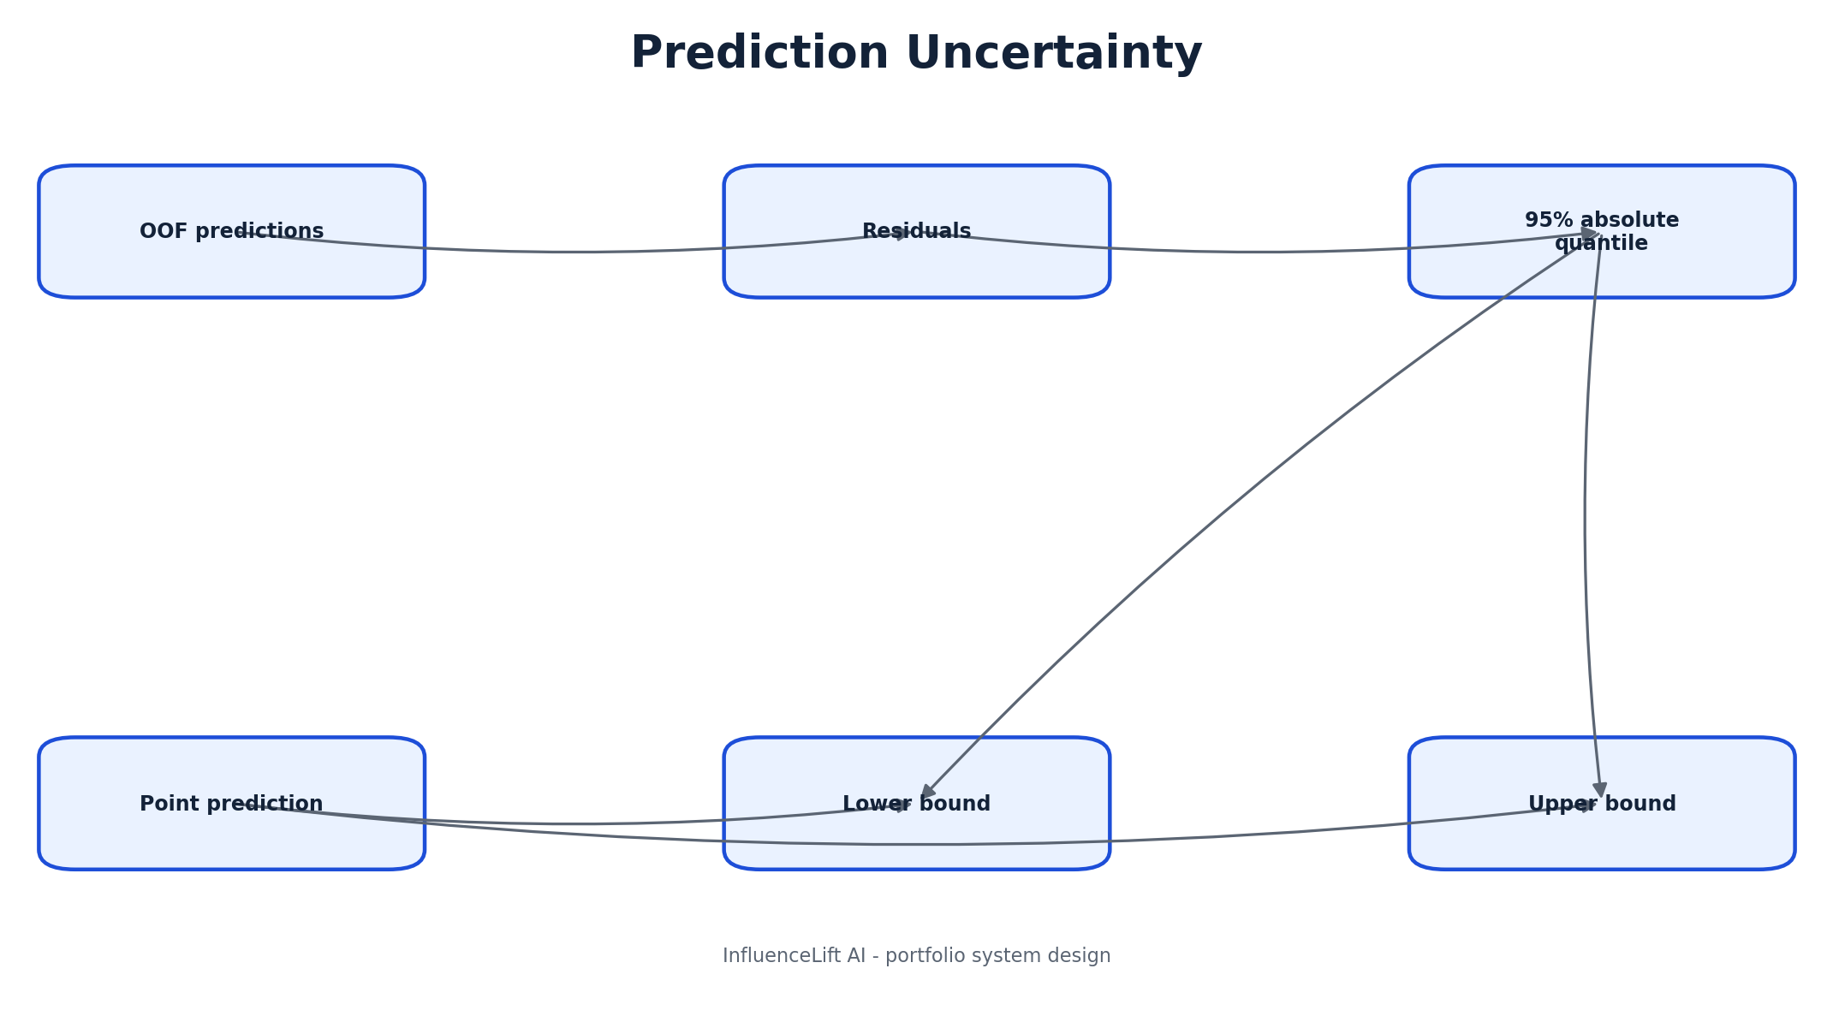
Figure 8: Prediction Uncertainty
Whiteboard opening: “I will use this prediction uncertainty view to show the system boundary and the main flow before diving into implementation.”

08A. Prediction Uncertainty - defense notes

Narration sequence
- 1. Explain the responsibility of **OOF predictions** and the data or decision it owns.
- 2. Explain the responsibility of **Residuals** and the data or decision it owns.
- 3. Explain the responsibility of **95% absolute quantile** and the data or decision it owns.
- 4. Explain the responsibility of **Point prediction** and the data or decision it owns.
- 5. Explain the responsibility of **Lower bound** and the data or decision it owns.
- 6. Explain the responsibility of **Upper bound** and the data or decision it owns.

Key trade-offs
- Keep current v1 architecture visually distinct from future enterprise additions.
- State the reliability or security risk at the most important boundary.
- Name the metric or test that proves the flow works.
- Describe the first change required at 100x scale.
Defense close: “This prediction uncertainty design is intentionally simple for the current workload, and the next evolution is driven by measured scale, governance, or ownership needs.”

09. API Request Sequence
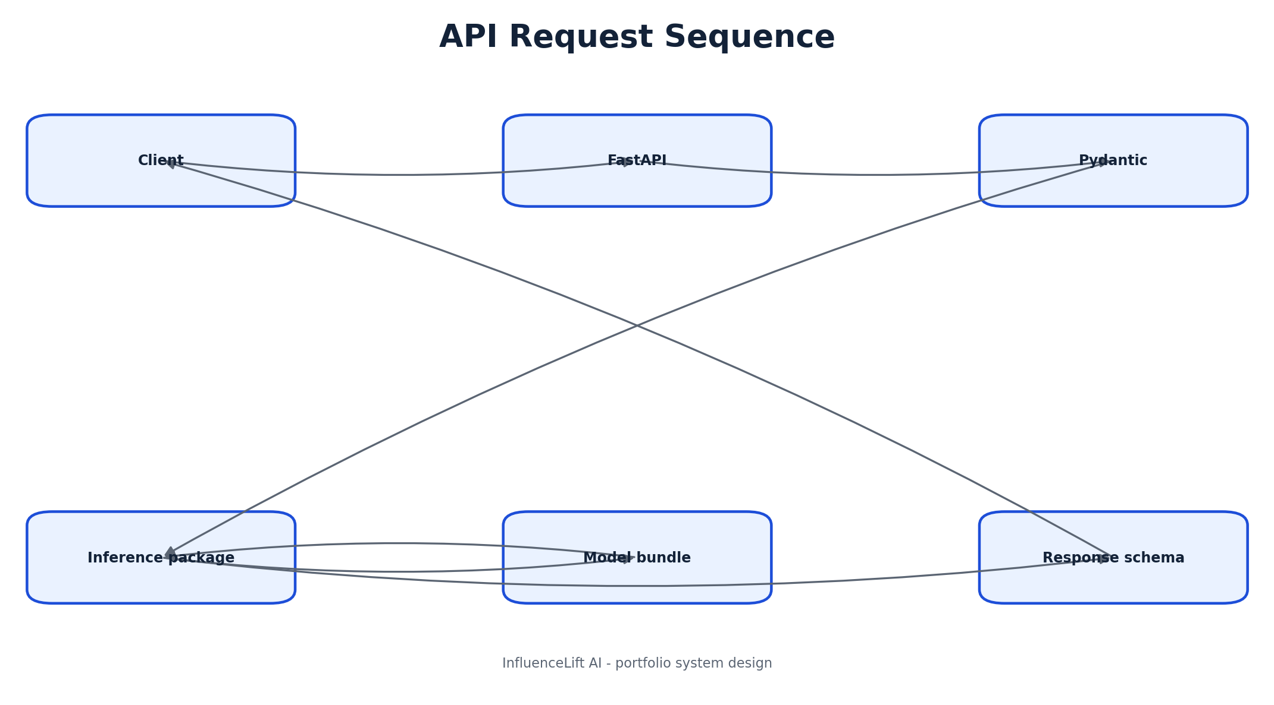
Figure 9: API Request Sequence
Whiteboard opening: “I will use this api request sequence view to show the system boundary and the main flow before diving into implementation.”

09A. API Request Sequence - defense notes

Narration sequence
- 1. Explain the responsibility of **Client** and the data or decision it owns.
- 2. Explain the responsibility of **FastAPI** and the data or decision it owns.
- 3. Explain the responsibility of **Pydantic** and the data or decision it owns.
- 4. Explain the responsibility of **Inference package** and the data or decision it owns.
- 5. Explain the responsibility of **Model bundle** and the data or decision it owns.
- 6. Explain the responsibility of **Response schema** and the data or decision it owns.

Key trade-offs
- Keep current v1 architecture visually distinct from future enterprise additions.
- State the reliability or security risk at the most important boundary.
- Name the metric or test that proves the flow works.
- Describe the first change required at 100x scale.
Defense close: “This api request sequence design is intentionally simple for the current workload, and the next evolution is driven by measured scale, governance, or ownership needs.”

10. Scenario Simulation
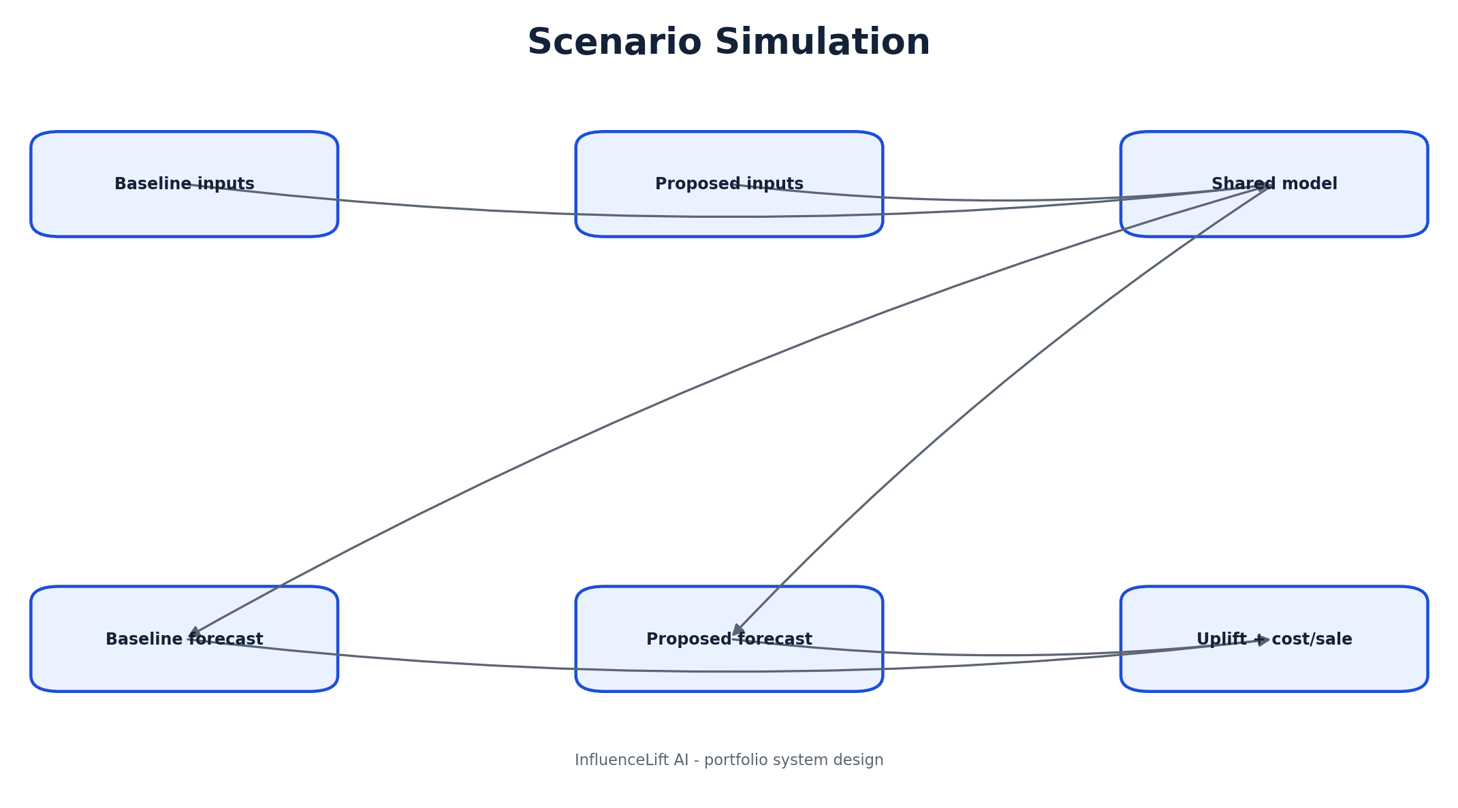
Figure 10: Scenario Simulation
Whiteboard opening: “I will use this scenario simulation view to show the system boundary and the main flow before diving into implementation.”

10A. Scenario Simulation - defense notes

Narration sequence
- 1. Explain the responsibility of **Baseline inputs** and the data or decision it owns.
- 2. Explain the responsibility of **Proposed inputs** and the data or decision it owns.
- 3. Explain the responsibility of **Shared model** and the data or decision it owns.
- 4. Explain the responsibility of **Baseline forecast** and the data or decision it owns.
- 5. Explain the responsibility of **Proposed forecast** and the data or decision it owns.
- 6. Explain the responsibility of **Uplift + cost/sale** and the data or decision it owns.

Key trade-offs
- Keep current v1 architecture visually distinct from future enterprise additions.
- State the reliability or security risk at the most important boundary.
- Name the metric or test that proves the flow works.
- Describe the first change required at 100x scale.
Defense close: “This scenario simulation design is intentionally simple for the current workload, and the next evolution is driven by measured scale, governance, or ownership needs.”

11. Deployment Topology
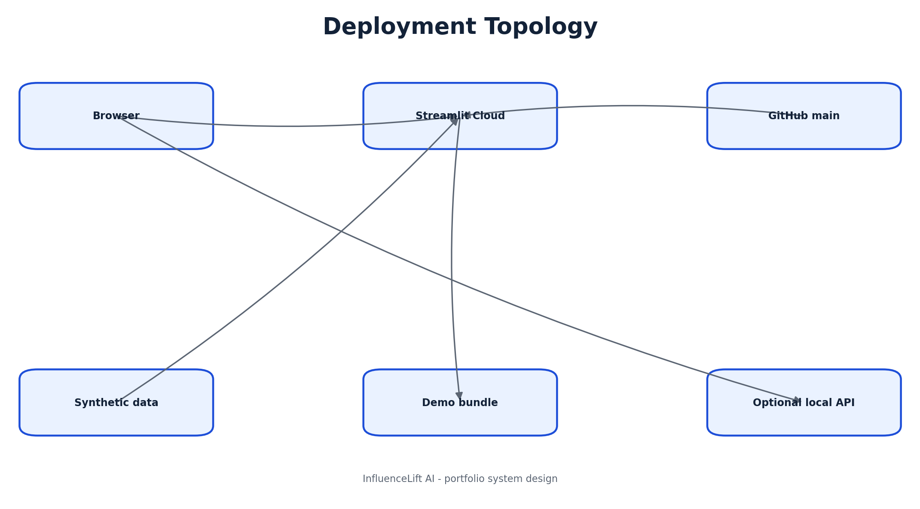
Figure 11: Deployment Topology
Whiteboard opening: “I will use this deployment topology view to show the system boundary and the main flow before diving into implementation.”

11A. Deployment Topology - defense notes

Narration sequence
- 1. Explain the responsibility of **Browser** and the data or decision it owns.
- 2. Explain the responsibility of **Streamlit Cloud** and the data or decision it owns.
- 3. Explain the responsibility of **GitHub main** and the data or decision it owns.
- 4. Explain the responsibility of **Synthetic data** and the data or decision it owns.
- 5. Explain the responsibility of **Demo bundle** and the data or decision it owns.
- 6. Explain the responsibility of **Optional local API** and the data or decision it owns.

Key trade-offs
- Keep current v1 architecture visually distinct from future enterprise additions.
- State the reliability or security risk at the most important boundary.
- Name the metric or test that proves the flow works.
- Describe the first change required at 100x scale.
Defense close: “This deployment topology design is intentionally simple for the current workload, and the next evolution is driven by measured scale, governance, or ownership needs.”

12. CI/CD Pipeline
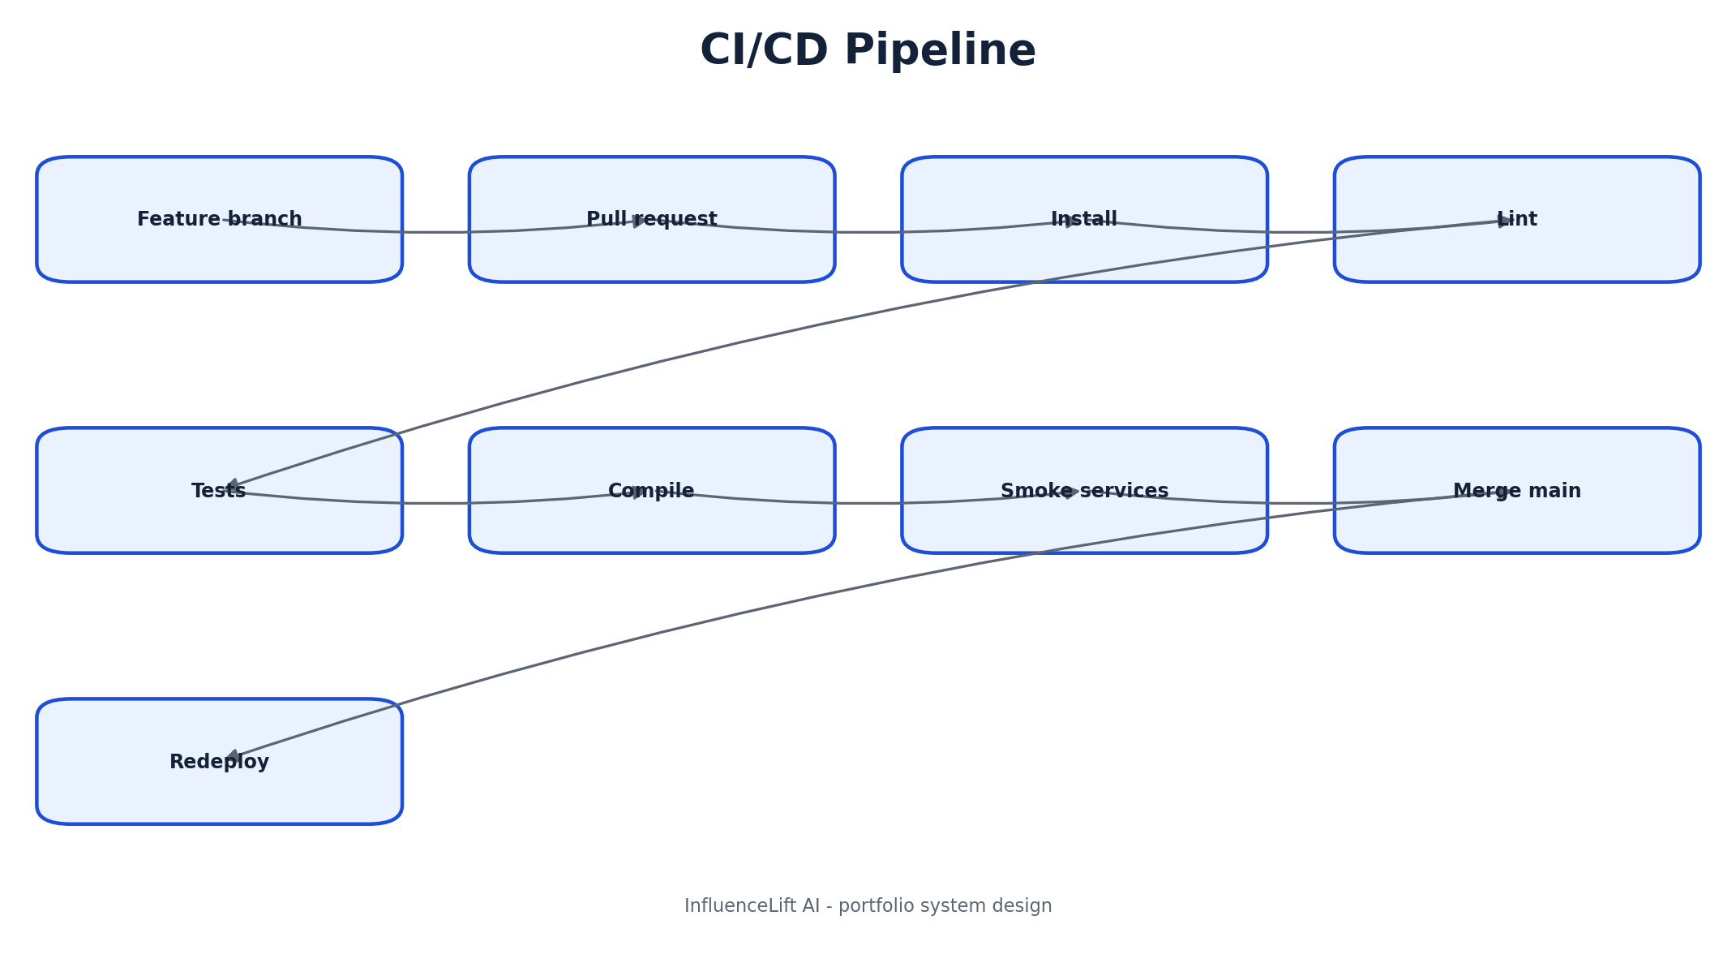
Figure 12: CI/CD Pipeline
Whiteboard opening: “I will use this ci/cd pipeline view to show the system boundary and the main flow before diving into implementation.”

12A. CI/CD Pipeline - defense notes

Narration sequence
- 1. Explain the responsibility of **Feature branch** and the data or decision it owns.
- 2. Explain the responsibility of **Pull request** and the data or decision it owns.
- 3. Explain the responsibility of **Install** and the data or decision it owns.
- 4. Explain the responsibility of **Lint** and the data or decision it owns.
- 5. Explain the responsibility of **Tests** and the data or decision it owns.
- 6. Explain the responsibility of **Compile** and the data or decision it owns.
- 7. Explain the responsibility of **Smoke services** and the data or decision it owns.
- 8. Explain the responsibility of **Merge main** and the data or decision it owns.
- 9. Explain the responsibility of **Redeploy** and the data or decision it owns.

Key trade-offs
- Keep current v1 architecture visually distinct from future enterprise additions.
- State the reliability or security risk at the most important boundary.
- Name the metric or test that proves the flow works.
- Describe the first change required at 100x scale.
Defense close: “This ci/cd pipeline design is intentionally simple for the current workload, and the next evolution is driven by measured scale, governance, or ownership needs.”

13. Observability Model
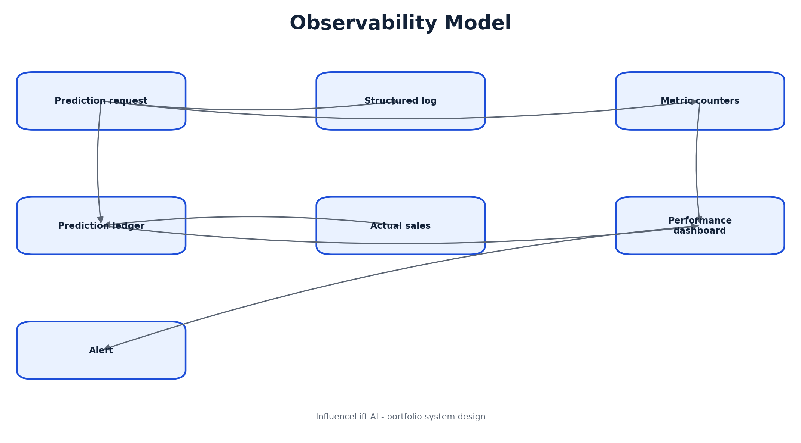
Figure 13: Observability Model
Whiteboard opening: “I will use this observability model view to show the system boundary and the main flow before diving into implementation.”

13A. Observability Model - defense notes

Narration sequence
- 1. Explain the responsibility of **Prediction request** and the data or decision it owns.
- 2. Explain the responsibility of **Structured log** and the data or decision it owns.
- 3. Explain the responsibility of **Metric counters** and the data or decision it owns.
- 4. Explain the responsibility of **Prediction ledger** and the data or decision it owns.
- 5. Explain the responsibility of **Actual sales** and the data or decision it owns.
- 6. Explain the responsibility of **Performance dashboard** and the data or decision it owns.
- 7. Explain the responsibility of **Alert** and the data or decision it owns.

Key trade-offs
- Keep current v1 architecture visually distinct from future enterprise additions.
- State the reliability or security risk at the most important boundary.
- Name the metric or test that proves the flow works.
- Describe the first change required at 100x scale.
Defense close: “This observability model design is intentionally simple for the current workload, and the next evolution is driven by measured scale, governance, or ownership needs.”

14. Security Boundaries
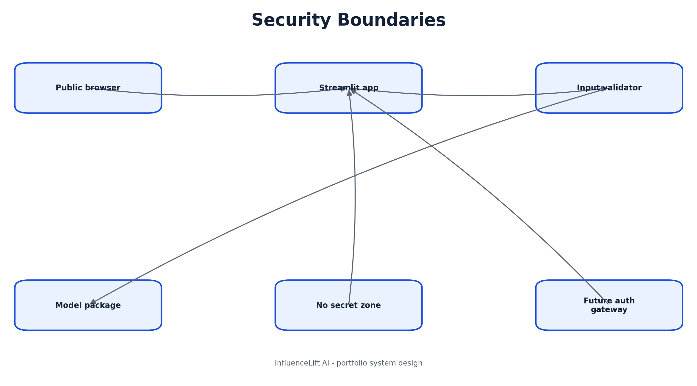
Figure 14: Security Boundaries
Whiteboard opening: “I will use this security boundaries view to show the system boundary and the main flow before diving into implementation.”

14A. Security Boundaries - defense notes

Narration sequence
- 1. Explain the responsibility of **Public browser** and the data or decision it owns.
- 2. Explain the responsibility of **Streamlit app** and the data or decision it owns.
- 3. Explain the responsibility of **Input validator** and the data or decision it owns.
- 4. Explain the responsibility of **Model package** and the data or decision it owns.
- 5. Explain the responsibility of **No secret zone** and the data or decision it owns.
- 6. Explain the responsibility of **Future auth gateway** and the data or decision it owns.

Key trade-offs
- Keep current v1 architecture visually distinct from future enterprise additions.
- State the reliability or security risk at the most important boundary.
- Name the metric or test that proves the flow works.
- Describe the first change required at 100x scale.
Defense close: “This security boundaries design is intentionally simple for the current workload, and the next evolution is driven by measured scale, governance, or ownership needs.”

15. Threat Model
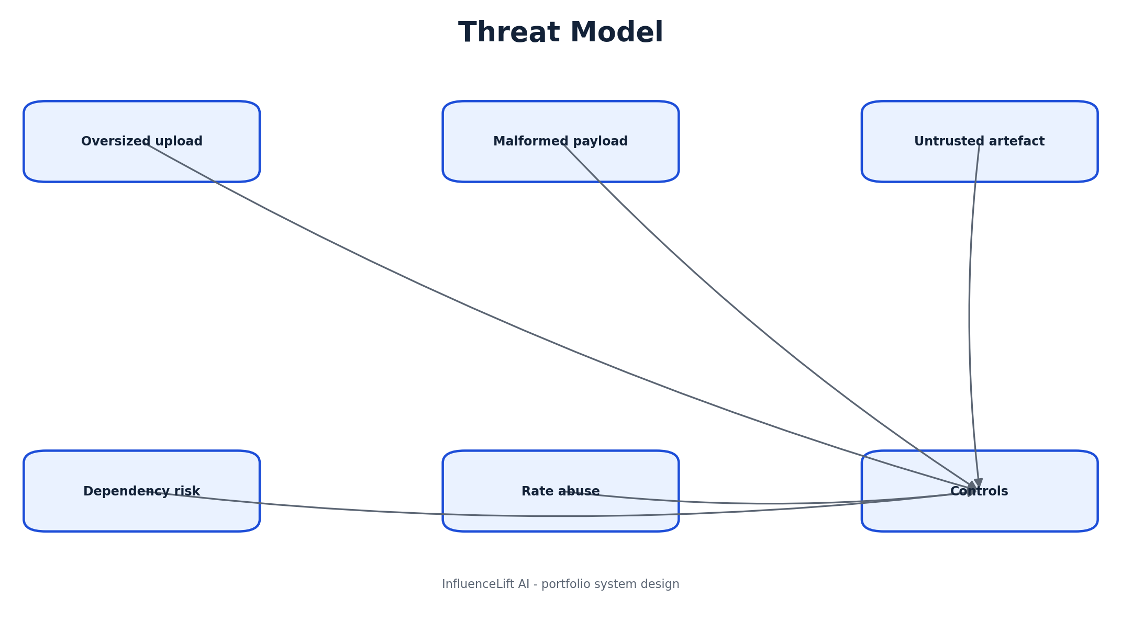
Figure 15: Threat Model
Whiteboard opening: “I will use this threat model view to show the system boundary and the main flow before diving into implementation.”

15A. Threat Model - defense notes

Narration sequence
- 1. Explain the responsibility of **Oversized upload** and the data or decision it owns.
- 2. Explain the responsibility of **Malformed payload** and the data or decision it owns.
- 3. Explain the responsibility of **Untrusted artefact** and the data or decision it owns.
- 4. Explain the responsibility of **Dependency risk** and the data or decision it owns.
- 5. Explain the responsibility of **Rate abuse** and the data or decision it owns.
- 6. Explain the responsibility of **Controls** and the data or decision it owns.

Key trade-offs
- Keep current v1 architecture visually distinct from future enterprise additions.
- State the reliability or security risk at the most important boundary.
- Name the metric or test that proves the flow works.
- Describe the first change required at 100x scale.
Defense close: “This threat model design is intentionally simple for the current workload, and the next evolution is driven by measured scale, governance, or ownership needs.”

16. Scale-out Architecture
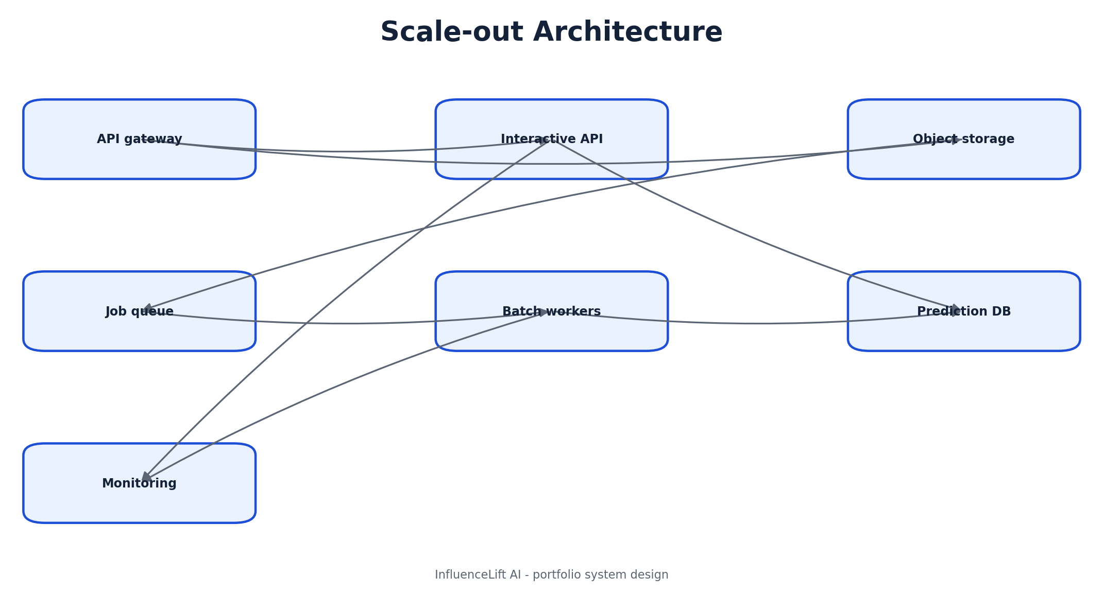
Figure 16: Scale-out Architecture
Whiteboard opening: “I will use this scale-out architecture view to show the system boundary and the main flow before diving into implementation.”

16A. Scale-out Architecture - defense notes

Narration sequence
- 1. Explain the responsibility of **API gateway** and the data or decision it owns.
- 2. Explain the responsibility of **Interactive API** and the data or decision it owns.
- 3. Explain the responsibility of **Object storage** and the data or decision it owns.
- 4. Explain the responsibility of **Job queue** and the data or decision it owns.
- 5. Explain the responsibility of **Batch workers** and the data or decision it owns.
- 6. Explain the responsibility of **Prediction DB** and the data or decision it owns.
- 7. Explain the responsibility of **Monitoring** and the data or decision it owns.

Key trade-offs
- Keep current v1 architecture visually distinct from future enterprise additions.
- State the reliability or security risk at the most important boundary.
- Name the metric or test that proves the flow works.
- Describe the first change required at 100x scale.
Defense close: “This scale-out architecture design is intentionally simple for the current workload, and the next evolution is driven by measured scale, governance, or ownership needs.”

17. Model Lifecycle
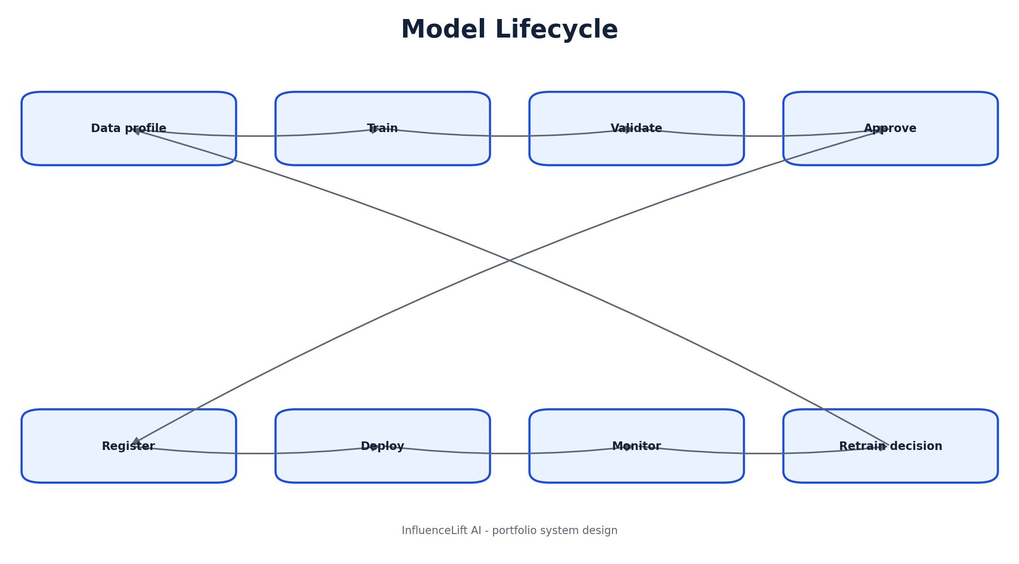
Figure 17: Model Lifecycle
Whiteboard opening: “I will use this model lifecycle view to show the system boundary and the main flow before diving into implementation.”

17A. Model Lifecycle - defense notes

Narration sequence
- 1. Explain the responsibility of **Data profile** and the data or decision it owns.
- 2. Explain the responsibility of **Train** and the data or decision it owns.
- 3. Explain the responsibility of **Validate** and the data or decision it owns.
- 4. Explain the responsibility of **Approve** and the data or decision it owns.
- 5. Explain the responsibility of **Register** and the data or decision it owns.
- 6. Explain the responsibility of **Deploy** and the data or decision it owns.
- 7. Explain the responsibility of **Monitor** and the data or decision it owns.
- 8. Explain the responsibility of **Retrain decision** and the data or decision it owns.

Key trade-offs
- Keep current v1 architecture visually distinct from future enterprise additions.
- State the reliability or security risk at the most important boundary.
- Name the metric or test that proves the flow works.
- Describe the first change required at 100x scale.
Defense close: “This model lifecycle design is intentionally simple for the current workload, and the next evolution is driven by measured scale, governance, or ownership needs.”

18. Failure Handling
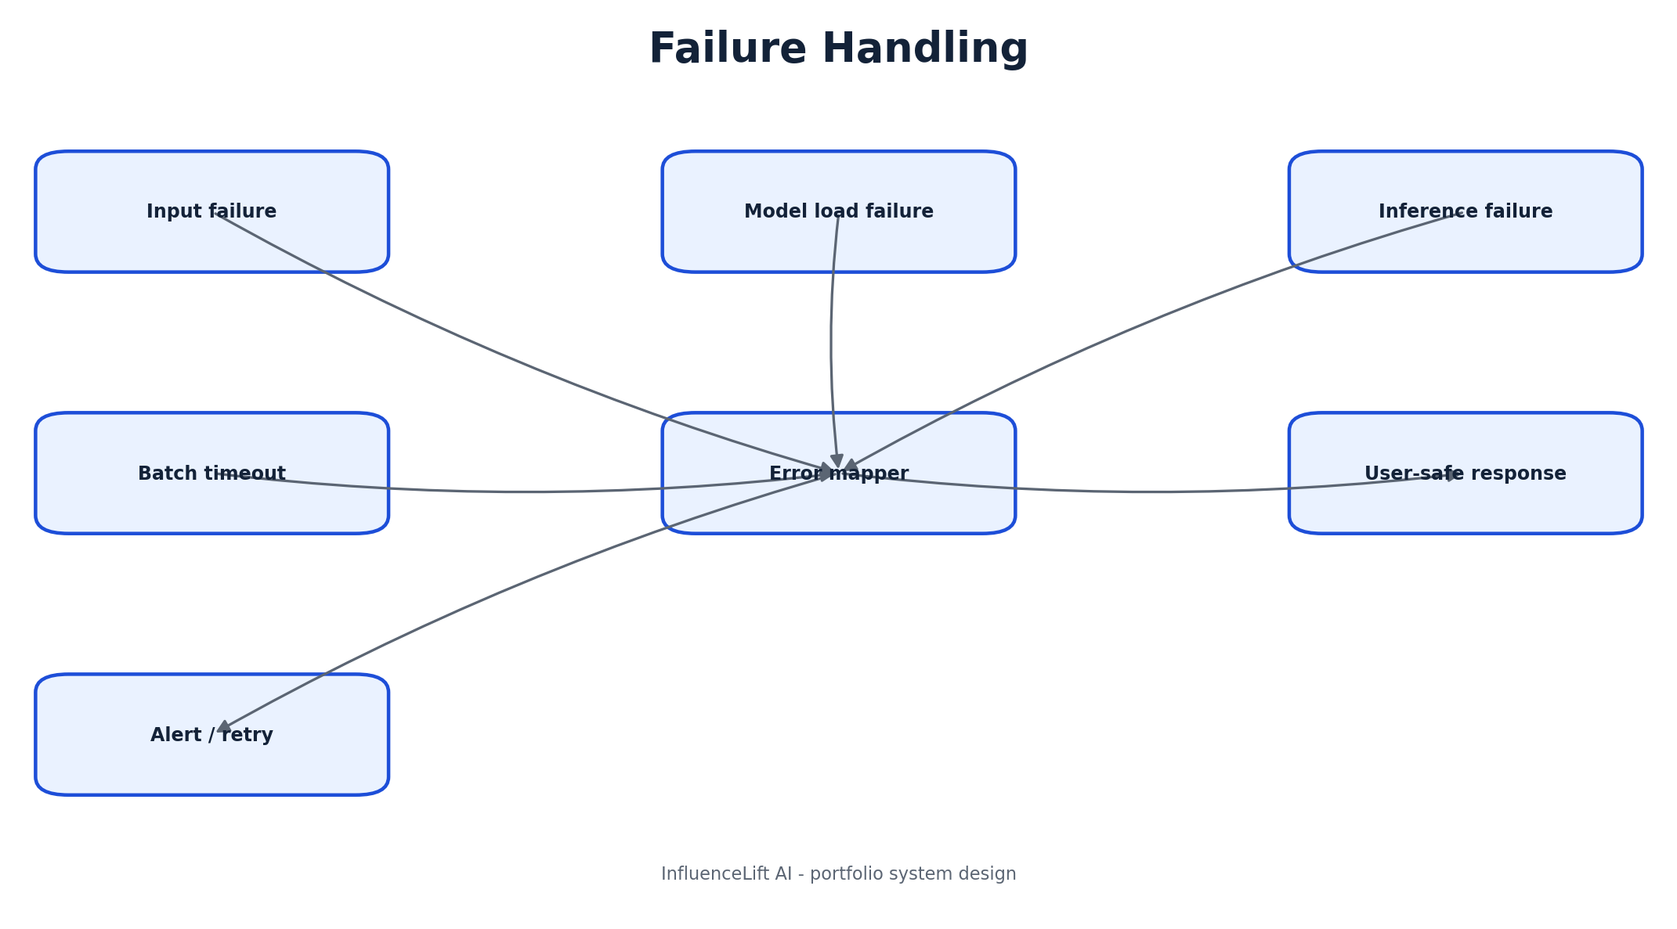
Figure 18: Failure Handling
Whiteboard opening: “I will use this failure handling view to show the system boundary and the main flow before diving into implementation.”

18A. Failure Handling - defense notes

Narration sequence
- 1. Explain the responsibility of **Input failure** and the data or decision it owns.
- 2. Explain the responsibility of **Model load failure** and the data or decision it owns.
- 3. Explain the responsibility of **Inference failure** and the data or decision it owns.
- 4. Explain the responsibility of **Batch timeout** and the data or decision it owns.
- 5. Explain the responsibility of **Error mapper** and the data or decision it owns.
- 6. Explain the responsibility of **User-safe response** and the data or decision it owns.
- 7. Explain the responsibility of **Alert / retry** and the data or decision it owns.

Key trade-offs
- Keep current v1 architecture visually distinct from future enterprise additions.
- State the reliability or security risk at the most important boundary.
- Name the metric or test that proves the flow works.
- Describe the first change required at 100x scale.
Defense close: “This failure handling design is intentionally simple for the current workload, and the next evolution is driven by measured scale, governance, or ownership needs.”

19. Data Storage Future
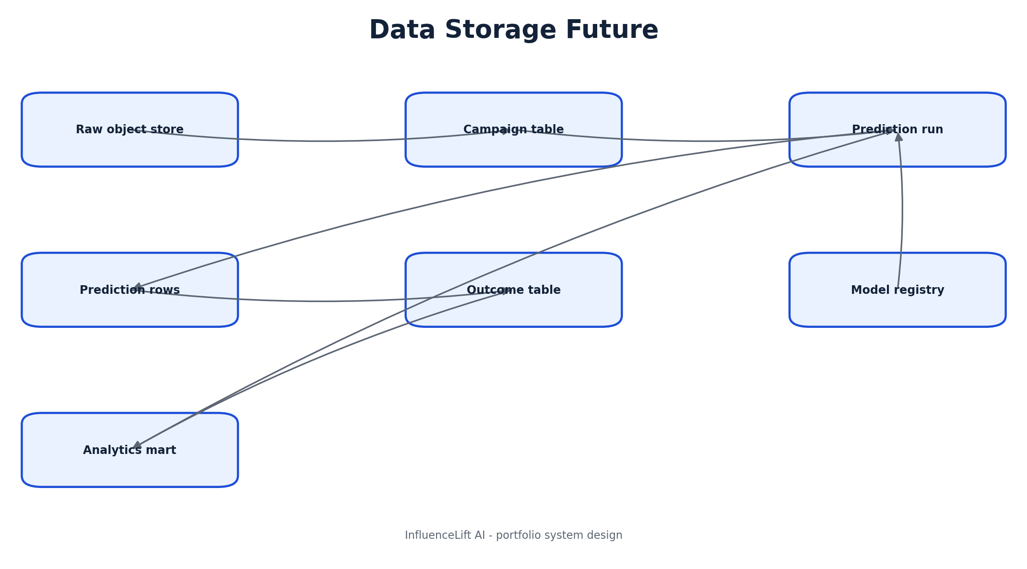
Figure 19: Data Storage Future
Whiteboard opening: “I will use this data storage future view to show the system boundary and the main flow before diving into implementation.”

19A. Data Storage Future - defense notes

Narration sequence
- 1. Explain the responsibility of **Raw object store** and the data or decision it owns.
- 2. Explain the responsibility of **Campaign table** and the data or decision it owns.
- 3. Explain the responsibility of **Prediction run** and the data or decision it owns.
- 4. Explain the responsibility of **Prediction rows** and the data or decision it owns.
- 5. Explain the responsibility of **Outcome table** and the data or decision it owns.
- 6. Explain the responsibility of **Model registry** and the data or decision it owns.
- 7. Explain the responsibility of **Analytics mart** and the data or decision it owns.

Key trade-offs
- Keep current v1 architecture visually distinct from future enterprise additions.
- State the reliability or security risk at the most important boundary.
- Name the metric or test that proves the flow works.
- Describe the first change required at 100x scale.
Defense close: “This data storage future design is intentionally simple for the current workload, and the next evolution is driven by measured scale, governance, or ownership needs.”

20. Roadmap Evolution
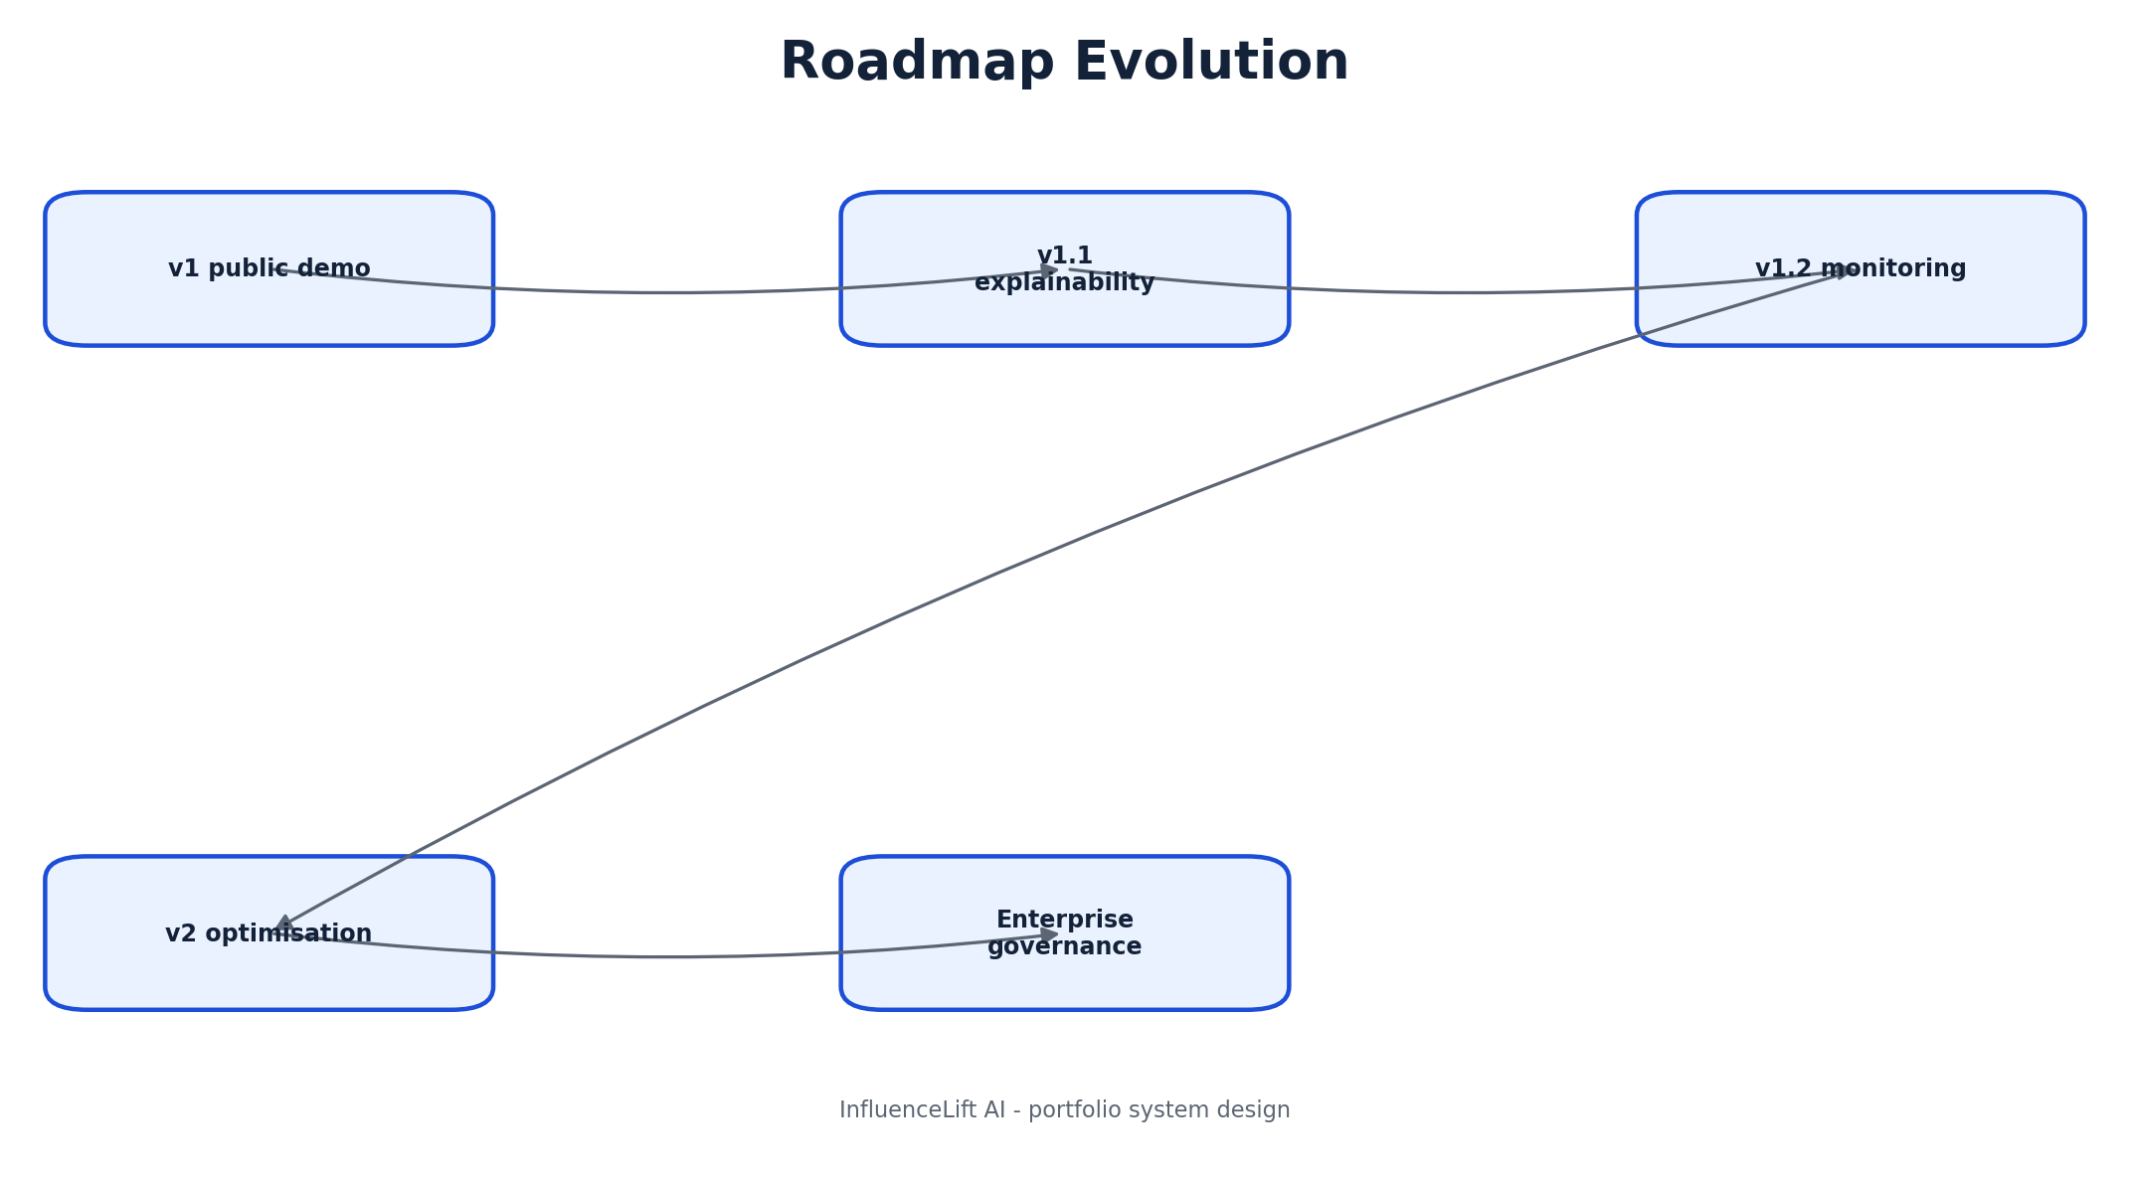
Figure 20: Roadmap Evolution
Whiteboard opening: “I will use this roadmap evolution view to show the system boundary and the main flow before diving into implementation.”

20A. Roadmap Evolution - defense notes

Narration sequence
- 1. Explain the responsibility of **v1 public demo** and the data or decision it owns.
- 2. Explain the responsibility of **v1.1 explainability** and the data or decision it owns.
- 3. Explain the responsibility of **v1.2 monitoring** and the data or decision it owns.
- 4. Explain the responsibility of **v2 optimisation** and the data or decision it owns.
- 5. Explain the responsibility of **Enterprise governance** and the data or decision it owns.

Key trade-offs
- Keep current v1 architecture visually distinct from future enterprise additions.
- State the reliability or security risk at the most important boundary.
- Name the metric or test that proves the flow works.
- Describe the first change required at 100x scale.
Defense close: “This roadmap evolution design is intentionally simple for the current workload, and the next evolution is driven by measured scale, governance, or ownership needs.”

