RobustWaste-AIoT
A Confidence-Aware Edge AI and IoT Framework for Smart Waste Segregation under Real-World Visual Degradation
Comparative Analysis of Related Work and Proposed Work

1. Comparative Analysis of Related Work
Three papers were reviewed: an experimental drone-based segregation study [1], an AI–IoT–blockchain architecture paper [2], and a review of AI and IoT for waste management in Indonesia [3]. They are compared with the proposed RobustWaste-AIoT framework along the dimensions that matter for a deployable segregation system: data realism, model, IoT layer, robustness, handling of uncertain samples, and edge suitability.
Table 1. Comparison of reviewed papers and the proposed framework
Aspect | Rajakumaran et al. [1] | Devi et al. [2] | Fuqaha & Nursetiawan [3] | RobustWaste-AIoT (proposed)
Type of work | Experimental: drone-based detection and classification | Conceptual architecture; evaluation described, not reported | Narrative review (Indonesia); no new data | Experimental, software-first framework
Venue / year | J. Phys.: Conf. Ser. 2471, 012030 (2023) | E3S Web Conf. 619, 03002 (2025) | J. Future AI and Technologies, vol. 2, no. 1 (2025) | This work
AI technique | CNN with ResNet50 (classification); Tiny-YOLOv3 with Darknet (multi-object detection) | Random Forest, linear regression, neural networks; Dijkstra / A* for routing | Survey of RF, LR, SVM, KNN, DT, ANN, RL and GA | MobileNetV3-Large with ResNet50 and EfficientNet-B0 baselines
Dataset | TrashNet, 2,527 images in 6 classes (studio-style photos); 10k images for YOLO training | None | None; cites Indonesian waste statistics | RealWaste: 4,752 landfill images, 9 material classes
Reported performance | 95% classification accuracy; 87.4% mAP | No measured accuracy | None (review) | RealWaste: 95.4–96.1% clean over two training runs (96.6% with a heavier ConvNeXt variant), at least 93.8% under degradation. TrashNet: 94.2% clean, at least 90.5% under degradation
IoT / communication | GPS and GSM location reporting from a drone | Smart bins (ultrasonic / IR), LoRaWAN, NB-IoT, blockchain ledger | Discusses smart bins, sensors, real-time monitoring | MQTT publish–subscribe with a virtual dashboard
Robustness to poor images | Not evaluated | Not addressed | Names data reliability as a challenge; no test | Explicit: low light, blur, noise, occlusion
Uncertain or unknown waste | Every image forced into a known class | Not addressed | Not addressed | Confidence-aware ACCEPT / REJECT; held-out unknown class
Edge suitability | Not assessed; ResNet50 is comparatively heavy | Low-power protocols and energy harvesting discussed | Notes cost and infrastructure limits | Parameters, model size and CPU latency measured
Hardware needed | Drone, camera, GPS / GSM modules | Sensor-equipped smart bins, blockchain network | Varies by system reviewed | None for the main experiments
Main limitation | Clean benchmark images; no degradation test; no reject option | No empirical validation of the proposed system | No experiments of its own | Simulated degradation; IoT layer is virtual
Sources: the three reviewed papers and the RealWaste dataset page. The last column is the design implemented in the accompanying code.

1.1 Observations on each paper
Rajakumaran et al. [1]. This is the closest experimental precedent. It combines a ResNet50 image classifier (reported 95% accuracy) with a Tiny-YOLOv3 detector (reported 87.4% mAP) and reports waste locations through GPS and GSM. Its evaluation uses TrashNet-style images, so it does not test what happens when the image is dark, blurred, noisy or partly hidden, and a prediction is always forced into one of the known classes. One practical citation note: the class counts listed in its dataset section add up to 2,620, not the 2,527 images it states, so quote the TrashNet total from the dataset itself.
Devi et al. [2]. It presents a complete urban architecture (smart bins, a data platform, AI segregation, route optimisation and a blockchain ledger) and compares LoRaWAN, NB-IoT and 5G. However, its results section describes how evaluation could be done (RMSE, MAE, a case study in a large city) instead of reporting measured values, and its figures show protocol coverage and power charts plus a qualitative stage-progress bar. Several entries in its reference list (for example on nitrates, diabetes treatment and jute fibre) are unrelated to waste management. It is best cited for the architectural idea and the protocol comparison, not as empirical evidence of segregation accuracy.
Fuqaha and Nursetiawan [3]. This review covers RF, LR, SVM, KNN, decision trees, ANN, reinforcement learning and genetic algorithms, and organises applications into collection, sorting, recycling and monitoring. It states that no new data were created. Its useful contribution for this work is the challenge list: data reliability and standardisation, privacy, cost and infrastructure, and ethics. It also notes that smart-bin systems struggle where stable connectivity and power are missing, which supports a lightweight model that runs on the device.

1.2 Research gaps identified
- G1 – Clean-image evaluation. Existing classifiers are reported on well-captured images, while real waste handling has poor light, motion blur, sensor noise and partial occlusion [1], [3].
- G2 – Forced classification. A prediction is always assigned to a known class, so uncertain or unfamiliar waste can contaminate a recyclable stream.
- G3 – Heavy or hardware-dependent designs. Drone and sensor-bin systems [1], [2] need physical hardware and often a heavy backbone, which raises cost and limits reproducibility.
- G4 – Missing empirical comparison. Architecture and review papers [2], [3] do not give measured, like-for-like comparisons of accuracy, robustness, latency and model size.

1.3 How RobustWaste-AIoT responds
Gap | Design element | Evidence produced
G1 | Visual degradation module and degradation-aware training | Accuracy and macro-F1 per condition; drop relative to clean (Table 2)
G2 | Confidence threshold with Unknown / Reject decision state | Coverage, accepted accuracy, wrong-accepted rate; held-out textile rejection (Tables 3, 4)
G3 | MobileNetV3-Large on a software-first pipeline with MQTT | Parameters, size, CPU latency; no hardware required (Table 1)
G4 | Four-model comparison and A–D ablation under one fixed split | Generated automatically by the compare script (Tables 1–5)

2. Proposed Work
This work proposes RobustWaste-AIoT, a confidence-aware Edge AI and Internet of Things (IoT) framework for automated waste segregation. Most waste classifiers are evaluated on clear, well-captured images. In a real waste-management setting, images may be affected by poor illumination, motion blur, partial occlusion, background clutter, camera noise, or damaged and dirty objects, which can reduce reliability and cause incorrect segregation. The framework therefore aims to keep decisions reliable when image quality drops, and to avoid forcing an uncertain sample into a wrong category: low-confidence samples are sent to an Unknown / Reject stream for manual inspection or further processing. The system is software-oriented. IoT functionality is realised with an MQTT communication layer and a virtual monitoring dashboard, so the framework can be evaluated without a physical smart-bin prototype.

2.1 System Architecture
The framework has six stages:
- Waste image acquisition.
- Image preprocessing and augmentation.
- Lightweight Edge-AI waste classification.
- Visual degradation robustness analysis.
- Confidence-aware segregation decision.
- IoT-based monitoring and reporting.
Waste Image → Preprocessing → Edge-AI Model → Confidence Analysis → Accept / Reject → MQTT Publisher → MQTT Broker → Dashboard

2.2 Dataset and Waste Categories
RealWaste [4] is used as the primary dataset. It contains 4,752 colour images (524 × 524 pixels) captured at the point of reception in a landfill environment, labelled with nine material types. Because the images come from real waste rather than isolated objects, they suit a study of degraded and ambiguous inputs. The nine source classes are mapped to six in-distribution categories, and Textile Trash is held out entirely as an unknown-waste test set that is never seen during training.
Table 2. RealWaste class mapping used in the proposed work
RealWaste class (images) | Experimental class | Images | Use
Cardboard (461) + Paper (500) | paper_cardboard | 961 | Train / val / test
Food Organics (411) + Vegetation (436) | organic | 847 | Train / val / test
Glass (420) | glass | 420 | Train / val / test
Metal (790) | metal | 790 | Train / val / test
Plastic (921) | plastic | 921 | Train / val / test
Miscellaneous Trash (495) | miscellaneous_trash | 495 | Train / val / test
Textile Trash (318) | Unknown (held out) | 318 | Unknown-waste test only
Each in-distribution class is split 70% / 15% / 15% into training, validation and test sets with a fixed random seed, and the same split is used for every model. Unknown / Reject is a decision state of the system, not a seventh training class. TrashNet [5] is used as a secondary benchmark, split 63% / 7% / 30% as in [1] (758 test images), so the proposed model can be compared with that study on the same dataset.

2.3 Visual Degradation Module
Instead of evaluating only on clean test images, the framework generates degraded versions of the test set under four conditions in addition to the normal condition. Each condition has a severity s in [0, 1]; the test severity is fixed at s = 0.65, and degradations are applied to the original image before resizing. During evaluation the random generator is seeded from the image content, so the same image always receives the same degradation and results are repeatable between runs.
Table 3. Degradation conditions (values at the test severity s = 0.65)
Condition | Operation | Value at s = 0.65
Normal | Image unchanged | –
Low light | Brightness factor = max(0.15, 1 − 0.8 s) | Brightness × 0.48
Blur | Gaussian blur, radius = 0.5 + 4.5 s | Radius ≈ 3.4 px
Noise | Additive Gaussian noise, σ = 8 + 42 s (pixel scale 0–255) | σ ≈ 35
Occlusion | Random black rectangle, side = (0.10 + 0.25 s) of image side | ≈ 26% of each side

2.4 Degradation-Aware Training
The training pipeline randomly applies one of the four degradations with probability 0.65 and a severity drawn uniformly from 0.35 to 0.85, followed by standard augmentation (horizontal flip, rotation up to 15°, random resized crop with scale 0.82–1.0, and mild colour jitter). This strategy is called degradation-aware training. The augmentations are used not only to enlarge the training set but to simulate conditions met in a real collection environment. Models are initialised from ImageNet weights, trained at 288 × 288 resolution on RealWaste (224 × 224 on TrashNet) with class-weighted cross-entropy to handle class imbalance (plus label smoothing of 0.1 on RealWaste), optimised with AdamW (learning rate 3 × 10⁻⁴, weight decay 10⁻⁴), with a learning-rate reduction on plateau of validation macro-F1 and early stopping after six epochs without improvement. The checkpoint with the best validation macro-F1 is kept. On RealWaste all models share the same settings: up to 40 epochs, patience 12, 288 × 288 inputs and label smoothing 0.1. These settings were strengthened, identically for every model, after an earlier run at 224 × 224 with 20–25 epochs in which the proposed model reached 94.6%. On TrashNet, whose validation set is very small, all four models used 224 × 224 inputs, up to 40 epochs and patience 12, without label smoothing.

2.5 Lightweight Edge-AI Classification
MobileNetV3-Large [6] is the proposed base architecture because it balances accuracy against computation and can run inference on limited hardware without continuous cloud processing. For comparison, ResNet50 [7] and EfficientNet-B0 [8] are trained under identical settings. Models are compared on classification accuracy, macro precision, recall and F1, parameter count, model size and inference latency, under both normal and degraded conditions.

2.6 Confidence-Aware Decision Mechanism
For an input image x, the classifier produces logits z and class probabilities p = softmax(z). The confidence is the highest probability, and the predicted class is its index [9]:
c = max_k p_k , ŷ = argmax_k p_k (1)
The decision rule with threshold T is:
Decision = ŷ (ACCEPT) if c ≥ T; Unknown / Reject if c < T (2)
The threshold is selected on the validation set only, by scanning T from 0.50 to 0.95 in steps of 0.01 and choosing the value with the largest coverage whose accepted-sample accuracy still meets a target (default 0.95):
T* = argmax_T Coverage(T) subject to AcceptedAccuracy(T) ≥ 0.95 (3)
If no threshold reaches the target, the threshold with the highest accepted accuracy is used and the result is flagged. The final test set is never used to tune T. The reject mechanism is evaluated with four quantities: coverage (fraction accepted), reject rate (1 − coverage), accepted accuracy, and the wrong-accepted rate (wrongly accepted samples divided by all samples), which measures the unsafe errors that would reach a recycling stream.

2.7 IoT-Based Monitoring Layer
MQTT is used because its lightweight publish–subscribe design suits IoT applications. For every classified item, the Edge-AI model publishes a JSON event to a broker topic, and a subscriber stores events for a dashboard:
- Predicted waste category and prediction confidence.
- Classification timestamp and the threshold in force.
- Image condition (normal, low light, blur, noise or occlusion) and source image name.
- Accepted or rejected decision; the dashboard accumulates the per-category counts.
Flow: Edge-AI Model → MQTT Publisher → MQTT Broker → Subscriber (CSV log) → Streamlit Dashboard. Classification runs on the edge device, so the cloud is used only for monitoring.

2.8 Operational Workflow
Algorithm 1. RobustWaste-AIoT workflow
- Acquire an input waste image.
- Resize to the training resolution and normalise.
- Apply the trained Edge-AI classification model.
- Obtain the predicted category and its confidence score c.
- If c ≥ T, accept the predicted category; otherwise assign the sample to Unknown / Reject.
- Publish the result (category, confidence, decision, condition, timestamp) using MQTT.
- Update the IoT monitoring dashboard.
- Store the prediction, confidence and operating condition for performance analysis.

2.9 Experimental Scenarios and Evaluation
Six scenarios are evaluated: (1) normal images as the baseline; (2) low light; (3) blur; (4) noise; (5) partial occlusion; and (6) unknown waste, where the held-out Textile Trash images test whether low-confidence samples are rejected. Metrics are grouped as follows.
Group | Metrics
Classification | Accuracy, macro precision, macro recall, macro F1, confusion matrix
Robustness | Accuracy and macro-F1 under each degradation; accuracy drop relative to normal
Confidence-aware decision | Coverage, reject rate, accepted accuracy, wrong-accepted rate, under every condition
Unknown waste | Mean confidence and reject rate on held-out Textile Trash
Edge suitability | Parameters, model size, average single-image CPU latency

2.10 Comparative Configurations and Ablation
Six trained models are compared on one fixed split. Two further configurations, the same framework on a ResNet50 backbone (RobustWaste-R50) and on a ConvNeXt-Tiny backbone (RobustWaste-ConvNeXt), check that the framework is not tied to one architecture and show what a heavier model gains. The four main models are: ResNet50, EfficientNet-B0 and MobileNetV3-Large with conventional training, and the proposed MobileNetV3-Large with degradation-aware training and confidence-aware rejection. An ablation isolates the contribution of each component:
Config | Training | Reject mechanism | Isolates
A | MobileNetV3, normal | No | Reference
B | MobileNetV3, degradation-aware | No | Effect of degradation-aware training
C | MobileNetV3, normal | Yes | Effect of confidence rejection
D | MobileNetV3, degradation-aware | Yes | Combined proposed system

2.11 Hypotheses
- H1: degradation-aware MobileNetV3 loses less performance than conventionally trained models under low light, blur, noise and occlusion.
- H2: a validation-selected confidence threshold raises the accuracy of accepted samples and lowers the wrong-accepted rate, at the cost of a higher reject rate.
- H3: the confidence mechanism rejects a meaningful share of unseen textile waste. This is tested, not assumed, because a softmax model can be confidently wrong on unfamiliar inputs.

2.12 Contributions
- A lightweight Edge-AI framework for classifying major waste categories on real landfill images.
- A degradation-aware training strategy for low light, blur, noise and partial occlusion.
- A confidence-aware decision mechanism that prevents uncertain samples from being forced into a wrong class.
- An Unknown / Reject stream that routes low-confidence and degraded samples to manual inspection, reducing wrongly accepted items.
- An MQTT-based IoT monitoring architecture integrated with the Edge-AI model.
- An evaluation that covers robustness, rejection behaviour, latency and model size, in addition to accuracy.

2.13 Software Implementation
The framework is implemented in Python with PyTorch and torchvision (models and training), scikit-learn (metrics), pandas and matplotlib (tables and figures), and paho-mqtt with Streamlit (IoT layer). Training was run on a Google Colab T4 GPU. Each stage of the architecture maps to a module of the released code:
Stage | Module | Function
Data preparation | scripts/prepare_realwaste.py, prepare_trashnet.py | Class merging, fixed-seed split, held-out textile set
Degradation module | degradations.py, robustness.py | Low light, blur, noise, occlusion; seeded per image for repeatable tests
Training | train.py, data.py, models.py | Pretrained backbones, class-weighted loss, degradation-aware augmentation, early stopping
Confidence-aware decision | threshold.py, compare.py | Validation-only threshold; accept / reject statistics
Evaluation | evaluate.py, robustness.py, ood.py, compare.py | Clean metrics, robustness, unknown waste, four-model tables, ablation A–D
IoT monitoring | infer.py, mqtt_subscriber.py, dashboard/app.py | MQTT publish, subscriber CSV log, Streamlit dashboard
All tables and figures in Section 3 are produced by one command (the compare script) from the trained checkpoints, with the same split and seed for every model, so the experiments can be reproduced from the released code.

3. Experimental Results and Discussion
All models were trained on the same RealWaste split (seed 42, 666 test images in the six in-distribution classes) on a GPU runtime, with identical settings (288 × 288 inputs, label smoothing 0.1, up to 40 epochs, early-stopping patience 12), and evaluated with the compare script. The confidence threshold of each model was chosen on the validation set only, with a target accepted accuracy of 0.95. All numbers below are produced by that script from the trained checkpoints, with repeatable (seeded) degradations. Section 3.6 repeats the study on TrashNet for a direct comparison with [1]. CPU latency is the average single-image time on a Colab CPU, so absolute values depend on the hardware and input size, while the ratios between models are what matter.

3.1 Clean performance and edge suitability
Table 4. Clean test performance and edge suitability (RealWaste)
Model | Acc. | Macro P | Macro R | Macro F1 | Params (M) | Size (MB) | CPU latency (ms)
ResNet50 | 0.9535 | 0.9508 | 0.9484 | 0.9495 | 23.52 | 90.03 | 180.6
EfficientNet-B0 | 0.9595 | 0.9578 | 0.9591 | 0.9583 | 4.02 | 15.60 | 48.8
MobileNetV3 (baseline) | 0.9505 | 0.9537 | 0.9458 | 0.9485 | 4.21 | 16.26 | 27.4
RobustWaste (proposed) | 0.9610 | 0.9634 | 0.9602 | 0.9612 | 4.21 | 16.26 | 27.4
RobustWaste-R50 (heavier backbone) | 0.9520 | 0.9464 | 0.9481 | 0.9467 | 23.52 | 90.03 | 185.5
In the main run the proposed model has the highest clean accuracy, 96.1% (640 of 666 images); retraining the same configuration later gave 95.35% (Section 3.7), so the expected accuracy is closer to 95.5–96%. The five models lie within about one point of each other (95.1–96.1%, a spread of roughly seven images), so the clean ranking should not be over-interpreted from a single split; the point is that the lightweight proposed model is at least as accurate as the heavy ones. It is 5.5 times smaller and 6.6 times faster on CPU than ResNet50 (27 ms against 181 ms), and 1.8 times faster than EfficientNet-B0. Using the same framework with a ResNet50 backbone (RobustWaste-R50) did not improve clean accuracy (95.2%) despite 5.6 times more parameters, so the lightweight backbone is the better choice. Test-time augmentation (averaging each image with its mirror image) was also evaluated and not adopted: the proposed model scored 95.95% with it against 96.10% without, and it doubles inference cost.

3.2 Robustness under visual degradation
Table 5. Test accuracy under visual degradation (drop relative to normal in brackets)
Model | Normal | Low light | Blur | Noise | Occlusion
ResNet50 | 0.9535 | 0.9174 (−3.6) | 0.7913 (−16.2) | 0.7432 (−21.0) | 0.9279 (−2.6)
EfficientNet-B0 | 0.9595 | 0.9384 (−2.1) | 0.6517 (−30.8) | 0.5180 (−44.1) | 0.9339 (−2.6)
MobileNetV3 (baseline) | 0.9505 | 0.9459 (−0.5) | 0.8814 (−6.9) | 0.8438 (−10.7) | 0.9234 (−2.7)
RobustWaste (proposed) | 0.9610 | 0.9595 (−0.2) | 0.9595 (−0.2) | 0.9444 (−1.7) | 0.9520 (−0.9)
RobustWaste-R50 | 0.9520 | 0.9535 (+0.2) | 0.9354 (−1.7) | 0.9339 (−1.8) | 0.9489 (−0.3)
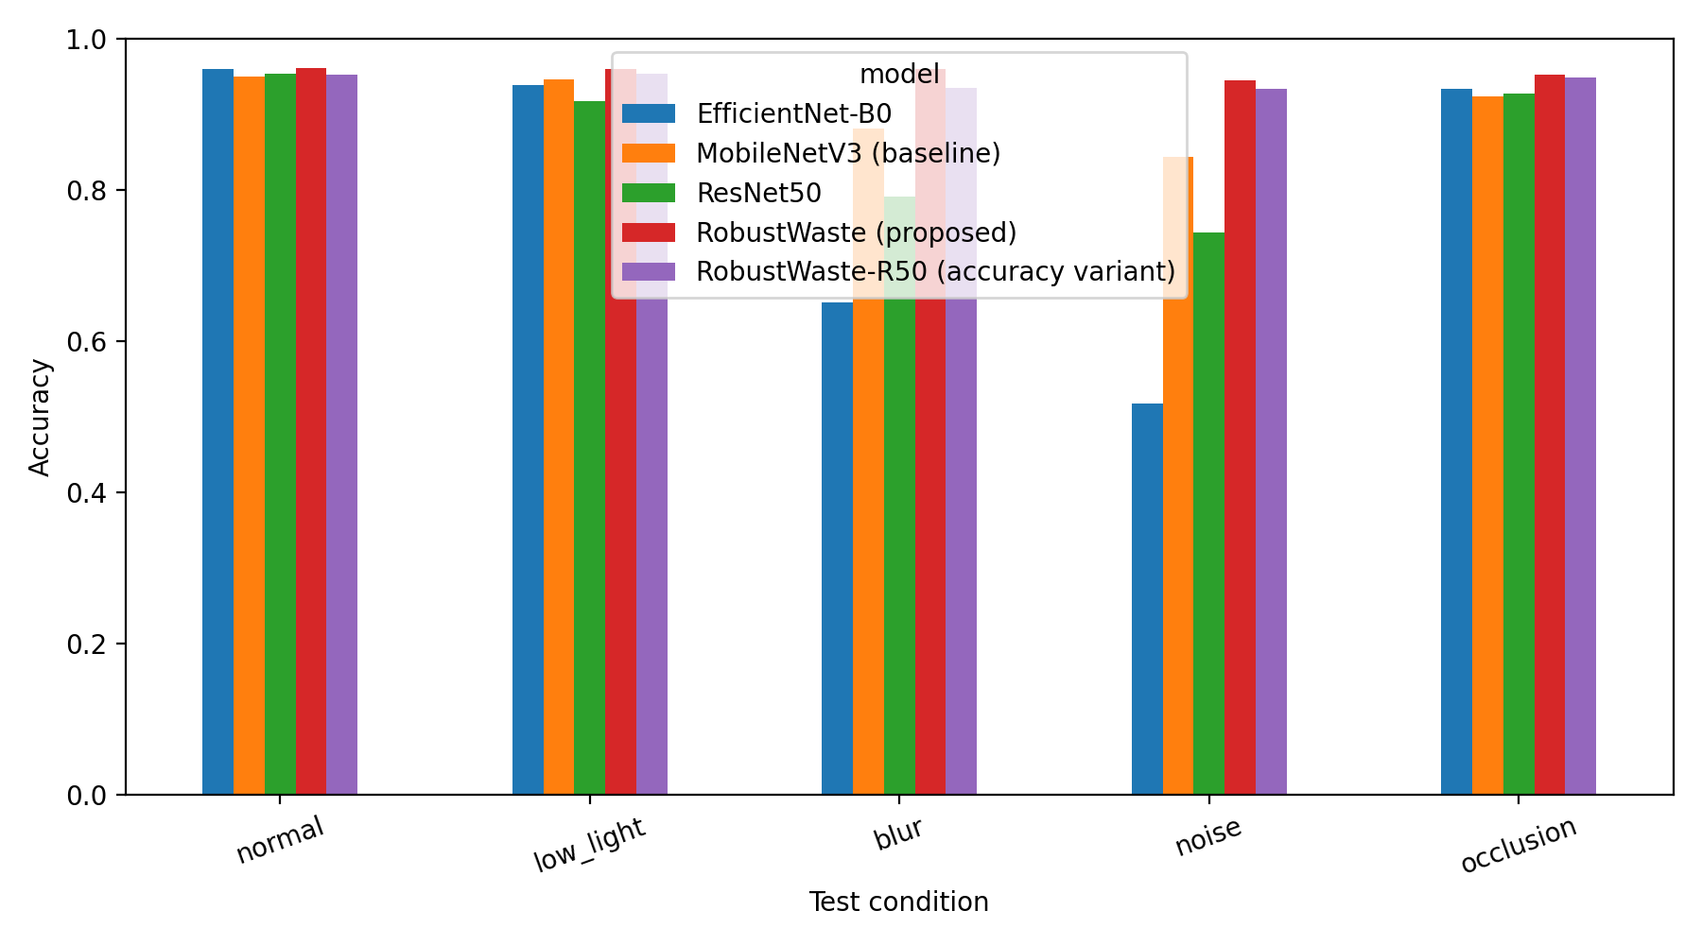
Fig. 1. Accuracy of the models under normal and degraded conditions (RealWaste)
The proposed model has the highest accuracy in every degraded condition, and its largest drop is 1.7 points (noise). Averaged over the four degradations, the accuracy drop is 0.7 points for the proposed model, 5.2 for the conventionally trained MobileNetV3, 10.9 for ResNet50 and 19.9 for EfficientNet-B0, whose accuracy falls to 52% under noise and 65% under blur. The mean accuracy over the four degraded conditions is 95.4% for the proposed model against 89.9%, 84.5% and 76.1% for the three conventionally trained models. Since the proposed model and the conventional MobileNetV3 share the same architecture, size and speed, the difference between them comes from degradation-aware training alone. The ResNet50 variant of the framework is also robust (largest drop 1.8 points), which shows that the benefit comes from the training strategy and not from one specific network. This supports hypothesis H1. The evaluation conditions are the same family of degradations used during training, so the result shows robustness to those degradations and not to arbitrary unseen corruptions.

3.3 Confidence-aware decision
Table 6. Wrongly accepted samples as a fraction of all samples (threshold chosen on validation)
Model | Normal | Low light | Blur | Noise | Occlusion
ResNet50 | 0.0315 | 0.0616 | 0.1396 | 0.1471 | 0.0495
EfficientNet-B0 | 0.0360 | 0.0495 | 0.2793 | 0.2958 | 0.0541
MobileNetV3 (baseline) | 0.0375 | 0.0405 | 0.0511 | 0.0976 | 0.0541
RobustWaste (proposed) | 0.0345 | 0.0345 | 0.0330 | 0.0495 | 0.0375
RobustWaste-R50 | 0.0405 | 0.0360 | 0.0571 | 0.0495 | 0.0420
All models received the threshold T = 0.50, the lowest value scanned (see text).
For every model the validation accuracy already exceeded the 0.95 target, so the selection rule returned the lowest threshold of the scan (0.50). Label smoothing also compresses the confidence values, so at this threshold the reject mechanism acts as a light filter that removes the least certain samples: the proposed model rejects only 1.2–2.4% of items and keeps an accepted accuracy of 95.0–96.6% in all conditions. Even so, the difference between models in the number of unsafe errors is large. Under blur and noise, ResNet50 wrongly accepts about 14% of items, EfficientNet-B0 about 28–30%, and the conventional MobileNetV3 up to 9.8%, while the proposed model stays at 3.3–5.0% in every condition. A stricter accepted-accuracy target (for example 0.97) would give a more selective operating point with a higher reject rate and was not run; it is a natural extension.
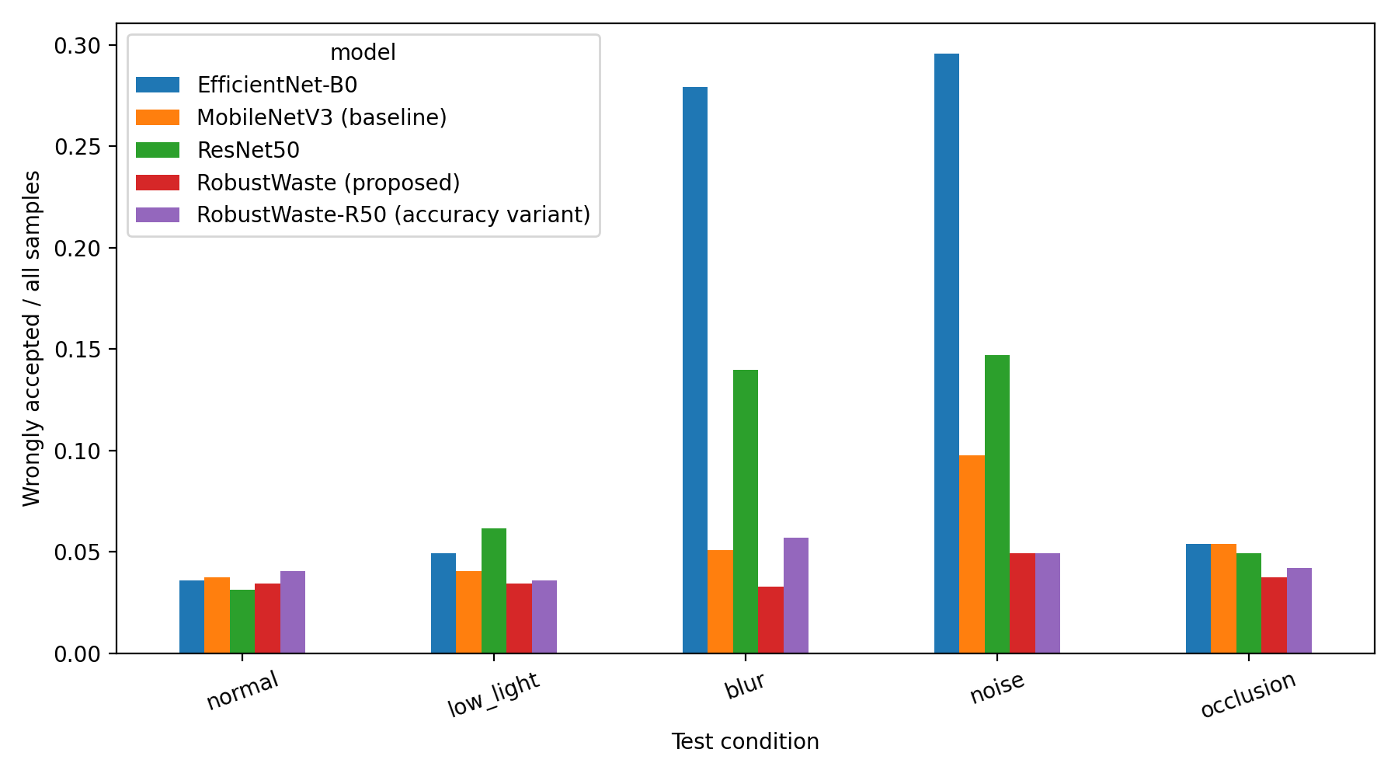
Fig. 2. Wrongly accepted samples as a fraction of all samples, per model and condition (RealWaste)

3.4 Unknown-waste rejection
Table 7. Held-out textile waste (318 images never seen in training)
Model | Threshold | Mean conf. | Reject rate | Wrongly accepted | Samples
ResNet50 | 0.50 | 0.7869 | 8.2% | 292 | 318
EfficientNet-B0 | 0.50 | 0.7975 | 6.9% | 296 | 318
MobileNetV3 (baseline) | 0.50 | 0.7875 | 8.2% | 292 | 318
RobustWaste (proposed) | 0.50 | 0.8004 | 7.5% | 294 | 318
RobustWaste-R50 | 0.50 | 0.7691 | 10.4% | 285 | 318
This result does not support hypothesis H3. Every model assigns a mean confidence of about 0.77–0.80 to textile waste it has never seen, and the mechanism rejects only 7–10% of it. Max-softmax confidence is therefore not a reliable detector of unseen material categories in this setting. The result also shows what the Unknown / Reject stream does and does not do: it filters uncertain samples of known classes, but it should not be presented as a general detector of unfamiliar waste. Which known class absorbs the textile images (for example miscellaneous_trash, which would be a relatively harmless destination) was not measured and is worth reporting as a follow-up.

3.5 Ablation
Table 8. Ablation, averaged over the four degraded conditions (RealWaste)
Config | Training | Reject | Accepted accuracy | Coverage | Wrong-accepted rate
A | Normal | No | 0.8986 | 1.0000 | 0.1014
B | Degradation-aware | No | 0.9538 | 1.0000 | 0.0462
C | Normal | Yes | 0.9329 | 0.9174 | 0.0608
D | Degradation-aware | Yes | 0.9606 | 0.9812 | 0.0387
Degradation-aware training alone (A to B) lowers the wrongly accepted rate from 10.1% to 4.6%. Confidence rejection alone (A to C) lowers it to 6.1%, but at the cost of rejecting about 8% of items. The combined system D has the best accepted accuracy (96.1%) and the lowest wrong-accepted rate (3.9%) while keeping coverage at 98.1%, so it is better than C on all three measures. The additional gain of rejection on top of degradation-aware training (B to D) is modest, 0.75 points, because the selected threshold is low. Most of the improvement therefore comes from degradation-aware training, with rejection providing a smaller extra safety margin.

3.6 Head-to-head with Rajakumaran et al. on TrashNet
The closest experimental precedent [1] reports 95% accuracy for a ResNet50 classifier on TrashNet. Accuracy values from different datasets cannot be compared fairly, so all four models were also trained and tested on TrashNet with the split of [1] (63% / 7% / 30%, 758 test images, seed 42). The ResNet50 run serves as a reproduction of the method of [1]. All four TrashNet models were trained with identical settings (up to 40 epochs, early-stopping patience 12). A first attempt with patience 6 stopped the proposed model at epoch 9 (best epoch 3) because the validation set contains only about 176 images and its score is noisy, so every model was retrained with the longer patience; the results below are from that complete re-run.
Table 9. Comparison with the method and result reported in [1] (TrashNet, 758 test images)
Method | Clean | Low light | Blur | Noise | Occl. | Size (MB) | CPU (ms)
Rajakumaran et al. [1], as reported (ResNet50) | 0.95 | n/r | n/r | n/r | n/r | n/r | n/r
ResNet50, reproduced here | 0.9433 | 0.9169 | 0.7216 | 0.7243 | 0.9222 | 90.03 | 122.2
RobustWaste (proposed) | 0.9420 | 0.9393 | 0.9274 | 0.9050 | 0.9420 | 16.26 | 20.5
n/r = not reported in [1]. CPU latency measured on a Colab CPU; the absolute value varies a little between runs, the ratio is about 6.
The reproduced ResNet50 reaches 94.3%, close to the 95% reported in [1], which gives confidence that the pipeline is a fair stand-in for that method. The proposed model reaches 94.2% on clean images, so it matches the earlier approach on clean accuracy but does not exceed the reported 95% (the gap is about six images). The difference appears when the image quality drops, which [1] does not test. Under the same test, the reproduced ResNet50 falls to about 72% under blur and noise, while the proposed model stays above 90% in every condition, with a largest drop of 3.7 points. It is also about 5.5 times smaller and about 6 times faster on CPU.
Table 10. TrashNet accuracy under visual degradation (drop relative to normal in brackets)
Model | Normal | Low light | Blur | Noise | Occlusion
ResNet50 | 0.9433 | 0.9169 (−2.6) | 0.7216 (−22.2) | 0.7243 (−21.9) | 0.9222 (−2.1)
EfficientNet-B0 | 0.9433 | 0.9169 (−2.6) | 0.8760 (−6.7) | 0.2375 (−70.6) | 0.9406 (−0.3)
MobileNetV3 (baseline) | 0.9367 | 0.9156 (−2.1) | 0.8549 (−8.2) | 0.8166 (−12.0) | 0.9156 (−2.1)
RobustWaste (proposed) | 0.9420 | 0.9393 (−0.3) | 0.9274 (−1.5) | 0.9050 (−3.7) | 0.9420 (0.0)
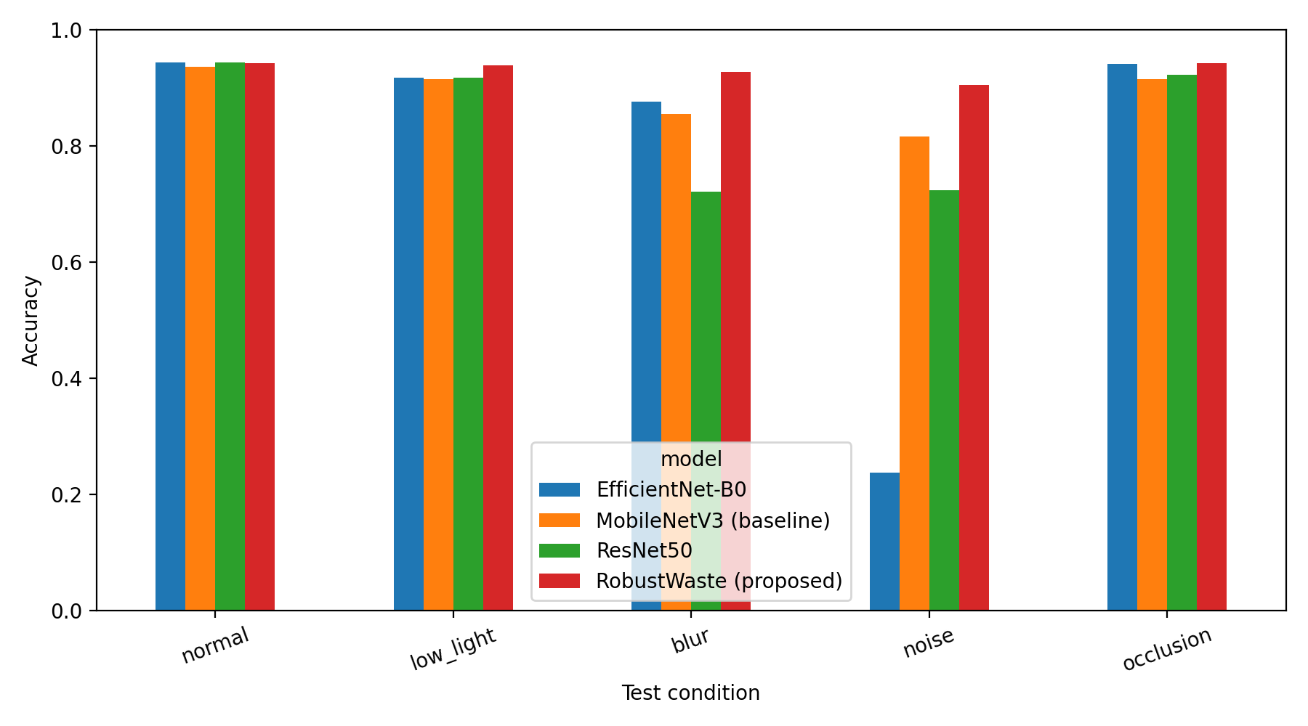
Fig. 3. TrashNet accuracy of the four models under normal and degraded conditions
The proposed model is the best or tied for best in every degraded condition (on occlusion it is within one image of EfficientNet-B0), and its mean accuracy over the four degradations is 92.8%, against 87.6% for the conventionally trained MobileNetV3, 82.1% for ResNet50 and 74.3% for EfficientNet-B0, which collapses to 24% under noise. On clean images the four models are within 0.7 points (about five images), which is within the noise of a single split.
Table 11. TrashNet ablation, averaged over the four degraded conditions
Config | Training | Reject | Accepted accuracy | Coverage | Wrong-accepted rate
A | Normal | No | 0.8757 | 1.0000 | 0.1243
B | Degradation-aware | No | 0.9284 | 1.0000 | 0.0716
C | Normal | Yes | 0.8877 | 0.9759 | 0.1092
D | Degradation-aware | Yes | 0.9626 | 0.9179 | 0.0343
Degradation-aware training alone (A to B) lowers the wrongly accepted rate from 12.4% to 7.2%, and adding confidence rejection (B to D) lowers it further to 3.4%. The proposed system selected a threshold of 0.85 and accepts 86.5–94.3% of items depending on the condition, with an accepted accuracy of 96.0–96.8%, which meets the 0.95 target in every condition on the test set. This comes at the cost of rejecting 6–13% of items for manual inspection. One caution applies to this comparison: the three conventional models received thresholds of about 0.50, so their reject mechanism is effectively inactive, because their validation accuracy already met the target on the small validation set. The lower wrong-accepted rate of the proposed system therefore combines the effect of the model with a stricter operating point. A comparison at matched coverage (a risk–coverage curve) would separate the two and is a natural extension.

3.7 Repeatability and ensemble variant
To keep the trained model files, the proposed configuration was trained again (same seed 42) together with two further seeds, and the three models were combined into an ensemble that averages their predicted probabilities (RobustWaste-Ens3). The retrained single model scored 95.35% on the clean test set, five images (0.75 points) below the main run, although the settings and seed were identical. The difference comes from non-deterministic GPU operations and shows the size of run-to-run variation, so clean accuracy differences below about one point should not be interpreted. The ensemble reached 95.80%, 0.45 points (three images) above the retrained single model and below the main run.
Table 12. Repeat run and 3-seed ensemble of the proposed model (RealWaste, test accuracy)
Model | Clean | Low light | Blur | Noise | Occl. | Size (MB) | CPU (ms)
Proposed, main run | 0.9610 | 0.9595 | 0.9595 | 0.9444 | 0.9520 | 16.26 | 27.4
Proposed, repeat run (seed 42) | 0.9535 | 0.9505 | 0.9520 | 0.9384 | 0.9459 | 16.26 | 33.9
RobustWaste-Ens3 (3 seeds) | 0.9580 | 0.9550 | 0.9595 | 0.9459 | 0.9550 | 48.79 | 113.4
CPU latency was measured on a shared Colab CPU, so the values for the two single runs of the same model differ by noise.
The ensemble keeps the robustness of the single model (largest drop 1.2 points, under noise) and, at the same threshold of 0.50, rejects 14% of unseen textile against 11% for the single model, which is still low. It costs about three times the size and latency (49 MB and about 113 ms against 16 MB and about 34 ms) for a gain of three images, so the single lightweight model remains the recommended edge configuration and the ensemble is reported only as an optional higher-cost variant.

3.8 Heavier accuracy variant (ConvNeXt-Tiny)
To test whether a heavier backbone improves accuracy, the framework was also trained with ConvNeXt-Tiny, using the same settings as the proposed model except a lower learning rate (10⁻⁴) and a batch size of 16, which suit this architecture. Its best validation macro-F1 was 0.966, against 0.953–0.955 for the lightweight model. On the test set it reached 96.55% (643 of 666 images), which is 0.45 points above the main run and 1.2 points above the repeat run of the lightweight model, so it did not reach 97%.
Table 13. ConvNeXt-Tiny accuracy variant compared with the lightweight proposed model (RealWaste)
Model | Clean | Low light | Blur | Noise | Occl. | Params (M) | Size (MB) | CPU (ms)
Proposed (MobileNetV3), main run | 0.9610 | 0.9595 | 0.9595 | 0.9444 | 0.9520 | 4.21 | 16.26 | 27.4
Proposed (MobileNetV3), repeat run | 0.9535 | 0.9505 | 0.9520 | 0.9384 | 0.9459 | 4.21 | 16.26 | 33.9
RobustWaste-ConvNeXt | 0.9655 | 0.9640 | 0.9535 | 0.9520 | 0.9580 | 27.82 | 106.21 | 196.2
CPU latency measured at 288 × 288 on a shared Colab CPU.
The ConvNeXt variant is the most accurate under low light, noise and occlusion, and slightly below the main run of the lightweight model under blur; its largest drop is 1.35 points. At the lowest threshold (0.50) it accepts 98.8–99.6% of items with an accepted accuracy of 95.3–96.7% and wrongly accepts 3.3–4.7% of all samples. It rejects only 5.4% of the unseen textile images (mean confidence 0.81), so the unknown-waste limitation also holds for the stronger backbone. The gain comes at a high price: 6.6 times the parameters, 6.5 times the size and roughly six to seven times the CPU latency (196 ms against 27–34 ms). Because retraining the lightweight model already changes its accuracy by about 0.75 points, the gain of 0.5–1.2 points is modest, and the ConvNeXt model is best described as an optional accuracy-oriented variant for settings where compute is not limited. The lightweight model remains the recommended edge configuration.

3.9 Summary of findings
- H1 (robustness): supported. Degradation-aware training keeps accuracy within 1.7 points of the clean result in every condition, while conventionally trained models lose up to 44 points.
- H2 (confidence rejection): partly supported. Rejection reduces wrongly accepted samples for the conventionally trained model, and adds a smaller margin for the proposed model, whose threshold ended at the lowest scanned value.
- H3 (unknown waste): not supported. Unseen textile waste receives high confidence and is mostly accepted by every model.
- TrashNet head-to-head with [1]: clean accuracy is comparable (94.2% against 94.3% for the reproduced ResNet50 and 95% reported in [1]), while accuracy under blur and noise is about 20 points higher than the reproduced ResNet50.
- Accuracy variant: a ConvNeXt-Tiny backbone reaches 96.55% clean accuracy (0.5–1.2 points above the lightweight model) with similar robustness, at about 6.5 times the size and 6–7 times the latency; 97% was not reached.
- Edge suitability: the proposed model reaches 95.4–96.1% clean accuracy (two training runs) with about one sixth of the size and latency of ResNet50. A ResNet50 backbone and a 3-seed ensemble did not give a worthwhile gain.

4. Limitations and Threats to Validity
- Degradations are synthetic and come from the same family used in training. They approximate real conditions but do not replace images captured by a real camera in poor light or through a dirty lens.
- The IoT layer is virtual. MQTT and the dashboard demonstrate the communication flow, but latency on real embedded hardware and network effects are not measured. CPU latency was measured on a cloud CPU.
- Softmax confidence is high for unfamiliar inputs: unseen textile waste received a mean confidence of about 0.91 and was mostly accepted. Calibration, energy-based scores or an explicit unknown class are natural follow-up work.
- All models received the loosest threshold (0.50) because their validation accuracy already met the 0.95 target, so the reject mechanism acts only as a light filter. A stricter target would give a more selective operating point; a risk–coverage comparison at matched coverage would separate the effect of the model from the effect of the threshold.
- The RealWaste training settings (288 × 288 inputs, label smoothing, 40 epochs, patience 12) were chosen after an earlier run in which the proposed model reached 94.6%. They were applied identically to all models, but they were not fixed in advance.
- The TrashNet validation set has only about 176 images, so early stopping and threshold selection are noisy. A first run with patience 6 stopped the proposed model too early; all models were retrained with patience 12, and the choice of patience should be reported.
- Retraining the same configuration changed clean accuracy by five images (96.1% against 95.35%), so single-run differences of about one point are within run-to-run noise; several seeds with mean and standard deviation would be more reliable.
- The ConvNeXt variant is a single run and was evaluated alone, so it has no ablation row; its small advantage over the lightweight model is within about one point.
- CPU latency was measured on a shared cloud CPU and varies by several percent between runs; ratios are more reliable than absolute milliseconds.
- RealWaste comes from one facility, and merging Vegetation into organic and Cardboard into paper changes the label granularity relative to the nine original classes.
- A single split and seed are used, with 666 test images (one image is about 0.15 percentage points). Small differences, such as the clean accuracy gaps between models, are within noise; the large robustness gaps are not. Repeating with several seeds and reporting mean and standard deviation would strengthen the claims.

References
[1] G. Rajakumaran, S. Usharani, C. Vincent and M. Sujatha, “Smart waste management: waste segregation using machine learning,” J. Phys.: Conf. Ser., vol. 2471, art. 012030, 2023, doi: 10.1088/1742-6596/2471/1/012030.
[2] A. Devi, N. Singh, N. Thandra, N. Gupta, Z. N. Salman and K. Natarajan, “AI and IoT-enabled smart urban waste management system for efficient collection, segregation, and disposal,” E3S Web Conf., vol. 619, art. 03002, 2025, doi: 10.1051/e3sconf/202561903002.
[3] S. Fuqaha and Nursetiawan, “Artificial intelligence and IoT for smart waste management: challenges, opportunities, and future directions,” J. Future Artif. Intell. Technol., vol. 2, no. 1, 2025, doi: 10.62411/faith.3048-3719-85.
[4] S. Single, S. Iranmanesh and R. Raad, “RealWaste: a novel real-life data set for landfill waste classification using deep learning,” Information, vol. 14, no. 12, art. 633, 2023; dataset: UCI Machine Learning Repository, doi: 10.24432/C5SS4G.
[5] G. Thung and M. Yang, “Classification of trash for recyclability status,” Stanford CS229 project report, 2016.
[6] A. Howard et al., “Searching for MobileNetV3,” in Proc. IEEE/CVF Int. Conf. Comput. Vis. (ICCV), 2019, pp. 1314–1324.
[7] K. He, X. Zhang, S. Ren and J. Sun, “Deep residual learning for image recognition,” in Proc. IEEE Conf. Comput. Vis. Pattern Recognit. (CVPR), 2016, pp. 770–778.
[8] M. Tan and Q. V. Le, “EfficientNet: rethinking model scaling for convolutional neural networks,” in Proc. Int. Conf. Mach. Learn. (ICML), 2019, pp. 6105–6114.
[9] D. Hendrycks and K. Gimpel, “A baseline for detecting misclassified and out-of-distribution examples in neural networks,” in Proc. Int. Conf. Learn. Represent. (ICLR), 2017.
[10] D. Hendrycks and T. Dietterich, “Benchmarking neural network robustness to common corruptions and perturbations,” in Proc. Int. Conf. Learn. Represent. (ICLR), 2019.

