Logo –
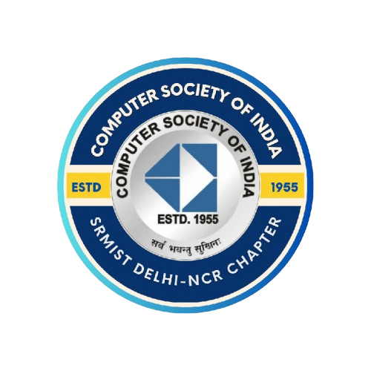

Event Name - Bid2Code

About –
Bid2Code is a high-stakes coding showdown where strategy meets skill. Teams start with 100 points, bid wisely on coding riddles, and let multipliers decide their fate across 5 rounds of alternating Web Development and Machine Learning challenges. It’s not just about coding — it’s about betting big on your confidence.

Concept –
Teams start with a pool of 100 points. As each round progresses, they can bid diff amounts of points for different problem statements based on the hints. On solving, they get rewarded with certain multiplier points. Teams with the maximum points win!

Team Composition –
4 members per team(mandatory).

Event format –

- Round 1 – Web Riddle Showdown
- Round 2 – ML Mystery Box
- Round 3 – CodeCraft Web Arena
- Round 4 – ML Mind Games
- Round 5 – The Grand Finale

Eligibility –

- Open to All Years – Students from 1st year to 4th year of undergraduate programs are eligible.
- Branch Neutral – Participants from any engineering/technology discipline can join (coding background preferred).
- Team Formation – Teams can have 4 members. Cross-year teams are allowed.
- Inter-College Participation – The event welcomes students from external colleges/universities as well, not restricted to the host institution.
- Fair Play – Each participant must register only in one team. No switching teams during the event.

Rules & Guidelines –

- All teams start with 100 points.
- Each round has 5 riddles; teams bid on 1 riddle only.
- Multipliers per round: 1.5×, 1.75×, 2×, 3×, 6×.
- If solved → score += bid × multiplier.
- If failed → deduction applies only in some rounds.
- Round 1: Optional bid, no deduction.
- Round 2: Compulsory bid, −25 points at failure on bidding.
- Round 3: Compulsory bid, −35 points at failure on bidding.
- Round 4: Compulsory bid, −45 points at failure on bidding.
- Round 5: Compulsory bid, no deduction.
- Bid once locked → cannot be changed.
- Submissions within allotted time.
- Leaderboard shown after each round.
- Tiebreaker – Sudden Death (WebDev); Time Limit – 5 minutes.

Judgement Criteria –

- 1st Place → Team with the highest final score after Round 5.
- 2nd Place → Team with the second-highest final score.
- 3rd Place → Team with the third-highest final score.

Prizes –
- 1st Place – Trophy + Certificate of Achievement
- 2nd Place – Certificate of Excellence
- 3rd Place – Certificate of Merit

Code of Conduct –

General Conduct
- Maintain decorum in the venue, and follow the rules set by the organisers.
Coding & Submissions
- Only authentic, genuine submissions will be considered.
Disqualification
- Plagiarism and misbehaviours will lead to disqualification.

Violation of the Code of Conduct may lead to warnings, point penalties, or removal from the event at organizers’ discretion.

How To Enter –

- Registrations will be taken exclusively through the official CSI website.
- Register before the deadline to secure your slot.
- Confirmation mail with further details will be sent after successful registration.

Important Notes –

- Carry your valid ID card and event registration proof at all times.
- Entry and exit must be logged at designated checkpoints.
- Team members must stay in their allotted spaces and avoid unnecessary movement.
- Maintain hygiene and cleanliness in the event premises.
- Bring your own laptop, chargers, and essential accessories.

Parth Mongia – 7015445239 Ashray Singh – 8574843299
3rd Year B. Tech CSE – Core A 3rd Year B. Tech CSBS(A)

Regards,
Team CSI Students’ Chapter,
SRM Institute of Science & Technology, Delhi-NCR Campus.

