Customer Shopping Behavior Analysis

1. Project Overview
This project focuses on analyzing customer shopping behavior using transactional data from 3,900 purchase records across multiple product categories. The primary objective is to uncover meaningful insights into customer spending patterns, purchasing preferences, subscription behavior, and product demand.
By leveraging Python for data cleaning and exploratory analysis, SQL for structured querying, and Power BI for visualization, the project provides actionable insights to support strategic decision-making and customer-centric marketing strategies. The analysis helps businesses enhance revenue, customer satisfaction, and retention.

2. Problem Statement
A leading retail company seeks to understand customer shopping behavior to improve sales performance and long-term loyalty. Key challenges include:
- Variations in purchasing patterns across demographics, product categories, and sales channels (online vs. offline).
- Identifying factors influencing repeat purchases, such as:
  - Discounts and promotional offers
  - Product reviews and ratings
  - Seasonal trends
  - Payment and shipping preferences
  - Subscription status
Goal: To enable optimized pricing strategies, improved product offerings, and targeted marketing campaigns.

3. Dataset Summary
Characteristic | Details
Number of Rows | 3,900
Number of Columns | 18
Key Features | Customer Demographics: Age, Gender, Location, Subscription Status; Purchase Details: Item Purchased, Product Category, Purchase Amount, Season, Size, Color; Shopping Behavior Indicators: Discount Applied, Promo Code Used, Previous Purchases, Purchase Frequency, Review Rating, Shipping Type
Missing Data | 37 missing values in Review Rating (imputed using median per product category)

4. Exploratory Data Analysis (EDA) Using Python
EDA was conducted to understand the dataset, ensure quality, and prepare data for deeper analysis.
4.1 Data Loading
- Dataset imported using Pandas for data manipulation.
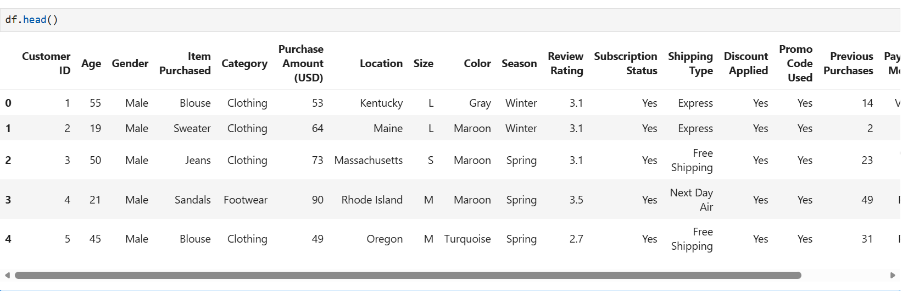
4.2 Initial Data Exploration
- df.info() examined dataset structure, data types, and missing values.
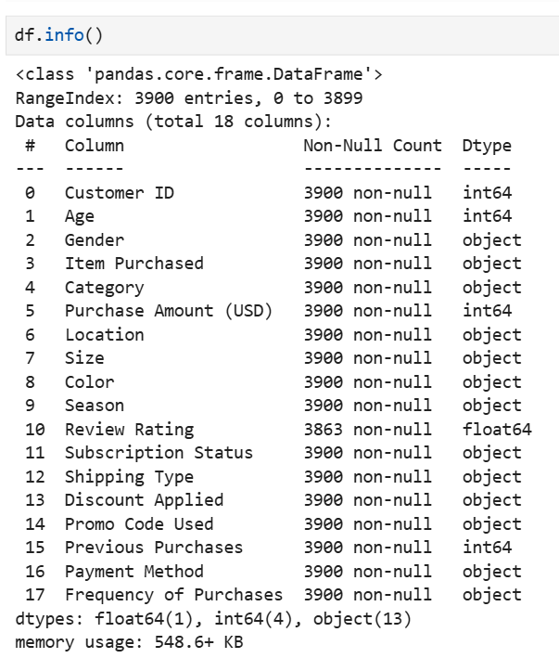
- df.describe() generated summary statistics for numerical variables.
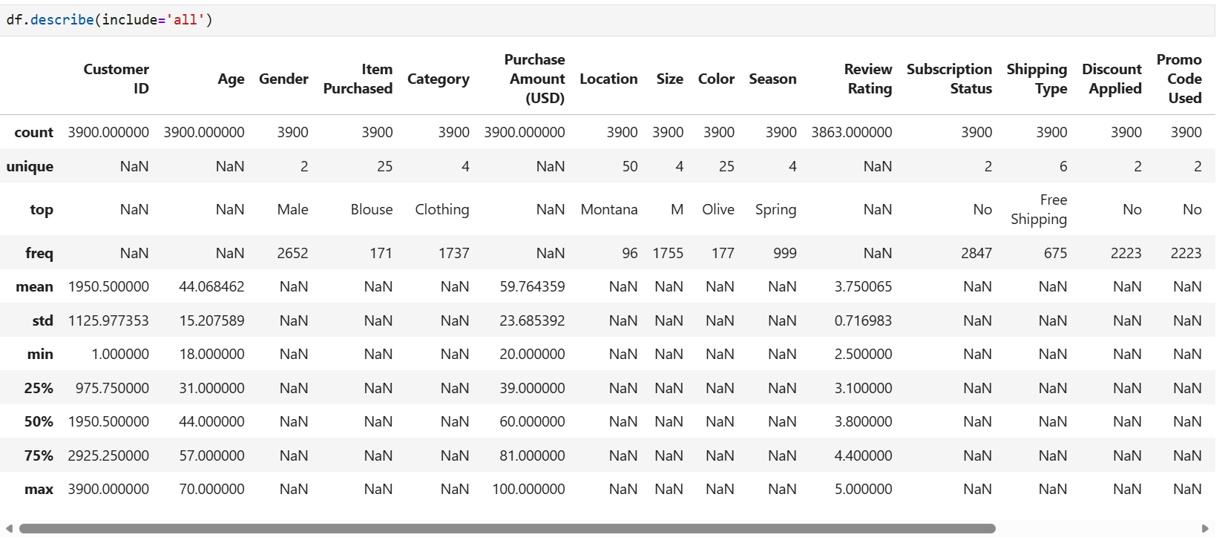
4.3 Missing Data Handling
- Missing values in Review Rating were imputed with the median per product category.
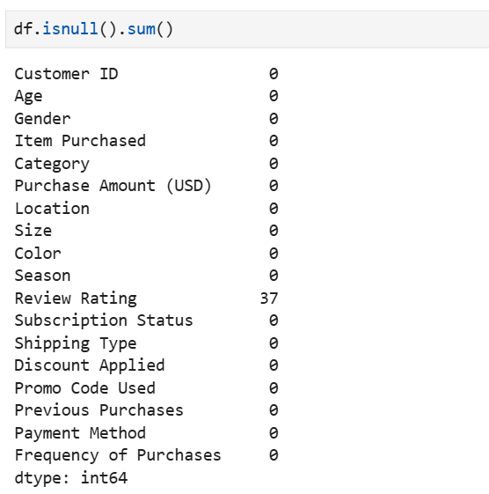
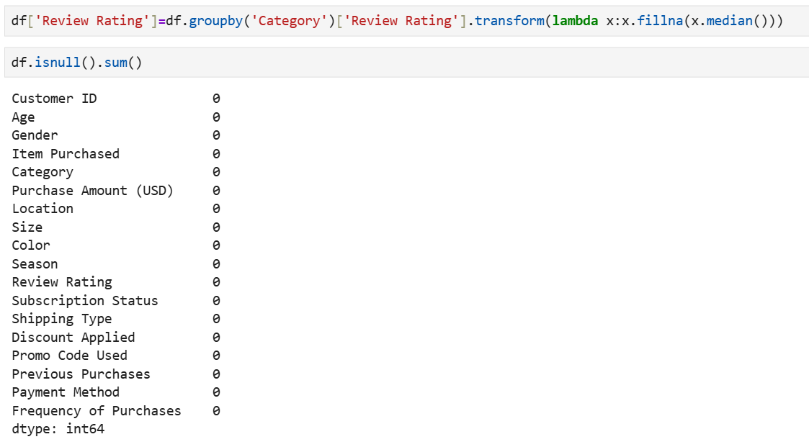
4.4 Column Standardization
- Column names converted to snake_case for consistency and readability.
4.5 Feature Engineering
- age_group: Customer ages binned into predefined ranges.
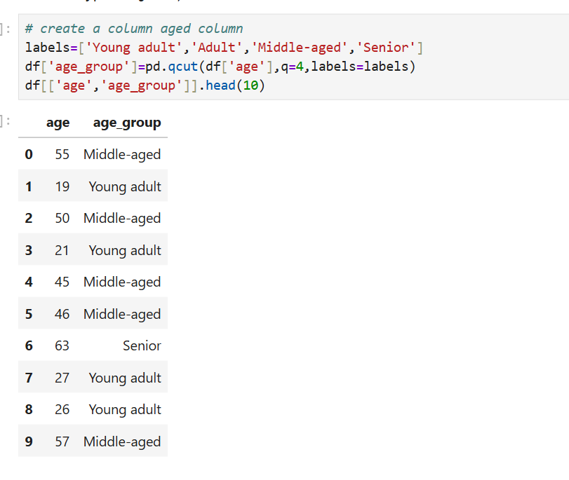
- purchase_frequency_dates: Derived to analyze buying patterns over time.
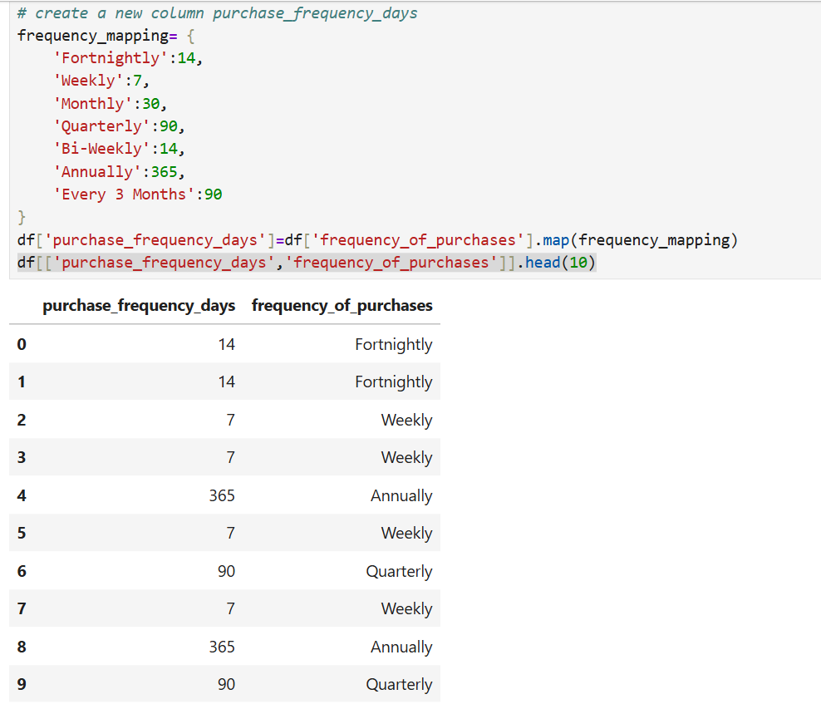
4.6 Data Consistency Check
- Redundancy detected between discount_applied and promo_code_used.
- Promo code column removed to avoid duplication.
4.7 Database Integration
- Cleaned dataset connected to MySQL Workbench for SQL analysis and Power BI visualization.
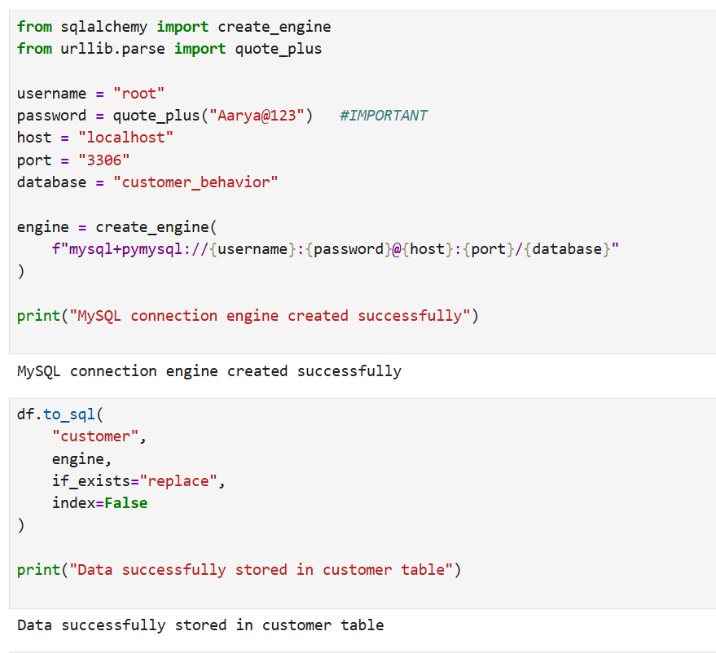

5. Data Analysis Using SQL
SQL queries were used to extract insights and validate patterns observed in Python EDA.
Key Analyses
- Revenue by Gender: Compared total revenue between male and female customers.
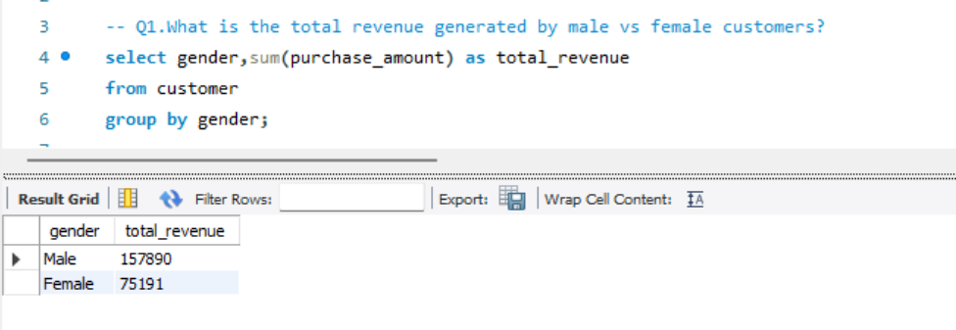
- High-Spending Discount Users: Identified customers availing discounts but spending above average.
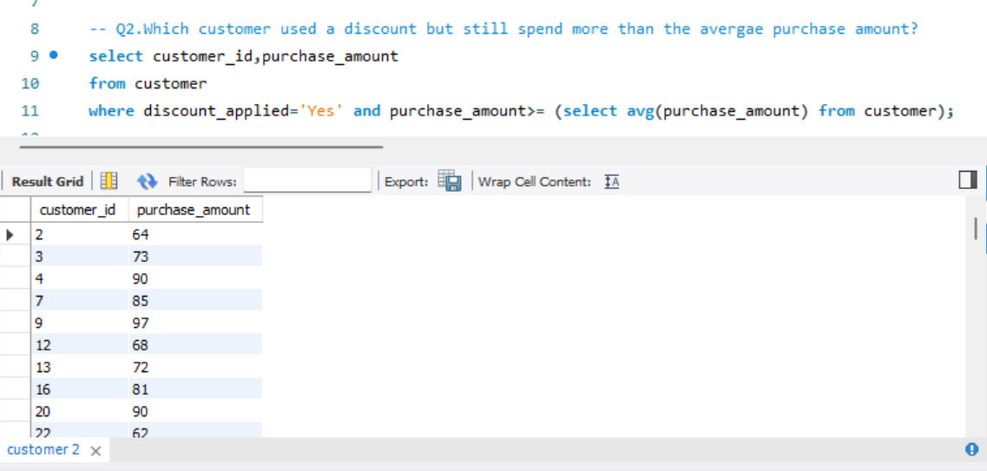
- Top 5 Products by Rating: Ranked products using average customer review ratings.
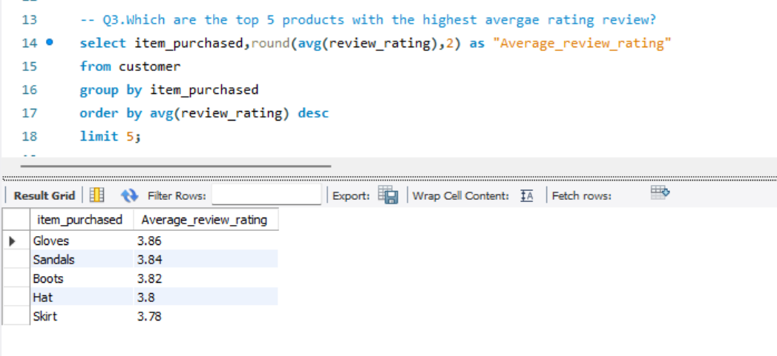
- Impact of Shipping Type: Compared purchase amounts between standard vs express shipping.
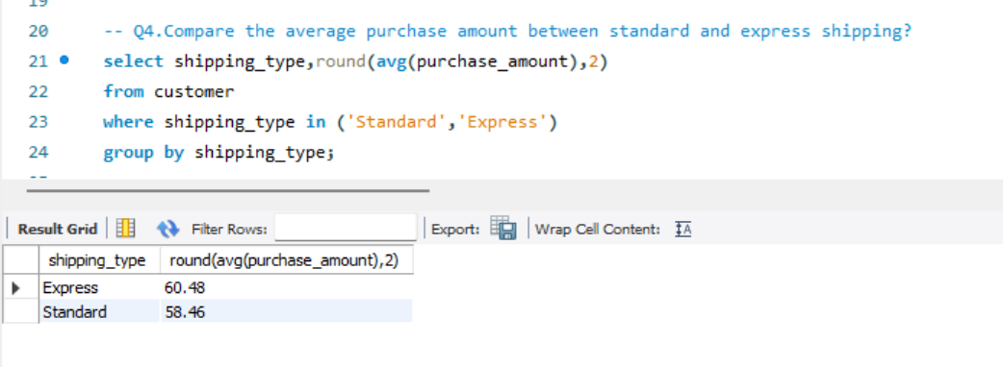
- Subscribers vs Non-Subscribers: Compared average spending and total revenue contribution.
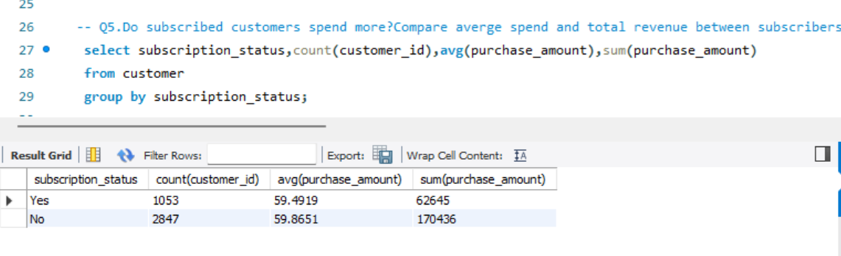
- Discount-Dependent Products: Identified products most influenced by discounts.
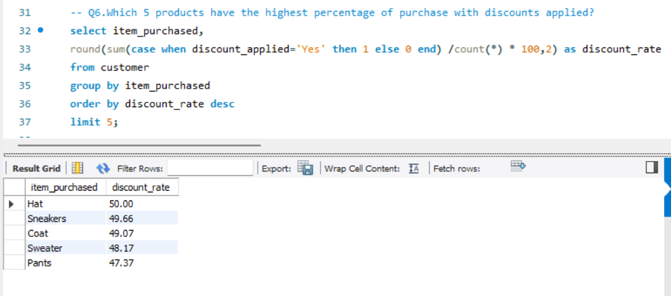
- Customer Segmentation: Classified customers as New, Returning, or Loyal based on purchase frequency.
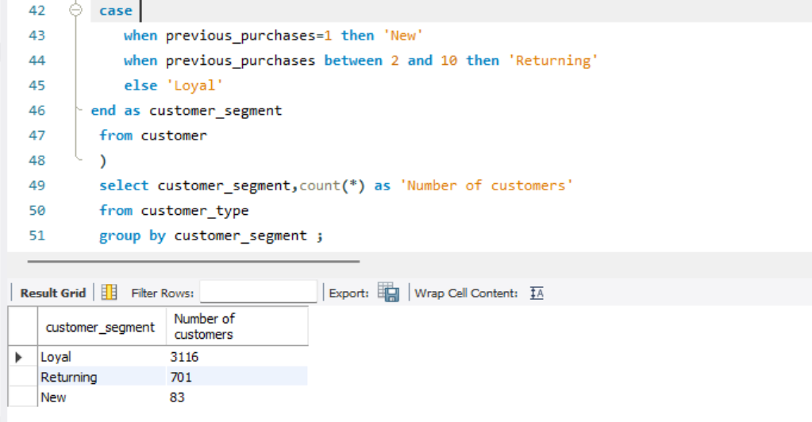
- Top 3 Products per Category: Highlighted category-wise bestsellers.
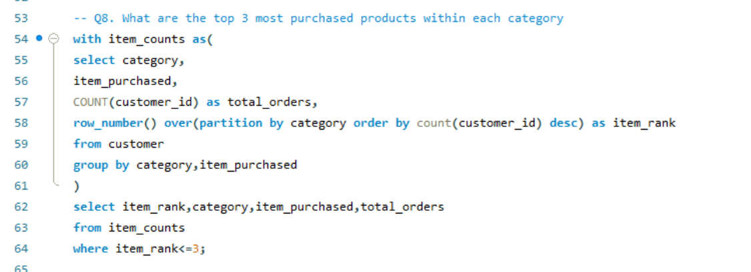
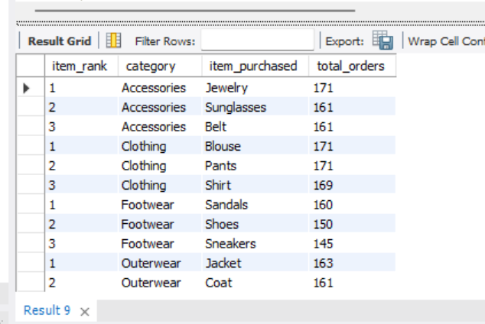
- Repeat Buyers & Subscription Behavior: Evaluated subscription likelihood among frequent buyers.
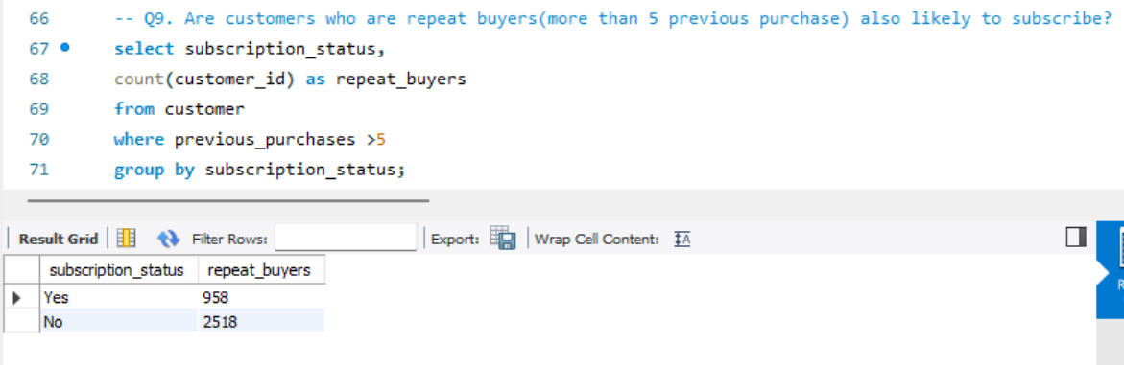
- Revenue Contribution by Age Group: Identified high-revenue demographic segments.
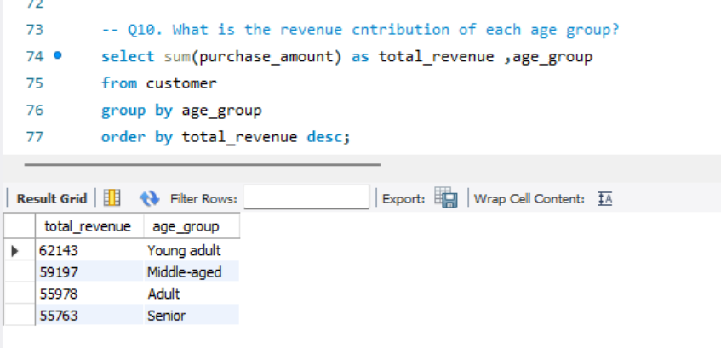
6. Power BI Dashboard
An interactive dashboard was developed to visualize insights for decision-makers.
Dashboard Features:
- Customer Overview: Displays total customers, average purchase amount and average review rating.
- Revenue Analysis: Shows revenue by category, and can include breakdowns by gender, age, and subscription status.
- Spending Behavior: Highlights the relationship between discounts, shipping type, and purchase amounts.
- Product Performance: Lists top-rated and bestselling products to identify key performers.
- Customer Segmentation: Categorizes customers as New, Returning, and Loyal customers for targeted marketing.
Interactive filters and drill-down features enable stakeholders to explore data dynamically.
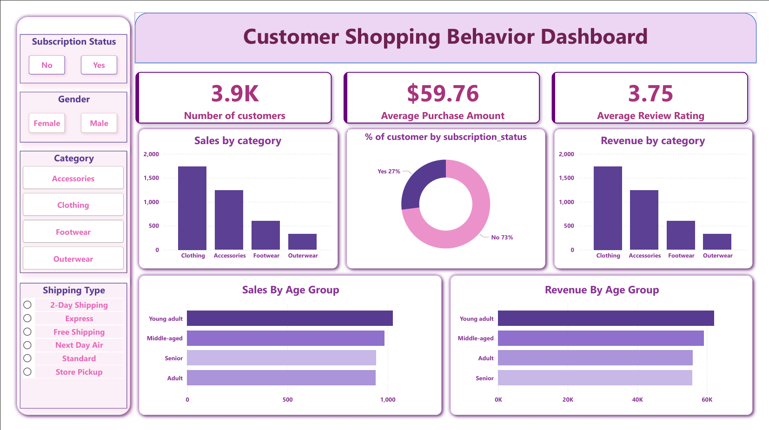

7. Business Recommendations
- Boost Subscription Adoption: Offer exclusive benefits (discounts, faster shipping, early access) to encourage subscriptions.
- Strengthen Loyalty Programs: Reward repeat buyers to enhance lifetime value.
- Review Discount Strategy: Balance sales volume growth with profit margin control.
- Strategic Product Positioning: Promote top-rated and bestselling products in campaigns.
- Targeted Marketing: Focus on high-revenue age groups and express-shipping users to improve ROI.

8. Executive Summary
The analysis of 3,900 customer transactions provided deep insights into:
- Demographic-based spending behavior
- Subscription patterns and repeat purchase tendencies
- Product performance and discount dependency
Using Python for EDA, SQL for structured analysis, and Power BI for visualization, the project successfully generated actionable insights that inform marketing strategy, loyalty programs, and sales optimization.

9. Conclusion
- Customer spending behavior varies across age groups and subscription status.
- Subscribers and repeat customers contribute higher revenue.
- Discounts influence purchases but require careful management to maintain profit margins.
- Certain products are highly discount-dependent.
- Targeted marketing and loyalty programs can improve customer retention and revenue.

10. Future Scope
- Predictive Analysis: Implement ML models to forecast purchasing behavior and spending trends.
- Customer Churn Analysis: Identify customers at risk and design retention strategies.
- Advanced Customer Segmentation: Apply clustering for detailed behavioral segments.
- Real-Time Data Integration: Continuous monitoring of transactions for timely insights.
- Personalized Recommendations: Suggest products based on past behavior.
- Marketing Campaign Evaluation: Analyze promotional effectiveness for future optimization.
- Integration with Social Media: Incorporate social sentiment data to understand brand perception and buying triggers.

11. References / Acknowledgements
- Dataset Source: Transactional dataset obtained from publicly available sources for educational purposes.
- Tools and Libraries: Analysis and visualization implemented independently using Python (Pandas), SQL (MySQL Workbench), and Power BI.
- Learning Resources: General guidance and learning references were consulted from publicly available tutorials and documentation to understand tool functionalities and best practices.

