# Economic Data Analysis 2022: Insights into Global Cost of Living and Purchasing Power

## Project Description

This project aims to analyze global economic trends through various economic indicators like the Cost of Living Index, Rent Index, and Local Purchasing Power Index. The analysis provides insights into how different regions of the world compare in terms of economic sustainability and affordability. It highlights the differences in economic status and living conditions, aiding stakeholders in making informed decisions related to finance, policy-making, and business strategies.

## Data Source

The primary dataset used in this analysis is the 'Cost of Living Index 2022', which includes data on various economic indicators such as Cost of Living Index, Rent Index, Groceries Index, and more across different countries. The data was sourced from reputable global economic databases, ensuring reliability and accuracy for the analysis.

## Methodology

The methodology section outlines the use of Python for data cleaning, preparation, and analysis, including exploratory data analysis and statistical modeling. The SQL queries were utilized to manage and query the data, providing structured insights into the economic indicators. Linear regression models were employed to predict future trends based on historical data.

## Results and Analysis

In this section, our analysis revealed several key trends and correlations in the global cost of living data for 2022:

- Variability in Cost of Living: We observed significant variability in the cost-of-living indexes across different countries. Developed nations typically showed higher cost of living indices, while developing countries had lower indices, reflecting the economic disparities.

- Rent Index Trends: The rent index was particularly high in urban and economically developed regions, correlating strongly with the cost-of-living index. Countries with higher rent indices generally demonstrated higher costs of living.

- Impact on Local Purchasing Power: There was a notable inverse relationship between the cost of living and local purchasing power indices. Regions with higher cost of living indices often had lower local purchasing power, indicating that higher costs could erode real income.

- Predictive Modeling Results: Linear regression models helped forecast local purchasing power based on economic indicators such as the cost of living and rent indices. The models exhibited reasonable accuracy, with coefficients of determination indicating that a significant portion of the variance in local purchasing power was predictable from these indices.

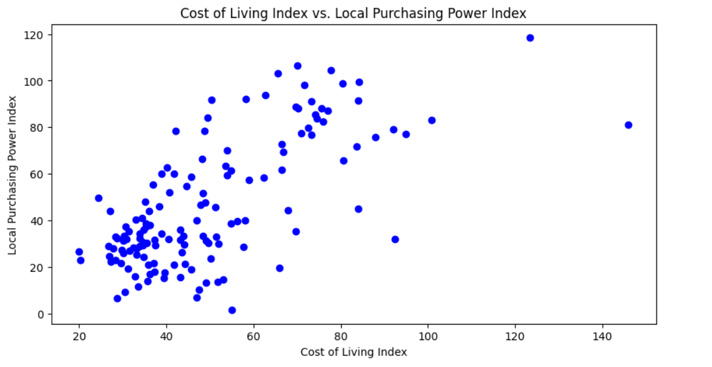

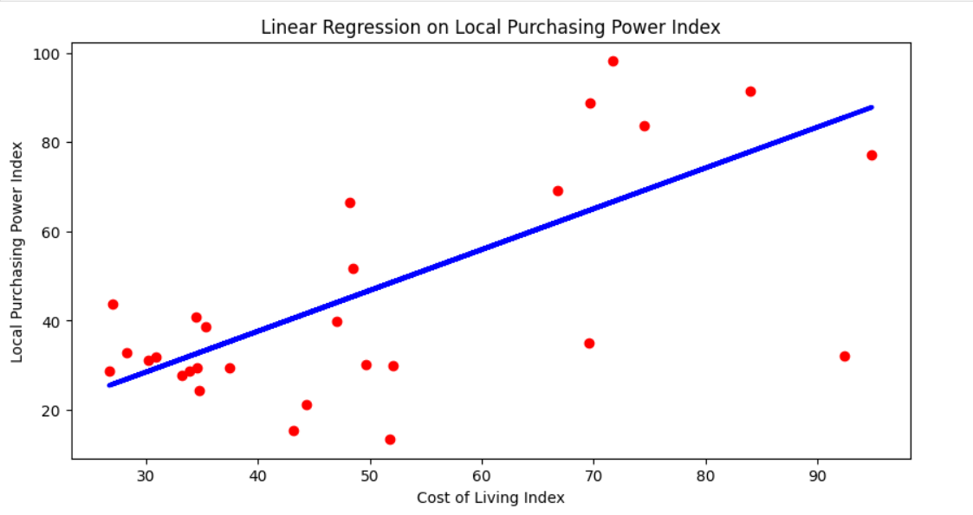

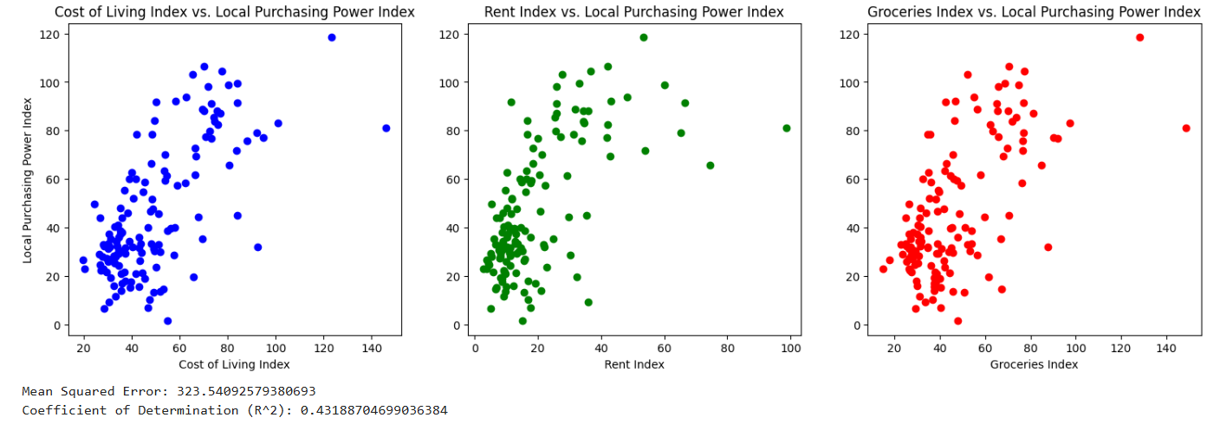

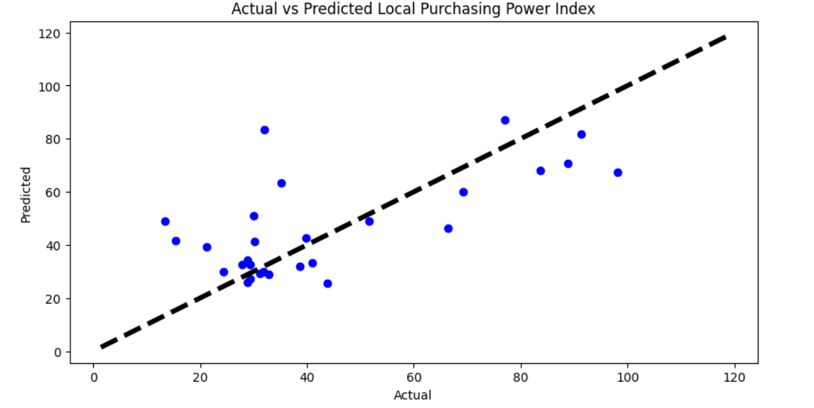

## Conclusions and Recommendations

Conclusions:

The analysis underscores the complex interplay between various economic factors like cost of living, rent, and local purchasing power. Understanding these relationships is crucial for policymakers, businesses, and investors aiming to make informed decisions.

The predictive models developed can be useful tools for economic planning and forecasting, helping stakeholders anticipate changes in purchasing power and economic conditions.

Recommendations:

- Policy Intervention: Governments should consider targeted economic policies in regions with high cost of living but low purchasing power to enhance affordability and quality of life.

- Business Strategy: Companies operating in international markets could use these insights to tailor their business strategies, pricing models, and employee compensation to align with regional economic conditions.

- Further Research: Additional studies incorporating more granular data, such as city-level indices and demographic factors, could refine the understanding and predictive accuracy of economic models.