# Wireframe

Wireframe

Credit Card Default Prediction

Revision Number – 1.0

Last Date of Revision – 16-05-2023

**ARYA DIXIT**

**Contents**

Wireframe

**[Abstract](https://docs.google.com/document/d/1ZLlZEVdMuxYl3o0PziQjZcUbNmAcz-PR/edit" \l "heading=h.gjdgxs)** [4](https://docs.google.com/document/d/1ZLlZEVdMuxYl3o0PziQjZcUbNmAcz-PR/edit" \l "heading=h.gjdgxs)

**Web Interface 5**

**User Input 5**

**Result Page 6**

**Abstract**

Wireframe

Our aim is to develop a Machine learning model and testing the model by using the data in relating to previous 6 months payment behaviour which is behavioural data and personal information which is demographic data as input of a client is used for this study.

The research study is conducted using Random Forest Algorithm , Decision tree , Logistic Regression. Our aim is to identify that credit card customer is likely to default in the coming month.

Credit risk plays a major role in the banking industry. Banking's main activities include granting loans, credit cards,investments, mortgages, etc. Credit cards are one of the fastest growing financial services offered by banks in recent years.

However, as the number of credit card users increases, banks are facing rising credit card failure rates. Therefore,data analytics can provide solutions to address current phenomena and manage credit risk.

**1. Web Interface**

Wireframe

Our web page is one single interface where both input from the user and the prediction is displayed.

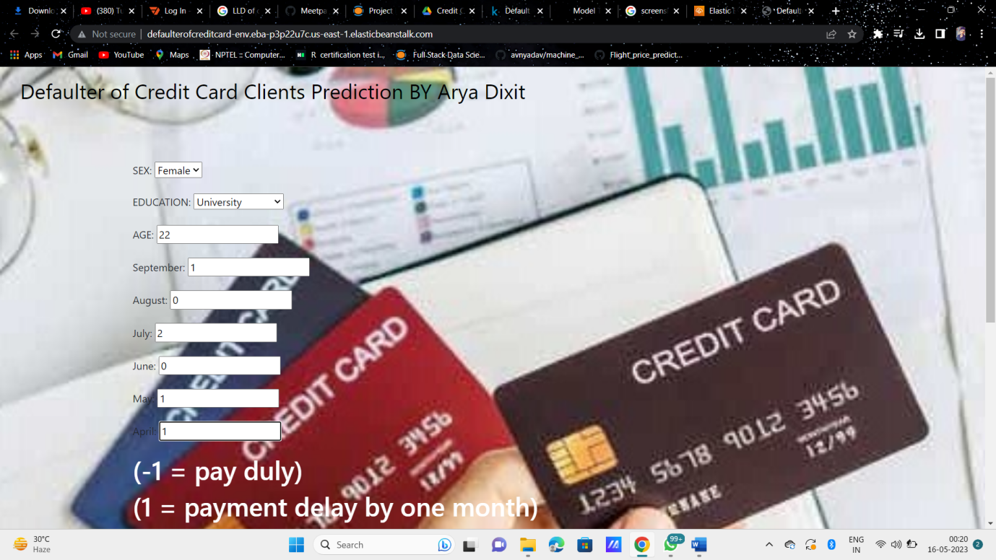

**2. User Input**

Whenever the user hits our url , they first see the user input page here they have to provide the information like:

* Every user input has its own dropdown where the user can select their input.
* After providing the required input and pressing the submit button, the page refreshes and displays the output

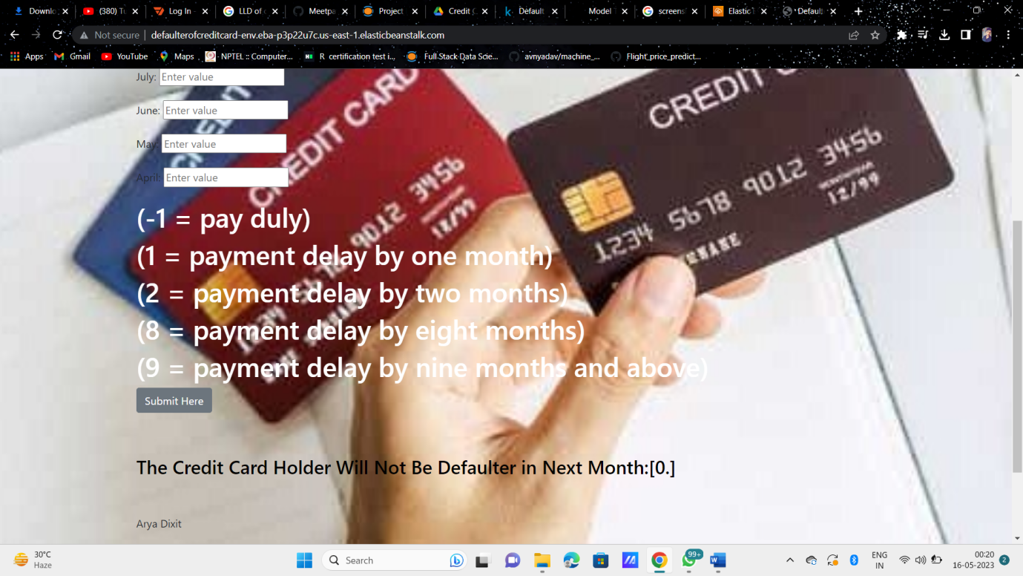

**3. Result Page**

Wireframe

After the user hits the submit button the page gets refreshed and the results are being displayed in the highlighted area in the above frame.

The user can refill all the inputs in same page and get the results in the same way.