**“INDIA COVID-19 TRACKER”**

**A**

**Major Project**

**Submitted in partial fulfilment for the award of**

**Bachelor of Engineering in**

**Computer Science & Engineering**

**Submitted to**

**RAJIV GANDHI PROUDYOGIKI VISHWAVIDYALAYA**

**BHOPAL (M.P.)**



Submitted By

**Abhinav Gupta – 0133CS16107**

**Aaryaa Agrawal – 0133CS161002**

**Aditya Singh Tomar – 0133CS161015**

**Chitransh Dodke – 0133CS161061**

Under the Guidance of

**Dr. Rajesh K. Shukla**

**HOD CSE DEPARTMENT**

**SAGAR INSTITUTE OF RESEARCH & TECHNOLOGY, BHOPAL (M.P.)**

**DEPARTMENT OF COMPUTER SCIENCE & ENGINEERING**

**SAGAR INSTITUTE OF RESEARCH & TECHNOLOGY**

**DEPARTMENT OF COMPUTER SCIENCE & ENGINEERING**



**CERTIFICATE**

This is to certify that Major project entitled “India Covid19 Tracker” submitted to Rajiv Gandhi Proudyogiki Vishwavidyalaya, Bhopal (M.P.) by ________ for partial fulfilment for the award of the degree of the Bachelor of Engineering in Computer Science & Engineering.

Abhinav Gupta – 0133CS161007

Aaryaa Agrawal – 0133CS161002

Aditya Singh Tomar – 0133CS161015

Chitransh Dodke – 0133CS161061

Dr. Rajesh K Shukla Dr Manish Manoria

HOD (CSE) Director

SIRT, Bhopal (M.P.) SIRT, Bhopal (M.P.)

**SAGAR INSTITUTE OF RESEARCH & TECHNOLOGY**

**DEPARTMENT OF COMPUTER SCIENCE & ENGINEERING**



**APPROVAL CERTIFICATE**

This is hereby certified that the Major Project entitled “INDIA COVID-19 TRACKER” being submitted by Abhinav Gupta – 0133CS16107, Aaryaa Agrawal- 0133CS161002, Aditya Singh Tomar – 0133CS161015, Chitransh Dodke – 0133CS161061 to the RGPV, Bhopal is a genuine work performed by him.

Internal Examiner External Examiner

Date: Date:

ACKNOWLEDGEMENT

This is one of the best moments of my B.E. program to publicly acknowledgment those who have contributed in many different ways to make my success a part of their own. The completion of the Major Project depends upon the co-operation, coordination and combined effects of several resources of knowledge energy.

I heartily thanks to **Dr. Rajesh K Shukla**, faculties of Department of Computer Science & Engineering, for accepting me to work under their Valuable Guidance, Closely Supervised this work over the past few months and offering many innovative ideas and helpful suggestions, which led to the successful completion of this dissertation work.

I am especially thankful Director, SIRT, Bhopal for his kind co-operation and rendering me all possible facilities.

I am thankful to all staff members of the CSE department and my friends for their timely help co-operation and suggestion for my project work. Lastly but not the least, i must express thanks to my family, without their moral support it was impossible for me to complete this minor project work.

Abhinav Gupta

Aaryaa Agrawal Aditya Singh Tomar

Chitransh Dodke

|  |  |
| --- | --- |
| **Table of Contents** | **Page No** |
| Abstract | 6 |
|  |  |
| Chapter 1 **Introduction** | 7 |
| 1.1 Problem Analysis | 7 |
| 1.2 Objective | 8 |
| 1.3 Proposed System | 9 |
| Chapter 2 Analysis | 10 |
| 2.1 Hardware and Software Requirement | 10 |
| 2.2 SRS | 11 |
| Chapter 3 Design | 12 |
| 3.1 Flow Chart | 12 |
| 3.2 E-R Diagram | 13 |
| 3.3 DFD | 14 |
| 3.4 Use Case | 15 |
| Chapter 4 Testing | 34 |
| 4.1 Outputs with Snapshots | 34 |
| Chapter 5 Conclusion and Future work | 40 |
| Chapter 6 Application and Limitation of project | 42 |
| Chapter 7 References | 43 |

**ABSTRACT**

* COVID-19 is an infectious disease caused by a newly discovered coronavirus. This new virus and disease were unknown before the outbreak began in Wuhan, China, in December 2019.
* At this time, there are no specific vaccines or treatments for COVID-19. However, there are many ongoing clinical trials evaluating potential treatments.
* Illness due to COVID-19 infection is generally mild, especially for children and young adults. However, it can cause serious illness: about 1 in every 5 people who catch it need hospital care. It is therefore quite normal for people to worry about how the COVID-19 outbreak will affect them.

**CHAPTER 1 | INTRODUCTION**

* 1. **Problem Analysis**
* Currently, large population in India is not able to acquire the exact number of people affected by corona virus.
* In every area, our government is trying to spread awareness about this disease, and take certain measures to control this epidemic.
* Many of the people find it difficult to know how many people are affected in their localities. So this covid-19 tracker app will help to find number of infected persons in every state and district of India.
* There is a need of some feasible approaches for India’s population to know exact data and help our government to stop the spread of deadly corona virus.
  1. **Objective**
* The objective of this project is to develop an app which will give exact number of infected populations from the corona virus.
* This tracker will provide state wise tally of number of patients suffering from corona virus. And further it will give district-wise tally.
* It eases the effort for looking of spread of COVID-19 across India as it’s data is obtained from Ministry of Health, India.
* It also provides daily data of number of tests, cases confirmed, deceased number and recovered number.
* Also, people can view relevant information about Covid19 spread, symptoms, preventions and helplines.
  1. Proposed System
* The system proposed is an aesthetic and functional android application which the commuters can easily use to find number of corona cases in their areas and can protect themselves from this thread of spread.
* The application automatically calculates the number of patients according to the official data provided by state as well as central government and updates itself automatically whenever new information is obtained.
* The application is dynamic and run in the real time environment so the catalogue for the locations, number of affected is always updated.

**CHAPTER 2 | ANALYSIS**

2.1 Hardware and Software Requirements

2.1.1 Hardware Requirements-

* **Processor:**Intel Core i5 or equivalent
* **Memory:**8 GB (64-bit)
* **Disk space: 5** GB

2.1.2 Software Requirements-

* Android Studio
* JDK8
* Gradle

2.2 SRS

As soon as the project idea is confirmed, we have started working on the requirements for the implementation of the project. The idea is to develop an android based application that uses a pre defined open source API and fetches data from it to display on the application dashboard. Also passing information to database through web service URL and updating the changes in the system. We did some research on current technologies that are used in industry and decided on understanding how Android works, how to connect to local storage with REST APIs, also seen some best practices in writing Java programs for android.

2.2.1 Functional Requirements

1. The android application displays the recent data of COVID-19 facts in India.

2. The android application enables users to see the exact number of cases and numbers related to it divided by demographics.

3. The android application enables users to check daily case timeline and relevant links of COVID-19 approved by ICMR.

2.2.2 Non Functional requirements

1. The designed system should have little or no down time. It should always be up and running.

2. The system should have a fast response time. System should not take more than 30 seconds minus loading

3. The system should be *secure* and respect the privacy of users.

4. The system Should allow the users to view COVID-19 facts in India.

5. The system should be scalable. Even with an increasing number of users, system should be able to perform effectively.

6. The system should be user friendly with ability to show users where they are in the system and guide them on some processes through programmed controls.

7. The system should be reliable. In case of system failure, the system should be able to recover quickly and continue working normally.

**CHAPTER 3 | DESIGN**

3.1 Flow Chart

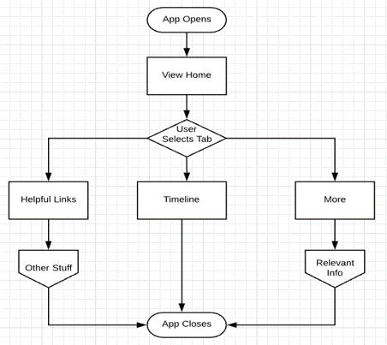

Figure 1

3.2 Use Case

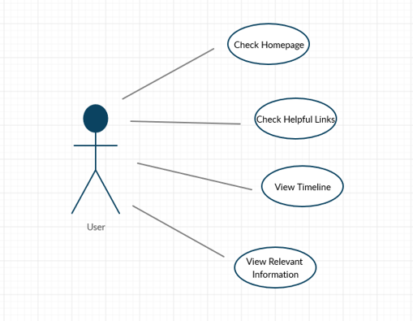

Figure 3

**CHAPTER 4 | TESTING**

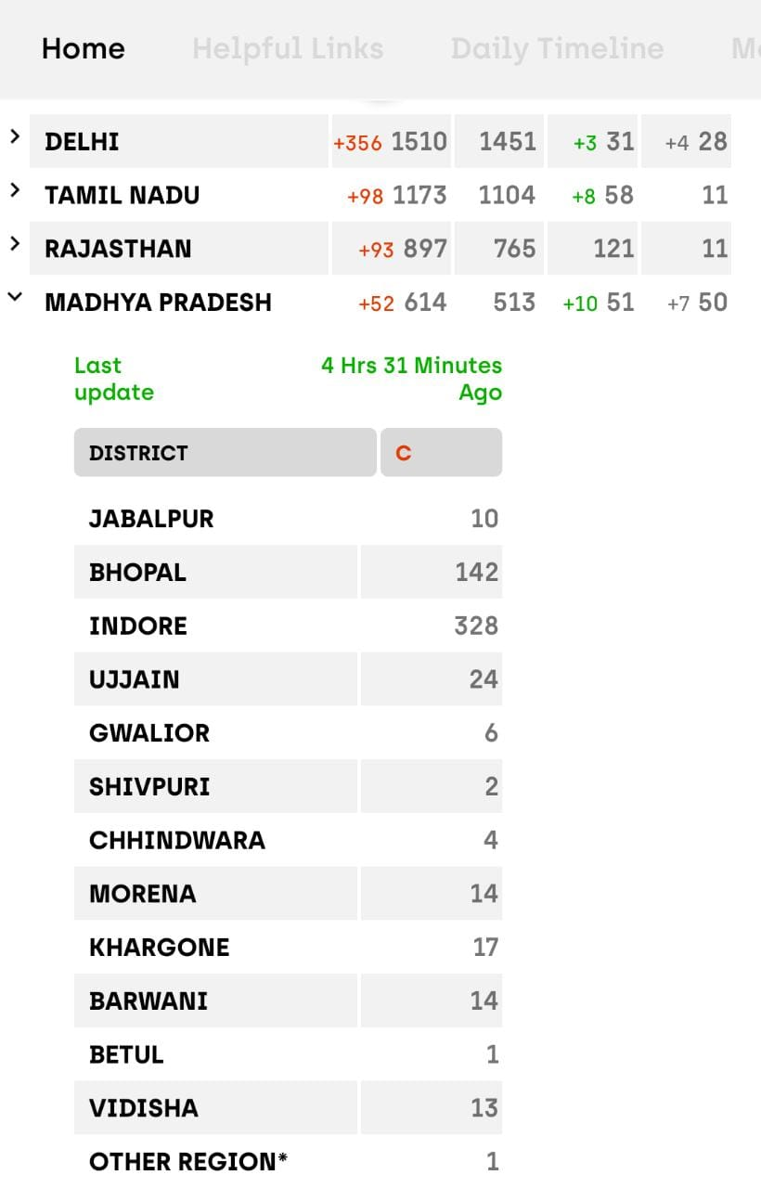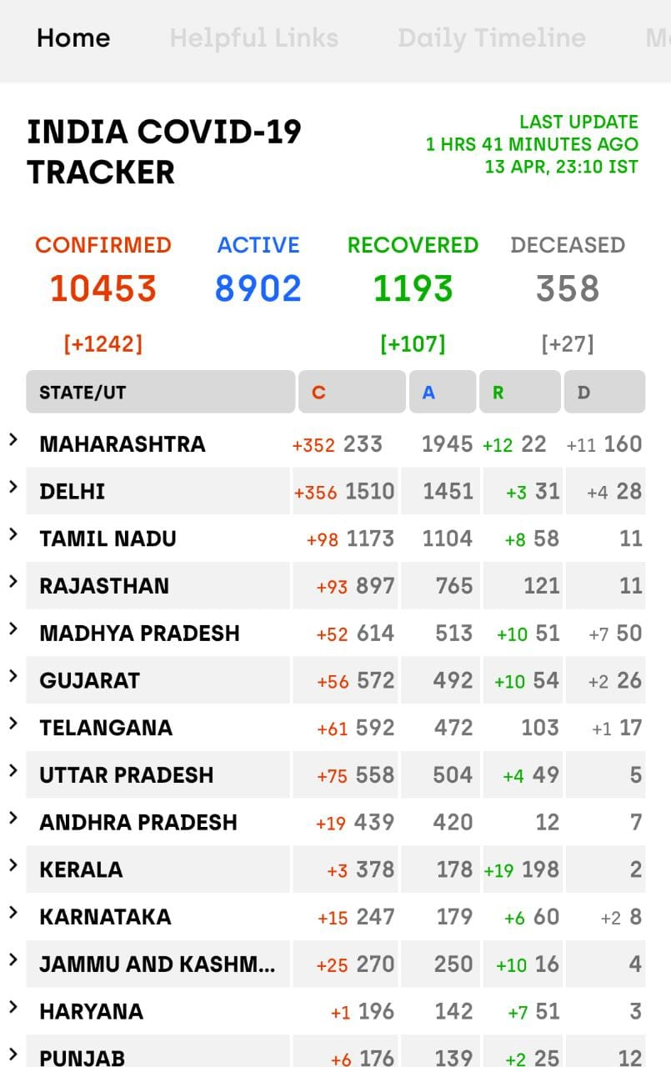4.1 Outputs with Snapshots

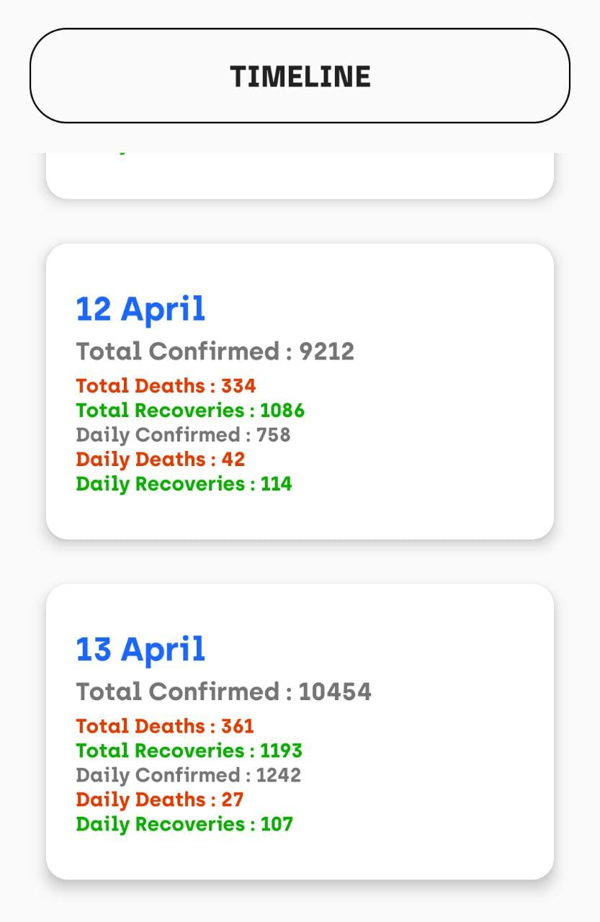 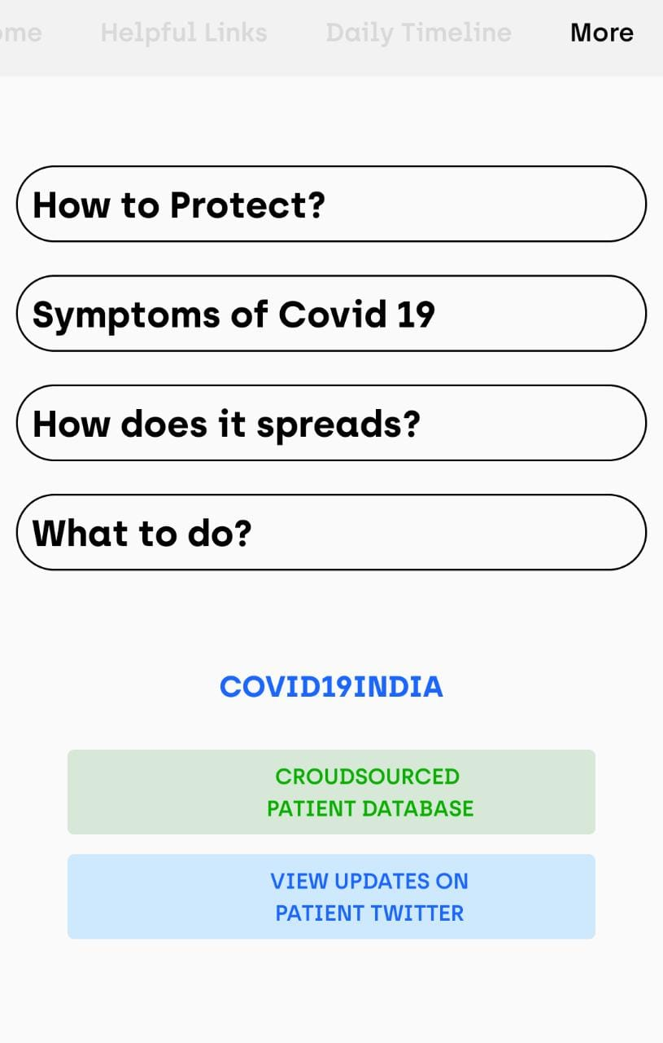

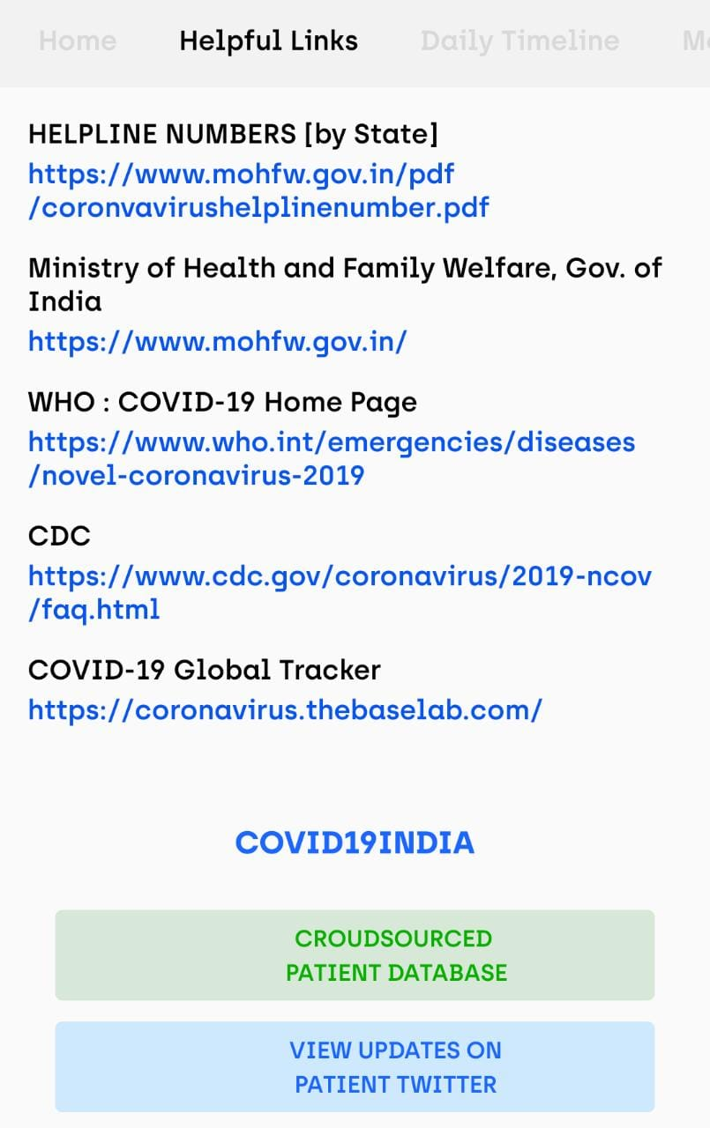

**CHAPTER 5 | CONCLUSIONS AND FUTURE WORK**

**5.1 Conclusions**

* As conclusion, the objective of tracking number of people affected by corona virus is achieved.
* It is a user-friendly application which displays all the data in a very simple and user-understandable format.
* With just few clicks on your phone you will be able to access all the information about your city or district in few seconds.
* This is a real-time application which will make us stay aware about this pandemic.

**5.2 Future Work**

* Further maps will be added so it will become more convenient for the users to obtain information.
* Adding more innovative features using web crawlers making it a piece of cake to acquire all the necessary data and updates.
* Creating a web application for the same proposed system making it responsive on the go.

**CHAPTER 6 | APPLICATIONS AND LIMITATIONS**

**APPLICATIONS**

➜The project can be deployed for users use where they can access important information, data and insights related to covid19.

➜The system can also be used for open source where people can collaborate to implement new systems and UIs like points of location with hotspots and affected areas and points where a covid19 positive person visited.

**LIMITATIONS**

1. It requires internet connection.
2. It is a mobile application and not a web application can only be used on android.
3. Requires a large database from trusted sources.
4. Requires high level precision.

**CHAPTER 7 | REFERENCES**

* **Ministry of Health and Family Welfare, Gov. of India**

<https://www.mohfw.gov.in/>

* **WHO : COVID-19 Home Page**

<https://www.who.int/emergencies/diseases/novel-coronavirus-2019>

* **CDC**

<https://www.cdc.gov/coronavirus/2019-ncov/faq.html>

* **COVID-19 Global Tracker**

<https://coronavirus.thebaselab.com/>