SIH 26157 — SAT-SA
Supervisory Analytics Tool for SOC Assessment
M.Tech 6-Member Team — Technical Feasibility & Hackathon Analysis

Executive Summary
SIH 26157 asks for an offline supervisory analytics and decision-support platform for NCIIPC examiners. The system should analyze periodic SOC operational data, identify potential execution gaps, negative-space signals, unusual operational patterns and entities/cases that deserve attention, and present evidence-backed findings for human review.
This is NOT a SIEM, SOC, real-time monitoring platform, packet-analysis system, continuous log collector or autonomous incident-response system. The strongest student implementation is a focused analytics engine with explainable findings and an examiner dashboard.

1. Problem Statement in Simple Language
NCIIPC examiners may need to assess the cyber-resilience and SOC operations of Critical Sector Entities. Manual sampling becomes difficult when there are large volumes of alerts and case-management records. The proposed tool should reduce the examiner's search space by automatically analyzing submitted operational evidence and highlighting where supervisory attention is most useful.

Who faces the problem?
- NCIIPC/supervisory examiners.
- Critical Sector Entities whose SOC operational evidence is assessed.
- Assessment teams that need scalable, repeatable analysis.

What exactly is expected?
An offline supervisory analytics platform that accepts structured/periodic SOC operational data, validates and normalizes it, reconstructs relevant workflows, identifies potential operational weaknesses and missing expected evidence, prioritizes findings, and provides an explainable dashboard for manual examiner review.

Team/Judge explanation
“Our solution is an offline supervisory analytics platform that analyzes periodic SOC alert and case-management data to identify operational weaknesses, execution gaps and missing expected workflow evidence. Instead of replacing a SOC or making autonomous decisions, it gives NCIIPC examiners explainable findings and prioritizes which entities and cases deserve manual review.”

2. What Exactly Do We Have to Build?

Input
- CSV/JSON or another structured periodic SOC submission format.
- Alert metadata.
- Case-management records.
- Investigation workflow records.
- Escalation records.
- Alert disposition/closure records.
- Asset/system inventory where available and justified.

Processing
- Data validation and normalization.
- Reconstruct alert → case → investigation → escalation → closure workflows.
- Rule-based execution-gap analysis.
- Negative-space analysis: identify potentially important expected activity for which supporting evidence is absent.
- Statistical analysis of investigation/assignment/closure times and operational behaviour.
- Optional anomaly detection.
- Risk/priority scoring.
- Generate evidence-backed, explainable findings.

Output
- Entity-level attention/priority.
- Finding category and severity.
- Supporting evidence.
- Expected vs observed workflow.
- Recommended manual-review priority.
- Assessment summary/report.

Required UI
- Login.
- Assessment dashboard.
- Entity assessment.
- Findings list.
- Finding drill-down/evidence view.
- Review queue.
- Report/export page.

Backend
- FastAPI REST API.
- Data ingestion endpoints.
- Analytics execution endpoints/services.
- Finding retrieval and filtering.
- Authentication/RBAC.
- Audit logging.
- Report generation.

Database
PostgreSQL is recommended because alerts, cases, investigations, escalations, assets and findings have strong relational relationships. SQLite can be used as an MVP fallback if PostgreSQL slows the team down.

AI/ML
AI/ML is NOT mandatory. Start with deterministic rules and statistics. If time permits, add a simple anomaly detector such as Isolation Forest. Do not train a custom LLM. An optional local/open-weight LLM may be used only to summarize already-generated structured findings; it should not be the authority deciding whether a supervisory failure occurred.

Security
- Authentication.
- Role-based access control.
- Password hashing.
- Authorization checks.
- Input/schema validation.
- Secure file upload.
- Audit trail.
- Parameterized database access.
- Minimal exposure of sensitive SOC information.
- Optional HTTPS and rate limiting.

3. System Architecture
[SCREENSHOT SPACE — INSERT THE SYSTEM ARCHITECTURE DIAGRAM HERE]
Suggested diagram to create/screenshot: Examiner/User → React Dashboard → FastAPI Backend → PostgreSQL + Analytics Engine. The Analytics Engine should contain Data Validation, Workflow Reconstruction, Execution-Gap Detection, Negative-Space Detection, Statistical Analysis, Optional Anomaly Detection and Risk/Priority Scoring. Output should flow to Findings/Review Queue/Reports.
Architecture principle: use a modular monolith rather than microservices. No cloud or external API should be required for the core demo.

4. Recommended Hackathon Tech Stack
Layer | Technology | Priority
Frontend | React + TypeScript + Vite | MUST/SHOULD
UI | Tailwind CSS | SHOULD
Charts | Apache ECharts | SHOULD
Backend | Python + FastAPI + Pydantic | MUST
Data | Pandas + NumPy | MUST
Statistics | SciPy | SHOULD
Database | PostgreSQL | SHOULD
Fallback DB | SQLite | OPTIONAL
ML | Scikit-learn + Isolation Forest | OPTIONAL
Infrastructure | Docker + Docker Compose | SHOULD
Security | RBAC + password hashing + validation + audit logging | MUST
Development | Git/GitHub + VS Code + Postman | MUST/SHOULD
CI/CD | GitHub Actions | OPTIONAL
Cloud | None required | DO NOT DEPEND ON IT
Kubernetes/Microservices | Not required | DO NOT BUILD

5. Resources Required

Datasets
Public SOC/security datasets can be used for realistic characteristics and experimentation, but they should not be assumed to exactly match NCIIPC's assessment schema.
- WitFoo Precinct6: public sanitized SOC/security event dataset described as containing about 2.1 million events and incident provenance graphs. Use it to study realistic security-event structure and relationships.
- SOC Analytics Alerts Synthetic: synthetic SOC alert dataset with fields such as severity, analyst, status, escalation and timing-related metrics. Useful for workflow/operational analytics prototyping.
- Your own assessment-oriented synthetic layer: create controlled scenarios for missing escalation, SLA deviations, missing investigation evidence, unusual closure and workload anomalies. Clearly disclose that these are synthetic validation scenarios.
Important limitation: the public problem statement does not provide actual NCIIPC/CSE operational data or an official ground-truth labelled dataset. Do not claim that public/synthetic data proves real-world accuracy.

APIs
No external API is required. The core application should work without internet. Avoid making OpenAI/Gemini/cloud SIEM/threat-intelligence APIs a dependency.

AI Models
- Rule engine: required.
- Statistical methods: required.
- Isolation Forest: optional.
- Local open-weight LLM: optional explanation/report layer.
- Custom LLM training: NOT recommended.
- Deep learning: NOT recommended.

Infrastructure
- Normal developer laptop is sufficient for the MVP.
- GPU is not required if ML remains lightweight and LLM is omitted.
- Local SSD storage is sufficient for a demo dataset.
- Docker can package the application for reliable offline demonstration.

Official documentation/resources
- FastAPI official documentation/tutorial.
- PostgreSQL official documentation.
- Docker official getting-started documentation.
- OWASP API Security Top 10.
- Scikit-learn documentation for Isolation Forest if ML is used.

6. Feature Prioritization

MUST HAVE
- CSV/JSON data import.
- Data validation.
- Workflow reconstruction.
- 5–8 meaningful supervisory detection rules.
- Execution-gap detection.
- Negative-space detection.
- Explainable findings.
- Priority/risk scoring.
- Dashboard.
- Finding drill-down.
- Authentication/RBAC.
- Audit trail.

SHOULD HAVE
- Entity comparison.
- Time trends.
- Analyst workload analysis.
- Filtering/search.
- PDF/CSV report.
- Configurable thresholds.
- Dataset profiling.

WOW FEATURES
- Explainable workflow graph.
- Negative-space heatmap.
- Examiner review queue that reduces a huge population to a small high-value sample.
- Multi-entity comparison.
- Counterfactual explanation such as: “If the expected escalation evidence existed, this signal would not be generated.”

DO NOT BUILD
- Full SIEM.
- Real-time log ingestion.
- Packet capture/inspection.
- Malware sandbox.
- Autonomous incident response.
- Custom LLM training.
- Blockchain.
- Kubernetes.
- Microservices.
- Mobile app unless explicitly required.

7. 6-Member Team Distribution

Member 1 — Architect + SOC Research
Requirements, SOC workflow, assessment methodology, architecture, definition of supervisory signals.
Deliverable: architecture + workflow/rule specification.

Member 2 — Data Engineer
Dataset discovery, cleaning, normalization, schema, synthetic scenarios, data pipeline.
Deliverable: validated assessment dataset + ingestion pipeline.

Member 3 — Analytics/ML
Rules, SLA calculations, workflow analysis, negative-space logic, anomaly detection, scoring.
Deliverable: analytics engine + validation results.

Member 4 — Backend + Security
FastAPI, PostgreSQL, APIs, authentication, RBAC, audit logs, validation.
Deliverable: working API + secure backend.

Member 5 — Frontend
React dashboard, charts, findings, drill-down, review queue, report UI.
Deliverable: working examiner dashboard.

Member 6 — Integration + QA + DevOps + Demo
Integration, test cases, Docker, deployment, documentation, demo dataset, presentation and backup demo.
Deliverable: stable end-to-end build + demo.

Dependencies
Do not work strictly sequentially. Freeze the data schema and API contract early. Frontend can use mock JSON while backend is being developed. Analytics can run against the finalized schema while the UI is being built. Member 6 should integrate continuously instead of waiting until the last hour.

Biggest bottleneck
Analytics methodology + dataset quality, especially defining defensible negative-space and workflow-execution expectations.

8. Reality Check for an M.Tech Team
Brutally honest assessment: the website and basic backend are manageable. The genuinely difficult part is deciding what constitutes a meaningful supervisory signal and validating that the system is not simply detecting patterns that the team itself injected.
Difficulty | Why it happens | Probability | Impact | Mitigation
Domain understanding | SOC assessment rules are unfamiliar. | High | High | Learn SOC workflow first; define findings as potential signals requiring review.
Dataset mismatch | Public datasets may not contain the exact workflow fields. | Very High | Very High | Use public data for realism plus a clearly documented assessment-oriented synthetic layer.
Negative-space detection | You must know what evidence should exist before declaring it missing. | High | Very High | Define explicit expected workflows by severity/type and use cautious language.
False positives | Legitimate exceptions can look like violations. | High | High | Show evidence, baseline, confidence/priority and manual-review recommendation.
ML complexity | Poorly understood ML can produce meaningless results. | Medium | High | Rules/statistics first; ML only as an optional secondary signal.
Six-person integration | Different modules can disagree on field names/contracts. | High | High | Freeze schema/API contract; use feature branches and continuous integration.
Security | A cybersecurity product with weak auth looks poor. | Medium | High | Implement RBAC, hashing, validation, authorization and audit logs.
Synthetic validation | Synthetic data can overstate effectiveness. | High | Very High | Use independent scenarios and disclose limitations; do not claim production accuracy.
Scope creep | AI/LLM/SIEM/cloud features can consume the entire sprint. | Very High | Very High | Feature freeze; prioritize core analytics and demo reliability.
Demo failure | Live environment can break at the worst time. | Medium | Very High | Offline deployment + fixed demo dataset + precomputed backup mode.

9. Hackathon Time Feasibility
Level | Achievability | What it means
Level 1 — Basic prototype | YES | CSV → Python rules → simple dashboard.
Level 2 — Functional MVP | YES, challenging | Database + API + analytics + dashboard + security.
Level 3 — Polished demo | POSSIBLE | Strong UX, explainability and reliable demo if scope is controlled.
Level 4 — Production-like | NO | Not realistic for a student hackathon.

Critical path
Understand assessment → define schema/workflow → implement analytics → validate findings → connect dashboard → security → final demo.

Can be mocked
- SOC submission data.
- Assessment periods.
- Multiple entities.
- Workflow expectations.
- Controlled validation scenarios.

Should NOT be mocked
- Detection calculations.
- Evidence supporting findings.
- Risk/priority reasoning.
- Workflow reconstruction.

If time runs short, cut in this order
- LLM.
- Advanced ML.
- Fancy reports.
- Extra charts.
- Nonessential security features.
Do NOT cut core detection, evidence, dashboard, validation or the main demo story.

10. Development Plan

Phase 1 — Requirement understanding
Study problem statement, SOC workflow, examiner role and out-of-scope items.

Phase 2 — Assessment methodology
Define execution gap, negative space, expected workflows, finding categories and priority rules.

Phase 3 — Data model
Freeze alert/case/investigation/escalation/closure/entity/finding schemas.

Phase 4 — Dataset
Acquire public data, clean it, map it and create controlled assessment scenarios.

Phase 5 — Analytics
Implement rules first; then statistics; optional anomaly detection.

Phase 6 — Backend
FastAPI + database + ingestion + findings APIs.

Phase 7 — Frontend
Dashboard + entity view + findings + drill-down + review queue.

Phase 8 — Security
Authentication, RBAC, validation, audit trail and secure access.

Phase 9 — Integration
Connect data → analytics → API → dashboard.

Phase 10 — Validation
Run known scenarios and measure detection behaviour/false positives.

Phase 11 — Deployment
Docker/local offline package and backup demo mode.

Phase 12 — Demo
3–5 minute story, screenshots/video backup, judge Q&A preparation.
Order: FIRST understand and define the assessment logic; SECOND freeze the data model; THIRD build analytics and data pipeline; THEN backend/frontend in parallel; LAST integrate, secure, validate and polish.

11. Parallel Development Plan
The exact hourly schedule depends on the hackathon duration. The following is a practical 36–48 hour sprint model.
Time | M1 | M2 | M3 | M4 | M5 | M6
0–4h | Requirements/workflow | Dataset discovery | Detection research | Architecture/API contract | UI wireframe | Repo/coordination
4–8h | Rule specification | Cleaning/schema | First rules | DB skeleton | Dashboard shell | Test setup
8–16h | Methodology review | Data pipeline | Detection engine | APIs | Dashboard | Integration
16–24h | Review rules | Validation data | Scoring | Auth/RBAC | Findings UI | Integration
24–32h | Testing | Test scenarios | Validation | Bug fixes | Drill-down | Docker
32–40h | Demo story | Final dataset | Metrics | Security review | UI polish | End-to-end QA
40h+ | Presentation | Backup data | Results | Deployment | Demo | Final QA

12. At Least 10 Technical Challenges
Challenge | Severity | Probability | Why | Solution
Dataset mismatch | Critical | High | Public data may not map to required workflow. | Use a documented normalized schema + controlled synthetic assessment layer.
Negative-space ambiguity | Critical | High | Missing evidence is not automatically proof of failure. | Define expected evidence and label outputs as potential signals.
False positives | Critical | High | Legitimate exceptions can be flagged. | Use thresholds, baselines, evidence and manual review.
Ground-truth limitations | Critical | High | No official labelled NCIIPC assessment dataset is supplied. | Use independent synthetic scenarios and disclose limitations.
ML overfitting | High | Medium | Model may learn dataset artifacts. | Keep ML optional and compare against rule/statistical baselines.
Large-data processing | High | Medium | Millions of records may be slow on laptops. | Aggregate first, index database, process batches and demo with a manageable subset.
API contract mismatch | High | High | Frontend/backend field names diverge. | Freeze OpenAPI/schema early.
Authentication/authorization bugs | High | Medium | Sensitive assessment data needs access control. | Use tested RBAC and object-level authorization.
File upload security | High | Medium | Malicious/invalid files can crash or exploit the system. | Size/type/schema validation and safe parsing.
Git conflicts | Medium | High | Six developers touch shared code. | Feature branches, small PRs, ownership boundaries.
Demo environment failure | Critical | Medium | Packages/services may fail offline. | Docker/local setup + backup static/precomputed mode.
Time management | Critical | Very High | Too many features for the available time. | MVHP feature freeze.

13. Failure Scenarios and Backup Plans

External API stops
Avoid external APIs for core functionality; application remains local.

Internet fails
Core system should run offline; keep dependencies installed/containerized.

Dataset unavailable
Use previously downloaded public dataset and your own validated synthetic dataset.

AI model performs poorly
Disable ML and use rule/statistical engine; ML is not the core.

GPU unavailable
Do not require GPU; omit local LLM if necessary.

Cloud deployment fails
Use local Docker deployment on the demo laptop.

Database fails
Maintain a clean local database snapshot and optional SQLite demo fallback.

Backend crashes
Keep a precomputed/static demo mode showing validated findings.

Frontend/backend integration fails
Use fixed mock JSON to demonstrate UI and separately show analytics output.

Authentication breaks
Test a known local examiner account before demo; keep a backup demo mode.

Two members edit same code
Feature branches + pull requests + clear module ownership.

Run out of time
Cut optional AI/ML/report polish first; preserve detection, evidence, dashboard and demo.

14. Cybersecurity Analysis

Attack surface
- File upload.
- REST API.
- Authentication/login.
- Authorization/object access.
- Database.
- Dashboard/browser.
- Report generation.
- Optional ML/LLM pipeline.
- Docker/local deployment.

Threats
- Malicious file upload.
- SQL injection.
- Broken object/function authorization.
- XSS through untrusted dataset values.
- Credential attacks.
- Sensitive data leakage.
- Log tampering or excessive logging.
- Prompt injection if an LLM is introduced.
- Model/data poisoning if models are trained or adapted.

Realistically implementable security
- MUST: authentication, RBAC, password hashing, input validation, authorization, audit trail, safe DB access.
- SHOULD: rate limiting, secure headers, HTTPS, encrypted backups.
- DO NOT SPEND HACKATHON TIME ON: custom cryptography, HSM integration, Kubernetes security or enterprise zero-trust implementation.

LLM security rule
If an LLM is used, do not send raw untrusted SOC fields directly into prompts. Feed the model structured, sanitized findings and use it only for explanation/report generation. The analytics engine remains authoritative.

15. What Judges May Ask

Q: Why aren't you building a SIEM?
A: Because SIEM/SOC functionality is outside the intended scope. Our tool consumes periodic SOC operational evidence and performs supervisory assessment rather than real-time monitoring.

Q: Why should we trust your finding?
A: Every finding contains the analytical rule/method, supporting evidence, expected workflow, observed behaviour and a recommendation for human review. It is not presented as an autonomous verdict.

Q: What is negative space?
A: Potentially important expected activity for which supporting evidence is absent from submitted operational data. Absence of evidence is treated as a signal for review, not automatically as proof of failure.

Q: Why not use an LLM for everything?
A: The core problem is structured operational analytics. Deterministic and statistical methods are more auditable. A local LLM can optionally summarize findings, but should not decide the supervisory verdict.

Q: Where did your data come from?
A: Public cybersecurity/SOC datasets can provide realistic characteristics, while an assessment-oriented synthetic layer is used because actual CSE operational data is sensitive and an official labelled dataset is not provided.

Q: Isn't synthetic validation weak?
A: Yes. We explicitly treat it as a limitation. We use independent scenarios and varied data to validate logic, but do not claim that this proves production effectiveness.

Q: Why should an examiner use this instead of manual sampling?
A: We do not eliminate manual review; we reduce the search space and prioritize where manual review is likely to have the highest value.

Q: Why PostgreSQL?
A: Alerts, cases, investigations, escalations and findings have strong relationships, so a relational database provides constraints, joins and analytical queries naturally.

Q: Why Python?
A: The core problem is data processing and analytics, and Python provides mature libraries for structured data and statistical/ML experimentation.

Q: What if your model is wrong?
A: The model is advisory. Evidence-backed deterministic rules remain independently usable, and high-impact findings are reviewable by an examiner.

16. Competitor Differentiation
A generic team will likely build: upload CSV → dashboard → anomaly score. That alone will look like a standard analytics dashboard.

3–5 differentiators
- Workflow-centric analysis: analyze Alert → Case → Investigation → Escalation → Closure rather than isolated records.
- Negative-space engine: identify expected workflow/evidence that appears missing.
- Explainability-first findings: WHAT, WHY, EVIDENCE, EXPECTED, OBSERVED, IMPACT and RECOMMENDATION.
- Examiner review prioritization: reduce a huge population to a small high-value manual-review sample.
- Multi-entity comparison: identify which entities deserve attention first.

17. 3–5 Minute Demo Strategy
- 0:00–0:30 — Problem: show why manual review does not scale.
- 0:30–1:00 — Upload: load one realistic assessment dataset.
- 1:00–1:30 — Processing: show record counts and analysis completion.
- 1:30–2:15 — WOW: show high-priority findings.
- 2:15–3:00 — Drill-down: show Expected vs Observed workflow and evidence.
- 3:00–3:30 — Explainability: show exactly why the finding was generated.
- 3:30–4:00 — Differentiation: explain that the system reduces examiner search space rather than replacing the examiner.

Main WOW moment
Show a critical workflow where the expected escalation evidence is absent, then trace the finding back to the exact records and explain why it is prioritized for manual review.

Avoid
- Live internet-dependent APIs.
- Unstable AI demos.
- Unnecessary real-time claims.
- Unvalidated ML graphs.
- Features you cannot explain.

Backup demo
Maintain a precomputed dataset and findings snapshot, plus a local offline build. Record a 3–5 minute demo video before final presentation.

18. Presentation/Pitch
- ProblemManual SOC supervisory sampling does not scale.
- Existing limitationsVolume, fragmented operational evidence and hidden workflow gaps.
- Our solutionOffline supervisory analytics and decision support.
- ArchitectureSimple modular pipeline from data to evidence-backed findings.
- TechnologyPython/FastAPI/PostgreSQL/React.
- Key featuresWorkflow analysis, negative space, explainability and prioritization.
- AI/MLOptional secondary anomaly detection, not the core decision-maker.
- CybersecurityRBAC, validation, authorization and audit trail.
- InnovationNegative-space + workflow-centric + examiner-prioritization approach.
- ResultsDetection examples, processing scale and validation scenarios.
- Future scopeExpert-labelled validation, broader assessment rules and integration with authorized submission systems.
- ImpactFaster, more consistent and targeted supervisory assessment.
Emphasize the problem-to-solution connection and the evidence behind findings. Do not spend presentation time explaining every framework or showing code.

19. Cost & Resource Reality
- Software: approximately ₹0 using open-source tools.
- Cloud: ₹0 required for MVP.
- GPU: ₹0 required.
- External APIs: ₹0 required.
- Storage: normal laptop SSD is sufficient for the demo.
- Potential paid cost: none should be necessary unless the team voluntarily chooses hosted infrastructure or a paid model/API.
Best strategy: keep the complete core product local/offline so network, API limits and cloud availability cannot break the demo.

20. Final Score
Category | Score
Technical feasibility | 7/10
Difficulty | 8/10
Innovation potential | 9/10
AI/ML potential | 7/10
Cybersecurity potential | 9/10
Demo potential | 8/10
Scalability potential | 9/10
Resource availability | 6/10
6-member team suitability | 7/10
Hackathon time feasibility | 6/10
Judge appeal | 8/10

Decision: 🟡 CONSIDER
26157 is a strong M.Tech-level cybersecurity problem, but it is not an easy “dashboard + AI” problem. The hard parts are assessment methodology, negative-space reasoning, dataset mismatch, false positives and validation. It is worth selecting if the team has enough preparation time and is willing to learn SOC/data analytics. If the goal is the easiest problem to complete quickly, this is not the safest choice.

FINAL OUTPUT

1. ONE-LINE PROBLEM
Build an offline supervisory analytics system that analyzes SOC operational data and tells examiners which entities, workflows and cases deserve attention—not a system that operates the SOC itself.

2. WHAT WE ACTUALLY HAVE TO BUILD
SOC data → validation → workflow reconstruction → execution-gap/negative-space/anomaly analysis → explainable findings → priority score → examiner dashboard → manual review queue.

3. RECOMMENDED TECH STACK
React + TypeScript + FastAPI + Python + Pandas + PostgreSQL + Scikit-learn + ECharts + Docker. No cloud dependency, no external API dependency and no custom LLM.

4. 6-MEMBER TEAM DIVISION
1 Architect/SOC Research; 2 Data Engineer; 3 Analytics/ML; 4 Backend/Security; 5 Frontend; 6 Integration/QA/DevOps/Demo.

5. MUST-HAVE FEATURES
Data upload, validation, workflow reconstruction, 5–8 detection rules, negative-space detection, explainable findings, priority scoring, dashboard, drill-down, authentication/RBAC and audit trail.

6. WOW FEATURES
Negative-space engine, explainable workflow graph, examiner review prioritization, multi-entity comparison and counterfactual explanations.

7. TOP 5 TECHNICAL RISKS
Dataset mismatch; negative-space ambiguity; false positives; weak ground truth; scope creep/integration failure.

8. REALITY CHECK
Website/backend are manageable. The real difficulty is deciding what should have happened and proving that a detected signal is meaningful. Do not attempt a production-grade system.

9. HACKATHON MVP
One realistic dataset + 5–8 strong detection rules + workflow reconstruction + negative-space detection + simple anomaly detection + explainable findings + priority queue + dashboard + secure local deployment.

10. WHY WE SHOULD / SHOULD NOT CHOOSE THIS PROBLEM
Choose it for strong cybersecurity/research/demo potential if you have preparation time. Avoid it if nobody wants to learn SOC/data analytics or if the team needs a very quick/easy project.

SCREENSHOT / VISUALS TO ADD MANUALLY
The following items are intentionally left as spaces because a Word document cannot automatically contain the exact visual artifact you may want to capture from your own architecture/demo:

A. System Architecture Diagram
Insert screenshot here. Recommended: Examiner → React → FastAPI → PostgreSQL + Analytics Engine → Findings/Review Queue/Reports.
_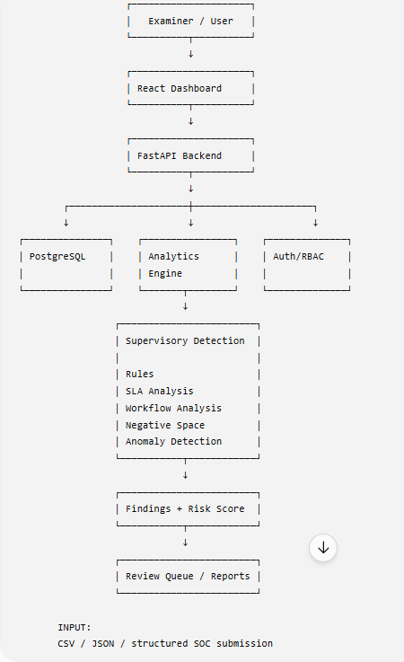__________________________________
_____________________________________________
________________________________________________________________________________
________________________________________________________________________________

B. End-to-End Workflow Diagram
Insert screenshot here. Recommended: SOC Data → Validation → Normalization → Workflow Reconstruction → Detection → Scoring → Findings → Examiner Review.
____________________________ 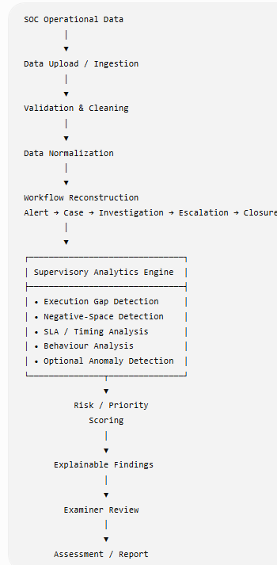 ____________________________________________________
________________________________________________________________________________
________________________________________________________________________________

C. Examiner Dashboard Mockup/Screenshot
Insert screenshot of your implemented dashboard or design. Include entity count, findings, priority distribution and trends.
________________________________________________________________________________
________________________________________________________________________________ 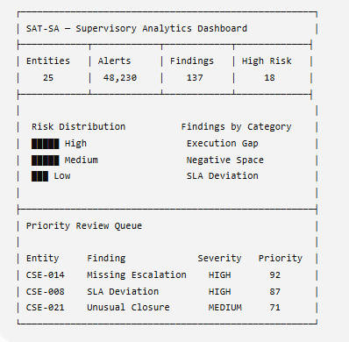
________________________________________________________________________________

D. Finding Drill-Down Screenshot
Insert screenshot showing Expected vs Observed workflow, evidence records and reason for flagging.
__________________________________ 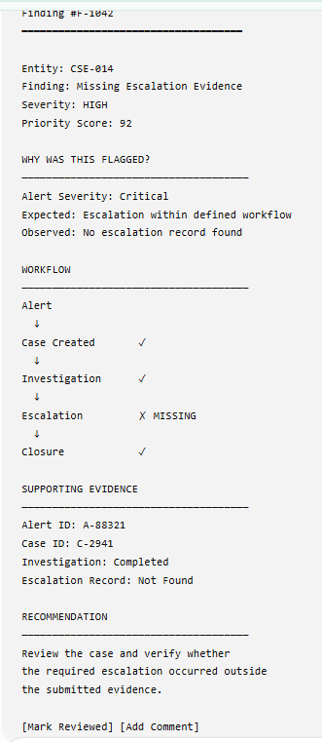 ______________________________________________
________________________________________________________________________________
________________________________________________________________________________

E. Negative-Space Example
Insert screenshot showing a missing expected action/evidence and how the system identifies it.
________________________________________________________________________________
_________________________________________ 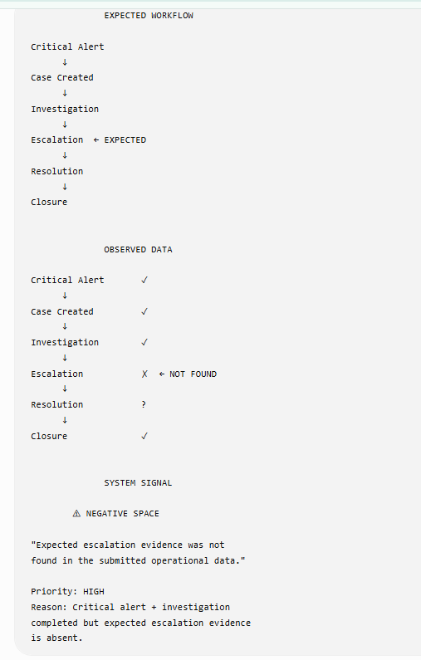 _______________________________________
________________________________________________________________________________

F. Technology/Architecture Stack Graphic
Optional screenshot: React → FastAPI → PostgreSQL → Python Analytics → Docker.
________________________________________________________________________________
_____________________ 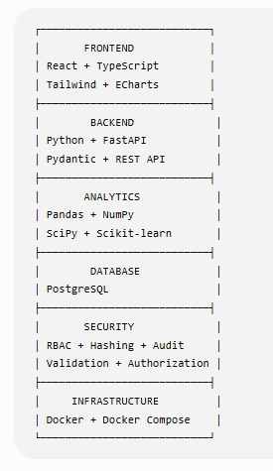 ___________________________________________________________
________________________________________________________________________________

G. Demo Results Screenshot
Insert screenshot of the final working system with realistic counts and 3–5 high-priority findings.
__________________ 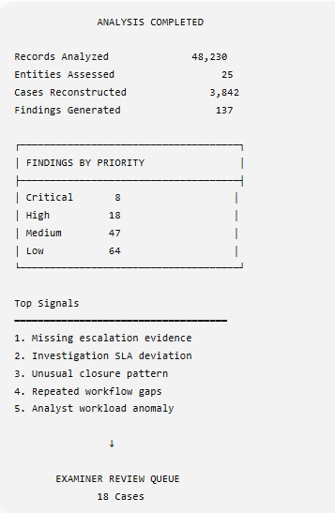 ______________________________________________________________
________________________________________________________________________________
________________________________________________________________________________

H. Optional Dataset Screenshot
Insert screenshot of dataset columns/sample records, but hide any sensitive information.
________________________________________________________________________________
________________________________________________________________________________ 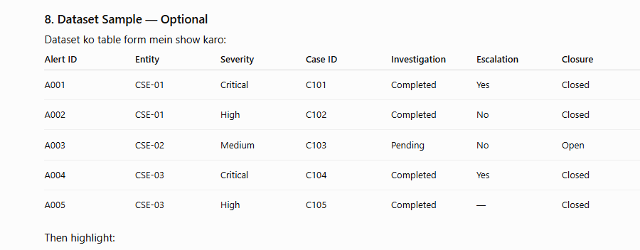
________________________________________________________________________________

Sources / Current Resources
For the final submission, verify the exact SIH problem statement and official rules from the official SIH/organizer material available to your team. Public resources used for planning include the problem-statement page, FastAPI documentation, PostgreSQL documentation, Docker documentation, OWASP API Security Top 10, and public SOC datasets.
Note: public SOC datasets are useful for prototyping, but they are not evidence that your system has been validated on actual NCIIPC/CSE data.

