HR Intelligence Dashboard Report – ZENVY

1. Introduction
This project focuses on building an HR Intelligence Dashboard for ZENVY with the objective of analyzing payroll data to detect financial leakages, compliance risks, and cost inefficiencies. The project follows an end-to-end data analytics lifecycle, starting from dataset creation to dashboard visualization and executive-level insights.

2. Dataset Creation
The dataset was created using SQL to simulate real-world, unstructured payroll data. It includes employee details, salary information, attendance, overtime, and employment status. The dataset intentionally contains missing values, inconsistencies, and anomalies to reflect real HR payroll challenges.
use zenvy;

CREATE TABLE hr_payroll (
employee_id INT PRIMARY KEY,
employee_name VARCHAR(50),
department VARCHAR(30),
designation VARCHAR(30),
salary DECIMAL(10,2),
attendance_days INT,
working_days INT,
overtime_hours INT,
overtime_pay DECIMAL(10,2),
salary_credit_amount DECIMAL(10,2),
salary_credit_date DATE,
bank_account VARCHAR(20),
employment_status VARCHAR(10)
);

INSERT INTO hr_payroll VALUES
(1,'Asha','IT','Analyst',30000,NULL,22,12,1800,30000,'2025-01-31','ACCT1001','Active'),
(2,'Rahul','Sales','Executive',35000,18,22,0,NULL,35000,'2025-01-31','ACCT1002','Active'),
(3,'Meena','Finance','Manager',50000,22,22,55,6000,56000,'2025-01-31','ACCT1003','Active'),
(4,'John','HR','Analyst',28000,20,22,8,1200,28000,'2025-01-31','ACCT1004','Inactive'),
(5,'Riya','IT','Executive',42000,NULL,22,15,2250,46000,'2025-01-31','ACCT1005','Active'),

(6,'Vikram','Sales','Manager',52000,22,22,3,450,52000,'2025-01-31','ACCT1006','Inactive'),
(7,'Sana','Finance','Analyst',31000,19,22,NULL,NULL,31000,'2025-01-31','ACCT1002','Active'), -- duplicate bank
(8,'Arjun','HR','Executive',39000,22,22,9,1350,39000,'2025-01-31','ACCT1008','Active'),
(9,'Nisha','IT','Manager',61000,16,22,42,6300,61000,'2025-01-31','ACCT1009','Active'),
(10,'Kiran','Sales','Analyst',33000,NULL,22,11,1650,33000,'2025-01-31','ACCT1010','Active'),

(11,'Priya','Finance','Executive',37000,22,22,0,0,37000,'2025-01-31','ACCT1011','Active'),
(12,'Amit','HR','Manager',48000,21,22,50,7000,48000,'2025-01-31','ACCT1012','Active'),
(13,'Neha','IT','Analyst',34000,NULL,22,NULL,NULL,34000,'2025-01-31','ACCT1013','Inactive'),
(14,'Rohit','Sales','Executive',36000,22,22,10,1500,41000,'2025-01-31','ACCT1014','Active'),
(15,'Anu','Finance','Manager',58000,22,22,6,900,58000,'2025-01-31','ACCT1015','Inactive'),

(16,'Suresh','HR','Analyst',29000,18,22,14,2100,29000,'2025-01-31','ACCT1016','Active'),
(17,'Kavya','IT','Executive',41000,22,22,0,NULL,41000,'2025-01-31','ACCT1017','Active'),
(18,'Manoj','Sales','Manager',55000,20,22,48,7200,60000,'2025-01-31','ACCT1018','Active'),
(19,'Deepa','Finance','Analyst',32000,NULL,22,9,1350,32000,'2025-01-31','ACCT1019','Active'),
(20,'Ramesh','HR','Executive',40000,22,22,12,1800,40000,'2025-01-31','ACCT1020','Inactive'),

(21,'Pooja','IT','Analyst',35000,22,22,5,750,35000,'2025-01-31','ACCT1021','Active'),
(22,'Yash','Sales','Executive',37000,NULL,22,8,1200,39000,'2025-01-31','ACCT1022','Active'),
(23,'Farah','Finance','Manager',62000,22,22,60,9000,70000,'2025-01-31','ACCT1023','Active'),
(24,'Ajay','HR','Analyst',30000,17,22,4,NULL,30000,'2025-01-31','ACCT1024','Active'),
(25,'Divya','IT','Executive',45000,NULL,22,15,2250,50000,'2025-01-31','ACCT1005','Inactive');

INSERT INTO hr_payroll VALUES
(26,'Hari','Sales','Analyst',34000,20,22,9,1350,34000,'2025-01-31','ACCT1026','Active'),
(27,'Sneha','IT','Executive',46000,NULL,22,14,2100,48000,'2025-01-31','ACCT1027','Active'),
(28,'Joseph','Finance','Manager',62000,22,22,45,7000,62000,'2025-01-31','ACCT1028','Active'),
(29,'Anjali','HR','Analyst',30000,18,22,NULL,NULL,30000,'2025-01-31','ACCT1029','Active'),
(30,'Vimal','IT','Executive',42000,22,22,6,900,42000,'2025-01-31','ACCT1030','Inactive'),

(31,'Farhan','Sales','Manager',56000,22,22,52,8000,64000,'2025-01-31','ACCT1031','Active'),
(32,'Keerthi','Finance','Analyst',33000,NULL,22,10,1500,33000,'2025-01-31','ACCT1032','Active'),
(33,'Anoop','HR','Executive',39000,21,22,7,NULL,39000,'2025-01-31','ACCT1033','Active'),
(34,'Latha','IT','Manager',65000,22,22,0,0,65000,'2025-01-31','ACCT1005','Active'),
(35,'Nitin','Sales','Analyst',35000,NULL,22,15,2250,38000,'2025-01-31','ACCT1035','Active'),

(36,'Rekha','Finance','Executive',41000,22,22,8,1200,41000,'2025-01-31','ACCT1036','Inactive'),
(37,'Sanjay','HR','Manager',58000,22,22,48,7200,58000,'2025-01-31','ACCT1037','Active'),
(38,'Mehul','IT','Analyst',36000,19,22,11,1650,36000,'2025-01-31','ACCT1038','Active'),
(39,'Pallavi','Sales','Executive',37000,22,22,NULL,NULL,37000,'2025-01-31','ACCT1039','Active'),
(40,'Ravi','Finance','Manager',60000,17,22,55,8500,68500,'2025-01-31','ACCT1040','Active'),

(41,'Swathi','HR','Analyst',31000,NULL,22,6,900,31000,'2025-01-31','ACCT1041','Active'),
(42,'Karthik','IT','Executive',44000,22,22,9,1350,44000,'2025-01-31','ACCT1042','Inactive'),
(43,'Maya','Sales','Manager',57000,21,22,14,2100,59000,'2025-01-31','ACCT1043','Active'),
(44,'Dinesh','Finance','Analyst',34000,NULL,22,0,0,34000,'2025-01-31','ACCT1044','Active'),
(45,'Isha','HR','Executive',40000,22,22,12,1800,45000,'2025-01-31','ACCT1045','Active'),

(46,'Kunal','IT','Manager',68000,22,22,4,NULL,68000,'2025-01-31','ACCT1046','Active'),
(47,'Bhavya','Sales','Analyst',36000,20,22,8,1200,36000,'2025-01-31','ACCT1047','Inactive'),
(48,'Siddharth','Finance','Executive',43000,NULL,22,15,2250,48000,'2025-01-31','ACCT1048','Active'),
(49,'Neetu','HR','Manager',59000,22,22,50,7800,59000,'2025-01-31','ACCT1049','Active'),
(50,'Abhishek','IT','Analyst',35000,18,22,6,900,35000,'2025-01-31','ACCT1050','Active'),

(51,'Tanya','Sales','Executive',38000,NULL,22,10,1500,38000,'2025-01-31','ACCT1051','Active'),
(52,'Rohini','Finance','Manager',61000,22,22,42,6300,61000,'2025-01-31','ACCT1052','Inactive'),
(53,'Vijay','HR','Analyst',32000,22,22,0,0,32000,'2025-01-31','ACCT1053','Active'),
(54,'Snehal','IT','Executive',45000,NULL,22,14,2100,50000,'2025-01-31','ACCT1054','Active'),
(55,'Naveen','Sales','Manager',58000,21,22,9,1350,58000,'2025-01-31','ACCT1055','Active'),

(56,'Ankita','Finance','Analyst',36000,22,22,NULL,NULL,36000,'2025-01-31','ACCT1056','Active'),
(57,'Varun','HR','Executive',41000,19,22,12,1800,41000,'2025-01-31','ACCT1057','Inactive'),
(58,'Monika','IT','Manager',67000,22,22,55,9000,76000,'2025-01-31','ACCT1058','Active'),
(59,'Gaurav','Sales','Analyst',34000,NULL,22,7,1050,34000,'2025-01-31','ACCT1059','Active'),
(60,'Puneet','Finance','Executive',42000,22,22,8,1200,42000,'2025-01-31','ACCT1060','Active'),

(61,'Ritu','HR','Analyst',33000,NULL,22,15,2250,36000,'2025-01-31','ACCT1061','Active'),
(62,'Aakash','IT','Executive',46000,22,22,6,900,46000,'2025-01-31','ACCT1062','Active'),
(63,'Nandini','Sales','Manager',59000,22,22,48,7200,59000,'2025-01-31','ACCT1063','Inactive'),
(64,'Sagar','Finance','Analyst',35000,18,22,11,1650,35000,'2025-01-31','ACCT1064','Active'),
(65,'Preeti','HR','Executive',40000,NULL,22,9,1350,43000,'2025-01-31','ACCT1065','Active'),

(66,'Rohan','IT','Manager',70000,22,22,0,0,70000,'2025-01-31','ACCT1066','Active'),
(67,'Simran','Sales','Analyst',36000,20,22,12,1800,36000,'2025-01-31','ACCT1067','Inactive'),
(68,'Alok','Finance','Manager',63000,22,22,60,9500,72500,'2025-01-31','ACCT1068','Active'),
(69,'Namita','HR','Analyst',31000,NULL,22,5,NULL,31000,'2025-01-31','ACCT1069','Active'),
(70,'Kishore','IT','Executive',45000,22,22,14,2100,48000,'2025-01-31','ACCT1070','Active'),

(71,'Tushar','Sales','Manager',60000,22,22,9,1350,60000,'2025-01-31','ACCT1071','Active'),
(72,'Anusha','Finance','Analyst',34000,NULL,22,8,1200,34000,'2025-01-31','ACCT1072','Active'),
(73,'Pradeep','HR','Executive',39000,21,22,15,2250,42000,'2025-01-31','ACCT1073','Inactive'),
(74,'Irfan','IT','Manager',68000,22,22,45,7000,68000,'2025-01-31','ACCT1074','Active'),
(75,'Lavanya','Sales','Analyst',35000,NULL,22,6,900,35000,'2025-01-31','ACCT1075','Active'),

(76,'Sameer','Finance','Executive',43000,22,22,10,1500,43000,'2025-01-31','ACCT1076','Active'),
(77,'Pankaj','HR','Manager',61000,22,22,52,8000,69000,'2025-01-31','ACCT1077','Active'),
(78,'Shilpa','IT','Analyst',36000,NULL,22,NULL,NULL,36000,'2025-01-31','ACCT1078','Inactive'),
(79,'Vikas','Sales','Executive',38000,22,22,8,1200,38000,'2025-01-31','ACCT1079','Active'),
(80,'Sunita','Finance','Manager',64000,18,22,55,8500,72500,'2025-01-31','ACCT1080','Active'),

(81,'Harish','HR','Analyst',32000,NULL,22,6,900,32000,'2025-01-31','ACCT1081','Active'),
(82,'Neelam','IT','Executive',46000,22,22,9,1350,46000,'2025-01-31','ACCT1082','Active'),
(83,'Amitabh','Sales','Manager',59000,22,22,48,7200,59000,'2025-01-31','ACCT1083','Inactive'),
(84,'Kriti','Finance','Analyst',35000,NULL,22,12,1800,35000,'2025-01-31','ACCT1084','Active'),
(85,'Sonal','HR','Executive',41000,22,22,15,2250,46000,'2025-01-31','ACCT1085','Active'),

(86,'Raj','IT','Manager',70000,22,22,0,0,70000,'2025-01-31','ACCT1086','Active'),
(87,'Mitali','Sales','Analyst',36000,20,22,8,1200,36000,'2025-01-31','ACCT1087','Active'),
(88,'Umesh','Finance','Executive',43000,NULL,22,14,2100,48000,'2025-01-31','ACCT1088','Active'),
(89,'Sneeraj','HR','Manager',62000,22,22,55,9000,71000,'2025-01-31','ACCT1089','Inactive'),
(90,'Kajal','IT','Analyst',35000,NULL,22,7,1050,35000,'2025-01-31','ACCT1090','Active'),

(91,'Rakesh','Sales','Executive',38000,22,22,10,1500,38000,'2025-01-31','ACCT1091','Active'),
(92,'Nikhil','Finance','Manager',65000,22,22,42,6300,65000,'2025-01-31','ACCT1092','Active'),
(93,'Aishwarya','HR','Analyst',33000,NULL,22,6,NULL,33000,'2025-01-31','ACCT1093','Active'),
(94,'Suresh','IT','Executive',46000,22,22,15,2250,51000,'2025-01-31','ACCT1094','Active'),
(95,'Kavitha','Sales','Manager',60000,22,22,48,7200,60000,'2025-01-31','ACCT1095','Inactive'),

(96,'Arvind','Finance','Analyst',36000,18,22,9,1350,36000,'2025-01-31','ACCT1096','Active'),
(97,'Bhanu','HR','Executive',40000,NULL,22,12,1800,43000,'2025-01-31','ACCT1097','Active'),
(98,'Chandan','IT','Manager',69000,22,22,55,9000,78000,'2025-01-31','ACCT1098','Active'),
(99,'Divakar','Sales','Analyst',35000,NULL,22,8,1200,35000,'2025-01-31','ACCT1099','Active'),
(100,'Lakshmi','Finance','Executive',42000,22,22,NULL,NULL,42000,'2025-01-31','ACCT1100','Inactive');

SELECT * FROM hr_payroll;

3. Data Cleaning & Preprocessing
Python (Pandas & NumPy) was used in Jupyter Notebook for data cleaning and preprocessing. Missing values in attendance and overtime pay were handled using business logic. Derived columns such as salary leakage, ghost employee flag, overtime abuse flag, attendance missing flag, and cost per employee were created. The cleaned dataset was saved for further analysis and dashboard creation.

import pandas as pd
import numpy as np
df = pd.read_csv(r"C:\Users\aryam\OneDrive\Desktop\DATA ANALYTICS\zeno talent internship\sample task\hr_data.csv")
df.head()
df.shape
df.info()
df.columns
df.columns = df.columns.str.strip().str.lower().str.replace(' ', '_')
df.columns
df['attendance_days'] = df['attendance_days'].fillna(0)
df['overtime_hours'] = df['overtime_hours'].fillna(0)
df['salary_credit_date'] = pd.to_datetime(df['salary_credit_date'], errors='coerce')
df['attendance_missing'] = np.where(df['attendance_days'] == 0, 'Yes', 'No')
df['salary_leakage'] = np.where(
df['salary_credit_amount'] > df['salary'],
df['salary_credit_amount'] - df['salary'],
0
)
df['overtime_abuse'] = np.where(df['overtime_hours'] > 40, 'Yes', 'No')
df['ghost_employee'] = np.where(
(df['employment_status'] == 'Inactive') & (df['salary_credit_amount'] > 0),
'Yes',
'No'
)
df.duplicated().sum()
df = df.drop_duplicates()
df['department'] = df['department'].str.strip().str.title()
df['designation'] = df['designation'].str.strip().str.title()
df['employment_status'] = df['employment_status'].str.strip().str.title()
df['cost_per_employee'] = df['salary_credit_amount'] + df['overtime_pay']
df['payroll_accuracy'] = np.where(
(df['salary_leakage'] == 0) & (df['attendance_missing'] == 'No'),
'Accurate',
'Review'
)
df.to_csv("hr_payroll_cleaned.csv", index=False)
df.isnull().sum()
df[['salary', 'salary_credit_amount', 'overtime_pay']].describe()
df.isnull().sum()
df['overtime_pay'] = df['overtime_pay'].fillna(0)
df['cost_per_employee'] = df['salary_credit_amount'] + df['overtime_pay']

4. KPI Definition
Key Payroll KPIs were defined to monitor payroll health. These include total employees, active and inactive employees, total payroll cost, average salary, salary leakage amount, overtime abuse count, ghost employee count, missing attendance count, payroll leakage percentage, and overtime dependency rate. These KPIs help in detecting risks and inefficiencies in payroll operations.

1)Total Employees = DISTINCTCOUNT(hr_payroll[employee_id])

2)Active Employees =
CALCULATE(
DISTINCTCOUNT(hr_payroll[employee_id]),
hr_payroll[employment_status] = "Active"
)

3)Inactive Employees =
CALCULATE(
DISTINCTCOUNT(hr_payroll[employee_id]),
hr_payroll[employment_status] = "Inactive"
)

Total Payroll Cost = SUM(hr_payroll[salary_credit_amount])

Average Salary = AVERAGE(hr_payroll[salary])

Salary Leakage Amount = SUM(hr_payroll[salary_leakage])

Salary Leakage Employees =
COUNTROWS(FILTER(hr_payroll, hr_payroll[salary_leakage] > 0))

Overtime Abuse Count =
COUNTROWS(FILTER(hr_payroll, hr_payroll[overtime_abuse] = "Yes"))

Ghost Employee Count =
COUNTROWS(FILTER(hr_payroll, hr_payroll[ghost_employee] = "Yes"))

Missing Attendance Count =
COUNTROWS(FILTER(hr_payroll, hr_payroll[attendance_missing] = "Yes"))

Cost per Employee = AVERAGE(hr_payroll[cost_per_employee])

Payroll Leakage % =
DIVIDE(
[Salary Leakage Amount],
[Total Payroll Cost]
)

Overtime Dependency Rate =
DIVIDE(
COUNTROWS(FILTER(hr_payroll, hr_payroll[overtime_hours] > 0)),
[Total Employees]
)

5. Dashboard Design (Power BI)
The cleaned dataset was imported into Power BI to create a four-page HR Intelligence Dashboard:
1. Executive Payroll Overview – High-level payroll summary and risks
2. Fraud & Risk Analysis – Salary leakage, ghost employees, and overtime abuse
3. Compliance & Attendance – Attendance gaps and payroll accuracy
4. Cost & Efficiency Analysis – Cost per employee and overtime dependency

SNAPSHOTS AND RESULTS :
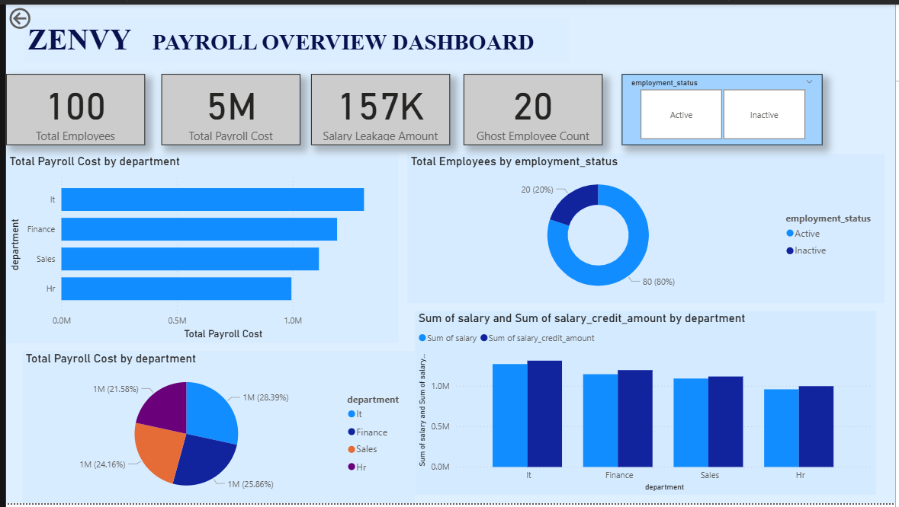
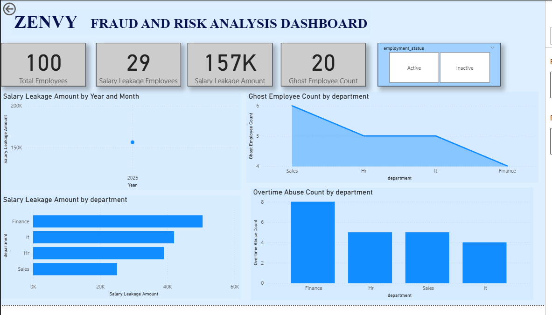

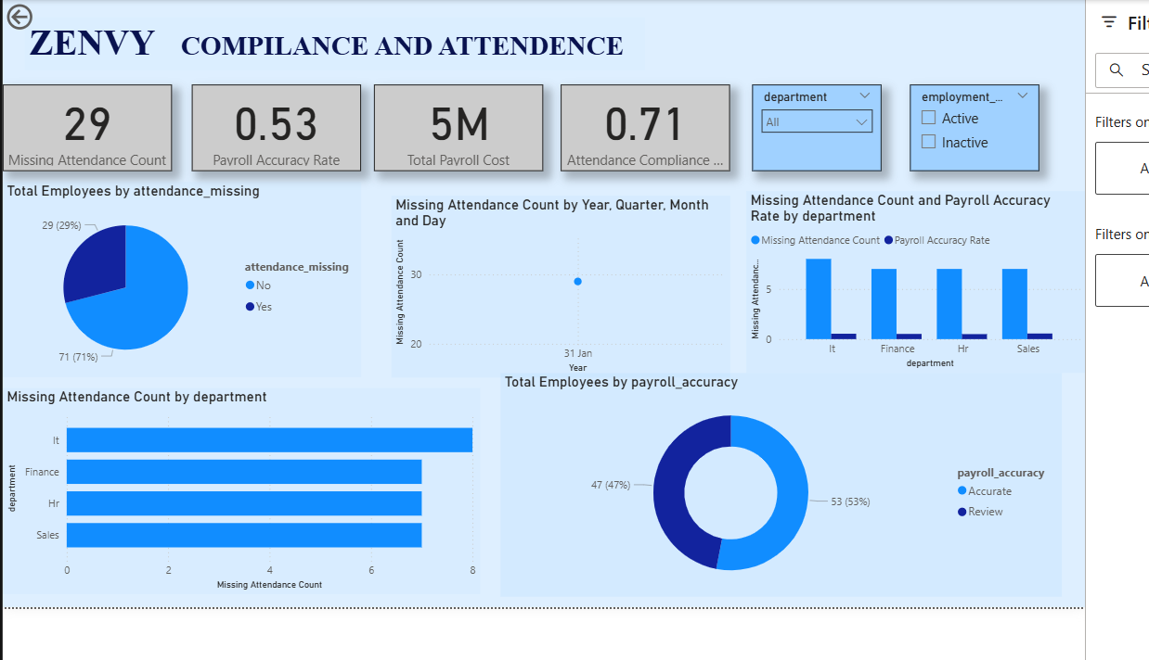

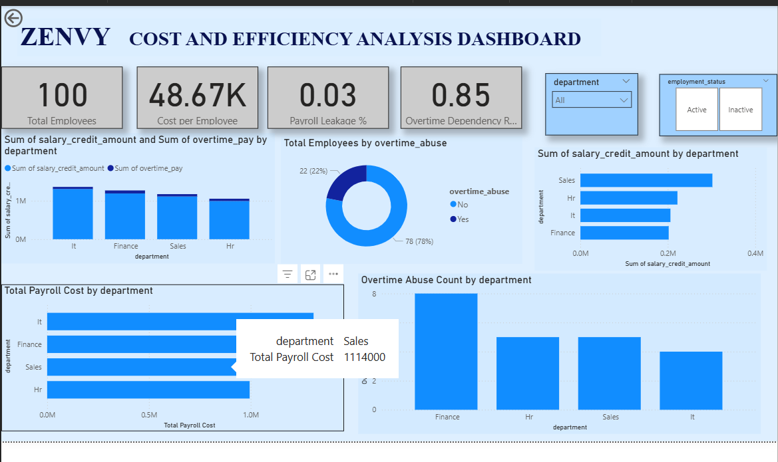

6. Executive Insights
The analysis revealed salary leakage across multiple employees, ghost employees receiving salary, and excessive overtime usage in certain departments. Missing attendance data impacted payroll accuracy. These insights highlight the need for stronger payroll validation, attendance integration, and periodic audits.

7. Conclusion
The HR Intelligence Dashboard provides actionable insights to management by transforming raw payroll data into meaningful information. This project demonstrates the application of SQL, Python, and Power BI in solving real-world HR analytics problems.

ARYA A

