Sorigin AMS Portal
Playwright Test Execution Report
Generated: 11/5/2026, 12:03:19 pm
Run started: 11/5/2026, 11:54:25 am
Wall-clock duration: 8m 52s
Base URL: https://ams.sorigin.app

Headline
67 passed · 2 failed · 13 skipped · 82 total tests
Overall pass rate: 82%

Cross-browser summary
Browser | Pass | Fail | Skipped | Flaky | Total | Duration
setup | 1 | 0 | 0 | 0 | 1 | 10.1 s
chromium | 22 | 0 | 5 | 0 | 27 | 7m 18s
firefox | 22 | 1 | 4 | 0 | 27 | 8m 27s
msedge | 22 | 1 | 4 | 0 | 27 | 10m 23s

Results by module
global.setup.ts
Test | Browser | Status | Duration
authenticate | setup | PASS | 10.1 s
assets
Test | Browser | Status | Duration
assets nav opens a list/table view | chromium | PASS | 39.9 s
data binding: at least one row/card renders on assets | chromium | PASS | 39.1 s
assets nav opens a list/table view | firefox | PASS | 22.1 s
data binding: at least one row/card renders on assets | firefox | PASS | 22.3 s
assets nav opens a list/table view | msedge | PASS | 25.7 s
data binding: at least one row/card renders on assets | msedge | PASS | 26.7 s
auth
Test | Browser | Status | Duration
happy path: valid creds reach dashboard | chromium | PASS | 34.7 s
shows an error for invalid password | chromium | PASS | 30.3 s
shows an error for invalid email format | chromium | PASS | 8.9 s
empty fields keep submit button disabled | chromium | PASS | 5.3 s
happy path: valid creds reach dashboard | firefox | PASS | 23.3 s
shows an error for invalid password | firefox | PASS | 17.0 s
shows an error for invalid email format | firefox | PASS | 11.6 s
empty fields keep submit button disabled | firefox | PASS | 14.4 s
happy path: valid creds reach dashboard | msedge | PASS | 17.6 s
shows an error for invalid password | msedge | PASS | 8.8 s
shows an error for invalid email format | msedge | PASS | 13.9 s
empty fields keep submit button disabled | msedge | PASS | 9.5 s
data-binding
Test | Browser | Status | Duration
overview triggers JSON API calls that return data | chromium | PASS | 16.7 s
overview triggers JSON API calls that return data | firefox | PASS | 26.6 s
overview triggers JSON API calls that return data | msedge | PASS | 30.1 s
filters
Test | Browser | Status | Duration
Assets: filter UI changes visible row count | chromium | PASS | 27.0 s
Tickets: filter UI changes visible row count | chromium | PASS | 15.9 s
Assets: filter UI changes visible row count | firefox | PASS | 36.6 s
Tickets: filter UI changes visible row count | firefox | PASS | 19.5 s
Assets: filter UI changes visible row count | msedge | PASS | 43.2 s
Tickets: filter UI changes visible row count | msedge | PASS | 24.2 s
gis-view
Test | Browser | Status | Duration
GIS view loads and renders a map element | chromium | PASS | 16.2 s
GIS view does not show a top-level error | chromium | PASS | 20.6 s
GIS view loads and renders a map element | firefox | PASS | 30.8 s
GIS view does not show a top-level error | firefox | PASS | 22.0 s
GIS view loads and renders a map element | msedge | PASS | 25.7 s
GIS view does not show a top-level error | msedge | PASS | 24.8 s
integration
Test | Browser | Status | Duration
overview → assets → reports navigates without error | chromium | PASS | 11.5 s
overview → assets → reports navigates without error | firefox | PASS | 26.5 s
overview → assets → reports navigates without error | msedge | PASS | 21.7 s
maintenance
Test | Browser | Status | Duration
maintenance page loads with visible content | chromium | PASS | 10.5 s
maintenance page loads with visible content | firefox | PASS | 15.9 s
maintenance page loads with visible content | msedge | PASS | 28.0 s
notifications
Test | Browser | Status | Duration
notifications page loads with visible content | chromium | PASS | 11.7 s
notifications page loads with visible content | firefox | PASS | 16.9 s
notifications page loads with visible content | msedge | PASS | 23.8 s
overview
Test | Browser | Status | Duration
overview page loads with visible content | chromium | PASS | 11.3 s
main navigation is visible after login | chromium | PASS | 10.2 s
overview renders numeric data somewhere on the page | chromium | PASS | 14.0 s
overview page loads with visible content | firefox | PASS | 14.6 s
main navigation is visible after login | firefox | PASS | 11.5 s
overview renders numeric data somewhere on the page | firefox | PASS | 17.4 s
overview page loads with visible content | msedge | PASS | 19.4 s
main navigation is visible after login | msedge | PASS | 19.0 s
overview renders numeric data somewhere on the page | msedge | PASS | 23.6 s
pagination
Test | Browser | Status | Duration
Assets: Next page button advances the data set | chromium | SKIP | 15.0 s
Tickets: Next page button advances the data set | chromium | SKIP | 13.3 s
Assets: Next page button advances the data set | firefox | SKIP | 18.3 s
Tickets: Next page button advances the data set | firefox | SKIP | 16.2 s
Assets: Next page button advances the data set | msedge | SKIP | 26.5 s
Tickets: Next page button advances the data set | msedge | SKIP | 26.8 s
reports
Test | Browser | Status | Duration
reports page loads with visible content | chromium | PASS | 14.1 s
reports page has interactive controls | chromium | PASS | 16.0 s
reports page loads with visible content | firefox | PASS | 18.8 s
reports page has interactive controls | firefox | PASS | 15.3 s
reports page loads with visible content | msedge | PASS | 31.7 s
reports page has interactive controls | msedge | PASS | 28.5 s
role-based-access
Test | Browser | Status | Duration
admin and viewer see different sidebar items | chromium | SKIP | 1.3 s
admin and viewer see different sidebar items | firefox | SKIP | 4.1 s
admin and viewer see different sidebar items | msedge | SKIP | 7.8 s
sorting
Test | Browser | Status | Duration
Assets: clicking a column header changes row order | chromium | SKIP | 15.6 s
Tickets: clicking a column header changes row order | chromium | SKIP | 13.3 s
Assets: clicking a column header changes row order | firefox | SKIP | 15.9 s
Tickets: clicking a column header changes row order | firefox | FAIL | 21.3 s
Assets: clicking a column header changes row order | msedge | SKIP | 28.5 s
Tickets: clicking a column header changes row order | msedge | FAIL | 35.0 s
tickets
Test | Browser | Status | Duration
tickets page loads with visible content | chromium | PASS | 13.3 s
tickets page loads with visible content | firefox | PASS | 18.4 s
tickets page loads with visible content | msedge | PASS | 20.7 s
ui-ux
Test | Browser | Status | Duration
no severe console errors on dashboard load | chromium | PASS | 6.8 s
responsive: layout still renders at 1280x800 | chromium | PASS | 5.3 s
no severe console errors on dashboard load | firefox | PASS | 16.0 s
responsive: layout still renders at 1280x800 | firefox | PASS | 13.4 s
no severe console errors on dashboard load | msedge | PASS | 15.4 s
responsive: layout still renders at 1280x800 | msedge | PASS | 16.4 s

Failure details
FAIL sorting.spec.ts › DA-1114 — Sorting validation › Tickets: clicking a column header changes row order
Browser: firefox
Location: sorting.spec.ts:82
Duration: 21.3 s
Error: expected Tickets row order to change after sort click
expect(received).toBeTruthy()
Received: false
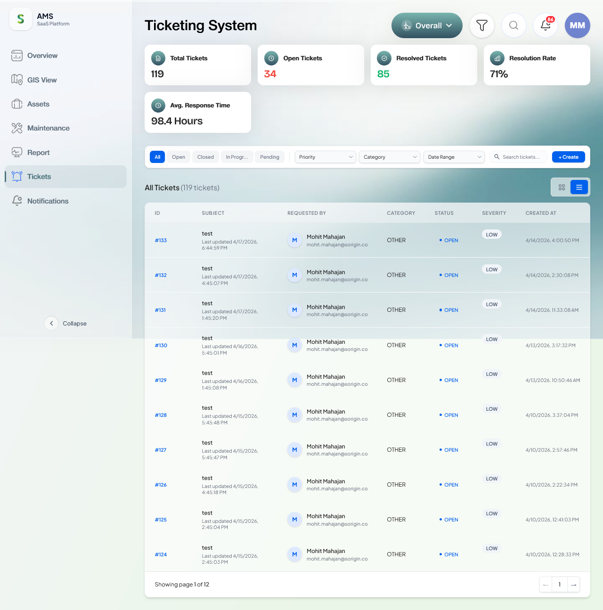
Screenshot: test-failed-1.png
FAIL sorting.spec.ts › DA-1114 — Sorting validation › Tickets: clicking a column header changes row order
Browser: msedge
Location: sorting.spec.ts:82
Duration: 35.0 s
Error: expected Tickets row order to change after sort click
expect(received).toBeTruthy()
Received: false
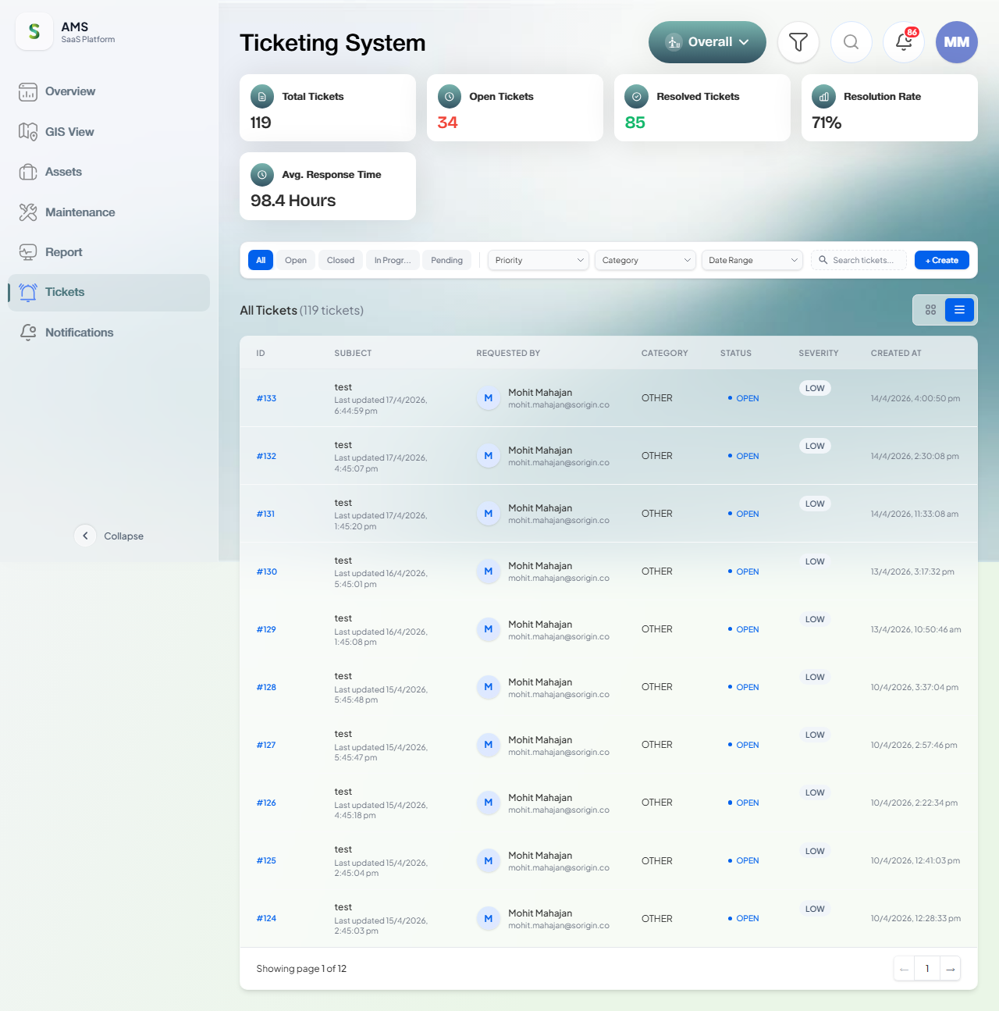
Screenshot: test-failed-1.png

Module proof screenshots
global.setup.ts
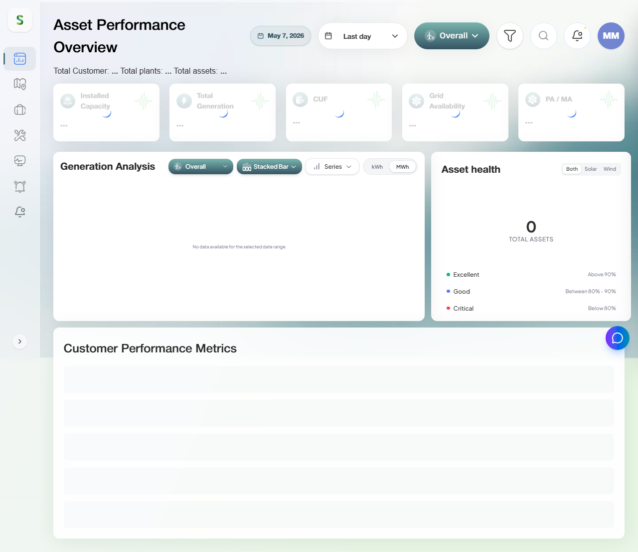
global.setup.ts — setup — authenticate
assets
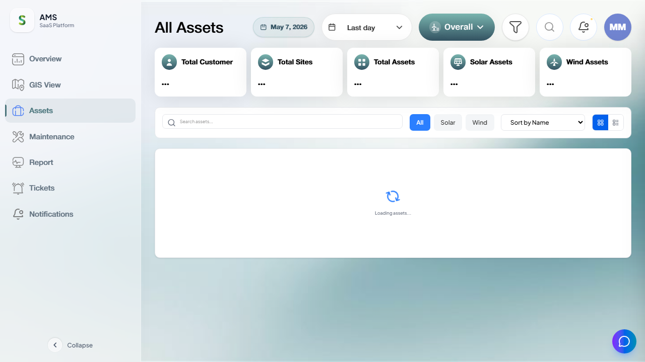
assets — chromium — assets nav opens a list/table view
auth
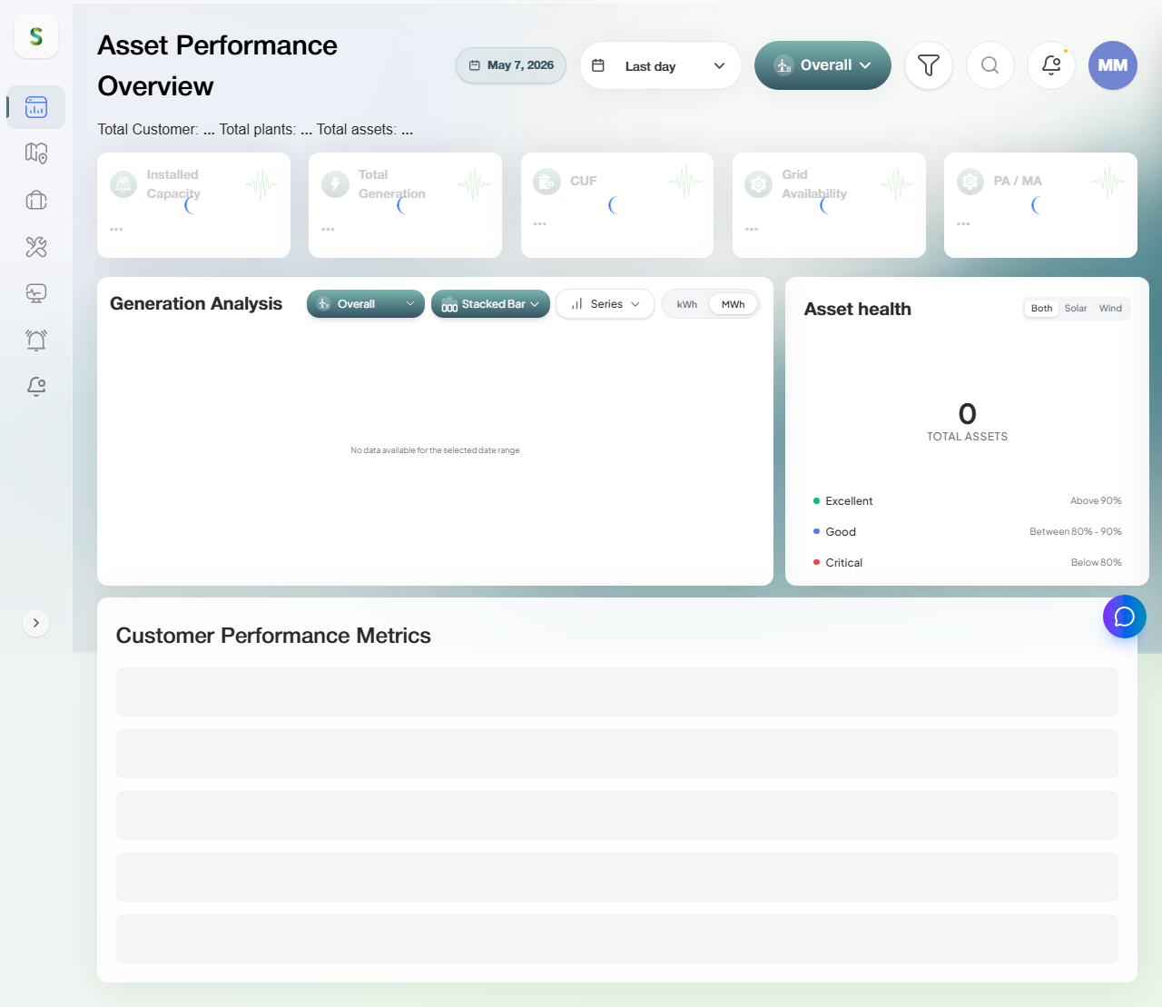
auth — chromium — happy path: valid creds reach dashboard
data-binding
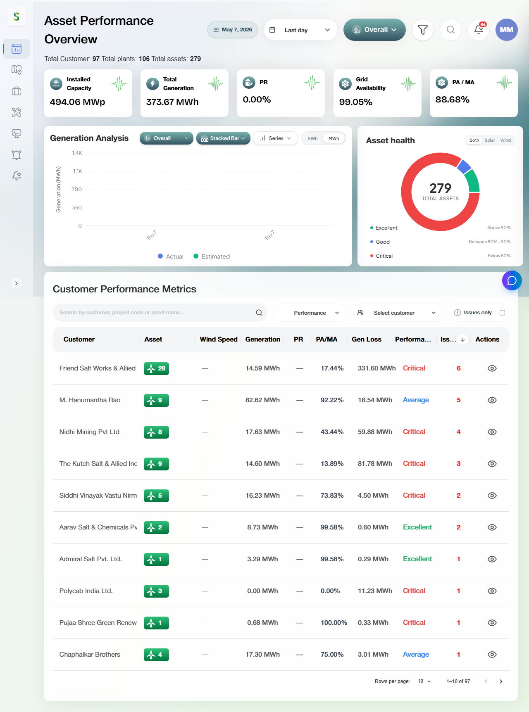
data-binding — chromium — overview triggers JSON API calls that return data
filters
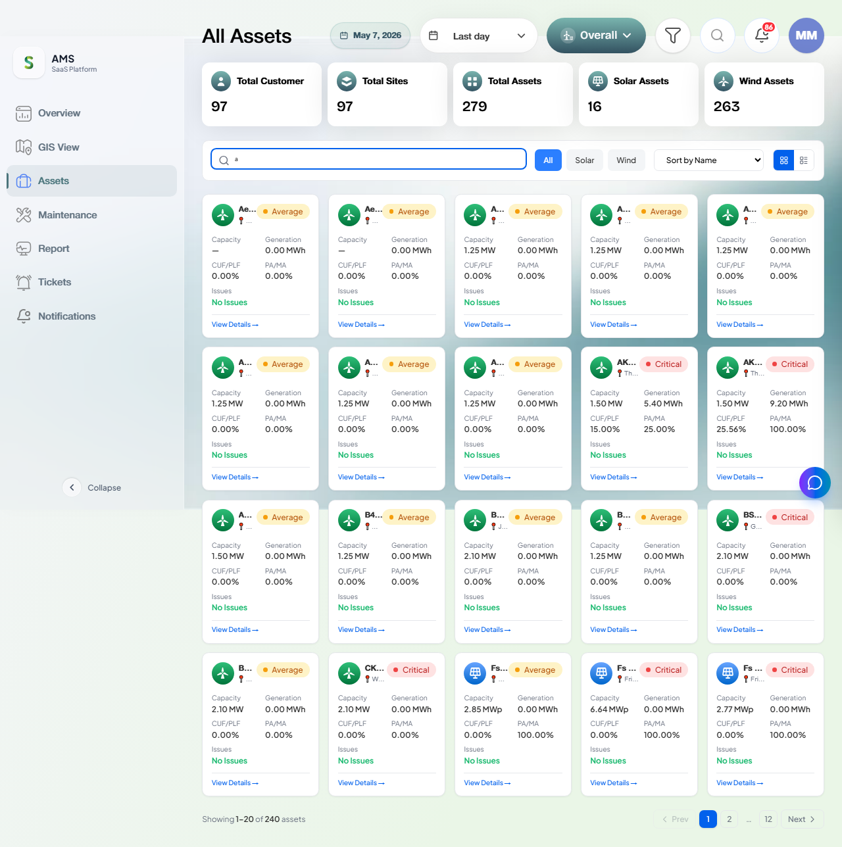
filters — chromium — Assets: filter UI changes visible row count
gis-view
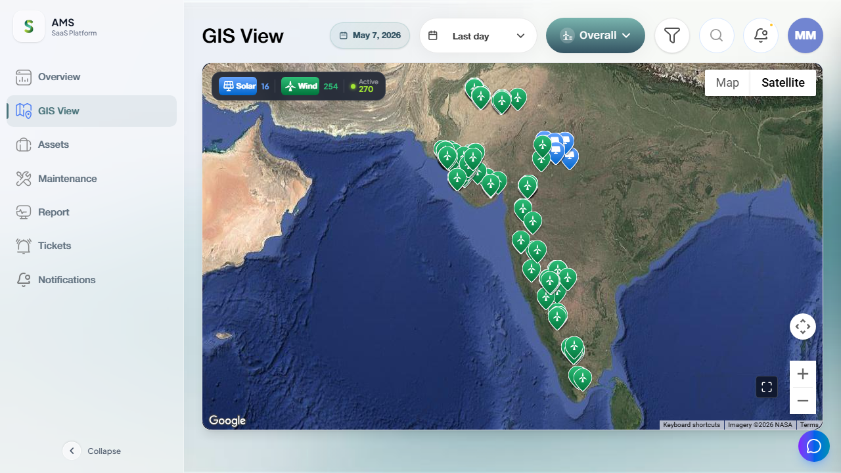
gis-view — chromium — GIS view loads and renders a map element
integration
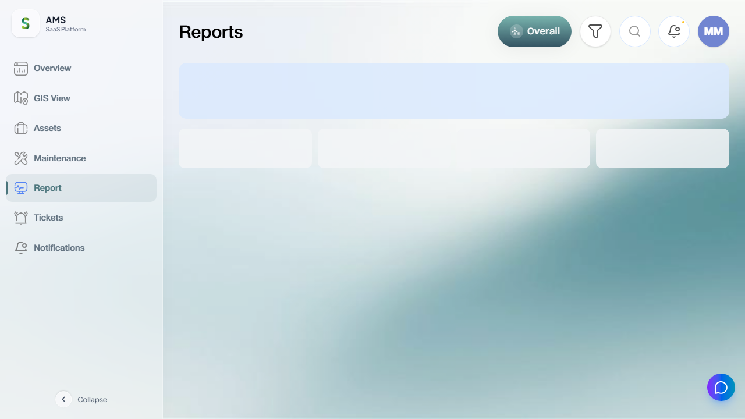
integration — chromium — overview → assets → reports navigates without error
maintenance
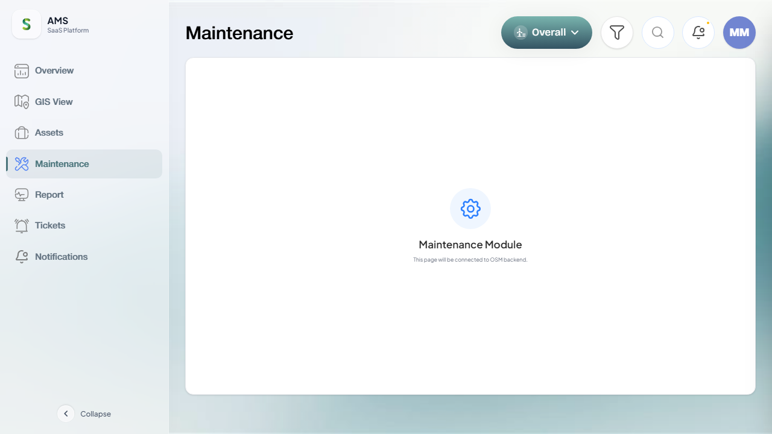
maintenance — chromium — maintenance page loads with visible content
notifications
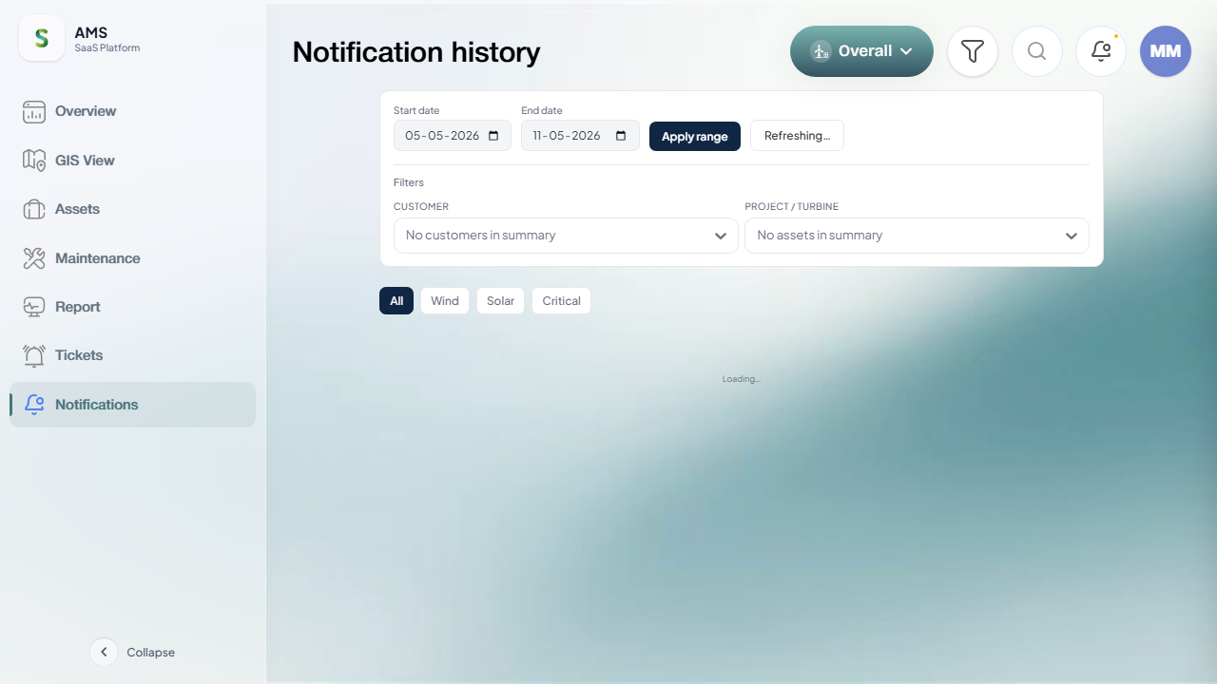
notifications — chromium — notifications page loads with visible content
overview
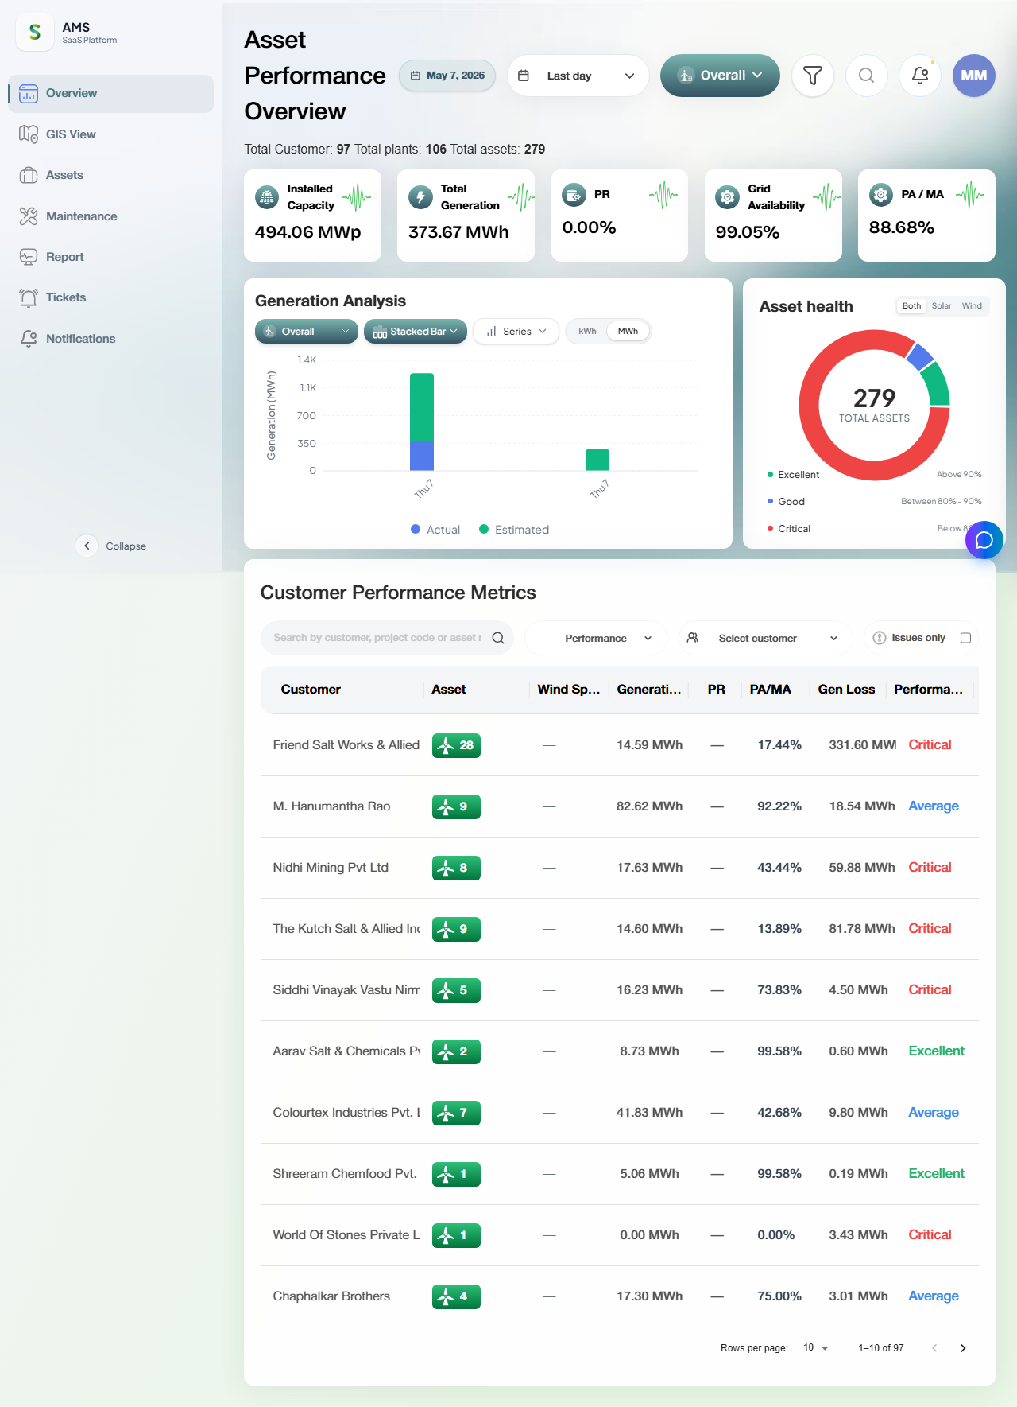
overview — chromium — overview page loads with visible content
reports
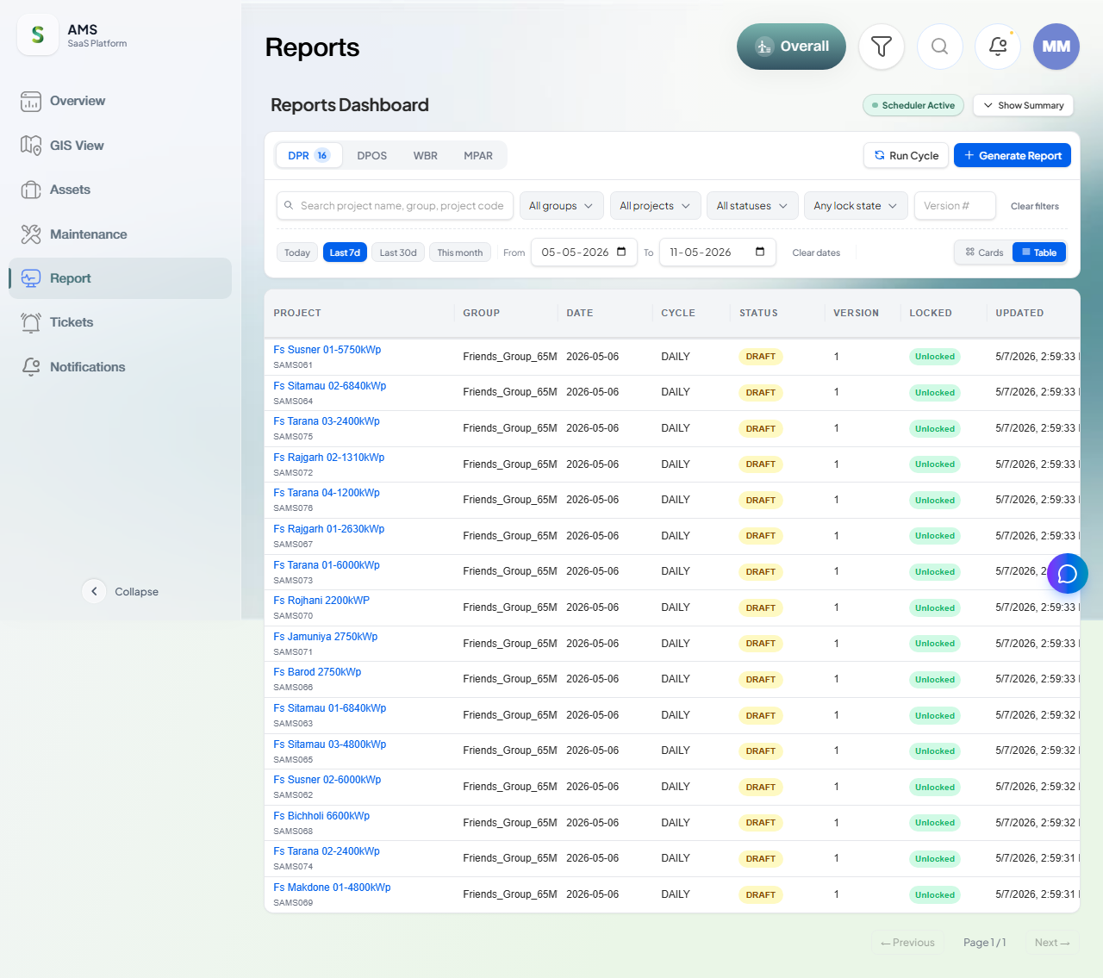
reports — chromium — reports page loads with visible content
tickets
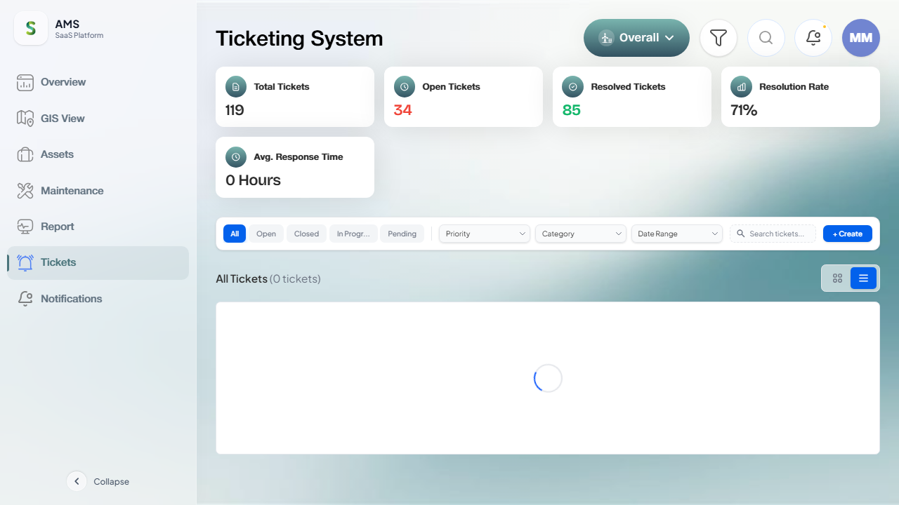
tickets — chromium — tickets page loads with visible content
ui-ux
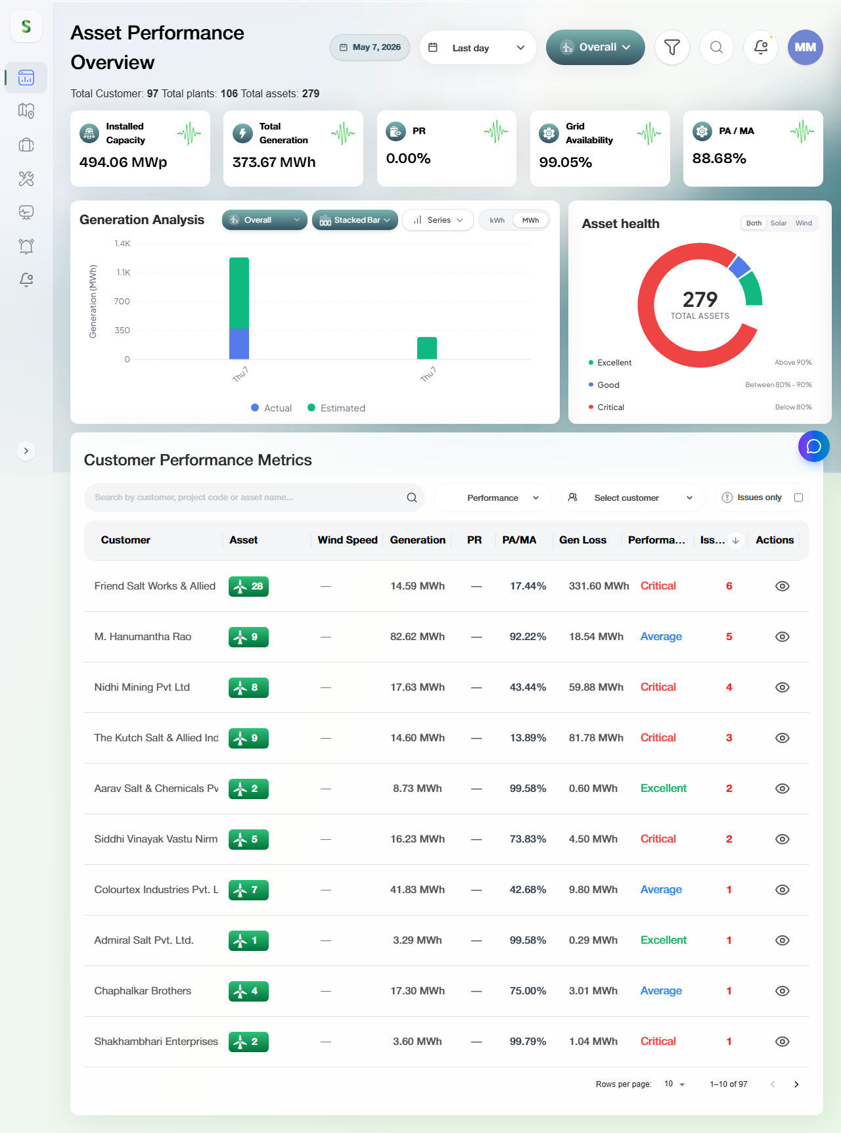
ui-ux — chromium — no severe console errors on dashboard load

How this report was generated
Generated by scripts/generate-docx-report.js, which reads test-results/results.json (Playwright JSON reporter output). To regenerate: `npm run report:docx`. To re-run tests + regenerate in one step: `npm run test:report`.

