ASHAR URBAN FUTURES LAB
Archonet
Mahek Chheda, Ramyakant Desabattula, Viral Gala

THESIS
Enterprise real estate feasibility in India is fragmented across consultants, architects, and legacy ERPs, forcing developers in land-scarce metros to take intuition-based decisions — Archonet targets 85,000+ active developers and 55,000+ architecture firms in India alone with an addressable opportunity of ₹14,000 Cr ($1.7Bn). Archonet's product suite (LandWise, FinWise, PlanWise, DealSpot) combines technical, financial, and design feasibility in one automated platform, supported by proprietary cadastral integration and 1.5 million calculations — a technical moat no point solution currently replicates. With 8 paying customers, 50+ platform pilots, and 100+ interactions in its first year of commercialisation, plus a product already in the hands of the Ashar team, the company is ready to be tested inside a live enterprise developer environment.
INVESTMENT SNAPSHOT
INDIA SAM | PAYING CUSTOMERS (Y1) | REVENUE TARGET (Y3)
$1.7Bn / ₹14,000 Cr | 8 customers | ₹100 Cr
85K+ developers + 55K+ architecture firms; ₹10L avg. annual revenue per entity | First year of paid customers; 50+ platform pilots, 100+ interactions | 500 customers @ ₹20L per entity by FY29; ₹5Cr raise for 12-month runway

MARKET & TRACTION
INDIA OPPORTUNITY | GLOBAL OPPORTUNITY | TRACTION PROOF
$1.7Bn / ₹14,000 Cr | $20Bn | 8 paying customers; 50+ pilots
85K+ active developers, 55K+ architecture firms; ₹10L avg. annual revenue per entity | 600K+ active developers, 400K+ architecture firms; $20K avg. annual revenue per entity | First year of paid customers; 100+ interactions; product access live with Ashar team

PRODUCT & TRACTION
Archonet's platform addresses three sequential layers of real estate feasibility — technical, financial, and design — through four products. LandWise (live, paying customers) is a land potential estimator covering all key Maharashtra regulations: DCPR 2034, UDCPR, and CDCPR, with inter-scheme combinations and cadastral data integration that the founders state no competitor has replicated. A developer enters plot parameters and receives FSI/built-up area statements, applicable scheme comparisons, and approval cost summaries in minutes. FinWise (initial traction) is a project cash flow forecaster covering product mix, timelines, and return summaries. PlanWise (under development; 9 months to PoC post-investment) will generate regulation-compliant 2D layouts and block massing. DealSpot (beta) is a land acquisition hub for centralised deal pipeline management.
Pricing is per-entity annual subscription tiered at ₹15L/year (LandWise), ₹20L/year (LandWise Pro), and ₹40L/year (LandWise Pro + FinWise) for 100 projects. The company states it is currently EBITDA positive. CAC is described as negligible today, estimated at 15–20% of annual revenue in the next two years; payback is immediate on subscription; LTV is stated at 6× annual contract value.
FOUNDER PROFILE
- Mahek Chheda (CEO) — B.Arch, Sir JJ College of Architecture; MBA, IIM Calcutta; MRED+D, UC Berkeley; 10+ years spanning architecture, management consulting (Bain & Co.), and private equity (Xander). Leads real estate market strategy, financial expertise, and regulatory intelligence; adaptive real estate research under review by Redwood City's planning department.
- Ramyakant Desabattula (CTO) — B.Tech (Computer Science), IIT Madras; MBA, IIM Calcutta; 10+ years in technology, eCommerce, and product management at Amazon, Blibli.com, and Jumia across India, SEA, and Middle East. Built proprietary GenAI pipelines for real estate design and visualization; co-founded ZupperMeal (2015).
- Viral Gala (COO) — B.Arch, Sir JJ College of Architecture; MBA, SIMSREE; 7+ years in architecture, interior design, and site execution at SRDA; licensed architect; Maativan project featured on ArchDaily (Building of the Year 2023 nomination); Iconic Galaxy, Colombo — Asia Pacific Property Awards 2021.
Founder score: 9/10 — Rare IIT+IIM+UC Berkeley+JJCOA combination with lived experience across architecture, private equity (Xander/Bain), and global product leadership (Amazon/Jumia); all three founders are full-time directors with 30+ combined years of direct industry experience.
Composite (team + traction + market): 8/10.
KEY RISKS
- Financial data withheld until term-sheet alignment: ARR, MRR, gross margins, burn rate, and customer names are not disclosed at this stage — the IC cannot independently verify the EBITDA-positive claim or validate pricing assumptions without audited figures.
- 8 paying customers in year one with no churn data: The company deems retention metrics "not applicable" as it is still in its first year of paid customers, leaving renewal risk — the single biggest SaaS valuation driver — entirely unquantified.
- Tech team is undersized for the product roadmap: The founders acknowledge needing 4 additional tech hires within 6 months to deliver PlanWise (9 months to PoC) and expand geographically; failure to hire in a scarce architecture+AI talent pool could delay the ₹100 Cr FY29 target.
INVESTMENT STRUCTURE
PHASE 1 — ₹5 Cr (stated ask) | 12-month runway; LandWise scale across Maharashtra; FinWise upsell to existing customers; 4 tech hires onboarded
PHASE 2 — TBD | Entry into NCR and Bengaluru with LandWise/FinWise; PlanWise PoC completed
PHASE 3 — TBD | Scale to Hyderabad and other key cities; international expansion (US, UAE) initiated
TOTAL CHEQUE | ₹5 Cr minimum; full release contingent on financial due diligence completion
EQUITY | 100% founder-held cap table; no ESOP pool created yet; specific equity % not disclosed in input

WHY THIS COULD WIN
- Cadastral integration and 1.5 million calculations form a proprietary technical moat that the founders state no competitor has replicated in 12–24 months, covering all Maharashtra regulatory regimes (DCPR 2034, UDCPR, CDCPR) with inter-scheme combinations.
- Global market analogues exist and are funded: Testfit (US) and Archistar (Australia) operate in the same automated feasibility space — validating enterprise willingness to pay for this category — while Archonet targets the underpenetrated Indian and UAE markets with local regulatory depth neither competitor has.
- Berkeley Skydeck (Pad 13) alumni and ULI Hines Americas finalist status provide institutional validation and international deal network access that early-stage Indian PropTech competitors are unlikely to match.
- Best Product Demo award at RealtyNXT ICTDD 25 and ArchDaily/Asia Pacific Property Awards recognition demonstrate both product quality and design credibility with the precise customer segment (developers, architects) Archonet is targeting.
OPEN QUESTIONS
- What is the current ARR and who are the 8 paying customers? — The founders have withheld all revenue figures, customer names, and financial statements pending term-sheet alignment; the IC cannot size the opportunity or verify EBITDA-positive status without this data.
- What equity is Archonet offering for the ₹5 Cr raise, and what is the pre-money valuation? — No valuation or cap table split is disclosed; without this, UFL cannot model its stake or MOIC.
- What is the specific ESOP plan and timeline? — No ESOP pool exists; with a stated need for 4+ critical tech hires in 6 months, the absence of an equity incentive structure is a material retention risk that must be resolved before a term sheet.
CATALYSTS
- PlanWise PoC is 9 months post-investment: Completion would transform Archonet from a two-product company into a full end-to-end feasibility suite, materially expanding TAM penetration and average contract value.
- Maharashtra map coverage completion (stated roadmap item): Full-state cadastral coverage would close the primary product gap relative to competitors and enable the 50-customer → 160-customer step-up in the Y1→Y2 business plan.
- NCR and Bengaluru market entry in 2027: First signed enterprise customer outside MMR would validate the geographic replication thesis and de-risk the ₹100 Cr FY29 revenue target.

REVENUE PROJECTION
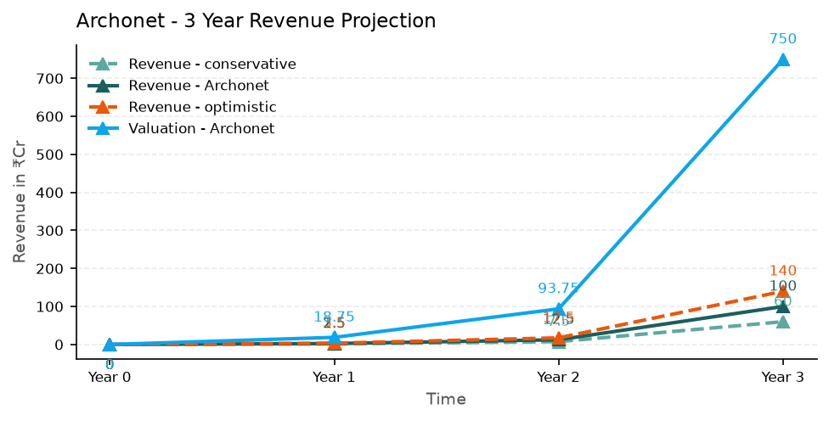

HOW WE ARRIVED AT THESE NUMBERS
Revenue model: per-entity annual subscriptions priced at ₹15L–₹40L per entity per year (tiered by product bundle, for 100 projects), with the founders projecting 50 customers @ ₹5L average in Y1, 160 customers @ ₹12.5L average in Y2, and 500 customers @ ₹20L average in Y3 to reach ₹100 Cr net revenue by FY29. Volume scales through geographic expansion (Maharashtra → NCR/Bengaluru → Hyderabad) and upsell from LandWise to LandWise Pro + FinWise bundles, with CAC estimated at 15–20% of annual revenue in years 2–3 and LTV at 6× annual contract value.
VALUATION METHOD
7.5× revenue (early-stage enterprise SaaS / PropTech comparable — Testfit, Archistar)
Conservative: 60 Cr — 300 customers × ₹20L average ACV. 7.5× = 450 Cr. Gated by slower enterprise adoption and geographic expansion delays.
Base: 100 Cr — 500 customers × ₹20L average ACV. 7.5× = 750 Cr. Primary driver is Maharashtra saturation plus NCR/Bengaluru entry as stated in go-to-market plan.
Optimistic: 140 Cr — 700 customers × ₹20L average ACV. 7.5× = 1050 Cr. Upside from UAE/US expansion and PlanWise premium bundle adoption ahead of schedule.
RECOMMENDATION
IC Decision? | CONDITIONAL YES. Studio Pick. Archonet presents one of the strongest founding teams in UFL Cohort 1 2026 — an IIT+IIM+UC Berkeley+JJCOA combination with private equity, global product, and licensed architecture pedigree, building in a validated global category (Testfit, Archistar) with a clear local regulatory moat. The single non-negotiable condition before a term sheet: Archonet must share audited or CA-certified revenue figures, the 8 customer names with contract values, and a proposed valuation/equity split — the current posture of withholding all financial data until "term-sheet alignment" is structurally backwards for an IC decision. Immediate next step: schedule a 60-minute financial due diligence call with all three founders and request the pitch deck, P&L, and cap table within 5 business days. ::highlight:: UFL stake at Base (Y3): ₹750 Cr × equity % (undisclosed) = stake TBD pending valuation disclosure → MOIC on ₹5 Cr investment cannot be computed until Archonet discloses pre-money valuation and equity offered.

Risks: All financial data withheld — EBITDA-positive claim unverified; 8 customers in year one with zero churn data — renewal risk unquantified; tech team undersized (4 critical hires needed in 6 months) — PlanWise and geographic expansion timelines at risk.
Ashar Urban Futures Lab · Internal Use Only · 29 June 2026

