PRACTICE SCHOOL REPORT
AHA Automotive Website Funnel, Compatibility OS & Marketing Intelligence Dashboard
Updated report with Streamlit UI direction, dynamic vehicle logic, Meta/Google tracking, dashboard sync, deployment, and validation.
Aaryan Kansal | 2024A2PS1033H | BITS Pilani Practice School

Company | AHA Automotive
Project | NexCruise digital marketing funnel and compatibility workspace
Student | Aaryan Kansal, 2024A2PS1033H
Primary Goal | Convert Meta/Instagram/WhatsApp traffic into qualified leads through compatibility checks and callback/WhatsApp actions.
1. Executive Summary
The project evolved from a simple landing page into a connected conversion system for AHA Automotive. The final ecosystem includes a React/Vite public funnel, a Streamlit Compatibility OS used as the main demo interface, and a marketing dashboard that receives first-party event and lead data.
Core outcome
AHA Automotive now has a premium UI direction, dynamic vehicle-specific experience, lead capture flow, and campaign tracking stack that supports Meta retargeting and Google Ads lead conversion.

2. System Surfaces
React/Vite Funnel | Static campaign landing website with hero CTAs, brand selector, compatibility form, FAQ, mini game, callback form, WhatsApp buttons, and tracking helpers.
Streamlit Compatibility OS | Final demo UI with glassy dark theme, UTM-aware hero content, model selection, compatibility workspace, 3D vehicle panels, mini game, and callback capture.
Marketing Dashboard | Internal operator surface from digital_marketing-master for campaign, lead, attribution, path drop-off, and first-party tracking visibility.
3. Premium Streamlit UI Direction
The visual direction was shifted toward a premium automotive-tech interface: dark navy base, translucent glass panels, blue/coral accents, large editorial typography, and tighter spacing. The aim was to avoid generic static-page styling and make the interface feel closer to a product cockpit.
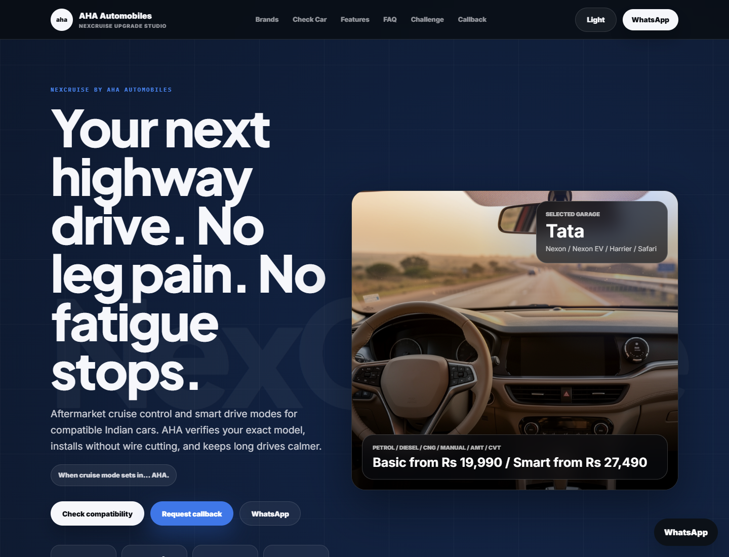
Figure 1. Rendered QA screenshot of the updated AHA Automotive funnel surface.
4. Dynamic Brand and Vehicle Model Experience
• Brand selector covers Tata, Mahindra, Hyundai, Kia, Maruti Suzuki, Toyota, Honda, and MG.
• AHA Automotive branding remains constant while vehicle copy, model lists, fit messages, and visual panel content adapt.
• Tata Nexon, Punch, and Safari model states were corrected so the hero and compatibility workspaces show the same selected model.
• Brand cards were kept inside a single-page flow instead of opening new tabs.
• Vehicle visuals were separated into two roles: hero side-view and compatibility top-down fitment view.
5. Tracking and Integration Work
Meta Pixel | Pixel ID 2687561291629470; PageView, Lead, Contact, Used_Tool, BrandSelected, FAQOpened, MiniGameCompleted, and WhatsAppClicked-style funnel events.
Meta Test Events | TEST40117 can be passed through test_event_code for Events Manager validation.
Google Ads | Conversion ID AW-18243205076; lead conversion destination AW-18243205076/UYYRCM7u18AcENTvhPtD.
First-party Dashboard | https://dashboard.ahaautomotive.in/api/track/event using canonical path IDs such as web.check_compatibility_click and web.callback_form_completion.
export function trackLead(eventName, data = {}) {
trackMeta("Lead", data);
trackFunnel(eventName, data);
trackGoogleAdsLeadConversion({
event_category: "lead",
event_label: eventName,
value: 1
});
}

This central function means a submitted form does not need three separate implementations. It routes one lead action into Meta, Google Ads, and the internal funnel tracker.
6. Dashboard Event Mapping
BrandSelected | web.insight_button_click
CheckCompatibilityClicked | web.check_compatibility_click
WhatsAppClicked | web.connect_with_aha_dost_click
RequestCallbackSubmitted | web.callback_form_completion
The dashboard payload includes sessionId, pagePath, UTM fields, pathType, stepId, contactNumber when available, and properties such as brand/model/city. This enables path drop-off and exact session matching when phone number is submitted.
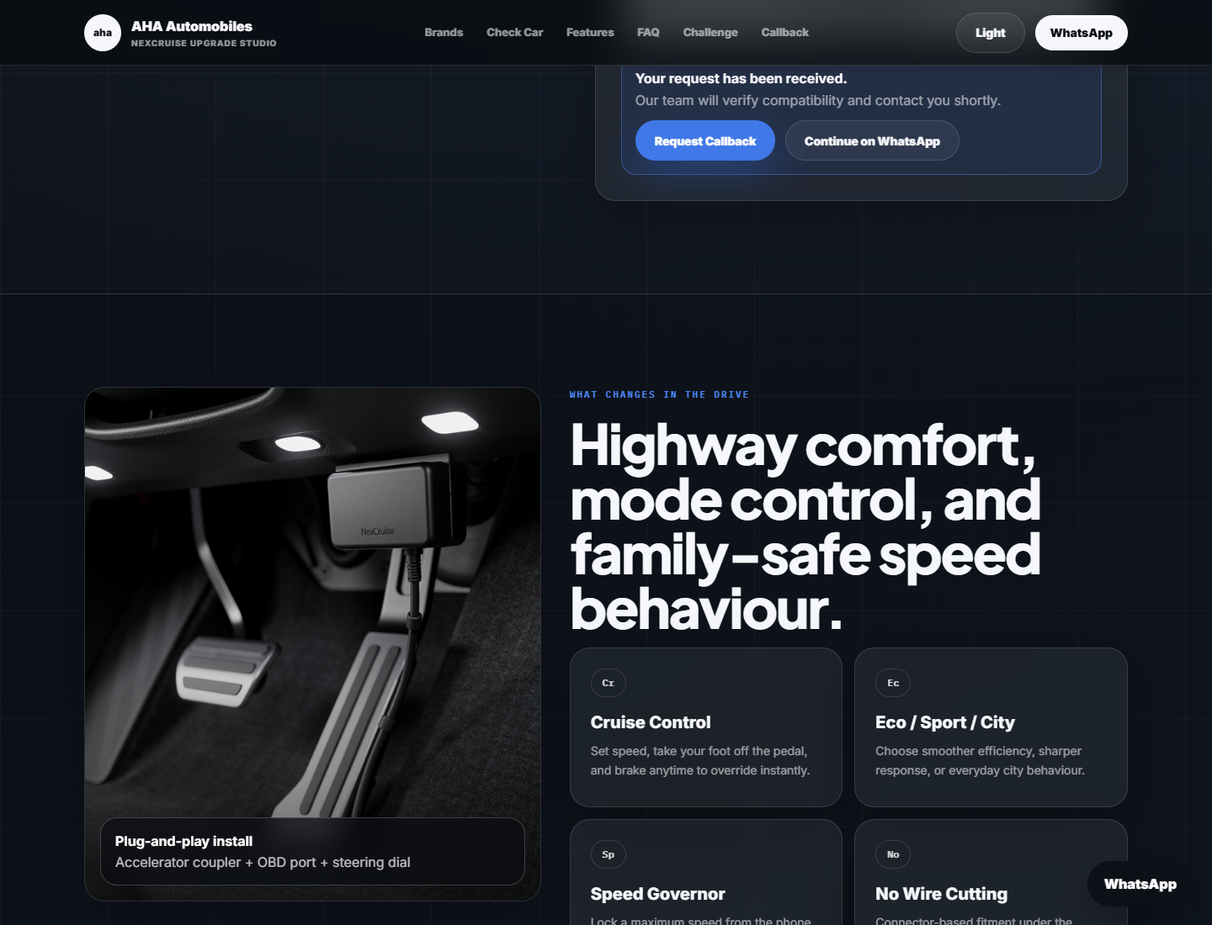
Figure 2. Compatibility form success state used during tracking QA.
7. Streamlit Tracking Implementation
if st.button("Run NexCruise scan", key="run_scan"):
run_compatibility_check()
track_event(
"CheckCompatibilityClicked",
data={
"brand": st.session_state.selected_brand,
"model": st.session_state.selected_model,
"city": st.session_state.selected_region,
},
)

Streamlit reruns the script after interactions, so tracking is attached to meaningful state transitions rather than DOM clicks. Brand selection is tracked through query parameter/state changes, compatibility scans through the scan button, mini-game completion through the AHA Zone action, and callback leads through the lead form.
8. Deployment and Local Run Commands
# React landing / Cloudflare Pages
cd one-page-landing-main
npm install
npm run dev
npm run build
# Build output: dist
# Streamlit final UI
pip install -r requirements.txt
streamlit run app.py
# Marketing dashboard
cd digital_marketing-master
npm install
npm run dev

9. Verification and Security
• React production build passed with npm run build.
• Touched Streamlit Python files passed python -m py_compile.
• Browser QA verified compatibility form success state.
• Event capture verified Meta PageView/Lead/custom events and Google Ads conversion payload.
• Event capture verified first-party dashboard payload for web.check_compatibility_click with session and UTM data.
• Secret scan found no hardcoded private dashboard tracking key; keys remain environment variables.
10. Final Status and Next Steps
• Replace placeholder WhatsApp number and social links before live campaigns.
• Finalize CRM/NeoDove/Google Sheets/Supabase backend route for production lead capture.
• Decide whether Streamlit remains hosted as the final UI or is rebuilt in React for fully static deployment.
• Add server-side Meta Conversion API for stronger browser-blocking resilience.
• Use final AHA Automotive product videos and approved brand assets in the public version.

