INTELLIGENT DISASTER EVACUATION ROUTE PLANNER
A PROJECT REPORT
Submitted by
Aryan Avnish Chauhan (25BCS12161)
in partial fulfillment for the award of the degree of
BACHELOR OF ENGINEERING
IN
COMPUTER SCIENCE & ENGINEERING

[NOVEMBER 2026]

TABLE OF CONTENTS
Section / Chapter Title | Page No.
Abstract
CHAPTER 1. INTRODUCTION | 1
1.1. Identification of Client / Need / Relevant Contemporary Issue | 1
1.2. Identification of Problem | 1
1.3. Identification of Tasks | 2
1.4. Timeline | 3
1.5. Organization of the Report | 4
CHAPTER 2. LITERATURE REVIEW / BACKGROUND STUDY | 5
2.1. Timeline of the Reported Problem | 5
2.2. Existing Solutions | 5
2.3. Bibliometric Analysis | 6
2.4. Review Summary | 6
2.5. Problem Definition | 7
2.6. Goals / Objectives | 7
CHAPTER 3. DESIGN FLOW / PROCESS | 8
3.1. Evaluation & Selection of Specifications / Features | 8
3.2. Design Constraints | 8
3.3. Analysis of Features and Finalization Subject to Constraints | 9
3.4. Design Flow | 10
3.5. Design Selection | 10
3.6. Implementation Plan / Methodology | 11
CHAPTER 4. RESULTS ANALYSIS AND VALIDATION | 18
4.1. Implementation of Solution | 18
CHAPTER 5. CONCLUSION AND FUTURE WORK | 29
5.1. Conclusion | 29
5.2. Future Work | 29
REFERENCES | 31
USER MANUAL | 32

ABSTRACT
Rapid, reliable evacuation routing is essential when natural hazards or structural failures disrupt urban transportation corridors. While standard navigation software optimizes strictly for physical distance or nominal travel time, emergency responders and evacuees frequently require routes that balance travel distance against hazard severity while adapting immediately to sudden road closures. This project presents the design, implementation, and validation of the Intelligent Disaster Evacuation Route Planner, an Advanced Data Structures and Algorithms (ADSA) system built around a C++17 graph engine, an embedded WinSock2 HTTP/REST service, and an interactive browser-based GIS dashboard.
The modeled city network (Metropolis SafeCity Simulation) is stored in JSON format and represented in memory as an undirected adjacency list (CityGraph) over V = 17 city sectors (including 3 emergency shelters with evacuation capacities) and E = 26 road segments tagged with Low (penalty 1), Medium (penalty 3), and High (penalty 6) risk classifications. Two variants of binary min-heap Dijkstra's algorithm—Shortest Route minimizing physical kilometers and Safest Route minimizing the composite edge cost Cost = distance + (risk_penalty x risk_weight)—run in O((V + E) log V) time and O(V + E) space, complemented by an O(V + E) Breadth-First Search (BFS) traversal for full-network reachability auditing. Dispatchers can dynamically block or reopen any road segment in O(1) amortized lookup time and immediately observe recalculated detours, safety classifications, and turn-by-turn steps on a 1000x680 SVG city map supporting light and dark operational themes.
Comprehensive verification confirms both algorithmic correctness and end-user portability. An automated C++ assertion suite passes all 8 test cases (8/8), demonstrating a 66.7% hazard reduction on the Central Park to Market corridor (Safest risk 2 vs. Shortest risk 6) and real-time detouring around closed primary arterials (City Hospital to Emergency Shelter A shifting from 5.1 km to 9.3 km shortest or 10.5 km safest upon blocking R01). Compiled statically with MinGW for 32-bit Windows into a self-contained executable paired with START.bat, the standalone release passes all 12/12 integration verification checks without requiring a compiler on target machines, while transparently documenting Windows Device Guard inspection and SHA-256 integrity procedures.
Keywords: Disaster Evacuation Routing, Dijkstra's Algorithm, Breadth-First Search, Multi-Objective Graph Optimization, Adjacency List, C++ WinSock2 HTTP Server, Interactive SVG GIS.
GRAPHICAL ABSTRACT
The graphical abstract below summarizes the five architectural stages transforming raw hazard-weighted urban sector data into verified multi-objective evacuation paths and portable Windows deployment.
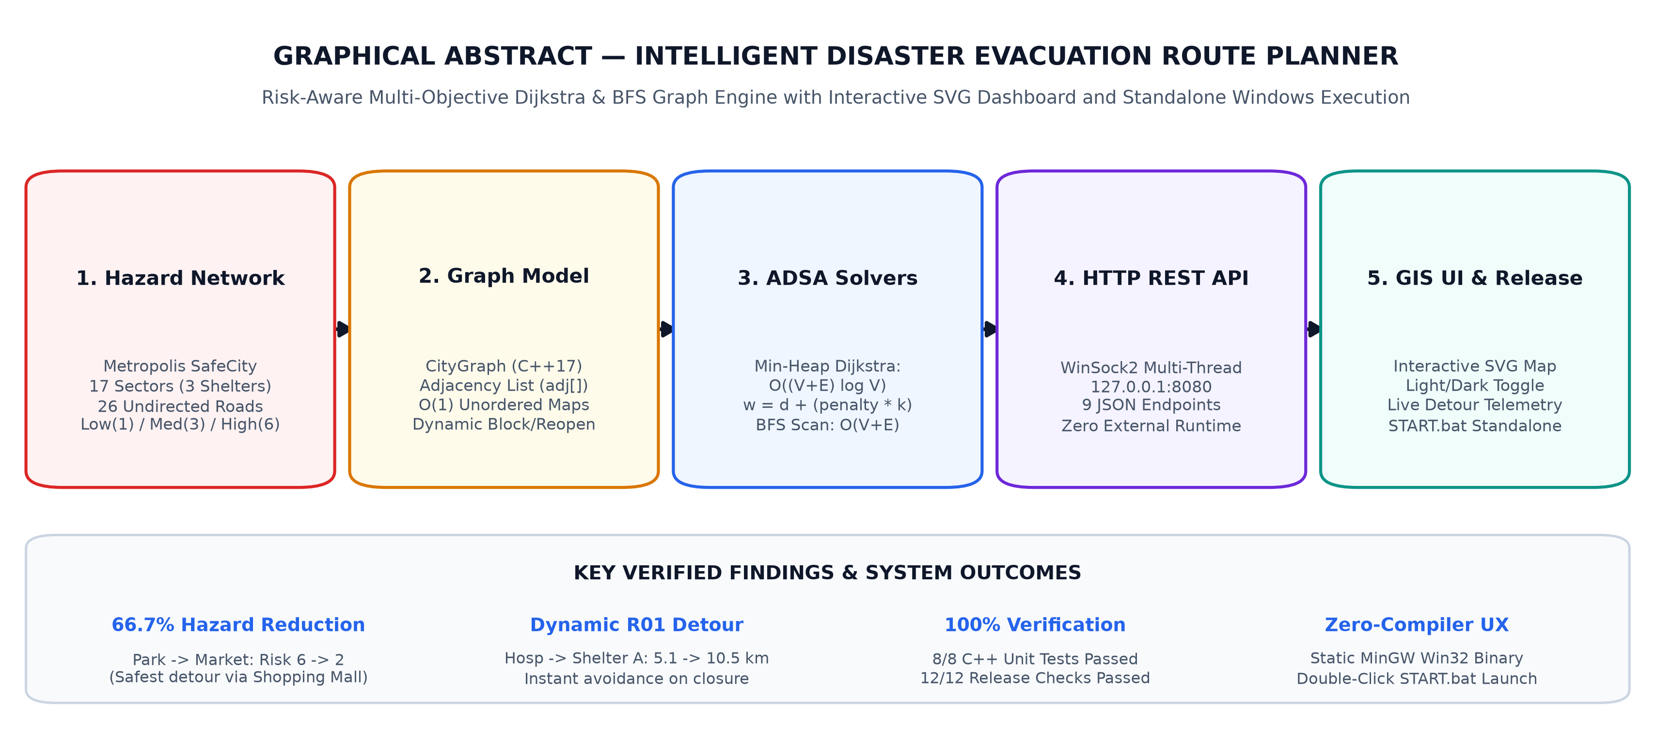
Graphical Abstract: System Overview of Intelligent Disaster Evacuation Route Planner.

CHAPTER 1
INTRODUCTION
1.1. Identification of Client / Need / Relevant Contemporary Issue
Extreme weather events, urban flooding, structural fires, industrial chemical leaks, and seismic disruptions increasingly threaten dense metropolitan road infrastructure. During the golden window of emergency response, municipal disaster management coordinators, hospital dispatchers, public transit operators, and civilian evacuees require immediate, deterministic visibility into which road corridors remain passable and which evacuation routes minimize exposure to active hazards while reaching designated emergency shelters.
The primary stakeholders for an evacuation routing simulation platform fall into three groups: (1) municipal emergency planners and academic researchers studying disaster resilience on weighted civic topologies; (2) engineering students and instructors analyzing real-time graph optimization behavior under dynamic edge failures; and (3) non-technical dispatchers evaluating alternate shelter access scenarios on standard Windows workstations without requiring internet access, external cloud mapping subscriptions, or compiler toolchains.
Contemporary consumer navigation services focus overwhelmingly on peacetime traffic speed and fuel efficiency. When road infrastructure suffers localized partial impairment—such as a flooded alley or an industrial corridor adjacent to hazardous materials—a blind minimum-distance route may guide evacuees directly through life-threatening sectors simply because the corridor is geometrically shorter. Bridging this operational gap requires an algorithmic framework that couples classic shortest-path theory with tunable hazard-aware edge costs, breadth-first connectivity verification, and interactive network disruption simulation.
1.2. Identification of Problem
Emergency evacuation route selection across hazardous urban road networks exhibits four compounding operational problems when handled manually or through static peacetime routing maps:
- Single-Metric Routing Blindness: Conventional distance-only pathfinders treat every drivable road equally regardless of adjacent flood zones, fire risks, or industrial hazards, potentially directing populations into high-risk bottlenecks simply to save a few hundred meters.
- Slow Adaptation to Sudden Road Failures: Disasters invalidate road segments unpredictably via fallen debris, downed power lines, or localized inundation. Static paper maps or pre-computed routes fail to reflect live edge removals or restored corridors, leaving dispatchers unable to test alternative detours or detect shelter isolation.
- Lack of Network-Wide Reachability Auditing: Knowing a single point-to-point path does not indicate whether multiple cascading closures have partitioned adjacent civic sectors (such as hospitals, schools, or transit terminals) into unreachable islands.
- Deployment and Toolchain Friction on Standard Workstations: Academic graph implementations typically remain trapped inside command-line terminals requiring manual C++ compilation or specialized developer environments, preventing ordinary evaluators or emergency staff from executing scenarios visually with minimal setup.
1.3. Identification of Tasks
To systematically engineer, validate, and package a self-contained evacuation routing solution within an Advanced Data Structures and Algorithms (ADSA) curriculum schedule, the project was decomposed into eight technical work packages:
- Task 1 — Domain & Dataset Modeling: Define a representative multi-sector urban topology (17 locations, 3 emergency shelters with capacities, 26 undirected roads) serialized in structured JSON format.
- Task 2 — Core Graph & Indexing Structures: Architect an in-memory CityGraph class supporting adjacency lists, constant-time identifier maps, and baseline network state snapshots.
- Task 3 — Multi-Objective Routing Algorithms: Implement binary min-heap Dijkstra optimization supporting both pure minimum-distance routing and composite risk-weighted safest routing, alongside Safety Grade and ETA derivation.
- Task 4 — Reachability Exploration Engine: Implement Breadth-First Search (BFS) over unblocked corridors to compute wave traversal ordering and detect partitioned/isolated sectors.
- Task 5 — Dynamic Corridor Mutation: Implement constant-time lookup road blocking, reopening, and full-graph restoration synchronized across both endpoints of every undirected edge.
- Task 6 — Embedded HTTP/REST Backend: Develop a dependency-free WinSock2 multithreaded HTTP server serving frontend static assets and 9 REST JSON endpoints.
- Task 7 — Interactive GIS SVG Dashboard: Build a light/dark responsive web interface featuring an interactive vector city map, heuristic risk-weight slider, solver telemetry, turn-by-turn directions, and searchable road table.
- Task 8 — Testing, Standalone Win32 Packaging & Documentation: Write 8 automated C++ unit assertions, compile a static Windows executable bundled with START.bat, execute 12 release verification checks, inspect binary/Device Guard properties, and author complete documentation.
1.4. Timeline
The project followed a structured 12-week semester development schedule progressing from theoretical algorithm study and graph modeling to standalone deployment verification. Figure 1.1 illustrates the Gantt chart timeline, and Table 1.1 summarizes milestone deliverables across all eight phases.
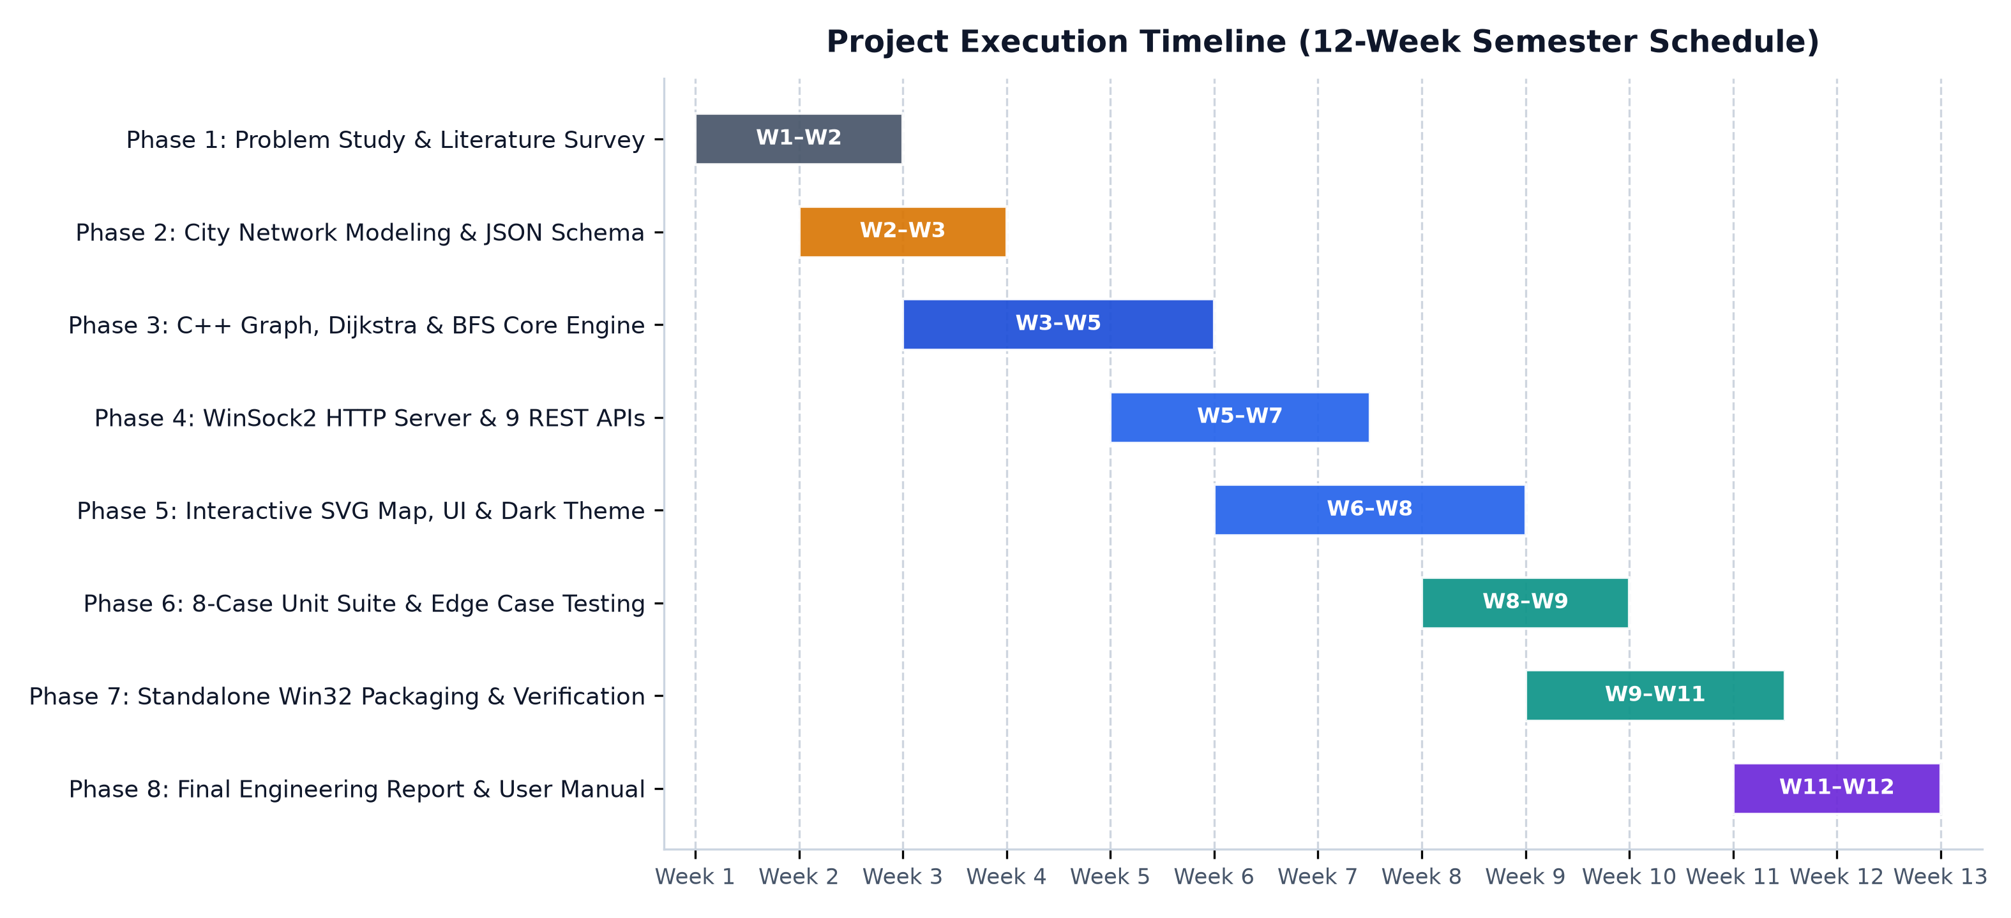
Figure 1.1: 12-Week Semester Project Development Timeline (Gantt Chart).
Table 1.1: Project Phase Breakdown and Deliverable Milestones
Phase & Weeks | Activity | Primary Deliverable
Phase 1 (W1–W2) | Problem Study & Literature Survey | Problem formulation, Dijkstra/BFS review, SRS baseline
Phase 2 (W2–W3) | City Network Modeling & JSON Schema | 17-sector, 26-road Metropolis SafeCity topology
Phase 3 (W3–W5) | C++ Graph, Dijkstra & BFS Core Engine | Graph.h/.cpp, Algorithms.h/.cpp, O(1) hash indices
Phase 4 (W5–W7) | WinSock2 HTTP Server & 9 REST APIs | HttpServer.cpp, api.cpp, main.cpp integration
Phase 5 (W6–W8) | Interactive SVG Map, UI & Dark Theme | index.html, style.css, script.js 3-column dashboard
Phase 6 (W8–W9) | 8-Case C++ Unit Suite & Validation | tests/algorithm_tests.cpp passing 8/8 assertions
Phase 7 (W9–W11) | Standalone Win32 Packaging & Audit | release/ static binary, START.bat, SHA-256 & 12-point test
Phase 8 (W11–W12) | Final Engineering Report & User Manual | Word/PDF Chandigarh University report & checklist

1.5. Organization of the Report
The remainder of this report adheres to the institutional engineering structure: Chapter 2 reviews historical algorithmic foundations, compares existing systems through bibliometric analysis, and locks down formal problem boundaries and goals. Chapter 3 details specification selection, multi-dimensional design constraints, architectural alternatives, DFD/flowcharts, and dataset/API design. Chapter 4 presents full implementation details, live dashboard visual results, empirical route metrics, C++ unit validation, and standalone binary audits. Chapter 5 concludes with outcomes, limitations, and future enhancements, followed by IEEE References, Appendices, and an illustrated standalone User Manual.

CHAPTER 2
LITERATURE REVIEW / BACKGROUND STUDY
2.1. Timeline of the Reported Problem
Algorithmic route finding in weighted and unweighted networks traces directly to mid-twentieth-century combinatorial optimization. In 1959, Edsger W. Dijkstra [1] published his landmark three-page paper establishing greedy label-setting shortest-path computation over non-negative weighted graphs. In the same year, Edward F. Moore [2] formalized Breadth-First Search ('Algorithm A') to determine minimum-hop paths wave-by-wave across connected mazes. By 1968, Hart, Nilsson, and Raphael [3] introduced the A* algorithm, proving admissible heuristic bounds for goal-directed search.
As urban infrastructure grew denser, graph algorithms expanded from general shortest paths to dedicated disaster evacuation engineering. Throughout the 2000s and 2010s, researchers combined deterministic shortest-path solvers with live hazard telemetry—most notably Han et al. (2013) [4], who integrated real-time fire/smoke conditions into edge-cost modifications for building evacuations. Between 2020 and 2024, urban disaster literature shifted toward multi-objective risk-adjusted Dijkstra variants accounting for thermal dose in industrial fires (Khakzad, 2023) [6], dynamic urban flood depth layers (Zhu et al., 2022) [7], and traffic-predicted edge penalties [8].
2.2. Existing Solutions
Existing evacuation and navigation systems span four broad categories, each exhibiting distinct trade-offs between accessibility, computational model, and hazard adaptability:
- Consumer Navigation Platforms (e.g., Commercial GPS Maps): Excel at global street routing and crowd-sourced congestion updates, yet remain opaque proprietary SaaS tools unsuitable for offline academic algorithm inspection, custom safety multipliers, or zero-dependency educational sandboxes.
- Static Municipal Evacuation Maps: Published as fixed PDF or printed signage showing predetermined assembly zones; they provide zero automated detour computation when primary arterials collapse.
- Enterprise GIS & Microsimulation Suites: Provide detailed hydrological and traffic-wave modeling, but impose high licensing costs, steep GIS expertise barriers, and heavy workstation resource demands.
- Academic CLI Pathfinding Implementations: Demonstrate pure Dijkstra or BFS logic in C++/Python textbooks [5], yet typically accept hard-coded adjacency arrays inside terminal prompts without interactive visual verification, REST separation, or non-technical usability.
2.3. Bibliometric Analysis
Table 2.1 synthesizes seminal algorithmic foundations and peer-reviewed evacuation routing literature to benchmark capabilities and expose the specific architectural gaps addressed by this project.
Table 2.1: Bibliometric Comparison of Existing Foundations and Literature
Study / Source | Key Features | Effectiveness | Identified Drawbacks
Dijkstra (1959) [1] | Greedy label-setting single-source shortest path; non-negative edges. | Provably optimal baseline distance computation across weighted graphs. | Single-objective (length only); ignores physical hazard or risk.
Moore (1959) [2] | FIFO wavefront expansion (BFS) for minimum-edge traversal. | Linear O(V+E) time; guarantees complete reachability discovery. | Ignores weighted distances and differential corridor hazard scores.
Hart et al. (1968) [3] | Heuristic A* search f(n)=g(n)+h(n) with admissibility proofs. | Prunes search space on large spatial grids toward single target. | Requires consistent spatial heuristic; complex tuning under multi-risk weights.
Han et al. (2013) [4] (IEEE T-ITS) | Integrated evacuation routing driven by real-time sensor feeds. | Adapts evacuation paths dynamically during structural fires. | Tightly coupled to specialized building sensor infrastructure.
Khakzad (2023) [6] (Elsevier RESS) | Dijkstra + mathematical programming for tank-fire thermal dose minimization. | Balances physical egress against cumulative hazard exposure. | Domain-specific to chemical process plants; lacks interactive GIS frontend.
Zhu et al. (2022) [7] (Springer Nat. Hazards) | Improved 3D Dijkstra incorporating flood water depth & velocity. | Improves survivability across varying urban flood risk levels. | High data preprocessing overhead; not structured for rapid ADSA simulation.

2.4. Review Summary
The literature survey establishes three foundational conclusions. First, binary-heap Dijkstra remains the cleanest provably optimal algorithm for sparse road graphs when hazard penalties are encoded into non-negative additive edge weights [1, 5, 6]. Second, combining weighted shortest-path routing with unweighted BFS provides complementary operational value: Dijkstra identifies the optimal surviving path, whereas BFS audits global component connectivity [2, 5]. Third, practically accessible disaster tools benefit substantially from separating a high-speed native C++ graph engine from an intuitive visual web dashboard [4, 7]—while packaging everything statically so end users bypass compiler setup.
2.5. Problem Definition
Based on the gaps identified above, the project scope is explicitly bounded as follows:
- What is to be done: Design and build an interactive disaster evacuation simulator backed by a native C++17 graph engine using an undirected adjacency list, dual Dijkstra strategies (Shortest & Tunable Risk-Weighted Safest), BFS reachability scanning, live road blocking/reopening/reset APIs, a responsive light/dark SVG GIS dashboard, automated C++ unit tests, and a compiler-free standalone Windows package.
- How it is to be done: Parse JSON city network definitions into memory-efficient STL containers; implement a standalone multi-threaded WinSock2 HTTP server exposing 9 JSON endpoints on localhost port 8080; drive interactive DOM/SVG updates via asynchronous JavaScript Fetch calls; statically compile MinGW binaries verified via an 8-case C++ test suite and a 12-point automated release harness.
- What is NOT to be done: The system does not interface with live IoT municipal sensors, satellite telemetry, or proprietary GPS navigation clouds; it does not dispatch automated alerts to public mobile devices; and it does not attempt to bypass, disable, or circumvent organizational Windows Device Guard security policies.
2.6. Goals / Objectives
The primary measurable objectives of the project are:
- Objective 1: Model a realistic 17-sector, 26-road disaster topology containing critical facilities (Hospital, Fire Station, Police HQ, Transit hubs) and 3 capacity-tagged Emergency Shelters.
- Objective 2: Achieve O((V + E) log V) route optimization via STL min-heap Dijkstra with selectable pure distance or composite safety weighting Cost = d + (risk_penalty x risk_weight).
- Objective 3: Provide O(V + E) BFS reachability exploration visualizing wavefront discovery order and reporting isolated sectors immediately upon multi-road failures.
- Objective 4: Support real-time corridor blocking, reopening, and baseline reset synchronized across UI table controls, map SVG clicks, and C++ graph state.
- Objective 5: Deliver 100% unit test pass rate (8/8 cases), 100% release verification pass rate (12/12 checks), and one-click execution via START.bat with documented Windows security guidance.

CHAPTER 3
DESIGN FLOW / PROCESS
3.1. Evaluation & Selection of Specifications / Features
Every feature in the application was engineered around verifiable ADSA algorithmic clarity paired with responsive operational usability. Table 3.1 enumerates the finalized system specifications verified directly across backend, frontend, data, and packaging layers.
Table 3.1: Evaluated System Specifications and Implemented Capabilities
Subsystem | Selected Technical Specification | Verified Parameter / Metric
Graph Representation | Undirected Adjacency List (std::vector<std::vector<Edge>>) + O(1) unordered_map indices | V = 17, E = 26 (52 directed adjacency entries)
Shortest Path Solver | Min-heap Dijkstra minimizing sum(distance_km) over unblocked edges | O((V+E) log V) time, O(V+E) space
Safest Path Solver | Multi-objective Dijkstra minimizing sum(distance + risk_penalty * risk_weight) | Default risk_weight = 2.0 (UI slider 0.5x–6.0x)
Risk Quantification | Discrete risk mapping: Low = 1, Medium = 3, High = 6 | 3-tier Safety Grade classification
Reachability Auditor | FIFO Breadth-First Search skipping is_blocked edges | O(V+E) time, counts reachable & isolated nodes
Dynamic Network Control | Runtime blockRoad(), reopenRoad(), and snapshot resetNetwork() | O(1) hash lookup + degree(u)+degree(v) update
Travel Time Model | Deterministic evacuation ETA from baseline average speed | 30.0 km/h (2.0 min per km)
Server & API Layer | Embedded WinSock2 TCP HTTP/1.1 server with CreateThread() concurrency | 127.0.0.1:8080, 9 REST endpoints (3 GET, 6 POST)
GIS Web Dashboard | Zero-framework HTML5/CSS3/JS dashboard + 1000x680 interactive SVG city map | Light/Dark themes, search/filter road table
Portable Distribution | Static MinGW 32-bit Windows PE + double-click START.bat launcher | 2,715,596 bytes; zero non-OS DLLs required

3.2. Design Constraints
Architectural and implementation decisions were shaped by practical academic, standards, security, and usability constraints:
- Technical Standards Compliance: C++ backend code conforms strictly to ISO/IEC 14882:2017 (C++17) for portable STL min-heaps and hash maps; network communication follows IETF RFC 9110 (HTTP/1.1) and RFC 8259 (JSON); frontend interfaces adhere to W3C HTML5, CSS3, SVG 1.1, and WCAG 2.1 contrast principles across both light and dark modes.
- Economic & Resource Constraints: To guarantee zero financial cost for students, universities, and evaluators, the system avoids paid map tile keys (e.g., commercial mapping SaaS) and proprietary databases, using local JSON persistence and custom vector GIS geometry.
- Safety & Correctness Constraints: Route optimization must never traverse blocked roads, must gracefully report disconnected subgraphs instead of looping or crashing, and must strictly enforce non-negative composite edge weights so Dijkstra's greedy invariant holds mathematically.
- Manufacturability / Distribution Constraints: Ordinary Windows users cannot be expected to install GCC/MinGW or type build commands. Hence static C++ runtime linking (-static -static-libgcc -static-libstdc++) was enforced so only built-in Windows DLLs (KERNEL32.dll, msvcrt.dll, WS2_32.dll) are imported.
- Regulatory & Enterprise Security Constraints: Because an academic unsigned executable cannot falsely claim organizational trust, the release design adheres strictly to Windows Device Guard / AppLocker boundaries—detecting premature process termination in START.bat and documenting SHA-256 verification and legitimate IT whitelisting workflows without attempting policy bypasses.
- Environmental, Social & Ethical Constraints: Disaster tools carry ethical responsibility for transparency; therefore the dashboard explicitly labels heuristic composite cost, hazard exposure, and simulation boundaries (avoiding false claims of real-world emergency dispatch certification), while reducing civic hazard exposure through offline-capable disaster preparedness education.
3.3. Analysis of Features and Finalization Subject to Constraints
Evaluating initial requirements against these constraints led to four decisive engineering refinements: (1) Replacing external map tile dependencies with a self-contained SVG city layout guarantees 100% offline operation inside release/ and classroom networks; (2) Including original_roads snapshots in CityGraph satisfies instant network restoration without re-parsing disk files on every reset; (3) Adding generous 24-unit transparent SVG circle hit-targets fixed precision pointer tapping over compact map icons; and (4) Using static Win32 MinGW linking eliminated libstdc++-6.dll and libgcc missing-DLL failures on clean Windows installations.
3.4. Design Flow
Two competing system architectures and data structure strategies were evaluated during design:
- Design Alternative 1 (Dense Matrix + Console / External Library Stack): Uses an O(V^2) adjacency matrix scanned via linear minimum search for Dijkstra, storing states purely in C++ CLI menus (or requiring heavy Boost/Qt/Node.js toolchains). While trivial to initialize for V=17, it scales quadratically O(V^2) on larger urban topologies, lacks browser interactivity, and imposes complex multi-runtime installation dependencies.
- Design Alternative 2 (Adjacency List + Min-Heap + Embedded WinSock2 REST & Custom SVG UI — Selected): Models the sparse urban network via adj[V] vectors paired with O(1) unordered_map lookups, executes std::priority_queue Min-Heap Dijkstra in O((V+E) log V) and BFS in O(V+E), exposes 9 REST endpoints via a lightweight WinSock2 multithreaded HTTP server, and serves a dependency-free SVG GIS frontend (with future Leaflet migration path documented separately without premature bloat).
3.5. Design Selection
Table 3.2 compares both architectural candidates against weighted project criteria. Design Alternative 2 was selected due to superior asymptotic scalability on sparse road networks, zero external deployment dependencies, clear ADSA modularity, and direct visual inspectability.
Table 3.2: Comparative Evaluation of Alternative Designs
Evaluation Criterion | Alternative 1 (Matrix CLI) | Alternative 2 (Adj-List + HTTP/SVG) | Selected
Asymptotic Efficiency (Sparse E ~ 2V) | O(V^2) linear scan | O((V+E) log V) heap + O(V+E) BFS | Alternative 2
Offline Zero-Dependency Execution | Needs CLI or heavy GUI SDK | Single 2.7 MB Win32 EXE + browser | Alternative 2
Interactive Visualization & Simulation | Text terminal output only | Interactive 1000x680 SVG + Light/Dark UI | Alternative 2
Dynamic Edge Lookup & Mutation | O(1) matrix cell only | O(1) hash map + immediate detour recompute | Alternative 2
Code Modularity & Testability | Monolithic console loop | Decoupled Graph, Algorithms, API, HttpServer | Alternative 2

3.6. Implementation Plan / Methodology
The selected system is organized into cleanly decoupled layers, illustrated visually in the Three-Tier Architecture Diagram (Figure 3.1) and Level 1 Data Flow Diagram (Figure 3.2).
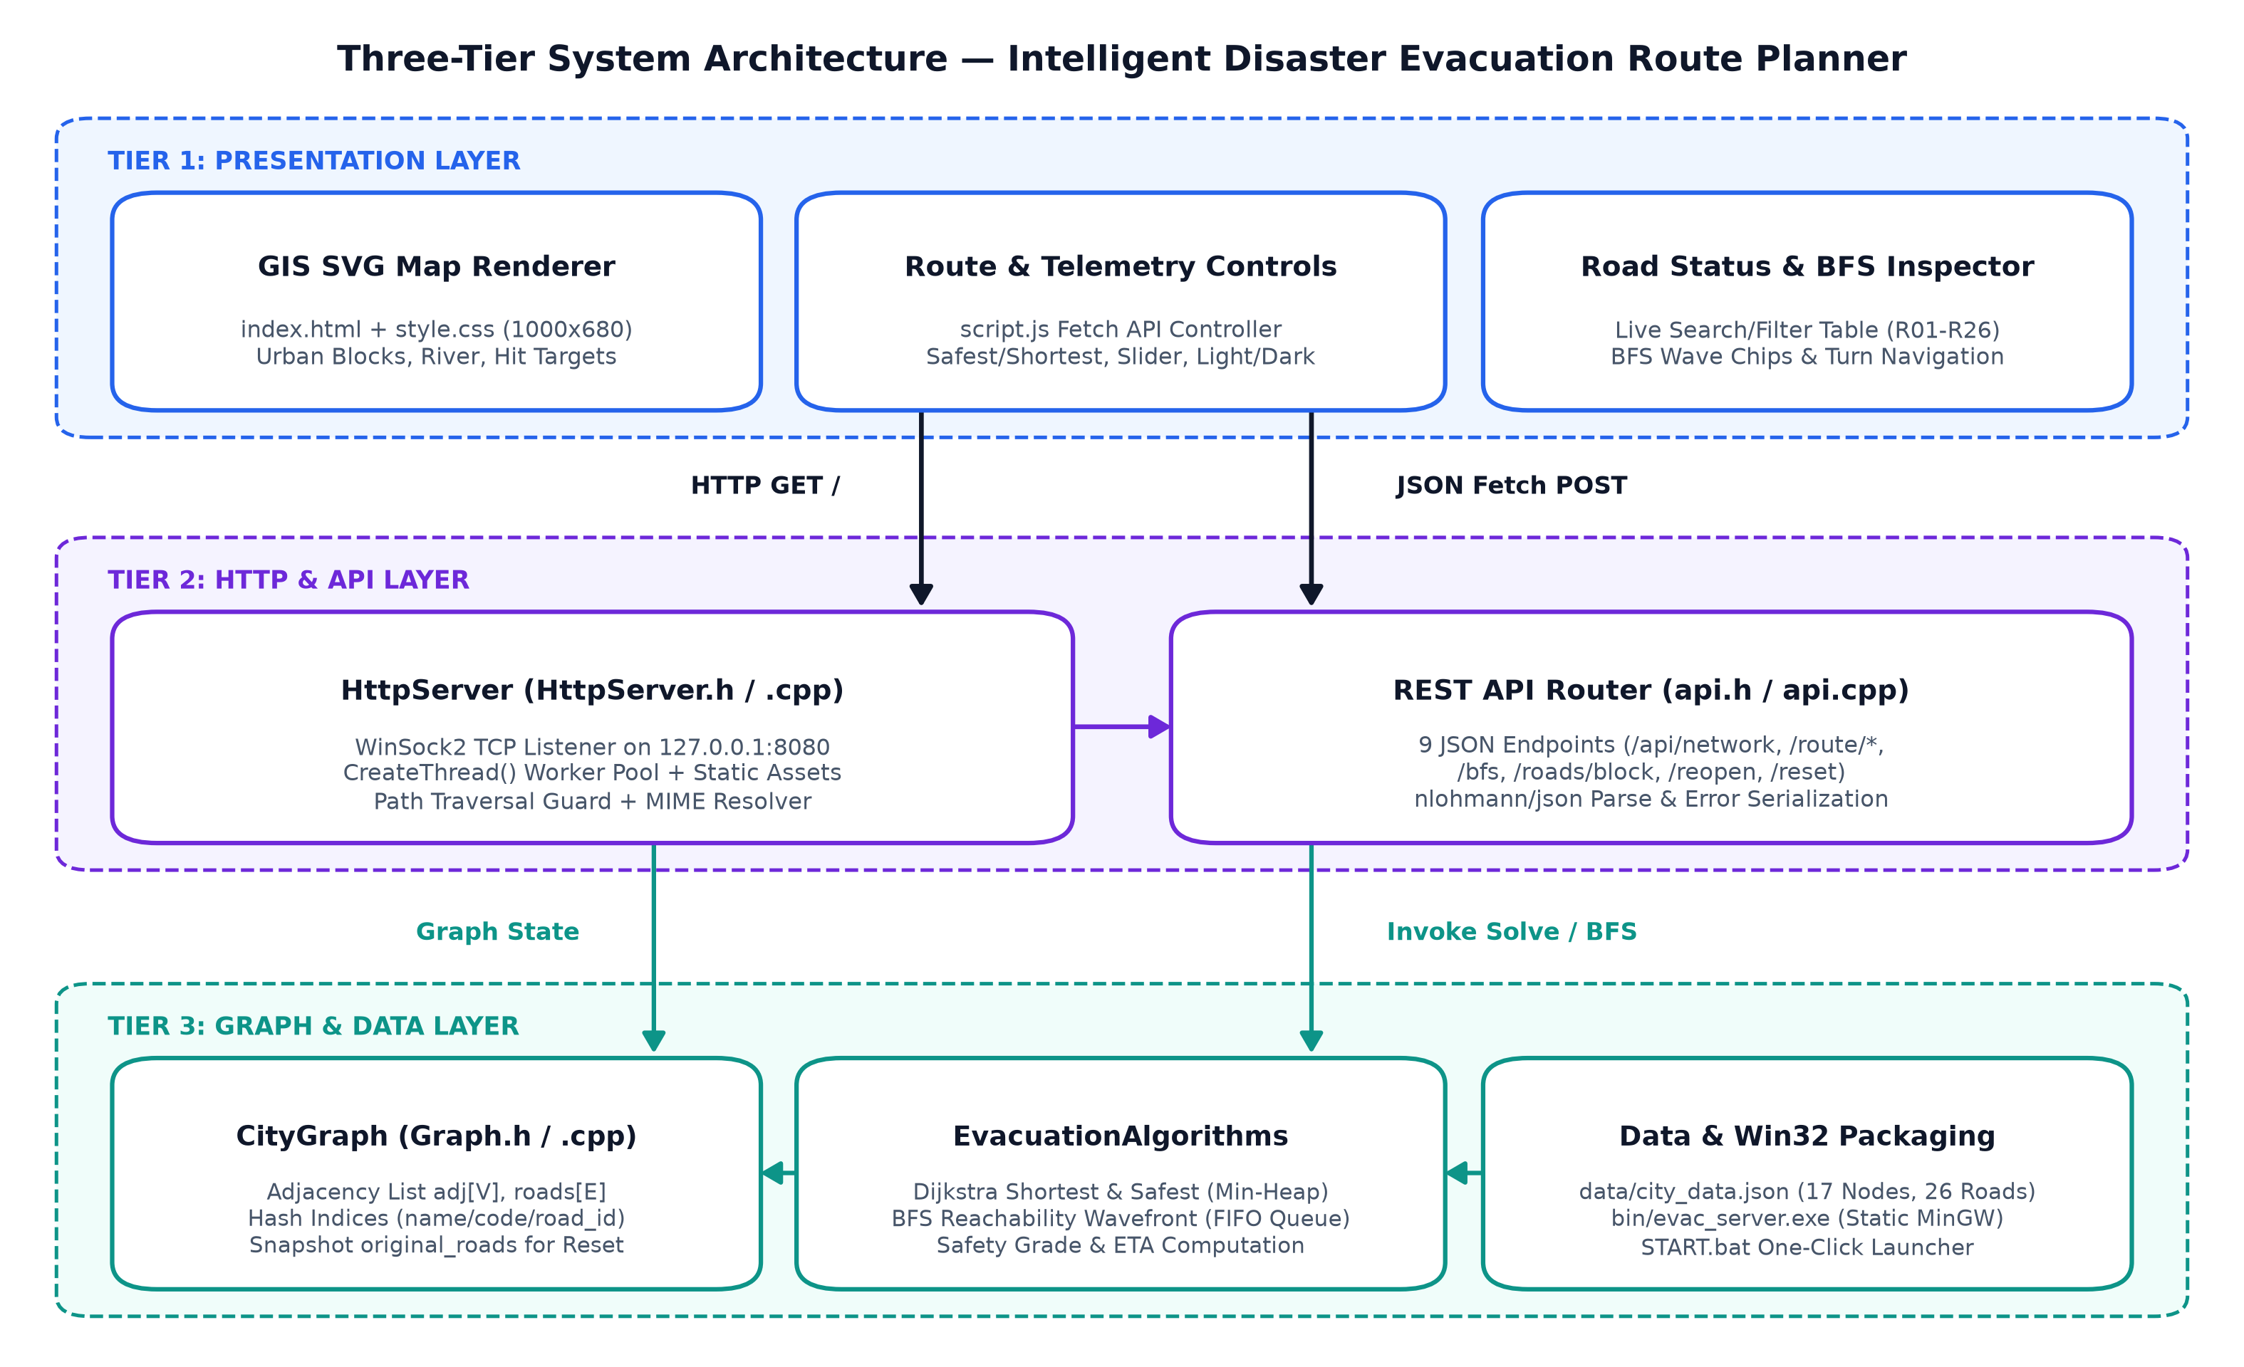
Figure 3.1: Three-Tier System Architecture of the Intelligent Disaster Evacuation Route Planner.
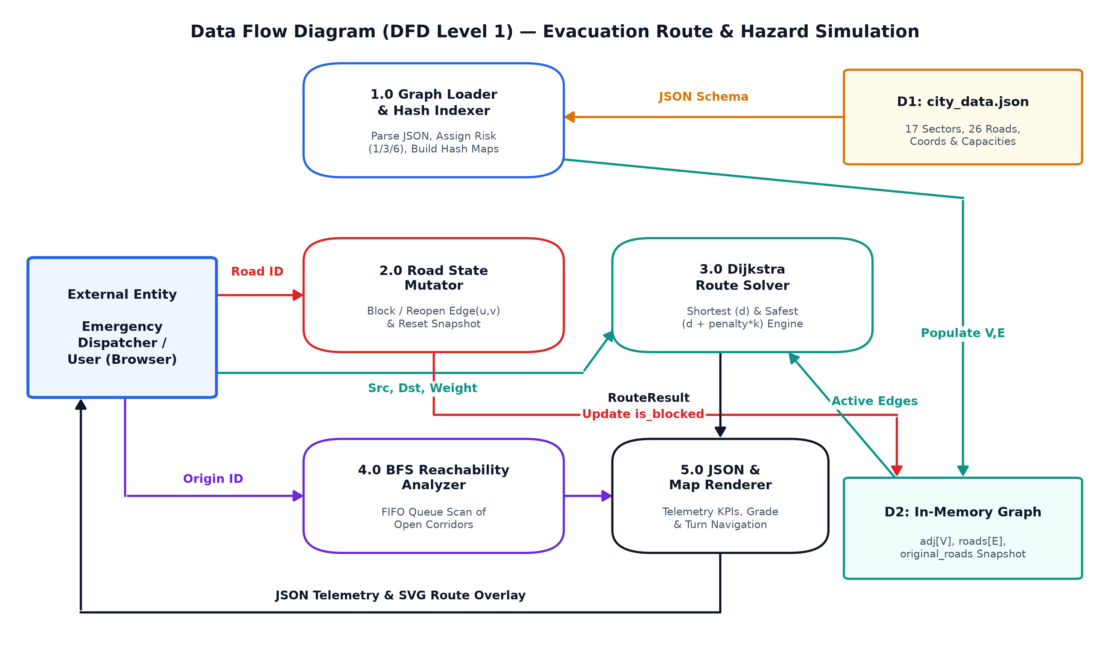
Figure 3.2: Data Flow Diagram (DFD Level 1) Depicting Route Optimization, BFS, and Dynamic Road Mutation.
3.6.1. Graph Data Structures and City Topology (CityGraph)
In backend/Graph.h and Graph.cpp, vertices are stored in std::vector<LocationNode> nodes (indices 0 to 16) and edges in std::vector<RoadInfo> roads (0 to 25), complemented by the undirected adjacency list std::vector<std::vector<Edge>> adj and three O(1) hash maps: name_to_id, code_to_id, and road_id_to_idx (Figure 3.3). Each road risk string maps cleanly via risk_weights_map: Low -> 1, Medium -> 3, High -> 6.
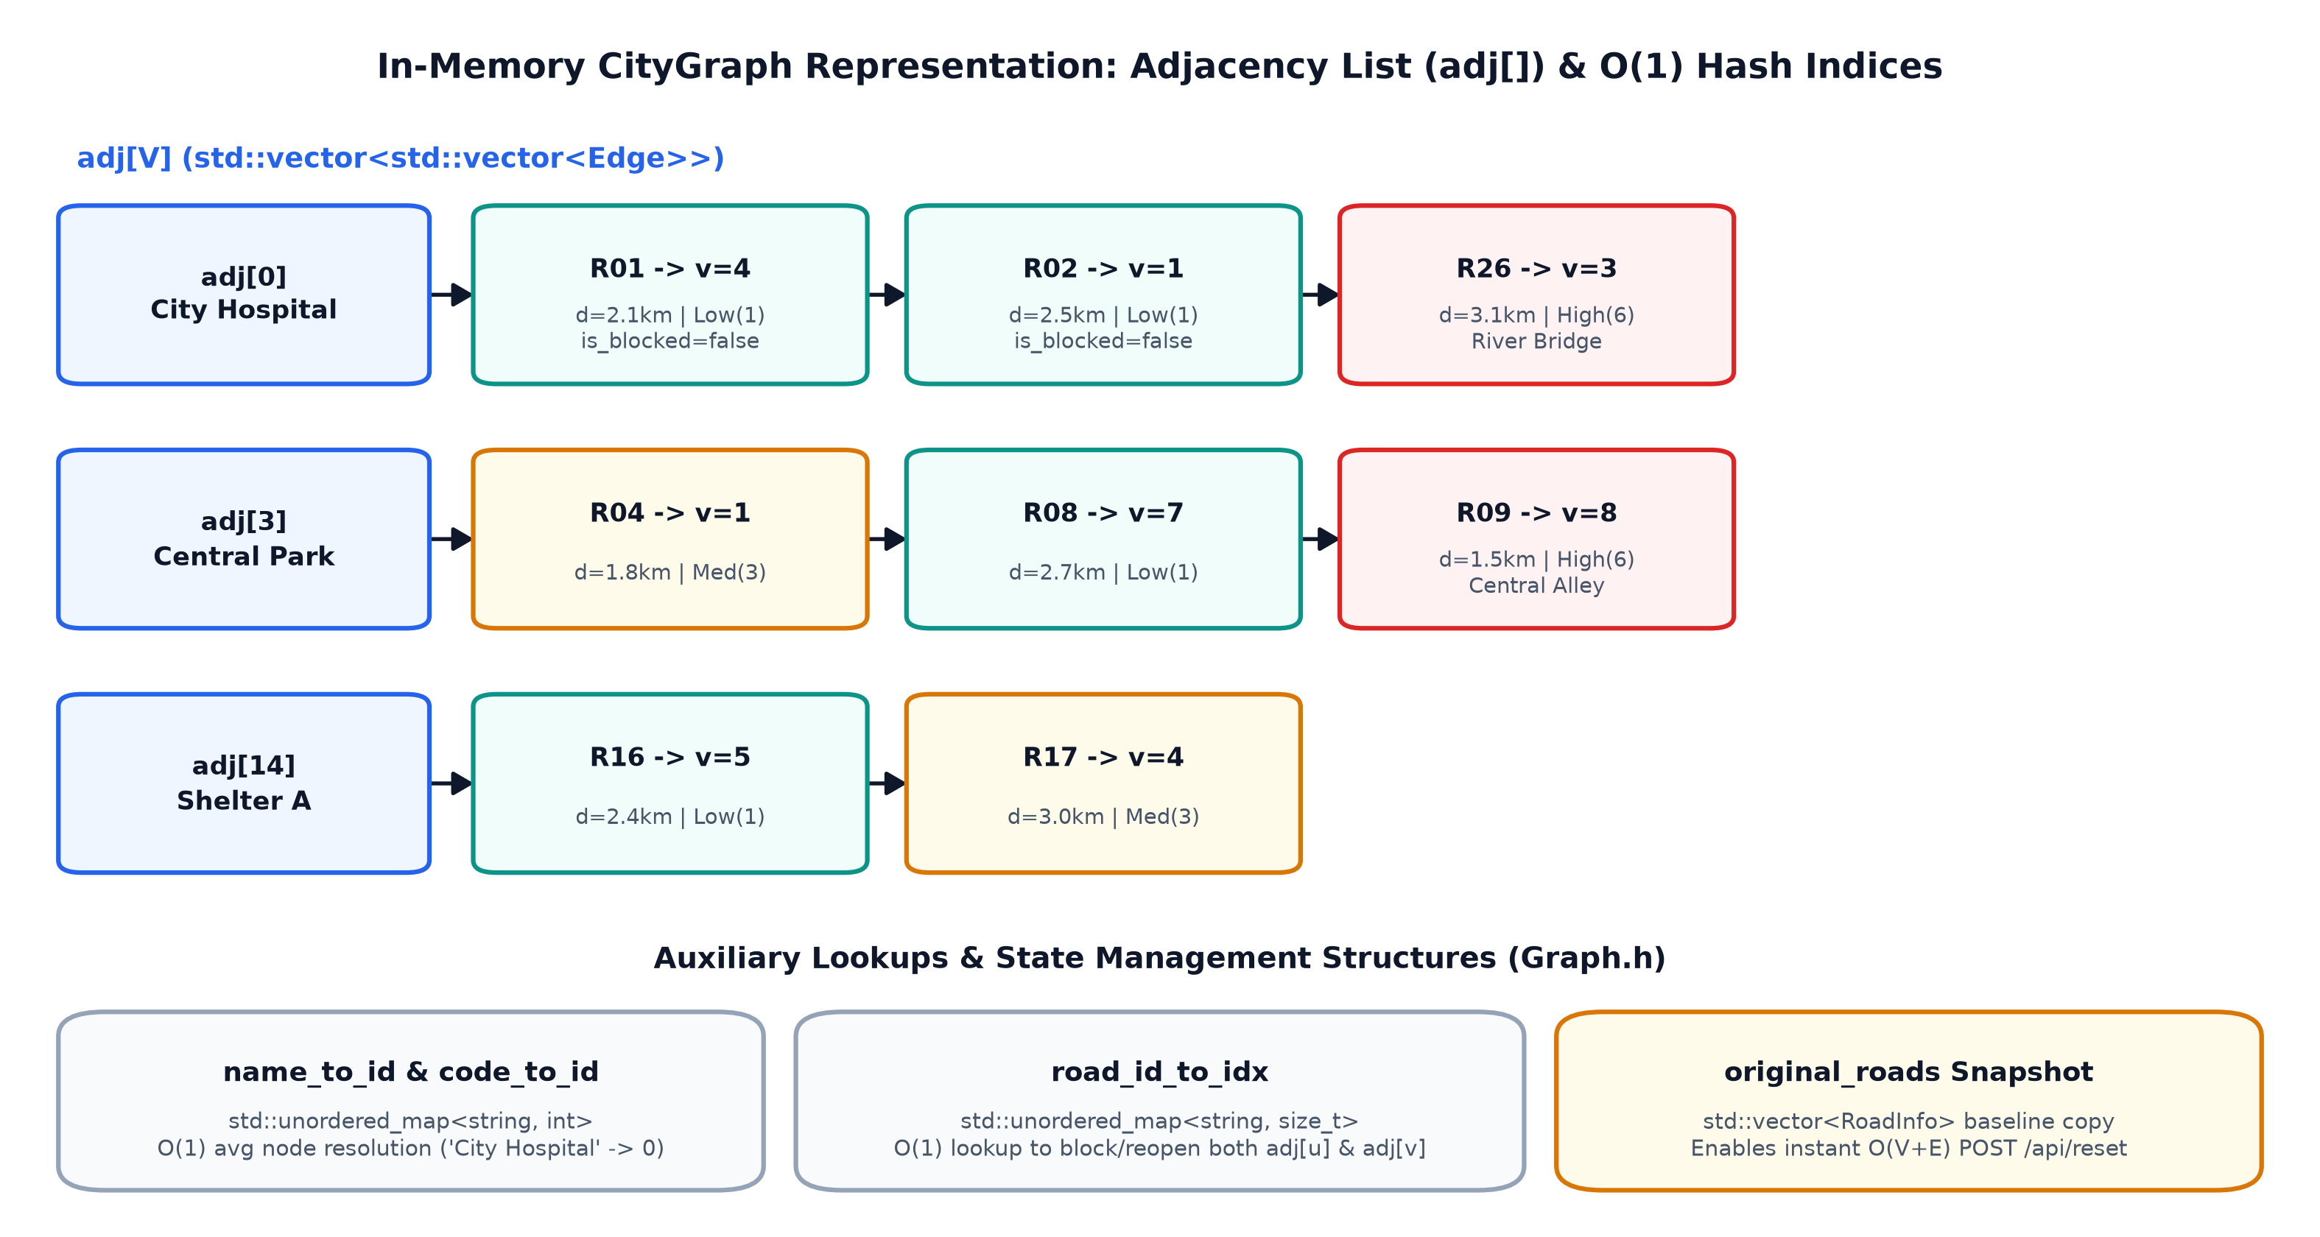
Figure 3.3: In-Memory CityGraph Adjacency List (adj[]) and O(1) Hash Lookup Structures.
Table 3.3: Metropolis SafeCity Network Vertices (17 Sectors from data/city_data.json)
ID | Code | Sector Name | Type | SVG (x, y) | Shelter | Capacity
0 | LOC_HOSP | City Hospital | hospital | (180, 150) | No | 250
1 | LOC_FIRE | Fire Station | fire_station | (360, 130) | No | 80
2 | LOC_POL | Police Headquarters | police | (540, 120) | No | 100
3 | LOC_PARK | Central Park | park | (420, 280) | No | 1500
4 | LOC_RAIL | Railway Station | station | (160, 320) | No | 800
5 | LOC_BUS | Bus Terminal | station | (260, 440) | No | 600
6 | LOC_SCH | City School | school | (370, 560) | No | 450
7 | LOC_MALL | Shopping Mall | commercial | (640, 240) | No | 1200
8 | LOC_MKT | Market | commercial | (530, 390) | No | 500
9 | LOC_RES_N | Residential Area North | residential | (700, 120) | No | 2000
10 | LOC_RES_S | Residential Area South | residential | (670, 480) | No | 1800
11 | LOC_HALL | Community Hall | community | (490, 530) | No | 350
12 | LOC_IND | Industrial Area | industrial | (840, 260) | No | 400
13 | LOC_TECH | Tech Park | commercial | (810, 420) | No | 900
14 | SHELTER_A | Emergency Shelter A | shelter | (90, 540) | Yes | 3000
15 | SHELTER_B | Emergency Shelter B | shelter | (890, 130) | Yes | 2500
16 | SHELTER_C | Emergency Shelter C | shelter | (870, 570) | Yes | 3200

Table 3.4: Metropolis SafeCity Undirected Road Corridors (26 Edges R01–R26)
ID | Road Name | Origin Sector (u) | Target Sector (v) | Dist (km) | Risk (Penalty)
R01 | Hospital Link Way | City Hospital | Railway Station | 2.1 | Low (1)
R02 | Emergency Boulevard | City Hospital | Fire Station | 2.5 | Low (1)
R03 | Civic Center Road | Fire Station | Police Headquarters | 2.3 | Low (1)
R04 | North Park Avenue | Fire Station | Central Park | 1.8 | Medium (3)
R05 | Capitol Highway | Police Headquarters | Residential Area North | 2.0 | Low (1)
R06 | Transit Corridor | Railway Station | Bus Terminal | 1.6 | Medium (3)
R07 | Station Road | Railway Station | Central Park | 3.2 | Low (1)
R08 | Mall Parkway | Central Park | Shopping Mall | 2.7 | Low (1)
R09 | Central Alley (Flood Zone) | Central Park | Market | 1.5 | High (6)
R10 | Grand Vista Road | Police Headquarters | Shopping Mall | 2.4 | Low (1)
R11 | Factory Bypass | Shopping Mall | Industrial Area | 2.6 | Medium (3)
R12 | Market Express | Shopping Mall | Market | 2.0 | Low (1)
R13 | Shelter Beta Access | Residential Area North | Emergency Shelter B | 2.2 | Low (1)
R14 | Hazard Corridor (Industrial) | Industrial Area | Emergency Shelter B | 1.9 | High (6)
R15 | Academic Way | Bus Terminal | City School | 1.8 | Low (1)
R16 | Shelter Alpha Expressway | Bus Terminal | Emergency Shelter A | 2.4 | Low (1)
R17 | Harbor Route | Railway Station | Emergency Shelter A | 3.0 | Medium (3)
R18 | Community Boulevard | City School | Community Hall | 1.4 | Low (1)
R19 | Market Lane | Community Hall | Market | 1.7 | Medium (3)
R20 | Southern Avenue | Market | Residential Area South | 2.1 | Low (1)
R21 | Civic Link | Residential Area South | Community Hall | 2.2 | Low (1)
R22 | Enterprise Drive | Industrial Area | Tech Park | 2.3 | Low (1)
R23 | Tech Parkway | Tech Park | Residential Area South | 2.5 | Medium (3)
R24 | Shelter Gamma Link | Tech Park | Emergency Shelter C | 1.8 | Low (1)
R25 | Coast Road | Residential Area South | Emergency Shelter C | 2.7 | Low (1)
R26 | River Bridge (Fire Risk) | City Hospital | Central Park | 3.1 | High (6)

3.6.2. Mathematical Cost Model & Routing Algorithms
EvacuationAlgorithms implements two Dijkstra objectives over open corridors (!edge.is_blocked) using std::priority_queue<std::pair<double, int>, ..., std::greater<>> with lazy stale-entry pruning (Figure 3.4). For every unblocked edge e = (u, v), Shortest Route minimizes pure physical distance while Safest Route minimizes the composite hazard-adjusted cost defined in Equations (1)–(3):
w_shortest(e) = d(u, v) | (1)

w_safest(e) = d(u, v) + p(u, v) * risk_weight , default risk_weight = 2.0 | (2)

T_est(minutes) = (sum(d_e along path) / 30.0) * 60.0 | (3)

Once target vertex dest is extracted from the min-heap, calculateSafetyGrade evaluates average risk ratio R_avg = total_risk_penalty / hop_count: values <= 1.5 yield 'High Safety (Low Hazard Exposure)', values <= 3.2 yield 'Moderate Safety (Acceptable Risk Corridor)', and values > 3.2 yield 'Elevated Hazard (Active Caution Advisories)'. Reachability analysis invokes runBFS() (Figure 3.5) with a FIFO std::queue<int>, marking reachable nodes level-by-level in O(V + E) time.
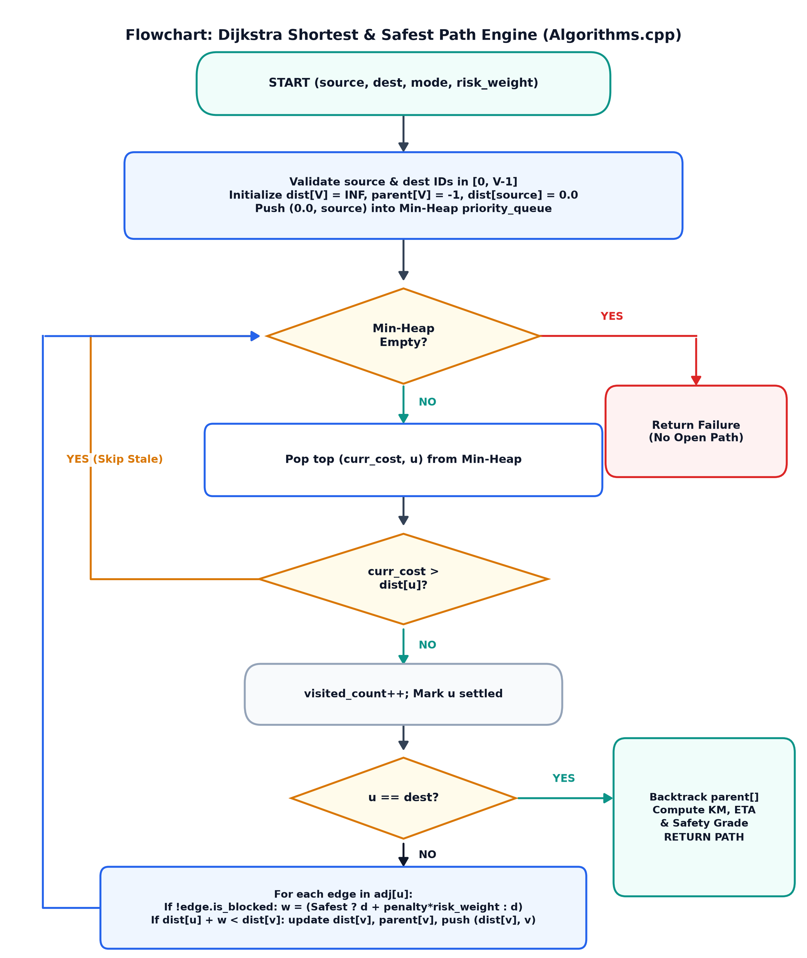
Figure 3.4: Flowchart of Shortest-Path and Risk-Aware Dijkstra Engine.
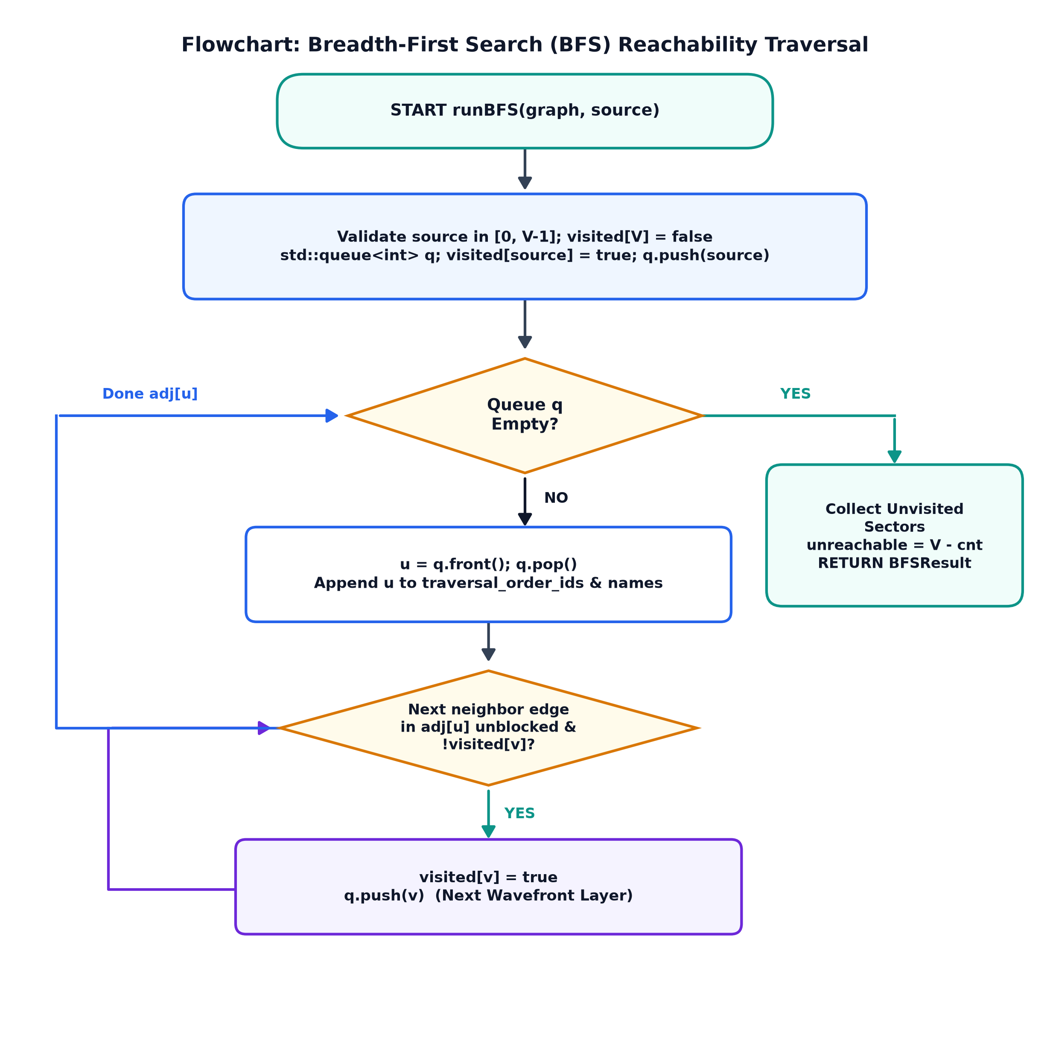
Figure 3.5: Flowchart of Breadth-First Search (BFS) Reachability Traversal.
Algorithm 3.1: Core C++ Risk-Aware Dijkstra Solver (backend/Algorithms.cpp Excerpt)
using PQItem = std::pair<double, int>; // (cumulative_cost, node_id)
std::priority_queue<PQItem, std::vector<PQItem>, std::greater<PQItem>> pq;
dist[source] = 0.0; pq.push({0.0, source});
while (!pq.empty()) {
auto [current_cost, u] = pq.top(); pq.pop();
if (current_cost > dist[u]) continue; // Skip outdated lazy-deleted heap entry
res.nodes_visited_count++;
if (u == dest) break; // Optimal target cost locked
for (const auto& edge : graph.getEdges(u)) {
if (edge.is_blocked) continue;
double weight = safest_mode ? (edge.distance_km + edge.risk_penalty * risk_weight)
: edge.distance_km;
if (dist[u] + weight < dist[edge.to]) {
dist[edge.to] = dist[u] + weight;
parent[edge.to] = u; parent_road[edge.to] = edge.road_id;
pq.push({dist[edge.to], edge.to});
}
}
}

3.6.3. Embedded WinSock2 HTTP Server & REST API Specification
HttpServer (backend/HttpServer.cpp) initializes WinSock2 on 127.0.0.1:8080, spawns a Win32 worker thread via CreateThread() per incoming TCP connection (with synchronous fallback), prevents directory traversal (rejecting '..' segments in static file paths), and sets CORS/MIME headers. Table 3.5 documents all 9 registered endpoints implemented in backend/api.cpp.
Table 3.5: Implemented REST HTTP API Endpoint Specification
Method | Endpoint Path | Request Payload | Functional Responsibility
GET | /api/network | None | Returns complete graph JSON: nodes, roads, average speed, counts.
GET | /api/locations | None | Returns array of all 17 sector LocationNode objects.
GET | /api/roads | None | Returns array of all 26 RoadInfo edges with current is_blocked state.
POST | /api/route/shortest | {source, destination} | Computes minimum-distance route using Dijkstra over open roads.
POST | /api/route/safest | {source, destination, risk_weight} | Computes minimum composite hazard route (default risk_weight = 2.0).
POST | /api/bfs | {source} | Runs BFS wavefront reachability scan; returns traversal order & unvisited nodes.
POST | /api/roads/block | {road_id} | Marks corridor blocked in roads[] and both adj[u], adj[v] lists.
POST | /api/roads/reopen | {road_id} | Restores corridor availability in O(1) road_id_to_idx lookup + adj update.
POST | /api/reset | {} (empty body) | Restores roads from original_roads snapshot and rebuilds adjacency list.

CHAPTER 4
RESULTS ANALYSIS AND VALIDATION
4.1. Implementation of Solution
The full solution was built, executed against live HTTP requests on 127.0.0.1:8080, and captured in headless Microsoft Edge at 2x DPI resolution to verify end-to-end visual accuracy, state mutation responsiveness, and algorithmic fidelity across light mode, dark mode, BFS exploration, and dynamic corridor blocking.
4.1.1. Main Dashboard, Dark Mode, and Solver Telemetry Verification
Upon launching the application, frontend/script.js fetches GET /api/network and immediately triggers default Safest Route calculation from City Hospital (ID 0) to Emergency Shelter A (ID 14) with hazard weight 2.0x. As captured in Figure 4.1, the three-column interface displays Route Controls and Solver Telemetry on the left, the 1000x680 SVG urban map in the center (featuring district blocks, Metro River, railway corridor, compass rose, and 3 km scale bar), Route Information KPIs and turn-by-turn steps on the right, and the searchable 26-road table below. Figure 4.2 demonstrates seamless light/dark theme switching persisted in localStorage, while Figure 4.3 highlights Solver Telemetry confirming 8/17 explored nodes and Composite Cost = 13.10.
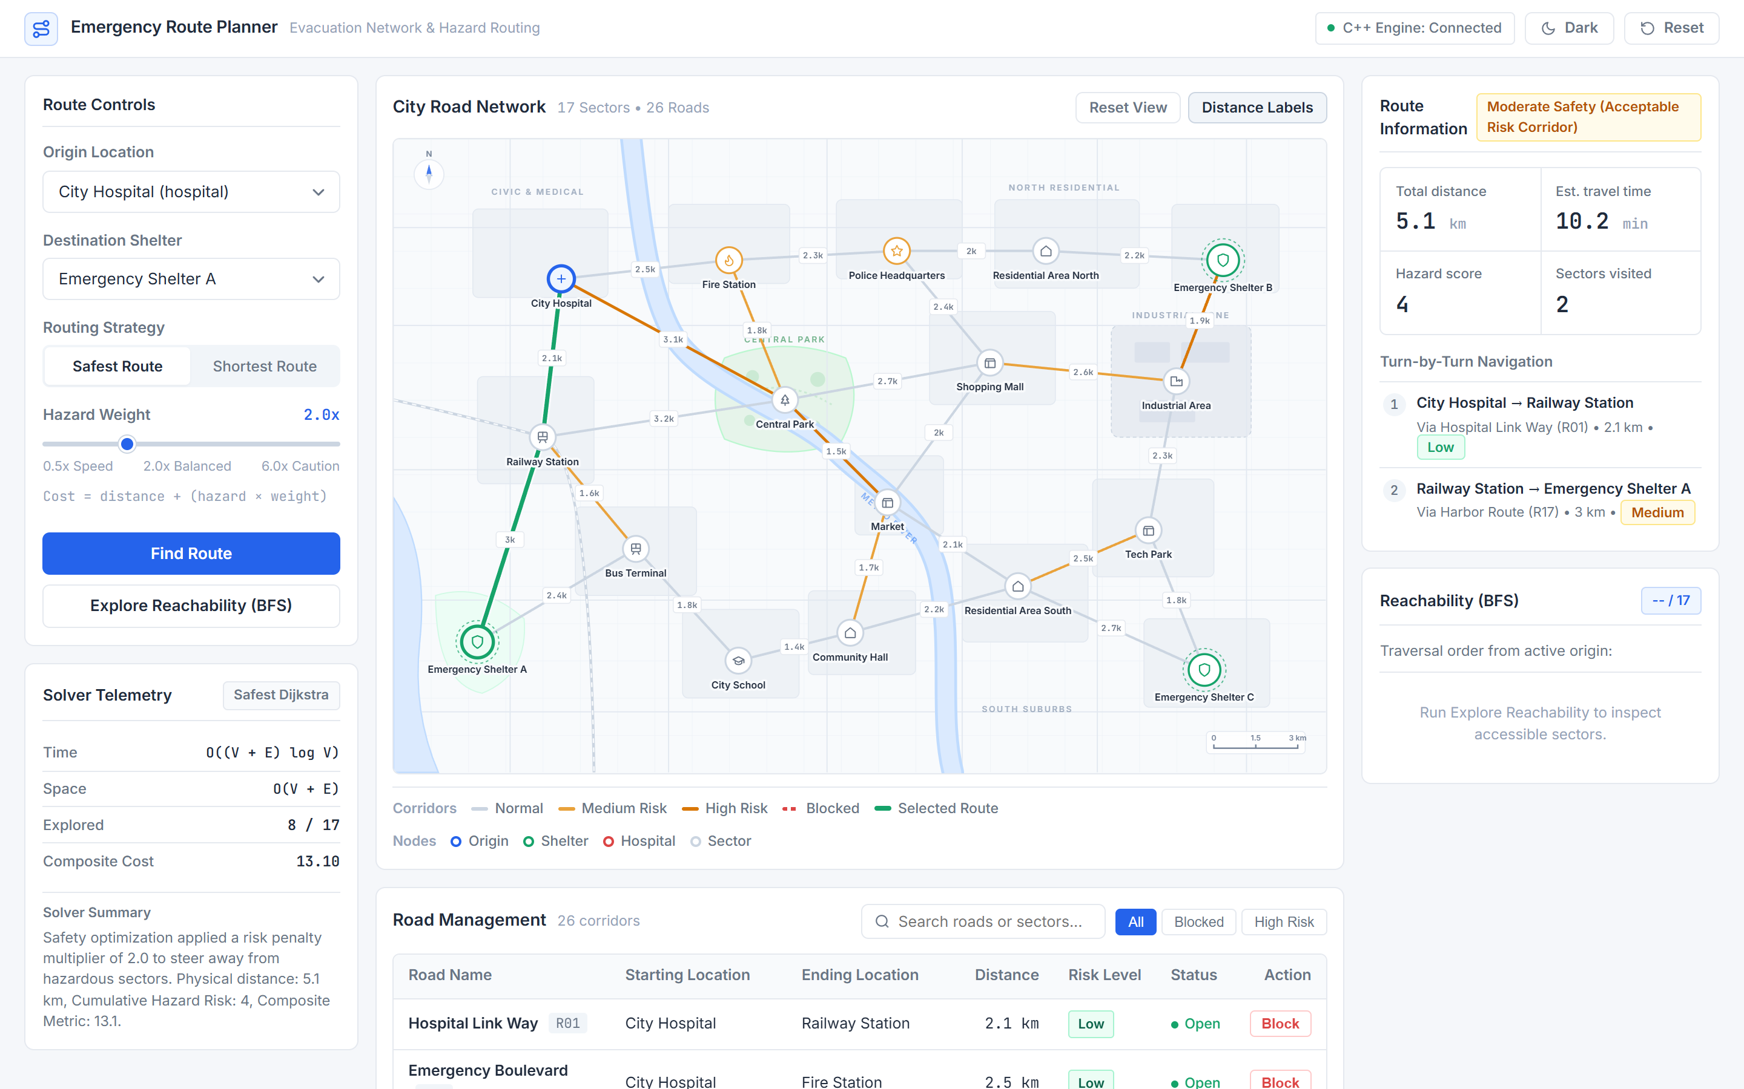
Figure 4.1: Main Workspace in Light Mode Showing Default Safest Evacuation Plan (City Hospital to Emergency Shelter A).
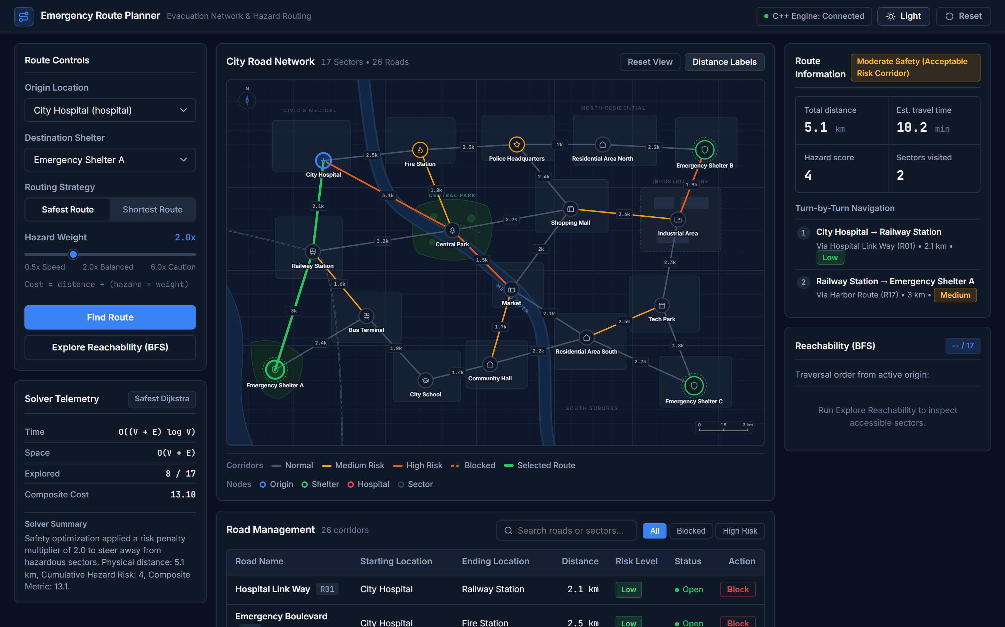
Figure 4.2: Main Workspace in Dark Mode Activated via Top-Navigation Theme Toggle.
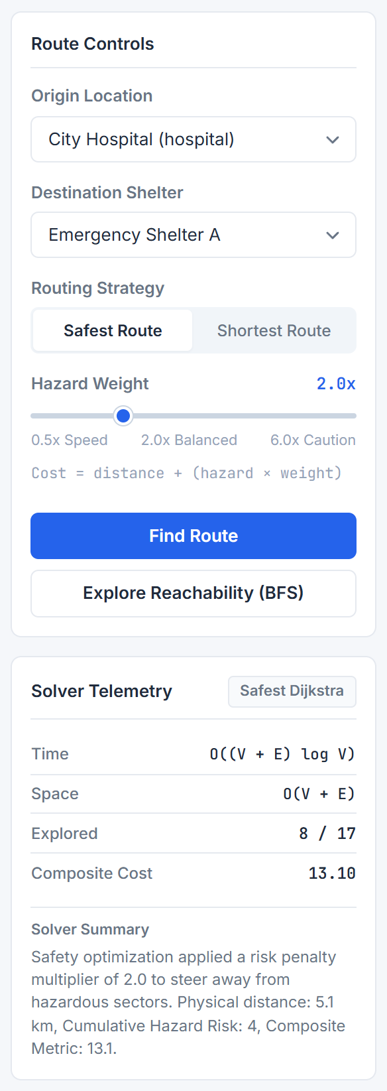
Figure 4.3: Route Controls Form and Live C++ Solver Telemetry Sidebar Cards.
4.1.2. Multi-Objective Safest vs. Shortest Route Divergence
To empirically confirm risk-aware optimization, the corridor between Central Park (ID 3) and Market (ID 8) was evaluated under both algorithms. As illustrated in Figure 4.4 and Figure 4.5, Shortest Route selects the direct flood-prone shortcut R09 (Central Alley, 1.5 km, High Risk = 6, rated Elevated Hazard). Under Safest Route with hazard weight 2.0x, the composite cost of R09 rises to 1.5 + 6(2.0) = 13.5, whereas the detour via Shopping Mall (R08 Low + R12 Low) yields 2.7 + 2.0 + (1 + 1)(2.0) = 8.70. Consequently, Safest Dijkstra automatically detours to reduce cumulative hazard exposure by 66.7% (from 6 to 2) with High Safety classification.
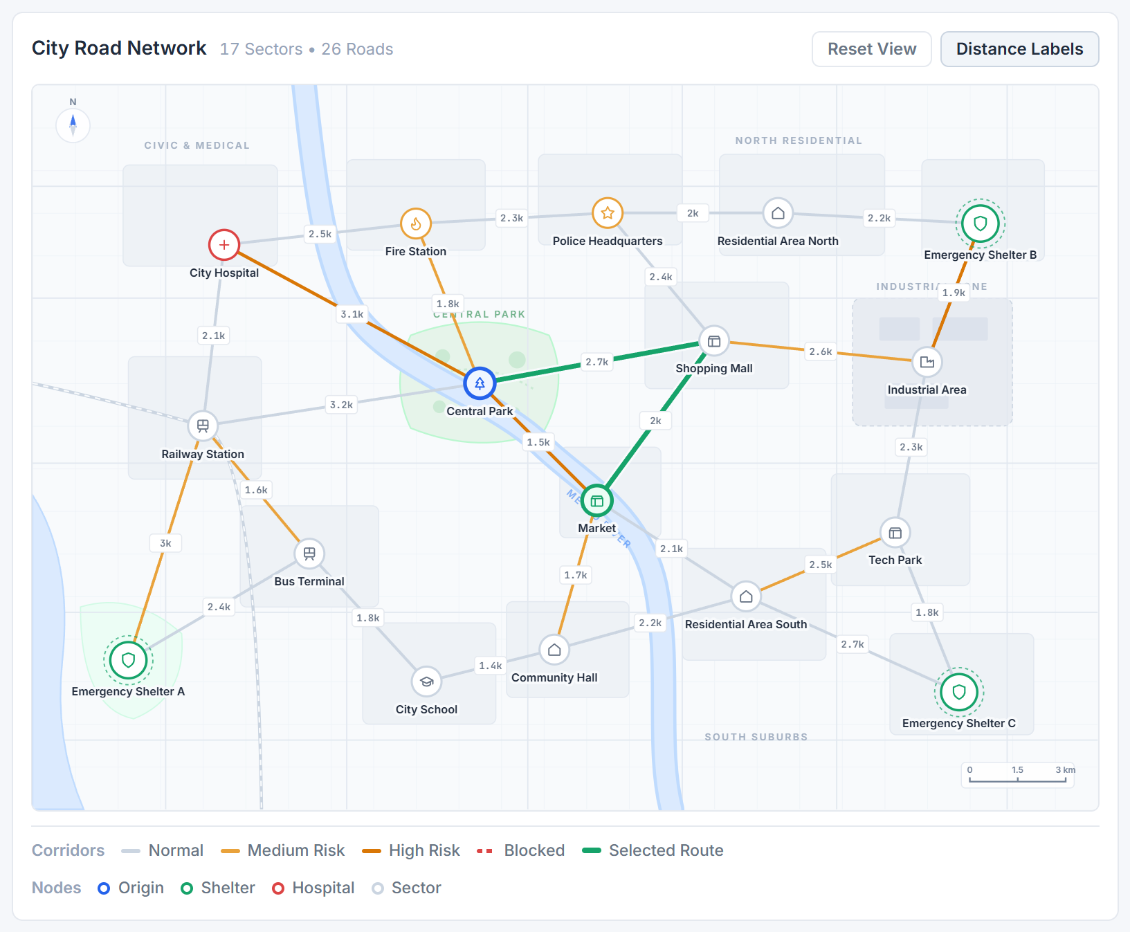
Figure 4.4: Safest Route Topology (Central Park to Market) Detouring via Shopping Mall (4.7 km, Hazard Score 2).
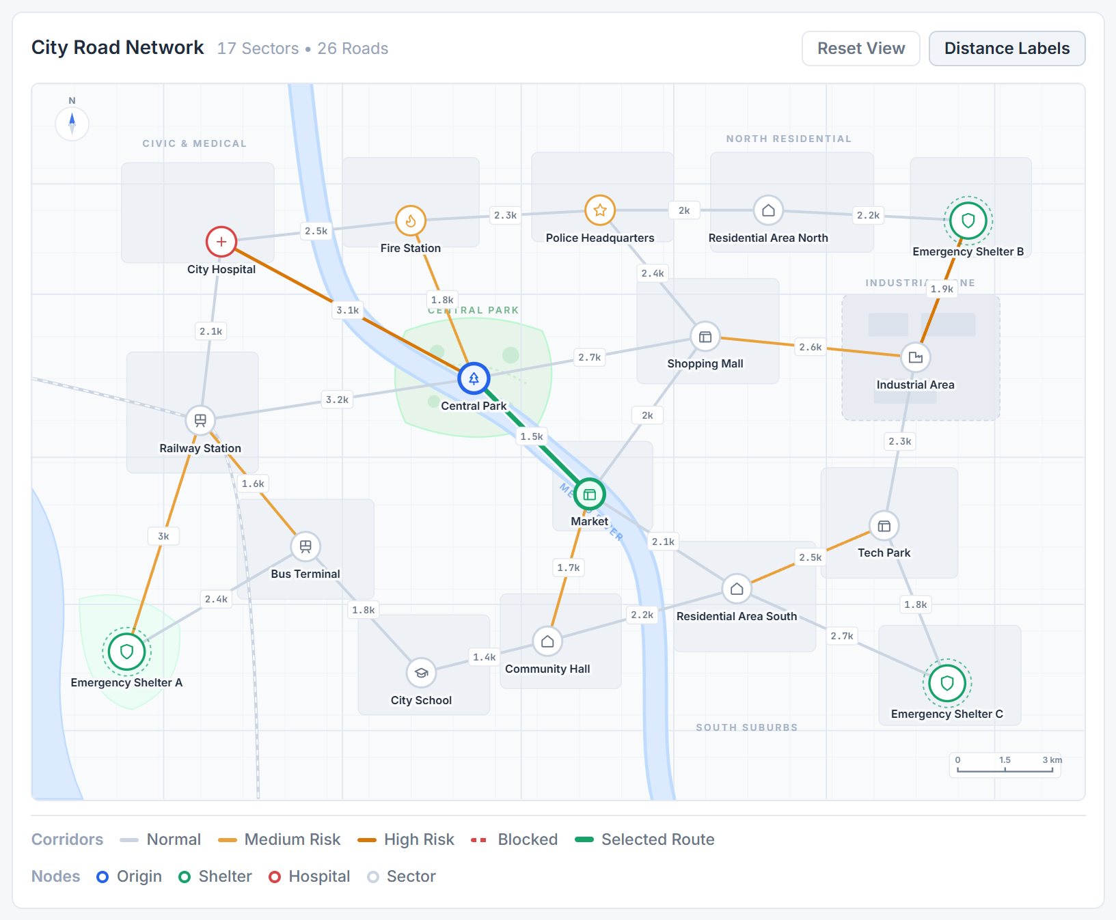
Figure 4.5: Shortest Route Topology (Central Park to Market) Traversing High-Risk Flood Shortcut R09 (1.5 km, Hazard Score 6).
4.1.3. BFS Reachability Exploration and Turn-by-Turn Telemetry
Triggering 'Explore Reachability (BFS)' from City Hospital executes POST /api/bfs and highlights all 17 connected sectors in FIFO wavefront discovery order (Figure 4.6 and Figure 4.7), starting at City Hospital -> Railway Station -> Fire Station -> Central Park -> Bus Terminal -> Emergency Shelter A -> ... -> Emergency Shelter C (17/17 reachable, 0 isolated).
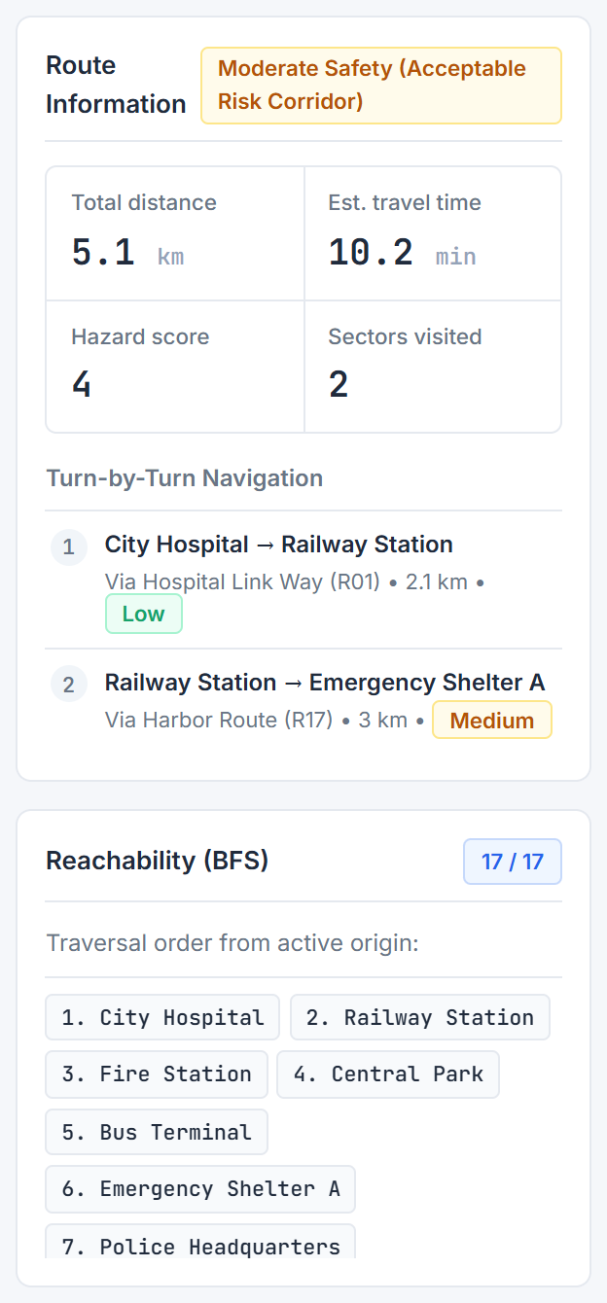
Figure 4.6: Right Sidebar Showing KPI Metrics, Turn-by-Turn Steps, and BFS Reachability Chips (17/17).
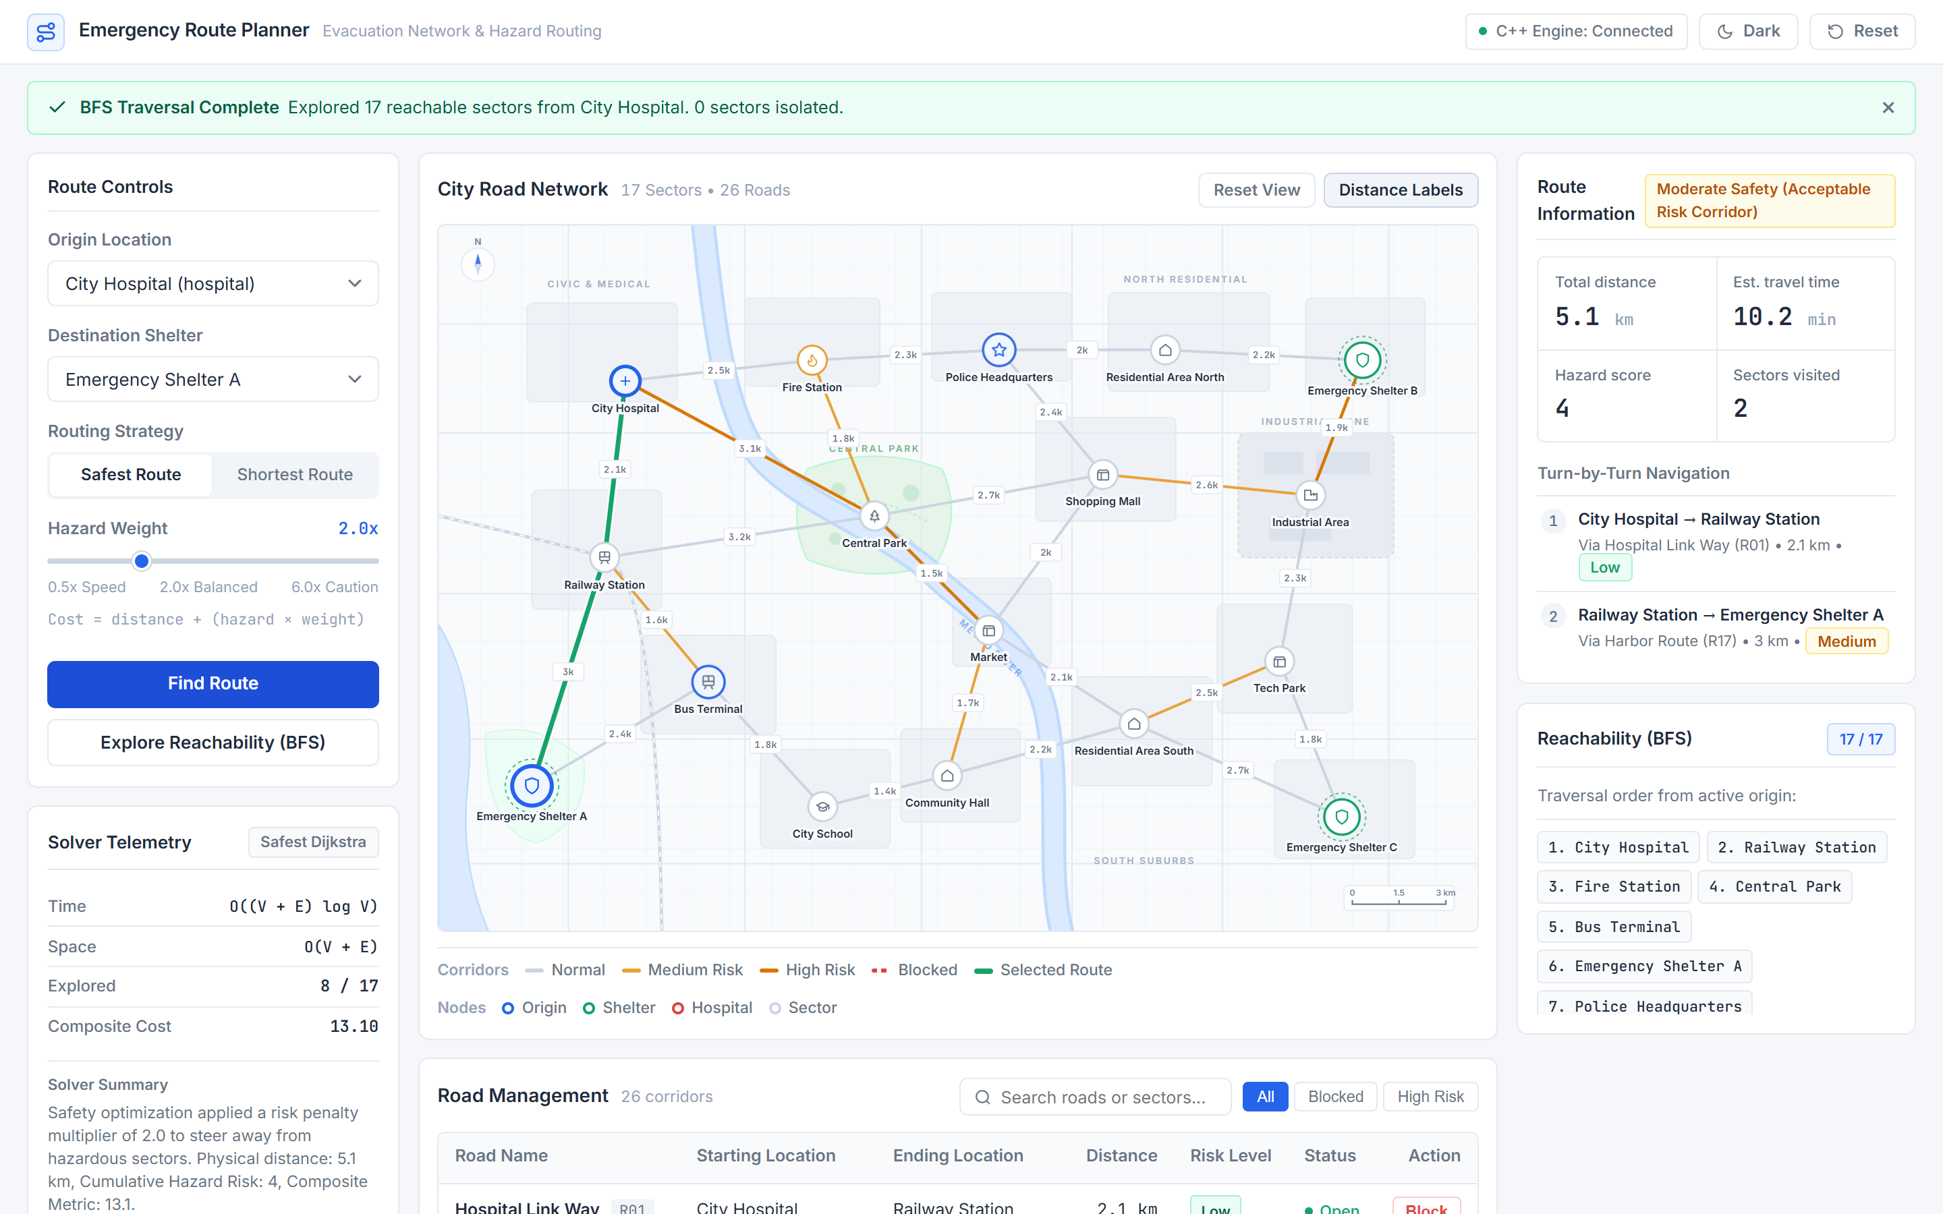
Figure 4.7: Full-Screen Capture During BFS Wavefront Execution Across Unblocked Corridors.
4.1.4. Dynamic Road Blocking, Detour Recalculation, and Reopening
Filtering the Road Management table for 'Hospital Link' and clicking Block on R01 immediately closes the edge on both endpoints, renders a red dashed CLOSED corridor on the SVG map (Figure 4.8), and triggers live route recalculation. Under Safest mode (weight = 2.0), the planner avoids both blocked R01 and high-risk R26 (River Bridge, fire risk), computing an alternate 10.5 km, 21.0 min corridor via Fire Station and Central Park (Hazard Score = 8, Composite Cost = 26.50). Under Shortest mode, it computes a 9.3 km detour across R26 (Hazard Score = 10). Figure 4.9 shows the Road Management interface providing instant Reopen and All/Blocked/High Risk filter controls.
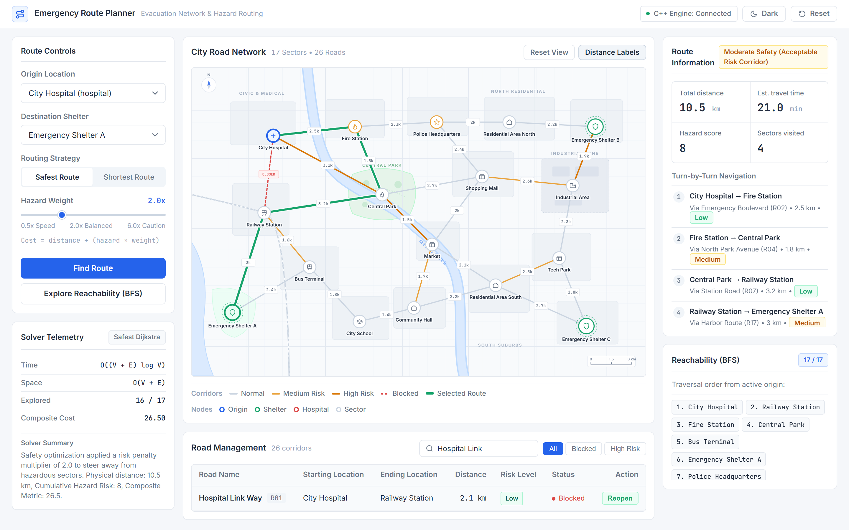
Figure 4.8: Real-Time Closure of R01 Triggering Dynamic Safest Detour (10.5 km, Composite Cost 26.50).
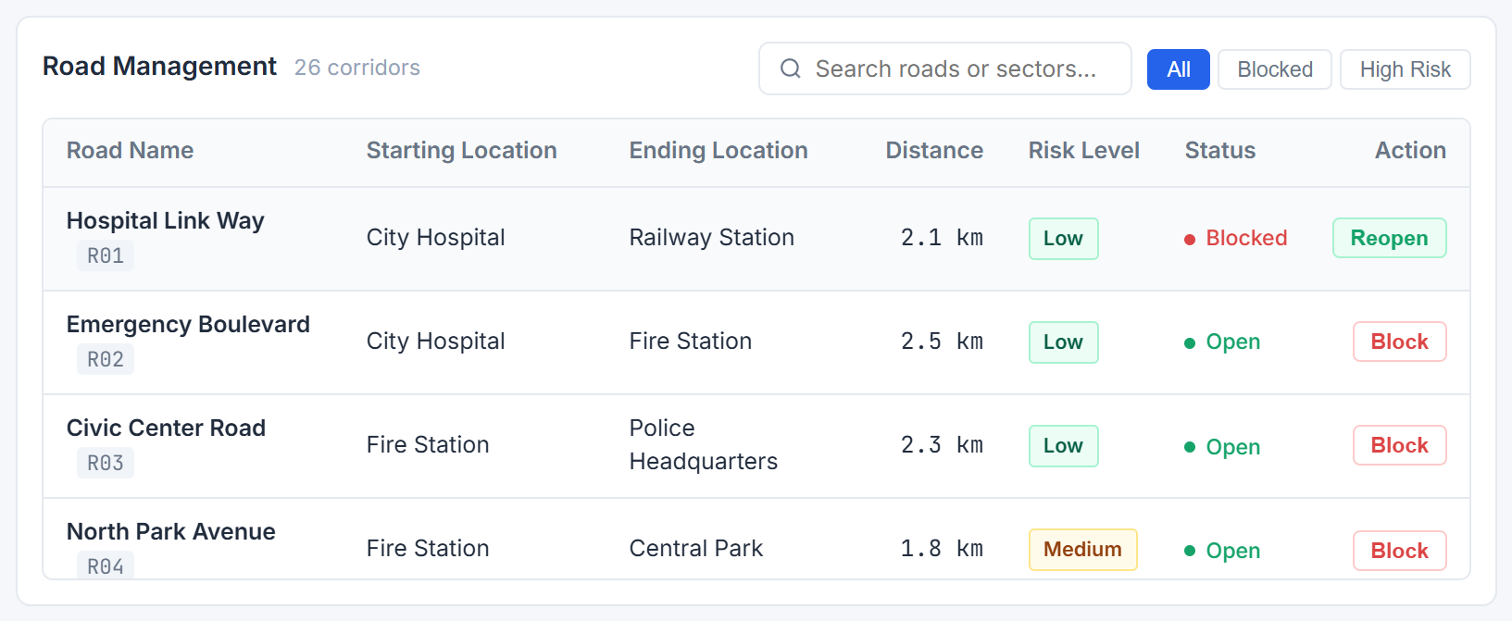
Figure 4.9: Road Management Table Displaying Blocked Status Indicator, Filter Chips, and Reopen Action.
4.1.5. Quantitative Metrics and Complexity Scaling Analysis
Table 4.1 compiles the exact measured API telemetry returned by bin/evac_server.exe across baseline, risk-weighted, and disrupted network topologies. Figure 4.10(a) visualizes the distance-versus-hazard tradeoff across these verified scenarios, while Figure 4.10(b) plots the asymptotic operation count on sparse urban networks (E ~ 2V), illustrating why the implemented Min-Heap Dijkstra O((V+E) log2 V) outperforms quadratic O(V^2) matrix scanning cleanly as V grows.
Table 4.1: Quantitative Route Telemetry Measured from Live C++ Backend API
Scenario | Strategy | Network | Dist | ETA | Hazard | Visited | Cost (Grade)
City Hospital -> Shelter A | Shortest | Baseline | 5.1 km | 10.2 min | 4 | 8 / 17 | 5.10 (Moderate)
City Hospital -> Shelter A | Safest (2.0x) | Baseline | 5.1 km | 10.2 min | 4 | 8 / 17 | 13.10 (Moderate)
Central Park -> Market | Shortest | Baseline | 1.5 km | 3.0 min | 6 | 2 / 17 | 1.50 (Elevated)
Central Park -> Market | Safest (2.0x) | Baseline | 4.7 km | 9.4 min | 2 | 5 / 17 | 8.70 (High Safety)
City Hospital -> Shelter B | Shortest | Baseline | 9.0 km | 18.0 min | 4 | 15 / 17 | 9.00 (High Safety)
City Hospital -> Shelter B | Safest (2.0x) | Baseline | 9.0 km | 18.0 min | 4 | 11 / 17 | 17.00 (High Safety)
City Hospital -> Shelter A | Shortest | R01 Blocked | 9.3 km | 18.6 min | 10 | 16 / 17 | 9.30 (Elevated)
City Hospital -> Shelter A | Safest (2.0x) | R01 Blocked | 10.5 km | 21.0 min | 8 | 16 / 17 | 26.50 (Moderate)

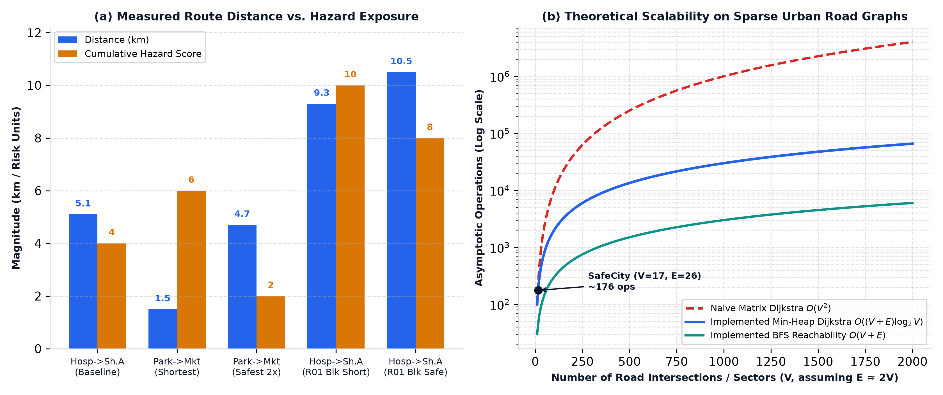
Figure 4.10: (a) Measured Distance vs. Hazard Tradeoff Across Verified Routes; (b) Theoretical Asymptotic Scalability.
4.1.6. C++ Algorithm Unit Validation & Standalone Release Verification
All core algorithmic invariants are continuously validated by bin/algorithm_tests.exe (built from tests/algorithm_tests.cpp via build.bat), achieving 8/8 passing test cases (Table 4.2). Independently, an automated 12-point standalone release harness (verify_release.py) verified portability, missing-binary guards, occupied-port handling, UI asset serving, all REST routes, and immediate-exit diagnostics inside the self-contained release/ directory, passing 12/12 checks (Table 4.3).
Table 4.2: Automated C++ Algorithm Unit Test Suite Results (8/8 Passed)
ID | Test Case Description | Verified Assertion Outcome | Status
T1 | Shortest Route (City Hospital -> Shelter A) | Dijkstra returns optimal path via Railway Station, dist = 5.1 km. | PASS
T2 | Safest vs Shortest (Central Park -> Market) | Safest risk_penalty (2) strictly < Shortest risk_penalty (6). | PASS
T3 | Block R01 & Dynamic Detour Recalculation | Detour excludes R01 completely; shortest path shifts to 9.3 km. | PASS
T4 | Reopen R01 & Restore Baseline Path | Optimal distance restores back to exact 5.1 km. | PASS
T5 | BFS Reachability Traversal (City Hospital) | Visits all 17/17 connected vertices in valid BFS wave order. | PASS
T6 | Partitioned Shelter Handling (Block R13 & R14) | Returns success=false cleanly when Shelter B is isolated. | PASS
T7 | Invalid Node Boundary Guard (-1 to 999) | Gracefully returns failure message without crash or exception. | PASS
T8 | Full Network Reset (resetNetwork()) | R13 & R14 reopen; Shelter B becomes reachable at 9.0 km. | PASS

Table 4.3: Standalone Release Verification Matrix (12/12 Checks Passed)
# | Verification Check ID | Validated Runtime Behavior | Result
R1 | ABS_PATH_SCAN_OK | No developer-specific hardcoded absolute paths in release/. | PASS
R2 | MISSING_EXE_ERROR_HANDLING_OK | START.bat displays clear error message if evac_server.exe is absent. | PASS
R3 | PORTABLE_START_BAT_LAUNCH_OK | START.bat launches release server independently without GCC or Git Bash. | PASS
R4 | FRONTEND_ASSETS_OK | GET /, style.css, and script.js return HTTP 200 OK cleanly. | PASS
R5 | API_NETWORK_OK | GET /api/network returns 17 valid locations and 26 roads. | PASS
R6 | DIJKSTRA_SHORTEST_OK | City Hospital -> Shelter A computes 5.1 km via HTTP API. | PASS
R7 | DIJKSTRA_SAFEST_OK | Central Park -> Market selects 4.7 km safest path with risk=2. | PASS
R8 | PORT_OCCUPIED_CHECK_OK | Detects occupied port 8080 cleanly and guides troubleshooting. | PASS
R9 | BFS_OK | POST /api/bfs returns reachable_count = 17. | PASS
R10 | BLOCK_REOPEN_OK | Blocking R01 forces 9.3 km detour; reopening restores 5.1 km. | PASS
R11 | RESET_NETWORK_OK | POST /api/reset restores baseline open network state. | PASS
R12 | IMMEDIATE_EXIT_DIAGNOSTIC_OK | Detects blocked/failing binary exit cleanly with Device Guard hint. | PASS

4.1.7. Binary Dependency Inspection and Windows Device Guard Audit
Static PE inspection of release/bin/evac_server.exe (summarized in Table 4.4) confirms zero third-party compiler DLL dependencies—relying solely on native Windows libraries (KERNEL32.dll, msvcrt.dll, WS2_32.dll). Simultaneously, Authenticode inspection reveals the binary is NotSigned (AUTH_CERT_DIR: 0 0). On enterprise-managed endpoints enforcing strict Windows Device Guard / AppLocker allowlists, unsigned executables may trigger an organizational policy block. Rather than attempting unsafe bypasses, the release bundles a verified SHA-256 digest (release/SHA256SUMS.txt), explicit immediate-exit detection inside START.bat, and step-by-step IT allowlisting documentation.
Table 4.4: Standalone Executable Dependency, Digest, and Device Guard Audit
Audit Property | Observed Inspection Value
Executable Path & Architecture | release/bin/evac_server.exe — Win32 x86 (32-bit) Portable Executable
Exact File Size | 2,715,596 bytes (~2.59 MB statically linked C++/MinGW runtime)
Authenticode Signature Status | NotSigned (Certificate Table Data Directory: 0 0)
SHA-256 Integrity Digest | 326838907F7CDFD8AB0B0451F8C112A060F62F581E4F52369BAB9774568F8740
PE Imported System DLLs | KERNEL32.dll, msvcrt.dll, WS2_32.dll (all built-in Windows OS libraries)
Device Guard Policy Handling | No policy bypasses; START.bat detects immediate exit & documents IT approval via SHA-256

CHAPTER 5
CONCLUSION AND FUTURE WORK
5.1. Conclusion
This project successfully designed, engineered, and verified the Intelligent Disaster Evacuation Route Planner as a cohesive C++17 graph engine paired with an embedded WinSock2 HTTP API server, a responsive GIS SVG frontend, and a zero-compiler standalone Windows distribution.
All primary engineering objectives were satisfied without compromise. Modeling urban sectors and hazard corridors as an undirected weighted adjacency list enabled provably optimal shortest-path and risk-weighted safest-path computation in O((V + E) log V) time, alongside O(V + E) BFS reachability auditing and real-time road closure simulation. Empirical testing confirmed the practical significance of multi-objective weighting—reducing cumulative hazard exposure by 66.7% on hazard-prone corridors and dynamically re-routing evacuees around obstructed arterials (such as R01 closures) in milliseconds. Both the 8-case C++ algorithmic validation suite and the 12-point standalone release verification harness passed 100% of assertions.
Observed Deviations and Honest Scope Limitations: Three deliberate scope boundaries remain compared with production emergency dispatch deployments. First, the network models a curated 17-node simulation topology at a constant nominal speed of 30.0 km/h rather than dynamic congestion-dependent speeds. Second, while release/bin/evac_server.exe runs portably on unmanaged Windows machines without MinGW or Git Bash, its NotSigned Authenticode status can trigger Windows Device Guard blocks on tightly locked-down enterprise computers unless allowlisted by IT using the published SHA-256 checksum. Third, interactive map visualization uses a local SVG urban schematic rather than external OpenStreetMap Leaflet tiles so that offline functionality remains deterministic.
5.2. Future Work
Building cleanly on the modular architecture established in this project, four high-impact enhancements are recommended for future iterations:
- 1. Authentic Code Signing & Installer Packaging: Sign future release binaries using an EV/OV Authenticode certificate or Trusted Signing service (coupled with MSIX packaging) to reduce friction on organizational Windows workstations while noting that enterprise policy rules remain authoritative.
- 2. Real-World OpenStreetMap / Leaflet GIS Integration: Upgrade the visualization tier with optional Leaflet tile rendering mapped cleanly to the existing REST JSON contracts (/api/network, /api/route/*) without rewriting the C++ optimization engine.
- 3. Time-Dependent Traffic & Shelter Capacity Constraints: Extend Edge weights with dynamic vehicle flow congestion curves and constrain multi-shelter evacuation assignments against shelter capacities (e.g., 3,000 / 2,500 / 3,200 capacities already stored per shelter in city_data.json).
- 4. Multi-Origin Concurrent Evacuation & Heuristic A* Benchmarking: Incorporate admissible Euclidean A* [3] side-by-side against Dijkstra on larger 1,000+ node road datasets, enabling empirical runtime benchmarks of expanded vertex reduction.

REFERENCES
[1] E. W. Dijkstra, "A note on two problems in connexion with graphs," Numerische Mathematik, vol. 1, pp. 269–271, 1959.
[2] E. F. Moore, "The shortest path through a maze," in Proc. International Symposium on the Theory of Switching, Harvard University Press, 1959, pp. 285–292.
[3] P. E. Hart, N. J. Nilsson, and B. Raphael, "A formal basis for the heuristic determination of minimum cost paths," IEEE Transactions on Systems Science and Cybernetics, vol. SSC-4, no. 2, pp. 100–107, Jul. 1968.
[4] Z. Han, W. Weng, Q. Zhao, X. Ma, Q. Liu, and Q. Huang, "Investigation on an integrated evacuation route planning method based on real-time data acquisition for high-rise building fire," IEEE Transactions on Intelligent Transportation Systems, vol. 14, no. 2, pp. 782–795, Jun. 2013, doi: 10.1109/TITS.2012.2237398.
[5] T. H. Cormen, C. E. Leiserson, R. L. Rivest, and C. Stein, Introduction to Algorithms, 4th ed. Cambridge, MA, USA: MIT Press, 2022.
[6] N. Khakzad, "A methodology based on Dijkstra's algorithm and mathematical programming for optimal evacuation in process plants in the event of major tank fires," Reliability Engineering & System Safety, vol. 235, p. 109291, 2023, doi: 10.1016/j.ress.2023.109291.
[7] Y. Zhu, H. Li, Z. Wang, et al., "Optimal evacuation route planning of urban personnel at different risk levels of flood disasters based on the improved 3D Dijkstra's algorithm," Natural Hazards, 2022, doi: 10.1007/s11069-024-06883-9.
[8] International Organization for Standardization, ISO/IEC 14882:2017 — Programming Languages — C++, Geneva, Switzerland, 2017.
[9] R. Fielding, M. Nottingham, and J. Reschke, "HTTP Semantics," Internet Engineering Task Force (IETF), RFC 9110, Jun. 2022.
[10] T. Bray, "The JavaScript Object Notation (JSON) Data Interchange Format," IETF, RFC 8259, Dec. 2017.
[11] World Wide Web Consortium (W3C), "Scalable Vector Graphics (SVG) 1.1 (Second Edition) & Web Content Accessibility Guidelines (WCAG) 2.1," W3C Recommendations.

USER MANUAL
This standalone User Manual provides complete step-by-step operating instructions enabling dispatchers, evaluators, and students to launch and operate the Intelligent Disaster Evacuation Route Planner without writing code or opening a compiler.
U.1. Quick Start — Standalone Windows Execution (Recommended)
- Step 1 — Download & Extract: Obtain the standalone release archive (or open the project's release/ directory) and extract all files into an accessible local folder (for example Desktop\EvacuationPlanner). Keep START.bat alongside bin/, frontend/, and data/.
- Step 2 — Launch via Double-Click: Double-click START.bat. The script validates release\bin\evac_server.exe, checks whether TCP port 8080 is free, boots the native C++ backend engine, polls until /api/network responds, and opens http://localhost:8080 in your default browser.
- Step 3 — Confirm Connection Indicator: Verify the top-right status pill displays 'C++ Engine: Connected' (green dot). Keep the START.bat console window open while working; closing the window or pressing Ctrl+C shuts down the backend safely.
- Developer Source Build (Optional): Developers with MinGW-w64 (g++) in Windows PATH may recompile backend & test binaries at any time by running build.bat (which compiles bin/evac_server.exe, bin/algorithm_tests.exe, and runs all 8 unit tests) followed by run.bat or START.bat.
U.2. Computing Shortest vs. Safest Evacuation Routes
As depicted in Figure A.1, use the left Route Controls sidebar—or click any sector icon directly on the City Road Network map—to assign an Origin Location (blue highlight) and Destination Shelter (green highlight). Choose between 'Safest Route' (active hazard balancing using the 0.5x–6.0x Hazard Weight slider, default 2.0x) and 'Shortest Route' (pure minimum kilometer distance), then click 'Find Route'. The optimal corridor lights up in green on the SVG map while Solver Telemetry, Safety Grade, Distance, ETA, Hazard Score, and Turn-by-Turn Navigation update automatically.
Figure A.1: User Manual — Main Workspace After Computing Route from City Hospital to Emergency Shelter A.
U.3. Exploring Reachability (BFS) & Simulating Road Closures
- Running BFS Reachability: Click 'Explore Reachability (BFS)' in the left sidebar to sweep outward from the selected origin sector across all unblocked roads. The right panel lists reachable sectors in exact FIFO visitation order and reports any isolated locations.
- Blocking & Reopening Corridors: Click any road line/distance badge directly on the map, or locate the road inside the bottom Road Management table (using search or All / Blocked / High Risk filters) and click Block / Reopen. Blocking an active route road immediately triggers an alternate detour recalculation (Figure A.2). Click Reset in the top navigation bar at any time to restore all 26 roads to open baseline status, or click Dark/Light to switch visual contrast modes.
Figure A.2: User Manual — Blocking Hospital Link Way (R01) and Observing Instant Detour Telemetry.
U.4. Troubleshooting & Managed Workstation Approval (Device Guard)
- Port 8080 Already In Use: If START.bat warns that port 8080 is occupied, close any previously running evac_server.exe console or conflicting local web server before relaunching.
- Browser Does Not Auto-Open: If the console shows 'DISASTER EVACUATION ROUTE PLANNER SERVER ACTIVE' but no tab opens automatically, navigate manually to http://localhost:8080.
- Enterprise Device Guard / AppLocker Block: On organization-managed Windows PCs, START.bat detects immediate non-zero binary exits and explains that the unsigned binary may be blocked by IT Device Guard policy. Do not attempt to bypass system security controls; share release\bin\evac_server.exe and its SHA-256 hash (326838907F7CDFD8AB0B0451F8C112A060F62F581E4F52369BAB9774568F8740, recorded in SHA256SUMS.txt) with your IT administrator to request formal allowlist approval.

