Eigen Values of a Matrix

### **Objective -**

To find the eigen values of a matrix

A = 1 2 3 4

2 1 2 2

3 2 1 3

4 2 3 1

By using -

1. QR iteration using Householder’s method
2. Find Heisenberg matrix and then use QR iteration method for Heisenberg matrix

#### QR iteration using Householder’s method -

Here is the algorithm for this method -

$A_{0}=A$

Loop until $A_{0}$ becomes lower diagonal matrix.

$$A_{0}=QR$$

$$A_{1}{=Q^{T}A}_{0}Q$$

$$A_{0}=A_{1}$$

Diagonal elements

of matrix $A_{0}$ are the eigen values of A

Matrix Q of a matrix A can be found by following code -

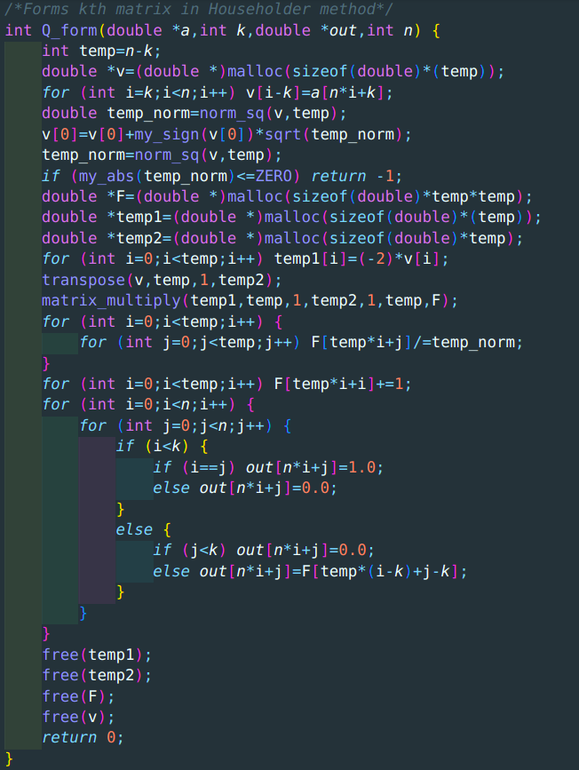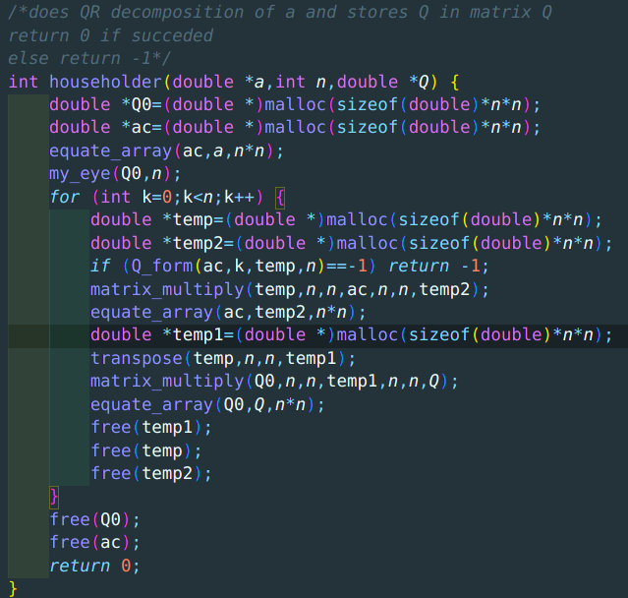

Here is the implication of algorithm -

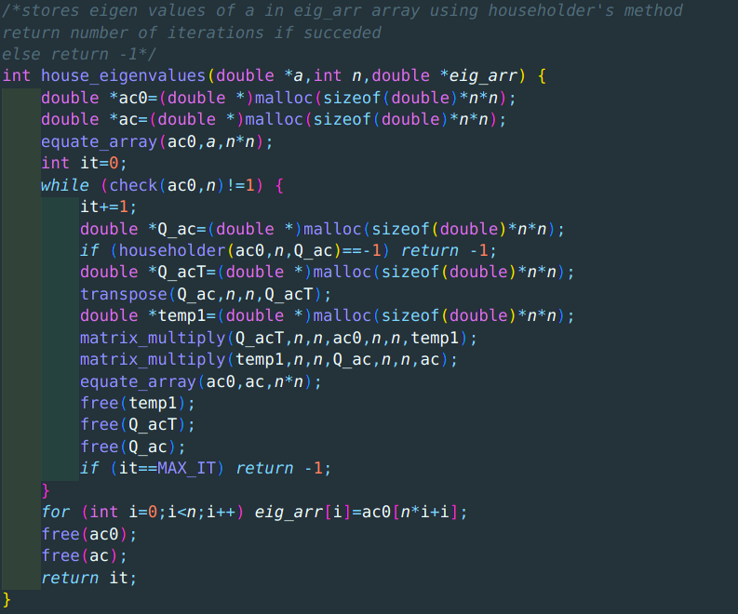

##### Result -

Eigen values are 9.1581, -3.00, -1.7115, -0.4466

Number of iterations - 64

Time taken - 0.001623s

#### Using Heisenberg matrix -

Property of an upper Heisenberg matrix -

$A_{ij}=0 if i>j+1$

Here is the code for finding Heisenberg matrix of A -

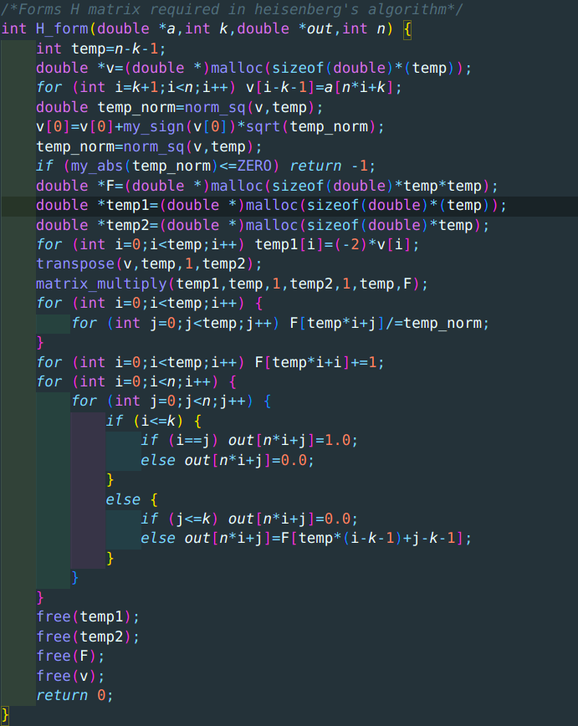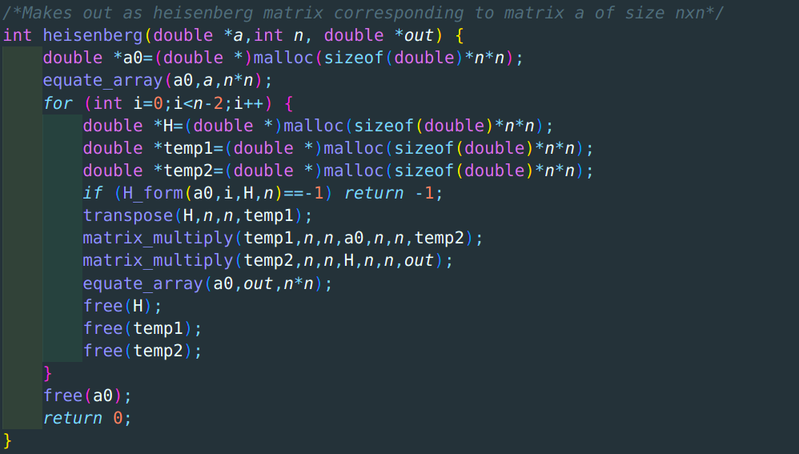

##### Result -

Eigen values are 9.1581, -3.00, -1.7115, -0.4466

Number of iterations - 65

Time taken - 0.001062s