Eigen Values of a Matrix

Objective -
To find the eigen values of a matrix
A = 1 2 3 4
2 1 2 2
3 2 1 3
4 2 3 1

By using -
- QR iteration using Householder’s method
- Find Heisenberg matrix and then use QR iteration method for Heisenberg matrix

QR iteration using Householder’s method -
Here is the algorithm for this method -
$A_{0}=A$
Loop until $A_{0}$ becomes lower diagonal matrix.
$$A_{0}=QR$$
$$A_{1}{=Q^{T}A}_{0}Q$$
$$A_{0}=A_{1}$$

Diagonal elements
of matrix $A_{0}$ are the eigen values of A
Matrix Q of a matrix A can be found by following code -
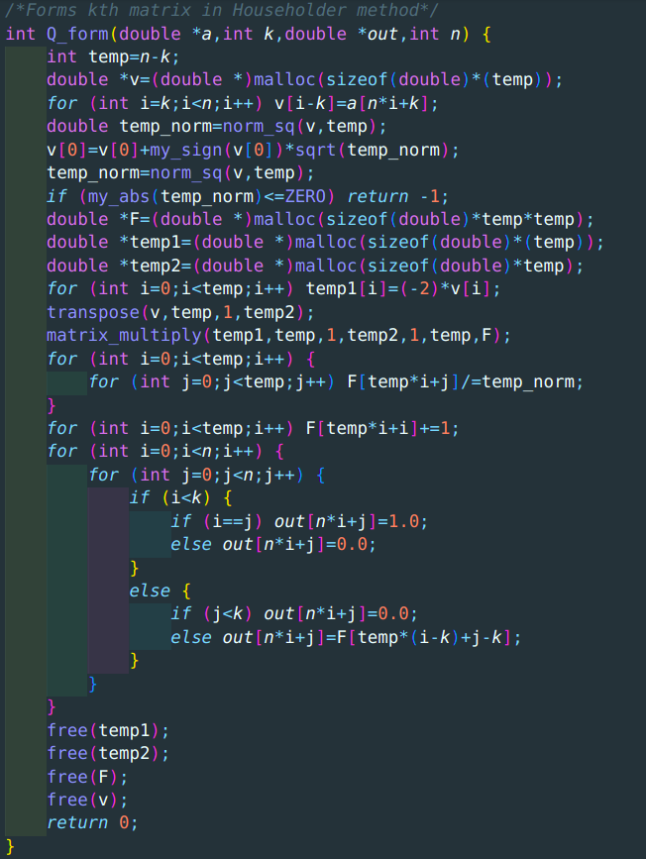

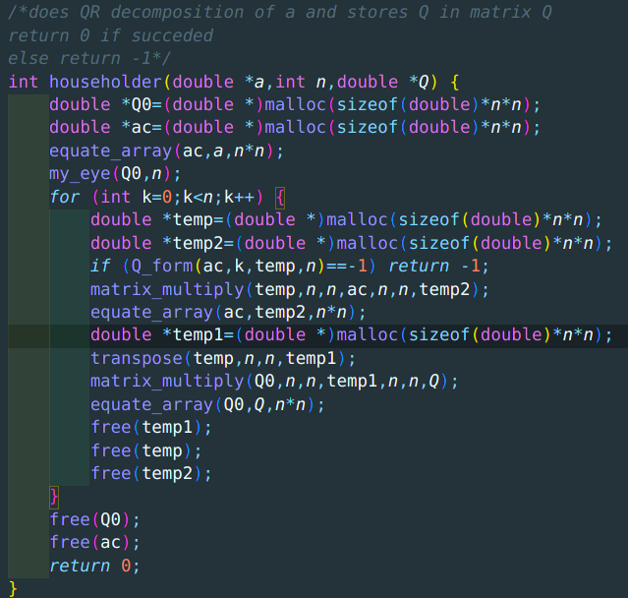

Here is the implication of algorithm -
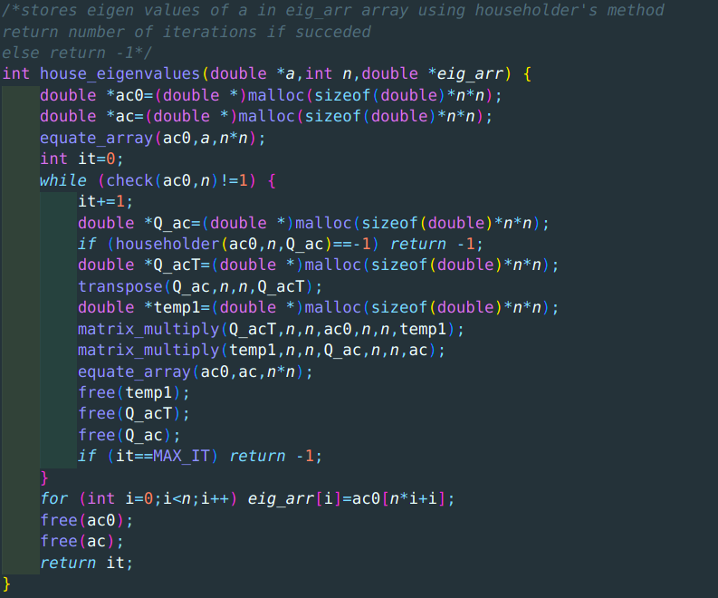

Result -
Eigen values are 9.1581, -3.00, -1.7115, -0.4466
Number of iterations - 64
Time taken - 0.001623s

Using Heisenberg matrix -
Property of an upper Heisenberg matrix -
$A_{ij}=0 if i>j+1$
Here is the code for finding Heisenberg matrix of A -

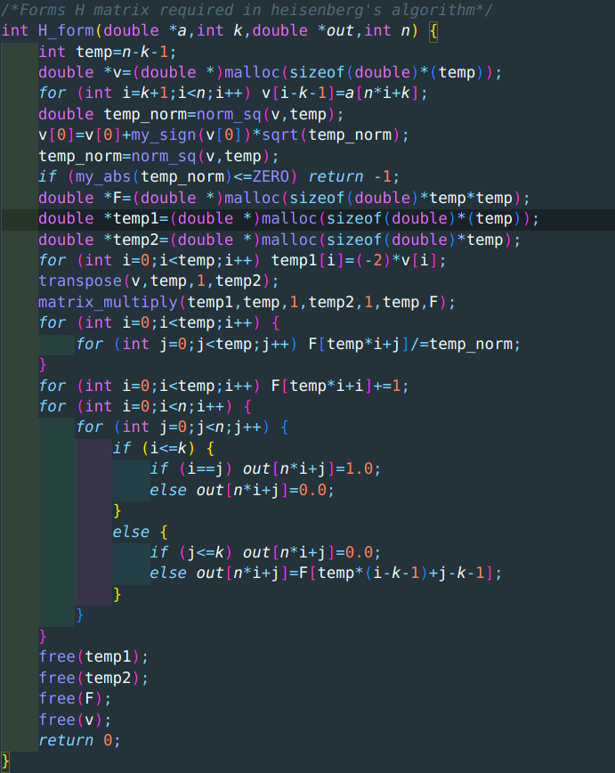
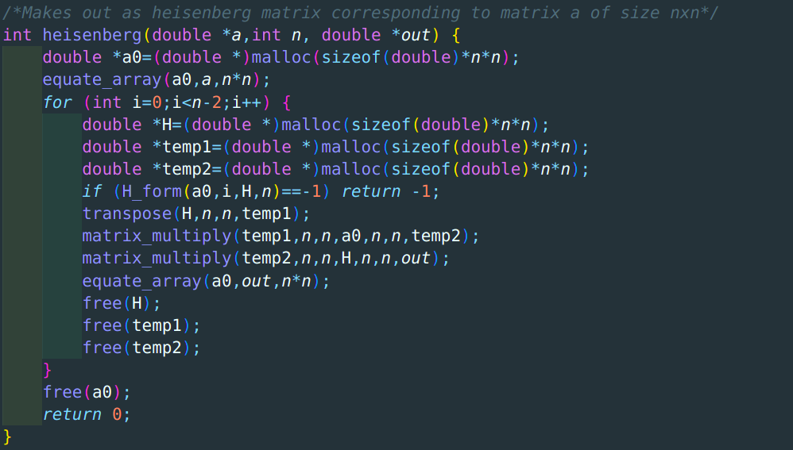

Result -
Eigen values are 9.1581, -3.00, -1.7115, -0.4466
Number of iterations - 65
Time taken - 0.001062s

