**Principal Component Analysis (PCA)**

## Aaryan

## CO21BTECH11001

PCA is a dimensionality reduction technique which tries to identify the subspace in which the data approximately lies.   
Suppose we are given a dataset $\{x^{\left(i\right)};i=1,…,m\}$.  
Let $x^{\left(i\right)}∈R^{n}$ for each i

Usually, some features of the data are strongly co-related with each other, that the data really lies approximately on a lesser dimensional subspace. To detect and perhaps remove this redundancy, we use PCA.

Prior to running PCA, we first pre-process the data to zero out the mean of the data and normalize the variance of the data –

1. Let $μ=\frac{1}{m}\sum_{i=1}^{m}{x^{\left(i\right)}}$
2. Replace each $x^{\left(i\right)}$ with $x^{\left(i\right)}-μ$.
3. Let $σ_{j}^{2}=\frac{1}{m}\sum_{i}{{\left(x_{j}^{\left(i\right)}\right)}^{2}}$
4. Replace each $x_{j}^{\left(i\right)}$ with $\frac{x_{j}^{\left(i\right)}}{σ_{j}}$

Let’s suppose that we want to project (n dimensional) data to k dimensional data, where k<n.  
Therefore, we should project the data on k vectors, say $u_{1},u_{2},…,u_{k}$, such that it represents maximum variance of data.

Let $u∈\{u_{1},u_{2},…,u_{k}\}$ and $x^{\left(i\right)}$ be a point in our dataset.

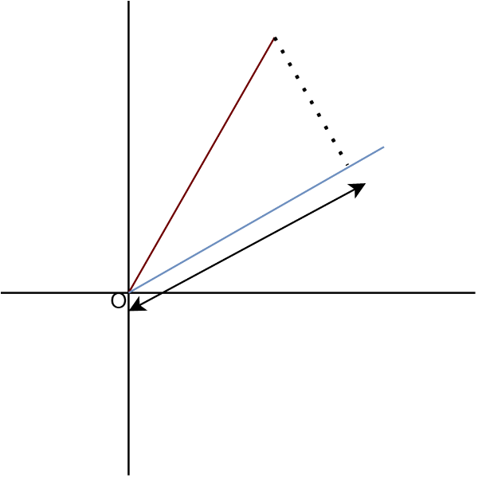The length of projection of $x^{\left(i\right)}$ on $u$ is given by ${x^{\left(i\right)}}^{T}u$.

${\left(x^{\left(i\right)}\right)}^{T}u$

$u$

$x^{\left(i\right)}$

To maximize the variance of the projections, we would like to choose a unit-length vector $u$ so as to maximize: $$\frac{1}{m}\sum_{i=1}^{m}{{\left({x^{\left(i\right)}}^{T}u\right)}^{2}}=\frac{1}{m}\sum_{i=1}^{m}{u^{T}x^{\left(i\right)}{x^{\left(i\right)}}^{T}u}=u^{T}\left(\frac{1}{m}\sum_{i=1}^{m}{x^{\left(i\right)}{x^{\left(i\right)}}^{T}}\right)u$$

Maximizing this s.t. $\left|\left|u\right|\right|=1$, gives principal eigen vector of $$∑=\frac{1}{m}\sum_{i=1}^{m}{x^{\left(i\right)}{x^{\left(i\right)}}^{T}}$$  
which is empirical covariance matrix of the data.

Therefore $u_{1},u_{2},…,u_{k}$ are top k eigen vectors of $∑$ i.e., eigen vectors corresponding to k dominant eigen values of $∑$.

To represent $x^{\left(i\right)}$ in this basis, $$y^{\left(i\right)}=\left[\begin{matrix}u_{1}^{T}x^{\left(i\right)} \\ u_{2}^{T}x^{\left(i\right)} \\ . \\ . \\ u_{k}^{T}x^{\left(i\right)}\end{matrix}\right]∈R^{k}$$

**Questions –**

1. PCA is a feature selection technique  
   (a) True  
   (b) False  
   **Ans.** (b)  
   In**PCA,** we obtain**Principal Components axis,** this is a**linear combination**of **all**the**original set**of feature variables which defines a new set of axes that explain most of the **variations**in the data. Therefore, it doesn’t result in development of a model that relies upon a **small set**of the original features.
2. Why is it important to standardize the data before applying PCA?  
   **Ans.** If we use features of different scales, we get misleading directions. So, we do standardization to assign equal weights to all the variables.
3. What is a good way to select how many dimensions to keep?  
   **Ans.** Calculate the proportion of variance for each feature, pick a threshold (say 90%), and add features until you hit that threshold.
4. List 2 advantages of Dimensionality reduction.  
   **Ans.** Less misleading data means model accuracy improves.  
   Less data means less storage space required.
5. List 2 dis-advantages of Dimensionality reduction.  
   **Ans.** Some information is lost.  
   It makes the independent variables less interpretable.
6. What is the major dis-advantage of PCA.  
   **Ans.** It doesn’t work well for non linearly correlated data.