**Date of submission:**

**Batch: a1 Roll No.: 16010123011**

**Div:A**

**Student Name:**

**Group Members:**

**1)Aaryan dubey**

**2)Aarya shevale**

**Mini_Project Report**

**Staff In-charge:**

|  |
| --- |
| **TITLE:** Application Web Development …………………………… |

**Literature Review:**

Web-based restaurant booking platforms have gained popularity due to their 24/7 availability, user-friendly interfaces, and ability to integrate with other restaurant management tools. A report by the Hospitality Technology Association (2022) found that over 70% of diners between the ages of 20 and 40 prefer making reservations online rather than by phone. Popular platforms like OpenTable and Resy offer features like real-time table availability, customer reminders, and automated confirmations, which reduce no-shows and help manage busy times efficiently.

Despite these advantages, many existing systems are built for large or high-end restaurants and may not suit smaller or local establishments. These platforms often charge subscription fees or take commissions per booking, which can be a burden for small businesses. Additionally, some restaurants may have privacy or customization concerns when using third-party services.

**Need Statement:**

While digital table booking tools are widely available, there is a need for a simple, self-hosted solution that provides essential booking features without the cost or complexity of third-party platforms. Many small or medium-sized restaurants seek a tool that is:

* Easy to use for both staff and customers
* Customizable to match the restaurant’s branding and needs
* Accessible from any device through a web browser
* Free from ongoing subscription costs or commissions

The proposed Restaurant Table Booking System aims to fill this gap by offering a lightweight, self-hosted web application that helps restaurants manage reservations efficiently. It gives restaurants full control over their data and provides a convenient booking experience for their customers without requiring advanced technical knowledge.

**Objectives:**

1. Develop a secure user authentication system
2. Create an intuitive expense logging interface
3. Implement dashboard visualizations
4. Design a responsive UI for all devices
5. Build a maintainable, modular codebase
6. Ensure data security with validation and encryption

**Step by step Flow of Application requirement:**

### ****User Table Booking Process****

1. User navigates to the table booking form.
2. User enters details (name, email, mobile number, booking date, time, number of guests).
3. System validates the input format.
4. Upon successful validation, booking request is submitted.
5. Confirmation message is displayed, and booking request enters the system.

### ****Admin Login Process****

1. Admin navigates to the login page.
2. Admin enters registered username and password.
3. System validates credentials.
4. If valid, admin is redirected to the dashboard.
5. If invalid, appropriate error message is displayed.

### ****Admin Dashboard Features****

1. **View Bookings:** Admin can see all submitted bookings with user details.
2. **Manage Bookings:** Admin can accept or reject bookings and add remarks.
3. **Rejected Bookings:** Separate section to view declined reservations.
4. **Accepted Bookings:** Section displaying confirmed reservations.
5. **Change Password:** Admin can update their login credentials.
6. **Logout:** Securely logs out of the system.
7. **Add Sub-Admins:** Admin can create new sub-admin accounts for delegation.

**Figma design:**

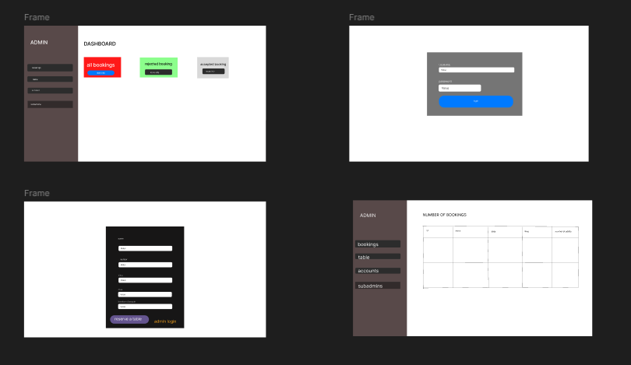

**Database Schema**

**Table: tbladmin**

* **ID** *(Primary Key, Auto Increment)*
* **AdminName** *(VARCHAR, 120)*
* **AdminuserName** *(VARCHAR, 20)*
* **MobileNumber** *(BIGINT, 10)*
* **Email** *(VARCHAR, 120)*
* **Password** *(VARCHAR, 120)*
* **AdminRegdate** *(TIMESTAMP, Default: CURRENT_TIMESTAMP)*
* **UserType** *(INT, 1)*

**Table: tblbookings**

* **ID** *(Primary Key, Auto Increment)*
* **BookingNo** *(BIGINT, 12)*
* **FullName** *(VARCHAR, 200)*
* **EmailId** *(VARCHAR, 200)*
* **PhoneNumber** *(BIGINT, 12)*
* **BookingDate** *(DATE)*
* **BookingTime** *(VARCHAR, 100)*
* **NoAdults** *(BIGINT, 20)*
* **NoChildrens** *(BIGINT, 20)*
* **TableId** *(INT, Foreign Key to tblrestables.ID)*
* **AdminRemark** *(VARCHAR, 255)*
* **BookingStatus** *(VARCHAR, 15)*
* **PostingDate** *(TIMESTAMP, Default: CURRENT_TIMESTAMP)*
* **UpdationDate** *(TIMESTAMP, Updates on modification)*

**Table: tblrestables**

* **ID** *(Primary Key, Auto Increment)*
* **TableNumber** *(VARCHAR, 100)*
* **CreationDate** *(TIMESTAMP, Default: CURRENT_TIMESTAMP)*
* **AddedBy** *(INT, Foreign Key to tbladmin.ID)*

**Screen Shots of developed Application :**

**Table booking page:**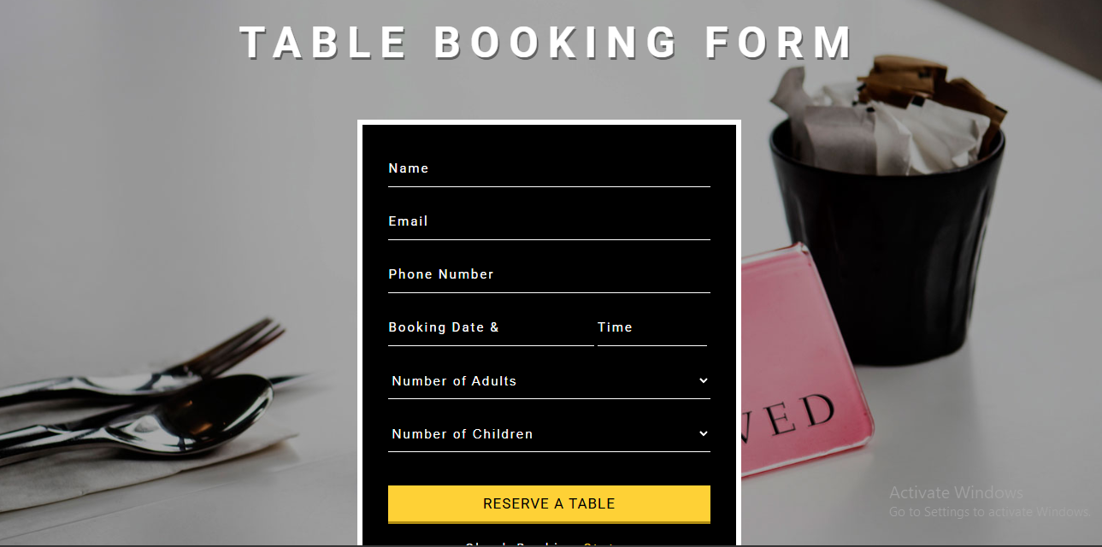

**Core Functionality Pages**

admin dashboard:  
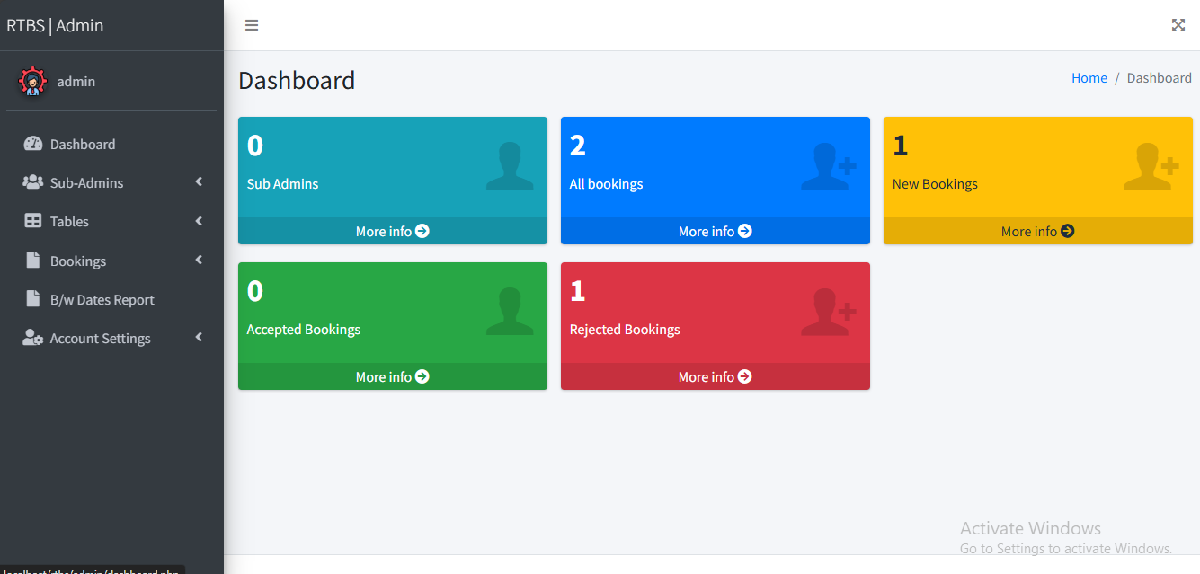

manage subadmins page:

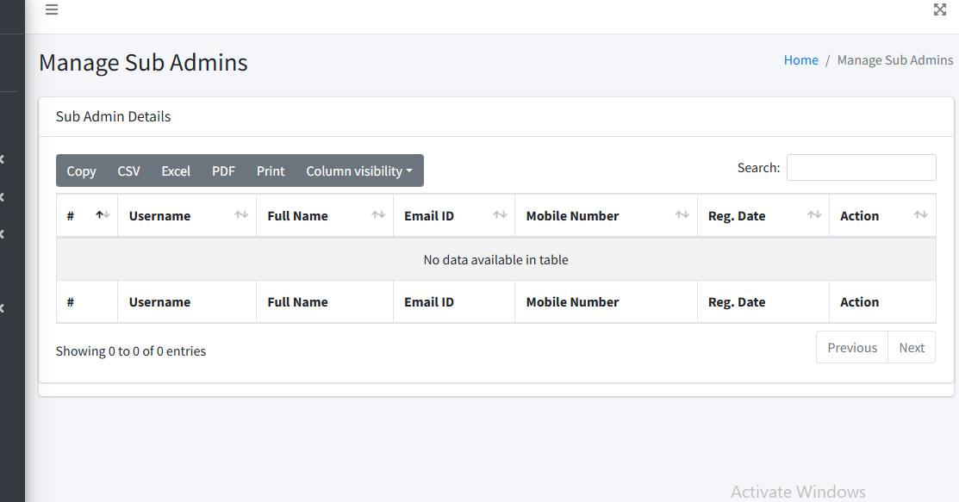

All bookings page:

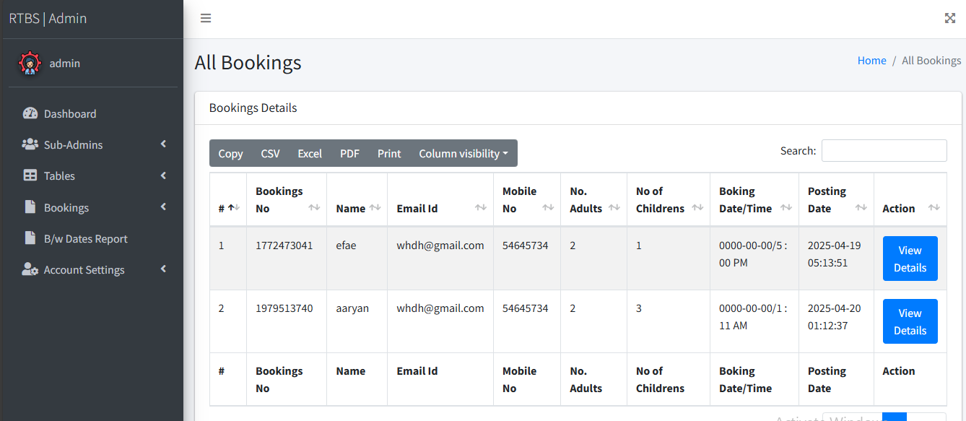

Rejected bookings page:

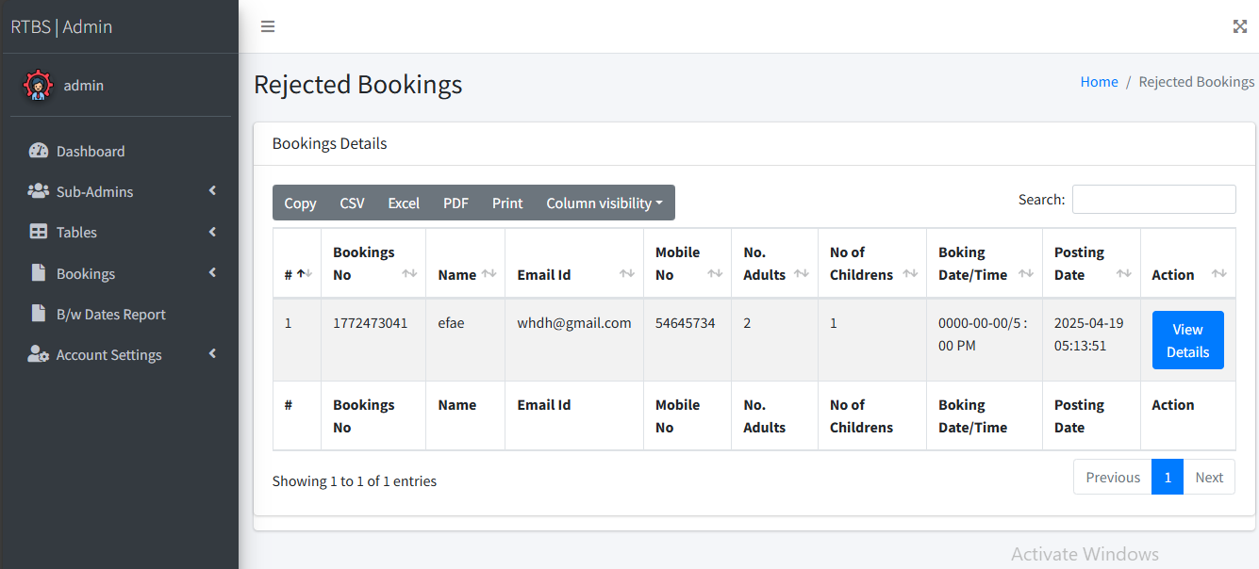

# B/w Dates Report page:

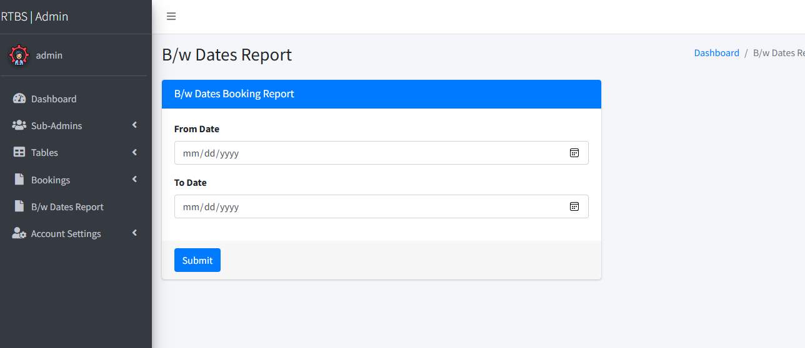

Change password page:

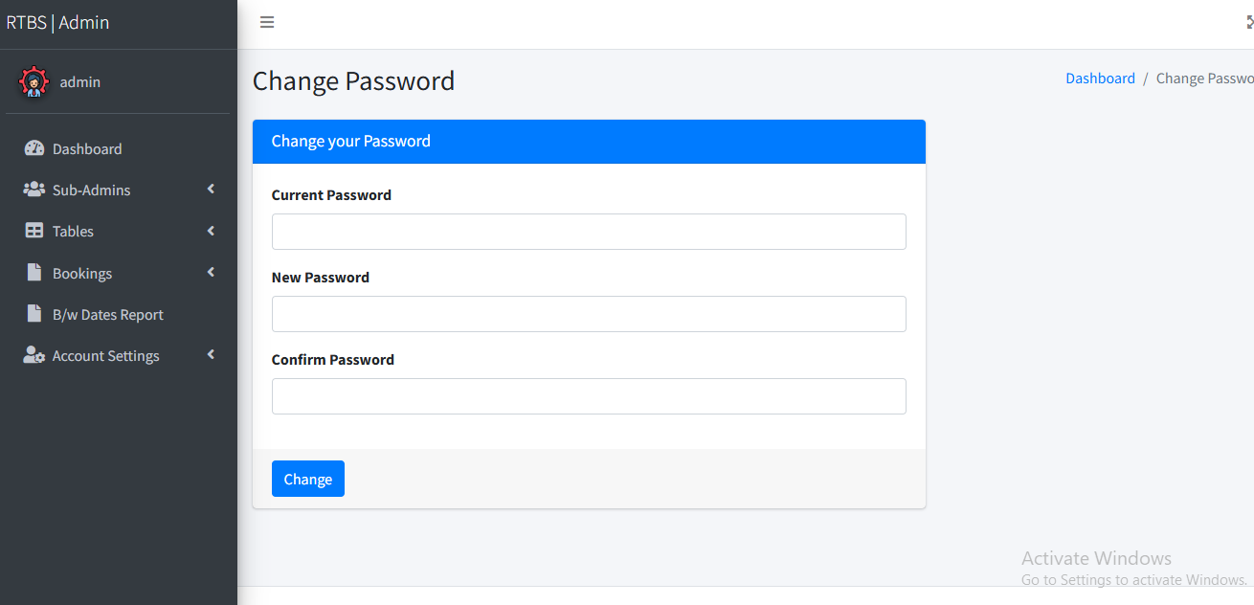

Admin login page:

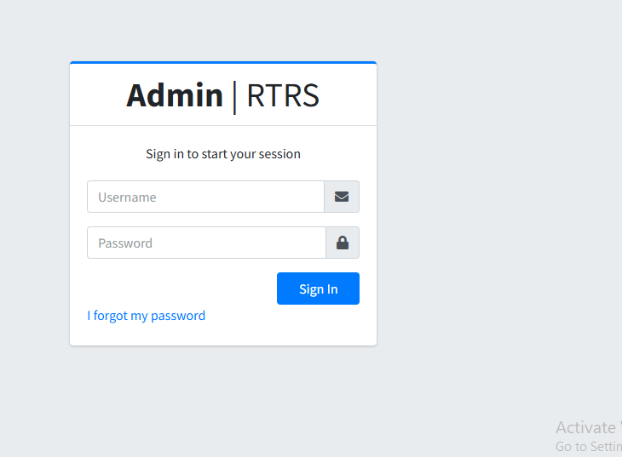

Accepted bookings page:

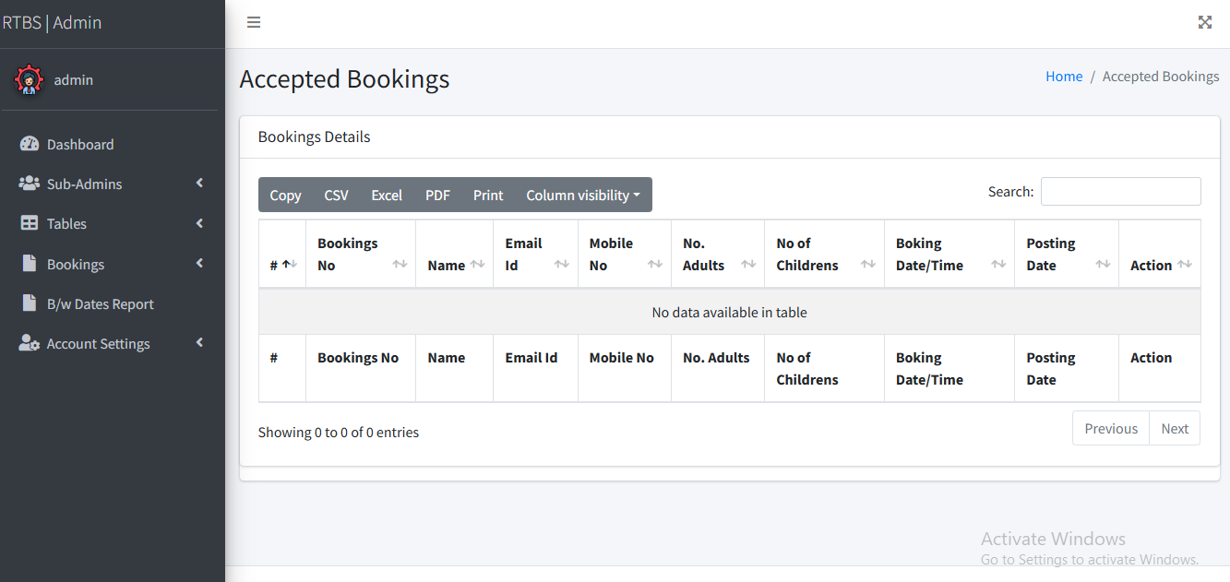

**Updated Github repository link:**

[**https://github.com/aaryan2604/table-booking-website**](https://github.com/aaryan2604/table-booking-website)

**Conclusion:**

The Restaurant Table Booking website simplifies the reservation process, making it easy for customers to secure a table without hassle. With a clean and user-friendly design, the platform ensures smooth booking experiences while providing real-time updates on availability.

Built using PHP and MySQL, the system offers a lightweight and efficient solution that can be easily deployed, allowing restaurant owners full control over their reservations. Its responsive layout ensures accessibility across devices, enabling users to book tables on-the-go or manage reservations from a desktop.

By prioritizing user experience and security, the website provides a reliable and convenient way for customers to reserve tables, reducing waiting times and improving overall service efficiency for both diners and restaurant managers.

**Future scope:**

• **AI-Powered Reservations** – Implement machine learning to suggest optimal booking times based on past trends and real-time restaurant occupancy.

• **Automated Waitlist System** – Introduce a smart waitlist that notifies users when a table becomes available.

• **Seamless Payment Integration** – Allow users to pay for bookings in advance or split bills digitally through payment gateways.

• **Loyalty & Rewards System** – Offer discounts, rewards points, or personalized offers based on frequent bookings.

• **Voice & Chatbot Assistance** – Enable table reservations via voice commands or AI-powered chatbots for a smoother booking experience.

• **Multi-Restaurant Support** – Expand the system to allow booking across multiple restaurants with unified management.

• **Customizable Dining Preferences** – Let users specify preferences such as seating location, ambiance, or dietary requirements.

• **Social Media & Review Integration** – Link booking experiences with social media sharing and real-time reviews.

• **Advanced Analytics for Restaurants** – Provide insights into peak hours, customer demographics, and booking patterns for better decision-making.

• **Mobile App Development** – Launch dedicated Android and iOS apps for seamless booking and notifications.

**Individual Contribution:**

|  |  |  |
| --- | --- | --- |
| **Name** | **Roll Number** | **Contribution** |
| **Aaryan dubey** | **16010123011** | **Php, mysql,html,css, javascript** |
| **Aarya shevale** | **16010123009** | **Mysql,html,css,bootstrap** |

**References:**

1. Bootstrap : <https://getbootstrap.com/docs/3.3/>
2. PHP Manual. Retrieved from <https://www.php.net/manual/en/>
3. Incorporated jQuery JavaScript into the website to enhance functionality and improve user interactions. referenced from:
   1. <https://learn.jquery.com/jquery-ui/getting-started/>
   2. <https://www.geeksforgeeks.org/jquery-ui/>
   3. <https://jquery.com/>