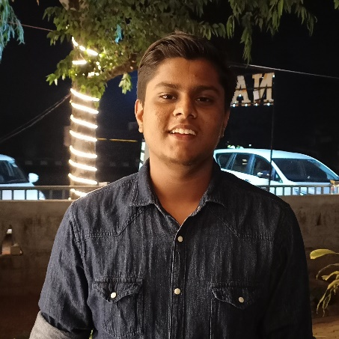RepèreÉcranEnveloppeCombiné

I am a passionate person pursuing engineering from Bhilai Institue of Technology, Durg in Electronics and Telecommunication. I have an experience of over two years in the field of Web Development and have worked on over 20 professional projects as a Frontend Developer.

SENIOR DEVELOPER - TechEffin – Raipur, Chhattisgarh

I have worked as a frontend developer and have contributed to the making of several websites.

Major accomplishments:

* Got to work on professional projects.

**EXPERIENCE**

July 2020

- Present

TECHNICAL HEAD - TEDxBITD - Durg, Chhattisgarh

Since being appointed as the Technical Head, I have worked on the complete design of the official website of TEDxBITD.

Major accomplishments:

* Enhanced my Leadership qualities.

Jan 2021

- Present

10th – St. Xavier’s High School – Raipur, Chhattisgarh

I scored an aggregate of 82.6% overall with 96 marks in Computer Science.

**EDUCATION**

2017

12th – St. Xavier’s High School – Raipur, Chhattisgarh

I scored an aggregate of 92.25% overall with 100 marks in Computer Science. Also, I was the overall topper of my school.

2019

[techeffin.com](http://www.techeffin.com)

[technohubbit.in](http://www.technohubbit.in)

[pcsinfralogistics.com](http://www.pcsinfralogistics.com)

**PROJECTS**

2020

[tedxbitd.in](http://www.tedxbitd.in)

[kavadrug.in](http://www.kavadrug.in)

2021

Raipur, Chhattisgarh

[aaryan610.github.io/portfolio](http://www.aaryan610.github.io/portfolio)

aaryankhandu123@gmail.com

+91 8103445828

**SKILLS**

mySQL

php

React JS

SCSS

JavaScript

CSS3

HTML

**INTERESTS**

PROGRAMMING

CRICKET AND VOLLEYBALL

When it comes to sports, I have always enjoyed playing these two the most and have also represented my school in Cricket and Volleyball.

I have developed a keen interest in programming since standard 8th, and I enjoy every bit of it.

**Aaryan Khandelwal**

**WEBSITE DESIGNER**