
SVKM’s NMIMS
Mukesh Patel School of Technology Management & Engineering /
School of Technology Management & Engineering
Year: Fourth | Program: BTI (CE) | Semester: VII
Subject:- Data Structures & Algorithms Lab

CipherChaos:Secure Two-Device Messaging
Team Details
Name | Aarya Nadiger | Jairus Jinu | Tanish Parikh
Roll No | C004 | C024 | C025
SAP ID | 70322300132 | 70322300020 | 70322300074
BTI (Computer Engineering)
Fourth Year, Semester VII
Faculty: Prof Priti Rumao
AY 2026-27
INDEX
Sr. No. | Topic | Page No.
1 | Introduction | 3
2 | Problem Statement | 3
3 | Need for Data Structures | 4
4 | Justification for Data Structure Selection | 4
5 | Progress Review (Week 10/11) | 5–6
6 | Algorithm / Pseudocode / Flowchart | 7–11
7 | Implementation and Output | 11–12
8 | Future Scope | 12
9 | Conclusion | 12
1 Introduction
CipherChaos in C is a Windows console messaging project implemented in a single C source file. It uses two program instances: a sender that prepares outgoing messages and a receiver that accepts them over TCP. The project demonstrates how a queue, linked list and hash table can operate on related message records.
The sender stores new messages in a FIFO queue and maintains a history of them. The receiver decrypts incoming text and records received messages. Both instances allow the user to display history, find a message by ID and inspect the hash buckets through a console menu.
Implemented objectives
1. Buffer outgoing messages in FIFO order and send either the front message or the full queue.
2. Maintain message history in a linked list.
3. Search message records by ID using a hash table with chaining.
4. Demonstrate shared-key XOR encryption and decryption.
5. Transfer messages using Windows TCP sockets and process delivery acknowledgments.
Project environment
The source uses standard C libraries and the Windows Winsock headers winsock2.h and ws2tcpip.h. The receiver listens on TCP port 5057. Two instances on the same computer use 127.0.0.1; the README also describes using the receiver’s IPv4 address on a local network.
Each outgoing message also receives a simulated pendulum sample generated by rand() % 4096. This value is transmitted with the message; the project does not read a physical sensor.
2 Problem Statement
Develop a menu-driven C application that organizes outgoing messages, sends them in insertion order, retains their history and retrieves them by ID. Demonstrate these operations using linked data structures while transferring XOR-encrypted text between a sender and receiver over TCP.
The implementation is an educational console demonstration. Its encryption consists of XOR with a shared numeric key, and its records remain in memory for the current session.
3 Need for Data Structures
A message has several uses during its lifetime. It may be waiting for delivery, remain available in history after delivery, and need to be found by its identifier. The program uses a separate data structure for each operation while sharing the same message record.
Queue for pending messages
The sender inserts new QueueNode records at the rear and processes them from the front. This preserves FIFO order. A message leaves the queue only after the sender receives its matching acknowledgment, so an unsuccessful transfer keeps the front message available for retry.
Linked list for history
The Message structure contains next, which links history records from head to tail. add_history() appends a new record without traversing the existing list. show_history() visits the records in insertion order and displays their ID, status and text.
Hash table for message lookup
The table has eight buckets. A message ID selects a bucket using id % BUCKETS. Records with the same bucket are chained through hash_next. find_message() searches only that bucket, and its explanation mode prints the bucket calculation and the IDs compared.
4 Justification for Data Structure Selection
A linked queue supports insertion and removal at its ends in O(1) time. It grows through dynamic allocation rather than using a fixed-capacity circular array. Removing a queue node does not remove its message from history.
The singly linked history list supports O(1) append using tail and O(n) display. Its next pointer maintains history order, while hash_next independently maintains bucket chains.
With eight buckets, hash lookup takes O(1 + n/8) expected time under even distribution and O(n) in the worst case. Chains grow as history grows because the bucket count is fixed.
Shared record ownership
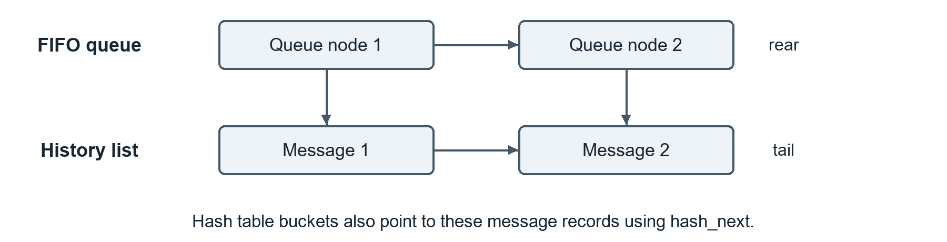
Queue nodes hold pointers to history records. On exit, queue nodes are freed first, then the history records are freed once.
5 Progress Review Week 10 and 11
This review records the implemented features, the project schedule from 12 to 17 October 2026, and the team’s shared responsibilities.
1. Project Planning & Scope
The implemented scope is a Windows console sender and receiver with FIFO queuing, linked history, hash lookup, XOR processing and TCP transfer.
2. Task Completion Status
The implemented work covers the three data structures, sender and receiver operations, menu handling and cleanup. The project period was 12–17 October 2026.
3. Timeline & Schedule
Project start: 12 October 2026. Project end: 17 October 2026. The six-day schedule below organizes the implementation and documentation work.
Date | Scheduled activities
12 Oct | Define the console messaging scope, review requirements and plan the queue, linked list and hash table.
13 Oct | Develop the assigned data structure operations and draft their report explanations.
14 Oct | Develop sender and receiver processing, XOR operations and input handling; integrate the modules.
15 Oct | Review the TCP transfer and acknowledgment flow; prepare sender, receiver and data-operation flowcharts.
16 Oct | Check message delivery, history, lookup and queue behavior; document program output and architecture.
17 Oct | Review the integrated program, assemble the report and complete the final documentation review.
4. Quality of Work
Functions separate input handling, history, queue operations, hash lookup, XOR processing and networking. Input validation and delivery checks support the console workflow.
5. Functionality Progress
Implemented menu operations include adding messages, showing queue and history, finding IDs, displaying buckets, sending one or all messages, and receiving messages.
6. Problem-Solving & Challenges
The reported undefined references to Winsock functions require linking ws2_32. The build command includes -lws2_32. transfer() loops over partial transfers; matching acknowledgments control dequeueing.
7. Documentation
README.md provides features, build instructions, menu usage and local-network setup. This report explains the implemented structures and process.
8. Team Contribution
The responsibilities were divided as follows.
Team member | Implementation responsibilities | Report responsibilities
Aarya Nadiger | Linked-list history and receiver-side message processing, including storing received messages and handling acknowledgments. | Linked-list explanation, receiver flowchart and introduction.
Jairus Jinu | FIFO queue operations and sender-side message processing, including selecting pending messages and removing them after acknowledgment. | Queue explanation, sender flowchart and problem statement.
Tanish Parikh | Hash-table insertion and lookup, XOR encryption and decryption, and console input validation. | Hash-table and XOR explanations, data-operation flowcharts and conclusion.
Equal participation: All three members shared implementation and documentation work equally, handling their assigned data structure operations and supporting application logic.
Communication and coordination: All three jointly integrated the modules, checked message delivery and reviewed the architecture, output and final report. They discussed progress and resolved integration issues together.
Algorithm and Flowcharts
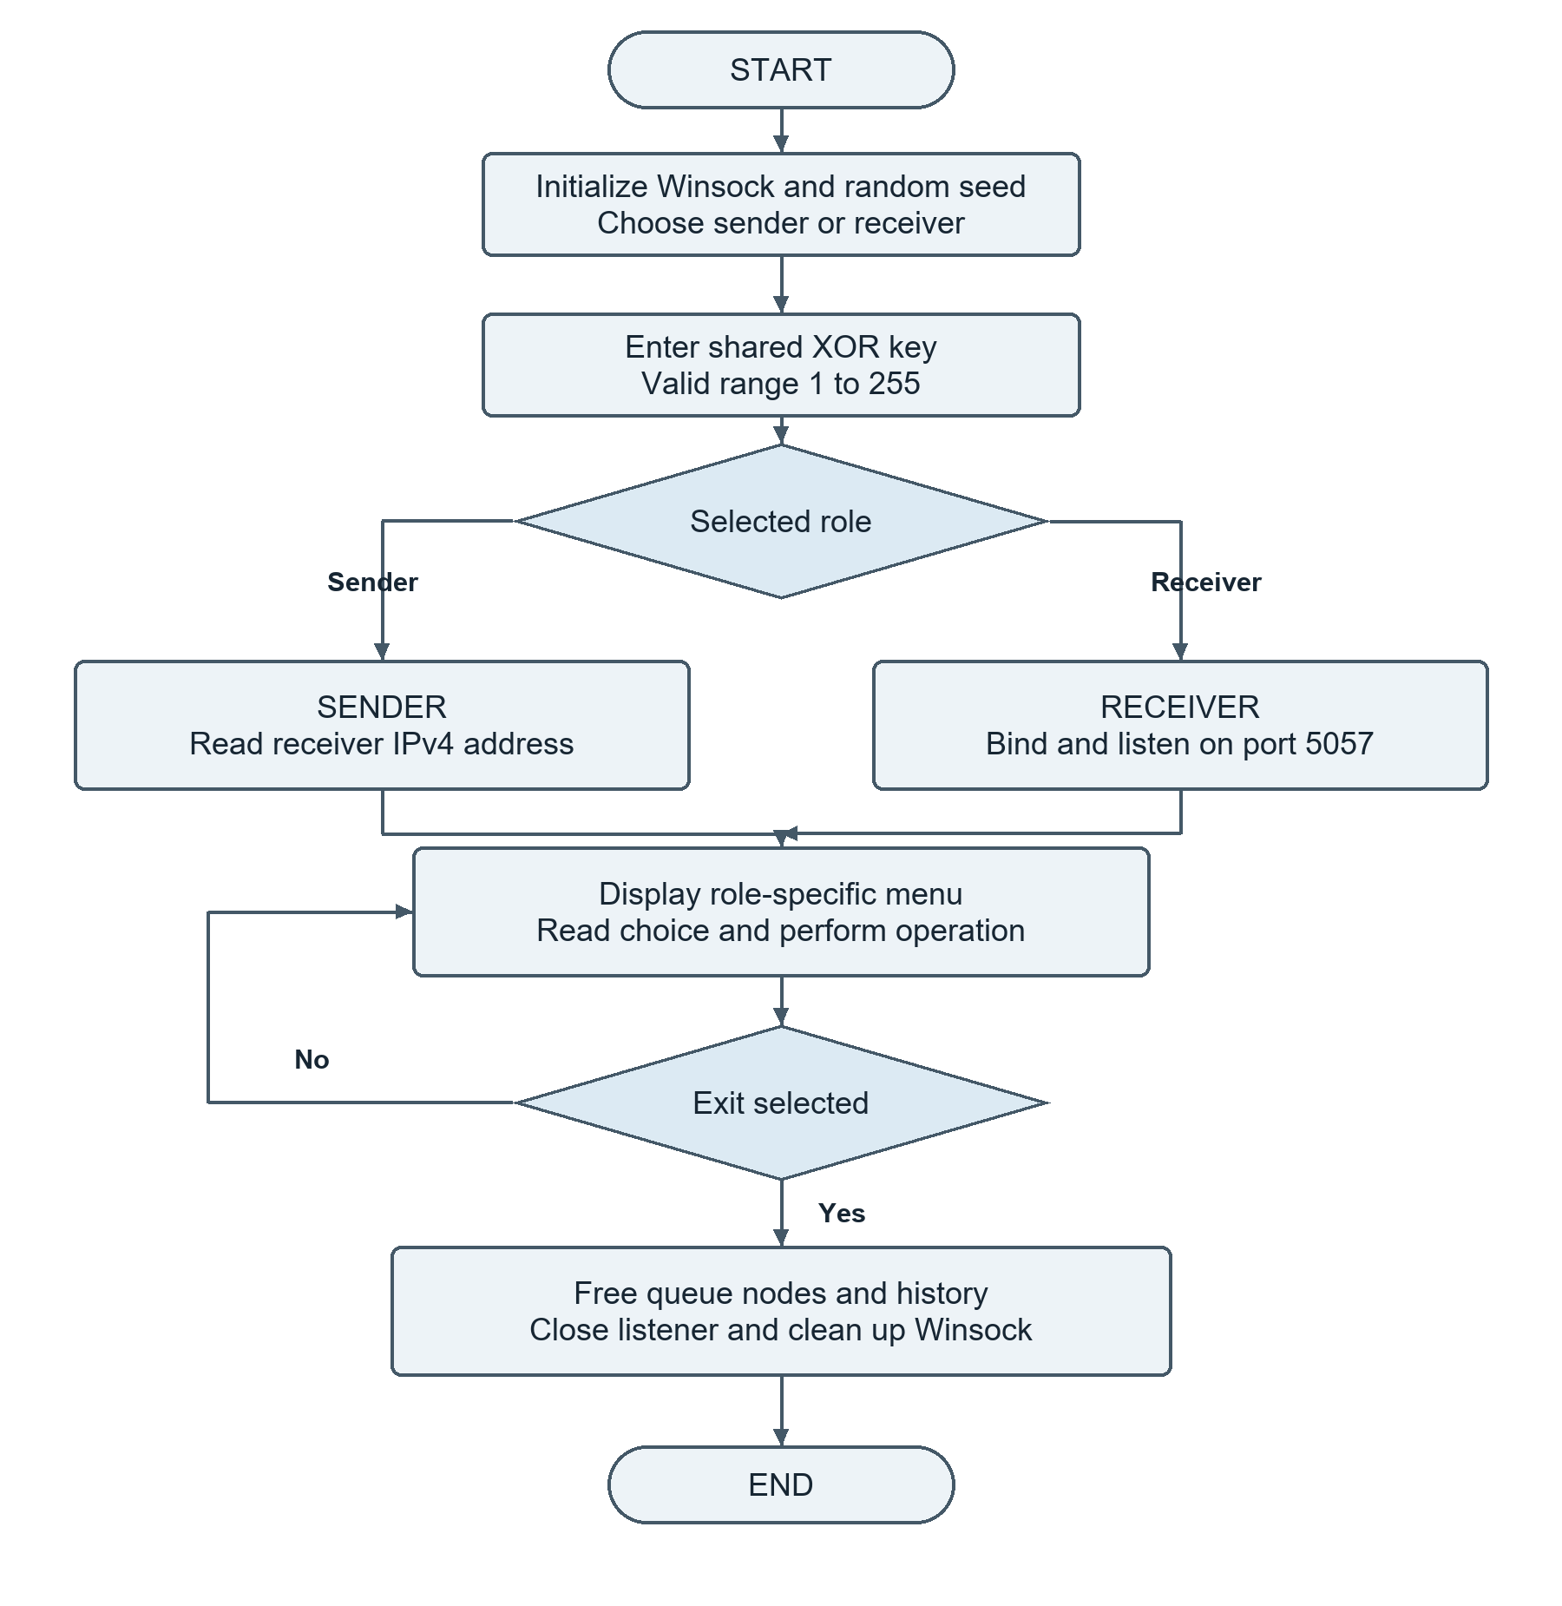
Program startup and menu flow. Initialization or setup errors return from the program.
Data Structure Operations
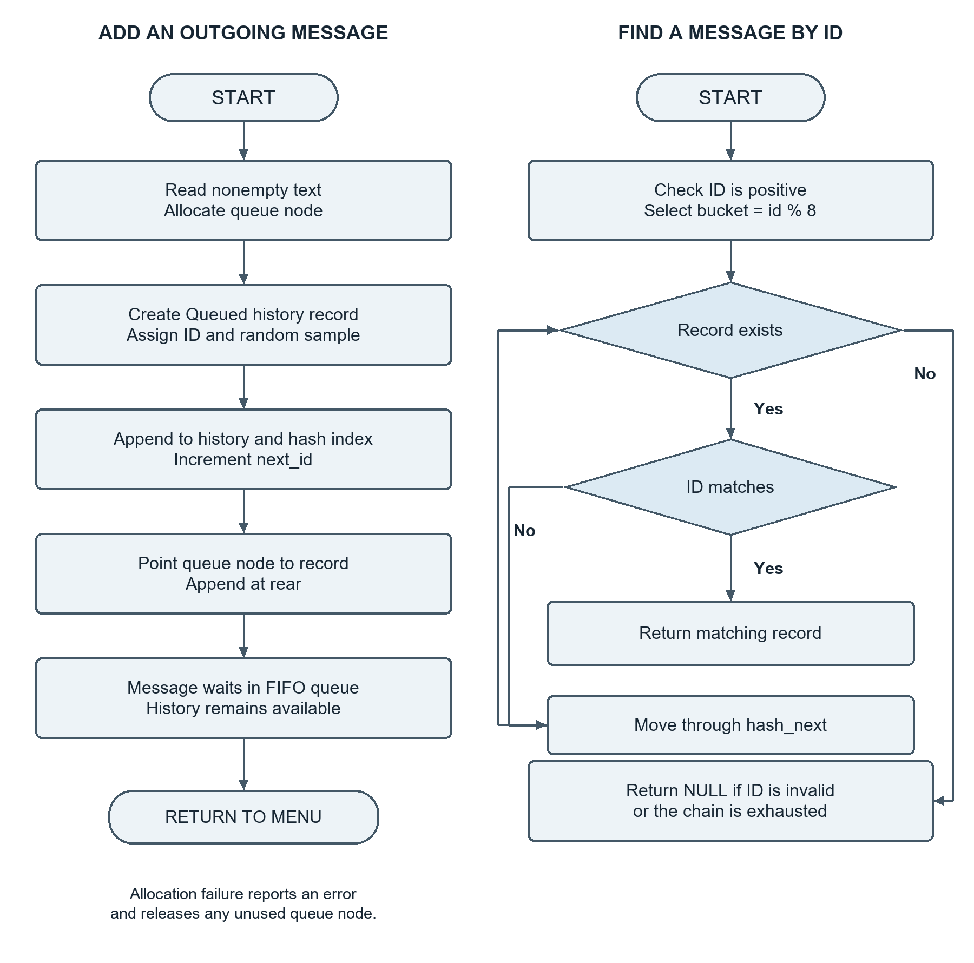
Message insertion and hash lookup. Queue nodes reference history records; hash collisions follow hash_next.
Sender Flowchart
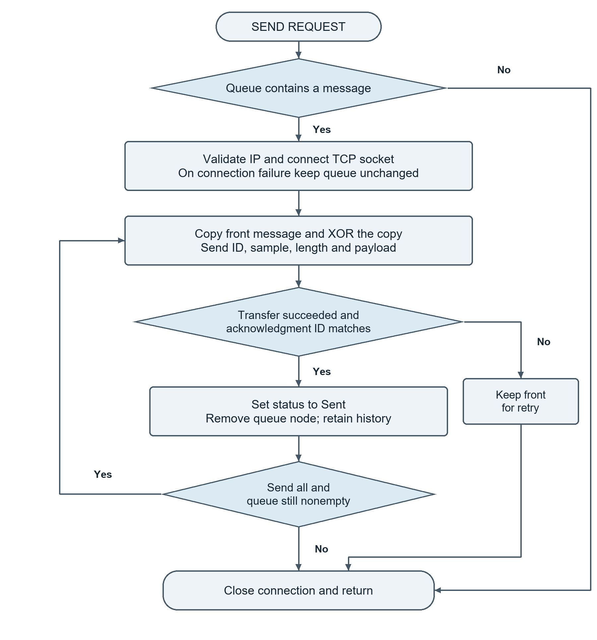
FIFO sending and acknowledgment handling. A failed confirmation retains the front message for retry.
Receiver Flowchart
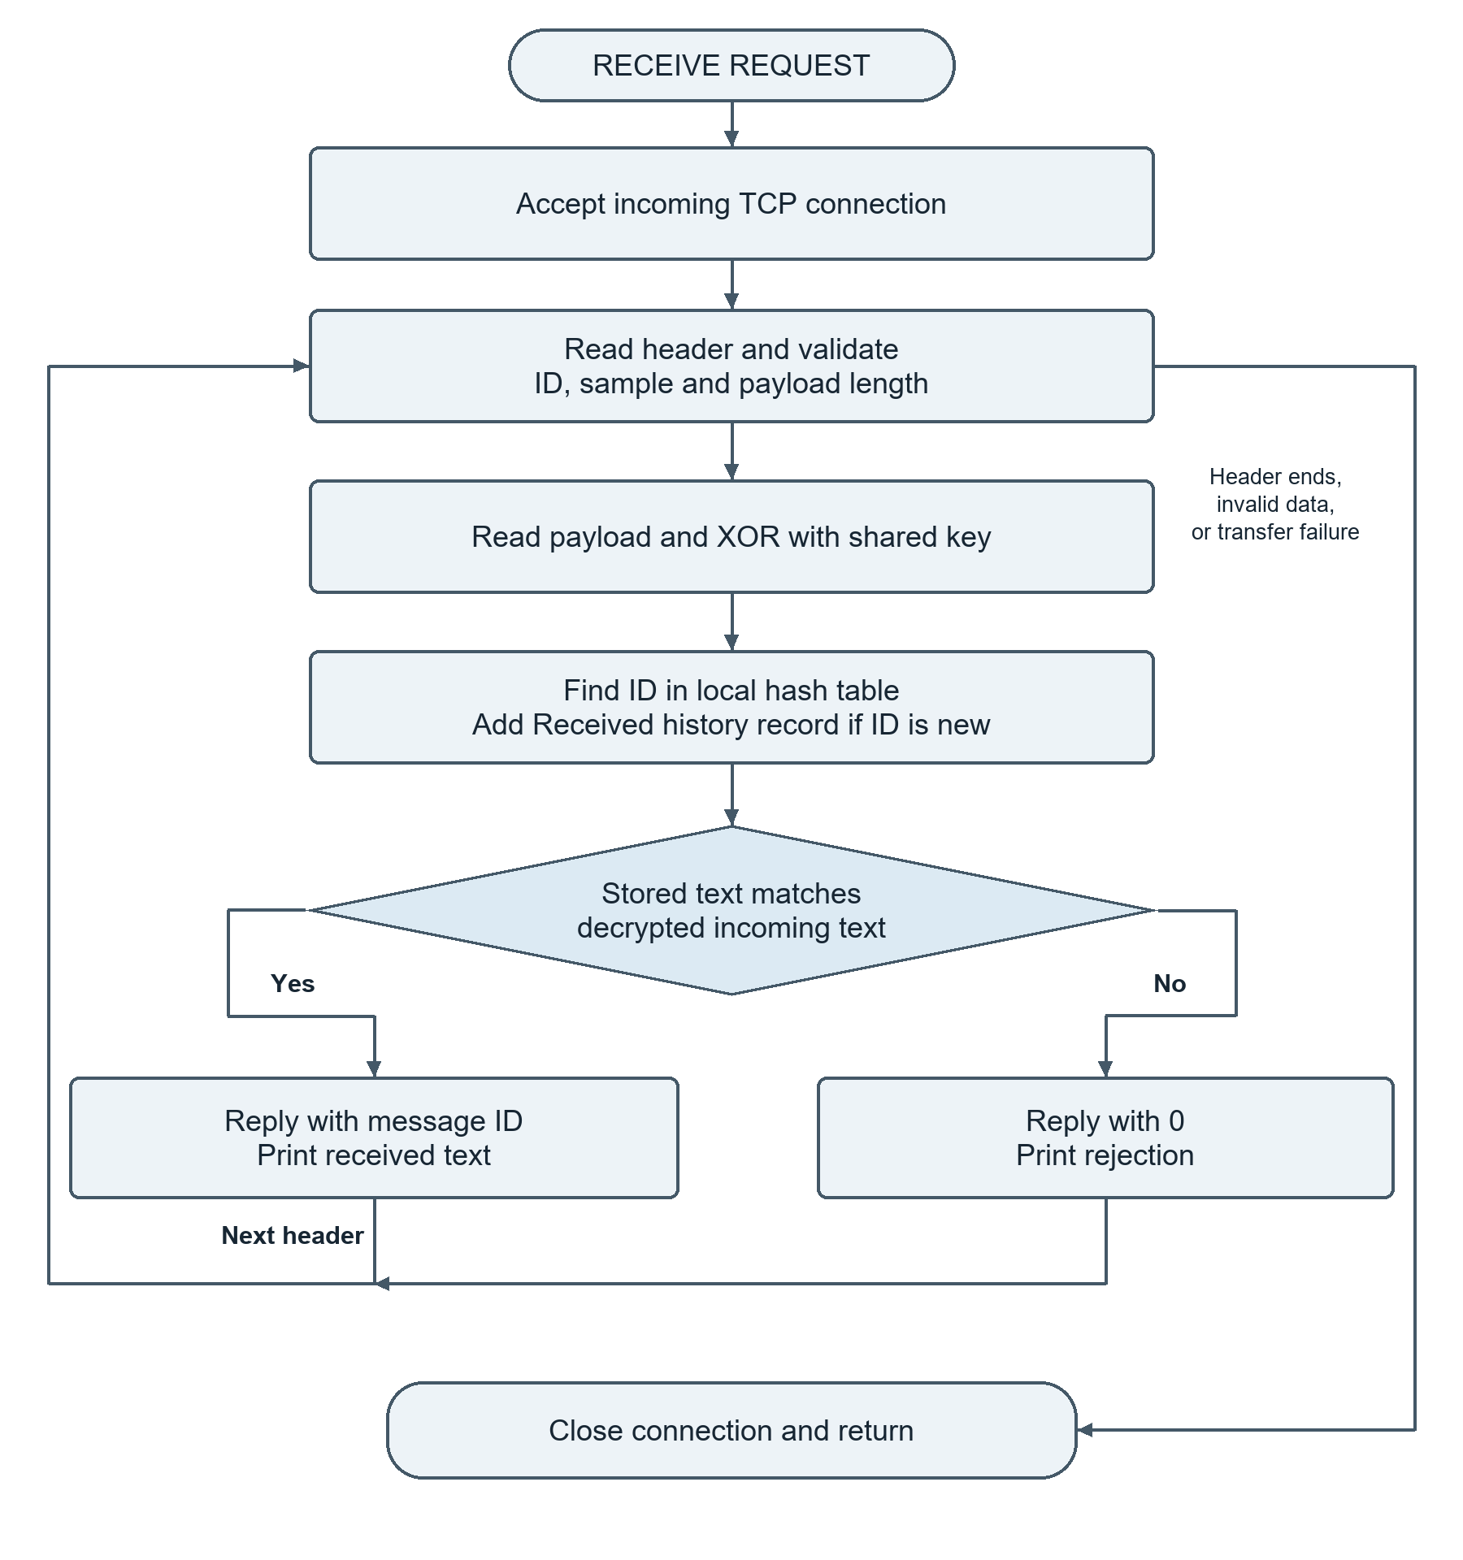
Receiving, XOR decryption, history lookup and acknowledgment. An existing ID with matching text is acknowledged again.
Process Architecture
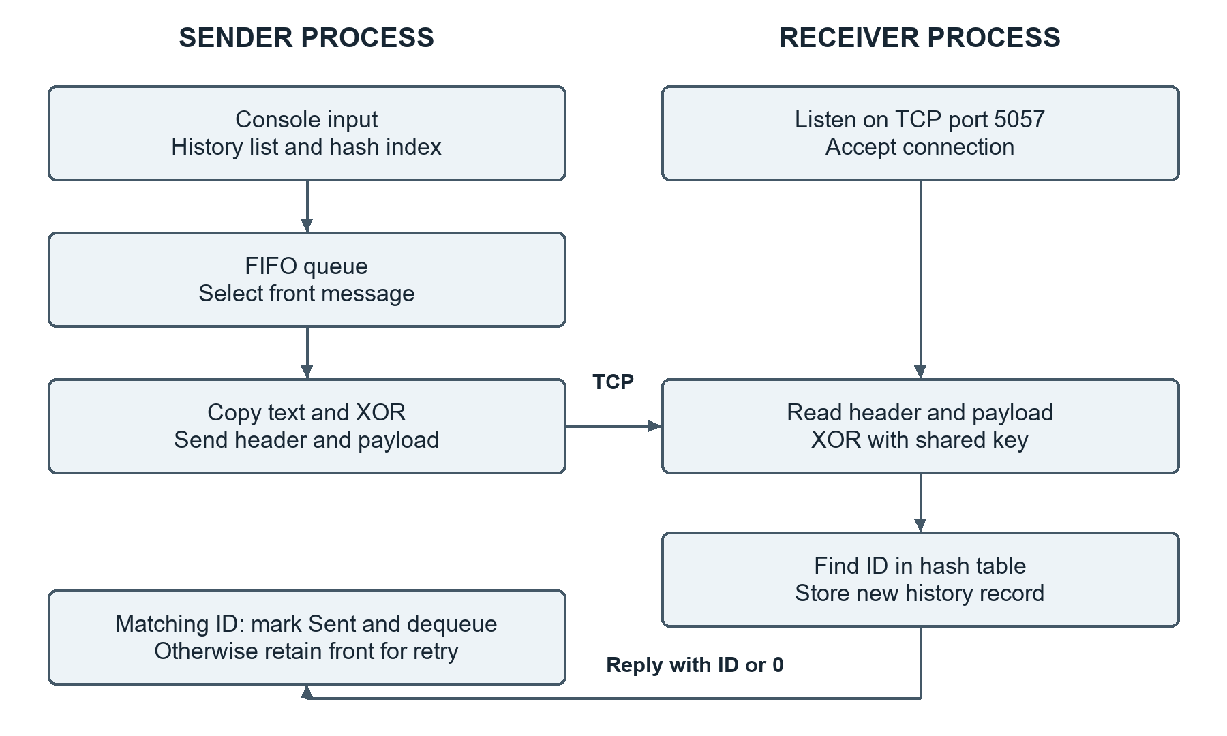
TCP connects two console processes. The header carries ID, sample and payload length; the payload contains XOR-processed text.
7 Implementation and Output
Source organization
main.c contains the implementation. Message stores ID, sample, text, status and history/hash pointers. QueueNode points to a shared history record; head/tail, front/rear and table[8] track the three structures.
Common menu: 1 History | 2 Find ID | 3 Hash table | 0 Exit
Sender: 4 Add | 5 Queue | 6 Send front | 7 Send all
Receiver: 4 Receive messages
Build and run
gcc main.c -o CipherChaosSimple.exe -lws2_32
Code::Blocks linker option: -lws2_32 (Settings > Compiler > Linker settings).
Run two instances with the same key. On the receiver, choose 4 to wait. On the sender, use 127.0.0.1 locally, add messages and select Send front or Send all. Choose Receive again before another connection.
Observed local demonstration
MinGW GCC compiled the source with ws2_32. Two local processes used key 8 and 127.0.0.1 to send Hello and World. These captured excerpts show FIFO delivery, retained history and an empty outgoing queue.
Sender queue and encrypted bytes
FRONT -> [1: Hello] -> [2: World] -> NULL
ID 1 encrypted bytes: 40 6D 64 64 67
Delivered ID 1. Dequeue FRONT; history remains.
ID 2 encrypted bytes: 5F 67 7A 64 6C
Delivered ID 2. Dequeue FRONT; history remains.
ID 1 | Sent | Hello
ID 2 | Sent | World
FRONT -> NULL (REAR is the last node)
Receiver history and search
Received ID 1 | Decrypted: Hello
Received ID 2 | Decrypted: World
ID 1 | Received | Hello
ID 2 | Received | World
Found: Received | Hello
The local check covers FIFO delivery, history, ID lookup and queue removal. Separate-computer operation and exhaustive failure testing were not verified.
8 Future Scope
The current scope is a Windows console program with session-only history. Keys are entered manually, IDs restart at 1, and pendulum samples are simulated. XOR provides an educational demonstration rather than secure encryption.
History supports display and ID search, but no individual deletion. Existing IDs with matching text are acknowledged again; there is no time-based replay window.
9 Conclusion
The queue preserves outgoing order, the linked list retains history, and the hash table retrieves records by ID. TCP carries the header and XOR-processed payload; a matching acknowledgment triggers dequeueing while history remains available.

