A Report on
Signals and Systems

Microphone Speaker Feedback and the Onset of Squeal
Submitted By
Aarya Nadiger - C004 - 70322300132
Jairus Jinu - C024 - 70322300020
Tanish Parikh - C025 - 70322300074

Department of Computer Engineering
Name of the Faculty
Prof. Priyanka Verma


Mukesh Patel School of Technology Management and Engineering
Vile Parle West Mumbai 400056

1 Abstract
This project explains why a microphone near a loudspeaker can produce a growing squeal. We represent the returning sound using a simple continuous time system and compare feedback gains just below and just above a normalized threshold of one. Laplace transforms connect the time signals to their poles. A negative pole real part gives a decaying oscillation, while a positive real part gives a growing oscillation.
The MATLAB program accepts two gain values in the Command Window and uses K = 1 as a fixed threshold reference. For the example inputs 0.98 and 1.02, the pole real parts are -2.5 and +2.5 per second. Over two seconds, the relative levels change by -43.4294 dB and +43.4294 dB. Four figures show the time responses, volume comparison, pole locations, and pitch with resonance.

2 Objective
- Find the Laplace and inverse Laplace transforms of decaying and growing sinusoidal signals.
- Compare the response for two feedback gains using the same initial amplitude.
- Plot the amplitude envelopes and identify the poles on the s plane.
- Relate pole locations to stability using the commands from the Laplace laboratory example.

3 Introduction
Sound from a loudspeaker can return to a nearby microphone and pass through the amplifier and loudspeaker again. If each return reinforces the sound strongly enough, a small disturbance grows. If the return is weaker, the disturbance fades. The frequency that is reinforced depends on the acoustic path.
We use one assumed resonance to demonstrate this effect. The model studies the beginning of squeal; it does not measure the room, microphone distance, or actual sound pressure. The plotted peak amplitude represents the relative volume trend in arbitrary units. No sound is recorded or played.

4 Theory

Feedback model
Let R(s) be the external input, Y(s) the output, and K the normalized feedback gain. For positive feedback, E(s) = R(s) + K Y(s). We assume the following simple resonant acoustic path, where b = 250 per second and w0 = 2 pi f0 with f0 = 1000 Hz.
$$G(s) = \frac{b s}{s^{2} + b s + {w_{0}}^{2}}$$
Using Y(s) = G(s) E(s) and rearranging gives the closed loop transfer function:
$$H(s) = \frac{Y(s)}{R(s)} = \frac{G(s)}{1 - K G(s)}$$
$$H(s) = \frac{b s}{s^{2} + b(1 - K)s + {w_{0}}^{2}}$$
This acoustic path is a modelling assumption. The analysis uses the course topics of system interconnection, Laplace transforms, and differential equations. The characteristic equation is the denominator set equal to zero:
$$s^{2} + b(1 - K)s + {w_{0}}^{2} = 0$$

Poles and free response
Set c = b(1 - K), r = -c/2, and wd = sqrt(w0² - r²). For the gains close to one used here, the poles form a complex conjugate pair:
$$p_{1} = r + j w_{d} p_{2} = r - j w_{d}$$
After a small disturbance, set the external input to zero. The differential equation is y″ + c y′ + w0² y = 0. Choosing y(0) = A and y′(0) = rA gives:
$$y(t) = A e^{rt} cos(w_{d} t) V(t) = A e^{rt}, t ≥ 0$$
V(t) is the peak amplitude envelope. The response oscillates between +V(t) and -V(t). Its magnitude decreases when r < 0 and increases when r > 0. The same pole pair appears in H(s) and in the Laplace transform of this free response. At the assumed resonance, G(jw0) = 1, so the returning signal is in phase with the output at that frequency.
For a causal rational system, all poles strictly in the left half plane give stability. Right half plane poles give instability. At K = 1, the poles lie on the imaginary axis: the free oscillation persists, but the system is not BIBO stable. The program compares one gain on each side of this boundary.

Laplace transform of the plotted signals
The supplied Laplace exercise includes exponential signals multiplied by cosine. The same transform pair explains the two responses. For causal signals starting at t = 0, with a > 0 and angular frequency w:
$$L\{e^{-at} cos(wt)\} = \frac{s + a}{{(s + a)}^{2} + w^{2}}$$
$$L\{e^{at} cos(wt)\} = \frac{s - a}{{(s - a)}^{2} + w^{2}}$$
The causal regions of convergence are Re(s) > -a and Re(s) > a respectively. Multiplication by the initial amplitude A scales each transform. In the example run, a = 2.5 and w = wd. The first denominator has left half plane poles; the second has right half plane poles. The program uses laplace and ilaplace to display and recover these general signal expressions.

5 Methodology
The program follows the simple sequence used in the supplied laboratory code: clear the workspace, define symbolic signals, calculate transforms, form transfer functions, display poles, and check stability. The symbolic parameters a and w are declared positive so the inverse transforms use exponential and cosine signals. Four figures use basic plot commands and subplot layouts.
Parameter | Value
Resonance frequency f0 | 1000 Hz, assumed
Damping coefficient b | 250 per second
Initial amplitude A | 0.001 arbitrary units
Time interval | 0 to 2 seconds
Time step | 1/48000 second
Example input gains | K1 = 0.98 and K2 = 1.02

Input procedure
Open acoustic_feedback.m in MATLAB and click Run. At the first prompt, enter a number between zero and one, such as 0.98, and press Enter. At the second prompt, enter a number between one and 1.1, such as 1.02, and press Enter. These limits keep the demonstration near the selected threshold. They are chosen input limits, not a universal physical limit.
The inputs are single numbers typed in the Command Window. A nonnumeric, complex, nonfinite, blank, or nonscalar input produces an explanatory message and ends the run. The values are normalized gains, not audio files, microphone distances, percentages, or measured speaker volumes. Re-running the program allows a new pair of gains. The frequency and initial amplitude remain fixed for a fair comparison.
The script requires Symbolic Math Toolbox for syms, laplace, and ilaplace, and Control System Toolbox for tf and pzmap, as in the supplied Laplace exercise.
These are illustrative model and plotting values, not measurements from a room or laptop. Only K1 and K2 are entered by the user. The derived values w0, r1, r2, w1, and w2 follow from the constants and the chosen gains.

Relative volume and resonance
The relative amplitude level is expressed in decibels using the following small extension to the main Laplace analysis:
$$ΔL(t) = 20 \log_{10}(\frac{V(t)}{A})$$
A ratio of one gives 0 dB. The reference is the initial amplitude A, so this is relative amplitude level rather than calibrated sound pressure level. Since V(t) is exponential, its decibel level changes linearly with time.
For the resonance plot, substitute s = j2πf into G(s) and plot 20 log10|K G(j2πf)|. At f0 the magnitude of G is one, so the two loop magnitudes are 0.98 and 1.02, lying below and above 0 dB. The phase alignment at f0 and the pole analysis complete the explanation; magnitude alone is not a stability test.

6 MATLAB Implementation

Code
clc;
clear;
close all;
syms t s;
syms a w positive;
x1 = exp(-a*t)*cos(w*t);
x2 = exp(a*t)*cos(w*t);
L1 = laplace(x1,t,s);
L2 = laplace(x2,t,s);
disp('Laplace transform below threshold:'); display(L1);
disp('Laplace transform above threshold:'); display(L2);
y1 = ilaplace(L1,s,t);
y2 = ilaplace(L2,s,t);
disp('Inverse Laplace transforms:');
display(y1);
display(y2);
f0 = 1000;
w0 = 2*pi*f0;
b = 250;
A = 0.001;
K1 = input('Enter gain below threshold (example 0.98): ');
K2 = input('Enter gain above threshold (example 1.02): ');
if ~isnumeric(K1) || ~isscalar(K1) || ~isreal(K1) || ...
~isfinite(K1) || ~isnumeric(K2) || ~isscalar(K2) || ...
~isreal(K2) || ~isfinite(K2)
disp('Enter one finite real number at each prompt and run again.');
return;
end
if K1<=0 || K1>=1 || K2<=1 || K2>=1.1
disp('Use 0 < K1 < 1 and 1 < K2 < 1.1 for this demonstration.');
return;
end
label1 = ['Below threshold K = ',num2str(K1)];
label2 = ['Above threshold K = ',num2str(K2)];
a1 = b*(1-K1);
a2 = b*(1-K2);
r1 = -a1/2;
r2 = -a2/2;
w1 = sqrt(w0^2-r1^2);
w2 = sqrt(w0^2-r2^2);
t = 0:1/48000:2;
v1 = A*exp(r1*t);
v2 = A*exp(r2*t);
v0 = A*ones(size(t));
y1 = v1.*cos(w1*t);
y2 = v2.*cos(w2*t);
y0 = A*cos(w0*t);
figure('Theme','light');
subplot(3,1,1);
plot(t,y1,'b',t,v1,'k--',t,-v1,'k--');
title(label1); ylabel('Amplitude (a.u.)'); grid on;
subplot(3,1,2);
plot(t,y0,'k',t,v0,'k--',t,-v0,'k--');
title('Threshold K = 1.00'); ylabel('Amplitude (a.u.)'); grid on;
subplot(3,1,3);
plot(t,y2,'r',t,v2,'k--',t,-v2,'k--');
title(label2); ylabel('Amplitude (a.u.)'); grid on;
xlabel('Time (s)');
sgtitle('Small disturbance responses and amplitude envelopes');
figure('Theme','light');
subplot(1,2,1);
semilogy(t,v1,'b',t,v2,'r');
title('Decay versus growth'); xlabel('Time (s)');
ylabel('Amplitude envelope (a.u.)'); legend(label1,label2); grid on;
subplot(1,2,2);
plot(t,20*log10(v1/A),'b',t,20*log10(v0/A),'k',t,20*log10(v2/A),'r');
title('Relative level change'); xlabel('Time (s)');
ylabel('Level change from initial value (dB)');
legend(label1,'Threshold K = 1.00',label2); grid on;
num = [b 0];
H1 = tf(num,[1 a1 w0^2]);
H2 = tf(num,[1 a2 w0^2]);
p1 = pzmap(H1);
p2 = pzmap(H2);
p0 = [1i*w0; -1i*w0];
kg = linspace(K1,K2,101);
rg = -b*(1-kg)/2;
wg = sqrt(w0^2-rg.^2);
xr = 1.5*max(abs([r1 r2]));
figure('Theme','light');
for panel = 1:2
subplot(1,2,panel);
plot(rg,wg,'k-',rg,-wg,'k-'); hold on;
plot(real(p1),imag(p1),'bx','MarkerSize',10);
plot(real(p0),imag(p0),'kx','MarkerSize',10);
plot(real(p2),imag(p2),'rx','MarkerSize',10);
plot([0 0],[-7000 7000],'k--');
xlim([-xr xr]); xlabel('Real part (1/s)');
ylabel('Imaginary part (rad/s)'); grid on;
if panel==1
ylim([-7000 7000]); title('Closed loop poles in the s plane');
else
ylim([min([w1 w2])-0.001 w0+0.001]);
title('Upper pole enlarged near the crossing');
text(r1,w1+0.0002,['K = ',num2str(K1)]);
text(0,w0+0.0002,'K = 1.00');
text(r2,w2+0.0002,['K = ',num2str(K2)]);
end
end
figure('Theme','light');
subplot(1,2,1);
ts = 0:1/48000:0.005;
ys = A*exp(r2*ts).*cos(w2*ts);
plot(ts*1000,ys,'r'); grid on;
title('Five cycles in five milliseconds');
xlabel('Time (ms)'); ylabel('Amplitude (a.u.)');
subplot(1,2,2);
f = 500:0.2:1500;
s = 1i*2*pi*f;
G = (b*s)./(s.^2+b*s+w0^2);
plot(f,20*log10(abs(K1*G)),'b',f,20*log10(abs(K2*G)),'r'); hold on;
plot([500 1500],[0 0],'k--'); grid on;
title('Loop resonance near 1 kHz');
xlabel('Frequency (Hz)'); ylabel('Loop magnitude (dB)');
legend(label1,label2,'Unity loop magnitude');
format short g;
disp('Poles below threshold:'); display(p1);
disp('Poles above threshold:'); display(p2);
if all(real(p1)<0)
disp(['K = ',num2str(K1),': System is STABLE']);
else
disp('Below-threshold system is not asymptotically stable');
end
if any(real(p2)>0)
disp(['K = ',num2str(K2),': System is UNSTABLE']);
else
disp('Check the chosen above-threshold gain');
end
fprintf('Envelope at 2 s: below = %.9f, above = %.9f\n', ...
v1(end),v2(end));
fprintf('Level change: below = %.4f dB, above = %.4f dB\n', ...
20*log10(v1(end)/A),20*log10(v2(end)/A));
fprintf('Oscillation frequency: %.6f Hz and %.6f Hz\n', ...
w1/(2*pi),w2/(2*pi));

Input and output
The following screenshot shows the revised program running in MATLAB Online R2026b with inputs K1 = 0.98 and K2 = 1.02. The Command Window displays the pole values, stability decisions, final envelopes, relative levels, and oscillation frequencies. The following four graphs are native MATLAB figure exports from the same model and inputs.
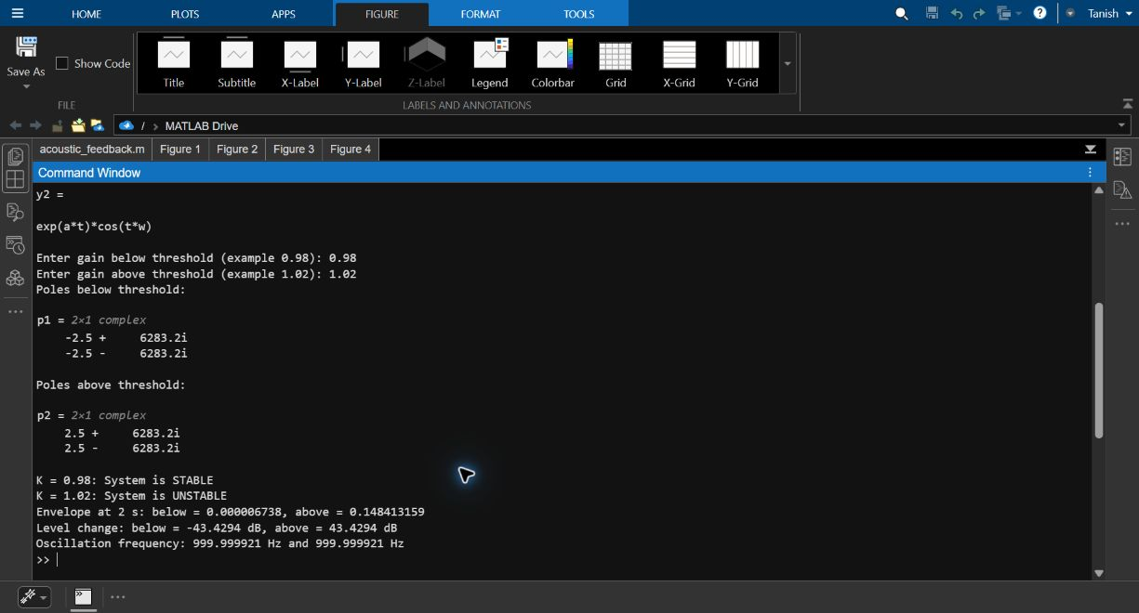
Figure 1 MATLAB input and numerical output

Reading the output
The stable poles have real part -2.5 per second. The unstable poles have real part +2.5 per second. Their imaginary parts are approximately ±6283.18481 rad/s, so both cases oscillate at approximately 1000 Hz. The condition all(real(p)<0) checks every pole correctly, including complex poles.
The generic transform calculation uses symbolic a and w. The numerical simulation then uses the chosen gains to calculate r and wd. The plotted waveform is the free response from an initial disturbance, rather than the impulse response of H(s).

Time responses
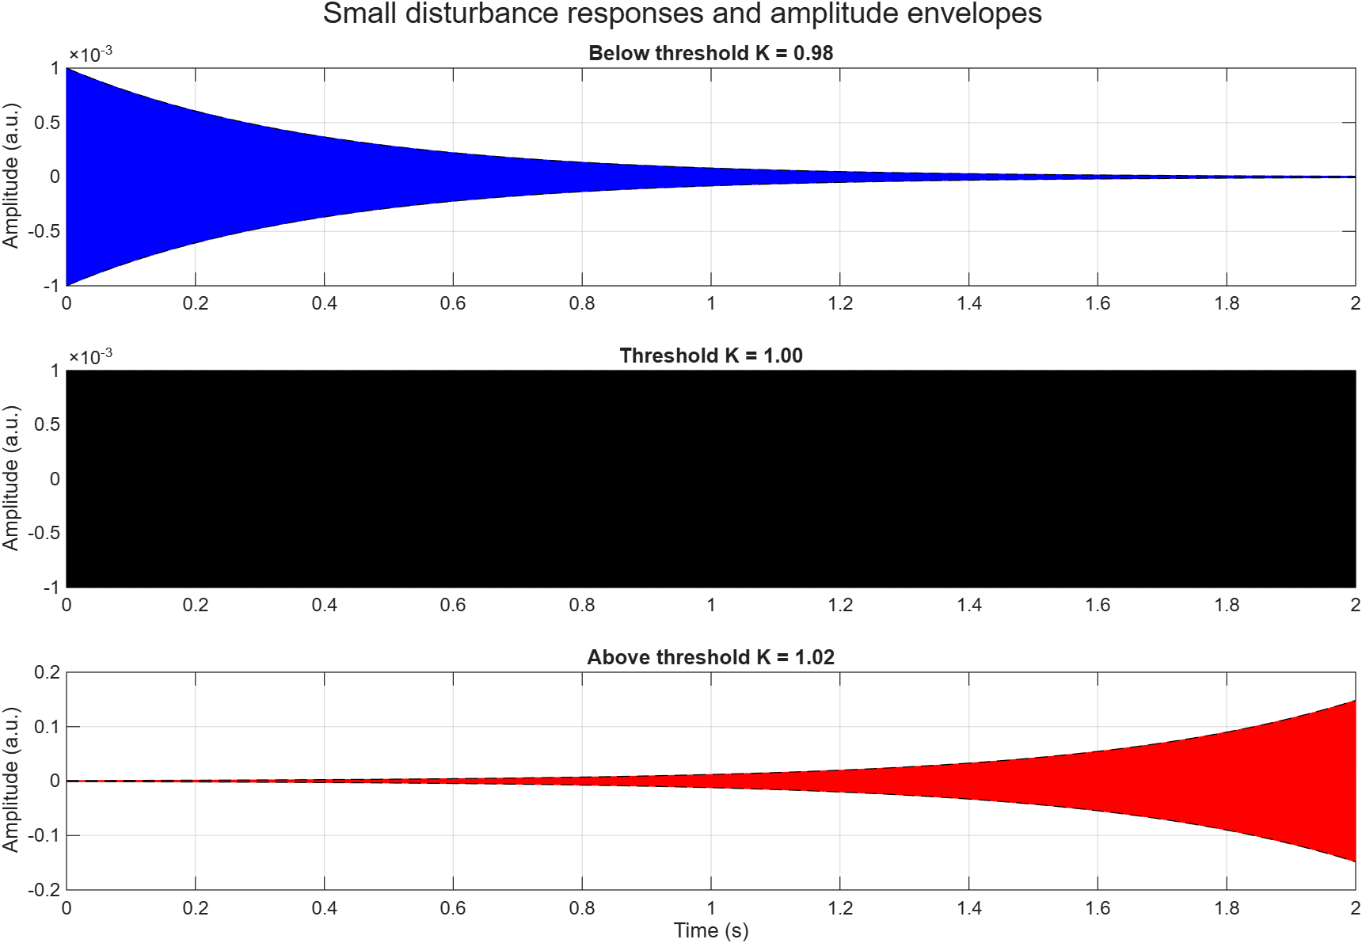
Figure 2 Responses below at and above the threshold
All three cases begin at amplitude 0.001. Below threshold, the oscillation fades because the poles have negative real parts. At K = 1, the unforced oscillation has a constant envelope. Above threshold, the oscillation grows because the poles have positive real parts. The panels use different vertical scales. At 1000 Hz, many cycles lie within the two second window, so the traces appear as dense bands.

Amplitude envelope comparison
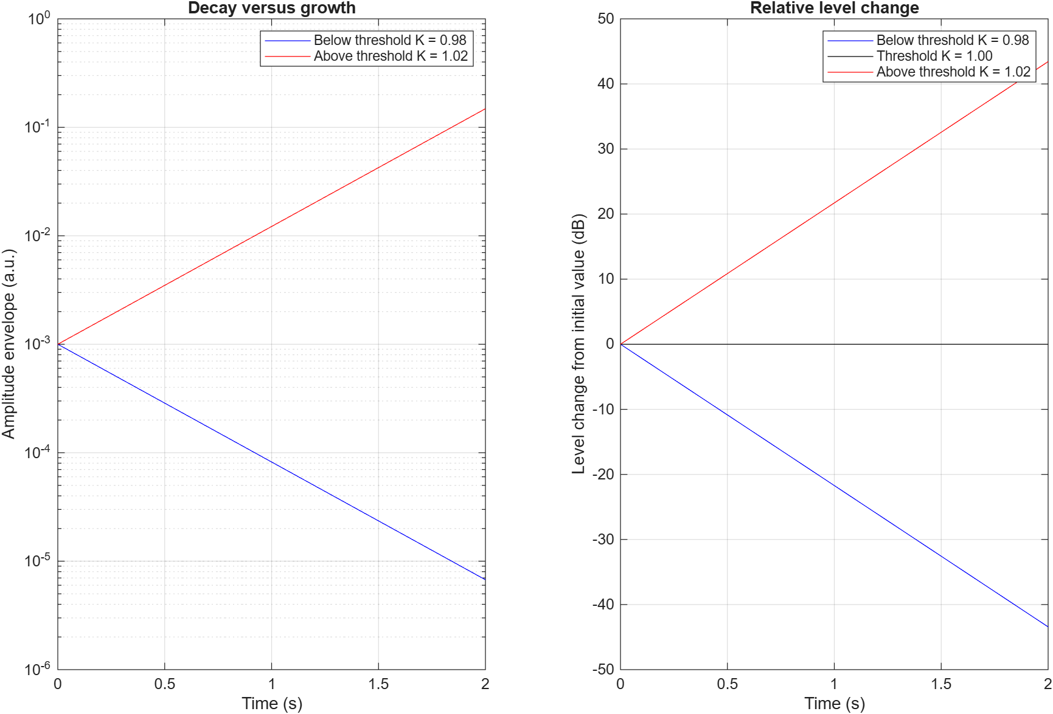
Figure 3 Amplitude envelopes and relative level change
The left panel uses a logarithmic amplitude axis to show both envelopes clearly. The growing curve rises to about 0.1484 while the decaying curve approaches zero. The right panel shows relative changes of +43.4294 dB and -43.4294 dB after two seconds. The K = 1 reference stays at 0 dB. These values describe change from the initial amplitude, not measured sound pressure level.

Pole locations
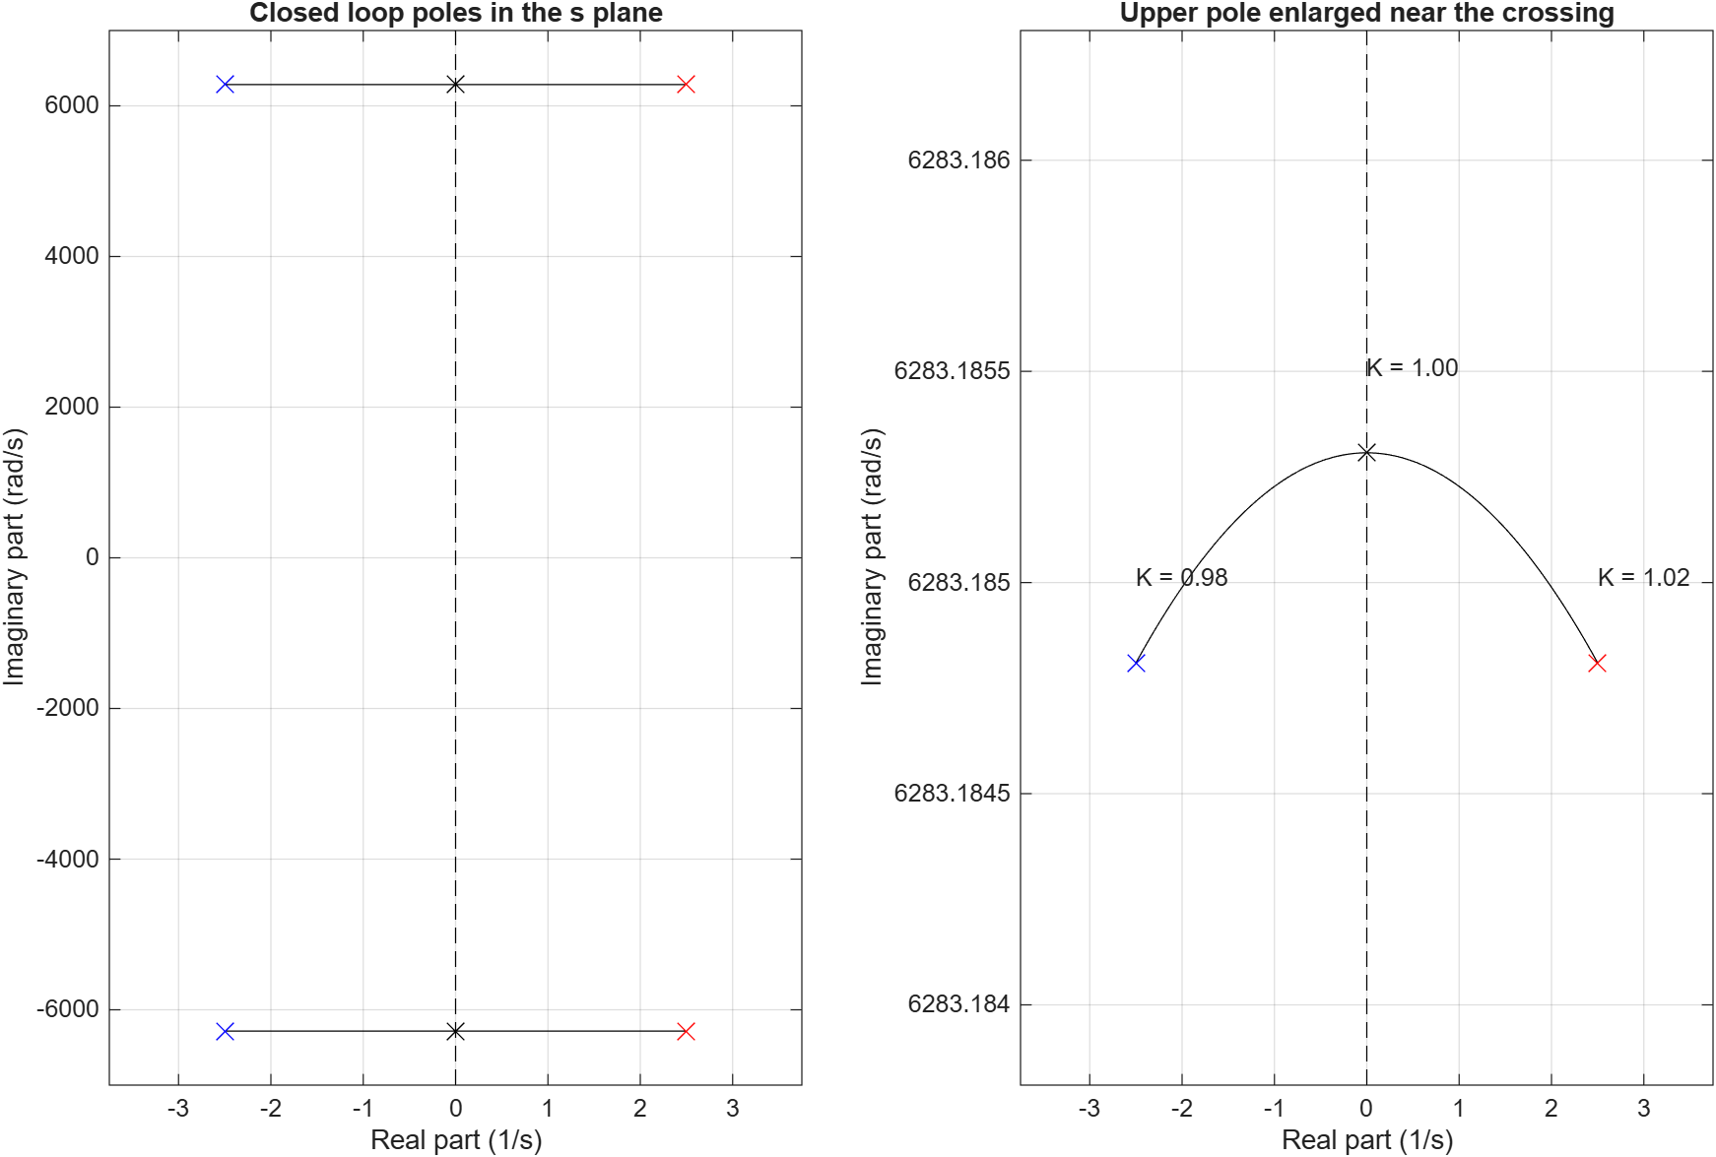
Figure 4 Closed loop poles and an enlarged upper pole view
The dashed imaginary axis, Re(s) = 0, separates the left and right half planes. Blue crosses mark K1 = 0.98 at -2.5 ± j6283.18481. Red crosses mark K2 = 1.02 at +2.5 ± j6283.18481. Black crosses mark the K = 1 reference. The curves connect pole locations as gain varies between the entered values. The enlarged upper-pole view shows the crossing clearly. These plots display poles; the transfer-function zeros are not shown.

Pitch and resonance
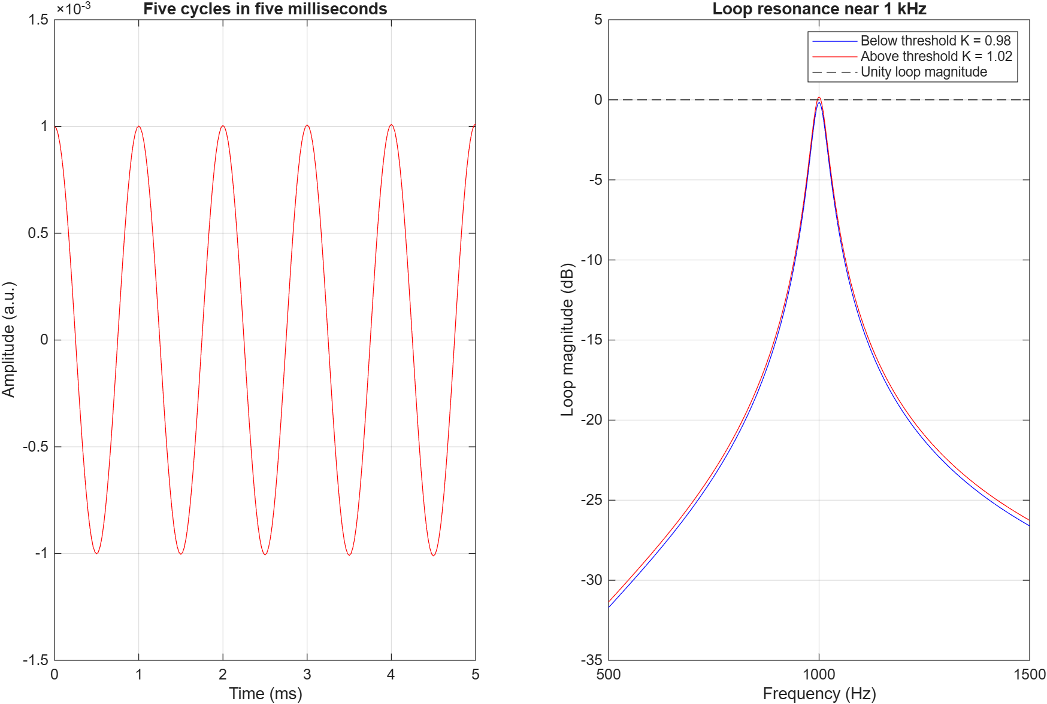
Figure 5 Short waveform segment and loop resonance
The short waveform has approximately five cycles in five milliseconds, giving a pitch close to 1000 Hz. The right panel peaks at the assumed resonance. At 1000 Hz the two loop levels are approximately -0.1755 dB and +0.1720 dB. The dashed 0 dB line marks unity loop magnitude. The assumed resonant path selects the tone; the example does not measure which frequency would squeal in a particular room.

7 Result
Gain K | Pole real part | Envelope at 2 s | Level change
0.98 | -2.5 per second | 0.00000673795 | -43.4294 dB
1.00 | 0 | 0.001 | 0 dB
1.02 | +2.5 per second | 0.148413159 | +43.4294 dB
The results agree with the amplitude-envelope expression in the theory section. Substituting r = -2.5 and r = +2.5 at two seconds gives the tabulated values. The pole real part therefore determines whether the amplitude decays or grows.

8 Applications
- Explaining feedback in classroom and auditorium public address systems.
- Understanding why stronger microphone to speaker coupling can start squeal.
- Demonstrating Laplace transforms and stability through a familiar sound system.

9 Conclusion
The simulation shows how a small change in feedback gain changes a fading tone into a growing oscillation. For the example inputs 0.98 and 1.02, the poles move from the left half plane to the right half plane, while the oscillation frequency stays close to the assumed 1000 Hz resonance. The time plots, amplitude envelopes, and pole map describe the same stability change.
This is a linear model of one resonance. It does not calculate microphone distance, room reflections, propagation delay, or amplifier clipping. A real sound system eventually reaches an output limit, so unlimited growth in the mathematical model describes the onset of squeal rather than its final loudness.

References
[1] Signals and Systems Course Policy 2026-27, course code 702EX0C010. Unit 1: elementary signals and system classification. Unit 2: LTI system interconnection. Unit 4: frequency-domain analysis of continuous-time LTI systems. Unit 5: Laplace transforms, regions of convergence, inverse transforms, and differential equations. Laboratory Exercise 8: stability using pole-zero locations.
[2] Laplace Transform code_exp_7.odt. Supplied laboratory code for syms, laplace, ilaplace, display, input, tf, pzmap, and a stability decision.
[3] Supplied mini project report on fingerprint identification. Reference for the cover, numbered sections, code comments, input and output presentation, results, and conclusion.
[4] SNS_REPORT_A074_A091. Supplied ECG project report. Reference for a stepwise code listing and figures followed by result analysis.

