DOCUMIND AI
Technical Documentation — Runtime Flow, Code Map & Verification
Source reviewed: documind_groq.py (single-file application)
Purpose of this document: describe the execution order, the role of each software component, where the work is implemented in the source file, and what was actually checked. Line references refer to the reviewed documind_groq.py version; line numbers can shift if the file is edited.

1. End-to-end software flow
The application is implemented primarily in one Python file. Streamlit is the default user interface. FastAPI is an optional REST interface; both call the same ingestion, SQLite, retrieval, and question-answering functions.
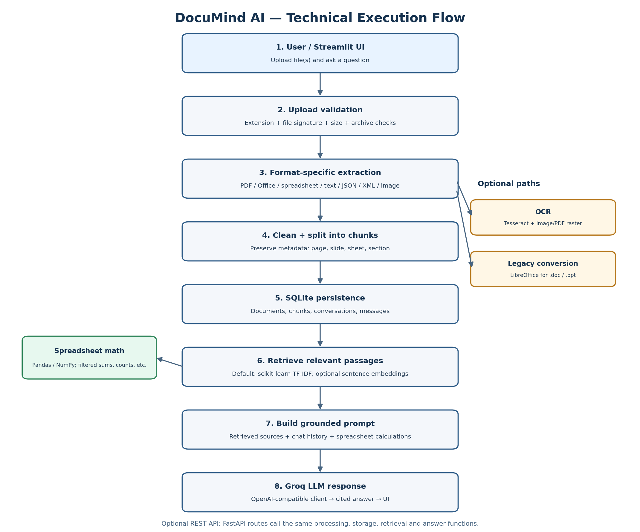

2. Runtime order: what runs first?
Stage | What happens | Source code | Software
1 — Python runtime & configuration | Python loads imports and settings; dotenv is attempted if installed; environment variables / Streamlit secrets are checked for configuration. | Lines 1–166 | Python, python-dotenv (optional)
2 — UI/API entry point | For normal use, Streamlit imports and runs run_ui(). The optional ASGI app is exposed as api for Uvicorn; API startup initializes logging and SQLite. | Lines 1737–1900; 1972–2125 | Streamlit; FastAPI + Uvicorn (optional)
3 — File upload & validation | Uploaded file is registered, size-limited, checked against allowed extension and detected file signature, and checked for unsafe archive expansion. | Lines 179–259; 1704–1731; UI upload flow around 1918–1946 | Python pathlib, zipfile; Streamlit/FastAPI
4 — Extraction | A processor is selected by extension. Parsers extract text/table-like content and attach source metadata. OCR and legacy Office conversion are optional. | Lines 291–363; format handlers around 371–842 | PyMuPDF, python-docx, pandas/openpyxl, python-pptx, Pillow; optional Tesseract / LibreOffice
5 — Clean, chunk & store | Text is normalized, divided into chunks with overlap, and saved with metadata in SQLite. Document status is updated as processing proceeds. | Lines 845–935; 969–1141; 1462–1497 | Python; SQLite
6 — Retrieval | Question text is matched against indexed chunks. TF-IDF is the default; sentence-transformers can be selected as an optional alternative. | Lines 1150–1240 | scikit-learn; optional sentence-transformers
7 — Answer preparation | Relevant passages and recent conversation history are assembled. Tabular questions can trigger a calculation plan before the final prompt is sent. | Lines 1327–1451; 1532–1641 | Pandas, NumPy, Python logic
8 — LLM call & answer display | The OpenAI-compatible SDK sends messages to the configured Groq endpoint; the returned answer and source metadata are stored and rendered in the chat UI. | Lines 1251–1324; 1590–1641; 1949–1969; 1972–2125 | openai Python SDK; Groq API; Streamlit

3. Code map: where each responsibility lives
Component | Implementation detail | Approx. lines
Configuration / model settings | Settings class, environment/secrets lookup, model names, upload/chunk/context limits. | 71–166
File safety checks | Supported extensions, signature detection, blocked MIME types, upload-size and archive-expansion checks. | 179–259
Processor registry | Maps file extensions to the appropriate extractor function. | 291–309
Document parsers | PDF, DOCX/DOC, plain text/Markdown/RTF/ODF, CSV/Excel, PowerPoint, JSON/YAML/XML/HTML and images. | 316–842
Text cleanup / chunking | Normalize text, remove repeated lines, split text while retaining source metadata. | 845–935
SQLite schema and CRUD | Tables for documents, chunks, conversations and messages; create/read/update/delete operations. | 969–1141
Retrieval/index | Base retriever, TF-IDF retriever, optional embedding retriever, cache invalidation and search. | 1150–1240
LLM client | Client setup, chat completion, image description helper and LLM error handling. | 1251–1324
Spreadsheet query logic | Schema description, question parsing, filtering and calculations over extracted tabular data. | 1327–1451
Document ingestion orchestration | Coordinates status updates, extraction, chunk creation and persistence for a document. | 1462–1497
Question answering | Selects searchable documents, retrieves context, creates source labels, adds calculation results, calls LLM and persists messages. | 1532–1641
Logging and upload helpers | Rotating log setup, public document shape, safe upload naming and finalization. | 1674–1731
Optional REST API | Health/config, upload/list/get/delete document, source lookup, conversations, chat and suggestions endpoints. | 1737–1900
Streamlit interface | Sidebar uploads and library, document inclusion toggles, conversation history, chat input, source expanders and retry. | 1914–2125

4. Data path through the application
- Upload: the UI/API accepts a file and enforces the per-file size limit before it becomes searchable.
- Validation: the code checks the extension and detected content signature. ZIP-based Office/OpenDocument formats are checked for excessive uncompressed size and entry count.
- Extraction: the registered handler returns an Extraction object containing Segments. Metadata can identify a page, slide, sheet, section, or other source location.
- Chunking: extracted segments are cleaned and divided into smaller text pieces. The configured defaults are CHUNK_SIZE=1000 characters and CHUNK_OVERLAP=150 characters.
- Persistence: SQLite stores document records, chunks, conversation records, and messages. Uploaded files are kept under the configured data directory.
- Retrieval: the default TF-IDF retriever ranks matching chunks. The optional sentence-transformers backend uses vector embeddings when explicitly configured and installed.
- Answering: retrieved context, source labels, recent chat history, and any calculated tabular results are included in the prompt. The system prompt instructs the model to ground answers in the supplied sources.
- Display: the answer, searched filenames, and source snippets are rendered in Streamlit; the same core answer function is reachable through POST /api/chat when the optional API is used.

5. Main dependencies and when they are used
Software / library | Role in the code | Use
Python standard library | Path/file handling, regex, JSON, SQLite, ZIP inspection, logging, threading and subprocess utilities. | Always
Streamlit | Main interactive upload/chat interface; session state and display of sources/status. | Default UI
OpenAI Python SDK | OpenAI-compatible chat client configured with the Groq base URL. | When generating AI answers
Groq API | Remote LLM inference for document Q&A; separate vision-model setting is used for image description. | Requires valid API key and network
SQLite | Local persistent storage for documents, chunks, conversations and messages. | Always
Pandas / NumPy | Tabular extraction and spreadsheet calculations; NumPy also supports retrieval scoring. | For spreadsheet and retrieval logic
scikit-learn | TF-IDF vectorization and similarity ranking; default retrieval backend. | Default retrieval
Document parsing packages | PyMuPDF, python-docx, python-pptx, openpyxl/xlrd, odfpy, striprtf, BeautifulSoup, Pillow, PyYAML and defusedxml cover supported formats. | As file format requires
Tesseract + pytesseract | OCR for images and scanned PDF pages when both Python wrapper and external executable are available. | Optional
LibreOffice | Headless conversion for legacy .doc/.ppt formats when installed. | Optional
FastAPI + Uvicorn | Exposes REST endpoints around the same core processing and answer functions. | Optional API mode
python-dotenv | Loads a local .env file if the package is installed; environment variables and Streamlit secrets are also supported. | Optional config helper

6. API mode (optional)
Start the REST API with: uvicorn documind_groq:api --port 8000
Method | Endpoint | Purpose
GET | /api/health | Basic service health response.
GET | /api/config | Supported formats, size limit, configured-model status and retrieval backend.
POST | /api/documents | Upload one or more files for validation and background processing.
GET / DELETE | /api/documents[/{doc_id}] | List documents, retrieve one document, or delete a document.
GET | /api/sources/{chunk_id} | Fetch a stored chunk/source record.
GET | /api/conversations; /api/conversations/{cid}/messages | List conversations and read messages.
POST | /api/chat | Submit a question to the same answer() workflow.
GET | /api/suggestions | Return generic suggested questions.

Workspace scoping: API routes expect a valid X-Workspace-Id header. The FastAPI application is created dynamically so that running the Streamlit script does not treat the module as an ASGI server.

7. Verification performed for this documentation
The following checks were executed against the reviewed source file in the current working environment. These are smoke checks, not a complete production test suite.
Check | Result | Evidence / boundary
Python syntax compilation | PASS | python -m py_compile documind_groq.py completed successfully.
Module import / API object | PASS | Module imported successfully; optional FastAPI app object was available in this environment.
Format detection and validation | PASS | A temporary plain-text sample was detected as text and accepted for .txt.
Text extraction | PASS | The registered plain-text processor returned extracted segment content.
Chunking | PASS | A short extracted sample produced a chunk with expected content.
SQLite smoke check | PASS | Database schema initialized in a temporary directory and a document record could be created/read.
TF-IDF retrieval smoke check | PASS | A query about quarterly revenue retrieved the synthetic finance sample ahead of unrelated text.
Live Groq inference / vision inference | NOT RUN | No external API call was made; API key validity, model availability, latency and generated-answer quality remain unverified.
Browser-based UI / deployment test | NOT RUN | No full interactive browser session or hosted deployment was performed.
Full multi-format regression suite | NOT RUN | Individual formats, OCR, LibreOffice conversion, large files and malformed/adversarial files were not exhaustively tested.

8. Important implementation and security notes
- The application is a single-file implementation, not a multi-package architecture. The line map above describes logical sections inside documind_groq.py.
- The default retriever is TF-IDF, not a vector database. Sentence-transformers is an optional alternative and requires its package/model to be available.
- OCR and legacy Office conversion depend on separately installed system software; their presence is checked at runtime.
- The source contains an inline API-key fallback in its configuration section. Do not commit or share a source file containing a live key. Rotate/revoke the exposed key and move credentials to GROQ_API_KEY in environment/.env or Streamlit secrets before sharing or deploying.
- SQLite is local persistence. For multi-user production deployment, add authentication/authorization, secret management, access controls, backups, rate limits and deployment-specific storage planning.
- This document reports only the checks listed in Section 7. Passing smoke checks does not prove that all file formats, API calls, security scenarios or production workloads work correctly.

9. How to run the application
Install dependencies from the project directory:
python -m pip install -r requirements_groq.txt
Start the default UI:
streamlit run documind_groq.py
Optional REST API:
uvicorn documind_groq:api --port 8000
Configure GROQ_API_KEY securely before testing real model responses. Model names and retrieval settings can be overridden with environment variables documented in the source configuration section.

