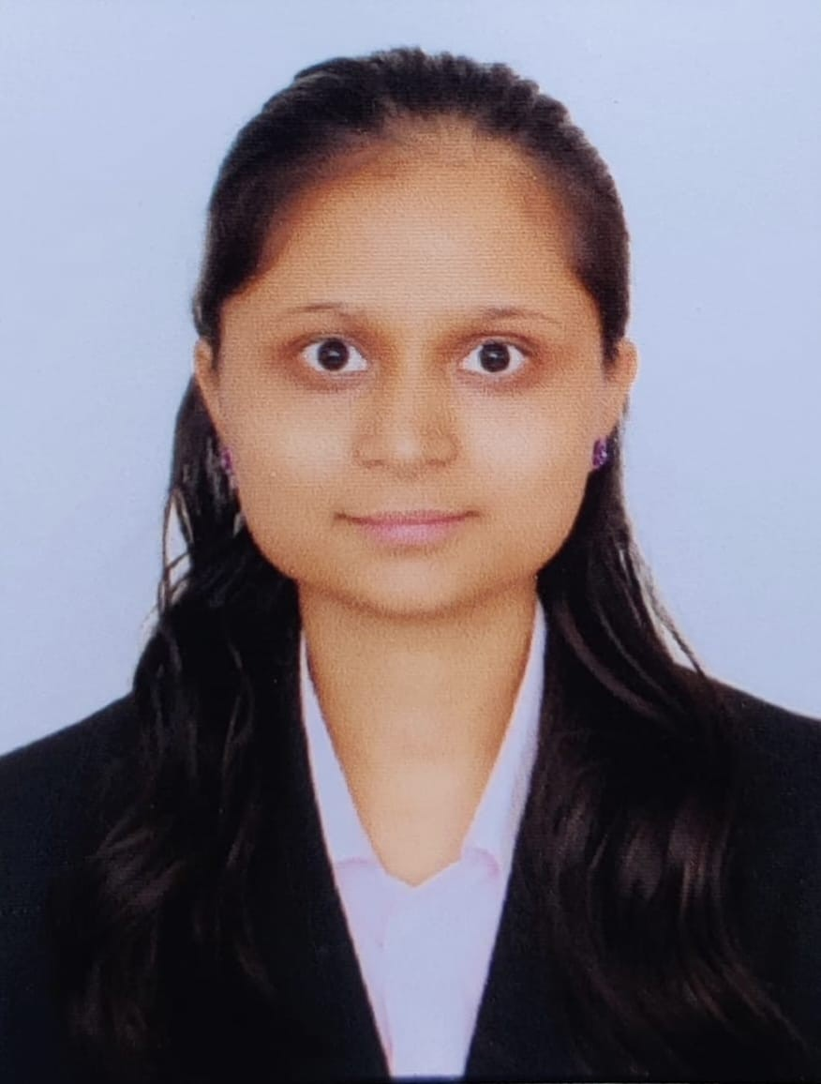

Aarya Suhas Nimbalkar

+

Pune, Maharashtra, India



**9822689542**

—

#

**aaryanimbalkar23@gmail.com**

[ï](https://www.linkedin.com/in/sai-mohite-830418257)

**https://www.linkedin.com/in/aarya-nimbalkar-b4b06125**

[**8**](https://www.linkedin.com/in/sai-mohite-830418257)

[§](https://github.com/aaryanimbalkar2004-maker)

**github.com/Aarya Nimbalka**

[**r**](https://github.com/aaryanimbalkar2004-maker)

**Summary** — Information Technology Engineering student with hands on experience through academic projects.Strong problem solving abilities,with a continuous drive to learn new technology.

# Experience

**Machine Learning Internship Sep 2024 – Oct 2024**

*Unified Mentor*

* Gained hands-on experience in core machine learning concepts and algorithms.
* Worked on real-world datasets to develop predictive models using Python and libraries like NumPy, pandas, and scikit-learn.

# Projects

**Online Polling System**

* Developed an online polling system that allows users to create and participate in polls or surveys via the internet.
* Implemented features for real-time voting, result tracking, and data security.

**Laptop Price Prediction**

* Predicted the price of a laptop based on various features using machine learning algorithms.
* Helps users estimate laptop costs and guides retailers for pricing strategies.

# Skills

|  |  |
| --- | --- |
| **Languages :** Java, Python  **Web Technologies :** HTML, CSS, Spring Boot  **Databases :** MySQL  **Core Concept :** OOP, DBMS, DSA  **Tools & Platforms :** VS Code, Eclipse, PowerBI  **Other Skills:** Java 8 Features,PowerBI  **Education** |  |
| **B.E. (Information Technology Engineering)** | *2022–2026* |
| *Vidya Pratishthan’s Kamalnayan Bajaj Institute Of Engineering and Technology, Baramati, Pune* **SGPA: 7.83**  **Higher Secondary (HSC) – Percentage: 87.17%** | *2022* |
| *Dattakala International School and Jr College,swami chincholi,Bhigwan,Daund*  **Secondary (SSC) – Percentage: 90.60%**  *Vidya Pratishthan’s New English Medium School,Baramati,Pune*  **Certifications & Achievements** | *2020* |

* **Completed Capgemini Java Full Stack Development Training**
* **Infosys Springboard :** Python Foundation Certification
* **Infosys Springboard :** Java Foundation Certification – **NPTEL Certification:** Database Management System
* **TCS iON:** Introduction to Soft Skills
* **Smart India Hackathon 2024 – Participant**
* **PowerBI Workshop - Google Developer Groups(3rd Rank)**