Understanding Direct and Indirect Speech | 
Master the art of reporting what people say—whether you're quoting their exact words or paraphrasing their message. This essential grammar skill transforms how you communicate in writing and conversation. | 




DIRECT SPEECH
What is Direct Speech?
Direct speech reports the exact words spoken by someone, preserved in their
original form. It captures the speaker's voice precisely as it was heard.
Key Feature Example
Uses quotation marks to enclose the speaker's original words Mary said, "I love reading books."

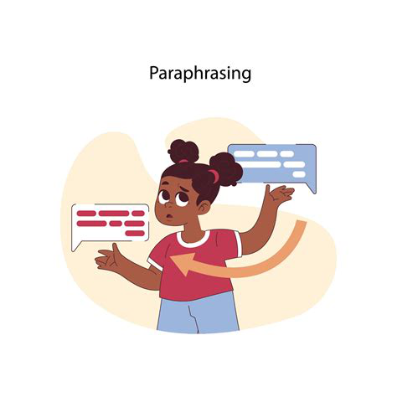


INDIRECT SPEECH
What is Indirect Speech?
Indirect speech (also called reported speech) conveys what someone said without
quoting their exact words. The message is paraphrased while maintaining the original
meaning.
Example: Mary said that she loved reading books.
No Quotation Marks Paraphrased Form
The sentence flows naturally without quotes Words are restructured to fit the reporting context

