
School of Future Tech
Case Study Report
on
Case Study 19: Reusable Moving Boxes
MoveLoop: Circular Logistics – Rental Model
by
Aaryan Keni
150096725197
B.Tech CSE 2025-29 | Go-to-Market & Customer Operations
Semester III : Sprint I

Index
1. Introduction to the Case Study.
2. Problem Statement / Case Background (Abstract).
3. Case Study Design.
4. Methods, Frameworks & Tools Applied in the Case Study.
5. Case Study Implementation Details and Snapshots.
6. Case Study Results and Conclusion.
7. References

1. Introduction to the Case Study
People who move between rented apartments usually buy or collect cardboard boxes that are used once and thrown away. MoveLoop is a proposed service that rents durable plastic moving boxes for ₹35 per box for seven days. Each box costs ₹420 and is expected to survive at least 30 rental cycles, so one box can earn many rentals before it is retired and recycled. The company must design deposits, pickup and return logistics inside a 5-kilometre service area.
This case study applies Go-to-Market and Customer Operations thinking to that business: who the customer is, what problem is solved, how the rental and return journey works, how boxes flow through the operation, whether the unit economics work, and how a 90-day pilot can prove it before scaling. Its primary syllabus focus is circular logistics and the rental model.
The case study shows how a physical asset (the box) is turned into a repeatable service: booked online, delivered, used for seven days, collected, inspected, cleaned and rented again, with a refundable deposit and QR-code tracking protecting the asset at every step.

2. Problem Statement / Case Background (Abstract)

Background
Renters in cities change homes often. Each move needs roughly 15–30 boxes for a typical flat. Cardboard boxes are cheap to buy but weak, bulky to store, and almost always discarded within days, creating packaging waste and repeated spending. Reusable plastic boxes are stronger and stackable, but a single household would never buy them for one move. A rental model spreads the cost of a durable box across many households.

Problem Statement
Renters moving between apartments must buy or hunt for single-use cardboard boxes that are flimsy, time-consuming to source and expensive to dispose of, generating avoidable packaging waste at every move.

Opportunity Statement
MoveLoop can capture this moment by delivering clean, sturdy, reusable boxes to the door for ₹35 per box per week and collecting them afterwards, turning one ₹420 box into about ₹1,050 of rental revenue over 30 cycles while cutting cardboard waste for every customer.

Abstract
This report designs the go-to-market and operations plan for MoveLoop. It defines target segments and a customer persona, builds a Value Proposition Canvas, maps the end-to-end rental journey and the box supply chain, and chooses booking, deposit and tracking processes. A unit-economics model shows that a box breaks even on rental fees alone after 12 rentals and after 17.5 rentals once variable costs are included, leaving about ₹300 profit per box over 30 cycles. A SWOT analysis and seven risks with mitigations are presented, followed by a recommended business model, two customer-acquisition routes at moving time, and a 90-day pilot-to-scale plan with measurable success criteria.
Note on figures: the rental price (₹35), rental period (7 days), box cost (₹420), lifespan (30 cycles) and 5-km service area come from the case. All other numbers (costs per rental, deposit, fees, fixed costs, demand) are reasoned assumptions to be validated in the pilot.

3. Case Study Design
MoveLoop is designed as a service with a customer-facing layer (booking, deposit, delivery) and an operations layer (hub, cleaning, tracking, reverse logistics), built in the following stages:
- Customer discovery: identify pain points, segments and a persona.
- Value design: Value Proposition Canvas and problem/opportunity statements.
- Journey and service design: rental and return journey with operational touchpoints.
- Operating flow: supply chain from sourcing to delivery, return, cleaning and end of life.
- Economics: revenue streams, costs, break-even and reuse-cycle calculations.
- Risk and strategy: SWOT, risks and mitigation, business model and go-to-market.
- Execution: 90-day pilot-to-scale plan with measurable criteria.

3.1 Target Segments and Customer Profile
Segment | Who they are | Why they need MoveLoop
Primary: young working renters | Age 22–35, single or flat-sharing, often no car, UPI-first, move every 1–3 years | Need boxes fast, no time to source cardboard, value convenience and low hassle
Secondary: small renting families | 2–4 members, larger volume (25–40 boxes), moving between rentals | Need sturdy stackable boxes for kitchen and books; want one predictable price
Seasonal: students | Hostel/PG movers at semester breaks | Short-term need, price sensitive, ideal for 7-day rental
Channel: B2B partners | Brokers, PG and co-living operators, housing societies | Recommend a ready service to tenants; earn referral fee; repeat demand

Customer profile (persona): Riya, 27, software engineer, rents a 2BHK flat and is moving within the same neighbourhood. She needs about 20 boxes, has no car, pays through UPI, finds services through Google and her broker, and wants the move done in one weekend without a pile of cardboard left behind.

3.2 Value Proposition Canvas
Customer Profile | What we know | Value Map | What MoveLoop offers
Customer jobs | Pack belongings safely; move on a fixed date; keep cost low; avoid clutter | Products and services | 7-day box rental; door delivery and pickup; booking and tracking; optional packing kit
Pains | Flimsy cardboard; time to find, buy and carry; storage and disposal; hidden costs; waste guilt | Pain relievers | No purchase or disposal; sturdy lidded boxes; doorstep service; clear price and refundable deposit
Gains | Strong stackable boxes; predictable price; fast, clean process; a more sustainable move | Gain creators | Uniform stackable boxes speed up packing; “cardboard avoided” count per move; referral rewards

3.3 End-to-End Customer Journey
Stage | Customer action | Touchpoint | Operational responsibility
1. Awareness | Confirms moving date; searches for boxes | Broker tip, Google search, Instagram, society WhatsApp group | Marketing, partner kits, clear price message
2. Booking | Chooses box count, date and 2-hour slot, shares address | WhatsApp / web form, confirmation message | Check address is inside 5-km zone; verify stock; lock inventory
3. Deposit | Pays deposit and fees by UPI | Payment link, booking ID | Deposit ledger, receipt, reminder one day before
4. Delivery | Receives boxes 1–2 days before the move | Rider, QR scan handover | Pick-pack at hub, scan-out, count and photo, on-time slot
5. Packing and move | Packs and moves; extends if needed | Day-5 reminder, helpline | Extension at ₹5/box/day; proactive support
6. Return | Requests pickup (old or new address inside zone) | Pickup request, rider visit | Scan-in count, condition check, close order
7. Refund and feedback | Gets refund; rates service; shares referral code | UPI refund, feedback form | Inspection-based settlement within 24 h; feedback loop

3.4 Supply Chain / Operating Flow
The operating flow is a closed loop: boxes are bought once, then cycle between hub, customer and cleaning station until they are retired and recycled (Figure 1 in Section 5). Key responsibilities are:
Step | Owner | Key responsibility | Control / KPI
1. Sourcing | Founder / procurement | Choose durable, stackable, lidded boxes; QR-tag each unit | Cost ₹420; defects below 1%
2. Hub stock | Hub supervisor | Storage, first-in-first-out issue, stock sync | Stock accuracy 99% or higher
3. Booking | Customer-ops executive | Validate order, slot, deposit | Confirmation in under 5 minutes
4. Delivery | Rider / driver | Scan-out, deliver, count with customer | On-time delivery 95% or higher
5. Customer use | Customer and support | Reminders, extensions | Returned on time 97% or higher
6. Pickup | Rider / driver | Scan-in, count, condition photo | On-time pickup 95% or higher
7. Inspect and clean | Hub team | Wash, dry, grade (A / B / retire), repair | 24-hour turnaround; grade A 95% or higher
8. End of life | Ops manager | Retire boxes near 30 cycles; sell plastic to recycler | 100% of retired boxes recycled

3.5 Business Model Canvas
Key Partners | Key Activities / Key Resources | Value Propositions | Customer Relationships / Channels | Customer Segments
Box manufacturer  Property brokers and rental platforms  Housing societies (RWAs)  PG and co-living operators  Rider / 3-wheeler partners  Plastic recyclers  UPI payment gateway | Activities  Sourcing and QR-tagging boxes  Booking and slot scheduling  Delivery and pickup  Inspection, washing, repair  Deposit handling and refunds  Resources  Box fleet (₹420 each)  Local hub with wash area  Riders and vehicle  Booking and tracking tools | Sturdy, clean boxes delivered and collected  No buying, storing or dumping cardboard  Predictable price: ₹35/box/7 days  Refundable deposit, transparent fees  Lower packaging waste per move | Relationships  WhatsApp support  Day-5 and day-7 reminders  Easy repeat booking  Referral credit  Channels  Broker and society tie-ups  Google local search / Maps  Instagram and WhatsApp link  QR flyers and referrals | Renters moving between apartments: young professionals, flat-sharers, small families  Students (seasonal)  B2B: brokers, PGs, co-living operators
Cost Structure  Box purchase (₹420 each; ₹14 per rental depreciation)  Logistics (about ₹9 per box)  Cleaning and repair (about ₹4)  Hub rent and staff, marketing and referral payouts  Payment fees, loss and damage allowance |  | Revenue Streams  Rental: ₹35 per box per 7 days  Delivery fee: ₹100 per order  Late / extension fee: ₹5 per box per day  Loss and damage fees  Packing add-ons (tape, wrap)  B2B partner bundles; recycled plastic value at end of life

4. Methods, Frameworks & Tools Applied in the Case Study
Key methods and concepts:
- Problem and opportunity framing – converting the customer pain into a clear problem statement and a “what we can do” opportunity statement.
- Segmentation and persona – primary, secondary, seasonal and channel segments; one detailed persona.
- Value Proposition Canvas – matching customer jobs, pains and gains to pain relievers and gain creators.
- Customer journey mapping and service touchpoints – seven stages from awareness to refund.
- Operations / supply-chain flow design – forward logistics (delivery) and reverse logistics (pickup, cleaning, redeployment).
- Unit economics – revenue per rental, variable cost per rental, contribution margin, break-even cycles, utilisation and payback.
- SWOT analysis and risk register – likelihood, impact and mitigation for seven risks.
- Business Model Canvas and go-to-market planning – model choice, two acquisition channels, 90-day pilot with KPIs.

Tools Used for the Case
- Analysis and calculations: worked by hand and checked in Python.
- Diagrams and charts: Python (matplotlib) for the operating-flow and break-even figures.
- Proposed operating tools: WhatsApp Business or a simple web form for booking, UPI payment links for deposits, QR codes with a Google Sheets / Airtable inventory for tracking.
- Report format: Word document following the School of Future Tech case study template.

5. Case Study Implementation Details and Snapshots
The plan was developed in the following stages: (1) process design for booking, deposit and tracking; (2) financial model and reuse-cycle calculation; (3) SWOT and risk analysis; (4) business model and go-to-market choice; (5) 90-day pilot plan.

5.1 Essential Booking, Deposit and Tracking Processes
Process | Design decision | Why
Booking | WhatsApp or web form; minimum 10 boxes; 2-hour delivery slot; map pin or pincode checked against the 5-km zone | Keeps deliveries batched and inside the profitable area
Deposit | ₹100 refundable deposit per box, paid by UPI; refund within 24 hours of inspection | Covers about 24% of box cost without scaring customers (a full ₹420 deposit on 20 boxes would be ₹8,400)
Loss and damage | Unrecoverable box charged ₹420 (deposit adjusted first); damaged boxes charged by grade; UPI mandate or card pre-authorisation for the balance | Protects the asset; the fee equals replacement cost
Rental period and fees | ₹35 per box for 7 days; extension or late fee ₹5 per box per day (= ₹35 / 7); delivery fee ₹100 per order | Fair pro-rata pricing; delivery fee funds logistics
Tracking | Unique QR on every box, scanned at hub-out, delivery, pickup and wash-in; status: In hub, With customer, Cleaning, Repair, Retired; cycle counter per box | Real-time stock, accountability, and retirement at about 30 cycles

5.2 Financial Model and Reuse-Cycle Calculation
Unit economics per box-rental (assumed for a 20-box order):
Item | Calculation | ₹ per box-rental
Rental fee | Given by case | 35
Delivery fee share | ₹100 order fee / 20 boxes | 5
Total revenue |  | 40
Box depreciation | ₹420 / 30 cycles | 14
Cleaning and inspection | Wash, dry, check | 4
Logistics | ₹180 round trip (delivery and pickup) / 20 boxes | 9
Payment fees | About 2% of revenue | 1
Loss and damage allowance | Provision beyond the deposit | 2
Total variable cost |  | 30
Contribution per box-rental | 40 – 30 (25% margin) | 10
Cash margin before depreciation | 40 – 16 | 24

Reuse-cycle calculations:
Measure | Working | Result
Lifetime rental revenue per box | 30 cycles × ₹35 | ₹1,050 (2.5× the box cost)
Break-even on rental fee alone | ₹420 / ₹35 | 12 rentals
True break-even after variable costs | ₹420 / ₹24 cash margin | 17.5 rentals
Lifetime profit per box at 30 cycles | 30 × ₹24 – ₹420 | ₹300
Cycle time and yearly cycles | 7 days rental + 3 days return and clean = 10 days; 365 / 10 = 36.5 maximum; 65% utilisation | About 24 cycles per year
Box life and payback | 30 / 24 per year; 17.5 / 24 per year | About 15 months life; about 9 months payback
Order-level result (20 boxes) | Revenue 20 × ₹40; contribution 20 × ₹10 | ₹800 revenue; ₹200 contribution
Customer comparison (assumed cardboard ₹50/box) | 20 × ₹50 plus tape vs MoveLoop ₹800 | About ₹200 cheaper, no disposal

Cycles achieved by a box | 30 | 25 | 20 | 17.5 | 12
Profit per box (₹) = cycles × 24 – 420 | 300 | 180 | 60 | 0 | –132
Sensitivity: a box must reach at least 18 cycles to earn money, so hygiene, damage control and returns matter more than price.
Scale and break-even (assumed): a lean hub costs about ₹40,000 per month (rent 12,000; ops staff and rider 18,000; marketing 8,000; software and misc 2,000). At ₹10 contribution, break-even is 40,000 / 10 = 4,000 box-rentals per month = 200 orders. At 2 rentals per box per month this needs a fleet of about 2,000 boxes (₹8.4 lakh). If the 5-km zone holds about 1,00,000 rented households and 20% move each year (about 1,667 moves a month), 200 orders is roughly a 12% share. Higher density, better utilisation and add-ons are the levers for profitability.

5.3 SWOT Analysis
Strengths | Weaknesses
• Durable box: about ₹1,050 revenue from a ₹420 asset  • Doorstep convenience for a stressful moment  • Compact 5-km zone gives dense routes and fast turnaround  • QR tracking gives full asset visibility  • Clear environmental story (no single-use cardboard) | • Thin margin: about ₹10 contribution per box-rental  • Heavy up-front capital (₹420 per box)  • Depends on boxes coming back  • Cleaning and logistics add labour and cost  • Service limited to a 5-km area; seasonal demand
Opportunities | Threats
• Frequent renter movement in large cities  • Brokers and societies as low-cost channels  • Add-ons: packing kits, furniture wraps, short storage  • B2B demand from PGs, hostels, co-living, offices  • Replicate hub-by-hub in new zones | • Free or cheap cardboard from shops and e-commerce  • Packers-and-movers bundling their own boxes  • Customer distrust of deposits  • Loss, theft and hygiene complaints  • Rising plastic prices; copycat competitors

5.4 Risks and Mitigation
Risk | Likelihood | Impact | Practical mitigation
1. Boxes lost or not returned | Medium | High | ₹100 deposit plus ₹420 loss fee; QR scans at every hand-off; late fee ₹5 per box per day; phone and address verification
2. Damaged or unhygienic boxes | Medium | Medium | Grade A / B / retire inspection; standard wash and dry; damage fee table; replace lids; rotate fleet
3. Low utilisation and seasonality | High | High | Broker and PG partnerships for steady demand; off-peak discounts; add-ons; adjust fleet size to demand
4. Logistics cost overrun or late delivery | Medium | High | Batch by route and slot; minimum 10 boxes; hard 5-km limit; ₹100 delivery fee
5. Deposit friction lowers sign-ups | Medium | Medium | Keep deposit low at ₹100; instant UPI refund; waive for verified repeat users
6. Competition from free cardboard and packers | High | Medium | Sell convenience, cleanliness and zero waste; price calculator; partner with packers for bundles
7. Cash tied up in inventory | Medium | High | Buy in phases (300 to 1,000 boxes); pilot first; track 17.5-cycle payback; explore leasing

5.5 Recommended Business Model and Go-to-Market Approach
Recommended model: a pay-per-use rental service with a refundable deposit, run as a single hyper-local hub (hub-and-spoke within 5 km). Revenue comes from the ₹35 weekly box fee, a ₹100 delivery fee, extension and loss fees, and packing add-ons, with B2B partner bundles added after the pilot. A single dense hub keeps routes short, turnaround fast and utilisation high.
Two ways to reach customers at moving time:
- Broker and society partnerships (intercept at lease signing). Property brokers, PG / co-living operators and housing-society WhatsApp groups recommend MoveLoop when a tenant signs or gives notice. Pay a ₹50 referral per completed order. Measure: share of orders from partners; target cost per order at or below ₹150.
- Search and social intent capture. Optimise a Google Business Profile for searches such as “moving boxes on rent near me”, run short Instagram Reels showing a stacked-box move, and use a single WhatsApp booking link. Measure: clicks to bookings and cost per booking.

5.6 90-Day Pilot-to-Scale Plan
Phase | Days | Key actions
1. Set up and validate | 1–30 | Buy 300 boxes (₹1,26,000) and QR-tag them; set up hub and wash area; WhatsApp booking form and UPI deposit flow; sign 3 brokers and 2 societies; collect 20 pre-bookings; run 10 friendly beta orders
2. Launch pilot | 31–60 | Open bookings in the 5-km zone; target 30 completed orders; daily stock and return review; fix process gaps weekly
3. Optimise and decide | 61–90 | Tune pricing, deposit and add-ons; test referral payout; decide on 200 more boxes, a second rider or a second hub (go / no-go review on Day 90)

Measurable success criteria (by Day 90):
KPI | Target
Completed orders (≈ 1,200 box-rentals) | 60 or more (60 live days × 300 boxes / 20 per order / 10-day cycle = 90 maximum, so 67% of capacity)
Fleet utilisation | 60% or higher
Boxes returned within 3 days of due date | 97% or higher
Loss plus unrecoverable damage | 2% of boxes or lower
On-time delivery and pickup (2-hour slot) | 95% or higher
Actual contribution per box-rental | ₹8 or higher
Customer rating and repeat / referral | 4.5 out of 5 and 20% or higher
Customer acquisition cost per order | ₹150 or lower
Scale trigger: if at least 6 of the 8 targets are met, expand to 1,000+ boxes and open a second hub; otherwise repeat the pilot after fixing the weakest metrics.

Snapshots
The following exhibits show the operating flow and the reuse-cycle economics used in this report.
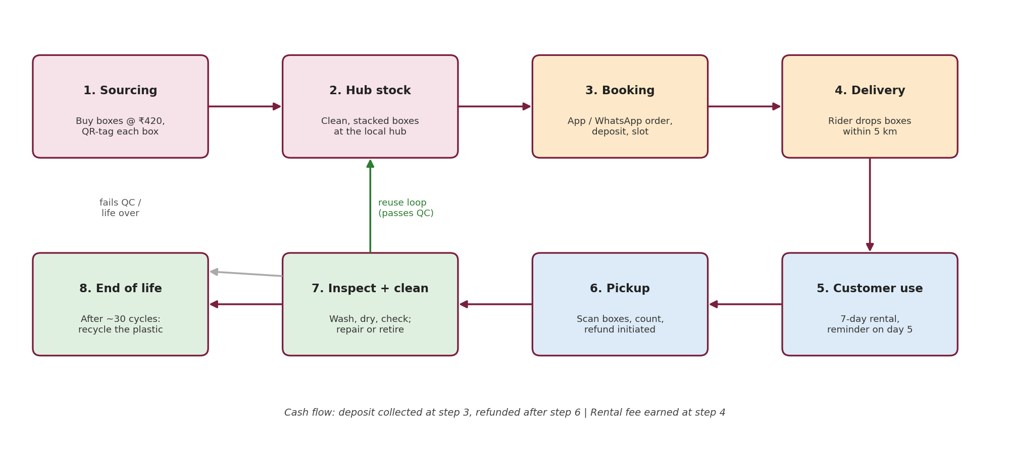
Figure 1: MoveLoop supply chain and reuse loop
Shows the eight-step flow from sourcing to end of life, the reuse loop after inspection, and where cash moves.
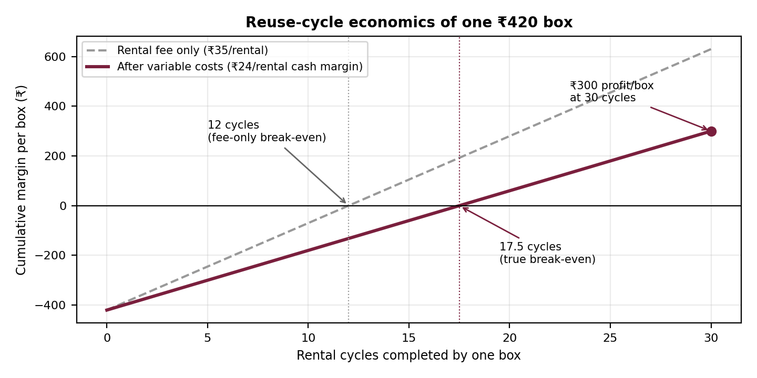
Figure 2: Cumulative margin per box against rental cycles
Shows break-even at 12 cycles on fees alone and at 17.5 cycles after variable costs, reaching ₹300 profit at 30 cycles.

6. Case Study Results and Conclusion.

Findings
- The core problem is single-use, hard-to-source cardboard at a stressful moment. Young working renters are the best first segment, with brokers and societies as low-cost channels.
- A box earns ₹1,050 in rentals over 30 cycles on a ₹420 cost. It breaks even after 12 rentals on fees alone and after 17.5 rentals once costs are included, earning about ₹300 per box at full life.
- Contribution is about ₹10 per box-rental (25%), so profit depends on utilisation, density and keeping boxes in good condition rather than on price. Break-even at the hub level is about 200 orders per month.
- A ₹100 per box deposit with QR tracking and a ₹420 loss fee balances customer trust and asset protection better than a full-cost deposit.
- The 5-km service area is a strength: shorter routes, quicker turnaround and easier customer trust.
- The biggest risks are non-returns, low utilisation and logistics cost; each has a practical mitigation and a KPI in the pilot.

Conclusion
This case study shows that reusable moving boxes can work as a rental business if operations are tight. The design links customer needs to a simple booking, deposit and tracking flow, a closed-loop supply chain and a clear reuse-cycle calculation. The margin per rental is thin, which makes the recommended hyper-local hub, partner-led acquisition and 90-day pilot with measurable criteria the sensible way to test demand, return behaviour and cost before investing in a larger fleet. All non-case numbers are assumptions that the pilot is designed to confirm or correct.

7. References
- Case Study no. 19: Reusable Moving Boxes (MoveLoop), Go-to-Market & Customer Operations, School of Future Tech, ITM Skills University, B.Tech CSE 2025-29, Semester III: Sprint I.
- Osterwalder, A. and Pigneur, Y., Business Model Generation (Business Model Canvas).
- Osterwalder, A. et al., Value Proposition Design (Value Proposition Canvas).
- Ellen MacArthur Foundation, materials on the circular economy and reuse / product-as-a-service models.
- Course material on Go-to-Market strategy, customer journey mapping, unit economics and SWOT analysis, Semester III.

